**Supplementary material**

**Appendix A: The hypothetical target trial and the emulated trial**

The right hand side of Table S1 describes the emulated trial in more detail. As argued by Lodi *et al.* it is important to contrast the differences between the target and emulated trials [26]. Focussing on these differences, we note that the main sources of potential discrepancies are:

* Patients are replicated in the emulated trial rather than being randomized. In fact, we can view the cloning process of the emulated trial as resulting in the “perfect” randomization in which there really are no differences between the patients at baseline – they are the same patients!
* In the emulated trial, we are not able to differentiate between patients dropping out, for example, due to adverse effects from medications, and those lost to follow-up. This might be a source of potential bias in the results, if the risk of PcP diagnosis was not the same in these two groups.
* Artificial censoring is introduced to adjust for potential selection bias in the emulated trial. The calculation of the IPWs to adjust for potential selection bias assumes that all potential confounders are taken into account. Making this assumption of so-called “no unmeasured confounding” is difficult to verify in practice.

**Table S1**: Hypothetical target trial and the emulated trial using observational data from COHERE.

|  |  |  |
| --- | --- | --- |
| **Component** | **Hypothetical target trial** | **Emulated trial using observational data** |
| **Aim** | To compare the risk of primary PCP diagnosis between those patients taking prophylaxis according to the current EACS guidelines(Strategy 1), with those taking PCP prophylaxis based on confirmed viral suppression, irrespective of CD4 count (Strategy 2). | *Same* |
| **Eligibility criteria** | Patient must be on ART (defined as any combination of 3 or more antiretrovirals of any type), be 16 years or older, iv.) have no history of previous PCP, and taking PcP prophylaxis in line with existing recommendations, (i.e. they have a CD4 count of less than <200 cells/µL and are on PcP prophylaxis). | *Same*  In addition, patients must have follow-up in a cohort after 1st June 1998.  Only visits at which the patient is on ART are included. |
| **Treatment Strategies** | Strategy 1: Take prophylaxis if CD4<200 cells/µL, and stop PcP prophylaxis if CD4 increases from <200 cells/µL to >200 cells/µL for >3 months.  Strategy 2 (new): Take PcP prophylaxis if not virologically suppressed (HIV RNA ≥ 400 c/ml), and stop PcP prophylaxis if the patient has confirmed viral suppression (two consecutive HIV RNA measurements <400 c/ml). | *Same* |
| **Treatment assignment** | Eligible patients are randomized to one of the two Strategies. | Eligible patients are replicated in the database, and then follow both strategies. |
| **Outcomes** | Time to primary PcP diagnosis | *Same* |
| **Follow-up period** | Patients continue until they are diagnosed with PcP (the endpoint), drop-out (non-compliance, adverse effects), are lost to follow-up, die, or the administrative end of follow-up is reached (5 years).  Patients are followed up on each of the strategies irrespective of whether they are no longer taking ART post-randomisation. | Patient records are included until they are diagnosed with PcP (the endpoint), drop-out (reason not identified in the database), die, or the administrative end of follow-up is reached (5 years).  They are artificially censored if they are no longer consistent with the respective strategy. |
| **Causal contrast(s)** | Intention to Treat effect  Per protocol effect i.e. the analysis set includes those not censored due to non-compliance, drop-out and death. | Intention to Treat effect: Since all patient are cloned and assigned to both arms an intention to treat analysis would include the same patients.  Per protocol effect only: Analogous approach, but we only censor those when they deviate from the strategy. |
| **Analysis plan** | 1. Intention to treat analysis 2. Per protocol analysis   Estimated hazard ratio of strategy 1 (baseline) compared to strategy 2, adjusted for any confounding factors. | No intention to treat analysis  Same for the per protocol analysis |

**Figure S1**: Hypothetical target trial: Eligibility, randomization and stopping criteria based on CD4 count or confirmed viral suppression (CVS, two consecutive HIV RNA measurements <400 c/ml).

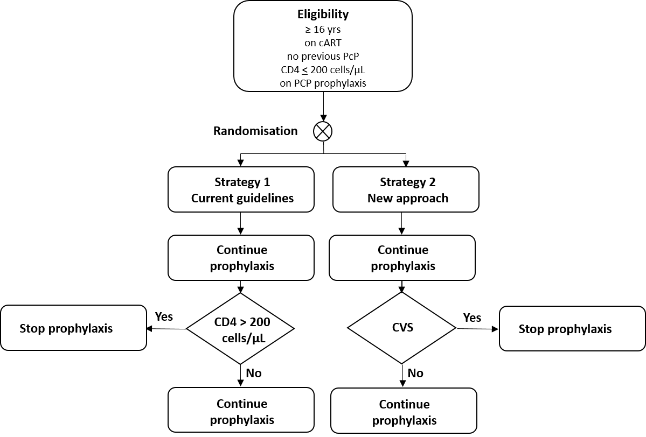

**Appendix B: Data set definition**

The cleaned 2015 merger of the COHERE database contained information from 170k patients with 4.4 million follow-up visits and 5’109 diagnoses of primary, and 652 of secondary, PcP. Patient visits following primary PcP diagnosis were excluded.

For the CD4 and HIV RNA measurements, we used last observation carried forward (LOCF) to estimate CD4 and HIV RNA for follow-up visits in which these measurements were not taken. We only included CD4 counts ≥ 0 cells/µL and ≤ 3000 cells/µL.

Primary PcP prophylaxis was defined as the following medications: any combination of sulfonamides and trimethoprim (J01EE), dapsone (J04BA02 or D10AX05), pentamidine (P01CX01) and atovaquone (P01AX06). LOCF was used to impute missing treatments for visits at which this information was not available.

Including visits after 1.1.98 for patients 16 years of age or older, and those with observed or LOCF values for CD4 counts and HIV RNA values resulted in a data set with 3.9 million follow-up visits for 160k patients. Patients that were still recorded as being in follow-up, but nonetheless had not had a follow-up visit in 2014, were assumed to have dropped out. Including only those taking primary PcP prophylaxis, and those taking ART at baseline, resulted in a data set with 39’800 patients and 931’804 follow-up visits with 467 primary PcP diagnoses.

We expanded this data set so that patient follow-up was no longer defined for each visit, rather on a monthly basis. That is, each patient has follow-up starting at time 0 (randomization) and continues in monthly steps (1 record per month) until PcP diagnosis, death, drop-out, or 5 years of follow-up is reached (i.e. at most 60 months of follow-up per patient). Again, LOCF was used to estimate CD4, HIV RNA and PcP prophylaxis in the expanded data set for missing values.

We selected those eligible for randomization in the hypothetical trial, that is, those with CD4 < 200cells/µL *and* taking PcP prophylaxis, defining this as “time 0” for the emulated trial, and discarded follow-up visits prior to this time-point. Furthermore, we excluded patients with PcP at time 0, along with those that died or dropped out at time 0. In addition, we only included those with complete baseline covariate data, which meant that some patients with missing geographical origin and mode of transmission were excluded.

We then replicated the remaining patients with their follow-up visits for assignment to both prophylaxis strategies. Taking into consideration a grace period for stopping prophylaxis of m=3 months, we artificially censored those patients on either arm not consistent with their respective prophylaxis strategy. Finally, we truncated follow-up at 60 months after randomization. The final (replicated) data set contained 252’026 months of follow-up (strategy = 1 136’425, strategy 2 = 115’603) from 94’825 observed visits (strategy 1 = 51’951, strategy 2 = 42’874) for 4’813 patients (on both arms), with 103 primary PcP diagnoses (strategy 1 =52, strategy 2 = 51).

A “consort”-type diagram for the emulated trial is shown in Figure S2.

**Figure S2**: “Consort”-like diagram for the study population

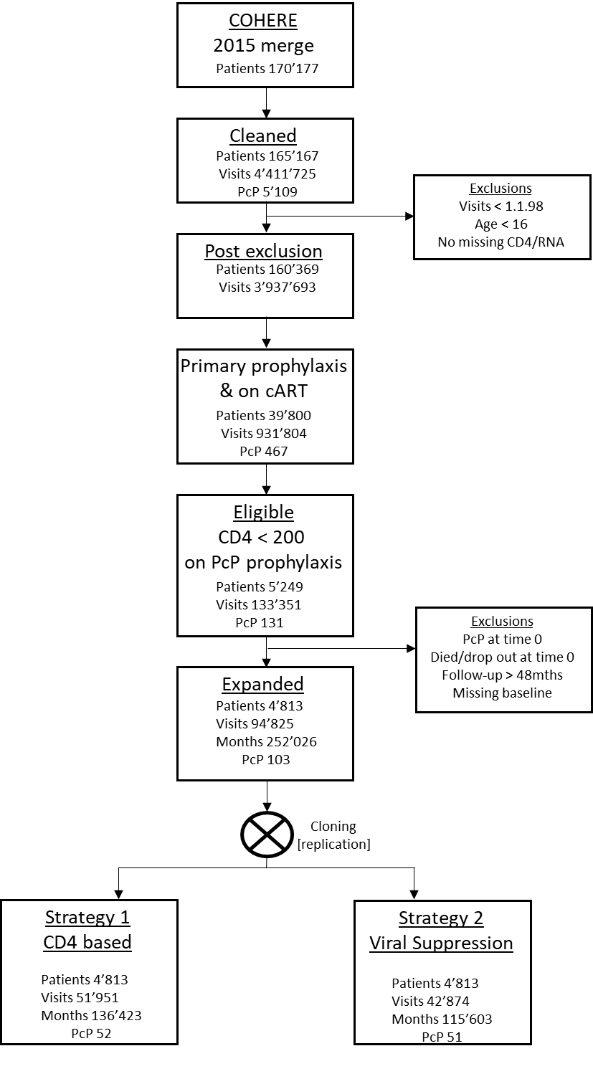

**Figure S3**: Estimated time to primary PcP diagnosis under existing strategy 1 (blue) and new strategy 2 (red, dashed). The curves are estimated from the observed (not bootstrapped) data for the following reference values fitting the pooled logistic model to the analysis set with baseline hazard including terms in time, time2 and time3; 40 year old heterosexual male of European origin with a baseline CD4 count of 130 cells/μL, baseline RNA of 1460 copies/ml, 93% on ART during follow-up, with follow-up starting in 2003;

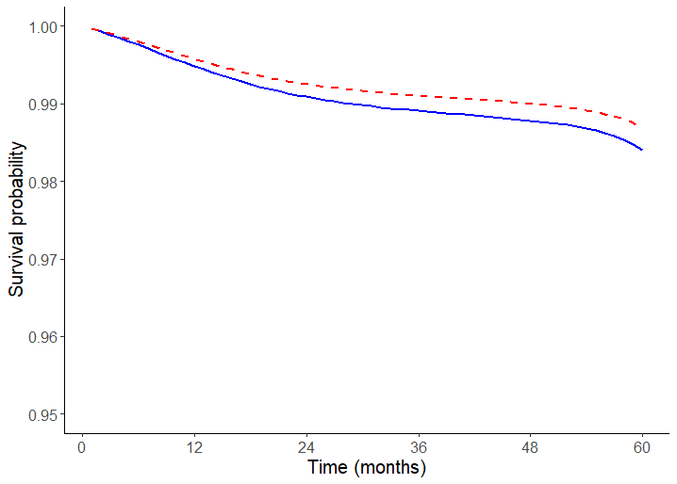

**Appendix C Modelling** – see separate PDF document