Supplementary Material (Figures)

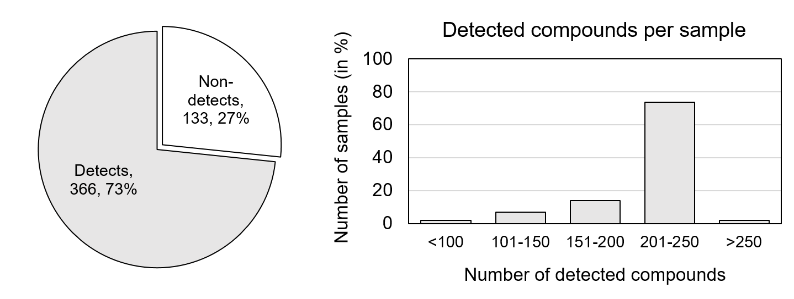
Figure S1: Quantitative LC-HRMS screening results. Left: pie-chart of the fraction of detected and non-detected target compounds. Right: barplot of the detected compound ranges per sample.

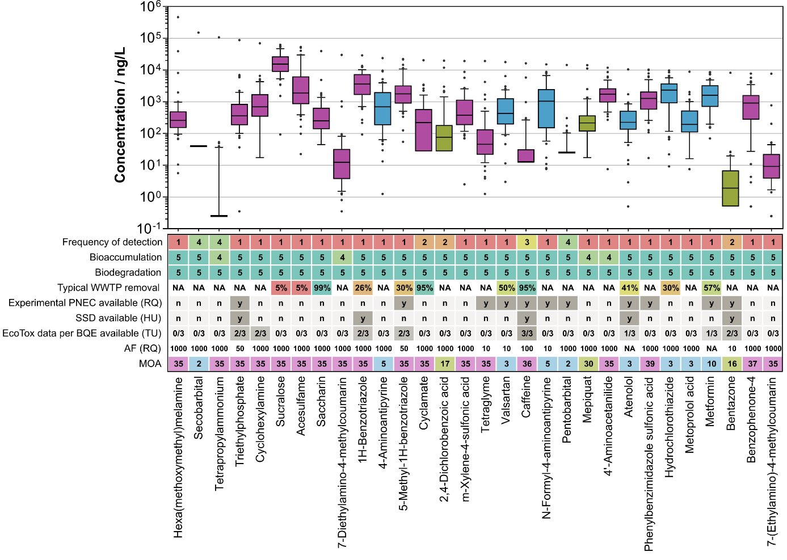
Figure S2: Top 30 compounds by Maximum concentration (based on dataset B; NA = MDL/2). Boxplot hinges are representing the 25th and 75th percentile, and the upper/lower whiskers: +/-1.5*IQR (interquartile range). The centre line represents the median concentration. Information on the scores (rows 1-3) are presented in table 1. Information on the MOA categories are presented in table 2. Experimental PNECs include regulatory-adapted EQS, as well as country specific EQS or proposals.
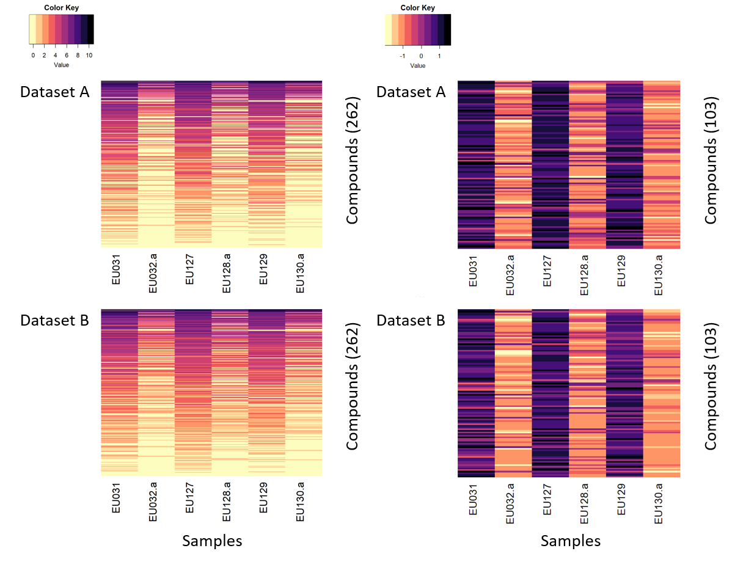
Figure S3: Impact of advanced wastewater treatment by ozonation. Heatmaps of glog-transformed concentration of detected compounds (rows) per sample (columns), before ozonation: EU031, EU127, EU129; after ozonation: EU032, EU128, EU130. Left: Based on all detected compounds (262). Right: Based on detected compounds with concentration reduction >50% in all three cases (103) and with additional z-score scaling by rows (compounds). Top: Based on dataset A (NA = 0). Bottom: Based on dataset B (NA = MDL/2).

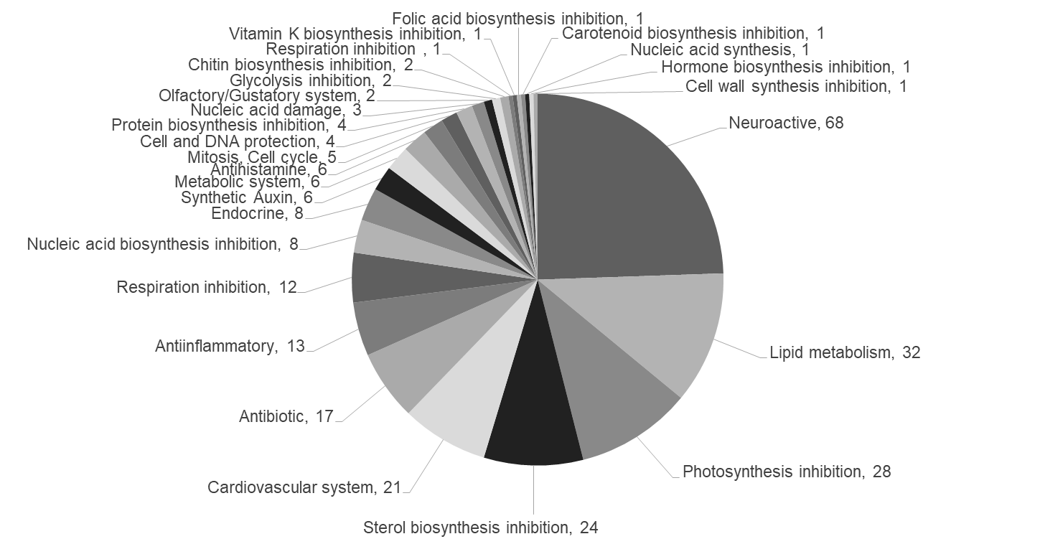
Figure S4: Specific mode of action information for detected compounds. Pi-chart of specific MOA information of the detected target compounds according to the three main use groups; pharmaceuticals (blue), pesticides & biocides (green), others (purple). In brackets: The number of compounds belonging to each MOA category.
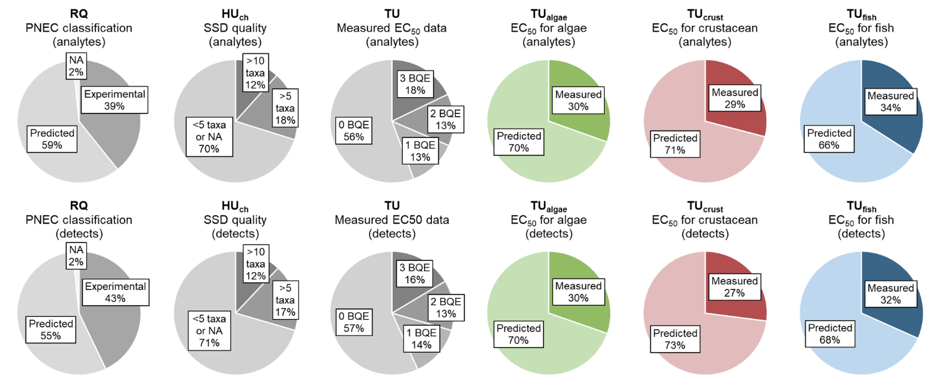
Figure S5: Availability of toxicity data.

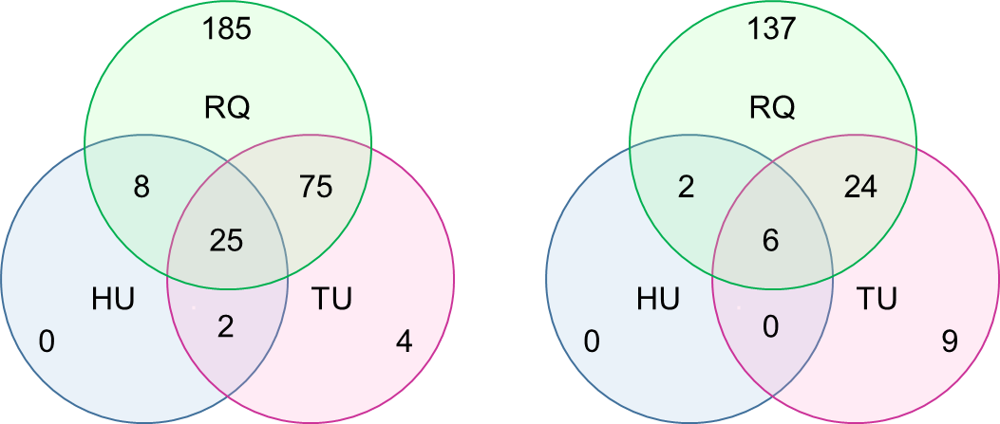
Figure S6: Venn diagram (based on dataset B; NA = MDL/2). Left: Number of priority compounds per metric exceeding the chronic risk threshold of 1. Right: Number of priority compounds exceeding the chronic risk threshold including a dilution factor of 10.

