Supplementary Appendix

Supplementary Results
OS by baseline PD-L1 expression
In patients with ≥ 5% programmed cell death (PD)-1 ligand (PD-L1) expression at baseline, median overall survival (OS) was 12.6 months (95% CI, 11.1-16.2) in the NIVO+RT arm and 14.2 months (95% CI, 12.3-17.3) in the TMZ+RT arm (HR, 1.3; 95% CI, 0.9-1.8). Median OS in patients with < 5% PD-L1 expression at baseline was 13.6 months (95% CI, 12.9-14.4) in the NIVO+RT arm and 15.2 months (95% CI, 13.2-16.2) in the TMZ+RT arm (HR, 1.3; 95% CI, 1.0-1.6) (Figure S1).

Investigator-assessed objective response rate
The median time to response was 2.4 months (range, 2.1-6.9) in the NIVO+RT arm and 2.9 months (range, 2.3-17.8) in the TMZ+RT arm. The median duration of response in all confirmed evaluable responders was 5.3 months (95% CI, 3.3-5.9) in the NIVO+RT arm and 4.5 months (95% CI, 2.1-5.8) in the TMZ+RT arm (Table S2).

Supplemental Tables and Figures

Table S1. Baseline Tumor Assessments Summary.
 | Nivolumab Plus  Radiotherapy  (n = 280) | Temozolomide Plus  Radiotherapy  (n = 280)
Patients with ≥ 1 lesion — no. (%)ª | 280 (100) | 280 (100)
Site of lesion^{a,b}  Temporal lobe  Frontal lobe  Parietal lobe  Occipital lobe  Corpus callosum  Basal ganglia  Brain stem  Thalamus  Cerebellum  Other | 116 (41.4)  88 (31.4)  57 (20.4)  24 (8.6)  13 (4.6)  2 (0.7)  1 (0.4)  3 (1.1)  0  22 (7.9) | 101 (36.1)  87 (31.1)  59 (21.1)  26 (9.3)  12 (4.3)  5 (1.8)  0  3 (1.1)  2 (0.7)  28 (10.0)
Measurable target lesion — no. (%) | 117 (41.8) | 111 (39.6)
SPD of measurable target lesions — mm²  No.  Median  Range | 116  515.5  75-3401 | 111  810.3  110-4648
Site of target lesion(s) — no. (%)^{b}
Temporal lobe  Frontal lobe  Parietal lobe  Occipital lobe  Corpus callosum  Basal ganglia  Brain stem  Thalamus  Other | 43 (15.4)  38 (13.6)  19 (6.8)  10 (3.6)  8 (2.9)  1 (0.4)  1 (0.4)  0  9 (3.2) | 41 (14.6)  30 (10.7)  21 (7.5)  12 (4.3)  9 (3.2)  4 (1.4)  0  1 (0.4)  8 (2.9)
SPD, sum of products of perpendicular diameters.
ª Includes both measurable and nonmeasurable lesions.
^{b} Patients may have lesions at > 1 site.

Table S2. Response Rates and Duration of Response Per Investigator Assessment.
 | Nivolumab Plus  Radiotherapy  (n = 116)ª | Temozolomide Plus  Radiotherapy  (n = 111)ª
Objective response rate — no. (%)  (95% CI) | 9 (7.8)  (3.6-14.2) | 8 (7.2)  (3.2-13.7)
Best overall response — no. (%)  Complete response  Partial response  Stable disease  Progressive disease  Unable to determine  Death prior to disease assessment  Discontinued early due to toxicity  Other  Not reported | 2 (1.7)  7 (6.0)  66 (56.9)  36 (31.0)  5 (4.3)  4 (3.4)  0  1 (0.9)  0 | 1 (0.9)  7 (6.3)  56 (50.5)  32 (28.8)  10 (9.0)  3 (2.7)  1 (0.9)  6 (5.4)  5 (4.5)
Duration of response  Median (95% CI) — mo | 5.3 (3.3-5.9) | 4.5 (2.1-5.8)
ª Patients who were evaluable for response.

Table S3. Demographic and Disease Characteristics of Responders.
 | Response | Age/Sex | PD-L1 Expression Level (%) | RPA Class | Surgery Type | Corticosteroid Useª
Nivolumab plus radiotherapy | PR | 64/F | 40 | V | Partial resection | > 3 mg/day
 | PR | 62/F | 40 | IV | Partial resection | No
 | PR | 66/F | 40 | IV | Complete resection | No
 | CR | 57/F | 5 | IV | Complete resection | No
 | PR | 65/M | 0 | IV | Partial resection | No
 | PR | 73/M | 0 | V | Partial resection | No
 | PR | 59/M | 0 | IV | Partial resection | ≤ 3 mg/day
 | CR | 49/F | 0 | IV | Partial resection | No
 | PR | 51/F | 0 | IV | Partial resection | No
Temozolomide plus radiotherapy | PR | 68/F | 20 | IV | Complete resection | No
 | PR | 69/F | 10 | IV | Partial resection | No
 | PR | 54/M | 1 | IV | Partial resection | No
 | PR | 53/M | 0 | IV | Partial resection | > 3 mg/day
 | CR | 44/M | 0 | IV | Partial resection | ≤ 3 mg/day
 | PR | 70/F | 0 | IV | Partial resection | No
 | PR | 53/F | 0 | IV | Partial resection | ≤ 3 mg/day
 | PR | 67/M | 0 | V | Complete resection | ≤ 3 mg/day
CR, complete response; PD-L1, programmed cell death ligand 1; PR, partial response; RPA, recursive-partitioning analysis.
ª Based on average corticosteroid use 5 days before start of dosing or randomization date for patients not treated (in dexamethasone equivalent). Patients enrolled at doses > 3 mg/day were tapered off; treatment did not commence until the dose was ≤ 3mg/day.

Table S4. Subsequent Therapies.
Patients — no. (%) | Nivolumab Plus  Radiotherapy  (n = 280) | Temozolomide Plus  Radiotherapy  (n = 280)
Any subsequent therapy | 178 (63.6) | 150 (53.6)
Surgery | 76 (27.1) | 44 (15.7)
Radiotherapy | 26 (9.3) | 24 (8.6)
Systemic therapy | 148 (52.9) | 129 (46.1)
Alkylating agent  Lomustine  Temozolomide  Fotemustine  Carmustine  Procarbazine  Ifosfamide | 115 (41.1)  25 (8.9)  109 (38.9)  4 (1.4)  5 (1.8)  3 (1.1)  1 (0.4) | 86 (30.7)  49 (17.5)  33 (11.8)  12 (4.3)  6 (2.1)  5 (1.8)  0
Other cytotoxic therapy  Carboplatin  Etoposide  Irinotecan  Vincristine | 13 (4.6)  6 (2.1)  2 (0.7)  7 (2.5)  1 (0.4) | 29 (10.4)  19 (6.8)  1 (0.4)  9 (3.2)  1 (0.4)
Anti-VEGF  Bevacizumab | 77 (27.5)  77 (27.5) | 81 (28.9)  81 (28.9)
Immunotherapy  Anti–PD-1  Nivolumab  Pembrolizumab  Oncolytic virus therapy  Vocimagene amiretrorepvec  Other immunotherapy  Investigational immunotherapy | 3 (1.1)  2 (0.7)  2 (0.7)  0  1 (0.4)  1 (0.4)  0  0 | 7 (2.5)  6 (2.1)  4 (1.4)  2 (0.7)  0  0  1 (0.4)  1 (0.4)
Cytotoxic free-radical – photodynamic therapy  Aminolevulinic acid  Talaporfin | 4 (1.4)  1 (0.4)  3 (1.1) | 0  0  0
Mitosis inhibitor (microtubilin) – chemotherapy  Carboplatin/paclitaxel | 2 (0.7)  2 (0.7) | 0  0
DNA cross-linker – chemotherapy  Cyclophosphamide | 1 (0.4)  1 (0.4) | 2 (0.7)  2 (0.7)
CDK4 and CDK6 inhibitors – chemotherapy  Palbociclib | 1 (0.4)  1 (0.4) | 0  0
VEGFR2 – TIE2 inhibitors – tyrosine kinase inhibitor  Regorafenib | 0  0 | 1 (0.4)  1 (0.4)
MEK1 and MEK2 inhibitors – MEK inhibitors  Trametinib | 1 (0.4)  1 (0.4) | 1 (0.4)  1 (0.4)
Other  Antineoplastic/investigational drug  Investigational drug | 10 (3.6)  5 (1.8)  4 (1.4)  1 (0.4) | 7 (2.5)  0  4 (1.4)  3 (1.1)
CDK, cyclin-dependent kinase; MEK, mitogen-activated protein kinase; PD-1, programmed cell death 1 protein; TIE2, tunica interna endothelial cell kinase 2; VEGF, vascular endothelial growth factor; VEGFR, vascular endothelial growth factor receptor.

Table S5. Treatment-Related Adverse Events.
 | Nivolumab Plus  Radiotherapy  (n = 278) |  |  | Temozolomide Plus Radiotherapy  (n = 275)
Treatment-Related Adverse Event — no. (%) | Any  Grade | Grade  3/4 | Grade  5 | Any  Grade | Grade  3/4 | Grade 5
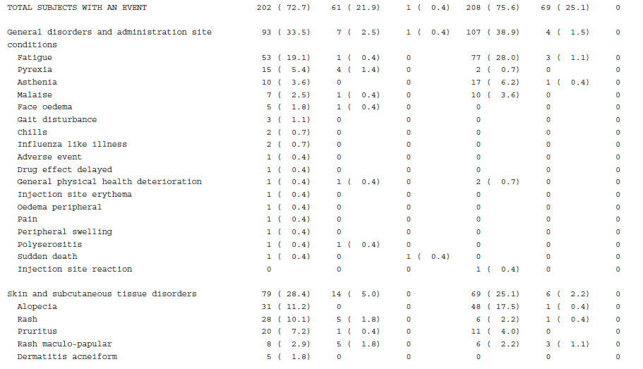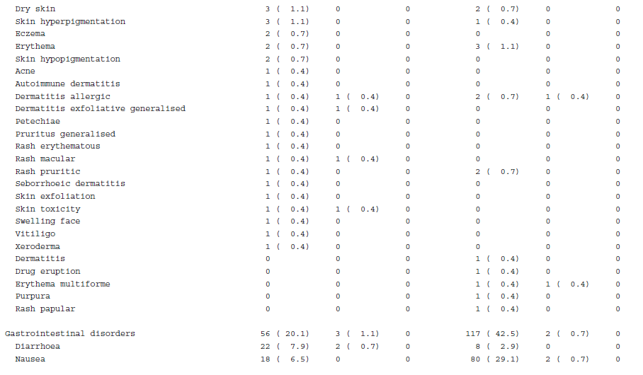

Table S5. Treatment-Related Adverse Events (cont).
 | Nivolumab Plus  Radiotherapy  (n = 278) |  |  | Temozolomide Plus Radiotherapy  (n = 275)
Treatment-Related Adverse Event — no. (%) | Any  Grade | Grade  3/4 | Grade  5 | Any  Grade | Grade  3/4 | Grade 5
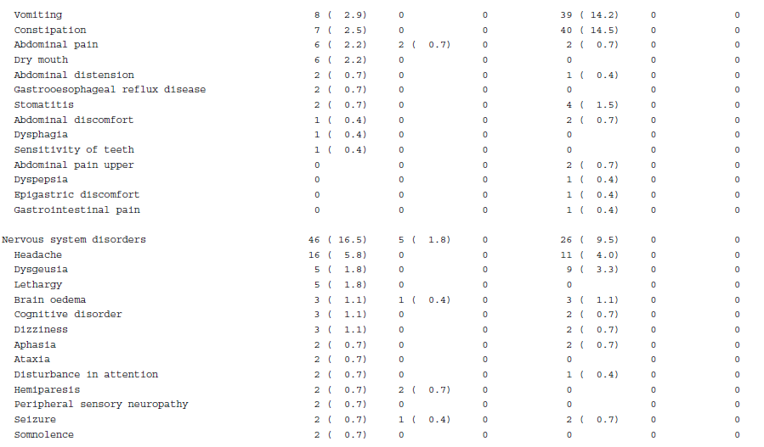
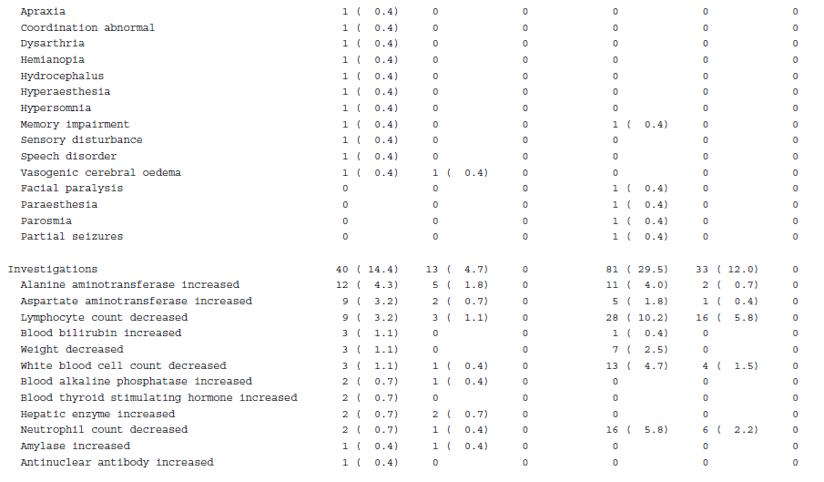
Table S5. Treatment-Related Adverse Events (cont).
 | Nivolumab Plus  Radiotherapy  (n = 278) |  |  | Temozolomide Plus Radiotherapy  (n = 275)
Treatment-Related Adverse Event — no. (%) | Any  Grade | Grade  3/4 | Grade  5 | Any  Grade | Grade  3/4 | Grade 5
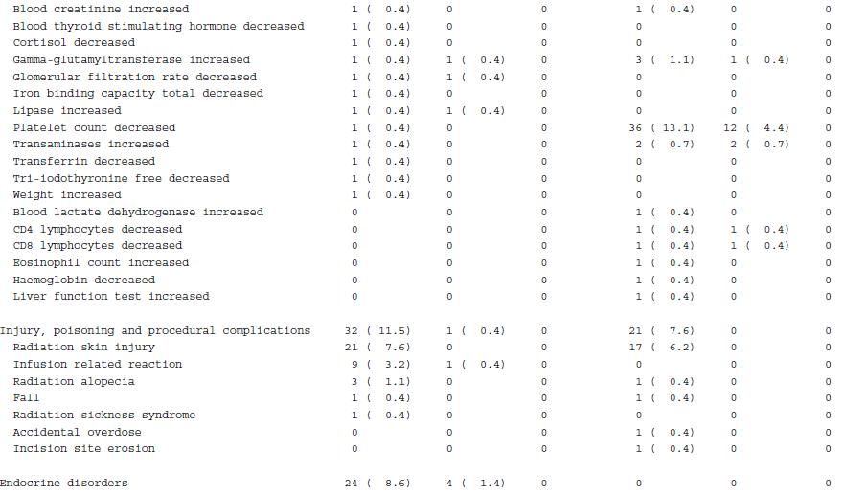
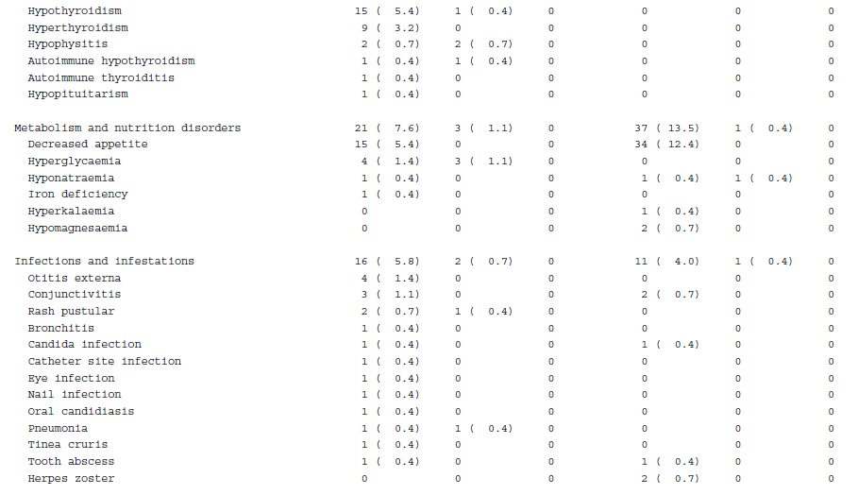

Table S5. Treatment-Related Adverse Events (cont).
 | Nivolumab Plus  Radiotherapy  (n = 278) |  |  | Temozolomide Plus Radiotherapy  (n = 275)
Treatment-Related Adverse Event — no. (%) | Any  Grade | Grade  3/4 | Grade  5 | Any  Grade | Grade  3/4 | Grade 5
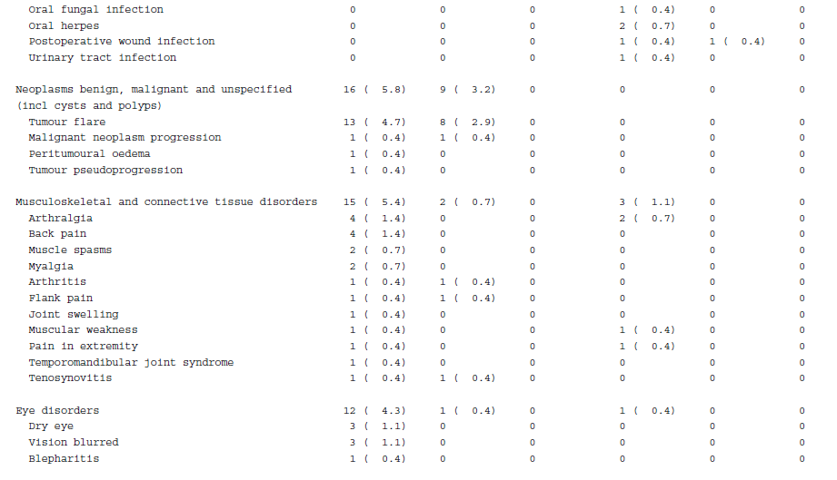
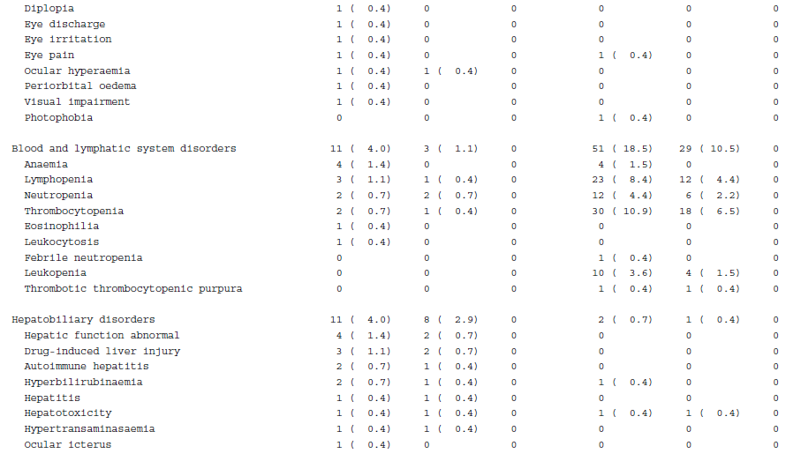
Table S5. Treatment-Related Adverse Events (cont).
 | Nivolumab Plus  Radiotherapy  (n = 278) |  |  | Temozolomide Plus Radiotherapy  (n = 275)
Treatment-Related Adverse Event — no. (%) | Any  Grade | Grade  3/4 | Grade  5 | Any  Grade | Grade  3/4 | Grade 5
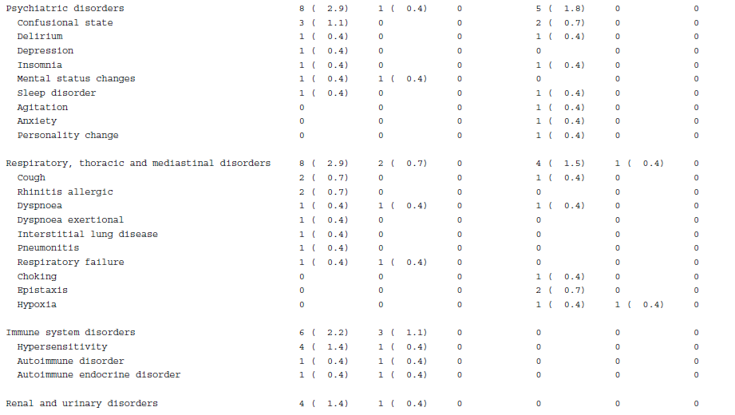
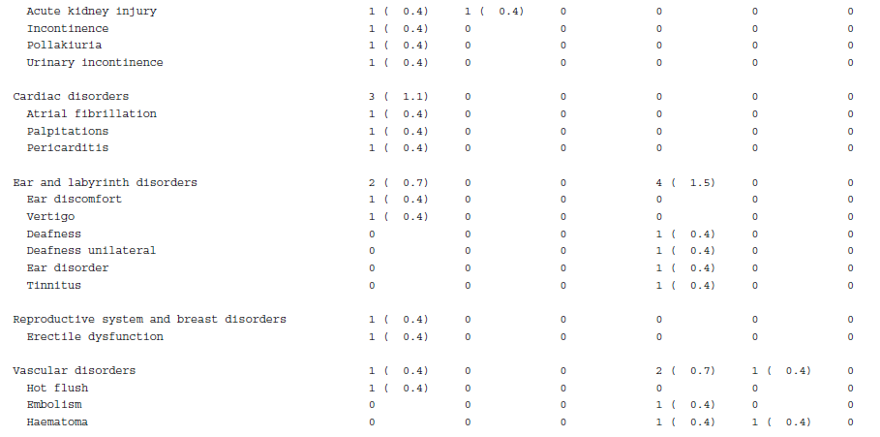

Data are based on a March 21, 2019, database lock. The safety analysis included all patients who received ≥ 1 dose of study drug. Some patients had > 1 adverse event. Includes events reported between first dose and 30 days after last dose of study therapy. Three treatment-related deaths were reported in the NIVO+RT arm due to vasogenic cerebral edema, sudden death, and respiratory failure (1 each); no treatment-related deaths were reported in the TMZ+RT arm.

Table S6. Immune-Mediated Select Adverse Events by Category.
 | Nivolumab Plus  Radiotherapy  (n = 278) |  | Temozolomide Plus  Radiotherapy  (n = 275)
 | Any Grade | Grade 3/4 | Any Grade | Grade 3/4
Treatment-related select AEs by category
Patients — no. (%)
Endocrine | 25 (9.0) | 4 (1.4) | 0 | 0
Gastrointestinal | 22 (7.9) | 2 (0.7) | 8 (2.9) | 0
Hepatic | 24 (8.6) | 11 (4.0) | 17 (6.2) | 6 (2.2)
Pulmonary | 2 (0.7) | 0 | 0 | 0
Renal | 2 (0.7) | 1 (0.4) | 1 (0.4) | 0
Dermal | 54 (19.4) | 12 (4.3) | 31 (11.3) | 5 (1.8)
Hypersensitivity/infusion reaction | 12 (4.3) | 1 (0.4) | 0 | 0
AE, adverse event.

Figure S1. OS by PD-L1 Expression.
A B
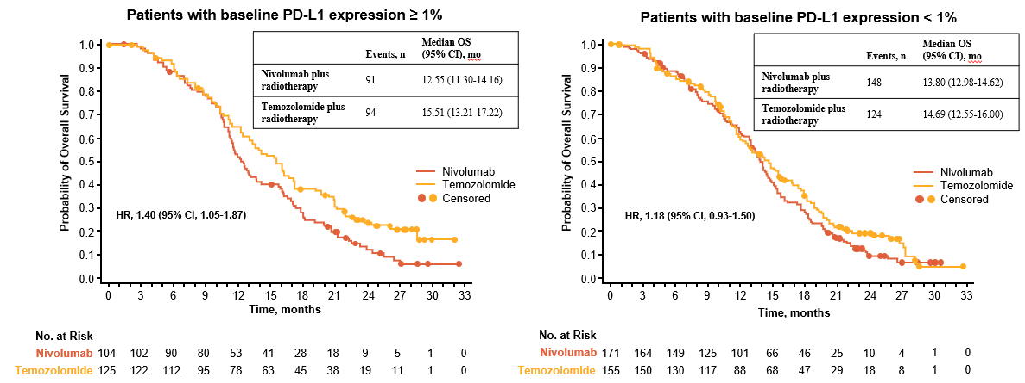
C D
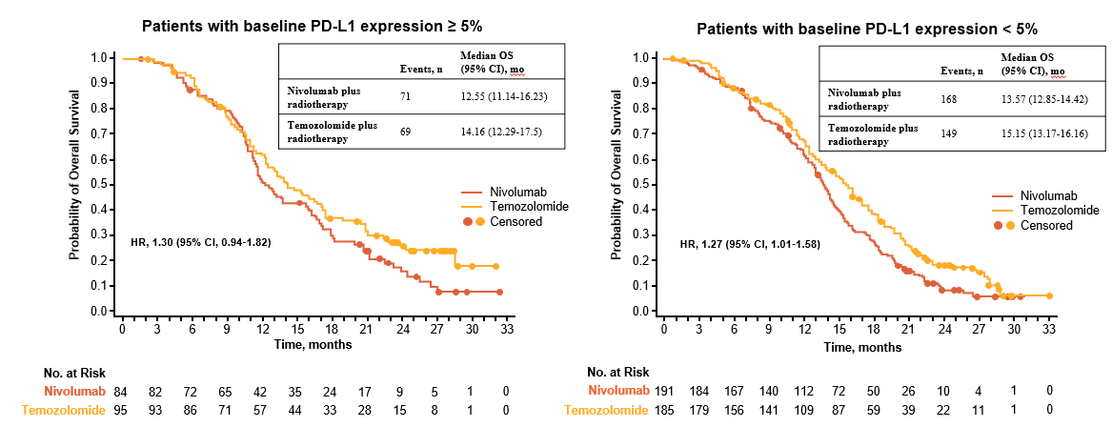
Figure S1. OS by PD-L1 Expression. Number of events, median OS, and Kaplan-Meier curves for OS in patients treated with nivolumab plus radiotherapy or temozolomide plus radiotherapy with baseline PD-L1 expression ≥ 1% (A), < 1% (B), ≥ 5% (C), and < 5% (D). Symbols indicate censored observations. Hazard ratios (HRs) and 95% CIs were estimated using a Cox proportional hazards model. OS, overall survival; PD-L1, programmed cell death ligand 1.

Figure S2. Time to Deterioration in Patient-Reported Outcome Analyses.
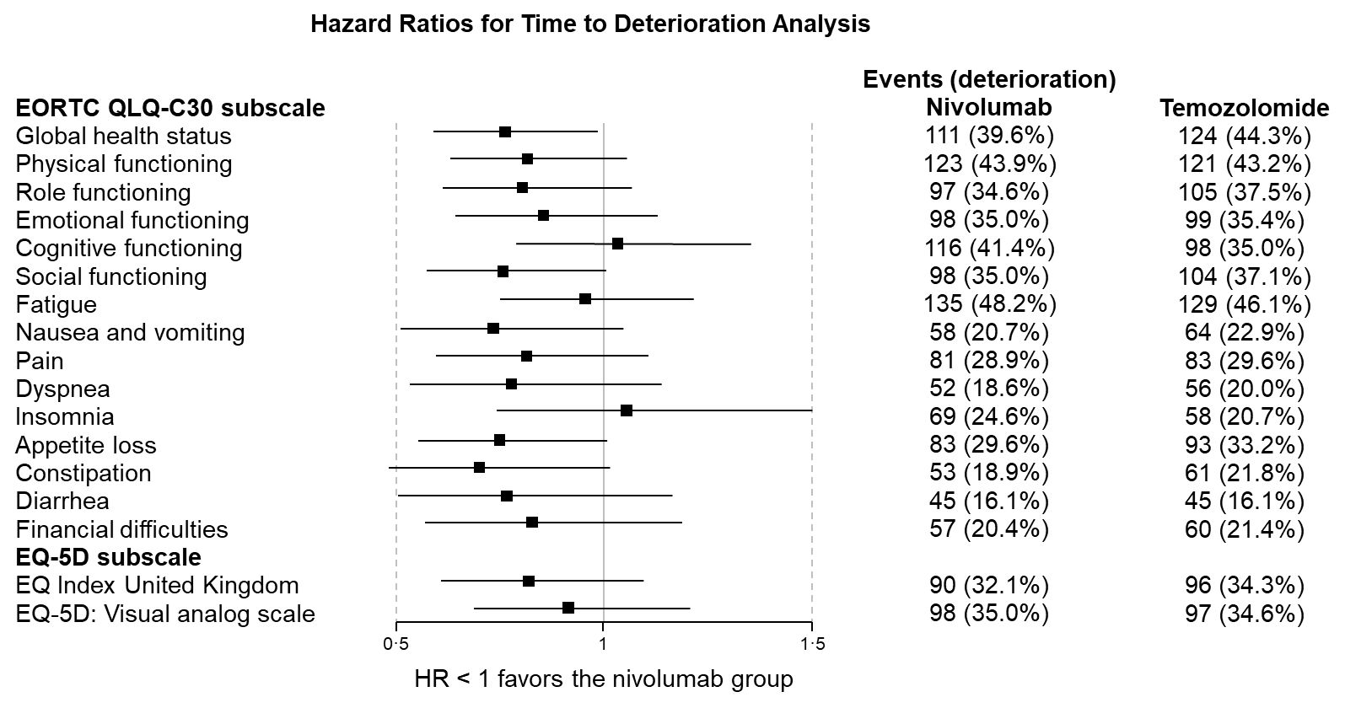
Figure S2. Time to Deterioration in Patient-Reported Outcome Analyses. Forest plot of hazard ratios for time to deterioration analyses in domains of health-related quality of life and for general health utilities (EQ-5D-3L index and visual analog scale). EORTC, European Organisation for Research and Treatment of Cancer; HR, hazard ratio.

