**SUPPLEMENT**

**Efficacy of secukinumab and adalimumab in psoriatic arthritis patients with concomitant moderate to severe plaque psoriasis: Results from the EXCEED, a randomised, double-blind head-to-head monotherapy study**

**Running Head: *Secukinumab versus Adalimumab in Psoriatic Arthritis Patients with Psoriasis***

* **Supplementary Appendix S1**
* **Supplementary Figures: 02**
* **Supplementary Table: 01**

AB Gottlieb1, JF Merola2, K Reich3, F Behrens4, P Nash5, CEM Griffiths6, W Bao7, P Pellet8, L Pricop7, IB McInnes9

1Department of Dermatology, Icahn School of Medicine at Mount Sinai, New York, United States

2Brigham and Women's Hospital, Harvard Medical School, Boston, United States

3Translational Research in Inflammatory Skin Diseases, Institute for Health Services Research in Dermatology and Nursing, University Medical Center Hamburg- Eppendorf, Hamburg, Germany

4Rheumatology University Hospital and Fraunhofer Institute for Molecular Biology and Applied Ecology IME, Branch for Translational Medicine and Pharmacology TMP and Fraunhofer Cluster of Excellence for Immune-Mediated Diseases CIMD, Goethe University, Frankfurt, Germany

5Department of Medicine, Griffith University, Brisbane, Australia

6The Dermatology Centre, Salford Royal NHS Foundation Trust, NIHR Manchester Biomedical Research Centre, University of Manchester, Manchester, United Kingdom

7Novartis Pharmaceuticals Corporation, East Hanover, United States

8Novartis Pharma AG, Basel, Switzerland

7Novartis Pharmaceuticals Corporation, East Hanover, United States

9University of Glasgow, Glasgow, United Kingdom

**Corresponding author:** **Alice B. Gottlieb MD, PhD**

Department of Dermatology

Icahn School of Medicine at Mount Sinai

10 Union Square East, New York

New York 10003, United States

Tel: +2128448800

E-mail: [alice.gottlieb@mountsinai.org](mailto:alice.gottlieb@mountsinai.org)

**Funding:** Novartis Pharma AG, Basel, Switzerland

**Appendix S1: Clinical Assessments**

1. **Musculoskeletal outcomes:**

ACR20/50 response is an outcome measure for assessing treatment efficacy in clinical trials of PsA, where improvement is defined as: ≥20/50% improvement in tender joint counts (TJC) (68 joints) and swollen joint counts (SJC) (66 joints) and ≥20/50% improvement in ≥3 of 5 other measures, including pain, patient’s global assessment, physician’s global assessment, self-assessed physical disability, and acute-phase reactant levels​.1,2

1. **Skin Outcomes:**

PASI score is a clinical tool used for the assessment of severity of lesions and the area affected in psoriasis patients (0 for no disease and 72 for maximal disease). PASI 75/90/100 represents the proportion of patients who have achieved 75/90/100% reduction in their PASI score from baseline.1,3

1. **Composite Indices Outcomes:**

DAPSA is a composite measure for the assessment of PsA disease activity including five disease domains of TJC, SJC, pain, patient global assessment, CRP levels. PASDAS is another composite index outcome measure to distinguish between the high and low disease activity in PsA patients, including seven domains of physician global assessment, patient global assessment, skin, peripheral joint counts, enthesitis, dactylitis, SF-36 PCS and acute-phase response. As per GRAPPA/OMERACT guidelines, PASDAS is derived from real life patient data and is multi-dimensional unlike DAPSA, as it evaluates enthesitis along with other domains involved in the disease.1,4

Some of the other PsA specific composite measures useful for the assessment of disease activity are MDA, VLDA and DAS-28. To achieve MDA, patients must meet five of seven criteria: TJC ≤1, SJC ≤1; PASI ≤1 or BSA ≤3; patient pain VAS ≤15; patient global assessment ≤20; HAQ ≤0.5 and tender entheseal points ≤1. VLDA has become a clinically stringent set of criteria relevant for the identification of disease remission, meeting all seven MDA criteria. DAS-28 was developed as a 28-joint-count (referring to 28 joints affected in rheumatoid arthritis [RA]) measure to assess disease activity in RA. Assessment involves evaluation of the number of TJC and SJC (out of 28), the erythrocyte sedimentation rate (ESR) or CRP levels, and the patient’s global assessment.1,5 HAQ-DI and DLQI are patient reported outcome instruments that assess the overall quality of life in PsA and psoriasis patients, respectively.

**References**

1 McInnes IB, Behrens F, Mease PJ *et al.* Secukinumab versus adalimumab for treatment of active psoriatic arthritis (EXCEED): a double-blind, parallel-group, randomised, active-controlled, phase 3b trial. *The Lancet* 2020; **395**: 1496-505.

2 Felson DT, Anderson JJ, Boers M *et al.* The American College of Rheumatology preliminary core set of disease activity measures for rheumatoid arthritis clinical trials. The Committee on Outcome Measures in Rheumatoid Arthritis Clinical Trials. *Arthritis Rheum* 1993; **36**: 729-40.

3 Feldman SR, Krueger GG. Psoriasis assessment tools in clinical trials. *Ann Rheum Dis* 2005; **64 Suppl 2**: ii65-8; discussion ii9-73.

4 Wong PC, Leung YY, Li EK *et al.* Measuring disease activity in psoriatic arthritis. *Int J Rheumatol* 2012; **2012**: 839425.

5 Coates LC, Strand V, Wilson H *et al.* Measurement properties of the minimal disease activity criteria for psoriatic arthritis. *RMD Open* 2019; **5**: e001002.

**Supplementary Figures:**

**Figure S1. Other musculoskeletal outcomes A) ACR70 response and B) Resolution of dactylitis through Week 52 in the psoriasis subset of PsA patients**

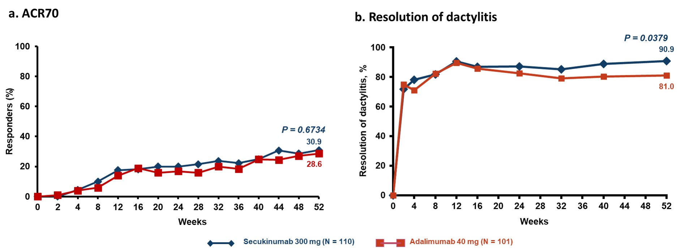

P versus adalimumab; Unadjusted p values are reported at Week 52

N, number of active PsA patients having BSA>10% or PASI ≥10 affected with psoriasis at baseline

ACR, American college of rheumatology;

Patients who discontinued study treatment before or at Week 50 or took csDMARDs after Week 36 are considered non-responders for the visits after discontinuation or taking csDMARDs. Multiple imputation is used for all other missing data.

**Figure S2. A. SF-36 PCS, B. SF-36 MCS and C. FACIT-Fatigue mean change from baseline through Week 52 in the psoriasis subset of PsA patients**

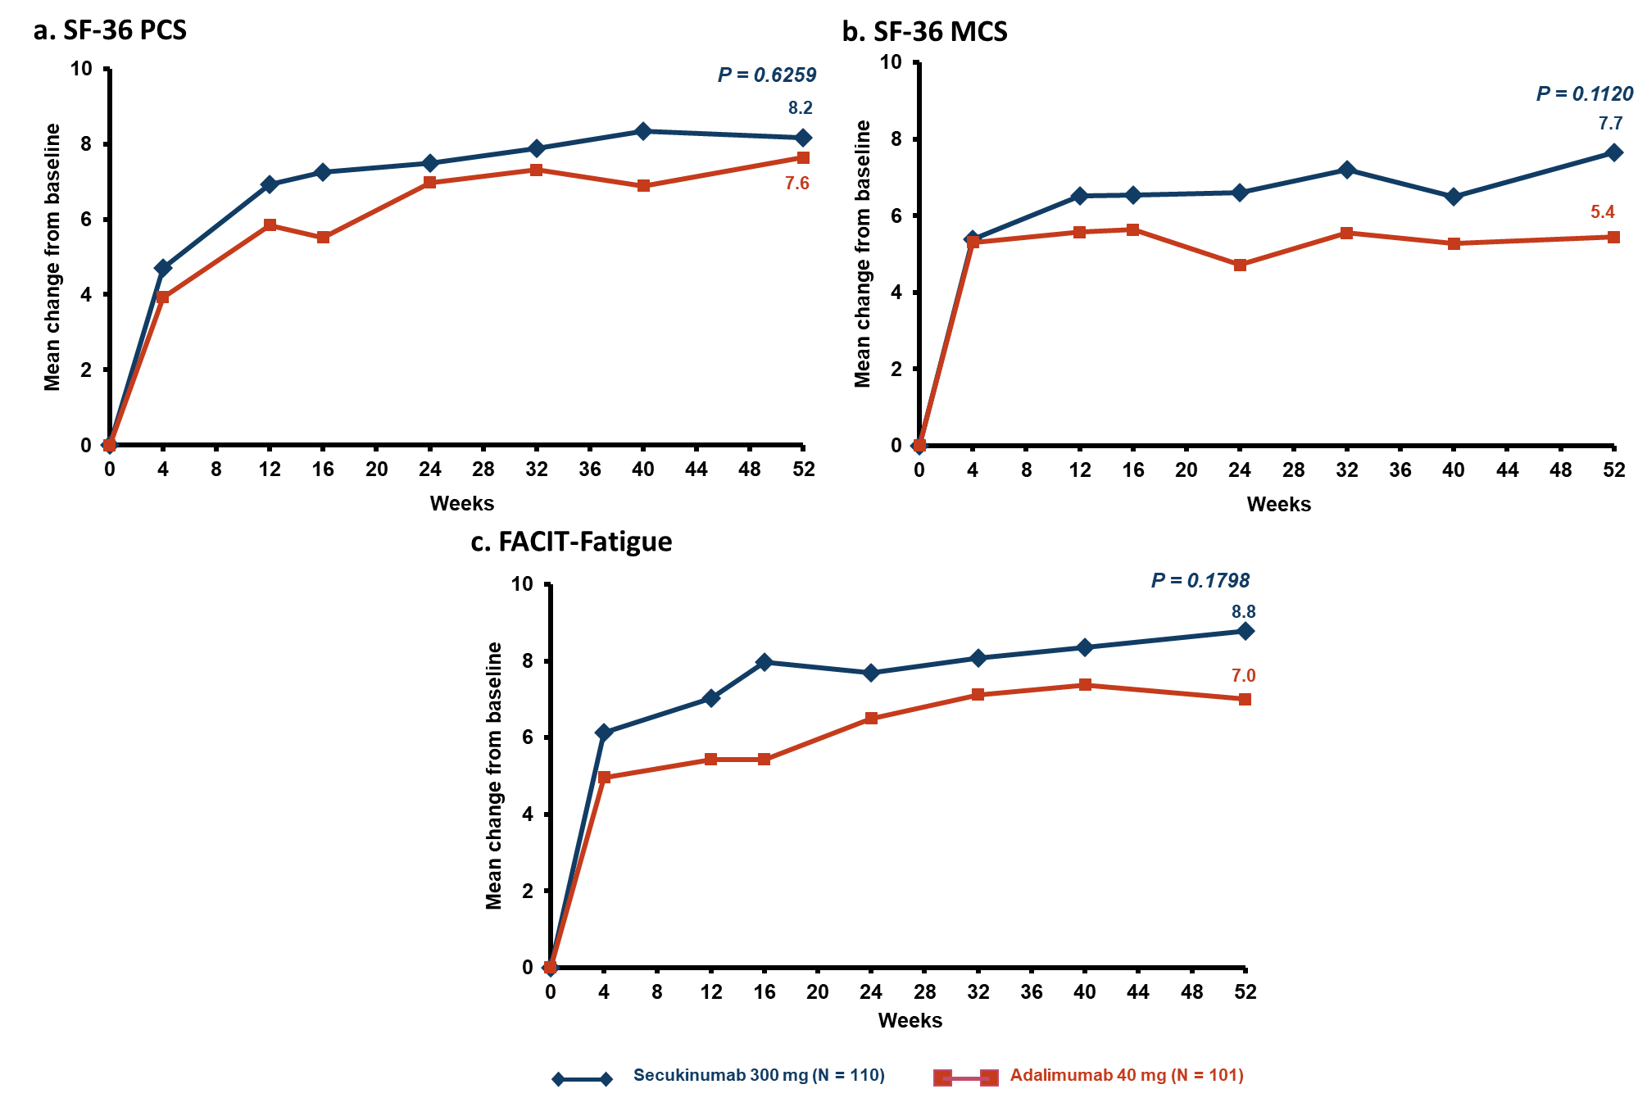

P versus adalimumab; Unadjusted p value is reported;

N, number of active PsA patients having BSA>10% or PASI ≥10 affected with psoriasis at baseline

csDMARD, conventional synthetic disease modifying anti-rheumatic drugs; FACIT, Functional Assessment of Chronic Illness Therapy; MMRM, Mixed Models Repeated Measures; Patients who discontinued study treatment before or at Week 50 or took csDMARDs after Week 36 are considered non-responders for the visits after discontinuation or taking csDMARDs; Data is presented using MMRM.

**Table S1: Interaction testing between psoriasis status and the treatment effect at Week 52**

|  |  |  |  |  |
| --- | --- | --- | --- | --- |
| Efficacy Endpoint | ACR20 | ACR50 | Resolution of enthesitis | Change from Baseline in  HAQ-DI |
| P-value | 0.8033* | 0.7158* | 0.4035* | 0.1531** |

*p-values are from a logistic regression model with treatment and psoriasis status as factors and treatment by psoriasis status included as interaction term, and baseline weight as a covariate (at Week 52).

**p-value is from MMRM with treatment group, psoriasis status and analysis visit as factors, weight and baseline score as covariates, and treatment by psoriasis status, treatment by analysis visit, and baseline score by analysis visit as interaction terms, as well as unstructured covariance structure.

ACR, American college of rheumatology; HAQ-DI, Health Assessment Questionnaire Disability Index; MMRM, Mixed Models Repeated Measures.