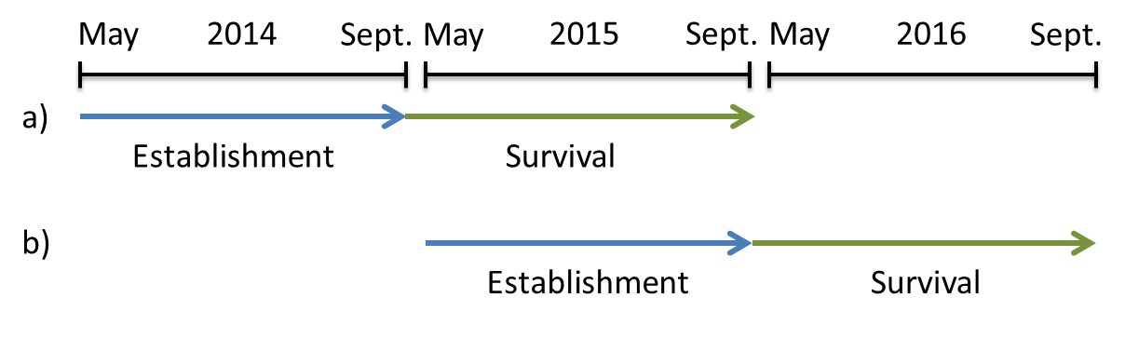
Figure S1: Seed translocation experiments conducted in a) 2014 and b) 2015. In each year, experimental replicates were installed at the beginning of the growing season end of May and seedling establishment of Swiss stone pine (Pinus cembra) was monitored before the end of the growing season end of September (blue arrows). Survival of each seedling was recorded at the end of the second growing season in the following year (green arrows).
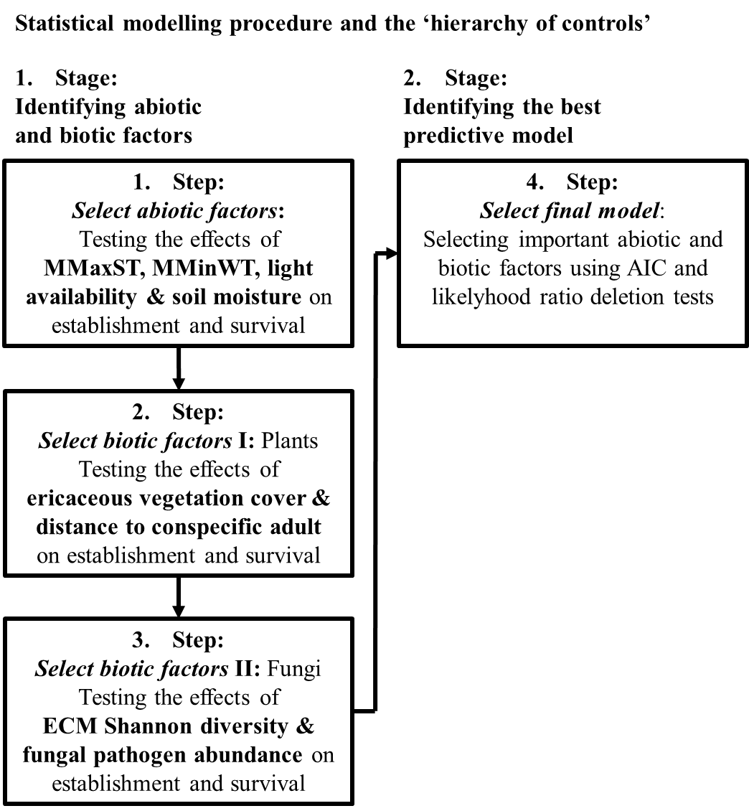
Figure S2: Schematic representation of the steps in the statistical modelling procedure and the ‘hierarchy of controls’ hypothesized to reduce uncertainty in modelling the establishment and survival of seedlings. The first stage serve to identify the important abiotic and biotic factors, which are tested for their importance in the establishment and survival process in the second stage using AICc and likelihood ratio deletion tests (according to Diaz et al., 2007; Manning et al., 2015). MMaxST = mean daily maximum temperature for the hottest three months, MMinWT = mean daily minimum temperature for the coldest three months (MMinWT was included in the survival models).

Table S1: Variable combinations fitted in the statistical modelling process. MMaxST = mean daily maximum temperature for the hottest three months, MMinWT = mean daily minimum temperature for the coldest three months (only included in the survival models), SM = soil moisture, LA = light availability, EVC = ericaceous vegetation cover.
Step | Parameter combinations tested
- Abiotic factors | - MMaxST, MMinWT, SM, LA
- MMaxST+MMaxST², MMinWT+MMinWT², SM+SM², LA+LA², MMaxST×MMinWT, MMaxST×SM, MMaxST×LA, MMinWT×SM, MMinWT×LA, SM×LA
- All combinations of parameters found to improve AICc from a) and b).

- Biotic factors I: Plants | - EVC, distance to adult  - EVC, distance to adult, EVC×distance to adult
- Biotic factors II: Fungi | - ECM Shannon, OTU 282, OTU 1192  - ECM Shannon+ECM Shannon², OTU 282+OTU 282², OTU 1198+OTU 1198²  - All combinations of parameters found to improve AICc from a) and b).
² indicates the fitting of quadratic terms.

Table S2: List of candidate OTUs identified by literature research and null model randomization tests. Taxonomic assignments were based on BLAST results from the NCBI database. Assignment of functions were conducted with all BLAST hits > 97 % similarity. Column „Literature” indicates whether the assigned taxonomic name of an OTU was found in the literature research as being pine-associated („yes“) or not („no“). Column “Test” shows if an OTU was identified as significantly associated with pine establishment or survival in a null model randomization test (“yes”) or not (“no”). Column “Response” lists the effect of an OTU on the respective response variable in a null model randomization test (E = establishment, S = survival, (-e) = without environmental factors, n. s. = not significant). “Effect size” shows the effect sizes obtain from the null model randomization test.
OTU | Function | Taxonomic assigment | Similarity | Accession | Literature | Test | Response | Effect size | Reference
1894 | Animal Pathogen-Saprotroph | Cryptococcus diffluens | 100 | AF145330 | no | yes | E, S | 0.10 | (Kurtzman et al. 2011)
1890 | Animal Pathogen-Saprotroph | Cryptococcus wieringae | 100 | AF444373 | no | yes | S, S (-e) | -0.17 | (Kurtzman et al. 2011)
1891 | Animal Pathogen-Saprotroph | Cryptococcus sp | 100 | EF159211 | no | yes | S | 0.16 | (Kurtzman et al. 2011)
1893 | Animal Pathogen-Saprotroph | Cryptococcus gastricus | 100 | AF145323 | no | yes | S | 0.25 | (Kurtzman et al. 2011)
139 | Ectomycorrhizal | Uncultered Tomentella clone | 100 | JQ791166.1 | yes | no | n. s. | / | (De Roman, Claveria & De Miguel 2005)
143 | Ectomycorrhizal | Uncultered Tomentella clone | 99 | FM992972.1 | yes | no | n. s. | / | (De Roman, Claveria & De Miguel 2005)
177 | Ectomycorrhizal | Wilcoxina rehmii | 100 | JX129137.1 | yes | no | n. s. | / | (Bidartondo, Baar & Bruns 2001; Bingham & Simard 2012)
749 | Ectomycorrhizal | Otidea leporina | 100 | KM010092.1 | yes | no | n. s. | / | (Olariaga et al. 2015)
1159 | Ectomycorrhizal | Paxillus involutus | 100 | KP753338.1 | yes | no | n. s. | / | (Cairney & Chambers 1999)
1324 | Ectomycorrhizal | Elaphomyces muricatus | 100 | KR029732.1 | yes | no | n. s. | / | (Miller & Miller 1984; De Roman, Claveria & De Miguel 2005)
1373 | Ectomycorrhizal | Lactarius rufus | 100 | KX394300.1 | yes | no | n. s. | / | (Giltrap 1979)
1728 | Ectomycorrhizal | Uncultured Cortinarius clone | 100 | KC412507.1 | yes | yes | S | / | (De Roman, Claveria & De Miguel 2005)
1791 | Ectomycorrhizal | Tylospora asterophora | 100 | KT447180.1 | yes | no | n. s. | / | (Erland & Taylor 1999)
1793 | Ectomycorrhizal | Tylospora fibrillosa | 100 | KP753374.1 | yes | no | n. s. | / | (Erland & Taylor 1999)
1862 | Ectomycorrhizal | Amanita submembranacea | 100 | FJ705275.1 | yes | no | n. s. | / | (Contu 2003)
2130 | Ectomycorrhizal | Amphinema byssoides | 98 | JQ711820.1 | yes | no | n. s. | / | (Erland & Taylor 1999)
1745 | Ectomycorrhizal | Rhizopogon sp | 100 | JN544495 | yes | yes | E, S, S (-e) | -0.09 | (Rinaldi et al. 2008; Tedersoo et al. 2010)
1792 | Ectomycorrhizal | Tylospora fibrillosa | 97.9 | AB254392 | yes | yes | E, S | 0.09 | (Rinaldi et al. 2008; Tedersoo et al. 2010)
1955 | Ectomycorrhizal | Piloderma sp | 100 | UDB001726 | yes | yes | E, S | -0.09 | (Rinaldi et al. 2008; Tedersoo et al. 2010)
2128 | Ectomycorrhizal | Amphinema byssoides | 100 | EF433987 | yes | yes | E | 0.11 | (Rinaldi et al. 2008; Tedersoo et al. 2010)
2151 | Ectomycorrhizal | Suillus cavipes | 99.2 | UDB003222 | no | yes | E | 0.09 | (Rinaldi et al. 2008; Tedersoo et al. 2010)
2194 | Ectomycorrhizal | Cortinarius brunneus | 99 | UDB017794 | no | yes | E, S, S (-e) | 0.10 | (Rinaldi et al. 2008; Tedersoo et al. 2010)
2209 | Ectomycorrhizal | Cortinarius rigens | 97.9 | JF907880 | no | yes | E, S | 0.10 | (Rinaldi et al. 2008; Tedersoo et al. 2010)
1125 | Ectomycorrhizal | Tricholoma inamoenum | 100 | UDB011572 | no | yes | S | -0.20 | (Rinaldi et al. 2008; Tedersoo et al. 2010)
1147 | Ectomycorrhizal | Russula puellaris | 100 | UDB017168 | no | yes | S | 0.30 | (Rinaldi et al. 2008; Tedersoo et al. 2010)
1149 | Ectomycorrhizal | Russula emetica | 100 | UDB000300 | no | yes | S | 0.30 | (Rinaldi et al. 2008; Tedersoo et al. 2010)
1150 | Ectomycorrhizal | Russula sapinea | 99.6 | UDB015996 | yes | yes | S | -0.12 | (Rinaldi et al. 2008; Tedersoo et al. 2010)
1151 | Ectomycorrhizal | Russula mustelina | 99.2 | UDB016021 | no | yes | S | 0.23 | (Rinaldi et al. 2008; Tedersoo et al. 2010)
1152 | Ectomycorrhizal | Russula clavipes | 99.3 | UDB011088 | no | yes | S | -0.21 | (Rinaldi et al. 2008; Tedersoo et al. 2010)
1154 | Ectomycorrhizal | Russula postiana | 100 | UDB000897 | no | yes | S | 0.23 | (Rinaldi et al. 2008; Tedersoo et al. 2010)
1302 | Ectomycorrhizal | Russula aquosa | 100 | UDB011293 | no | yes | S, S (-e) | -0.13 | (Rinaldi et al. 2008; Tedersoo et al. 2010)
1323 | Ectomycorrhizal | Elaphomyces muricatus | 99 | KF359559 | yes | yes | S | 0.19 | (Rinaldi et al. 2008; Tedersoo et al. 2010)
135 | Ectomycorrhizal | Tomentella sp | 99.1 | JQ791170 | yes | yes | S | -0.13 | (Rinaldi et al. 2008; Tedersoo et al. 2010)
1382 | Ectomycorrhizal | Cortinarius sp | 100 | UDB019886 | no | yes | S | 0.23 | (Rinaldi et al. 2008; Tedersoo et al. 2010)
142 | Ectomycorrhizal | Tomentella sp | 98.6 | KF514672 | yes | yes | S | 0.24 | (Rinaldi et al. 2008; Tedersoo et al. 2010)
1759 | Ectomycorrhizal | Hygrophorus albicastaneus | 98.2 | DQ097873 | no | yes | S | 0.12 | (Rinaldi et al. 2008; Tedersoo et al. 2010)
1794 | Ectomycorrhizal | Tylospora fibrillosa | 97.4 | AB254392 | yes | yes | S | 0.15 | (Rinaldi et al. 2008; Tedersoo et al. 2010)
1874 | Ectomycorrhizal | Cortinarius caesiobrunneus | 100 | UDB017795 | yes | yes | S, S (-e) | 0.28 | (Rinaldi et al. 2008; Tedersoo et al. 2010)
1954 | Ectomycorrhizal | Piloderma sp | 100 | UDB001733 | yes | yes | S | 0.35 | (Rinaldi et al. 2008; Tedersoo et al. 2010)
2127 | Ectomycorrhizal | Amphinema byssoides | 100 | UDB008257 | yes | yes | S | -0.23 | (Rinaldi et al. 2008; Tedersoo et al. 2010)
2129 | Ectomycorrhizal | Amphinema sp | 100 | UDB001719 | no | yes | S | -0.14 | (Rinaldi et al. 2008; Tedersoo et al. 2010)
2160 | Ectomycorrhizal | Lactarius necator | 99.6 | EU711629 | no | yes | S, S (-e) | -0.21 | (Rinaldi et al. 2008; Tedersoo et al. 2010)
2181 | Ectomycorrhizal | Cortinarius sanguineus | 99.5 | JN114099 | no | yes | S | 0.24 | (Rinaldi et al. 2008; Tedersoo et al. 2010)
2182 | Ectomycorrhizal | Cortinarius croceus | 99.5 | UDB021419 | yes | yes | S, S (-e) | 0.23 | (Rinaldi et al. 2008; Tedersoo et al. 2010)
2183 | Ectomycorrhizal | Cortinarius transatlanticus | 100 | UDB021507 | no | yes | S | -0.14 | (Rinaldi et al. 2008; Tedersoo et al. 2010)
2188 | Ectomycorrhizal | Cortinarius disjungendulus | 97.4 | KM273090 | yes | yes | S | 0.24 | (Rinaldi et al. 2008; Tedersoo et al. 2010)
2190 | Ectomycorrhizal | Cortinarius integerrimus | 99 | JF907926 | yes | yes | S | 0.25 | (Rinaldi et al. 2008; Tedersoo et al. 2010)
2191 | Ectomycorrhizal | Cortinarius acutus | 98 | FJ769529 | no | yes | S | 0.13 | (Rinaldi et al. 2008; Tedersoo et al. 2010)
2192 | Ectomycorrhizal | Cortinarius obtusus | 99 | HQ604666 | no | yes | S | 0.26 | (Rinaldi et al. 2008; Tedersoo et al. 2010)
2197 | Ectomycorrhizal | Cortinarius colus | 99.5 | UDB002224 | yes | yes | S | 0.18 | (Rinaldi et al. 2008; Tedersoo et al. 2010)
2198 | Ectomycorrhizal | Cortinarius fillionii | 100 | HQ845171 | no | yes | S | 0.21 | (Rinaldi et al. 2008; Tedersoo et al. 2010)
2199 | Ectomycorrhizal | Cortinarius acutovelatus | 99.5 | UDB001000 | no | yes | S | -0.13 | (Rinaldi et al. 2008; Tedersoo et al. 2010)
2200 | Ectomycorrhizal | Cortinarius biformis | 98.9 | DQ481700 | no | yes | S | 0.12 | (Rinaldi et al. 2008; Tedersoo et al. 2010)
2201 | Ectomycorrhizal | Cortinarius sp | 97.5 | JQ975956 | yes | yes | S, S (-e) | 0.19 | (Rinaldi et al. 2008; Tedersoo et al. 2010)
2202 | Ectomycorrhizal | Cortinarius sp | 100 | UDB018310 | yes | yes | S | 0.17 | (Rinaldi et al. 2008; Tedersoo et al. 2010)
2204 | Ectomycorrhizal | Cortinarius sobrius | 100 | KF732429 | yes | yes | S, S (-e) | -0.12 | (Rinaldi et al. 2008; Tedersoo et al. 2010)
2205 | Ectomycorrhizal | Cortinarius testaceofolius | 100 | EU693242 | no | yes | S | -0.26 | (Rinaldi et al. 2008; Tedersoo et al. 2010)
2206 | Ectomycorrhizal | Cortinarius anomalus | 100 | UDB001008 | no | yes | S | 0.11 | (Rinaldi et al. 2008; Tedersoo et al. 2010)
2210 | Ectomycorrhizal | Cortinarius caperatus | 99.5 | UDB001079 | no | yes | S | 0.28 | (Rinaldi et al. 2008; Tedersoo et al. 2010)
430 | Ectomycorrhizal | Tylospora asterophora | 98 | UDB002638 | yes | yes | S, S (-e) | 0.13 | (Rinaldi et al. 2008; Tedersoo et al. 2010)
713 | Ectomycorrhizal | Wilcoxina sp | 97.5 | EF619913 | no | yes | S, S (-e) | 0.30 | (Rinaldi et al. 2008; Tedersoo et al. 2010)
753 | Ectomycorrhizal | Inocybe fuscidula | 100 | AM882887 | no | yes | S | -0.12 | (Rinaldi et al. 2008; Tedersoo et al. 2010)
754 | Ectomycorrhizal | Inocybe lanuginosa | 99.5 | HQ604311 | no | yes | S | 0.33 | (Rinaldi et al. 2008; Tedersoo et al. 2010)
783 | Ectomycorrhizal | Hygrophorus olivaceoalbus | 98.9 | UDB000558 | no | yes | S | 0.15 | (Rinaldi et al. 2008; Tedersoo et al. 2010)
789 | Ectomycorrhizal | Piloderma byssinum | 97.5 | EF619739 | no | yes | S, S (-e) | 0.13 | (Rinaldi et al. 2008; Tedersoo et al. 2010)
852 | Ectomycorrhizal | Hygrophorus speciosus | 98.9 | DQ097884 | no | yes | S | 0.13 | (Rinaldi et al. 2008; Tedersoo et al. 2010)
88 | Ectomycorrhizal | Amanita olivaceogrisea | 99.4 | UDB015459 | yes | yes | S | 0.23 | (Rinaldi et al. 2008; Tedersoo et al. 2010)
894 | Ectomycorrhizal | Wilcoxina sp | 100 | AM999663 | yes | yes | S, S (-e) | 0.18 | (Rinaldi et al. 2008; Tedersoo et al. 2010)
897 | Ectomycorrhizal | Cortinarius acutus | 100 | UDB001002 | no | yes | S | 0.31 | (Rinaldi et al. 2008; Tedersoo et al. 2010)
1146 | Ectomycorrhizal | Russula paludosa | 99.6 | JX029923 | no | yes | S (-e) | 0.15 | (Rinaldi et al. 2008; Tedersoo et al. 2010)
1153 | Ectomycorrhizal | Russula vinosa | 100 | UDB000350 | no | yes | S (-e) | 0.23 | (Rinaldi et al. 2008; Tedersoo et al. 2010)
1286 | Ectomycorrhizal | Cenococcum geophilum | 98 | FJ440882 | no | yes | S (-e) | 0.26 | (Tedersoo et al. 2014)
1309 | Ectomycorrhizal | Russula cessans | 97.3 | UDB001716 | no | yes | S (-e) | 0.23 | (Rinaldi et al. 2008; Tedersoo et al. 2010)
138 | Ectomycorrhizal | Tomentella badia | 98.2 | JQ711987 | no | yes | S (-e) | 0.15 | (Rinaldi et al. 2008; Tedersoo et al. 2010)
1744 | Ectomycorrhizal | Rhizopogon salebrosus | 98.8 | AF377152 | yes | yes | S (-e) | 0.18 | (Rinaldi et al. 2008; Tedersoo et al. 2010)
1819 | Ectomycorrhizal | Hydnotrya michaelis | 99.1 | EU784274 | no | yes | S (-e) | -0.26 | (Rinaldi et al. 2008; Tedersoo et al. 2010)
1876 | Ectomycorrhizal | Piloderma bicolor | 100 | UDB001740 | no | yes | S (-e) | 0.18 | (Rinaldi et al. 2008; Tedersoo et al. 2010)
1958 | Ectomycorrhizal | Piloderma olivaceum | 98.9 | UDB001747 | no | yes | S (-e) | -0.19 | (Rinaldi et al. 2008; Tedersoo et al. 2010)
1993 | Ectomycorrhizal | Cenococcum geophilum | 98.6 | AY394919 | no | yes | S (-e) | 0.27 | (Tedersoo et al. 2014)
2180 | Ectomycorrhizal | Cortinarius semisanguineus | 98 | JQ711941 | no | yes | S (-e) | 0.20 | (Rinaldi et al. 2008; Tedersoo et al. 2010)
2189 | Ectomycorrhizal | Cortinarius uraceus | 100 | KJ206522 | no | yes | S (-e) | 0.25 | (Rinaldi et al. 2008; Tedersoo et al. 2010)
2196 | Ectomycorrhizal | Cortinarius malachius | 100 | KF617653 | no | yes | S (-e) | -0.33 | (Rinaldi et al. 2008; Tedersoo et al. 2010)
96 | Ectomycorrhizal | Suillus tomentosus | 100 | JN544503 | no | yes | S (-e) | -0.18 | (Rinaldi et al. 2008; Tedersoo et al. 2010)
1335 | Lichenized | Cladonia cornuta | 98.8 | FJ536352 | no | yes | E | -0.10 | (James et al. 2006)
925 | Lichenized | Melanohalea exasperatula | 99.3 | AY611090 | no | yes | E | 0.09 | (Esslinger 2014)
1333 | Lichenized | Cladonia arbuscula | 98.8 | AY170775 | no | yes | E (-e), S | -0.10 | (James et al. 2006)
1331 | Lichenized | Cladonia rangiferina | 98.8 | JQ695918 | no | yes | S | -0.15 | (James et al. 2006)
1337 | Lichenized | Cladonia rangiferina | 98.1 | AF458306 | no | yes | S, S (-e) | -0.26 | (James et al. 2006)
1749 | Lichenized | Trapeliopsis granulosa | 99.3 | AF353569 | no | yes | S | 0.18 | (Esslinger 2014)
1870 | Lichenized | Cladonia arbuscula | 97.5 | GU169267 | no | yes | S | 0.23 | (James et al. 2006)
410 | Lichenized | Cetraria islandica | 100 | JQ301699 | no | yes | S, S (-e) | -0.17 | (Esslinger 2014)
132 | Lichenized | Cladonia arbuscula | 97.6 | AY170775 | no | yes | S (-e) | 0.14 | (James et al. 2006)
1338 | Lichenized | Cladonia novochlorophaea | 99.4 | GU188414 | no | yes | S (-e) | -0.12 | (James et al. 2006)
1340 | Lichenized | Cladonia fimbriata | 100 | GU188404 | no | yes | S (-e) | 0.21 | (James et al. 2006)
1342 | Lichenized | Cladonia cenotea | 98.2 | AF457900 | no | yes | S (-e) | -0.15 | (James et al. 2006)
211 | Lichenized | Cladonia humilis | 97.5 | KC415933 | no | yes | S (-e) | -0.13 | (James et al. 2006)
312 | Lichenized | Pseudevernia furfuracea | 100 | FR799280 | no | yes | S (-e) | 0.14 | (Esslinger 2014)
498 | Lichenized | Pseudevernia cladonia | 100 | AF297736 | no | yes | S (-e) | -0.28 | (Esslinger 2014)
282 | Pathogenic | Gremmenia infestans | 99 | KU063958.1 | yes | no | n. s. | / | (Burdon et al. 1992; Barbeito et al. 2013)
1198 | Pathogenic | Gremmenia infestans | 98 | KM216393.1 | yes | no | n. s. | / | (Burdon et al. 1992; Barbeito et al. 2013)
258 | Undefined Root Endophyte | Cadophora sp | 100 | FJ553685 | no | yes | E, S | -0.11 | (Tedersoo et al. 2010)
968 | Undefined Root Endophyte | Phialocephala glacialis | 98.6 | EU434843 | no | yes | E (-e), S | -0.09 | (Newsham 2011)
1209 | Undefined Root Endophyte | Cadophora finlandica | 98.6 | AF486119 | no | yes | S | 0.26 | (Tedersoo et al. 2010)
2069 | Undefined Root Endophyte | Phialocephala fortinii | 97.1 | AY033087 | no | yes | S | 0.20 | (Newsham 2011)
538 | Undefined Root Endophyte | Phialocephala sphaeroides | 97.9 | AY524845 | no | yes | S | -0.18 | (Newsham 2011)
733 | Undefined Root Endophyte | Cadophora luteo-olivacea | 97.3 | AY249066 | no | yes | S | -0.17 | (Tedersoo et al. 2010)
1481 | Undefined Root Endophyte | Leptodontidium sp | 100 | FJ552955 | no | yes | S (-e) | 0.15 | (Jumpponen & Trappe 1998)
1851 | Undefined Root Endophyte | Leptodontidium sp | 99.3 | JF300526 | no | yes | S (-e) | 0.16 | (Jumpponen & Trappe 1998)
1375 | Wood Saprotroph | Trechispora byssinella | 98 | AY969779 | no | yes | S | -0.12 | (Gilbertson & Ryvarden 1987; Rinaldi et al. 2008. Tedersoo et al. 2010)
337 | Wood Saprotroph | Trechispora sp | 99.5 | KJ140560 | no | yes | S | -0.14 | (Gilbertson & Ryvarden 1987; Rinaldi et al. 2008. Tedersoo et al. 2010)
700 | Wood Saprotroph | Trechispora sp | 100 | JF300723 | no | yes | S | -0.25 | (Gilbertson & Ryvarden 1987; Rinaldi et al. 2008. Tedersoo et al. 2010)

Following OTUs significantly associated with establishment and survival, but were not present in databases: 3, 5, 8, 16, 20-24, 31, 32, 34, 35, 37, 38, 43, 44, 46-48, 51, 55, 57, 62, 64, 74, 81, 92, 96, 97, 106, 107, 115, 124, 132, 136, 138, 140, 141, 147, 149, 150, 152, 162, 168, 170, 172-183, 190, 196, 203, 206, 210- 212, 214-217, 220, 223-227, 236, 237, 240-246, 256, 257, 259, 261-269, 272-274, 276, 310, 312, 314-316, 318, 320, 321, 323, 325, 327, 333, 338, 339, 348, 351, 355-360, 363-366, 372, 375, 377-379, 381, 382, 387, 389, 390-392, 394, 395, 397, 407, 411, 412, 419-424, 432-436, 441, 443, 444, 448, 449, 455-457, 459, 461-470, 472- 475, 477-482, 484, 488, 492-494, 496-507, 509-513, 515-518, 524, 525, 529, 535-537, 609, 623, 643, 646, 653, 656-658, 669, 671, 674, 678, 679, 685, 686, 688-692, 694, 701, 705, 712, 720, 726, 728, 731, 732, 738, 742, 744, 747, 748, 750, 752, 760-762, 764, 767, 775-777, 780, 787, 790, 795, 805, 812-815, 822, 823, 826, 827, 831, 834, 840-843, 855, 856, 858-861, 865, 877, 885, 887, 888, 890, 892, 893, 900, 902, 904, 905, 907, 908, 910, 918, 920, 926-928, 932, 933, 935, 941, 944, 946-948, 950-967, 970, 972-974, 976- 980, 982, 984, 986, 988, 990-992, 994, 996, 997, 1001, 1002, 1007, 1017, 1051, 1053, 1057, 1058, 1060, 1061, 1070, 1074-1076, 1078, 1084, 1087, 1088, 1090, 1092-1094, 1097, 1101, 1110, 1113, 1116, 1118, 1123, 1126, 1137, 1146, 1153, 1161, 1165, 1173, 1176, 1177, 1179, 1180, 1184, 1185, 1187, 1191, 1192, 1194, 1195, 1197, 1199-1201, 1203-1205, 1208, 1213, 1214, 1241, 1247, 1249, 1252-1255, 1257, 1258, 1275-1278, 1282, 1286-1288, 1291, 1296, 1309, 1317, 1330, 1334, 1336, 1338, 1340, 1342, 1352, 1354, 1357, 1366, 1367, 1370, 1371, 1377, 1378, 1380, 1416, 1420-1423, 1428, 1429, 1432-1434, 1439, 1440, 1442, 1444, 1448-1451, 1455-1457, 1459, 1460, 1464, 1465, 1471-1474, 1476, 1481, 1484-1486, 1494, 1499-1502, 1505-1507, 1510, 1512, 1514, 1516, 1517, 1519, 1529, 1531, 1537, 1553, 1556, 1580, 1593, 1635, 1636, 1641-1645, 1647-1651, 1653, 1655, 1656, 1664, 1665, 1669, 1673, 1676-1688, 1703, 1707, 1712, 1717, 1719-1721, 1723, 1729, 1731, 1732, 1736, 1742, 1744, 1746, 1754, 1757, 1758, 1771, 1774, 1780, 1782-1785, 1801, 1807, 1809-1811, 1817, 1819-1822, 1826-1829, 1831, 1832, 1837, 1841, 1848-1851, 1853, 1856, 1866, 1867, 1869, 1876, 1877, 1879-1892, 1909, 1916, 1919, 1924, 1929, 1936-1939, 1948, 1951-1953, 1956-1959, 1961-1966, 1968-1972, 1981-1983, 1986, 1988, 1993, 1994, 1997, 2000, 2008, 2009, 2016, 2022, 2024, 2026-2034, 2036, 2037, 2039, 2041, 2043, 2046, 2054, 2071, 2074, 2076, 2077, 2083, 2085-2089, 2095, 2108, 2116- 2118, 2121, 2124, 2129, 2130, 2134, 2150, 2157, 2165-2169, 2174, 2177, 2178, 2180, 2189, 2193, 2196, 2207

References
Barbeito, I., Brücker, R.L., Rixen, C. & Bebi, P. (2013). Snow Fungi—Induced Mortality of Pinus cembra at the Alpine Treeline : Evidence from Plantations. Arctic, Antarctic and Alpine Research, 45, 455–470.
Bidartondo, M.I., Baar, J. & Bruns, T.D. (2001). Low ectomycorrhizal inoculum potential and diversity from soils in and near ancient forests of bristlecone pine (Pinus longaeva). Canadian Journal of Botany, 79, 293–299.
Bingham, M.A. & Simard, S.W. (2012). Mycorrhizal networks affect ectomycorrhizal fungal community similarity between conspecific trees and seedlings. Mycorrhiza, 22, 317–326.
Burdon, J.J., Wennstrom, A., Ericson, L., Muller, W.J. & Morton, R. (1992). Density-dependent mortality in Pinus sylvestris caused by the snow blight pathogen Phacidium infestans. Oecologia, 90, 74–79.
Cairney, J.W.G. & Chambers, S.M. (1999). Ectomycorrhizal Fungi: Key Genera in Profile, 1st ed. Springer Berlin Heidelberg, Heidelberg.
Contu, M. (2003). A revised key to Amanita section Vaginatae (Fr.) Quél. in Europe. Field Mycology, 4, 128–136.
Díaz, S., Lavorel, S., De Bello, F., Quétier, F., Grigulis, K., & Robson, M. T. (2007). Incorporating plant functional diversity effects in ecosystem service assessments. Proceedings of the National Academy of Sciences, 104 (52), 20684–20689.
Erland, S. & Taylor, A.F.S. (1999). Resupinate Ectomycorrhizal Fungal Genera. Ectomycorrhizal Fungi, pp. 347–363. Springer Berlin Heidelberg, Heidelberg.
Esslinger, T. L. (2014). A cumulative checklist for the lichen-forming, lichenicolous and allied fungi of the continental United States and Canada, Version 22. Opuscula Philolichenum 17: 6-268.
Gilbertson, R. L., & Ryvarden, L. (1986). North American Polypores: Volume 1: Abortiporus - Lindtneria. In Fungiflora (p. 433). Oslo.
Giltrap, N.J. (1979). Experimental Studies on the Establishment and Stability of Ectomycorrhizas. Universtiy Sheffield.
James, T. Y., Kauff, F., Schoch, C. L., Matheny, P. B., Hofstetter, V., Cox, C. J., Celio, G., Gueidan, C., Fraker, E., Miadlikowska, J., Lumbsch, H. T., Rauhut, A., Reeb, V., Arnold, A. E., Amtoft, A., Stajich, J. E., Hosaka, K., Sung, G. H., Johnson, D., O'Rourke, B., Crockett, M., Binder, M., Curtis, J. M., Slot, J. C., Wang, Z., Wilson, A. W., Schüßler, A., Longcore, J. E., O'Donnell, K., Mozley-Standridge, S., Porter, D., Letcher, P. M., Powell, M. J., Taylor, J. W., White, M. M., Griffith, G. W., Davies, D. R., Humber, R. A., Morton, J. B., Sugiyama, J., Rossman, A. Y., Rogers, J. D., Pfister, D. H., Hewitt, D., Hansen, K., Hambleton, S., Shoemaker, R. A., Kohlmeyer, J., Volkmann-Kohlmeyer, B., Spotts, R. A., Serdani, M., Crous, P. W., Hughes, K. W., Matsuura, K., Langer, E., Langer, G., Untereiner, W. A., Lücking, R., Büdel, B., Geiser, D. M., Aptroot, A., Diederich, P., Schmitt, I., Schultz, M., Yahr, R., Hibbett, D. S., Lutzoni, F., McLaughlin, D. J., Spatafora, J. W., Vilgalys, R. (2006). Reconstructing the early evolution of Fungi using a six-gene phylogeny. Nature, 443 (7113), 818–822.
Jumpponen, A., & Trappe, J. M. (1998). Dark septate endophytes: A review of facultative biotrophic root-colonizing fungi. New Phytologist, 140 (2), 295–310.
Manning, P., de Vries, F.T., Tallowin, J.R.B., Smith, R., Mortimer, S.R., Pilgrim, E.S., Harrison, K.A., Wright, D.G., Quirk, H., Benson, J., Shipley, B., Cornelissen, J.H.C., Kattge, J., Bönisch, G., Wirth, C., Bardgett, R.D. (2015). Simple measures of climate, soil properties and plant traits predict national-scale grassland soil carbon stocks. Journal of Applied Ecology, 52 (5), 1188–1196.
Miller, S.L. & Miller, O.K.J. (1984). Synthesis of Elaphomyces muricatus plus Pinus sylvestris ectomycorrhizae. Canadian Journal Of Botany, 62, 2363–2369.
Newsham, K. K. (2011). A meta-analysis of plant responses to dark septate root endophytes. New Phytologist, 190 (3), 783–793.
Olariaga, I., Vooren, N. Van, Carbone, M. & Hansen, K. (2015). A monograph of Otidea (Pyronemataceae, Pezizomycetes). Persoonia, 35, 166–229.
Rinaldi, A. C., Comandini, O., & Kuyper, T. W. (2008). Ectomycorrhizal fungal diversity: seperating the wheat from the chaff. Fungal Diversity, 33, 1–45.
De Roman, M., Claveria, V. & De Miguel, A.M. (2005). A revision of the descriptions of ectomycorrhizas published since 1961. Mycological research, 109, 1063–1104.
Tedersoo, L., Bahram, M., Polme, S., Koljalg, U., Yorou, N.S., Wijesundera, R., Luiz, L.V., Vasco-Palacios, A.M., Thu, P.Q., Suija, A., Smith, M.E., Sharp, C., Saluveer, E., Saitta, A., Rosas, M., Riit, T., Ratkowsky, D., Pritsch, K., Poldmaa, K., Piepenbring, M., Phosri, C., Peterson, M., Parts, K., Partel, K., Otsing, E., Nouhra, E., Njouonkou, A.L., Nilsson, R.H., Morgado, L.N., Mayor, J., May, T.W., Majuakim, L., Lodge, D.J., Lee, S.S., Larsson, K.H., Kohout, P., Hosaka, K., Hiiesalu, I., Henkel, T.W., Harend, H., Guo, L.D., Greslebin, A., Grelet, G., Geml, J., Gates, G., Dunstan, W., Dunk, C., Drenkhan, R., Dearnaley, J., De, Kesel, A., Dang, T., Chen, X., Buegger, F., Brearley, F.Q., Bonito, G., Anslan, S., Abell, S., Abarenkov, K. (2014). Global diversity and geography of soil fungi. Science, 346, 6213.
Tedersoo, L., May, T. W., & Smith, M. E. (2010). Ectomycorrhizal lifestyle in fungi: Global diversity, distribution, and evolution of phylogenetic lineages. Mycorrhiza, 20 (4), 217–263.

