**Supplementary File 3**



Supplementary Figure 1. Maximum likelihood tree from analysis of the COI-dataset in MEGA X. Bootstrap support (500 replicates) on branches.

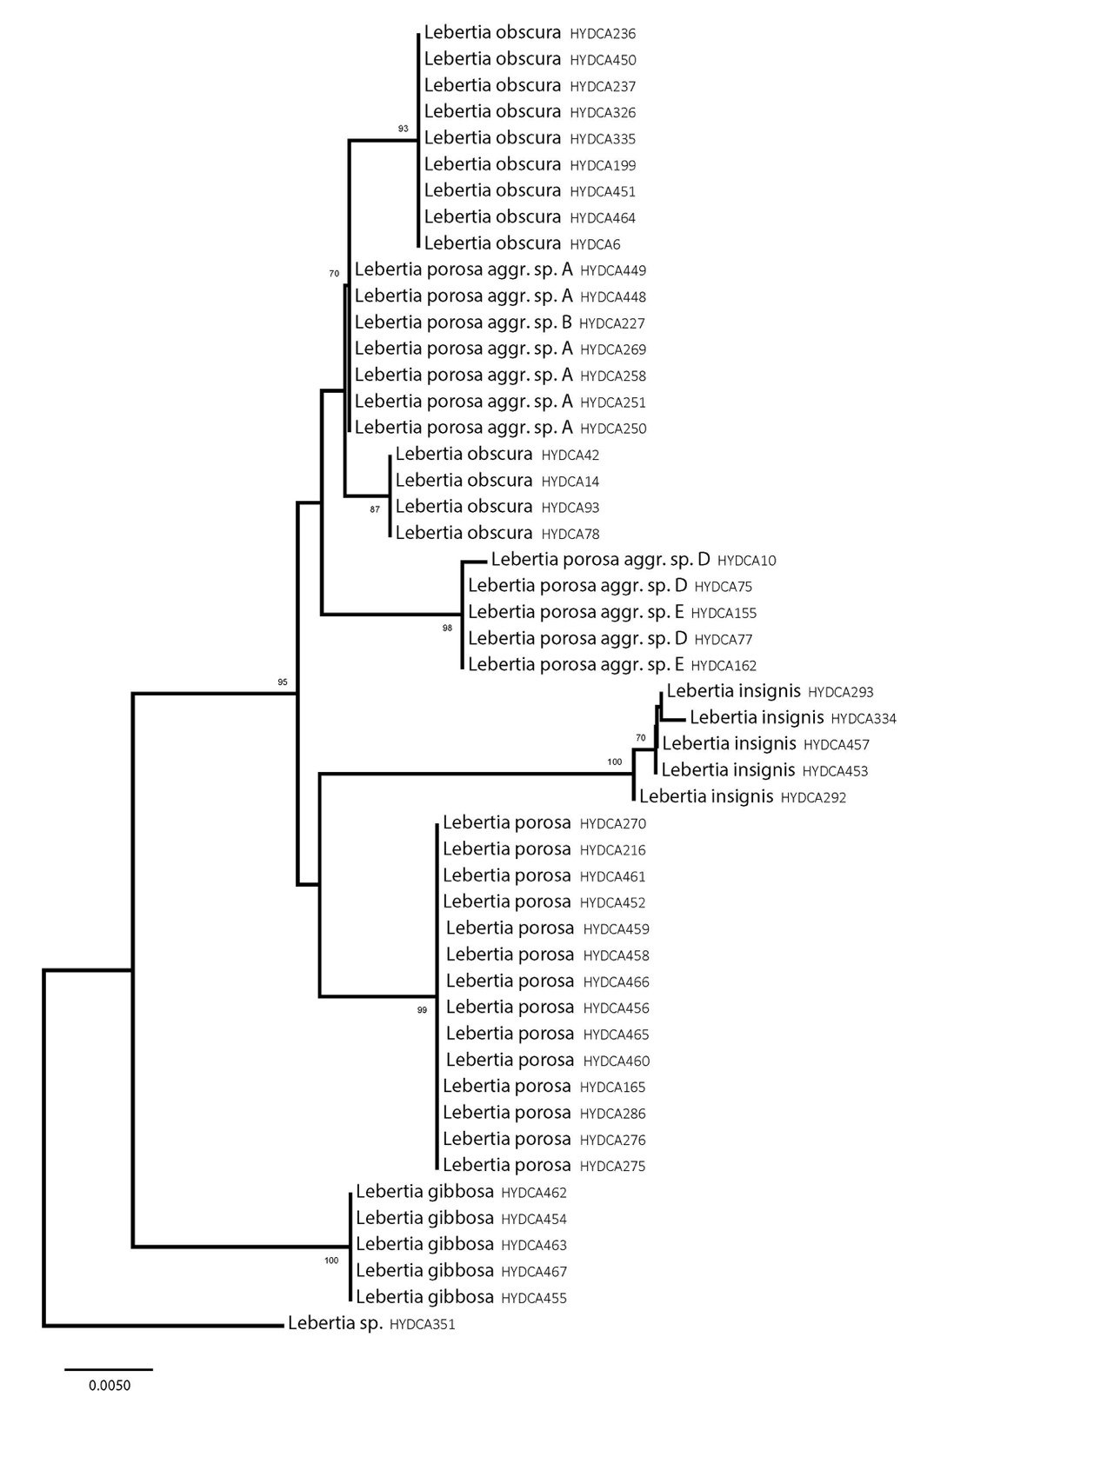

Supplementary Figure 2. Maximum likelihood tree from analysis of the 18S-dataset in MEGA X. Bootstrap support (500 replicates) on branches.

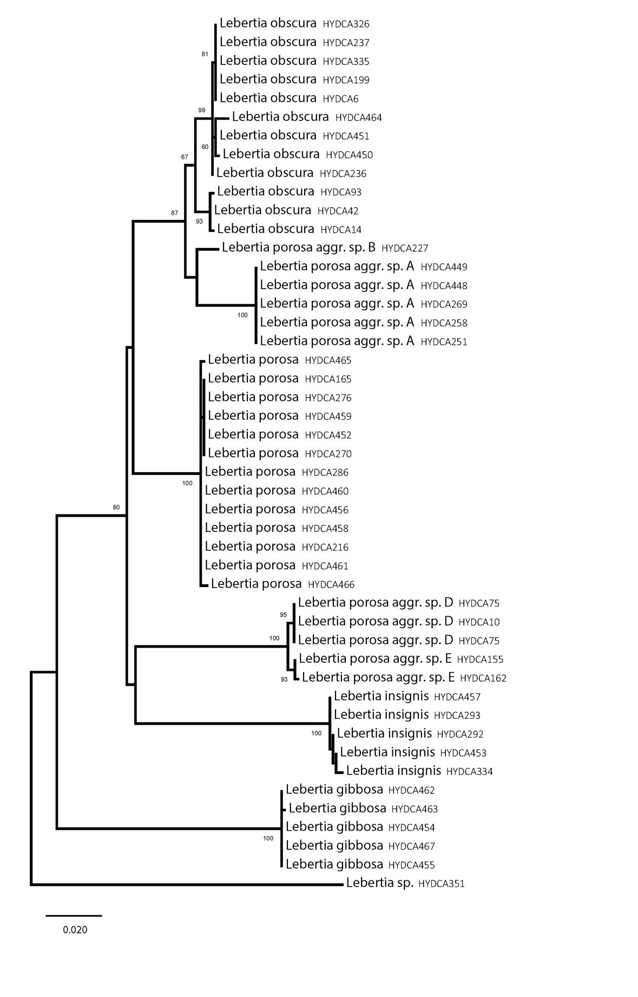

Supplementary Figure 3. Maximum likelihood tree from analysis of the 28S-dataset in MEGA X. Bootstrap support (500 replicates) on branches.