Supplementary Material

Supplementary table 1

Eurofins primer used for qRT- PCR

Target | Species | Sequence | Direction
Hprt | mouse | AGGCCAGACTTTGTTGGATTTGAA | forward
 |  | CAACTTGCGCTCATCTTAGGCTTT | reverse
Abhd6 | mouse | AAG ACC AGG TGC TTG ATG TGT CC | forward
 |  | TCC ATC ACT ACC GAA TGG CCA CAG | reverse
Abhd12 | mouse | TTG ACT GGT TCT TCC TCG ACC CC | forward
 |  | CCG AGA TGG TGC AGC AAT GTT G | reverse

Supplementary table 2

Bio-Rad primer used for qRT- PCR

Target | Species | ID
Hprt | mouse | qMmuCED0045738
Mgll | mouse | qMmuCID0040130

Supplementary figure S1

S1 Flow cytometric gating strategies
Schematic presentation of the lymphoid (a, c) and myeloid (b) gating strategies for analysis of single cell suspensions of tumors. Tumor infiltrating leukocytes (CD45⁺) were pre-gated for time and single cells. Dead cells were excluded and an additional lymphocyte gate was used to exclude myeloid cells from the lymphoid panel.

(a) T cells were determined as CD45⁺/CD3⁺; NK cells as CD45⁺/CD3⁻/NKp46⁺; B cells as CD45⁺/CD3⁻/CD19⁺; CD8⁺ T cells as CD45⁺/CD3⁺/CD8⁺; CD4⁺ T cells as CD45⁺/CD3⁺/CD4⁺; T effector (T eff) cells as CD45⁺/CD3⁺/CD8⁺/CD44⁺ or CD45⁺/CD3⁺/CD4⁺/CD44⁺; T memory cells as CD45⁺/CD3⁺/CD8⁺/CD44⁺/CD62L⁺ or CD45⁺/CD3⁺/CD4⁺/CD44⁺/CD62L⁺ ; T naïve cells as CD45⁺/CD3⁺/CD8⁺/CD62L⁺ or CD45⁺/CD3⁺/CD4⁺/CD62L⁺ and NK T cells as CD45⁺/CD3⁺/NKp46⁺. PD-1 expression was determined measuring median fluorescence intensity (MFI) of CD4⁺ and CD8⁺ T cells in the BV421 channel.
(b) Eosinophils were identified as CD45⁺/CD11b⁺/CD11c⁻/Siglec-F⁺; neutrophils as CD45⁺/CD11b⁺/CD11c⁻/Siglec-F⁻/Ly6G⁺; monocytes as CD45⁺/CD11b⁺/CD11c⁻/Siglec-F⁻/Ly6G⁻/Ly6C⁺ and macrophages as CD45⁺/CD11b⁺/CD11c^{-/+}/Siglec-F⁻/Ly6G⁻/Ly6C⁻/F4/80⁺.
(c) INF-γ⁺ CD8⁺ T cells were gated as CD45⁺/CD3⁺/CD8⁺/INFγ⁺. Granzyme-B⁺ CD8⁺ T cells were gated as CD45⁺/CD3⁺/CD8⁺/granzyme-B⁺.

S2 LC-MS analytics
Equipment, materials, method parameters and a full list of analytes

Abbreviations for lipids
Abbreviation | Lipid species
FA | Free Fatty Acid
LPC O | Ether-lysophosphatidylcholine
LPE | Lysophosphatidylethanolamine
LPG | Lysophosphatidylglycerol
LPI | Lysophosphatidylinositol
PE | Phosphatidylethanolamin
PG | Phosphatidylglycerol
PI | Phosphatidylinositol
PS | Phosphatidylserine
LPC | Lysophosphaditylcholine
Cer | Dihydroceramid
DG | Diglyceride
LacCer | Lactosylceramide
PC | Phosphatidylcholine
PC O | Ether-phosphatidylcholine
CE | Cholesteryl esters
SM | Sphingomyelin
FC | Cholesterol
TG | Triglyceride
2-AG | 2-Arachidonoyl glycerol
2-OG | 2-Oleoyl glycerol
OEA | Oleoyl ethanolamide
AEA | Arachidonoyl ethanolamide
PEA | Palmitoyl ethanolamide
VEA | Vaccenic acid ethanolamide

Materials
Water, isopropyl alcohol, methanol, acetonitrile (LC-MS grade), hexane (UV/IR grade) and methyl-tert-butyl-ether (MTBE, HPLC-grade) were purchased from Carl Roth (Karlsruhe, Germany). Ammonium formate (for mass spectrometry, ≥ 99.0 %), butylated hydroxytoluene (BHT, 99%) and oleic acid (> 98%) were obtained from Sigma-Aldrich (Munich, Germany) and formic acid (98-100 %) from AppliChem (Darmstadt, Germany). Ethyl acetate (≥ 99.8 %) was purchased from Fisher Chemicals (Schwerte, Germany).

Endocannabinoids and structurally related compounds

Reference substances
Analytes
Arachidonoyl Ethanolamide (AEA) Cayman Chemical Company, Ann Arbor, MI, USA
Palmitoyl Ethanolamide (PEA) Cayman Chemical Company, Ann Arbor, MI, USA
Oleoyl Ethanolamide (OEA) Cayman Chemical Company, Ann Arbor, MI, USA
1-arachidonoyl glycerol (1-AG) Cayman Chemical Company, Ann Arbor, MI, USA
2-arachidonoyl glycerol (2-AG) Cayman Chemical Company, Ann Arbor, MI, USA
2-oleoyl glycerol (2-OG) Cayman Chemical Company, Ann Arbor, MI, USA

Working solutions for the generation of calibrator and QC-samples were prepared as a mixture of all analytes by serial dilution using acetonitrile.

Internal standards
AEA-d₈ Cayman Chemical Company, Ann Arbor, MI, USA
PEA-d₄ Cayman Chemical Company, Ann Arbor, MI, USA
OEA-d₄ Cayman Chemical Company, Ann Arbor, MI, USA
1-AG-d₅ Cayman Chemical Company, Ann Arbor, MI, USA
2-AG-d₅ Cayman Chemical Company, Ann Arbor, MI, USA
1-OG-d₅ Avanti Polar Lipids, Alabaster, AL, USA

A working solution (20 ng/mL) of the internal standards was prepared as a mixture using acetonitrile as solvent

Instrumentation
Mass spectrometer QTRAP 6500+ (Sciex, Darmstadt, Germany)
Turbo Ion Spray in positive ESI
HPLC Agilent Technologies 1290 Infinity II (Agilent, Waldbronn, Germany)
G4220A – 1290 BinPump
G4226A – 1290 Sampler
G1330B – 1290 Thermostat
G1316C – 1290 TCC
LC-column Acquity UPLC BEH C18 2.1x100mm column, 1.7 µm (Waters, Eschborn, Germany), heated at 55 °C, flow rate 400 µL/min
Precolumn: VanGuard 2.1 x 5 mm, 1.7 µm (Waters, Eschborn, Germany)
Solvent A Water + 0.0025% formic acid
Solvent B Acetonitrile + 0.0025% formic acid
Injection volume 10 µL

Gradient
Time (min) | Sol. A (%) | Sol. B (%)
0.00 | 80.0 | 20.0
0.20 | 80.0 | 20.0
0.30 | 35.0 | 65.0
5.00 | 5.0 | 95.0
6.00 | 5.0 | 95.0
6.01 | 80.0 | 20.0
8.00 | 80.0 | 20.0

MRM-transitions
Analytes | Q1 | Q3 (Quan/Qual) | IS
AEA | 348.3 | 287.3 / 62.2 | AEA-d₈
PEA | 300.2 | 62.2 / 283.2 | PEA-d₅
OEA | 326.3 | 62.2 / 309.2 | OEA-d₄
1-AG | 379.2 | 287.3 / 269.2 | 1-AG-d₅
2-AG | 379.2 | 287.3 / 269.2 | 2-AG-d₅
2-OG | 357.3 | 265.2 / 339.1 | 1-OG-d₇

Lower (LLOQ) and upper limits of quantification (ULOQ) in ng/sample

Analytes | LLOQ (pg) | ULOQ (pg)
AEA | 2.5 | 200
PEA | 75 | 100
1-AG | 6.25 | 500
2-AG | 6.25 | 500
OEA+VEA* | 12.5 | 500
2-OG | 6.25 | 500
*as a shortened gradient was used, separation of OEA and VEA was not possible and therefore, analytes were evaluated as sum.

LC-HRMS lipid screening & quantification of oleic acid
Internal standards and their concentration in the working solution for the lipid screening (all from Avanti Polar Lipids, Alabaster, AL, USA)

Analytes | Concentration (µg/mL)
Arachidonic acid-d8 | 0.1
CE 18:1-d7 | 5
Cer d18:1/16:0-d7 | 0.02
Cholesterol-d7 | 1.5
DG 15:0/18:1-d7 | 0.3
LacCer d18:1/17:0 | 0.06
LPC 18:1-d7 | 0.3
LPC O-16:0-d4 | 0.02
LPE 18:1-d7 | 0.02
LPG 17:1 | 0.02
LPI 17:1 | 0.02
PC 15:0/18:1-d7 | 2
PC O-18:0/18:1-d9 | 0.2
PE 15:0/18:1-d7 | 0.1
PE O-18:0/18:1-d9 | 0.1
PG 15:0/18:1-d7 | 0.1
PI 15:0/18:1-d7 | 0.1
PS 15:0/18:1-d7 | 0.025
SM d18:1/18:1-d9 | 0.4
TG 15:0/18:1-d7/15:0 | 0.6

Reference substance, limits of quantification and internal standard used for quantification
Oleic acid Sigma-Aldrich, Munich, Germany
Oleic acid-d9 Avanti Polar Lipids, Alabaster, AL, USA
LLOQ (ng/sample) 20
ULOQ (ng/sample) 2000

Instrumentation
Mass spectrometer Orbitrap Exploris 480 (Thermo Fisher Scientific, Dreiech, Germany)
HESI-source
HPLC Vanquish Horizon (Thermo Fisher Scientific, Dreiech, Germany)
Vanquish Compartment H
Vanquish Split Sampler HT
Vanquish Pump H
LC-column Zorbax RRHD Eclipse Plus C8 1.8 µm 50 x 2.1 mm ID (Agilent, Waldbronn, Germany), heated at 40 °C, flow rate 300 µL/min
Precolumn: ZORBAX Eclipse Plus C8, 2.1 mm, 1.8 µm (Agilent, Waldbronn, Germany)
Solvent A Water + 0.1% formic acid + 10 mM ammonium formate
Solvent B Acetonitrile:isopropanole 2:3 (v/v) + 0.1% formic acid
Injection volume 2 µL (positive ion mode), 5 µL (negative ion mode)

LC-gradient
Time (min) | Sol. A (%) | Sol. B (%)
0.00 | 75.0 | 25.0
0.30 | 75.0 | 25.0
1.50 | 20.0 | 80.0
11.00 | 0.0 | 100.0
12.00 | 0.0 | 100.0
12.50 | 75.0 | 25.0
14.00 | 75.0 | 25.0

Supplementary figure S3

S3 Monoglyceride hydrolase (MGH) activity in tissue lysates of JZL184 treated mice. Correlations between tumor weight/volume with ABHD6 and ABHD12 mRNA expression in WT mice
(a) MGH activity was determined in liver lysates of vehicle and JZL184 (16 mg/kg)-treated C75Bl/6J wild type mice. Data show means + SD of one representative experiment, n=10. Statistical differences were assessed using student’s t-test, ***p<.001.
(b) Single cell suspensions of KP tumors of WT mice treated with JZL184 or vehicle were performed and stained with Annexin-V-FITC/PI to detect differences in CD45⁻ cell apoptosis or (c) with anti-BrdU-FITC to identify changes in CD45⁻ cell proliferation. Data show means + SD of one representative experiment. n=8. (d) Ki67-immunohistochemical staining of KP tumor sections from WT mice treated with JZL184 or vehicle. Calibration bar: 100 µm
(e, f) Relative mRNA expression of ABHD6 and (g, h) ABHD12 in KP cell tumors of WT mice was correlated with ex vivo-measured tumor weight and volume. Correlations were determined by using Pearson’s correlation coefficient (r).

Determination of monoglyceride hydrolase (MGH) activity
MGH activity assays in liver lysates and cell pellets were performed as described previously by Taschler et al. 2011, with some modifications [1]: livers were homogenized on ice in solution A (0.25 M sucrose, 1mM EDTA, 20 µM dithiothreitol, 0.05% Triton X-100, 20 µg/ml leupeptin, 2 µg/ml antipain, 1 µg/ml pepstatin, pH 7.0) using an Ultra Turrax (IKA, Staufen, Germany). Lysates were centrifuged at 20,000 g for 30 min at 4 °C, and MGH activity was measured in the lipid-poor infranatant. The substrate for the determination of MGH activity contained 1 mM rac-1(3)-oleoyl glycerol (OG) (Sigma Aldrich) bound to defatted bovine serum albumin (BSA) in an equimolar ratio in 50 mM potassium phosphate buffer, pH 7.0. Liver protein (20 µg) was then incubated with 100 µl of substrate for 30 min at 37 °C. Thereafter, the reaction was stopped by the addition of chloroform, and by rigorous vortexing. Phases were separated by centrifugation at 8,000 g for 5 min at 4 °C. Glycerol concentrations in the aqueous phase were determined using a commercial kit (free glycerol reagent, Sigma Aldrich). Protein concentrations of tissue lysates were determined by a Bio-Rad protein assay according to the manufacturer’s instructions (Bio-Rad) and by using BSA as a standard.

Determination of tumor cell proliferation and viability in vitro and in vivo
KP cells were seeded in 6-well plates (3.5 x 10⁵ cells per well) in complete medium. The following day, cells were starved in medium without FBS for 4 hrs and subsequently treated with different concentrations of 2-AG for 24 hrs. Bromodeoxyuridine (BrdU, BD Biosciences) was added for 4 hrs to allow its incorporation, followed by harvesting of the cells. The sample was then divided into two halves whereby one half was processed for BrdU-staining according to the manufacturer’s protocol (FITC BrdU Flow Kit, BD Pharmingen), and the other half was used for annexin-V/PI staining (FITC Annexin V Apoptosis Detection Kit I, BD Pharmingen). BrdU⁺ as well as annexin-V/PI⁺ KP cells were measured on a BDCanto (BD Biosciences).
In order to identify changes in tumor cell proliferation in vivo, mice were injected with 1.5 mg BrdU 16 hrs prior to sacrifice. Single cell suspensions of the tumors were performed as described and, after treatment with viability dye and anti-CD45 antibody (to exclude dead cells and leukocytes), staining of BrdU⁺ cells was performed according to manufacturer’s protocol,.

Supplementary figure S4

S4 In situ hybridization (ISH) of MGL mRNA in KP cell tumors of MGL KO mice and expression of monoglyceride hydrolases in KP cells from cell culture
(a) Representative gel of MGL mRNA expression in primary human cancer-associated fibroblasts and (b) primary mouse dermal fibroblasts with and without TGF-β for fibroblast differentiation. (c) In KP cell tumors of MGL KO mice, MGL mRNA is visible in tumor cells (arrows) but not in (d) F4/80-positive macrophages (arrows), (e) FSP-positive fibroblasts (arrows denote MGL mRNA), (f) endothelial cells (positive for von Willebrand factor [vWF]; arrows), and (g) (alpha) α-SMA-positive fibroblasts (arrows denote MGL mRNA). Calibration bars: 20µm (h) Graph showing % of MGL mRNA colocalization with indicated cell populations in tumor sections of MGL KO mice. Cells from 3 different tumor sections were used for quantification. >60 cells/section were evaluated for colocalization. Data show means + SD (i) Expression of MGL, ABHD6 and ABHD12 mRNA in KP cells in vitro. n=3. One-way ANOVA with Tukey’s post hoc test. **p<.01, ***p<.001.
(j) ABHD6 and (k) ABHD12 mRNA expression in tumors of MGL WT and KO mice normalized to KP cells in vitro (KP cells).

Supplementary figure S5

OEA+VEA
PEA
AEA
2-OG
2-AG

S5 2-AG levels and lipid profiles in KP tumors of MGL KO vs. WT mice
(a) Tumors were snap frozen in liquid nitrogen and the tissue homogenate was subsequently analyzed with mass spectrometry. Graphs show 2-AG and other endocannabinoid (and endocannabinoid-like) lipid levels from JZL184 (16 mg/kg) and vehicle-treated mice with KP cell tumors (n=10). Statistical differences were assessed by using student’s t-test. *p<.05; **p<.01. (b) 2-AG levels in tumor-adjacent white adipose tissue and KP cell tumors of MGL KO and WT mice. n=5. 2-AG data are semi-quantitative. The highest value of the standard curve was chosen for values >ULOQ. Statistical differences were assessed by using two-way ANOVA with Sidak’s multiple comparison test. *<.05, **<.01, ***p<.001. (c) Mass spectrometry lipid screening of MGL KO and WT KP cell tumors. Red color indicates significantly increased levels in tumors of MGL KO compared to WT mice. Blue color indicates significantly elevated levels in tumors of MGL WT as compared to MGL KO mice.

Supplementary figure S6

S6 CD8⁺ T cell proliferation in response to 2-AG
(a) T cells from MGL WT and KO mice were stained with eF450-proliferation dye prior to α-CD3/CD28-antibody stimulation. T cells from WT mice were additionally treated with indicated concentrations of 2-AG. Flow cytometric analysis revealed no difference in proliferation of CD8⁺ T cells. n=4 (b) Representative histograms of CD8⁺ T cells stained with proliferation dye BV421 and stimulation with and w/o α-CD3/CD28-antibodies for 3 days. Number in the left upper corner of the histogram depicts % of proliferated CD8+ T cells.

Supplementary figure S7

S7 Proliferation and viability of KP cells in vitro is unaffected by 2-AG
(a) KP cells were incubated with different concentrations of 2-AG for 24 hrs. Changes in proliferation after 2-AG incubation were measured via differences in BrdU-incorporation. Data show means + SD, n=4. (b) Viability of KP cells after treatment with indicated concentrations of 2-AG was determined via measurement of Annexin-V-FITC and/or PI positive cells by flow cytometry. Data show means + SD, n=3. Statistical differences were assessed using one-way or two-way ANOVA with Tukey’s multiple comparison test.

Supplementary figure S8

S8 Viability and purity of bone marrow-derived eosinophils (BMDEs)
Bone marrow was isolated from C57BL/6J wild type mice, differentiated to BMDEs and used on day 14 showing a viability (fixable viability dye, FVD) and purity (Siglec-F⁺) of about 94 and 93 %, respectively.

Supplementary figure S9

S9 Generation of MGL-overexpressing KP cells
KP cells were lentivirally transduced with an LVX-IRES Puro CFP vector (encoding the murine MGL) or with a control (ctrl) plasmid. (a) Representative plots of successfully transduced control (KP_ctrl) and MGL-overexpressing (KP_MGL) KP cells (CFP⁺).
(b) MGL overexpression was confirmed with qRT-PCR. Data show means + SD and were normalized to MGL expression of parental KP cells. n=3. (c) Monoacylglycerol hydrolase (MGH) activity was measured in the MGL-overexpressing (KP_CFP_MGL) and control cells (KP_ctrl). Data show mean + SD (n=2).
(d) Proliferation of the generated cell lines was monitored by BrdU incorporation. Data indicate means + SD of three independent experiments (n=3). Statistical differences were assessed using student’s t-test.

Supplementary figure S10

KP_MGL>KP_ctrl
KP_MGL<KP_ctrl

S10 Lipid profile in MGL-overexpressing KP_MGL vs. KP_ctrl (control) tumors
Mass spectrometry lipid screening of KP_MGL vs. KP_ctrl tumors. Red color indicates increased levels in KP_MGL vs. KP_ctrl tumors. Blue color indicates elevated levels in KP_ctrl compared to KP_MGL tumors.

Whole MGL mRNA gels used in Supplementary figures S4A and S4B and areas that have been cropped
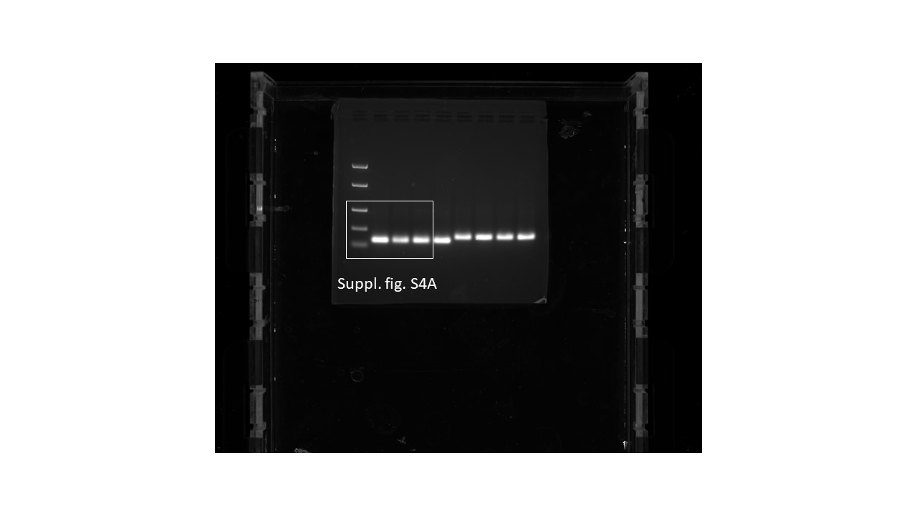

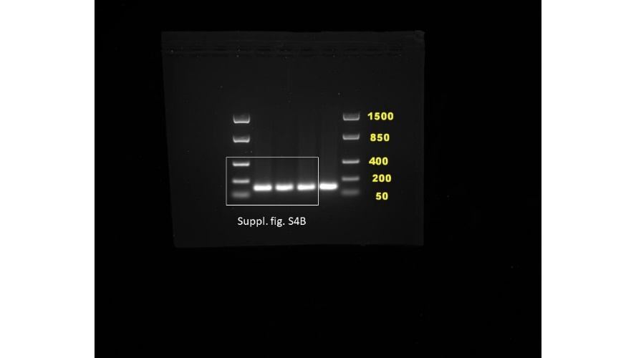

References

1. Taschler, U.; Radner, F.P.W.; Heier, C.; Schreiber, R.; Schweiger, M.; Schoiswohl, G.; Preiss-Landl, K.; Jaeger, D.; Reiter, B.; Koefeler, H.C.; et al. Monoglyceride Lipase Deficiency in Mice Impairs Lipolysis and Attenuates Diet-Induced Insulin Resistance. J. Biol. Chem. 2011, 286, 17467–17477, doi:10.1074/jbc.M110.215434.

