Multimedia Appendix

Appendix 2

Initial view of the registry website after loading
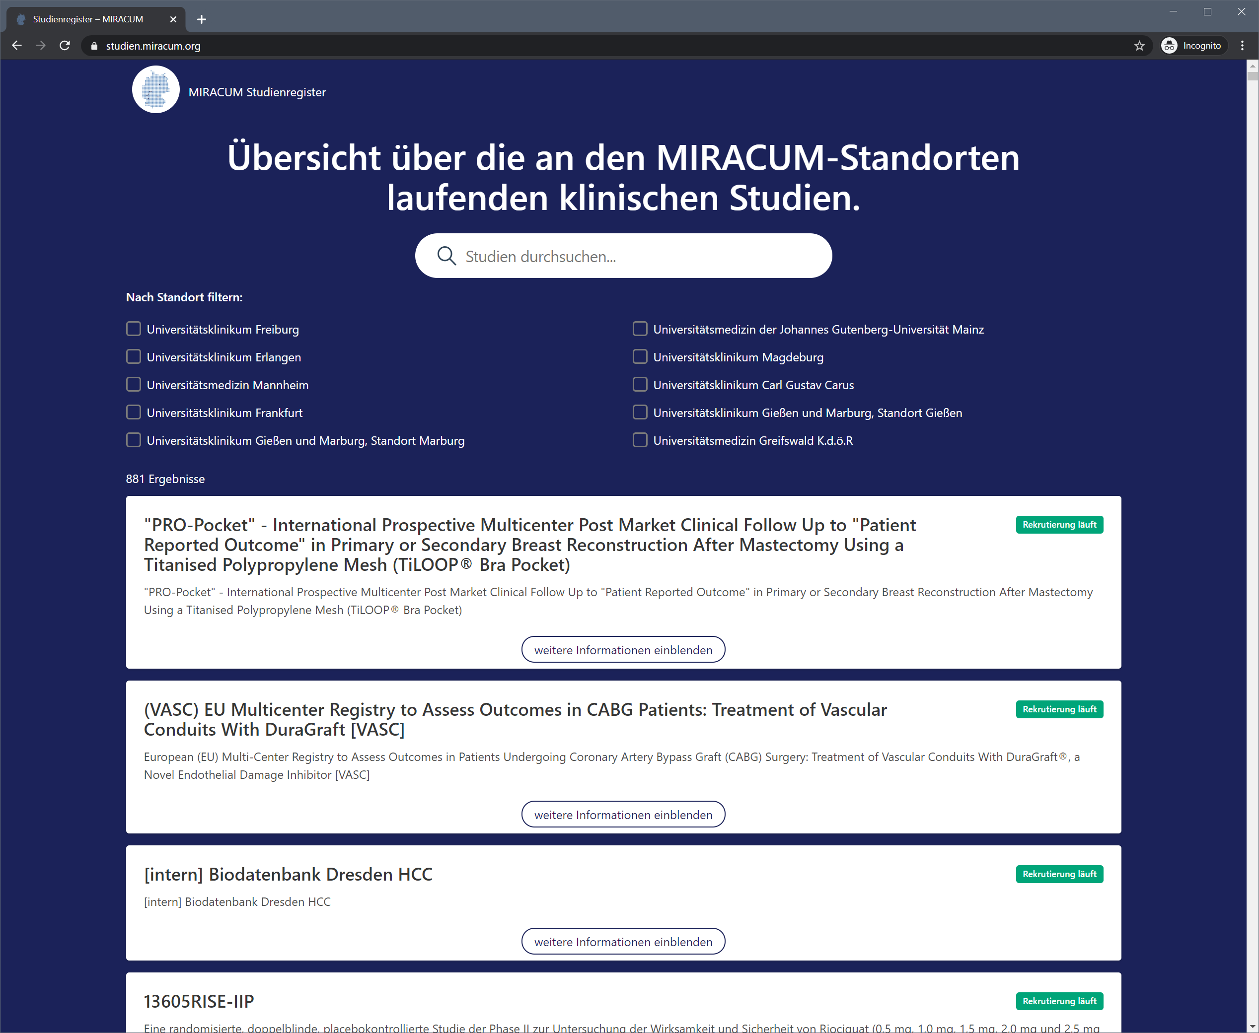

Expanded view of a study record
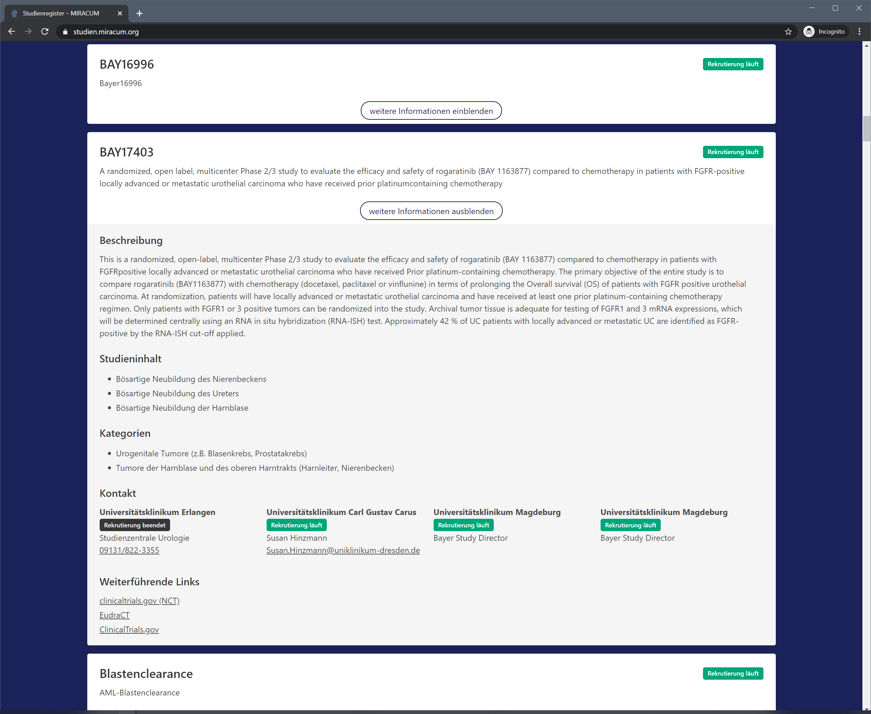

Search Results after filtering by site and keyword “Leukemia”
