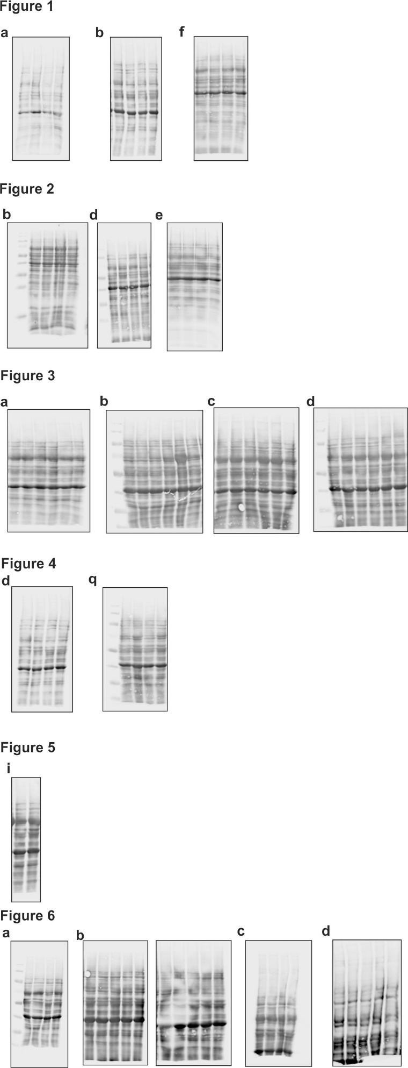

Figure S1: Total protein stain
Membranes were stained with Revert 700 Total Protein Stain kit before blocking. The figure shows the membrane of every blot, which was used to create the figures within this publication.

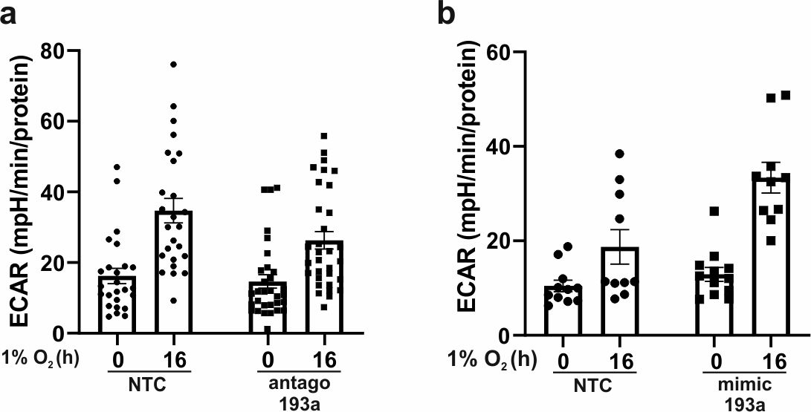

Figure S2: Individual values of Fig 1c and 1g
a The extracellular acidification rate (ECAR) of normoxic and hypoxic NTC and antago 193a macrophages was measured by Seahorse. Glycolysis-dependent acidification was calculated by subtracting basal acidification from glucose-induced acidification. Each dot represents one well in the measurement. 8 Buffys were used in the experiments. b Glycolysis-dependent acidification of normoxic, hypoxic NTC, and mimic 193a macrophages was measured by Seahorse. Each dot represents one well in the measurement. 5 Buffys were used in the experiments. All data are expressed as mean values ± SEM, *p ≤ 0.05

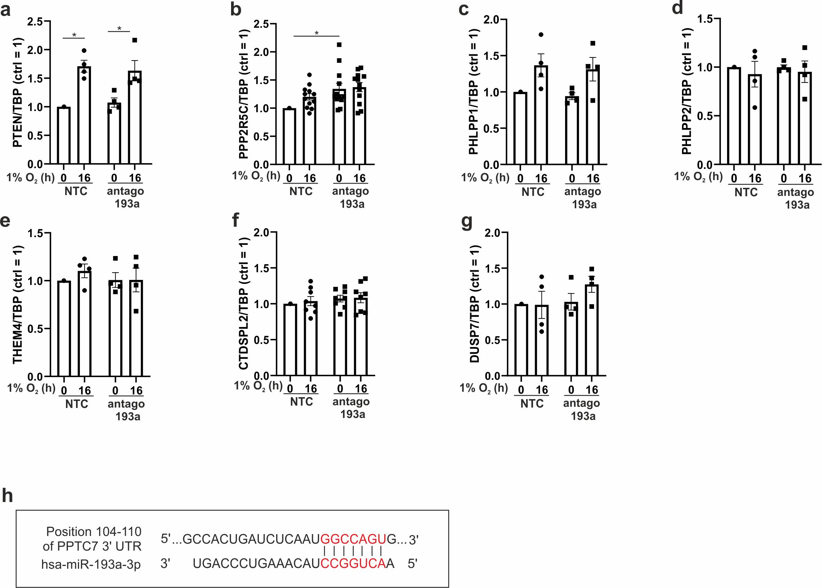

Figure S3: mRNA regulation of Akt-regulating phosphatases
a-g Primary human macrophages were transfected with antagomir against miR-193a-3p (antago 193a) or a non-targeting control (NTC) and incubated for 16 h under hypoxia (1% O₂). mRNA of phosphatidylinositol 3,4,5-trisphosphate 3-phosphatase and dual-specificity protein phosphatase (PTEN), Serine/threonine-protein phosphatase 2A 56 kDa regulatory subunit gamma isoform (PPP2R5C), PH domain leucine-rich repeat-containing protein phosphatase (PHLPP) 1, PHLPP 2, Acyl-coenzyme A thioesterase (THEM4), CTD small phosphatase-like protein 2 (CTDSPL2), and dual specificity protein phosphatase 7 (DUSP7) was analyzed and normalized to TATA-Box binding protein (TBP). h Position 104-110 of the 3’ UTR sequence of protein phosphatase PTC7 homolog (PPTC7) including the predicted binding site of miR-193a-3p (red). All data are expressed as mean values ± SEM, *p ≤ 0.05

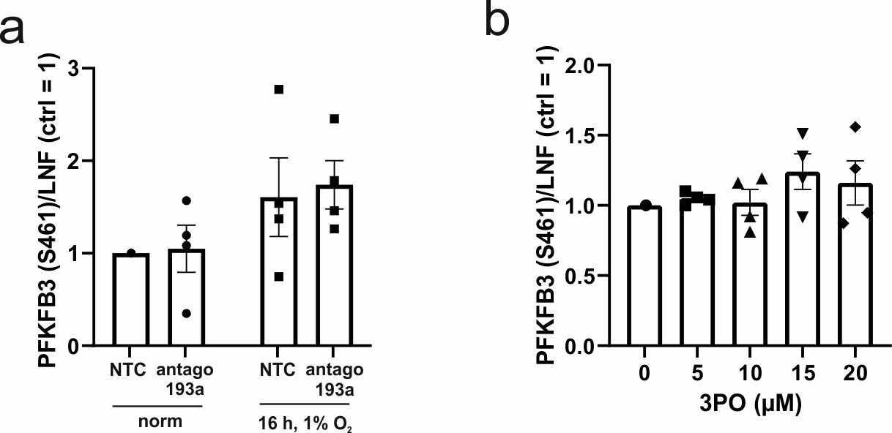

Figure S4: Quantification total PFKFB3
a Macrophages were transfected with antagomir against miR-193a-3p (antago 193a) or a non-targeting control (NTC) and incubated for 16 h under hypoxia (1% O₂). Total PFKFB3 was determined by Western analysis and normalized to LNF. b Cells were treated with increasing concentrations of the PFKFB3 inhibitor 3PO 1 h prior to hypoxic incubation. Total PFKFB3 was measured by Western analysis and normalized to LNF. All data are expressed as mean values ± SEM, *p ≤ 0.05

