Supplementary Information
for the manuscript:

Electron carriers involved in autotrophic and heterotrophic acetogenesis in the thermophilic bacterium
Thermoanaerobacter kivui

Alexander Katsyv¹, Surbhi Jain¹, Mirko Basen² and Volker Müller¹*

¹Department of Molecular Microbiology & Bioenergetics, Institute of Molecular Biosciences, Johann Wolfgang Goethe University, Frankfurt am Main, Germany

²Microbiology, Institute of Biological Sciences, University of Rostock, 18059 Rostock, Germany

*correspondence address: Prof. Volker Müller, Department of Molecular Microbiology & Bioenergetics, Institute of Molecular Biosciences, Johann Wolfgang Goethe University, Frankfurt am Main, Germany; Phone: 49-6979829507; Fax: 49-69-79829306;
E-mail: vmueller@bio.uni-frankfurt.de

Fig. S1
Fig. S2
Fig. S3
Fig. S4
Fig. S5
Fig. S6
Fig. S7
Fig. S8
Fig. S9
Fig. S10
Fig. S11
Fig. S12
Fig. S13
Table S1

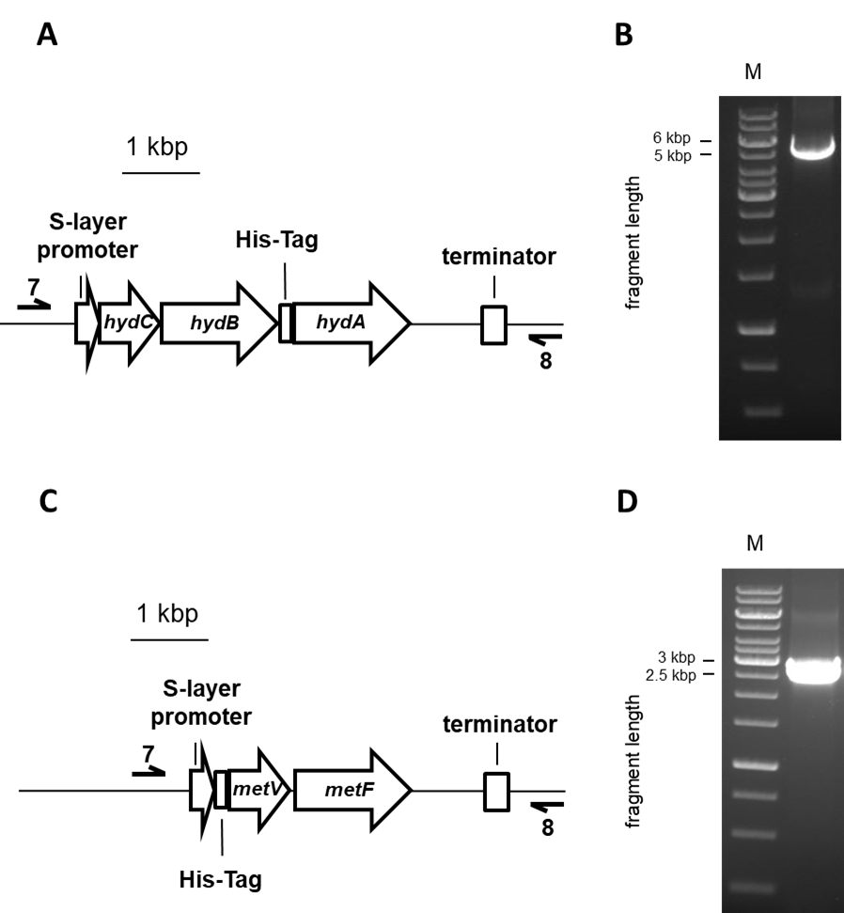
Fig. S1. Verification of the pMU131_His-hydABC and pMU131_His-metFV constructs transformed in T. kivui. To verify the nature of the plasmids pMU131_His-hydABC and pMU131_His-metFV after propagation, T. kivui colonies were picked and the plasmids were checked by using primer pairs seq1_for (7)/ seq2_rev (8) (Tab. S1) binding on the pMU131 backbone and amplifying the complete His-hydABC (A) or His-metFV (C). The resulting size was 5405 bp (B) or 2768 bp (D). M, Gene Ruler 1 kb DNA ladder.

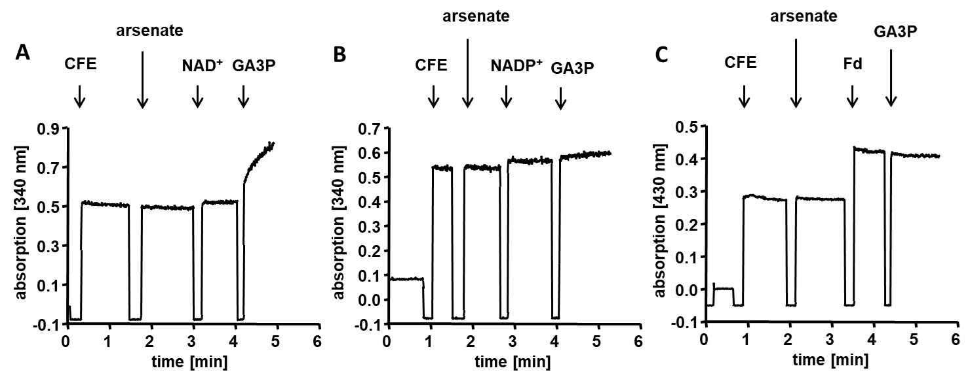
Fig. S2. NAD⁺-dependent GA3P-DH activity. GA3P-DH activity was measured in 1.8-ml anoxic cuvettes containing an overall liquid volume of 1 ml under a 100% N₂ atmosphere (1 × 10⁵ Pa) at 66 °C. The GA3P:NAD⁺/NADP⁺/Fd oxidoreductase assay contained 200 - 500 μg CFE of glucose-grown T. kivui cells, 5 mM arsenate and 4 mM NAD⁺ (A) or 4 mM NADP⁺ (B) or 30 μM Fd (C) in buffer C (50 mM Tris/HCl, 10 mM NaCl, 2 mM DTE, pH 7.5). The reaction was started by addition of 1 mM GA3P. Reduction of NAD⁺ or NADP⁺ was monitored at 340 nm and reduction of Fd at 430 nm, respectively.

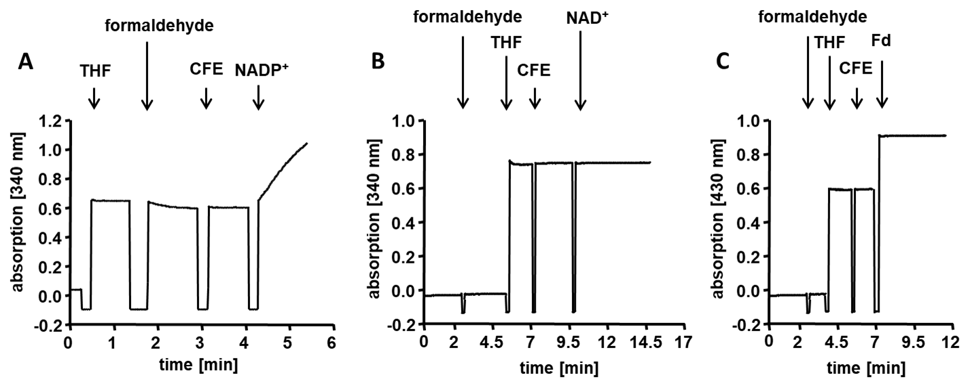
Fig. S3. NADP⁺-dependent methylene-THF dehydrogenase activity. Methylene-THF dehydrogenase activity was measured in 1.8-ml anoxic cuvettes containing an overall liquid volume of 1 ml under a 100% N₂ atmosphere (1 × 10⁵ Pa) at 66 °C. The assay contained 200 - 500 μg CFE of glucose-grown T. kivui cells, 1.5 mM formaldehyde and 0.5 mM THF in buffer C (50 mM Tris/HCl, 10 mM NaCl, 2 mM DTE, pH 7.5). The reaction was started by addition of 1 mM NAD⁺ (A), 1 mM NADP⁺ (B) or 30 µM Fd (C). Reduction of NAD⁺, NADP⁺ or Fd was monitored at 340 or 430 nm, respectively.

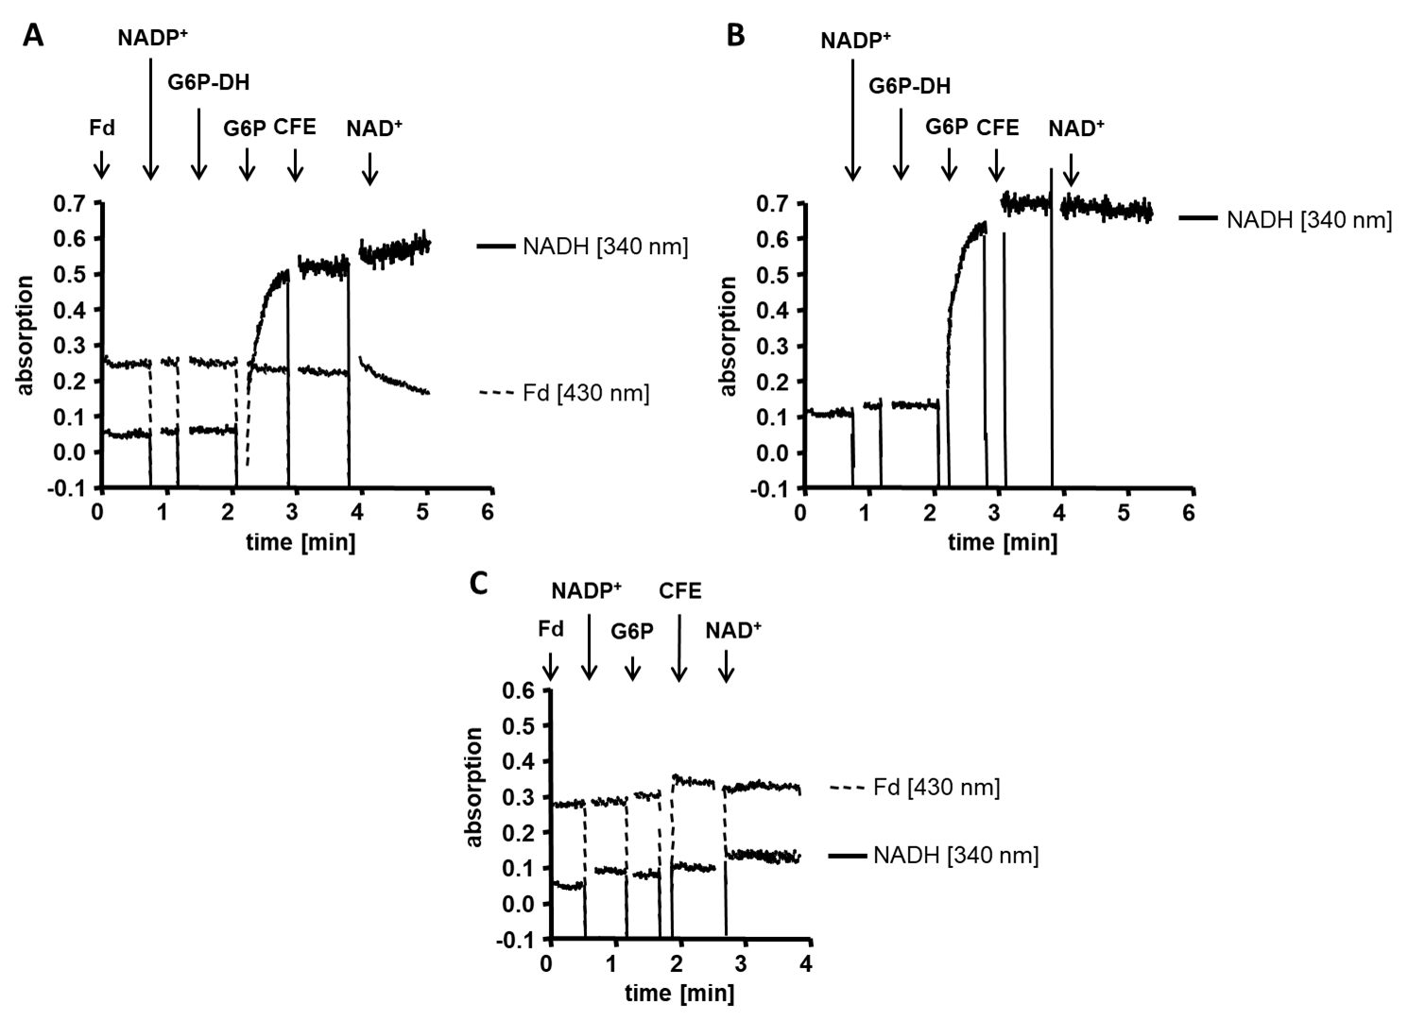
Fig. S4. NADPH-dependent reduction of NAD⁺ and Fd in CFE of glucose-grown T. kivui cells. NAD⁺-dependent NADPH:Fd ocidoreductase activity was measured in 1.8-ml anoxic cuvettes containing an overall liquid volume of 1 ml under a 100% N₂ atmosphere (1 × 10⁵ Pa) at 66 °C. The assay contained 410 μg CFE of glucose-grown T. kivui cells and 30 µM Fd in buffer C (50 mM Tris/HCl, 10 mM NaCl, 2 mM DTE, pH 7.5). To keep the level of NADPH constant, 0.1 mM NADP⁺ were prereduced with 1 unit G6P-DH and 20 mM G6P (NADP⁺ reducing system) as reported previously (Kremp et al. 2020). The reaction was started by addition of 1 mM NAD⁺. In controll assays either Fd (B) or G6P-DH (C) was omitted. Reduction of NAD⁺ and NADP⁺ was monitored at 340 nm and reduction of Fd at 430 nm, respectively.

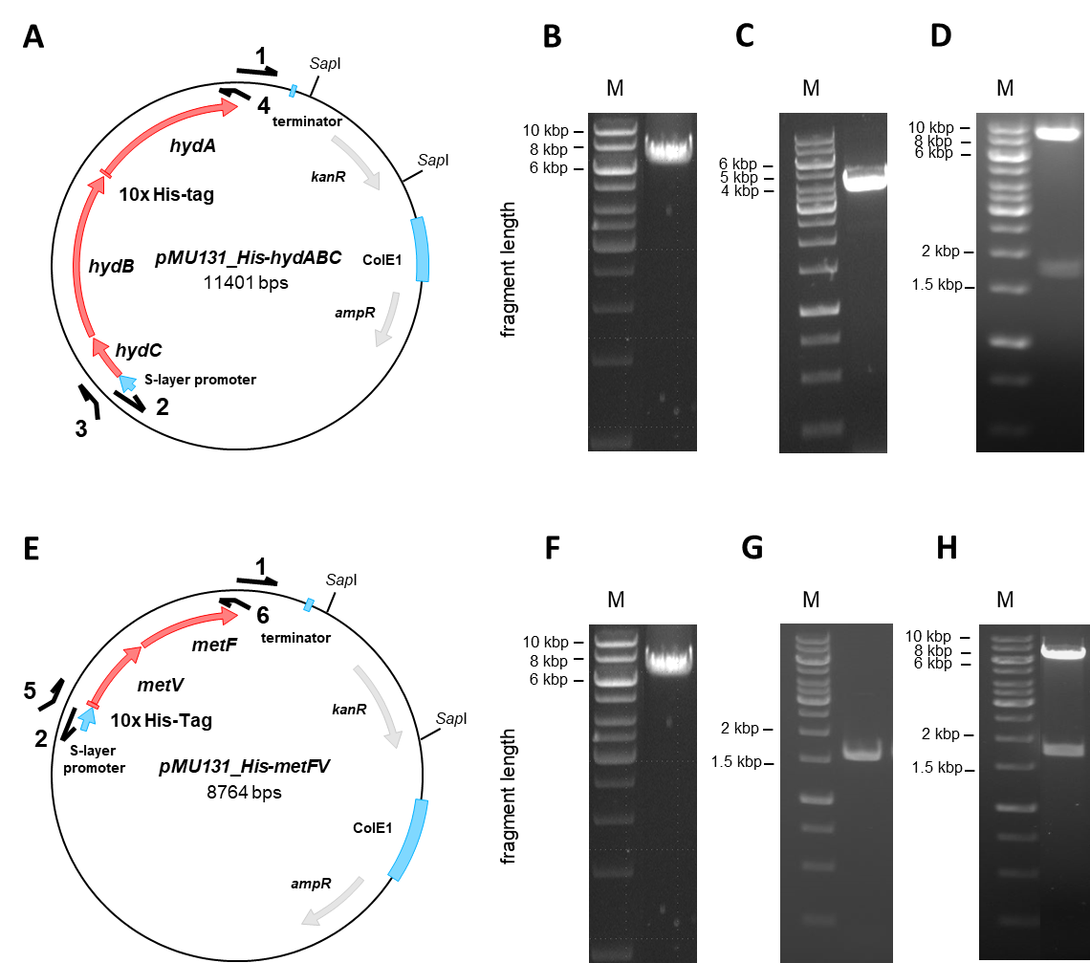
Fig. S5. Cloning of pMU131_His-hydABC and pMU131_His-metFV. For the production of His-HydABC and His-MetFV in T. kivui the constructs pMU131_His-hydABC and pMU131_His-metFV were cloned (A, E). Therefore, pMU131 backbone, including a S-layer-promoter, was amplified using corresponding primers (1, 2) via PCR (B, F) (Tab. S1). His-metFV (G) was amplified from genomic DNA of T. kivui via PCR, using corresponding primers (5, 6) (Tab. S1), containing an additional DNA sequence coding for a 10x His-tag. HydABC (C) was amplified from genomic DNA of T. kivui via PCR using corresponding primers (3, 4) (Tab. S1). Amplified hydABC or His-metFV and pMU131 were fused via Gibson Assembly and transformed in E. coli HB101. In case of pMU131_His-hydABC, a DNA sequence coding for a 10x His-tag was introduced at the 3’-end of the gene hydA using corresponding primers, via site directed mutagenesis. Afterwards, plasmids were isolated and digested with SacI. The resulting sizes for pMU131_His-hydABC were 1826 bp and 9575 bp (D) and for pMU131_His-metFV 1826 bp and 6938 bp (H). M, Gene Ruler 1 kb DNA ladder.
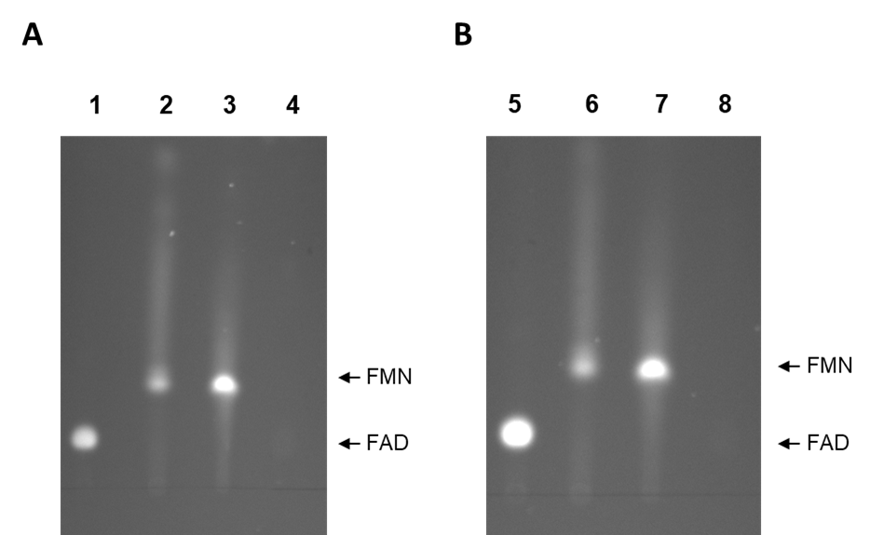
Fig. S6. Thin layer chromatography (TLC) of the favins extracted from His-HydABC and His-MetFV. Flavins of ~ 1 nmol His-HydABC (A) or His-MetFV (B) were separated on a TLC plate using 60% [v/v] n-butanol, 15% [v/v] glacial acetic acid and 25% [v/v] H₂O as the mobile phase. 1 nmol of FAD and FMN was used as standards. For this experiment His-HydABC and His-MetFV was purified with buffers additionally mixed with 10 µM FAD and 10 µM FMN. lane 1 and 5, FAD; lane 2 and 6, FMN; lane 3, His-HydABC; lane 7, His-MetFV; lane 4 and 8, buffer B.

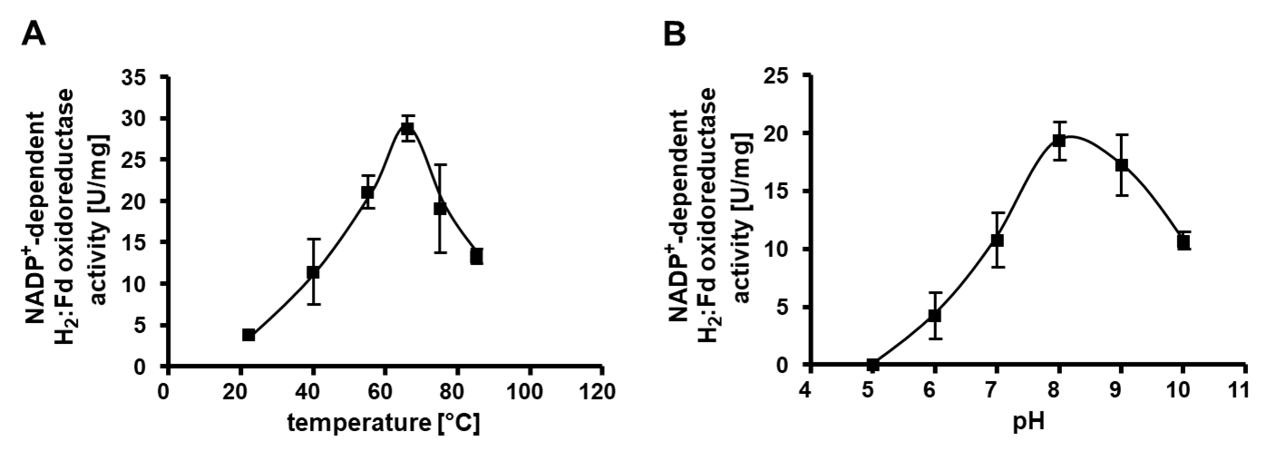
Fig. S7. pH optimum and temperature profile of purified His-HydABC. Temperature (A) or pH (B) effect on the NADP⁺-dependent H₂:Fd oxidoreductase activity was meassured in 1.8-ml anaerobic cuvettes containing an overall liquid volume of 1 ml under a 100% H₂ atmosphere (2 × 10⁵ Pa) at 22 - 85 °C (A) or 66 °C (B). The assay contained 1 ml of buffer D (50 mM EPPS, 10 mM NaCl, pH 8) (A) or buffer E (50 mM Tris, 50 mM MES, 50 mM CHES, 50 mM CAPS, 50 mM Bis-Tris, 10 mM NaCl, 2 mM DTE, 4 µM Resazurin, pH 5 - 10) (B), 5 - 10 μg His-HydABC, 5 µM FMN and 30 μM Fd. The reaction was started by addition of 4 mM NADP⁺. Reduction of NADP⁺ (340 nm) and Fd (430 nm) were monitored simultaneously. Shown is the average of two measurements from one representative experiment out of two independent replicates. Error bars represent the SEM.

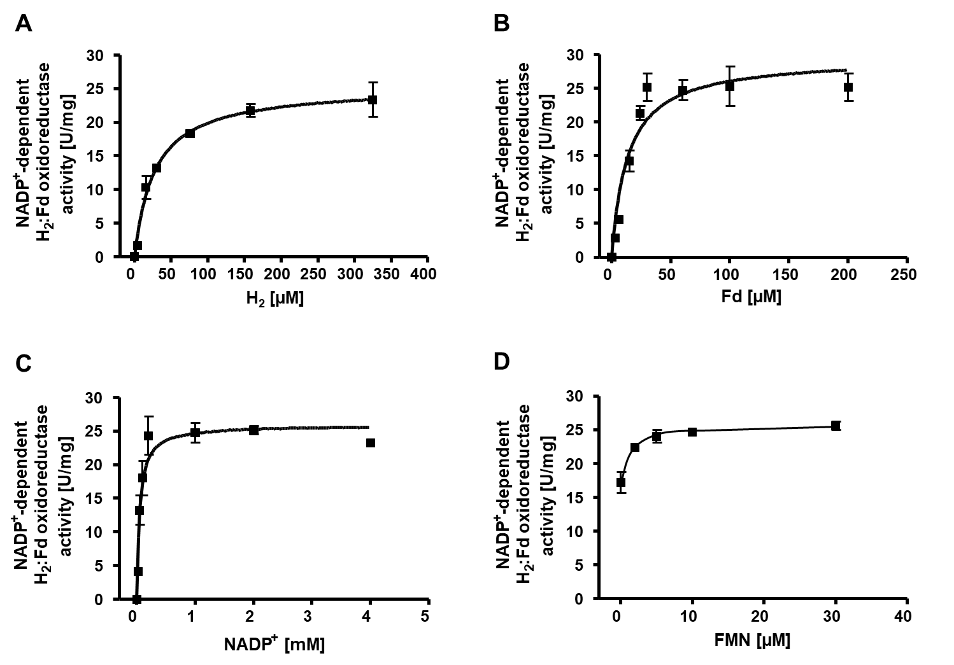
Fig. S8. H₂, Fd, NADP⁺ and FMN dependence on His-HydABC activity. NADP⁺-dependent H₂:Fd oxidoreductase activity was meassured in 1.8-ml anoxic cuvettes containing an overall liquid volume of 1 ml under a H₂ atmosphere at 66 °C. The assay contained 1 ml of buffer D (50 mM EPPS, 10 mM NaCl, pH 8), 5 - 10 μg His-HydABC, different amounts of H₂ (A), Fd (B), NADP⁺ (C) or FMN (D). Reduction of NADP⁺ (340 nm) and Fd (430 nm) were monitored simultaneously. Shown is the average of two measurements from one representative experiment out of two independent replicates. Error bars represent the SEM.

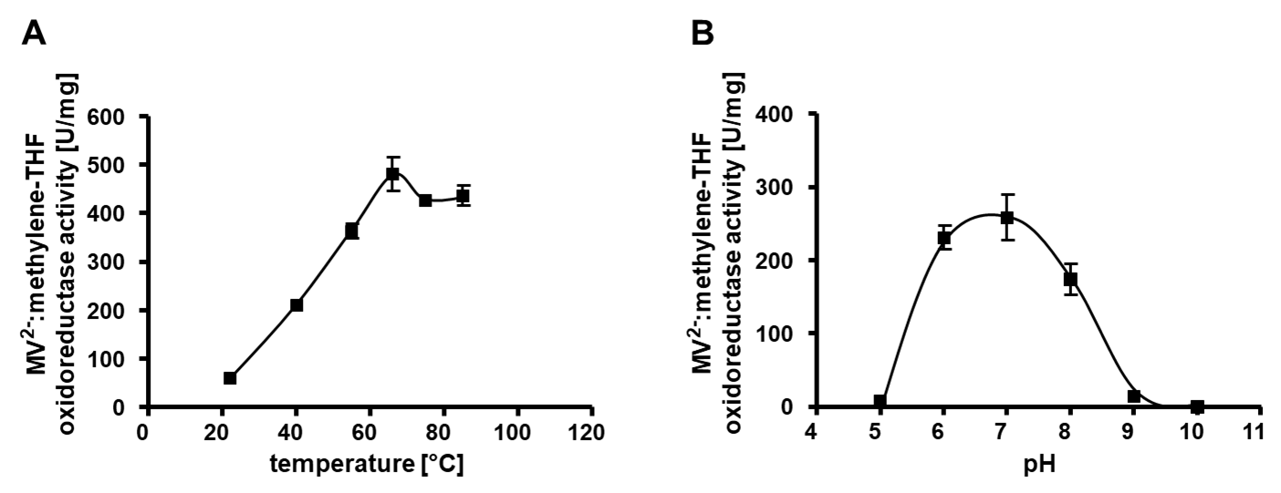
Fig. S9. pH optimum and temperature profile of purified His-MetFV. Temperature (A) or pH (B) effect on the MV²⁻:methylene-THF oxidoreductase activity was meassured in 1.8-ml anaerobic cuvettes containing an overall liquid volume of 1 ml under a 100% N₂ atmosphere (1 × 10⁵ Pa) at 22 - 85 °C (A) or 66 °C (B). The assay contained 1 ml of buffer F (50 mM KP_{i}, 20 mM ascorbate, pH 7) (A) or buffer E (50 mM Tris, 50 mM MES, 50 mM CHES, 50 mM CAPS, 50 mM Bis-Tris, 10 mM NaCl, 2 mM DTE, 4 µM Resazurin, pH 5 - 10) (B), 0.5 mM THF, 1.5 mM formaldehyde, 10 mM MV and 5 mM sodium dithionite. The reaction was started by addition of 2 - 5 μg His-MetFV. Oxidation of MV (600 nm) was monitored spectrophotometrically. Shown is the average of two measurements from one representative experiment out of two independent replicates. Error bars represent the SEM.

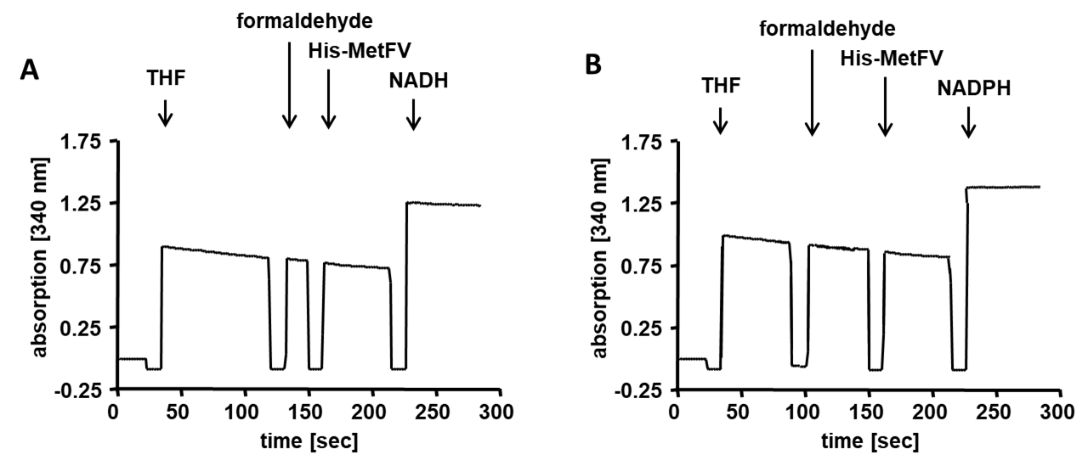
Fig. S10. NADH/NADPH:methylene-THF oxidoreductase activity of His-MetFV. MTHFR activity was measured in 1.8-ml anoxic cuvettes containing an overall liquid volume of 1 ml under a 100% N₂ atmosphere (1 × 10⁵ Pa) at 66 °C. The assay contained 20 μg His-MetFV, 1.5 mM formaldehyde and 0.5 mM THF in buffer F (50 mM KP_{i}, 20 mM ascorbate, pH 7). The reaction was started by addition of 0.5 mM NADH (A) or NADPH (B). Oxidation of NADH or NADPH was monitored at 340 nm, respectively.

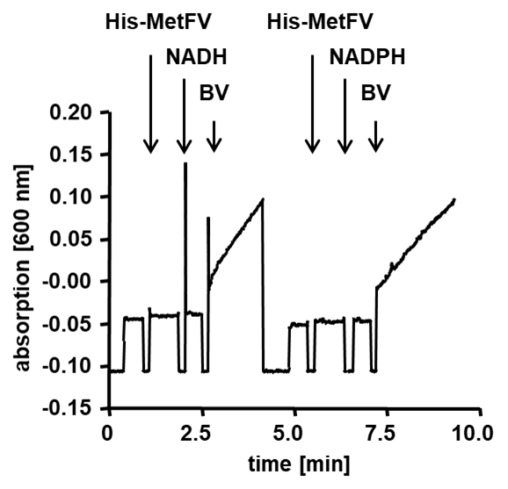
Fig. S11. NADH/NADPH:BV oxidoreductase activity of His-MetFV. MTHFR activity was measured in 1.8-ml anoxic cuvettes containing an overall liquid volume of 1 ml under a 100% N₂ atmosphere (1 × 10⁵ Pa) at 66 °C. The assay contained 30 μg His-MetFV and 0.5 mM NADH or NADPH in buffer F (50 mM KP_{i}, 20 mM ascorbate, pH 7). The reaction was started by addition of 10 mM BV. Reduction of BV was monitored at 600 nm, respectively.

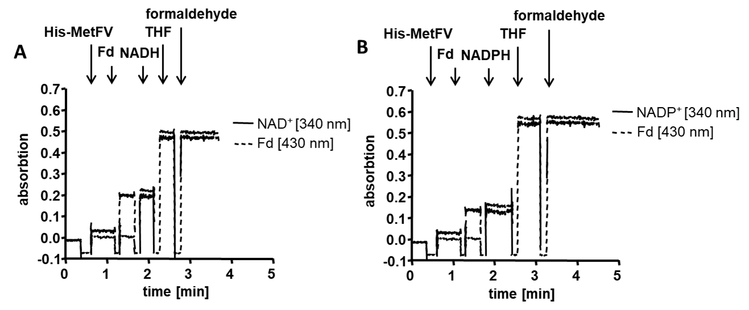
Fig. S12. Fd-dependent NADH/NADPH:methylene-THF oxidoreductase activity of His-MetFV. MTHFR activity was measured in 1.8-ml anoxic cuvettes containing an overall liquid volume of 1 ml under a 100% N₂ atmosphere (1 × 10⁵ Pa) at 66 °C. The assay contained 20 μg His-MetFV, 0.5 mM THF, 0.5 mM NADH (A) or NADPH (B) and 30 μM Fd in buffer F (50 mM KP_{i}, 20 mM ascorbate, pH 7). The reaction was started by addition of 1.5 mM formaldehyde. Oxidation of NADH or NADPH and reduction of Fd was monitored at 340 and 430 nm, respectively.

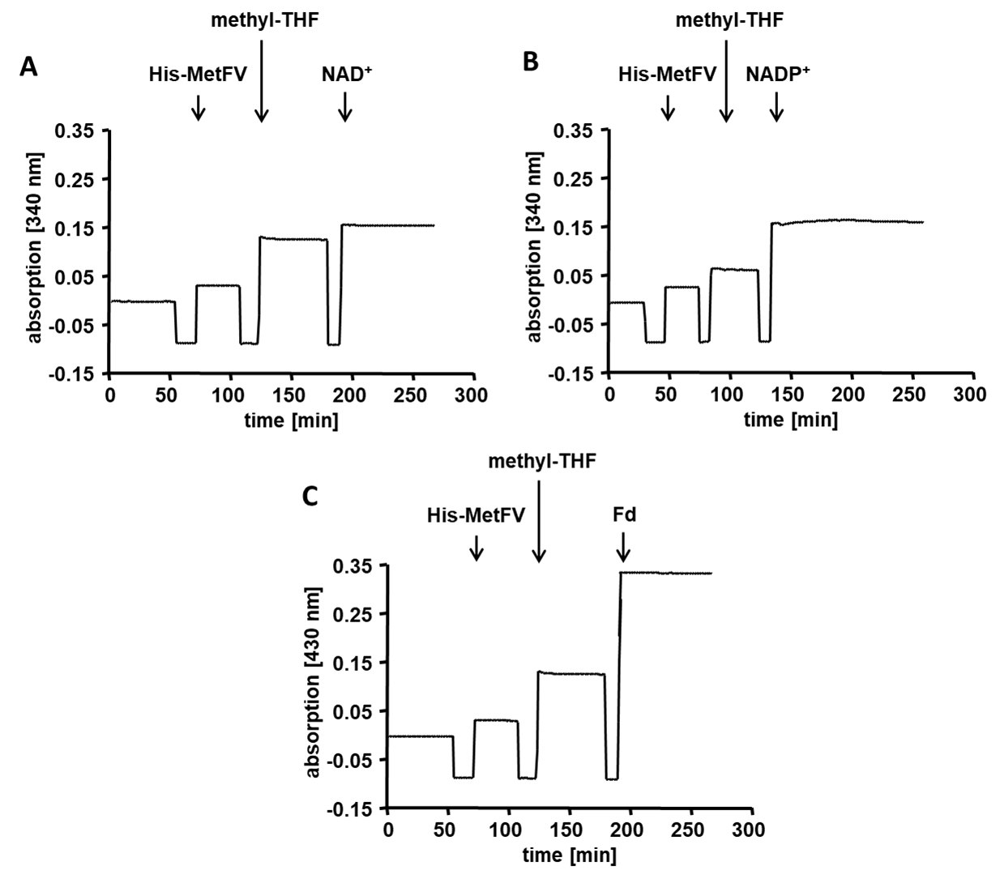
Fig. S13. Methyl-THF:NAD⁺/NADP⁺/Fd oxidoreductase activity of His-MetFV. MTHFR activity was measured in 1.8-ml anoxic cuvettes containing an overall liquid volume of 1 ml under a 100% N₂ atmosphere (1 × 10⁵ Pa) at 66 °C. The assay contained 15 - 30 μg purified His-MetFV and 1 mM methyl-THF in buffer F (50 mM KP_{i}, 20 mM ascorbate, pH 7). The reaction was started by addition of 4 mM NAD⁺ (A), 4 mM NADP⁺ (B) or 30 µM Fd (C). Reduction of NAD⁺, NADP⁺ or Fd was monitored at 340 or 430 nm, respectively.

Tab. S1. Corresponding primers used in this work.
No. | Primer | Sequence (5’→ 3’)
1 | pMU131_for | TTTTTTAAATTTATCCAGGATAAAAGAGAAGACTC
2 | pMU131_rev | ACAGTCAATCCTCCTCCTTG
3 | HydABCTK_for | caaggaggaggattgactgtATGTGTAATTGCTGCTGC
4 | HydABCTK_rev | tcctggataaatttaaaaaaTTAATATTCTTTCTTTCTTGAGTGATAG
5 | His-MetFVTK_for | caaggaggaggattgactgtATGCACCATCATCATCACCATCATCATCATCATGTCATTACAGAACATAAACCTTTTG
6 | His-MetFVTK_rev | tcctggataaatttaaaaaaTTACAAATTGCACATGTCAAG
7 | seq1_for | TCTAACACAATTATATCATAAGGATTGATA
8 | seq2_rev | AGTATTGTCAATATATTCAAGGCAA
9 | His-HydA_for | catcatcatcatcatAACATGGTAATGTTAACAATAG
10 | His-HydA_rev | gtgatgatgatggtgCATTAAAATCTCACTCCTTTC

References

Kremp F, Roth J, Müller V (2020) The Sporomusa type Nfn is a novel type of electron-bifurcating transhydrogenase that links the redox pools in acetogenic bacteria. Sci Rep 10:14872. https://doi.org/10.1038/s41598-020-71038-2

Schönheit P, Wäscher C, Thauer RK (1978) A rapid procedure for the purification of ferredoxin from Clostridia using polyethylenimine. FEBS Lett 89:219-222. https://doi.org/10.1016/0014-5793(78)80221-X

