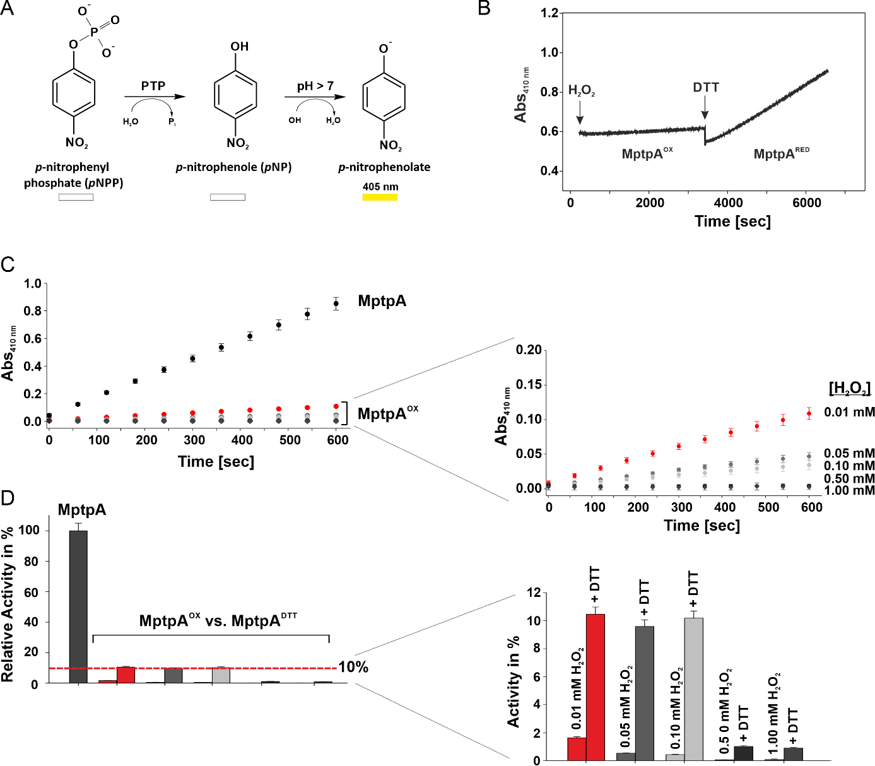
Fig. S1 Oxidative inactivation and reactivation of MptpA. A, Dephosphorylation reaction of p-nitrophenyl phosphate (pNPP) to p-nitrophenolate a chromogenic product with absorbance at 405 nm. B, Continuous Assay of H₂O₂-mediated (30 mM) inactivation and DTT-induced (60 mM) reactivation of MptpA. Thiol-free MptpA (3 µM) was added to a solution of assay-buffer (25 mM Tris/HCl, pH 8.0) containing the substrate p-nitrophenyl phosphate (pNPP, 1 mM) at 25 °C. After nearly complete inactivation of the enzyme was achieved, solution of DTT in water was added (final concentration 60 mM). The experiment was conducted in a quartz cuvette and enzyme activity was measured by monitoring the enzyme-catalyzed release of p-nitrophenolate ion from the substrate p-NPP at 405 nm. C, Phosphatase activity assay of MptpA after oxidation at various concentrations of H₂O₂ (1.0, 0.50, 0.10, 0.05 and 0.01 mM) in presence of (25 mM) NaHCO₃. The enzyme activity was monitored using p-NPP as substrate and the measurement of absorbance at 405 nm of the dephosphorylation product. The absorption detected at 405 nm refers to the reduced amount of the chromogenic dephosphorylation product (p-nitrophenolate, p-NPP). The decrease of this signal observed for the oxidized MptpA (oxMptpA) clearly indicates reduction of the MptpA activity after oxidation. D, Reactivation of inactive oxMptpA after incubation with the reducing agent dithiothreitol (DTT, 10 mM) at 25 °C for 30 min. The activity of the native MptpA was set to 100%. The restored relative phosphatase activity of the oxMptpA was estimated to 2-10 % (depending on concentration of H₂O₂ used for oxidation), suggesting some degree of oxidation reversibility by cellular glutathione. The error bars has been estimated as ± 5%.
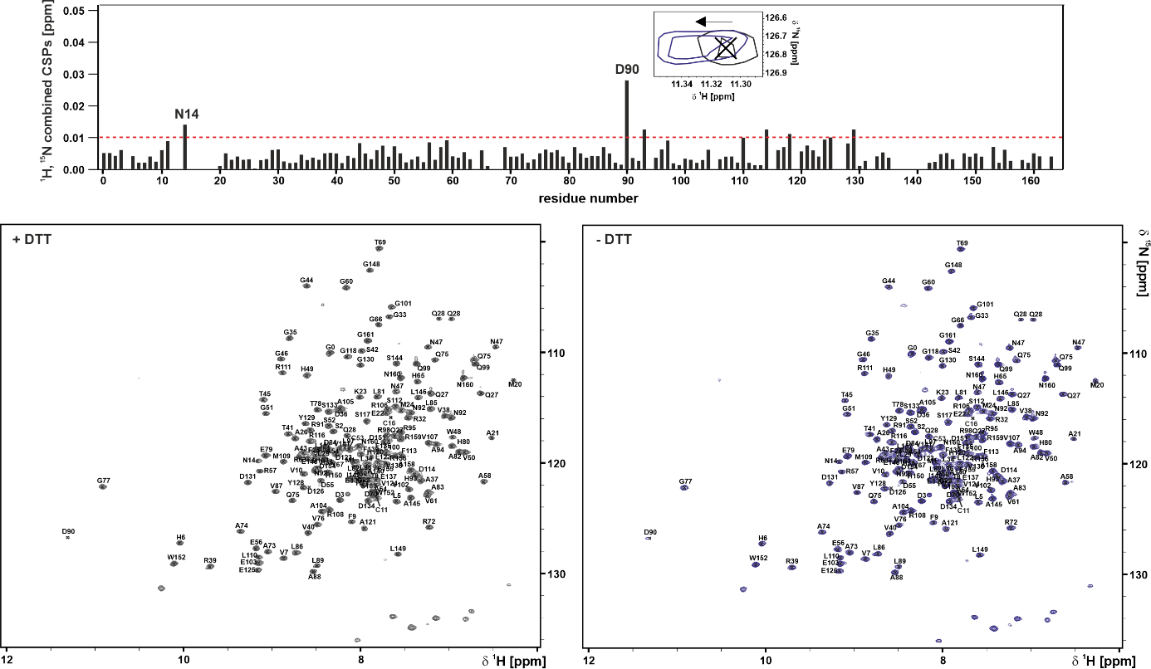
Fig. S2 NMR spectra of MptpA at non reducing conditions.2D-(¹H,¹⁵N)-HSQC spectra of MptpA measured in presence (left) and absence (right) of DTT. Both spectra look the same for almost all residues, indicating that the removal of DTT from the buffer solution has no effect on MptpA native folding. (on top)Plot of ¹H, ¹⁵N combined CSPs (in ppm) as a function of residue number of MptpA obtained after comparison of 2D (¹H,¹⁵N)-HSQC spectra of MptpA measured in presence and absence of DTT.
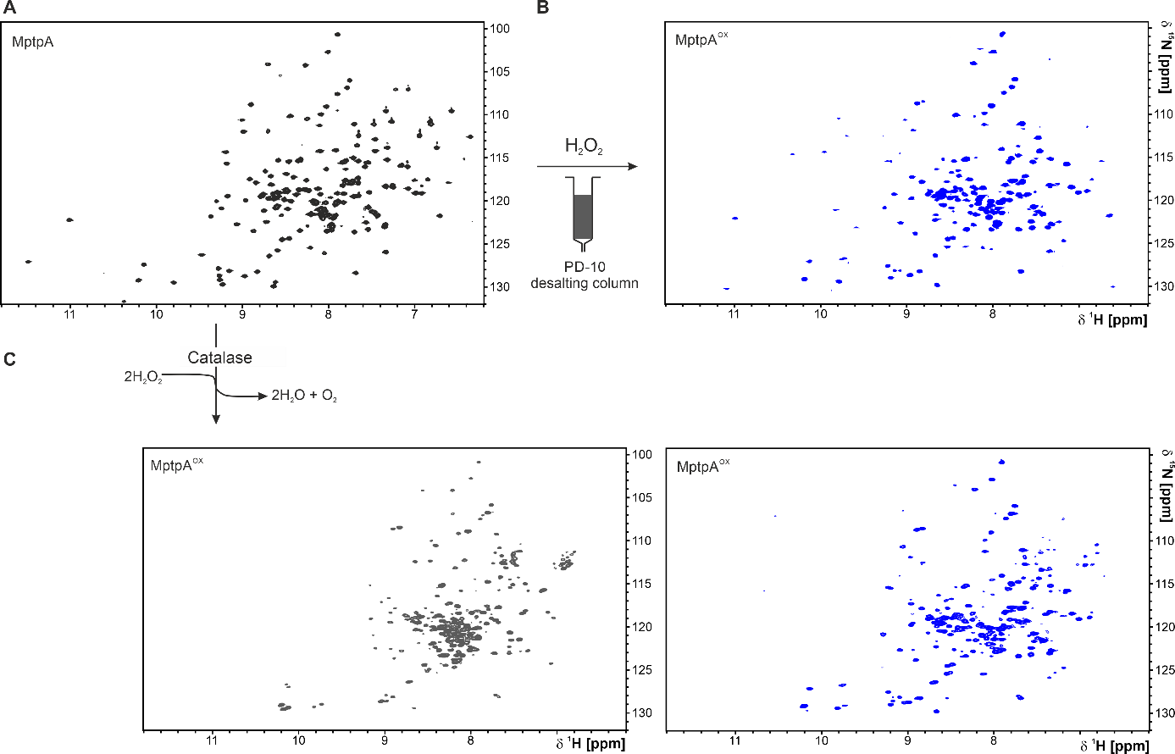
Fig. S3 Oxidative modification of MptpA studied by NMR spectroscopy. A, 2D-(¹H,¹⁵N)-HSQC spectra of MptpA in buffer used for oxidation studies (25 mM HEPES/NaOH, pH 7.0, 150 mM NaCl, 10% D₂O / 90% H₂O). B, 2D-(¹H,¹⁵N)-HSQC spectra of MptpA after incubation with H₂O₂ (50 mM) and NaHCO₃ (25 mM) at 25 °C for 2.5 min and additional gel filtration using PD10 desalting column. contain Sephadex G-25 resin (GE Healthcare). C, 2D-(¹H,¹⁵N)-HSQC spectra of MptpA after treatment with H₂O₂ (50 mM) and NaHCO₃ (25 mM) at 25 °C. The oxidation reaction was quenched using 5u (left) and 50u (right) of catalase (Thermo Scientific™). H₂O₂-decomposition with higher amount of catalase (50u) allowed isolation of uniformly folded oxidized state of MptpA as those observed when using PD10 desalting column.
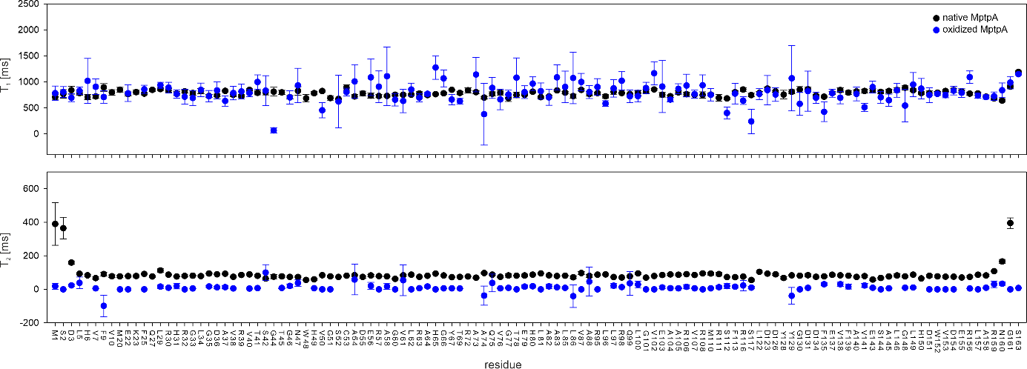
Fig. S4 Backbone dynamics of MptpA. Heteronuclear relaxation studies of MptpA performed using standard heteronuclear ¹⁵N relaxation experiments on the ¹⁵N - uniformly labeled MptpA before and after oxidation with H₂O₂ (50 mM) and NaHCO₃ (25 mM). The obtained relaxation rates of ¹⁵N-T₁ (top) and ¹⁵N-T₂ (bottom) of the native and oxidized MptpA are similar. The T₁ longitudinal ¹⁵N relaxation rates were determined from spectra with different delays of 10, 100, 400, 600, 800, 1000, 1200 and 1500 ms. T₂ transverse ¹⁵N relaxation rates were determined using the following delays: 33.92, 67.84, 101.76, 135.68, 169.6, 203.52, 237.44, and 271.36 ms.
Materials and Methods

Table 1 Buffers used for purification of MptpA.

Loading buffer | 50 mM Tris/HCl (pH 8.0), 300 mM NaCl,  5 mM DTT, 50 mM Imidazole
Dialysis buffer | 50 mM Tris-HCl (pH 8.0), 300 mM NaCl,  5 mM DTT
Elution buffer | 50 mM Tris/HCl (pH 8.0), 300 mM NaCl,  5 mM DTT and 500 mM Imidazole
NMR-buffer | 25 mM HEPES/NaOH buffer (pH 7.0),  150 mM NaCl

M9-aa-expression medium
Modified M9 medium containing unlabeled L-amino acids: 0.1 g asparagine, 0.4 g alanine, 0.4 g arginine, 0.25 g aspartic acid, 0.05 g cysteine, 0.4 g glutamine, 0.4 g glutamic acid, 0.4 g glycine, 0.1 g histidine, 0.1 g isoleucine, 1.0 g leucine, 0.1 g lysine hydrochloride, 0.05 g methionine, 0.05 g phenyl-alanine, 0.1 g proline, 1.6 g serine, 0.1 g threonine, 0.1 g tyrosine, and 0.05 g valine.

