Supplementary material
Full title: Myocardial Fibrosis and Inflammation by CMR Predict Cardiovascular Outcome in People Living With HIV

Short title: Myocardial Inflammation and Fibrosis and Outcome in HIV

CMR acquisition and postprocessing
Details of acquisition and postprocessing were reported previously(1-3). Standardization of T1-mapping acquisition on Siemens platform was performed prior to the onset of patient recruitment. Comparability and reproducibility of measurements were determined at each location for each field strength. All subjects underwent a standardized CMR protocol for routine assessment of cardiac volumes, mass and LGE imaging, 3-Tesla (T) scanner equipped with advanced cardiac software on Siemens Skyra with 6 channel coil (Skyra, Siemens Healthineers, Erlangen, Germany, Software Version VE11).

Sequence parameters:
- Cine imaging was performed using a balanced steady-state free precession sequence in combination with parallel imaging (SENSitivity Encoding, factor 2) and retrospective gating during expiratory breath- hold (TE/TR/flip-angle: 1.7ms/3.4ms/60°, spatial resolution 1.8x1.8x8 mm), as a gapless short axis (SAX) stack for assessment of cardiac volumes and function, or single slice long-axis views (2-chamber, 3-chamber, and 4 chamber view).
- Myocardial perfusion was performed after a Regadenosone bolus (400mcg/5ml iv.) during the delivery of gadolinium-based contrast agent (GBCA, gadobutrol 0.1mmol/kg, Gadovist®, Bayer, Leverkusen, Germany) at 3 ml/s by an injector pump using a dual bolus delivery scheme (the first bolus with 5%, the second bolus with 100% GBCA, both followed by chaser of 20ml saline, with a break of 15 between two boluses) (4, 5). Three short axis views, defined at 25%, 50% and 75% of end-systolic length of the left ventricle in the 3 and 4-chamber view were acquired at every heartbeat (6). Sequence parameters include steady-state free precession sequence, TE/TR/flip-angle 2.0/3.5/35-50°, saturation preparation pre-pulse, 100ms pre-pulse delay, typical acquired resolution of 2.5×2.5×8mm.
- LGE imaging was performed using whole heart coverage of SAX slices ~15 minutes after administration of above bolus of 0.1 mmol gadobutrol/kg body weight (Gadovist®, Bayer, Leverkusen, Germany), using a mid-diastolic inversion prepared 2-dimensional gradient echo sequence (TE/TR/flip-angle 2.0 msec/3.4 msec/25°, acquired voxel size 1.4x1.4x8mm) with an individually adapted prepulse delay to achieve optimally nulled myocardium.
- T1 mapping: Balanced steady state free precession single breath-hold modified Look-Locker Imaging (Goethe CVI® MOLLI) was used for T1 mapping and performed in a single midventricular SAX slice at mid-diastole, prior to contrast administration, respectively (TE/TR/flip-angle: 1.64msec/3.3msec/50°, acquired voxel size 1.8x1.8x8 mm, phase encoding steps n=166, 6/8 half scan, 11 images corresponding to 3 different inversion times using a nonselective 180° prepulse in an algorithm of n-images/n-beats 3(2)3(2)5 MOLLI scheme(1). T1 mapping sequence examcards used in this study have been published previously(1).
- T2-prepared SSFP pulse sequence (T2-FLASH)(7): A T2-prepared steady-state free precession sequence was used to generate three T2W images with different T2 preparation times (TE T2P = 0 ms, 24 ms, 55 ms). Other sequence parameters include repetition time 3 × RR, acquisition time 7xRR, image matrix 96 × 160, echo spacing (ms) 2.6, single shot acquisition, flip angle 40°, bandwidth 1488, parallel acquisition (acceleration) GRAPPA 2.

Image analysis
Assessment of cardiac volumes and LV mass was performed using semi-automated contour detection (SuiteHeart®, Neosoft, Pewaukee, WI). Endocardial LV borders were traced at end-diastole and end-systole. The papillary muscles were included as part of the LV cavity volume. LV end-diastolic (EDV) and end-systolic (ESV) volumes were determined using rule of discs. Ejection fraction (EF) was computed as EDV-ESV/EDV. All volumetric indices were normalized to body surface area (BSA).
All patients are informed about the importance of their breath holding before scanning, specifically for mapping acquisitions. We conduct strict quality control of images routinely while scanning, by inspecting any breathing motion during data acquisition, assessing the quality of the maps during the acquisition, by examining the measurements, the mean, max and min values within the ROI to avoid blood contamination, etc. All staff at our institution undergo extensive training in CMR scanning and in acquisition of mapping techniques in particular.
T1 and T2 measurements were performed conservatively within the septal myocardium (ConSept) in a midventricular short axis (SAX) slice outside the area of LGE, as previously described and validated(1-3). The main reason for the choice of septum, the main being the most stable part of the myocardium with as little influenced by the surrounding tissues. As such the likelihood of inclusion of voxels affected by tissues other than myocardium (such as blood pool, epicardial fat, lung) is minimized. The quality of the motion correction and co-registration of the inline maps was verified on-the scanner and if unsatisfactory, the acquisition was repeated by asking the patient to hold breath. Manual motion correction by propagating the septal ROI through the 11 images, followed by the manual image co-registration was performed if not resolved by means above. In patients with post-infarction scar in septal myocardium, mapping measurements were performed in remote myocardium elsewhere within the midventricular SAX slice, avoiding the artefact-prone lateral wall. All acquisitions that cannot be resolved by improved acquisition are postprocessed by manual motion correction of the ROI in 11 images.
The readers of the core lab are highly trained postdoctoral students that have achieved within 2 % intra-individual and within 3 % interrater variability for T1 and T2 mapping measurements and within 5% and 8% for LGE FWHM, respectively, against a set of the gold-standard measurements. The measurements are performed in line with local standard operating procedures, and the core lab is subjected regularly to quality assurance procedures. Blood lab of University Hospital Frankfurt employs usual analytical quality assurance procedures.
Myocardial perfusion defect was classified as significant/relevant myocardial ischemia according to the presence of regional hypoperfusion in 2 segments of a 32 segment model (8), (5), i.e:
- 60 degrees in either the basal or the midventricular slices or
- 90 degrees in the apical slice or
- any transmural defect or
- two adjacent slices.
LGE was quantified by a semiautomatic detection method using a previously validated method of full-width at half maximum (FWHM) and reported as a percentage of total LV mass(9).
Systematic Coronary Risk Score Evaluation (SCORE) is the European cardiovascular disease risk assessment model, which is based on a large data set tested thoroughly on European data. It operates with hard, reproducible end points (CVD death)(10).
Endpoint definitions
Cause of death was established from a combination of death certification, available postmortem data, patients’ physicians and review of medical records for patients who died while hospitalized. Mode of death was classified according to a modified Hinkle-Thaler system(13). Sudden cardiac death (SCD) was defined as unexpected death either within 1 hour of cardiac symptoms in the absence of progressive cardiac deterioration, during sleep, or within 24 hours of last being seen alive. HF death was defined as death associated with unstable, progressive deterioration of pump function despite active therapy. Aborted SCD was diagnosed in patients who received an appropriate implantable cardioverter-defibrillator (ICD) shock for ventricular arrhythmia or had a documented nonfatal episode of ventricular fibrillation or spontaneous sustained ventricular tachycardia (>30 seconds in duration) causing hemodynamic compromise and requiring cardioversion. Primary endpoint events were adjudicated by independent physicians, with no access to the information on the T1 mapping imaging results.
A uni- and multivariable Cox proportional hazards model was used for analyzing predictive associations of variables with the outcome. Univariable Cox regression models was fitted for each continuous to test the assumption of linearity with the outcome. The proportional hazards assumption required by the Cox model was investigated by examining time-dependent behaviour of the variables (either continuous or in binary categorisation) looking for interaction with time in the analysis. All variables returned as non-significant for interaction with time, suggesting that it is not necessary to treat any of the covariates as time-dependent in the model. Kaplan-Meier curves are used for visualizing the cumulative event free survival. A log-rank test was performed to compare event free survival curves in subjects for dichotomized variables.
Multi-collinearity/interdependency of variables (and overfitting) in multivariate analyses was minimized/avoided by accounting for the rule of thumb for Cox models with a minimum of 10 outcome events per predictor variable, by the use of clinical scores, which integrate a number of similar clinical parameters, allowing us to represent these in a more condensed fashion.

Post-hoc power analyses were performed as comparisons of the rates for increased T1 or T2 in patients with events versus those without using Post-hoc Power Calculator (http://clincalc.com/Stats/Power.aspx).
Post hoc power analysis for T1:
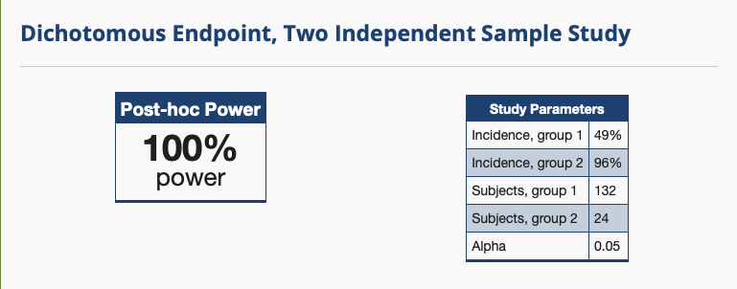
Post hoc power analysis for T2:
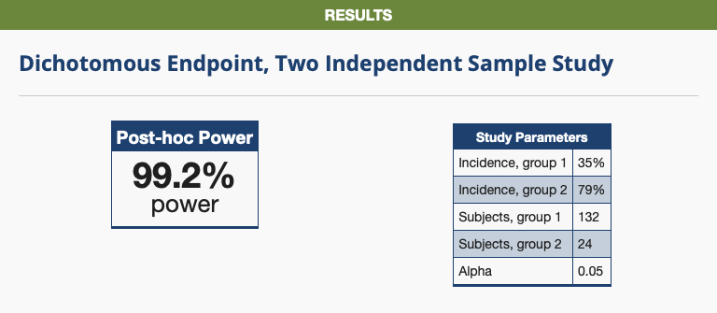

Figures 1S. The added explainability of the predictive association with outcome. Chi-Sq values of the Cox regression models that incrementally included other clinical variables in addition to native T1 (A), including blood markers (hsTropT, NTproBNP) and LVEF and LGE. Plot B examines the added value of cardiovascular prediction scores (B). D:A:D, data collection on adverse effects of anti-HIV drugs; HIV; human immunodeficiency virus; FRS – Framingham Risk Score, Meta‐Analysis Global Group in Chronic (MAGGIC) Heart Failure Risk Score.
A

B

References:
1. Puntmann VO, Carr-White G, Jabbour A, et al. T1-Mapping and Outcome in Nonischemic Cardiomyopathy. JACC Cardiovasc Imaging 2016;9:40–50.
2. Dabir D, Child N, Kalra A, et al. Reference values for healthy human myocardium using a T1 mapping methodology: results from the International T1 Multicenter cardiovascular magnetic resonance study. Journal of Cardiovascular Magnetic Resonance 2014;16:34.
3. Rogers T, Dabir D, Mahmoud I, et al. Standardization of T1 measurements with MOLLI in differentiation between health and disease – the ConSept study. Journal of Cardiovascular Magnetic Resonance 2013;15:78.
4. Ishida M, Schuster A, Morton G, et al. Development of a universal dual-bolus injection scheme for the quantitative assessment of myocardial perfusion cardiovascular magnetic resonance. Journal of Cardiovascular Magnetic Resonance 2011;13:73.
5. Hussain ST, Paul M, Plein S, et al. Design and rationale of the MR-INFORM study: stress perfusion cardiovascular magnetic resonance imaging to guide the management of patients with stable coronary artery disease. Journal of Cardiovascular Magnetic Resonance 2012;14:1503.
6. Haslbauer J et al, JCMR 2018, April 2018, V964., Clin Res Cardiol 107, Suppl 1, April 2018,
7. Giri S, Chung Y-C, Merchant A, et al. T2 quantification for improved detection of myocardial edema. Journal of Cardiovascular Magnetic Resonance 2009;11:56.
8. Nagel E, Greenwood JP, McCann GP, et al. Magnetic Resonance Perfusion or Fractional Flow Reserve in Coronary Disease. New England Journal of Medicine 2019;380:2418–2428.
9. Thiele H, Kappl MJE, Conradi S, Niebauer J, Hambrecht R, Schuler G. Reproducibility of Chronic and Acute Infarct Size Measurement by Delayed Enhancement-Magnetic Resonance Imaging. J. Am. Coll. Cardiol. 2006;47:1641–1645.
10. Conroy RM, Pyörälä K, Fitzgerald AP, et al. Estimation of ten-year risk of fatal cardiovascular disease in Europe: the SCORE project. 2003;24:987–1003.
11. Winau L, Hinojar Baydes R, Braner A, et al. High-sensitive troponin is associated with subclinical imaging biosignature of inflammatory cardiovascular involvement in systemic lupus erythematosus. Annals of the Rheumatic Diseases 2018;77:1590–1598.
12. Puntmann VO, Carerj ML, Wieters I, et al. Outcomes of Cardiovascular Magnetic Resonance Imaging in Patients Recently Recovered From Coronavirus Disease 2019 (COVID-19). JAMA Cardiol. 2020 Jul 27:e203557
13. Gulati A, Jabbour A, Ismail TF, et al. Association of Fibrosis With Mortality and Sudden Cardiac Death in Patients With Nonischemic Dilated Cardiomyopathy. JAMA 2013;309:896.

