Supplemental Information
Study 1 Rule Out Questionnaire. The specific questions used in the Rule Out Questionnaire are as follows:
(1) I have experienced stressful events in the past
(2) I am currently distressed by a stressful event
(3) I am aware that this survey will ask me to reflect on a stressful event I have experienced in the past. Traumatic events are not a focus of the study
(4) I have experienced a traumatic event
Participants who answered the following to at least one of the above questions (1.False, 2.True, 3. False, 4.True) were excluded from participation and immediately viewed an exit page which encouraged them to engage in a calming activity, reach out to trusted friends/family or local health providers, and provided information regarding crisis resources.

Study 2 Rule Out Questionnaire. The specific questions used in the Rule Out Questionnaire are as follows:
(1) I have experienced stressful events in the past
(2) I am currently distressed by a stressful event
(3) I am aware that this survey will ask me to reflect on a stressful event. I understand I can leave the survey at any time.
(4) I have experienced a traumatic event
Participants who answered the following to at least one of the above questions (1.False, 2.True, 3. False, 4.True) were excluded from participation and immediately viewed an exit page

Table S1
Full Initial Category Lists for Qualitative Data
Topic | Type of Stressor | Subjective Resilience | Helpful
Categories† | Safety  Natural Disaster  Discrimination  Unexpected event | Active coping  Keep up everyday life  Positive mindset  Altruism  Religiosity  Giving social support  Foresight  Calm down and focus  Cohesion to a social group  Situation normalizes  Bounce back  Received Social Support  Hope  Resilience from others  Humor  Self-definition  Fighting it out/biting through it  Getting back to normal  Recovery  Help  Friendship/family  Time frame (if stated) | Nothing  Counseling services  Financial resources  Foresight/ Planning  Proper training before/ Experience  Living closer together/ Contact to someone with experience in this situation/ Communication/ Counseling services  Different time  Successful Initial Treatment  Experience  Do not do again  Wishful thinking
†Includes all suggested initial categories, prior to combining similar categories
Table S2. Study 2 Correlation Table
 | 1 | 2 | 3 | 4 | 5 | 6 | 7 | 8 | 9 | 10 | 11 | 12 | 13 | 14 | 15 | 16 | 17 | 18 | 19 | 20 | 21
1. FLCRS | -
2. BRS | .39* | -
EXITS
3. Before | .17* | .1 | -
4. After | .48* | .27* | .18* | -
5. New | .26 | .11 | .43* | .30* | -
COPE
6. Distraction | .04 | -.15 | .11 | -.02 | .23* | -
7. Active Coping | .27* | .24* | .00 | .32* | .15 | -.16 | -
8. Denial | -.18* | -.23* | .12 | -.25* | .07 | .25* | -.42* | -
9. Substance Use | -.18* | -.20* | .04 | -.13 | -.02 | .26* | -.38* | .38* | -
10. Emotional Support | .32* | .00 | .23* | .2* | .20* | .39* | .24* | .04 | -.1 | -
11. Instrumental Support | .28 | .06 | .21* | .32* | .21* | .16 | .32* | -.03 | -.16 | .61* | -
12. Behavioral Disengagement | -.19* | -.19* | .04 | -.28* | -.12 | .33* | -.55* | .52* | .47* | .01 | -.12 | -
13.Venting | -.04 | -.21* | .08 | .03 | -.01 | .23* | -.08 | .34* | .33* | .24* | .19* | .22 | -
14.Positive Reframe | .25* | .27* | .11 | .09 | .30* | .36* | .23* | .05 | .03 | .31* | .11 | .01 | -.02 | -
15. Planning | .3* | .22* | -.04 | .30* | .12 | -.12 | .73* | -.47* | -.42* | .23* | .27* | -.47* | -.15 | .15 | -
16. Humor | .14 | .06 | .06 | .05 | .08 | .25* | -.13 | .06 | .33* | .08 | .09 | .27* | .17* | .24* | -.12 | -
17. Acceptance | .32* | .32* | -.03 | .32* | .10 | -.00 | .47* | -.34* | -.27* | .19* | .27* | -.31* | -.10 | .29* | .54* | .14 | -
18. Religion | .12 | .09 | .23* | -.1 | .23* | .26* | -.05 | .27* | .07 | .21* | .13* | .21* | .06 | .44* | -.05 | .04 | -.01 | -
19. Blame | -.17* | -.32* | .14 | -.23* | .01 | .30* | -.52* | .52* | .6* | .03 | -.13 | .56* | .34* | .01 | -.46* | .25* | -.33* | .13 | -
PANAS
20. Positive Affect | .07 | .19* | .12 | .13 | .19* | -.05 | .09 | -.07 | .01 | -.03 | -.03 | .02 | -.08 | .33* | .19* | .00 | .12 | .22* | -.03 | -
21.Negative Affect | -.24* | -.38* | .11 | -.16 | .01 | .21* | -.05 | .36* | .27* | .25* | .17 | .14 | .37* | -.03 | -.1 | .01 | -.19* | .00 | .37* | -0.19 | -
Note: FLCRS = Fletcher-Lyons Collective Resilience Scale, BRS = Brief Resilience Scale, EXITS = Exeter Identity Transitions Scale , COPE = Adapted Brief Cope Inventory, PANAS= Positive and Negative Affect Schedule,,
*p < .05

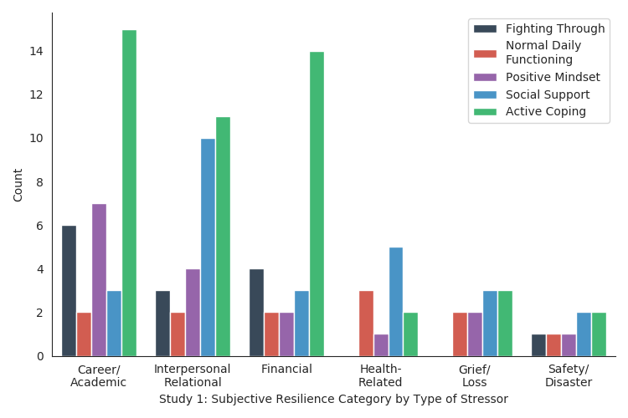
Figure S1: Study 1 Subjective resilience category by type of stressor identified

