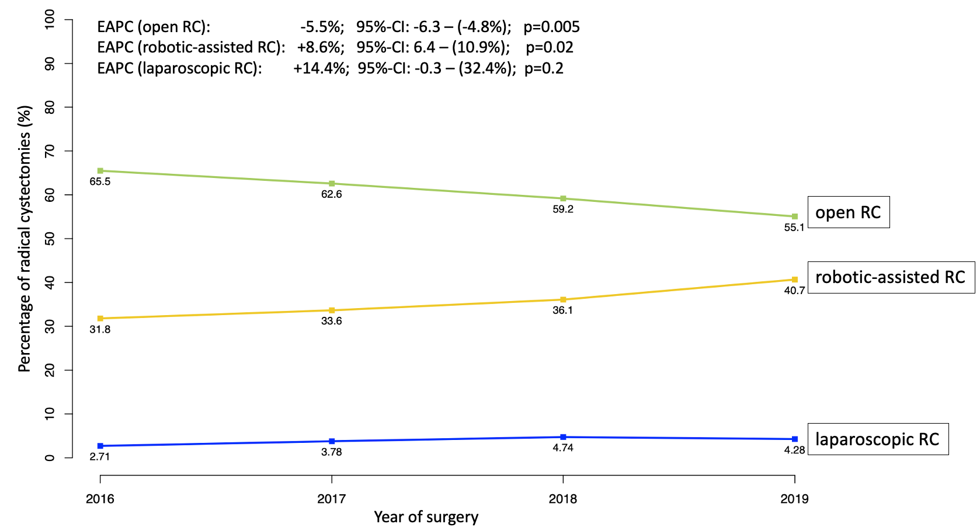

Abbreviations: EAPC= Estimated annual percentage change; RC= Radical cystectomy; 95%-CI=95%-Confidence interval;

