Appendix S1: Prediction of floral resource landscapes.
This Appendix describes how plant functional traits were measured and how they entered trait-based models of sugar amount per inflorescence and flowering phenology, reports the trait effects detected by these models, and describes how the floral resource-landscapes predicted by these models were phenology-averaged for use in the seed set analyses.

Trait measurements
Plant size was measured as the aboveground canopy height. Trunk length to first branching was measured from the ground to the first branching node. To determine specific leaf area (SLA) we placed at least five fresh leaves per plant in plastic bags and scanned them with an area meter LI-COR LI 3100C. Thereafter we dried the leaves for 3 days in an oven at 60°C to determine the leaf dry mass with a high precision scale. Inflorescence length was measured from the base to the top of the inflorescences of a subsample of at least 20 individuals per species. For all inflorescences from which nectar was sampled, we estimated the proportion of open florets. Cone mass was measured with a high precision scale.

Trait based models of sugar amount per inflorescence and flowering phenology
The trait-based models for sugar amount per inflorescence and the phenology of flowering inflorescences included the following functional traits: resprouting ability (Rebelo 2001), plant size, trunk length to first branching, SLA, inflorescence size and cone mass. All traits were averaged per population except plant size (for which we used individual-level measurements) and resprouting ability (which is a species-level trait).
For analyses of sugar amount per inflorescence we used linear mixed-effects models with crossed random effects of site and species identity. All analyses were performed in R 3.0.1 (R Core Team, 2013) using package lme4 (Bates et al. 2013). To correct for temporal variation in sugar amounts, we included linear and quadratic effects of the proportion of flowering florets (as a measure of flowering status) and the hour of inflorescence sampling. This model was then simplified by stepwise-backward variable selection (Crawley 2007) omitting all variables with P > 0.05. .
Analyses of the phenology of inflorescence number used generalized linear mixed models with Poisson errors (R-package lme4, Bates et al. 2013). In addition to the interactions between plant size and the other functional traits mentioned above (which were used to predict maximal inflorescence number), the maximal model for inflorescence number included the interaction of species identity with the squared time difference between the day on which inflorescences were censused and the species’ peak flowering day (thus describing species-specific flowering phenologies). The peak peak flowering day for each species (Table S1) was obtained from phenological information for populations in our study region that is provided by the Protea Atlas Project (Rebelo 2001).

Trait effects on sugar amount per inflorescence and flowering phenology
The minimal adequate model for sugar amount per inflorescence includes a positive effect of inflorescence size (χ²_{1 df} = 29.1, p<0.001) and a humped-shaped effect of the proportion of open florets per inflorescence, where young and old inflorescences had lower sugar content than middle-aged inflorescences (χ²_{1 df} = 43.7, p<0.001). The minimal adequate model of phenology (number of inflorescences per plant individual) estimated negative effects of squared time difference for all species and thus described hump-shaped flowering phenologies with widths varying between species (see Table S1). The model also included SLA as well as interactions of plant size with trunk length to first branching, sprouting ability and inflorescence size. Plant size had a positive effect and its interaction with trunk length to first branching and inflorescence size was also positive (χ²_{1 df} = 37.6, p<0.001; and χ²_{1 df} = 22.2, p<0.001, respectively), additionally the effect of interactions of plant size with sprouting ability had a negative effect (χ²_{1 df} = 4.5, p<0.05). In addition SLA shows a negative effect (χ²_{1 df} = 4.8, p<0.05). The validation of this phenology model with independent data on the sums of flowering inflorescences on focal plants per species and site showed that this model has high predictive power (Fig. S1). Hence, we used the phenology and inflorescence sugar models to predict temporal variation in plant sugar amounts of all mapped Protea plants.
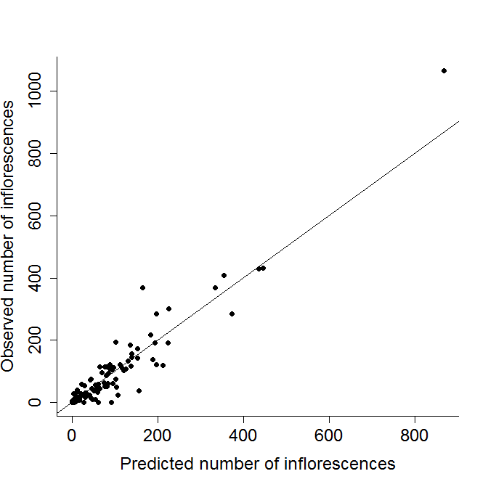
Figure S1: Validation of the trait-based model for flowering phenology. The figure plots observed sums of flowering inflorescences on focal plants per species, site and date of observation versus corresponding predictions of the phenology model. The line shows the 1:1 identity.

Table S1: Flowering phenology of the 19 studied Protea species as described by the trait-based model for the number of flowering inflorescences. This model describes the phenology of the number of flowering inflorescences as proportional to a normal probability density function with mean μ (the peak flowering day) and standard deviation σ (determining the extent of the flowering period).
Species | Peak flowering day, µ (day of year) | Extent of flowering period, σ
Protea acuminata | 206 | 18.66
Protea burcchelii | 215 | 59.41
Protea coronata | 152 | 23.13
Protea compacta | 203 | 81.99
Protea cynaroides | 145 | 77.13
Protea eximia | 282 | 82.60
Protea laurifolia | 202 | 58.37
Protea lepidocarpodendron | 188 | 60.61
Protea longifolia | 189 | 44.04
Protea lorifolia | 181 | 77.40
Protea magnifica | 296 | 43.17
Protea mundii | 108 | 27.53
Protea nana | 240 | 57.15
Protea neriifolia | 184 | 194.29
Protea nitida | 197 | 28.86
Protea obtusifolia | 192 | 80.64
Protea punctata | 85 | 44.24
Protea repens | 179 | 47.57
Protea susannae | 110 | 66.71

Calculation of phenology-averaged properties of floral resource-landscapes
Seed set integrates over the entire flowering period of an inflorescence and thus over temporally varying floral resources X_{j} of another plant j in the community. For the seed set analyses, we thus calculated the floral resource amounts of plant j that are experienced by an average inflorescence of focal plant i, $E\left(X_{j}\right)$. To this end, we temporally averaged X_{j} weighting by the focal plant phenology $f_{i}\left(t\right)$.
Any property that is proportional to the flowering phenology of plant j, $f_{j}\left(t\right)$, (such as inflorescence number or sugar amount per plant) can be expressed as
$X_{j}\left(t\right)$ =$f_{j}\left(t\right)\frac{max⁡[X_{j}\left(t\right)]}{max⁡[f_{j}\left(t\right)]}$.
The average of $X_{j}$ weighted by the phenology of focal plant i is
$$E\left(X_{j}\right)=\frac{\int_{0}^{365}{X_{j}\left(t\right)f_{i}\left(t\right)dt}}{\int_{0}^{365}{f_{i}\left(t\right)dt}}$$
$=\frac{\max\left[X_{j}\left(t\right)\right]}{\max\left[f_{j}\left(t\right)\right]}\frac{\int_{0}^{365}{f_{j}\left(t\right)f_{i}\left(t\right)dt}}{\int_{0}^{365}{f_{i}\left(t\right)dt}}$ (Eq. 1)

The phenology model (see above) describes flowering phenology as proportional to a normal probability density function $n\left(t;μ,σ\right)$ with mean μ (the peak flowering day) and standard deviation σ (describing the extent of the flowering period). Projecting this phenology model (in which time is centred on the species-specific peak flowering day) to the time interval [0, 365] and assuming (without loss of generality) that $μ ϵ (-\frac{365}{2},\frac{365}{2})$, we obtain the phenology of each plant as a piece-wise combination of two normal PDFs
$f\left(t\right)=\left\{\begin{matrix}n\left(t; μ, σ\right) & t ϵ [0,μ+\frac{365}{2}) \\ n\left(t; μ+365, σ\right) & t ϵ [μ+\frac{365}{2},365]\end{matrix}\right\}$ (Eq. 2)
To calculate the integral $\int_{0}^{365}{f_{j}\left(t\right)f_{i}\left(t\right)dt}$ we make use of the fact that for any time t the product $f_{i}\left(t\right)$ $f_{j}\left(t\right)$is a product of two normal probability density functions $,$which is a function $g\left(t\right)$ that itself is proportional to a normal probability density function.
Since for each plant, $f(t)$ is composed of two normal PDFs with different means (Eq. 2), the integral $\int_{0}^{365}{f_{j}\left(t\right)f_{i}\left(t\right)dt}$ in Eq. 1 has to be calculated as the piecewise sum of integrals over the functions g obtained for $μ_{i} or μ_{i}+365$ and $μ_{j} or μ_{j}+365$.
If $μ_{i} < μ_{j},$
$$\int_{0}^{365}{f_{j}}\left(t\right)f_{i}\left(t\right)dt=\int_{0}^{μ_{i}+\frac{365}{2}}{g\left(t;μ_{i},μ_{j}\right)+\int_{μ_{i}+\frac{365}{2}}^{μ_{j}+\frac{365}{2}}{g\left(t;μ_{i}+365,μ_{j}\right)+\int_{μ_{j}+\frac{365}{2}}^{365}{g\left(t;μ_{i}+365,μ_{j}+365\right)}}}$$
and if $μ_{i}>= μ_{j},$
$$\int_{0}^{365}{f_{j}}\left(t\right)f_{i}\left(t\right)dt=\int_{0}^{μ_{i}+\frac{365}{2}}{g\left(t;μ_{i},μ_{j}\right)+\int_{μ_{i}+\frac{365}{2}}^{μ_{j}+\frac{365}{2}}{g\left(t;μ_{i},μ_{j}+365\right)+\int_{μ_{j}+\frac{365}{2}}^{365}{g\left(t;μ_{i}+365,μ_{i}+365\right)}}}$$
Figure S2: Relationship between variables describing floral resource landscapes. Blue plots show variables used in the pollinator visitation model, red plots show phenology-averaged variables used in the seed set model. The variable names are: var 1= inflorescence number, var 2= sugar amount per inflorescence, var 3= neighbourhood-scale density, var 4= neighbourhood-scale plant purity, var 5= neighbourhood-scale sugar amount, var 6= neighbourhood-scale resource quality, var 7= neighbourhood-scale resource purity, var 8= site-scale sugar density, var 9= site-scale resource quality, var 10= site-scale resource purity.

Video S1: Spatiotemporal dynamics of a floral resource landscape. (A) Map of 16,948 shrub individuals on study site 4 with colours indicating different Protea species (see legend in (B)). (B) Flowering phenologies of the nine Protea species on this site (shown as the number of flowering inflorescences of a median-sized plant). (C) Spatiotemporal dynamics of nectar sugar over the course of one year (date indicated by the grey line in (B)).

References
Bates, D., Maechler, M., Bolker, B. & Walker, S. (2014). lme4: Linear mixed-effects models using Eigen and S4. R package version 1.1-7, URL: http://CRAN.R-project.org/package=lme4. Last accessed 31. March 2015

Crawley, M.J. (2007). The R book. Wiley Publishing, Chichester.

R Core Team. (2015). R: A language and environment for statistical computing. R Foundation for statistical Computing, Vienna, Austria. URL http://www.R-project.org/.

Rebelo, T. (2001). Proteas: field guide to the proteas of South Africa. Fernwood; Global, Vlaeberg; London.

