Supplementary Material

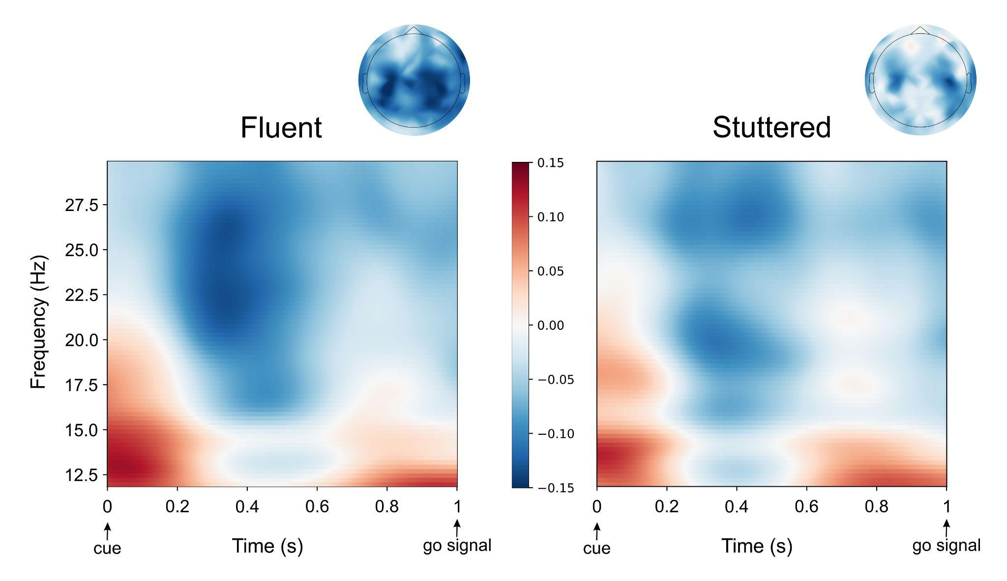

Figure S1. Time-frequency representation for fluent and stuttered trials. Beta-band (12 to 30 Hz) time-frequency representation of fluent (left) and stuttered (right) trials across participants (N = 29). The corresponding topographies are shown above each plot for times between 0.2 and 0.5 seconds after the cue and for frequencies between 22 and 27 Hz.

Whole-brain event-related fields exploratory analysis
In addition to the hypothesis-driven analyses in frequency space, we explored the differences between stuttered and fluent trials in the raw signal, i.e., in their event related fields (ERFs). MEG signals were digitally low-pass filtered at 30Hz using MNE-python’s default parameters with firwin design and epoched between -2700 ms and 500 ms relative to the onset of presentation of the go signal (green asterisk; Fig. 1, main body). Epochs were mean-centered, linearly detrended, and equalized in counts as above so that each participant had the same number of epochs per trial type (stuttered, fluent). We applied each participant’s previously computed inverse model (see Power-spectral density in source space section above) to the average across trials of each condition (i.e., its ERF) and each projection was morphed to a common (fsaverage) space. Finally, we computed the normalized difference between the trial types as (stuttered-fluent)/(stuttered+fluent) before averaging across subjects. To explore differences between the trial types between the cue presentation and the go signal, we performed a series of one-sample cluster-based permutation tests (1000 permutations; two-tailed) across participants (N = 29) with an initial t-threshold equivalent to p < 0.01 and a subsequent cluster threshold of p < 0.05 as before. Specifically, the tests were performed at the whole-brain level (i.e., using all 5124 sources) using a sliding window of 100 ms with a temporal overlap of 50 ms (i.e., sliding forward in increments of 50 ms). Results are reported for clusters that exceeded the p < 0.05 threshold.

Four significant clusters were identified in the times between the cue and go signal presentation (Fig S2): a cluster in the right superior frontal cortex (stuttered > fluent at 200 - 300 ms; p = 0.041) presenting some overlap with the previously identified R-preSMA cluster albeit slightly more anterior (Fig S3); two distinct clusters (both stuttered > fluent at 500 - 600 ms) covering much of the left superior frontal gyrus (p = 0.035) and right anterior dorsolateral prefrontal cortex (p = 0.041); and a cluster (stuttered > fluent at 550 - 650 ms) at the left posterior temporal cortex (p = 0.038).

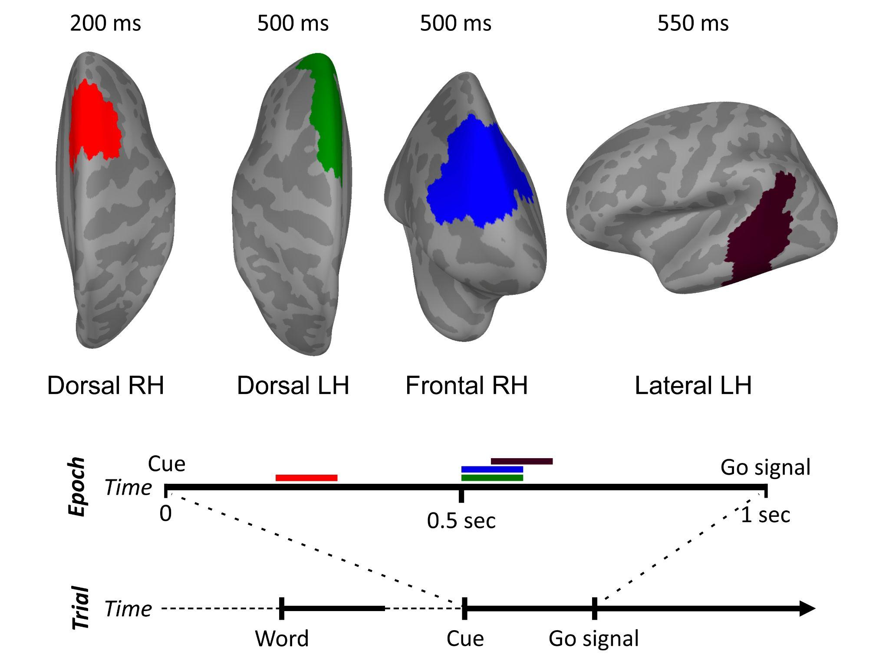

Figure S2. Whole-brain ERF analysis results. The analysis yielded four distinct clusters with greater activity in stuttered compared to fluent trials (p < 0.05). Between 200 and 300 ms after the Cue, there was greater activity for stuttered trials in the right dorsal frontal cortex (red cluster), in a cluster largely overlapping in time and spatial location that identified in the PSD analysis (see main text, Fig. 3, and Fig S3). This was followed by greater activity for stuttered trials between 500 and 600 ms in the left superior frontal gyrus (green cluster) and in the right dorsolateral prefrontal cortex (blue cluster). There was also greater activity for stuttered trials in the left posterior superior and middle temporal cortex (dark violet cluster) between 550 and 650 ms. The timeline of events in the experimental trial and the temporal segment corresponding to the epoched data (0 to 1 second after Cue presentation) are shown below the clusters. The approximate times in which significant differences were found are indicated by horizontal bars with the color of each cluster. RH: Right Hemisphere. LH: Left Hemisphere.

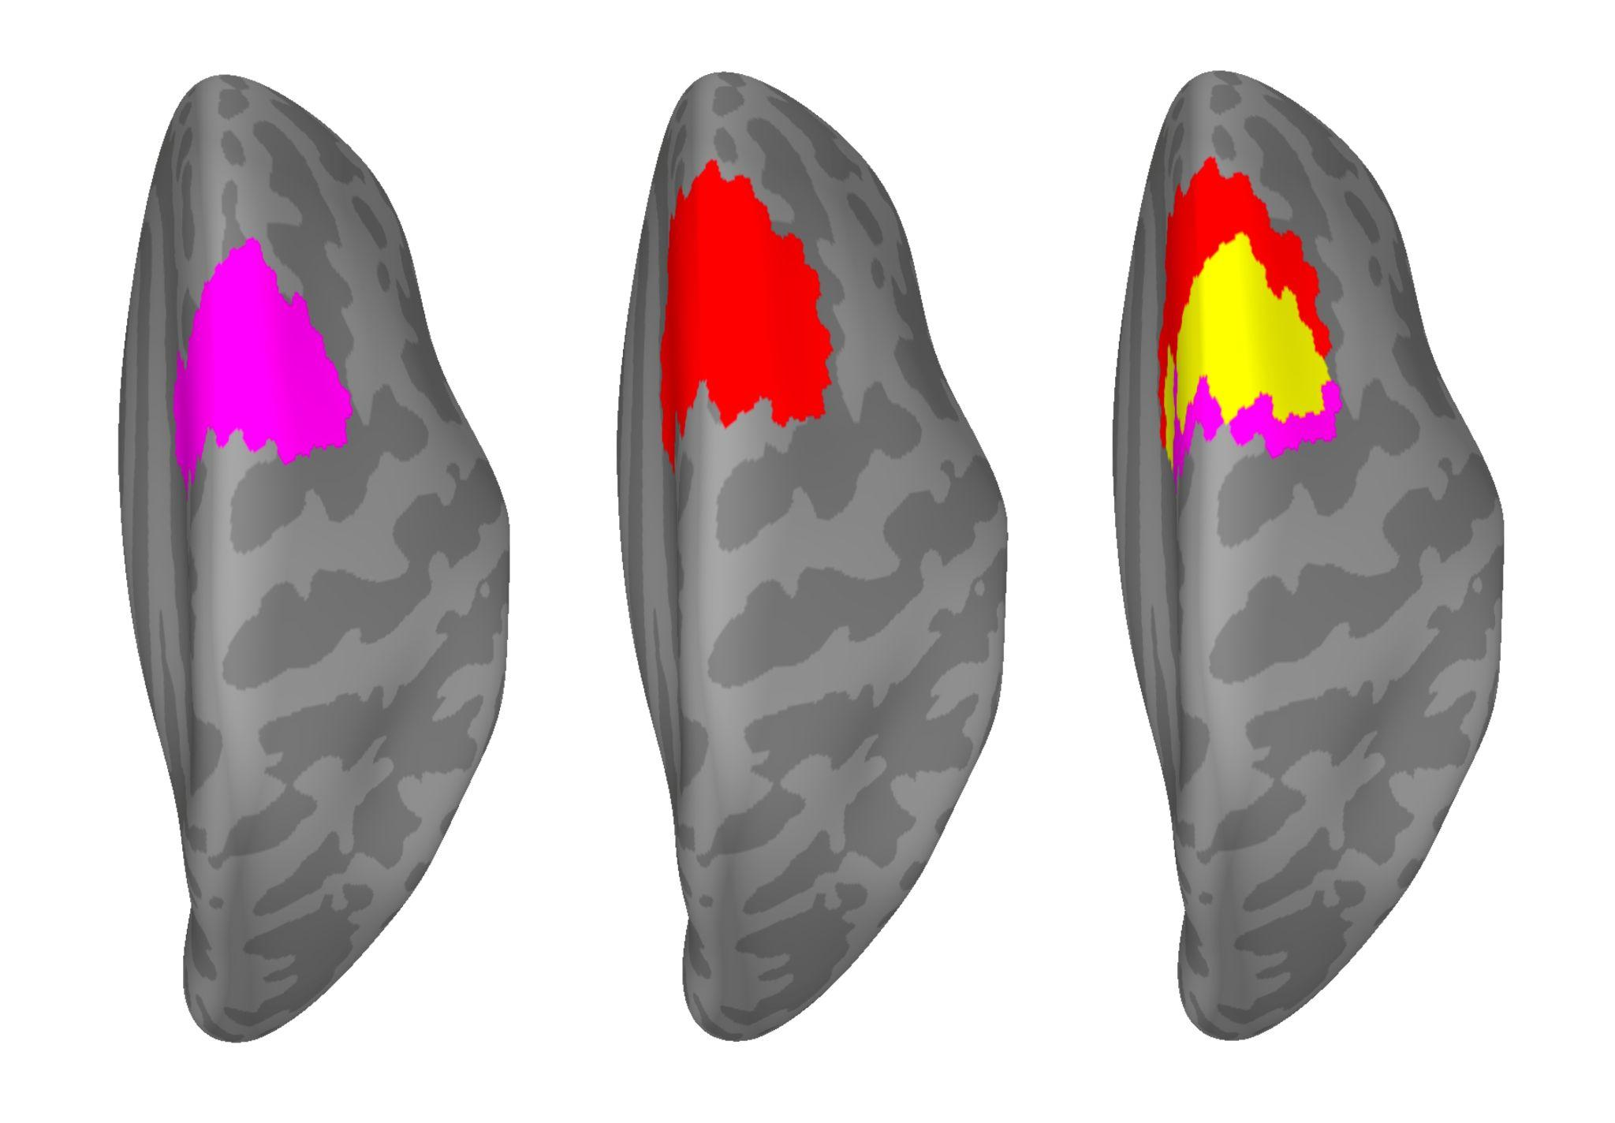
Figure S3. Location and overlap of right superior frontal clusters. R-pre-SMA cluster showing greater beta power between 200 and 500 ms after Cue presentation for stuttered compared to fluent trials (magenta; left). Right superior frontal cluster showing more activity (ERF) between 200 and 300 ms also for stuttered compared to fluent trials (red; middle). The overlap between the two clusters indicates a large shared area (in yellow) and a slightly more anterior location of the ERF cluster. R-preSMA: Right pre-Supplementary Motor Area. ERF: Event Related Field.

