Supplemental Figures

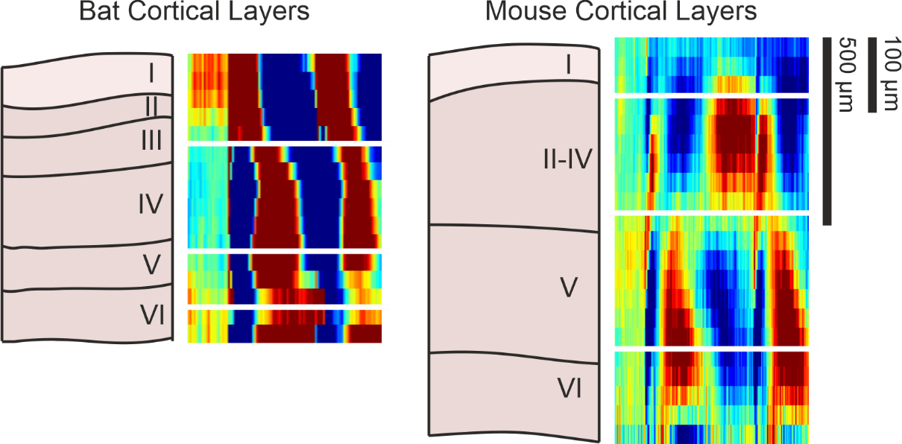
Supp Figure 1 Anatomical comparison; A representation of an A1 columnal section and lines denoting rough layer boundaries were generated based on figures from García-Rosales et al. (2019) for Seba’s short-tailed bat A1 laminar anatomy and from Chang & Kawai (2018) for black 6 mouse A1 laminar anatomy. These are set next to appropriately and relatively sized group average CSD profiles (Figure 1; 1 mm for mice and 750 µm for bats) to show representative layer designations in comparison with these references.

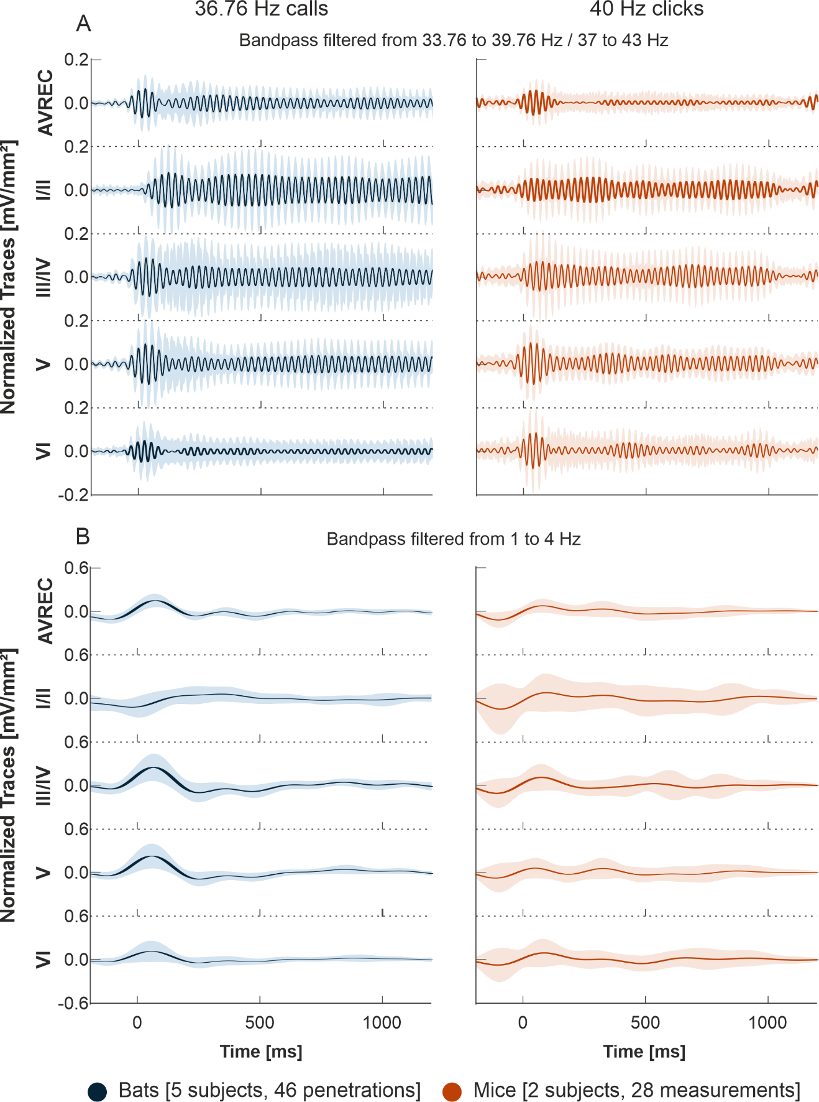
Supp Figure 2 AVREC and layer traces bandpass filtered. A: Bat averaged auditory cortex AVREC trace (top) and all layer traces (I/II, III/IV, V, VI in descending order), in response to 36.76 Hz click-like distress calls (blue) bandpass filtered 3 Hz above and below presentation frequency and C: bandpass filtered from 1 to 4 Hz. B: Mouse averaged auditory cortex AVREC and layer traces, in response to 40 Hz click-trains (orange) ) bandpass filtered 3 Hz above and below presentation frequency and D: bandpass filtered from 1 to 4 Hz. Layer traces were calculated on sink activity only. Confidence intervals are shown in SEM. Traces were all normalized per measurement due to separate penetrations in bat group. Normalization was done before filtering according to the first detected peak of the AVREC at 2 Hz (not shown).

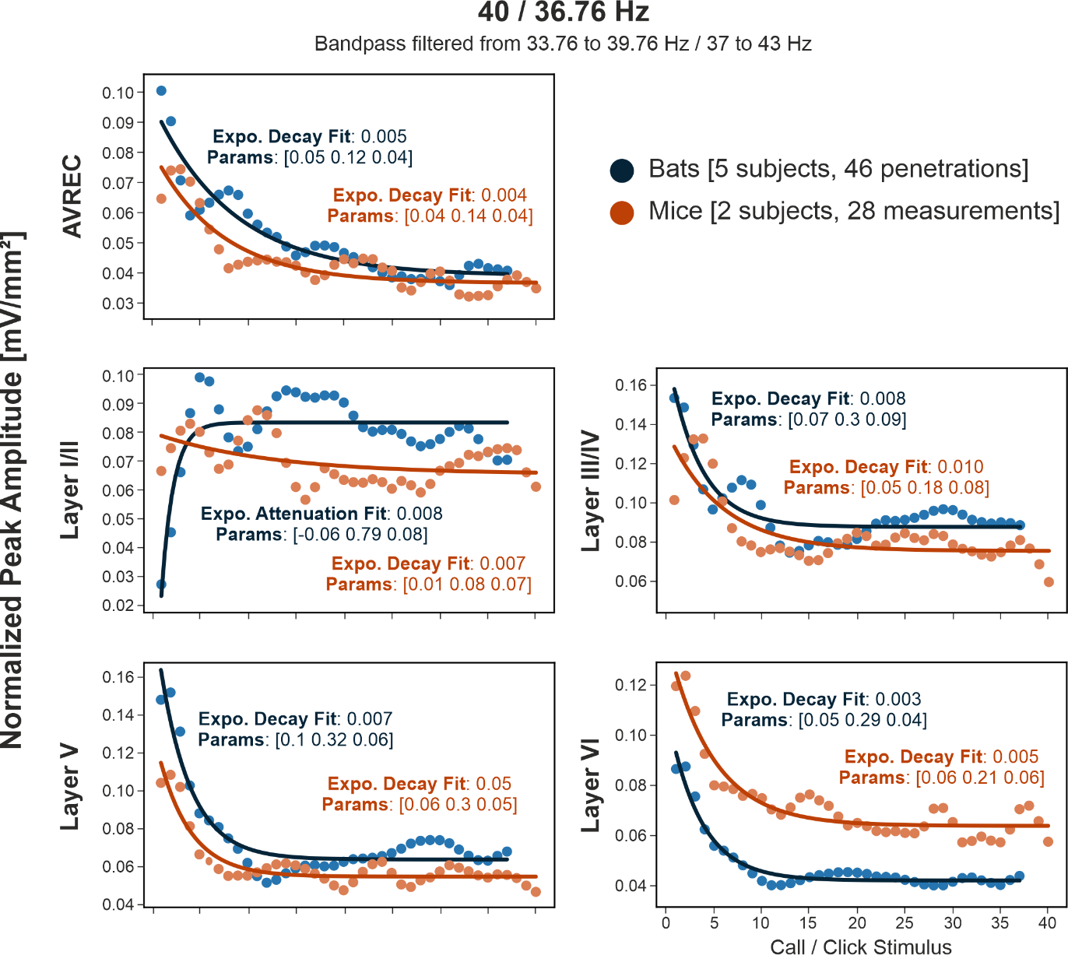
Supp Figure 3 Model Fit Analysis bandpass filtered. Bandpass filtered +/- 3 Hz around the presentation frequency, bat (blue) and mouse (orange) group-averaged response peak amplitudes over consecutive stimulus repetition of 40 or 36.76 Hz with overlaid model fit. The model selected, exponential or linear decay is overlaid, along with the fit value calculated by RMSE and the model parameters. The closer to zero that the model fit is, the better fit it is. For expo.: parameters are [dynamic range, rate of decay, offset]. For linear: [NA]

