Supplementary Information

Tunnel dynamics of quinone derivatives and its coupling to protein conformational rearrangements in respiratory complex I

Jonathan Lasham^{1,*}, Outi Haapanen¹, Volker Zickermann^{2,3}, Vivek Sharma^{1,4,*}

¹ Department of Physics, University of Helsinki, 00014 Helsinki, Finland.
² Institute of Biochemistry II, University Hospital, Goethe University, 60438 Frankfurt am Main, Germany.
³ Centre for Biomolecular Magnetic Resonance, Institute for Biophysical Chemistry, Goethe University, 60438 Frankfurt am Main, Germany.
⁴ HiLIFE Institute of Biotechnology, University of Helsinki, 00014 Helsinki, Finland.

* jonathan.lasham@helsinki.fi
* vivek.sharma@helsinki.fi

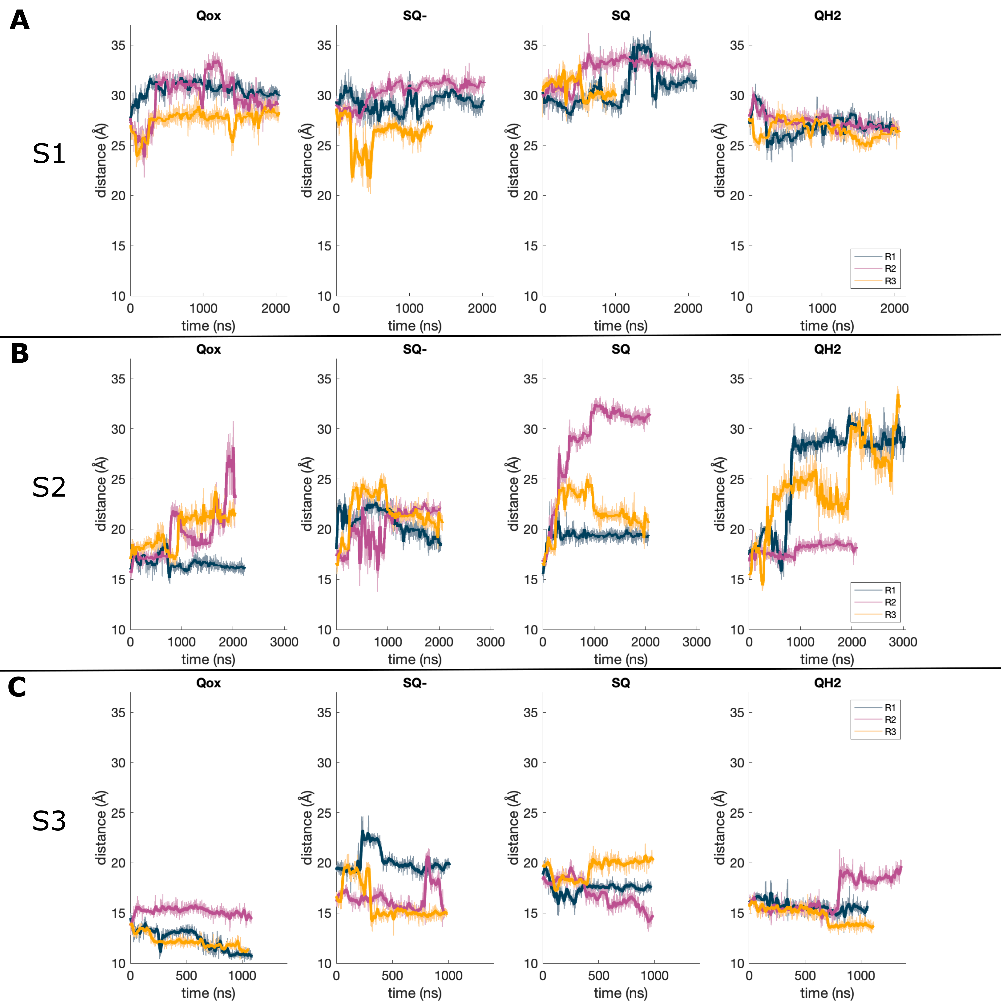
Fig. S1: Distance of Q9 head group center of mass (COM) from N2 cluster COM over time for S1 (A), S2 (B) and S3 (C) simulations. Different simulation replicas are shown in different colours, and the bold line shows a rolling average based on the previous 20 frames.
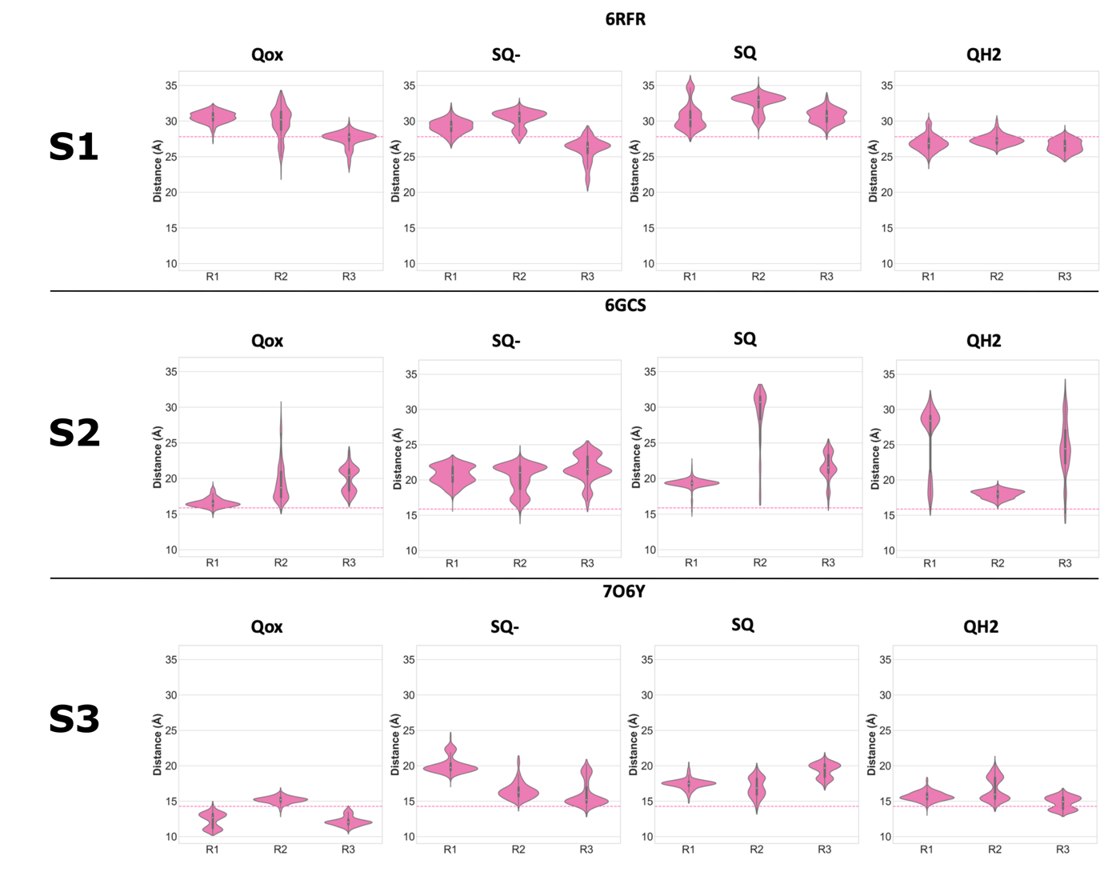
Fig. S2: Violin plots showing the distance of Q9 head group (COM) from N2 cluster (COM) for S1 (A), S2 (B) and S3 (C) simulations for individual simulation replicas. The pink shaded area represents the histogram of data from all trajectory frames for each individual replica. The pink dotted line represents the position of the Q head group observed in the structures.

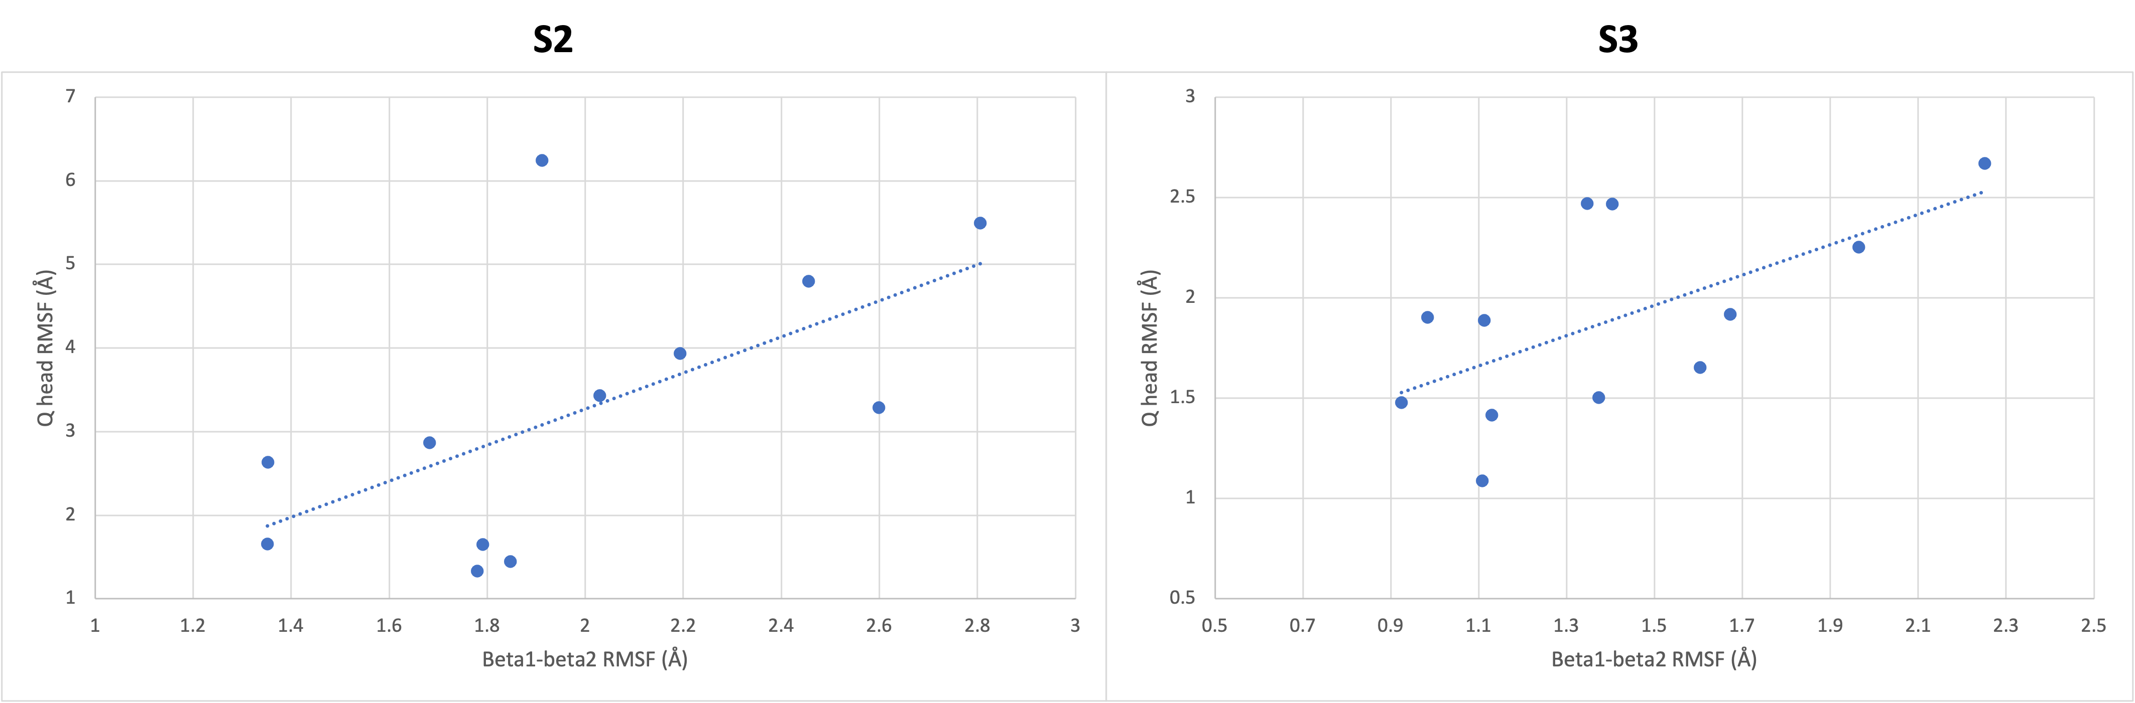
Figure S3 – Scatter plot of RMSF (root mean square fluctuation) values of C_{α} atoms of β1-β2^{NDUFS2} loop and Q head atoms for S2 and S3 simulations.

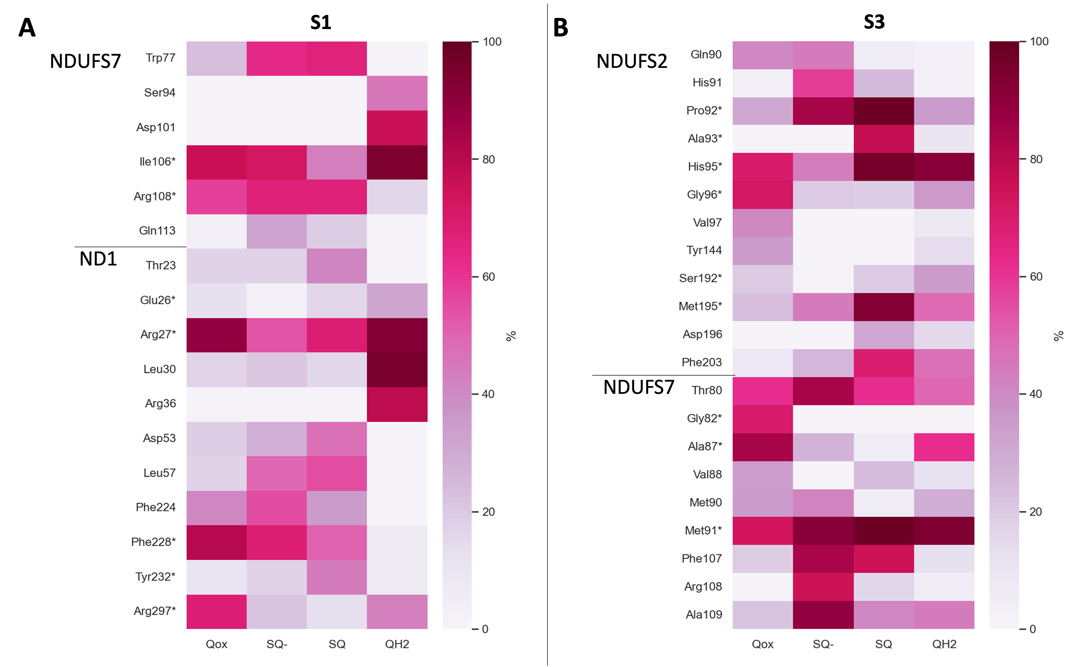
Figure S4 – Interactions between the Q head group and protein residues in S1 simulations based on structure PDB 6RFR (A) and in S3 simulations based on high resolution structure PDB 7O6Y (B). The asterisk (*) denotes interactions between the Q head group and protein residues present in the respective structure.

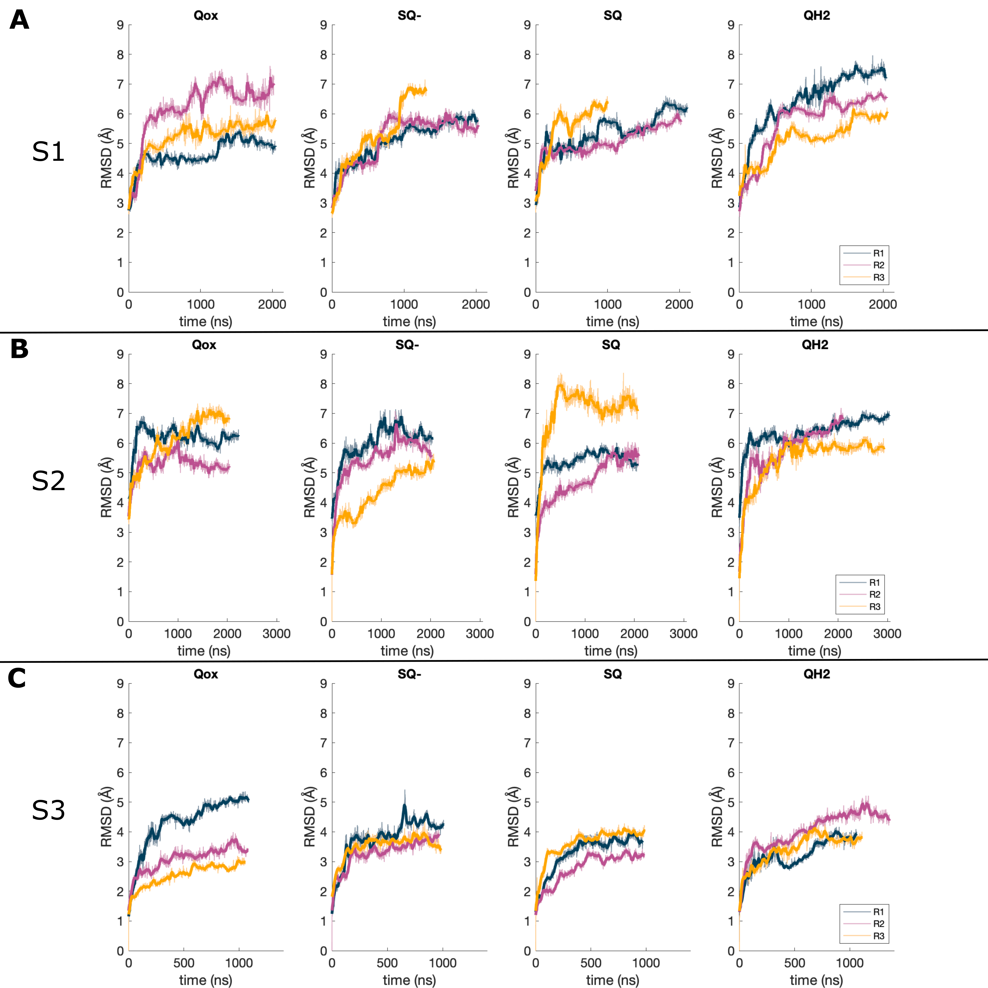
Fig. S5: RMSD (root mean square deviation) of CA atoms over time for S1 (A), S2 (B) and S3 (C) simulations. The RMSD was calculated for all protein C_{α} atoms, for the 6 subunits included in the models (ND3, ND1, NDUFS2, NDUFS3, NDUFS7, NDUFS8). Different simulation replicas are shown in different colours, and the bold line shows a rolling average based on the previous 20 frames.

 |  | Conservation | Mutation data
NDUFS2 | His91 | Conserved | H91A – reduced activity
 | Pro92 | Conserved
 | Ala93 | Partly conserved
 | Ala94 | Partly conserved | A94I – decreased activity
 | His95 | Conserved | H95A – decreased activity
 | Gly96 | Conserved
 | Met195 | Partly conserved | M195F – decreased activity
 | Leu200 | Partly conserved
 | Phe203 | Partly conserved | F203W – increased activity
 | Leu204 | Partly conserved
 | Phe207 | Conserved | F207W – decreased activity
NDUFS7 | Trp77 | Conserved | W77A/I/E – decreased activity
 | Thr80 | Partly conserved
 | Ala87 | Partly conserved
 | Val88 | Partly conserved | V88L/M/F – decreased activity
 | Met90 | Conserved | M90A/E – decreased activity
 | Met91 | Partly conserved | M91C/K – decreased activity
 | Ser94 | Partly conserved | S94A – no effect
 | Asp101 | Partly conserved | D101A – decreased activity
 | Ile105 | Partly conserved | I105A – no effect
 | Ile106 | Partly conserved | I106F/A – decreased activity
 | Phe107 | Partly conserved | F107A/P – decreased activity
 | Arg108 | Conserved | R108A/E – decreased activity
 | Ala109 | Partly conserved | A109G/S/C/L – decreased activity
 | Asp115 | Conserved | D115N – decreased activity
ND1 | Thr23 | Partly conserved
 | Glu26 | Conserved | E24K – human disease
 | Arg27 | Conserved | R25Q – human disease
 | Leu30 | Partly conserved
 | Arg36 | Conserved | R34H – human disease
 | Asp53 | Conserved | D62E – P. denitrifcans - decreased activity
 | Lys56 | Conserved | K67A - P. denitrifcans - decreased activity
 | Leu57 | Partly conserved
 | Arg199 | Conserved | R195Q – human disease
 | Asp203 | Conserved | D213A/E/N – E. coli – decreased activity
 | Glu206 | Conserved | E216A – E. coli – decreased activity
 | Phe224 | Partly conserved
 | Phe228 | Partly conserved
 | Tyr232 | Conserved
 | Ile294 | Partly conserved
 | Arg297 | Conserved | R291A – E. coli – decreased activity
Table S1 - List of residues mentioned in the current work, along with their conservation and mutation data (if available). Mutation data for NDUFS2 is taken from [1], for NDUFS7 from [2-4] and for ND1 from[5].

 | S2 |  | S3
Ion pair | Qox (stay) | QH2 (move) | Qox | QH2
R108 … E206 | Closed | Open | Open | Open
R199 … E206 | Mostly open | Mostly closed | Open | Mostly open
R297 … E206 | Mostly closed | Mostly open | Closed | Open
R297 … D203 | Mixed | Closed | Open | Open
R27 … D101 | Open | Closed | Mixed | Mixed
K56 … D115 | Mostly closed | Mostly open | Closed | Closed
Table S2 – Ion pairs identified to change with Q diffusion in the Q tunnel in S2 and S3 simulations. Data is shown for both Qox and QH2 species. See also main text Fig. 5. Closed was defined as the distance between Arg:CZ, Lys:NZ, Glu:CD, and Asp:CG atoms being < 5.5 Å.

References
[1] H. Angerer, H.R. Nasiri, V. Niedergesäß, S. Kerscher, H. Schwalbe, U. Brandt, Tracing the tail of ubiquinone in mitochondrial complex I, Biochimica et Biophysica Acta (BBA)-Bioenergetics 1817(10) (2012) 1776-1784.
[2] U. Fendel, M.A. Tocilescu, S. Kerscher, U. Brandt, Exploring the inhibitor binding pocket of respiratory complex I, Biochimica et Biophysica Acta (BBA)-Bioenergetics 1777(7) (2008) 660-665.
[3] E.G. Yoga, O. Haapanen, I. Wittig, K. Siegmund, V. Sharma, V. Zickermann, Mutations in a conserved loop in the PSST subunit of respiratory complex I affect ubiquinone binding and dynamics, Biochimica et Biophysica Acta (BBA)-Bioenergetics 1860(7) (2019) 573-581.
[4] A. Garofano, K. Zwicker, S. Kerscher, P. Okun, U. Brandt, Two aspartic acid residues in the PSST-homologous NUKM subunit of complex I from Yarrowia lipolytica are essential for catalytic activity, Journal of Biological Chemistry 278(43) (2003) 42435-42440.
[5] R. Baradaran, J.M. Berrisford, G.S. Minhas, L.A. Sazanov, Crystal structure of the entire respiratory complex I, Nature 494(7438) (2013) 443-448.

