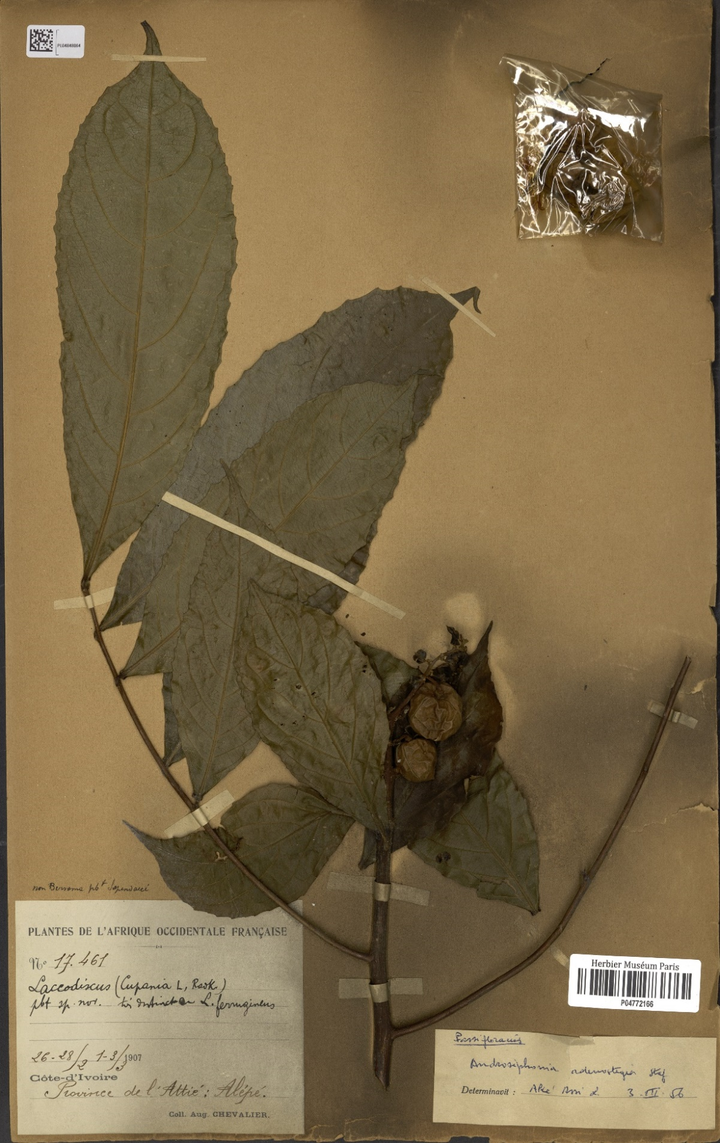
Supp. File 1. Plates of Androsiphonia adenostegia Stapf used in this study
Androsiphonia adenostegia Stapf (A.J.B. Chevalier 17461, P04772166 !). Credit : MNHN- Renobota
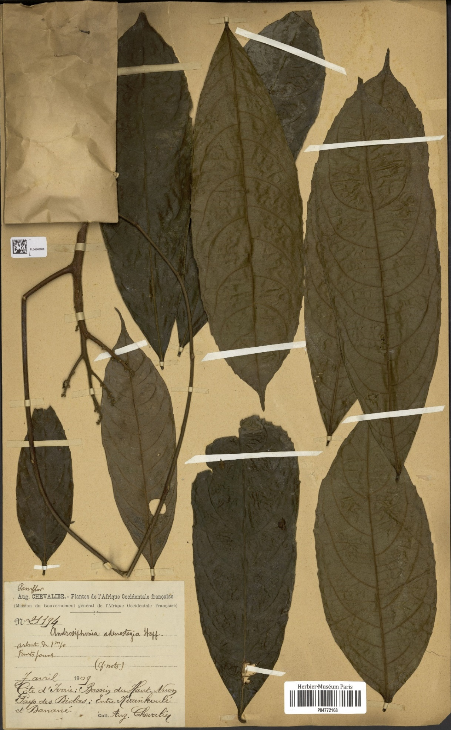
Androsiphonia adenostegia Stapf (A.J.B. Chevalier 21194, P04772168 !) Credit : MNHN- Renobota

