Table 1S. Developmental parameters estimated from the time course of chlorophyll content alterations. SD: standard deviation of the mean; n: number of samples; doy: day of the year. Data of time course 2013. Different letters indicate that means of a parameter are significantly different on the species level (one-way ANOVA with Tukey's post test).
Parameter | Unit | mean |  | SD |  | n
Q. frainetto
Rate of increase | [SPAD units/wk] | 4.8 | ± | 1.1 | a/b | 22
End of development | [doy] | 161.9 | ± | 7.0 | a | 22
Duration of plateau | [days] | 105.5 | ± | 26.3 | a/b | 22
Begin of senescence | [doy] | 267.0 | ± | 26.9 | a/b | 22
Rate of decline | [SPAD units/wk] | –6.1 | ± | 3.8 | a | 22
Q. ilex
Rate of increase | [SPAD units/wk] | 5.5 | ± | 1.4 | a | 19
End of development | [doy] | 177.3 | ± | 11.0 | b | 19
Duration of plateau | [days] | n.M | ± | n.M | - | 0
Begin of senescence | [doy] | n.M | ± | n.M | - | 0
Rate of decline | [SPAD units/wk] | n.M | ± | n.M | - | 0
Q. pubescens
Rate of increase | [SPAD units/wk] | 4.1 | ± | 1.4 | b | 24
End of development | [doy] | 159.5 | ± | 7.8 | a | 24
Duration of plateau | [days] | 128.4 | ± | 36.1 | a | 21
Begin of senescence | [doy] | 282.0 | ± | 13.0 | a | 21
Rate of decline | [SPAD units/wk] | –2.8 | ± | 2.4 | b | 21
Q. robur
Rate of increase | [SPAD units/wk] | 4.1 | ± | 1.0 | b | 21
End of development | [doy] | 166.8 | ± | 8.3 | a | 21
Duration of plateau | [days] | 88.9 | ± | 30.1 | b | 18
Begin of senescence | [doy] | 255.0 | ± | 30.4 | b | 18
Rate of decline | [SPAD units/wk] | –4.7 | ± | 3.2 | a/b | 18
Q. rubra
Rate of increase | [SPAD units/wk] | 3.0 | ± | 0.9 | c | 23
End of development | [doy] | 164.7 | ± | 13.8 | a | 23
Duration of plateau | [days] | 103.5 | ± | 15.6 | a | 17
Begin of senescence | [doy] | 271.0 | ± | 11.9 | a/b | 17
Rate of decline | [SPAD units/wk] | –6.6 | ± | 4.3 | a | 17

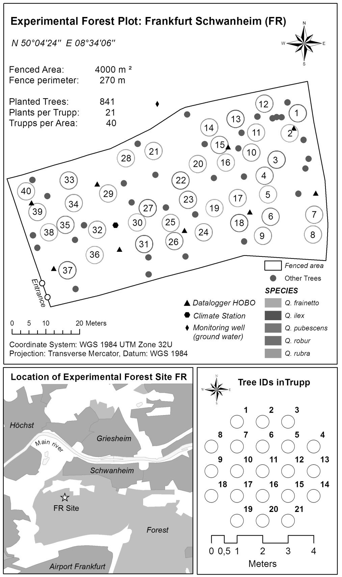

Fig. 1S. Experimental forest site in Frankfurt Schwanheim (FR). Map shows location of site, location of Clusters and measuring devices on site as well as information on tree identification. Tree IDs are four digit numbers composed of Cluster ID and tree ID as used in different assessments on the site. Map in the lower left corner was created from digital land model data: ©GeoBasis-DE BKG 2015, http://www.bkg.bund.de.

Fig. 2S. Historical record of late frost events at Frankfurt. Minimal temperature (T_{min}) in the month of May as black triangles, fitted by linear regression. Days with T_{min} lower than 0°C in May symbolized by grey columns. Record from DWD station 1420 Frankfurt airport for the years 1949–2014.

Fig. 3S. Species-specific fit of homographic model with 90% prediction bands of area based chlorophyll content to SPAD correlation. A–E: Black solid line symbolizes the all species model. Broken black line indicates species-specific model. Grey shaded area marks the 90% prediction intervals of the all species model. Grey solid lines give 90% prediction interval of species-specific model. Data points symbolized in dark grey. F: Data combined from Q. frainetto, Q. ilex, Q. pubescens, Q. robur and Q. rubra (n = 490) containing leaves from the whole growing season 2013. Chl a (R² = 0.903) and Chl b (R² = 0.832) fitted by polynomial 2. order regression.

