Limited Neutralisation of the SARS-CoV-2 Omicron Subvariants BA.1 and BA.2 by Convalescent and Vaccine Serum and monoclonal antibodies
Alexander Wilhelm*, Marek Widera*#, Katharina Grikscheit, Tuna Toptan, Barbara Schenk, Christiane Pallas, Melinda Metzler, Niko Kohmer, Sebastian Hoehl, Rolf Marschalek, Fabian A. Helfritz, Timo Wolf, Udo Goetsch, Sandra Ciesek#

* contributed equally
# corresponding authors: M. Widera (marek.widera@kgu.de); S. Ciesek (sandra.ciesek@kgu.de)

Supplementary Tables and Figures

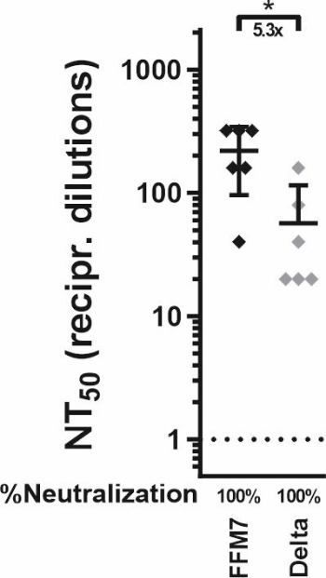

Supplementary Figure 1 - Antibody-mediated neutralisation of authentic SARS-CoV-2 variants. Values represent reciprocal dilutions micro-neutralisation titers resulting in 50% virus neutralisation (NT₅₀) of SARS-CoV-2 variants B.1 (parental, FFM7³⁴, D614G) and B.1.617.2 (Delta³⁰) (grey). Neutralisation assays were performed using serum samples obtained from vaccinated individuals. Mean titers and relative portion (%) of neutralising sera against each variant are indicated below each panel. Mean values of two technical replicates per sample are depicted with 95% confidence intervals and SD. Statistical significance was calculated by Wilcoxon Rank Sum Test. Asterisk indicate p-value as * (p < 0.05).

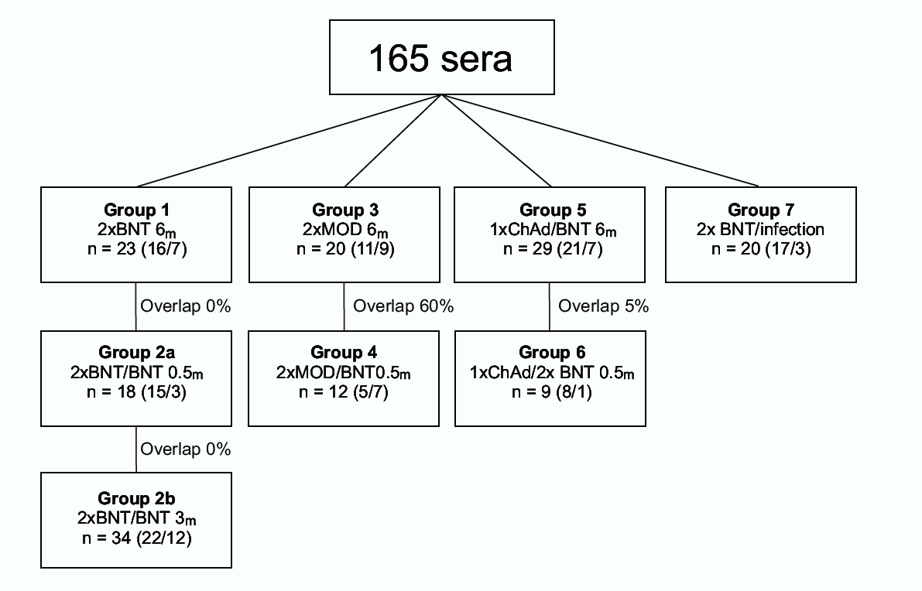

Supplementary Figure 2 – Overview of sera used in this study. Detailed listing of the 165 samples indicating the relative overlaps between the groups. BNT=BNT162b2; MOD=mRNA-1273; ChAd= ChAdOx1. The figures in brackets indicate the number of male and female (male/female) donors.

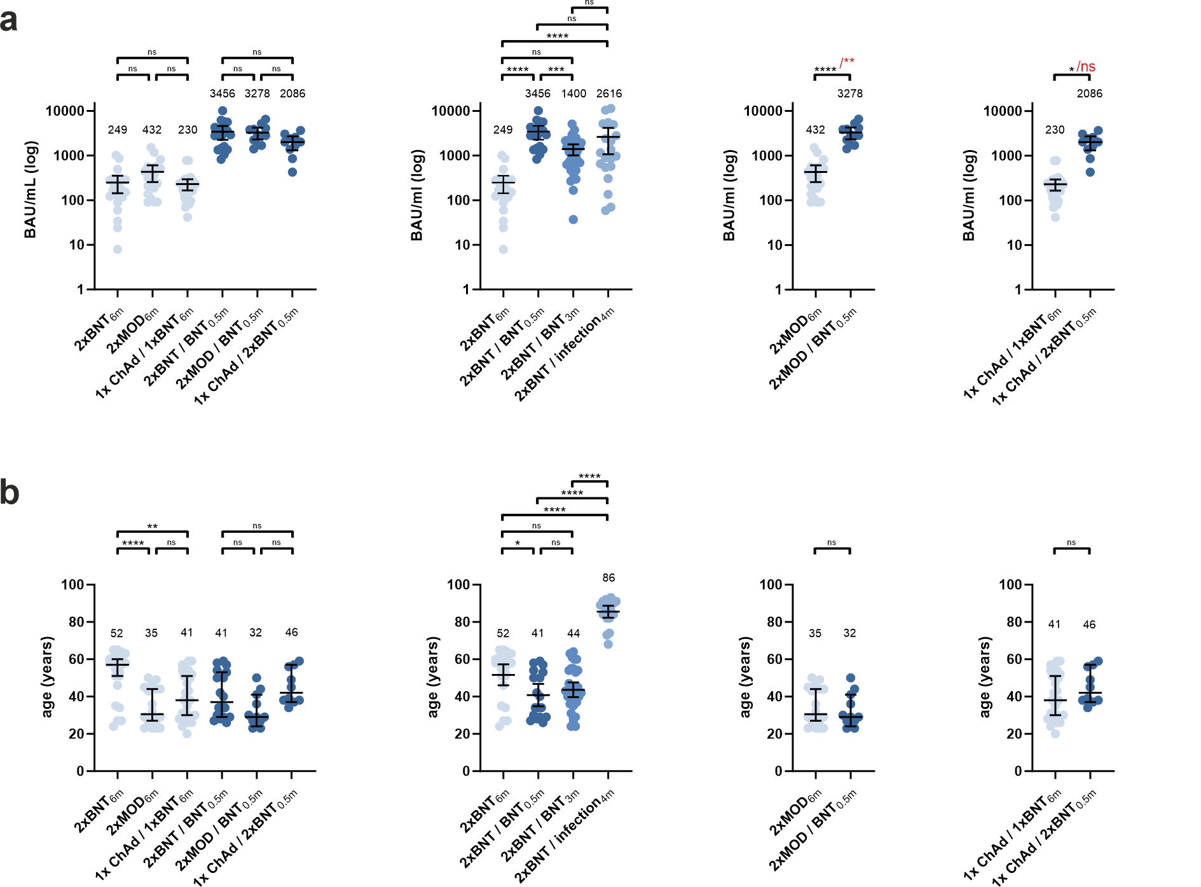

Supplementary Figure 3 –Sensitivity analysis of one-way ANOVA test for differences in IgG antibody responses and age distribution. A one-way ANOVA test was conducted excluding sera originated from identical donors (red asterisks) to evaluate differences in categories of p-values obtained from the one-way ANOVA test containing all sera used in this study (black asterisks) (see Figure 2). Statistical significances were calculated by one-way ANOVA with Tukey’s multiple comparison tests. Asterisks indicate p-values as * (p < 0.05), ** (p < 0.01), *** (p < 0.001), **** (p<0.0001), and ns (p>0.05)

Supplementary Table 1: Mutations in the spike proteins of SARS-CoV-2 variants of concern. Compared to the parental SARS-CoV-2 Omicron subvariants BA.1 and BA.2 gained distinct substitutions, insertions and deletions. Amino acid substitutions exclusively found in BA.1 and BA.2 are highlighted in bold.

Parental: B.1 D614G
Alpha: B.1.1.7 HV69-70del, Y144del, N501Y, A570D, D614G, P681H, T716I, S982A, D1118H
Beta: B.1.351 L18F, D80A, D215G, R246I, K417N, E484K, N501Y, D614G, A701V
Gamma: P.1 L18F, T20N, P26S, D138Y, R190S, K417T, E484K, N501Y, D614G, H655Y, T10277I
Delta: B.1.617.2 T19R, T95I, G142D, E156-, F157-, R158G, L452R, T478K, D614G, P681R, D950N
Omicron BA.1: B.1.1.529.1 A67V, HV69-70del, T95I, del143-145, Y145D, N211I, L212deI, ins214EPE, G339D, S371L, S373P, S375F, K417N,
N440K, G446S, S477N, T478K, E484A, Q493R, G496S, Q498R, N501Y, Y505H, T547K, D614G, H655Y, N679K,
P681H, N764K, D796Y, N856K, Q954H, N969K, L981F
Omicron BA.2: B.1.1.529.2 T19I, L24S, PPA25-27del, G142D, V213G, G339D, S371F, S373P, S375F, T376A, D405N, R408S, (K417N), N440K, _____________S477N, T478K, E484A, Q493R, N501Y, Y505H, D614G, H655Y, N679K, P681H, N764K, D796Y, Q954H, N969K

GISAID¹ Lineage Comparison: Alaa Abdel Latif, Julia L. Mullen, Manar Alkuzweny, Ginger Tsueng, Marco Cano, Emily Haag, Jerry Zhou, Mark Zeller, Emory Hufbauer, Nate Matteson, Chunlei Wu, Kristian G. Andersen, Andrew I. Su, Karthik Gangavarapu, Laura D. Hughes, and the Center for Viral Systems Biology. Accessed 12 February 2022. outbreak.info (available at https://outbreak.info/compare-lineages?pango=Omicron&pango=BA.1&pango=BA.2&pango=Alpha&pango=Beta&pango=Gamma&pango=Delta gene=S&threshold=94&nthresh=1&sub= false&dark=false).

1. Elbe S, Buckland-Merrett G. Data, disease and diplomacy: GISAID's innovative contribution to global health. Glob Chall. 2017;1(1):33-46.

Supplementary Table 2 - Additional sequencing primers. Primers used to complement for dropouts while using the ARTIC protocol for SARS-CoV-2 sequencing

Genome ID | Genome position |  | Name | Pool # | Strand | Sequence
MN908947.3 | 2780 | 2813 | SARS-CoV-2_10_LEFT_alt1 | 2 | + | TGAATATCACTTTTGAACTTGATGAAAGGATTG
MN908947.3 | 3156 | 3177 | SARS-CoV-2_10_RIGHT_alt1 | 2 | - | GGTTGAAGAGCAGCAGAAGTG
MN908947.3 | 7127 | 7156 | SARS-CoV-2_23_RIGHT_alt1 | 1 | - | AGAATCTAAACCACTAAGACAAACACTAC
MN908947.3 | 8367 | 8392 | SARS-CoV-2_27_RIGHT_alt1 | 1 | - | AATGTTGTGACTTTTTGCTACCTGC
MN908947.3 | 22742 | 22774 | SARS-CoV-2_76_LEFT_alt1 | 2 | + | ATGTCTATGCAGATTCATTTGTAATTAGAGGT
MN908947.3 | 23120 | 23141 | SARS-CoV-2_76_RIGHT_alt1 | 2 | - | GTCCACAAACAGTTGCTGGTG
MN908947.3 | 23914 | 23944 | SARS-CoV-2_79_RIGHT_alt1 | 1 | - | AATTGGTGGTGTTTTGTAAATTTGTTTGAC
MN908947.3 | 26242 | 26268 | SARS-CoV-2_88_LEFT_alt1 | 2 | + | TTATGTACTCATTCGTTTCGGAAGAG
MN908947.3 | 26592 | 26621 | SARS-CoV-2_89_LEFT_alt1 | 1 | + | TAGGTTTCCTATTCCTTACATGGATTTGT
MN908947.3 | 26966 | 26991 | SARS-CoV-2_89_RIGHT_alt1 | 1 | - | CTAGATGGTGTCCAGCAATACGAAG
MN908947.3 | 27218 | 27251 | SARS-CoV-2_90_RIGHT_alt1 | 2 | - | ATTAGTAATATCTCTGCTATAGTAACCTGAAAG

Supplementary Table 3: Demographic and medical data of serum donors used for this study. Demographic and medical data were only available to a limited extend for all groups (age, gender, and IgG levels) while additional data (BMI, comorbidities) was available for certain groups only. Table is provided in the .xlsx -file format.

Supplementary Table 4: Determination of differences in neutralisation titres against SARS-CoV-2 variants between BNT162b2(BNT)-vaccinated individuals including demographic covariates age and gender by multivariate linear regression.
Neutralisation | 2xBNT_{6m} vs. 2xBNT / BNT_{0.5m} | 2xBNT_{6m} vs. 2xBNT / BNT_{3m} | 2xBNT / BNT_{0.5m} vs. 2xBNT / BNT_{3m}
Delta | p<0.001 | p<0.001 | p<0.001
BA.1 | p<0.001 | p=0.038 | p<0.001
BA.2 | p<0.001 | p=0.003 | p<0.001

