Supplementary Material
Supplementary Table S1
Means and standard deviations respectively frequencies of the used variables
 | M (SD) or frequency | N
Urbanicity (% number of inhabitants ≥ 100 000) | 61.9 % | 399
CBCL total score | 29.61 (18.25) | 394
Cortisol concentration in morning urine (ng/ml) ª | 29.99 (25.72) | 368
Creatinine concentration in morning urine (mg/dl) | 73.95 (30.99) | 368
Time of urine sample | 7:44 (0:59) | 368
Wearing a night diaper | 4.6 % | 368
Cortisol concentration in saliva (nmol/l): ª
Baseline sample before stress test | 1.90 (1.74) | 337
10 minutes after stress test | 2.07 (1.88) | 337
30 minutes after stress test | 2.37 (2.0) | 337
40 minutes after stress test | 2.54 (2.49) | 337
AUC_{I} of salivary cortisol concentration ^{b} | 1.80 (9.08) | 337
Daytime of baseline sample (% morning) | 49.9 % | 337
Household income per month in Euro | 4 280.79 (2117.18) | 399
Years of education of the mother | 14.62 (2.34) | 399
Sex of the child (% female) | 53.6 % | 399
Notes. ª Not transformed values, before winsorizing. ^{b} calculated using log10-transformed values

Supplementary Table S2
Product-Moment-correlations by Pearson of the used variables
 | 1 | 2 | 3 | 4 | 5 |  | 6 | 7 | 8 | 9 | 10 | 11 | 12 | 13 | 14
1 Urbanicity ª | 1
2 CBCL total score ^{b} | .07 | 1
3 Urinary cortisol ^{c, d} | -.09⁺ | -.04 ^{l} | 1
4 Salivary cortisol baseline ^{e, f} | .13* | -.06 ^{m} | .01 ^{n} | 1
5 Salivary cortisol 10 min ^{e, f} | .06 | -.09^{+, m} | .002 ^{n} | .74** | 1
6 Salivary cortisol 30 min ^{e, f} | .04 | -.09^{+, m} | .01 ^{n} | .54** | .82** |  | 1
7 Salivary cortisol 40 min ^{e, f} | .05 | -.08 ^{m} | -.02 ^{n} | .45** | .72** |  | .90** | 1
8 AUC_{I} salivary cortisol ^{f, g} | -.07 | -.05 ^{m} | -.003 ^{n} | -.31** | .35** |  | .59** | .60** | 1
9 Time Saliva Sample ^{f, h} | .08 | .11*^{, m} | -.06 ^{n} | -.23** | -.24** |  | -.23** | -.29** | -.07 | 1
10 Time Urine Sample ^{d} | .05 | .10^{+, l} | .11* | .03 ^{n} | .03 ^{n} |  | .07 ^{n} | .09 ^{n} | .04 ^{n} | -.11^{+, n} | 1
11 Wearing a night diaper ^{d, i} | -.07 º | .12*^{, l} | .16** | -.03 ^{n} | .004 ^{n} |  | .04 ^{n} | .07 ^{n} | .07 ^{n} | -.03 ^{n} | .12* | 1
12 Household income ^{j} | -.14** | -.31** | .09⁺ | -.06 | .05 |  | .05 | .07 | .13* | -.18** | -.08 | -.04 | 1
13 Maternal years of education ^{h} | -.14** | -.24** | .11* | -.06 | .08 |  | .09 | .06 | .15** | -.06 | -.09⁺ | -.04 | .54** | 1
14 Sex child ^{k} | .05 º | .10⁺ | .08 | .02 | -.04 |  | -.07 | -.11⁺ | -.09⁺ | .02 | -.05 | .08 º | -.02 | .03 | 1
Notes. ** p < .01, * p < .05, + p < .10 (two-sided), N = 399.
ª less than 100 000 inhabitants is coded as 1. ^{b} n = 394. ^{c} in ng/ml. ^{d} n = 368. ^{e} in nmol/l. ^{f} n = 337. ^{g} calculated using log10-transformed values. h Spearman-Rank-correlation.
^{i} not wearing a night diaper is coded as 0. ^{j} per month, in Euro. ^{k} female is coded as 0. ^{l} n = 364. ^{m} n = 333. ^{n} n = 317. º Phi coefficient.

Supplementary Figure S3
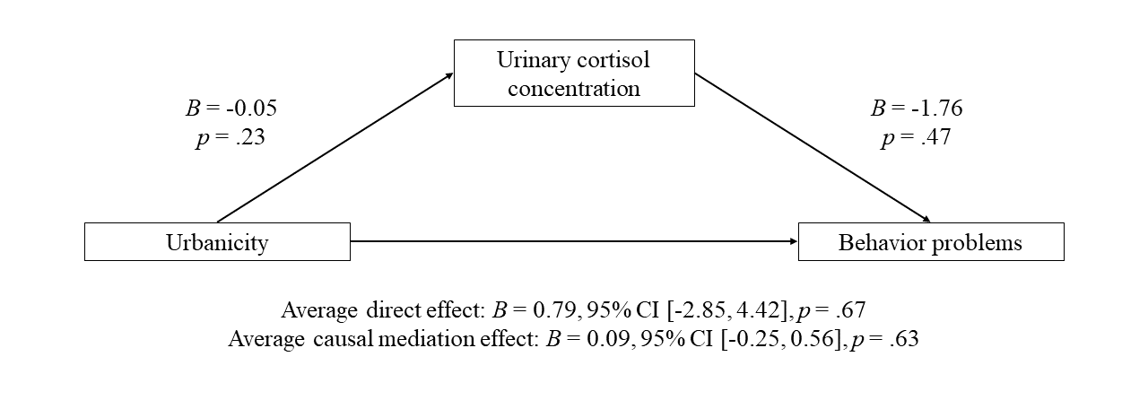
Figure S3. Mediation analysis of the relationship of urbanicity and behavior problems using urinary cortisol concentration as mediator and the covariates sex, household income, years of education of the mother, wearing a night diaper, and time of urine sample, n = 364
Supplementary Table S4
Parameter estimation to predict log10-transformed urinary cortisol
 | B | SE B | t | p
Constant | -1.15 | 0.23 | -5.02 | < .001
Urbanicity ª | -0.05 | 0.04 | -1.20 | .23
Sex ^{b} | 0.05 | 0.04 | 1.38 | .17
Household income | 0.000006 | 0.00001 | 0.51 | .61
Maternal education | 0.02 | 0.01 | 2.12 | .03
Wearing a night diaper ^{c} | 0.26 | 0.09 | 2.73 | .007
Time of urine sample | 0.00001 | 0.000006 | 2.35 | .02
Notes. n = 364.
ª less than 100,000 inhabitants was coded as 1. ^{b} female was coded as 0. ^{c} not wearing a night diaper was coded as 0.
Supplementary Table S5
Parameter estimation to predict CBCL total score
 | B | SE B | t | p
Constant | 34.65 | 10.90 | 3.18 | .002
Urinary cortisol ª | -1.76 | 2.44 | -0.72 | .47
Urbanicity ^{b} | 0.81 | 1.92 | 0.42 | .67
Sex ^{c} | 3.10 | 1.83 | 1.69 | .09
Household income | -0.002 | 0.0005 | -4.18 | < .001
Maternal education | -0.63 | 0.47 | -1.34 | .18
Wearing a night diaper ^{d} | 8.28 | 4.40 | 1.88 | .06
Time of urine sample | 0.0003 | 0.0002 | 1.28 | .20
Notes. n = 364.
ª log10-transformed. ^{b} less than 100,000 inhabitants was coded as 1. ^{c} female was coded as 0. ^{d} not wearing a night diaper was coded as 0.

Supplementary Figure S6
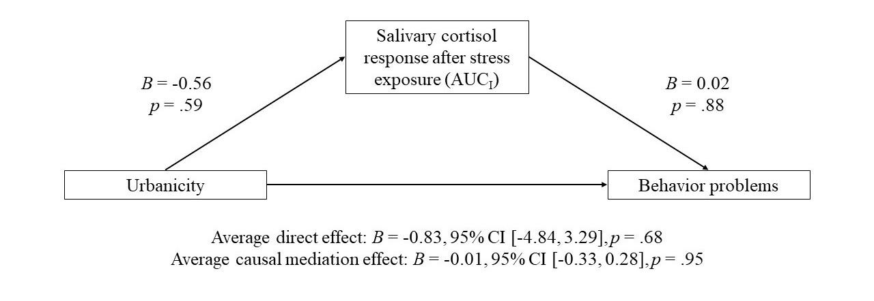
Figure S6. Mediation analysis of the relationship of urbanicity and behavior problems using salivary cortisol response after stress exposure (AUC_{I}; calculated using log10-transformed values) as mediator and the covariates sex, household income, years of education of the mother, and time of baseline saliva sample, n = 333
Supplementary Table S7
Parameter estimation to predict AUC_{I} of salivary cortisol concentration (calculated using log10-transformed values)
 | B | SE B | t | p
Constant | 0.66 | 4.97 | 0.13 | .89
Urbanicity ª | -0.56 | 1.03 | -0.54 | .59
Sex ^{b} | -1.54 | 0.99 | -1.57 | .12
Household income | 0.0002 | 0.0003 | 0.78 | .43
Maternal education | 0.47 | 0.25 | 1.89 | .06
Time of baseline saliva sample | -0.0001 | 0.00007 | -1.65 | .099
Notes. n = 333.
ª less than 100,000 inhabitants was coded as 1. ^{b} female was coded as 0.

Supplementary Table S8
Parameter estimation to predict CBCL total score
 | B | SE B | t | p
Constant | 44.08 | 9.75 | 4.52 | < .001
AUC_{I} of salivary cortisol concentration ª | 0.02 | 0.11 | 0.15 | .88
Urbanicity ^{b} | -0.85 | 2.02 | -0.42 | .68
Sex ^{c} | 2.68 | 1.94 | 1.38 | .17
Household income | -0.002 | 0.0006 | -4.44 | < .001
Maternal education | -0.52 | 0.49 | -1.06 | .29
Time of baseline saliva sample | 0.00008 | 0.0001 | 0.64 | .53
Notes. n = 333.
ª calculated using log10-transformed values. ^{b} less than 100,000 inhabitants was coded as 1. ^{c} female was coded as 0.
Supplementary Figure S9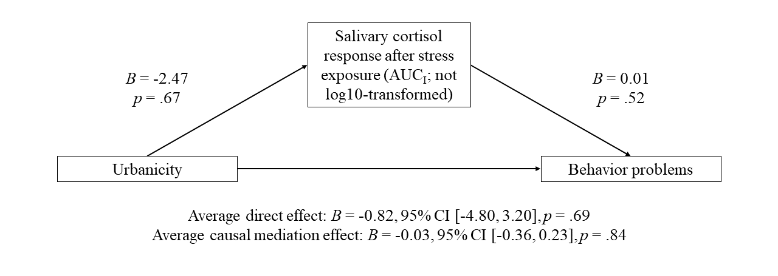
Figure S9. Mediation analysis of the relationship of urbanicity and behavior problems using salivary cortisol response after stress exposure (AUC_{I}) as mediator and the covariates sex, household income, years of education of the mother, and time of baseline saliva sample, n = 333
Supplementary Table S10
Parameter estimation to predict AUC_{I} of salivary cortisol concentration
 | B | SE B | t | p
Constant | 20.78 | 28.40 | 0.73 | .46
Urbanicity ª | -2.47 | 5.89 | -0.42 | .67
Sex ^{b} | -14.18 | 5.63 | -2.52 | .01
Household income | 0.001 | 0.002 | 0.64 | .52
Maternal education | 2.11 | 1.42 | 1.49 | .14
Time of baseline saliva sample | -0.0007 | 0.0004 | -1.79 | .074
Notes. n = 333.
ª less than 100,000 inhabitants was coded as 1. ^{b} female was coded as 0.

Supplementary Table S11
Parameter estimation to predict CBCL total score
 | B | SE B | t | p
Constant | 43.84 | 9.75 | 4.49 | < .001
AUC_{I} of salivary cortisol concentration | 0.01 | 0.02 | 0.64 | .52
Urbanicity ª | -0.83 | 2.02 | -0.41 | .68
Sex ^{b} | 2.83 | 1.95 | 1.45 | .15
Household income | -0.002 | 0.0006 | -4.46 | < .001
Maternal education | -0.54 | 0.49 | -1.10 | .27
Time of baseline saliva sample | 0.00009 | 0.0001 | 0.69 | .49
Notes. n = 333.
ª less than 100,000 inhabitants was coded as 1. ^{b} female was coded as 0.

