Supporting Information

Supplementary Methods

Selection of treatment attributes
The selection of the attributes was informed by an expert meeting involving five experts—four physicians and one patient ambassador. The meeting included in-depth discussion of potential attributes and a ranking exercise. Before the meeting with the experts, RTI Health Solutions and UCB Pharma staff met to develop a list of 15 potential attributes to be considered for inclusion in the discrete choice experiments (DCE), selected from a comprehensive list of 67 attributes. The list of 15 potential attributes was presented for discussion during the expert meeting. These attributes were reduction in the frequency of focal (partial-onset) seizures; independence; cognitive problems; clinical depression; other psychiatric adverse events; aggressive behavior; drug-drug interactions; somnolence; fatigue; change in body weight; dizziness; other neurologic adverse events; nausea/vomiting; dosing/pill burden; and cardiovascular adverse events. A ranking exercise was then performed to determine the most and least important attributes, resulting in selection of the final seven attributes.

Patient satisfaction with the treatment consultation
Patients were asked which treatment aspects were most important to them from the following list:
- Reduction of seizures
- Independence
- Cognitive problems
- Changes in personality
- Fatigue and somnolence
- Other neurologic side effects
- Interactions of the new medication with other medications
- Change in body weight
- Issues with digestion
- Dermatologic issues
- Cardiovascular side effects
- Reproduction/fertility
- None

Statistical analysis
The random parameters logit (RPL) model related patients’ treatment choices to the attribute levels of each treatment profile in the choice questions. The RPL model mitigated potential estimation bias in the mean preference weight estimates due to unobserved preference heterogeneity among patients by estimating a distribution around each mean preference parameter, and accounted for the fact that each patient made multiple treatment choices over a series (panel) of choice questions.
Based on the specification assumed for each attribute, the following utility model was estimated:
Eq (1) V = β_{EFF}1 × EFF1 + β_{EFF2} × EFF2
+ β_{DEP1} × DEP1 + β_{DEP2} × DEP2
+ β_{PER1} × PER1 + β_{PER2} × PER2
+ β_{THINK1} × THINK1 + β_{THINK2} × THINK2
+ β_{DIZZ1} × DIZZ1 + β_{DIZZ2} × DIZZ2
+ β_{WHT1} × WHT1 + β_{WHT2} × WHT2
+ β_{TRD1} × TRD1 + β_{TRD2} × TRD2 + β_{TRD3} × TRD3,
where V is the systematic indirect utility for a particular treatment profile, β is a parameter estimate for each attribute level, and variables are as follows:
- EFF1-3: Effects-coded variable indicating the chance of becoming seizure-free (EFF1=60% chance; EFF2=45% chance; EFF3=25% chance). EFF3 was omitted for model identification.
- DEP1-3: Effects-coded variable indicating the chance of developing clinical depression (DEP1=none; DEP2=4% chance; DEP3=10% chance). DEP3 was omitted for model identification.
- PER1-3: Effects-coded variable indicating personality changes (PER1=none; PER2=mild; PER3=moderate-to-severe). PER3 was omitted for model identification.
- THINK1-3: Effects-coded variable indicating trouble thinking clearly (THINK1=none; THINK2=mild; THINK3=moderate-to-severe). THINK3 was omitted for model identification.
- DIZZ1-3: Effects-coded variable indicating dizziness (DIZZ1=none; DIZZ2=mild; DIZZ3=moderate-to-severe). DIZZ3 was omitted for model identification.
- WHT1-3: Effects-coded variable indicating change in body weight in 6 months (WHT1=5% weight loss; WHT2=no change; WHT3=5% weight gain). WHT3 was omitted for model identification.
- TRD1-4: Effects-coded variable indicating feeling sleepy or tired (TRD1=none; TRD2=sleepiness; TRD3=mild-to-moderate tiredness; TRD4=severe tiredness). TRD4 was omitted for model identification.
The preference weights were statistically significantly different from 0 at the 5% level if the confidence interval (CI) did not include 0. The significance of each preference weight indicated the significance of each attribute level relative to the mean effect of that attribute (normalized to be 0).
If the CIs for any pair of levels of the same attribute did not overlap, the mean estimates for those attribute levels were statistically significantly different from each other at the 5% level of significance.

Supplementary Tables
TABLE S1 Initial list of antiseizure medication treatment attributes
Benefit or risk | Attribute | Levels experienced (some, most, all) of the time
Benefit | Reduce my number of seizures | Some reduction in frequency and severity/significant reduction for the patient in frequency and severity/seizure-free
Benefit | Able to live independently: driving, bathing/dressing/cooking/walking/climbing stairs/doing light household | With no, little, or some assistance (add driving as highest level). To add quality of life: "need to have" (=basic needs such as ability for dressing) to live independently a normal life to what is "nice to have" (eg, specific leisure activities) for a normal life
Benefit | Able to combine with future therapies if needed to obtain better seizure control (and treat other ailments) | Able with (1) all other therapies, (2) some other therapies, (3) no other therapies
Benefit | Able to maintain work and school schedule without physical limitations | Always, most of the time, none of the time
Benefit | Able to socialize with my family and friends due to my epilepsy | Always, most of the time, none of the time
Benefit | Feeling positive and cheerful (some, most, all) of the time (reword mood stabilization, having a normal mood) | Always, most of the time, none of the time (or better, stable, worse mood)
Benefit | Able to keep up with daily dose schedule/easy to follow doctor's orders/important to have a choice of syrup, pills, or infusion | (Some, most, all) of the time (or number of pills per day 1, 2, 3)
Benefit | Important for new drug to work quickly/easy to find the right dose | Not, somewhat, very important
Benefit | Able to avoid falling and hurting myself/worry less about falling | Always, most of the time, none of the time
Benefit | % chance of being seizure-free over the next 2 years | 1 in 5, 3 in 5, or 5 in 5 chance
Benefit | Able to participate in sports and exercise without physical limitations | Always, most of the time, none of the time
Benefit | Able to participate in leisure time activities and hobbies | Always, most of the time, none of the time
Benefit | Ability to drive a car | Always, most of the time, none of the time/never, only during the day, or any time of day
Benefit | Able to live independently: bathing/dressing/cooking/walking/driving | With no, little or some assistance
Benefit | Able to do light household chores/climb stairs | Always, most of the time, none of the time
Benefit | Able to maintain work schedule without emotional limitations | Always, most of the time, none of the time
Benefit | Able to maintain work schedule without experiencing pain or discomfort | Levels neither discussed nor proposed
Benefit | Dose adjustments for renal or hepatic impairment | Levels neither discussed nor proposed
Risk | Decreased memory and attention (as a result of drug) | Levels neither discussed nor proposed
Risk | Drug-drug interactions | (Some, most, all) of the time
Risk | Worrying about the disease, quality of life (social, insecurity) – reduce worry about: having a seizure in the next year, hurting yourself while having a seizure, embarrassing yourself while having a seizure | Slightly, moderately, significantly
Risk | % chance of feeling dizzy or having blurred vision for a short period | Levels neither discussed nor proposed
Risk | Gastrointestinal adverse event (nausea, vomiting) – feeling sick | Always, most of the time, none of the time
Risk | Increase in weight | Minus 15, 0, plus 15 lbs
Risk | Arrhythmias, QTc, PR, lipid abnormalities | Levels neither discussed nor proposed
Risk | Reproductive, pregnancy, malformations, contraceptives, developmental | Levels neither discussed nor proposed
Risk | Willing to pay out of pocket | $0, 25, 75, 150, 300/month
Risk | Benefit: reducing the chance of death from prolonged seizures or SUDEP/Risks: shortness of breath and swelling or skin diseases | Levels neither discussed nor proposed
Risk | Blood disorders, bone marrow depression | Levels neither discussed nor proposed
Risk | Hair loss | None, some, a lot
Risk | Experience temporary loss of consciousness caused by a fall in blood pressure | (Some, most, all) of the time
Risk | Feel short of breath | (Some, most, all) of the time
Risk | Having difficulty learning and remembering new things | (Some, most, all) of the time
Risk | Fear or worry about having a seizure – reduce worry about: having a seizure in the next year, hurting yourself while having a seizure, embarrassing yourself while having a seizure | Levels neither discussed nor proposed
Risk | Causes difficulty with daily activities | Levels neither discussed nor proposed
Risk | Short-term side effects <select one> – Lasts for ___ | A day, week, month
Risk | Nausea/vomiting symptoms – feeling sick | (Some, most, all) of the time
Risk | Risk or chance of death from prolonged seizures | 0, 1, or 2% chance
Risk | Able to control movement, speech, eye movement, and swallowing | (Some, most, all) of the time
Risk | Feel heart is racing | (Some, most, all) of the time
Risk | Difficulty urinating | No, ½ time, always
Risk | Difficult going to the bathroom | (Some, most, all) of the time
Risk | Need for counseling for depression | Weekly, monthly, yearly
Risk | Decreasing dose due to breastfeeding | By 25, 50, or 75%
Risk | Feeling dizzy/feeling like you are spinning or swaying/feel like I am going to faint | (Some, most, all) of the time
Risk | Feel drowsy, tired, or pepless | (Some, most, all) of the time
Risk | Short-term non-psychotic symptoms (irritability, anxiety, nervousness, anger, aggression, apathy, hostility, panic attack, insomnia, belligerence, anger, agitation, restlessness, tearfulness, apathy, altered mood, mood swings, affect lability, psychomotor hyperactivity) – feeling <select from the above>/feel downhearted and blue/thinking about suicide/feeling my epilepsy is hopeless/unable to sleep/experiencing mood changes | (Some, most, all) of the time
Risk | Long-term non-psychotic symptoms (depression, depressed mood lability, psychomotor hyperactivity, abnormal behavior, adjustment disorder) – feeling <select from the above>/feel downhearted and blue/thinking about suicide/feeling my epilepsy is hopeless/unable to sleep/experiencing mood changes | (Some, most, all) of the time
Risk | Risk or chance of bruising or bleeding | 0, 5, 10% chance
Risk | Risk or chance of infection | 0, 5, 10% chance
Risk | Shortness of breath and swelling | Once a month, once a week, most nights
Risk | Risk or chance of severe skin disease | 0, 10, 20% chance
Risk | Risk or chance of headache and fever | 0, 5, 10% chance
Risk | Experience double vision | Once a month, once a week, most nights
Risk | Cardiac rhythm | Levels neither discussed nor proposed
Risk | Short-term cardiovascular: edema, aggravation of hypertension, hypotension, syncope and collapse, aggravation of coronary artery disease | Levels neither discussed nor proposed
Risk | Long-term cardiovascular: congestive heart failure, arrhythmias, and atrioventricular block, thrombophlebitis, thromboembolism, and adenopathy or lymphadenopathy | Levels neither discussed nor proposed
Risk | Blood dyscrasias (eg, neutropenia, thrombocytopenia, pancytopenia) | Levels neither discussed nor proposed
Risk | Aplastic anemia, agranulocytosis, pancytopenia, bone marrow depression,  thrombocytopenia, leukopenia, leukocytosis, eosinophilia, acute intermittent porphyria | Levels neither discussed nor proposed
Risk | Transient diplopia, oculomotor disturbances, nystagmus, peripheral neuritis, paresthesias, tinnitus, and hyperacusis | Levels neither discussed nor proposed
Risk | Psychotic symptoms (psychotic disorder  along with hallucination, paranoia, acute psychosis, and psychotic behavior) | Levels neither discussed nor proposed
Risk | Drug reaction with eosinophilia and systemic symptoms (DRESS), also known as multiorgan hypersensitivity | Levels neither discussed nor proposed
Risk | Polypharmacy drug interactions | Levels neither discussed nor proposed
Risk | Risk of liver or kidney damage | Levels neither discussed nor proposed
Risk | Multiorgan hypersensitivity | Levels neither discussed nor proposed
Risk | % chance of osteoporosis | Levels neither discussed nor proposed
Risk | % chance of reproductive disorders, such as mental growth retardation during pregnancy | Levels neither discussed nor proposed

TABLE S2 Post hoc subgroup analysis of patient preference weights based on a discrete choice experiment survey before treatment consultation (Enrolled Set [ES], n = 305ª)

Variable | Subgroup comparison | n | p value
Country^{b} | Germany | 134 | .0626
 | Italy | 76 | .2304
 | Other countries (Denmark, France, Ireland, the Netherlands, Spain, the UK) | 95 | Reference group
Age | <65 years | 246
 | ≥65 years | 59 | .0408
 | ≤45 years | 147 | .0564
 | >45 years | 158
Sex | Female | 159 | .3396
 | Male | 146
Education level^{c} | Secondary school or less | 197 | .5891
 | More than secondary school | 106
Employment^{c} | Employed full-time or part-time | 131 | .2560
 | Not employed full-time or  part-time | 172
Time since diagnosis^{c} | Diagnosed 6.33 or fewer years ago | 153 | .3554
 | Diagnosed more than 6.34 years ago | 151
Failed ASMs^{d} | No failed ASMs or missing values | 166 | .7413
 | One or more failed ASMs | 139
Reason for discontinuation of ASM planning to be stopped^{c} | Due to lack of efficacy | 148 | .8144
 | Not due to lack efficacy | 87
Seizure type^{c} | With FBTCS | 97 | .3601
 | Without FBTCS | 88
Levetiracetam experience^{c} | With prior levetiracetam | 180 | .9609
 | Without prior levetiracetam | 122
Patient experience^{c} | More experienced (diagnosed more than 6.33 years ago and has prior failure with an ASM) | 92 | .3645
 | Less experienced | 212
ªAlthough the ES included 310 patients, five did not complete the survey before the consultation. ^{b}Systematic differences in preferences were tested between two subgroups at a time using the Wald test. Therefore, the table presents the P values for the difference between Germany compared with all other countries and Italy compared with all other countries. The p value for the difference between Germany and Italy was p = .0325. ^{c}The total subgroup sample size is <305 due to missing data. ^{d}Previous ASMs with a documented reason for discontinuation. Abbreviations: ASM, antiseizure medication; FBTCS, focal to bilateral tonic-clonic seizures.

TABLE S3 Physician conditional relative importance, conditional multinomial logit model (Physician Preference Set, n = 94ª)
Chance of becoming  seizure-free | Chance of developing clinical depression | Personality changes | Trouble thinking clearly | Dizziness | Change in  body weight in  6 months | Feeling sleepy or tired
Order of importance | mean (95% confidence interval)
1 | 10.0  (8.6–11.4) | 6 | 3.1  (1.8–4.4) | 2 | 7.5  (6.2–8.9) | 3 | 6.2  (4.9–7.5) | 5 | 4.4  (3.0–5.7) | 7 | .7  (−.6–1.9) | 4 | 5.4  (3.9–7.0)
ªForty-nine physicians completed a total of 94 surveys (each physician completed the survey for up to three patients).

Supplementary Figures

FIGURE S1 Patient preferences based on a discrete choice experiment survey, before and after treatment consultation, random parameters logit model (Patient Preference Comparison Set, n = 273)
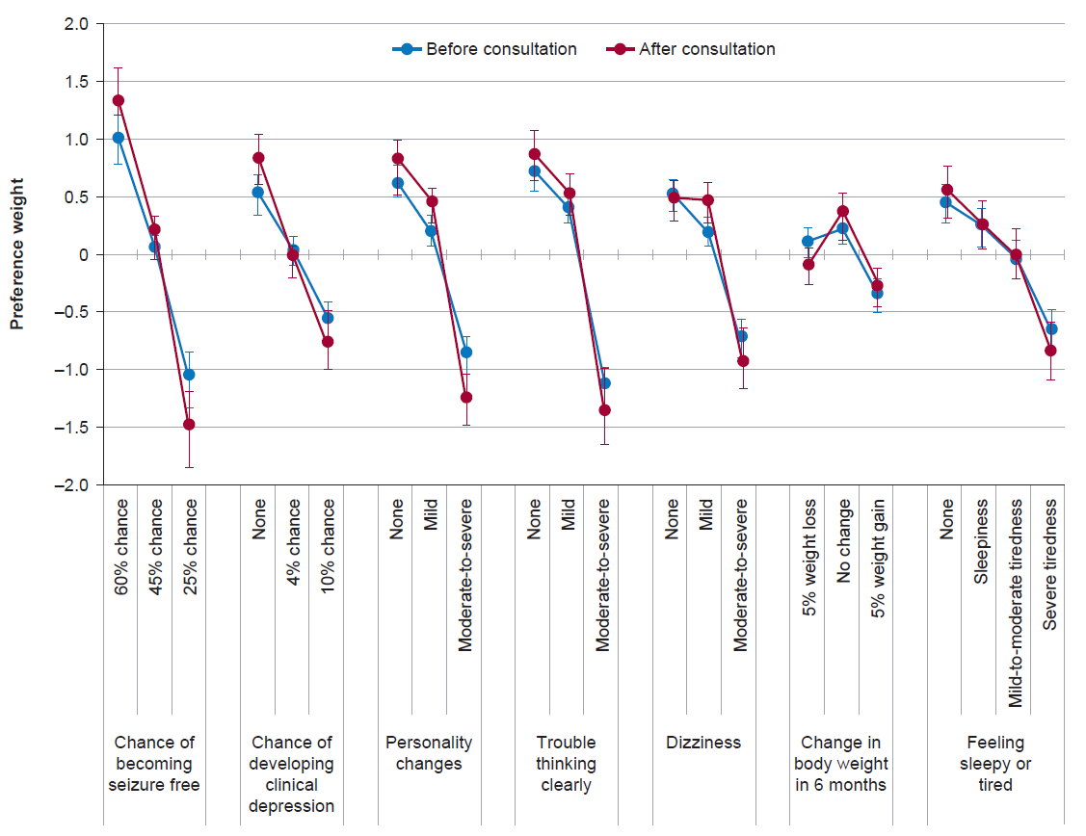
Error bars represent 95% confidence intervals.

FIGURE S2 Post hoc subgroup analysis of patient preference weights based on a discrete choice experiment survey before treatment consultation, random parameters logit model (Enrolled Set [ES], n = 305ª), by country 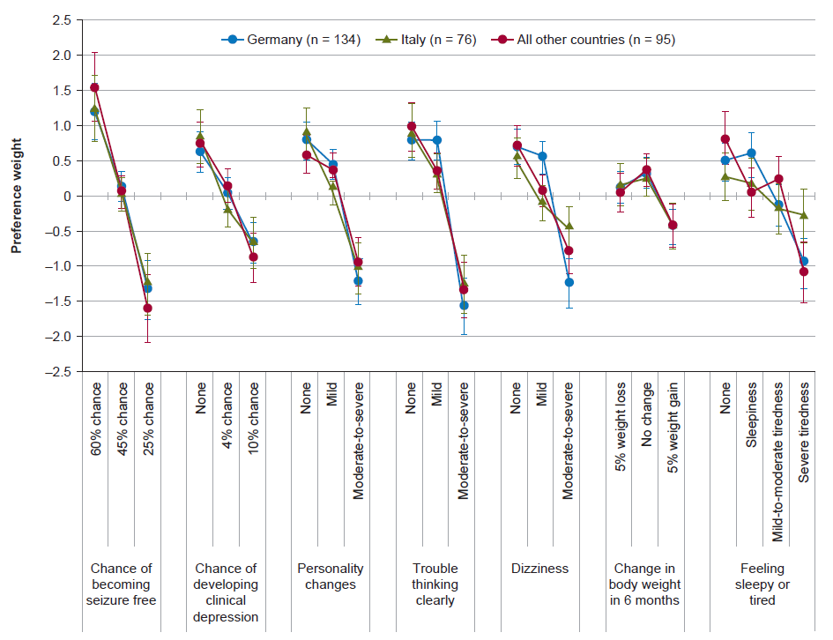 Error bars represent 95% confidence intervals. ªAlthough the ES included 310 patients, five patients did not complete the survey before the consultation.

FIGURE S3 Post hoc subgroup analysis of patient preference weights based on a discrete choice experiment survey before treatment consultation, random parameters logit model (Enrolled Set [ES], n = 305ª), by age (<65 years vs. ≥65 years) 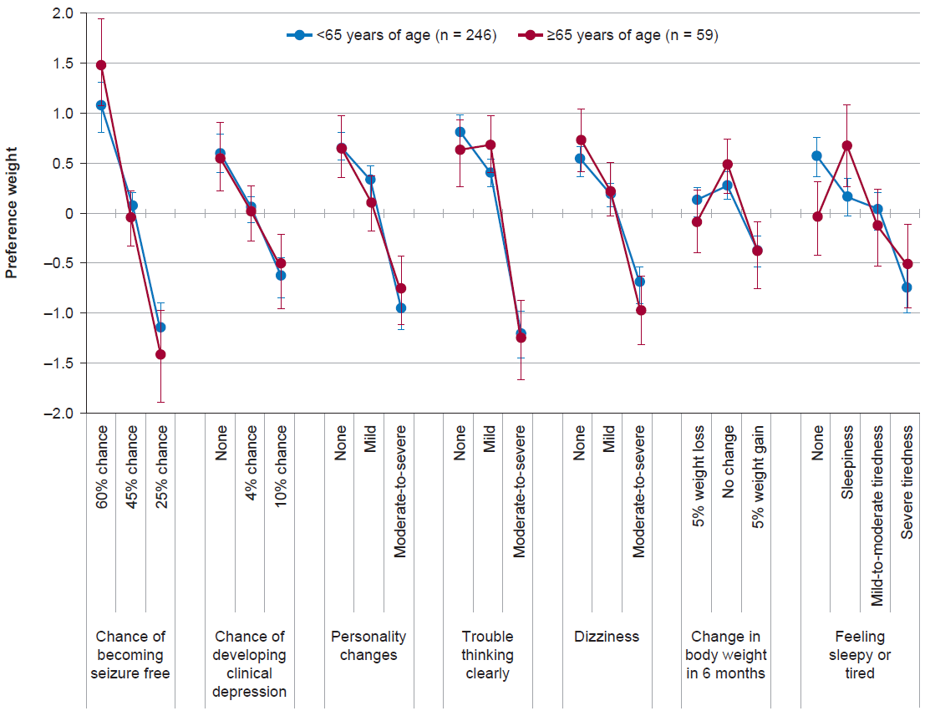 Error bars represent 95% confidence intervals. ªAlthough the ES included 310 patients, five patients did not complete the survey before the consultation.

FIGURE S4 Post hoc subgroup analysis of patient preference weights based on a discrete choice experiment survey before treatment consultation, random parameters logit model (Enrolled Set [ES], n = 305ª), by age (≤45 years vs >45 years) 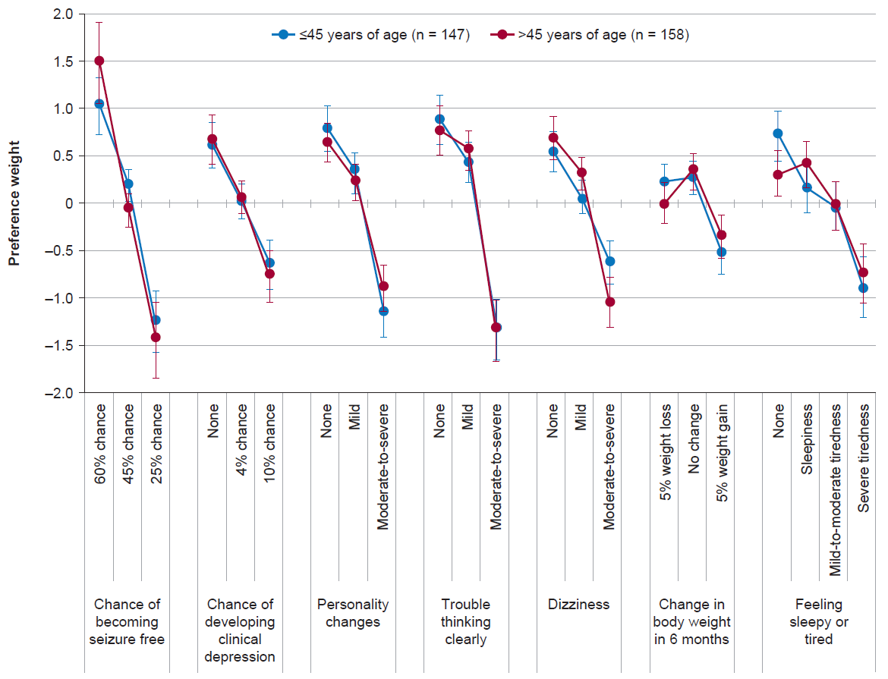 Error bars represent 95% confidence intervals. ªAlthough the ES included 310 patients, five patients did not complete the survey before the consultation.

FIGURE S5 Post hoc subgroup analysis of patient preference weights based on a discrete choice experiment survey before treatment consultation, random parameters logit model (Enrolled Set [ES], n = 305ª), by sex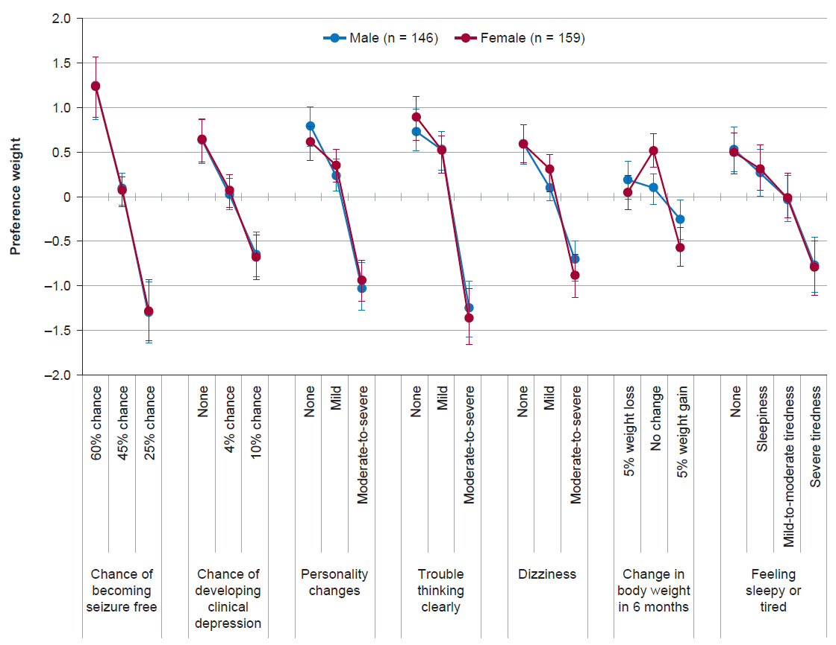 Error bars represent 95% confidence intervals. ªAlthough the ES included 310 patients, five patients did not complete the survey before the consultation.

FIGURE S6 Post hoc subgroup analysis of patient preference weights based on a discrete choice experiment survey before treatment consultation, random parameters logit model (Enrolled Set [ES], n = 303ª), by education level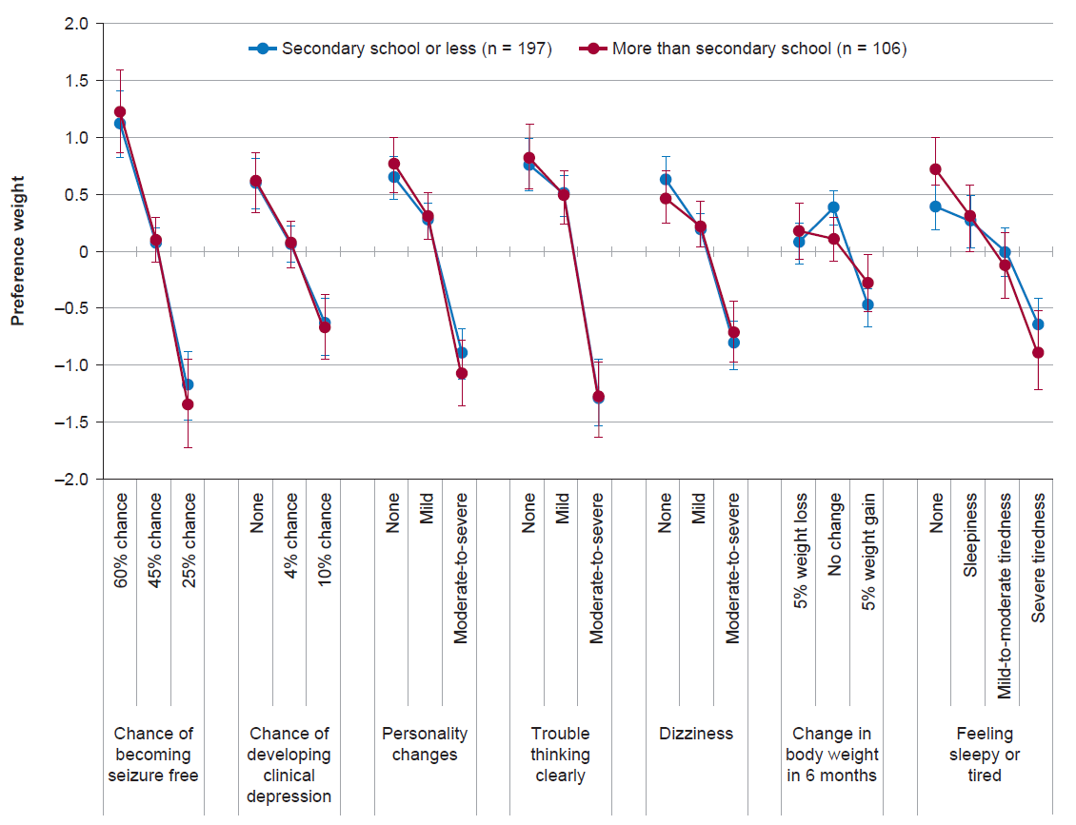 Error bars represent 95% confidence intervals. ªAlthough the ES included 310 patients, five patients did not complete the survey before the consultation, and the total subgroup sample size is <305 due to missing data.

FIGURE S7 Post hoc subgroup analysis of patient preference weights based on a discrete choice experiment survey before treatment consultation, random parameters logit model (Enrolled Set [ES], n = 303ª), by employment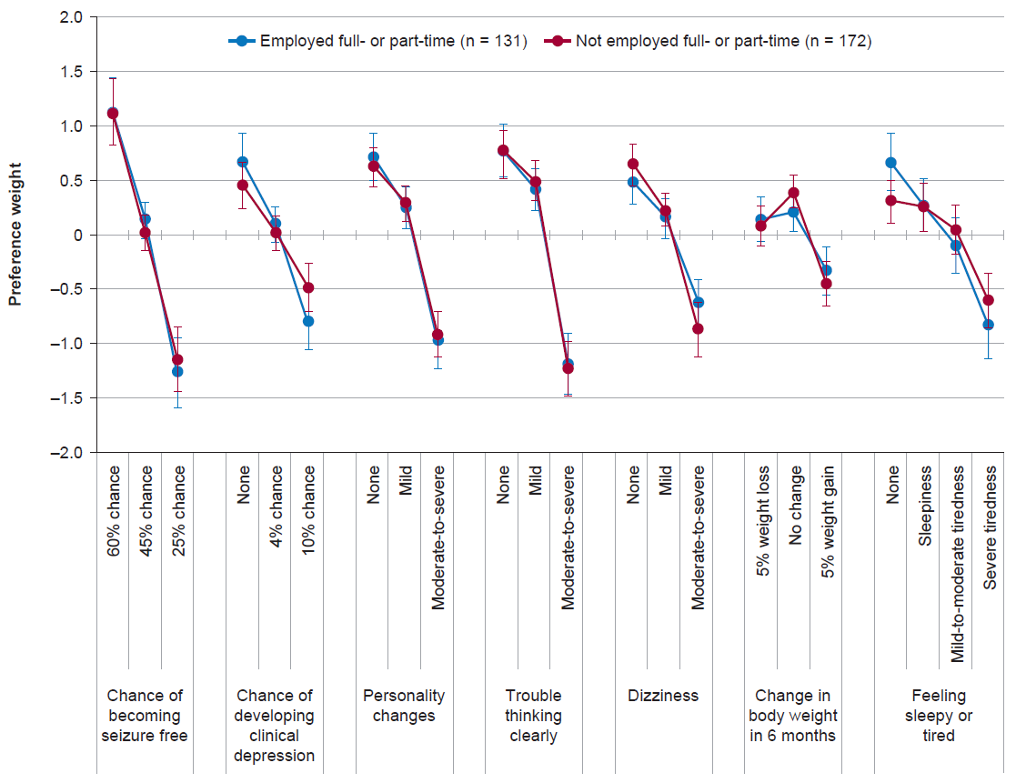 Error bars represent 95% confidence intervals. ªAlthough the ES included 310 patients, five patients did not complete the survey before the consultation, and the total subgroup sample size is <305 due to missing data.

FIGURE S8 Post hoc subgroup analysis of patient preference weights based on a discrete choice experiment survey before treatment consultation, random parameters logit model (Enrolled Set [ES], n = 304ª), by time since epilepsy diagnosis 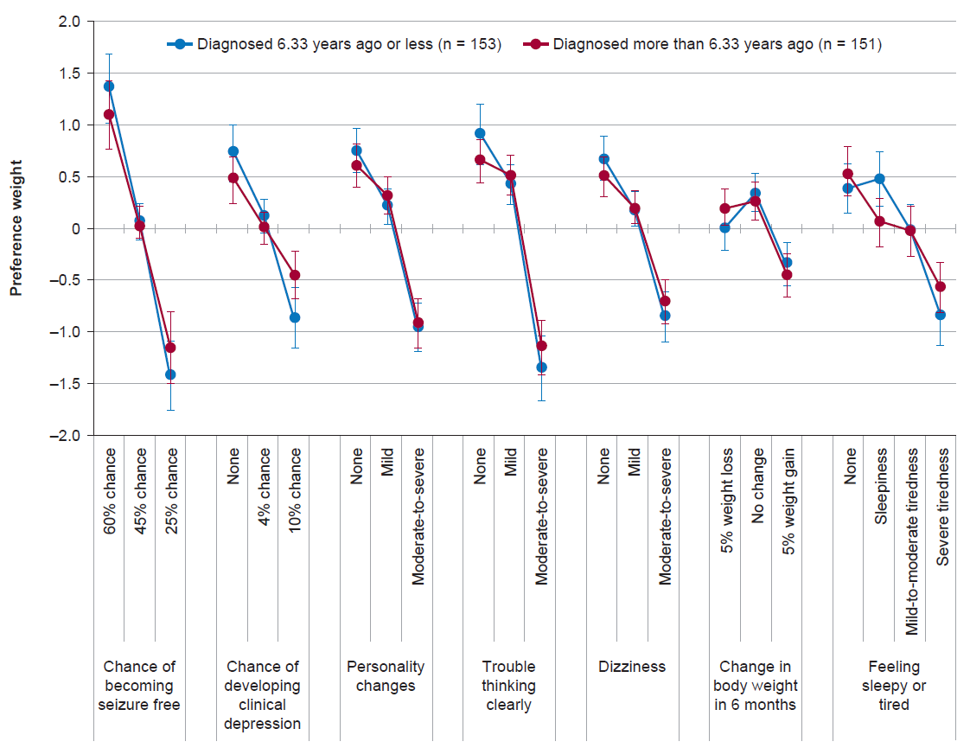 Error bars represent 95% confidence intervals. ªAlthough the ES included 310 patients, five patients did not complete the survey before the consultation, and the total subgroup sample size is <305 due to missing data.

FIGURE S9 Post hoc subgroup analysis of patient preference weights based on a discrete choice experiment survey before treatment consultation, random parameters logit model (Enrolled Set [ES], n = 305ª), by failed ASMs^{b} 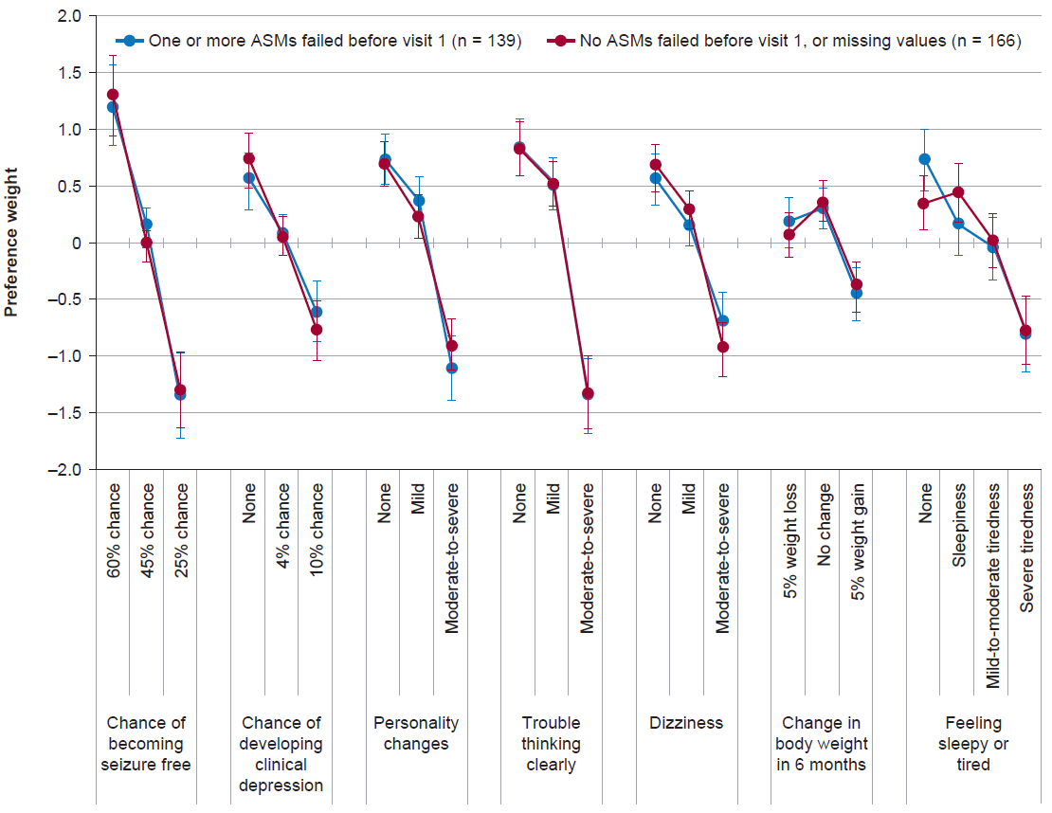 Error bars represent 95% confidence intervals. ªAlthough the ES included 310 patients, five patients did not complete the survey before the consultation. ^{b}Previous ASMs with a documented reason for discontinuation. ASM, antiseizure medication.

FIGURE S10 Post hoc subgroup analysis of patient preference weights based on a discrete choice experiment survey before treatment consultation, random parameters logit model (Enrolled Set [ES], n = 235ª), by reason for discontinuation of previous ASMs 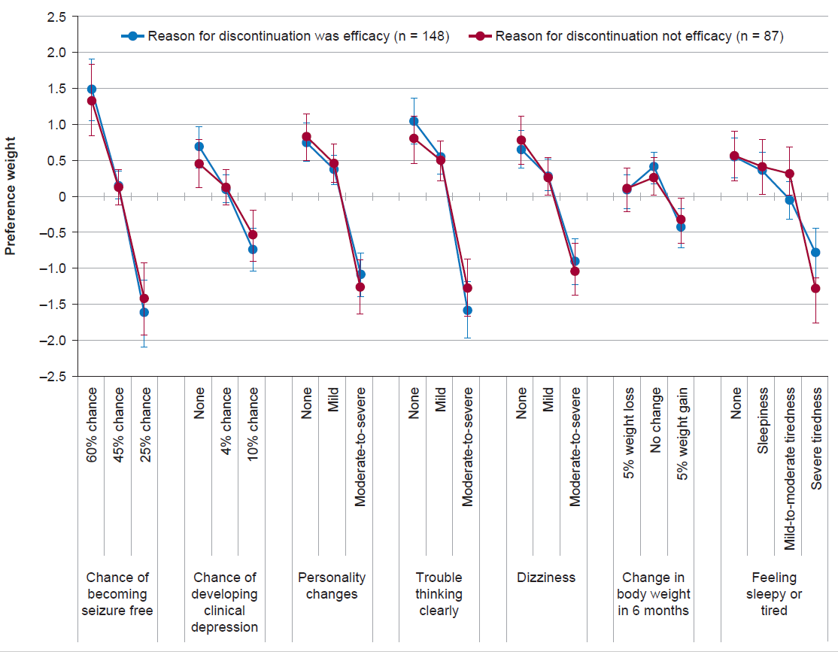 Error bars represent 95% confidence intervals. ªAlthough the ES included 310 patients, five patients did not complete the survey before the consultation, and the total subgroup sample size is <305 due to missing data. ASM, antiseizure medication.

FIGURE S11 Post hoc subgroup analysis of patient preference weights based on a discrete choice experiment survey before treatment consultation, random parameters logit model (Enrolled Set [ES], n = 185ª), by seizure type 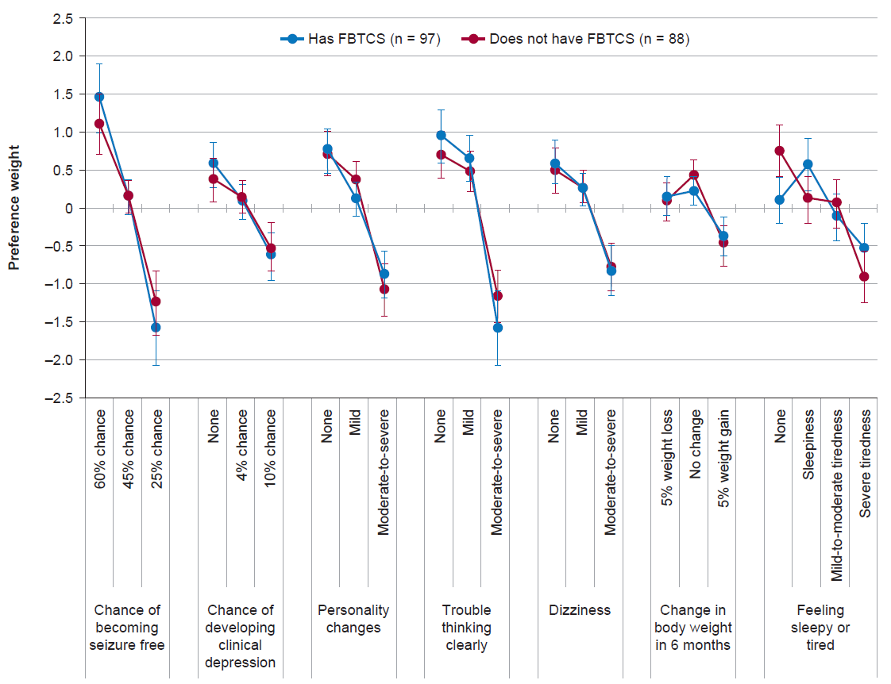 Error bars represent 95% confidence intervals. ªAlthough the ES included 310 patients, five patients did not complete the survey before the consultation, and the total subgroup sample size is <305 due to missing data. FBTCS, focal to bilateral tonic-clonic seizures.

FIGURE S12 Post hoc subgroup analysis of patient preference weights based on a discrete choice experiment survey before treatment consultation, random parameters logit model (Enrolled Set [ES], n = 302ª), by levetiracetam experience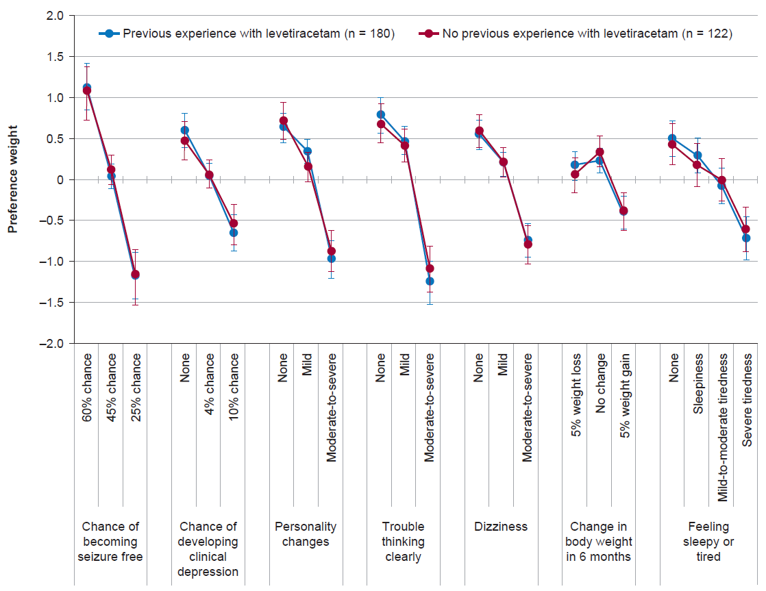 Error bars represent 95% confidence intervals. ªAlthough the ES included 310 patients, five patients did not complete the survey before the consultation, and the total subgroup sample size is <305 due to missing data.

FIGURE S13 Post hoc subgroup analysis of patient preference weights based on a discrete choice experiment survey before treatment consultation, random parameters logit model (Enrolled Set [ES], n = 304ª), by patient experience 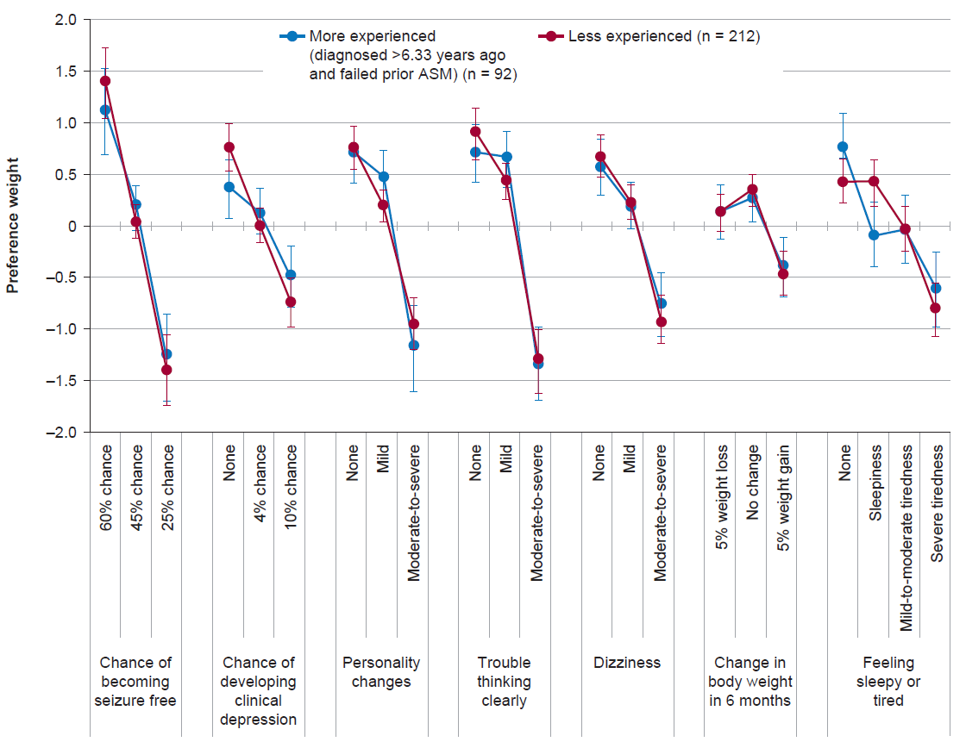 Error bars represent 95% confidence intervals. ªAlthough the ES included 310 patients, five patients did not complete the survey before the consultation, and the total subgroup sample size is <305 due to missing data. ASM, antiseizure medication.
FIGURE S14 Patient and physician preferences based on a discrete choice experiment survey, conditional multinomial logit model
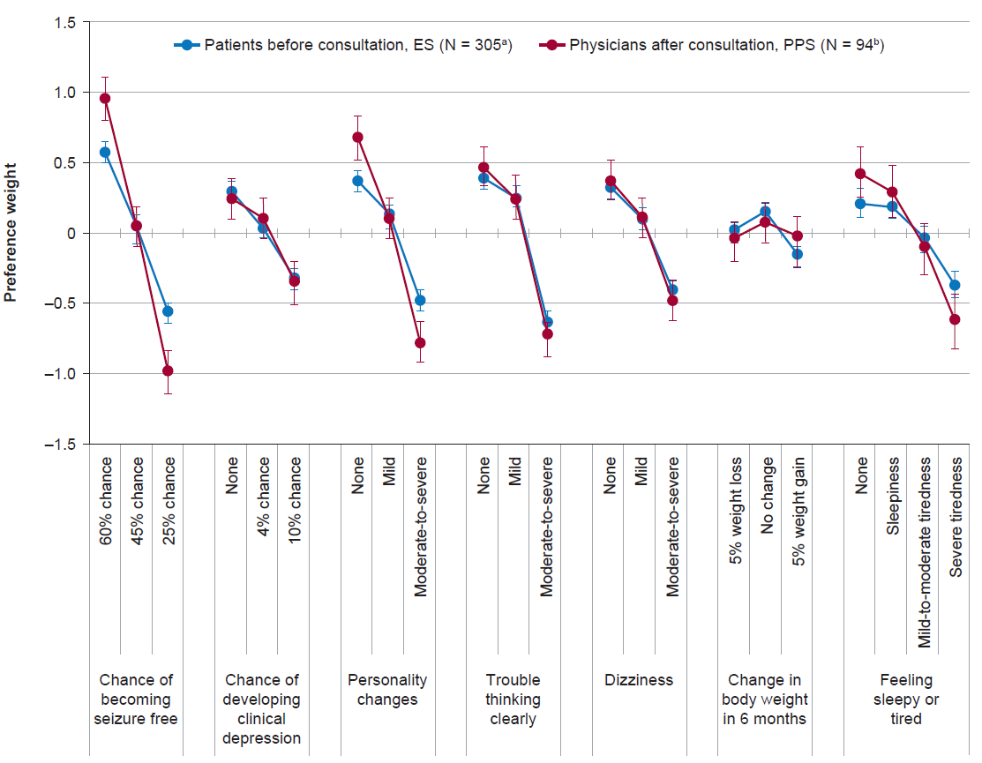
ªAlthough the ES included 310 patients, five patients did not complete the survey before the consultation. ^{b}Forty-nine physicians completed a total of 94 surveys (each physician completed the survey for up to three patients). ES, Enrolled Set; PPS, Physician Preference Set.

Investigator appendix
The authors acknowledge the EP0076 study investigators for their contributions to data acquisition: Manny Bagary, MD (Barberry National Centre for Mental Health – Neuropsychiatry, Birmingham, UK); Sergio Barbieri, MD (Fondazione IRCCS Cà Granda – Ospedale Maggiore Policlinico, Unità Operativa Neurofisiopatologia, Milano, Italy); Simone Beretta, MD (A.O. San Gerardo di Monza, Neurofisiopatologia, Monza, Italy); Julien Biberon, MD (Centre Hospitalier Regional Et Universitaire De Tours – Neurologie, Tours, France); Giovanni Boero, MD (Ospedale SS Annunziata, Neurologia, Taranto, Italy); Alice Brockington, MD (Sheffield Teaching Hospitals NHS Foundation Trust, Sheffield, UK); Roberto Cantello, MD (Azienda Ospedaliera “Maggiore della Carità” Clinica Neurologica, Novara, Italy); Francisco Javier Carod Artal, MD (Raigmore Hospital, Neurology, Inverness, UK); Jakob Christensen, MD (Aarhus Universitetshospital, Neurologisk Forskning, Aarhus, Denmark); Daniel Costello, MD (Cork University Hospital, Department of Neurology, Cork, Ireland); Arielle Crespel, MD (CHU - Hôpital Gui De Chauliac – Explorations Neurologiques, Montpellier, France); Filippo Dainese, MD (Ospedale SS Giovanni e Paolo, UOC Neurologia, Venezia, Italy); María De Toledo Heras, MD (Hospital Universitario La Princesa, Neurologia, Madrid, Spain); Philippe Derambure, MD (CHRU - Hôpital Roger Salengro – Neurophysiologie, Lille, France); Adrien Didelot, MD (Hôpital St-Joseph St-Luc, Lyon, France); Elisa Fallica, MD (Azienda Ospedaliero-Universitaria di Ferrara, U.O. Neurologia, Ferrara, Italy); Irene Florindo, MD (Azienda Ospedaliero-Universitaria di Parma, Neurologia, Parma, Italy); Nicoletta Foschi, MD (Ospedale Pediatrico G. Salesi, AOU Ospedali Riuniti Umberto I, SOD Clinica Neurologica, Ancona, Italy); Benito Galeano Bilbao, MD (Hospital Universitario Puerta del Mar, Neurología, Cádiz, Spain); Carlo Andrea Galimberti, MD (Istituto Neurologico Nazionale a Carattere Scientifico Fondazione Mondino, Centro per la diagnosi e Cura dell’Epilessia, Pavia, Italy); Antonio Gambardella, MD (Azienda Ospedaliero Universitario Mater Domini, Neurologia, Catanzaro, Italy); Nuria García Barragán, MD (Hospital Universitario Ramón y Cajal, Neurologia, Madrid, Spain); Filippo Giorgi, MD (Ospedale S. Chiara, Clinica Neurologica, Università di Pisa, Pisa, Italy); Jesús González de la Aleja, MD (Hospital Universitario 12 de Octubre, Neurologia, Madrid, Spain); Hajo Hamer, MD (Universitätsklinikum Erlangen, Neurologie, Erlangen, Germany); Edouard Hirsch, MD (CHU de Strasbourg, Service de Neurologie, Hôpital de Hautepierre, Strasbourg, France); Christoph Kellinghaus, MD (Klinikum Osnabrück, Epilepsiezentrum Münster Osnabrück, Osnabrück, Germany); John Paul Leach, MD (Queen Elizabeth Hospital, Neurology, Glasgow, UK); Emeline Lecadet, MD (Hôpital de La Cavale Blanche, Brest, France); Holger Lerche, MD (Universitätsklinikum Tübingen, Neurologie, Tübingen, Germany); Jan Lewerenz, MD (Universitatsklinikum Ulm, Abteilung für Neurologie, Ulm, Germany); Louis-Georges Maillard, MD (Centre Hospitalier Universitaire De Nancy - Hôpital Central - Service de Neurologie, Nancy, France); Thomas Mayer, MD (Kleinwachau - Sachsisches Epilepsiezentrum Radeberg, Radeberg, Germany); Oriano Mecarelli, MD (Umberto I Policlinico di Roma, Università La Sapienza, Dipartimento Neuroscienze Umane, Roma, Italy); Stefano Meletti, MD (Nuovo Ospedale Civile S. Agostino-Estense, Neurologia, Modena, Italy); Katarzyna Mieszczanek, MD (Aalborg University Hospital, Aalborg, Denmark); Fabio Minicucci, MD (Ospedale San Raffaele - Centro Per l’Epilessia, Neurologia, Milano, Italy); Rajiv Mohanraj, MD (Salford Royal NHS Foundation Trust, Salford, UK); Vincent Navarro, MD (CHU Pitié Salpetrière, Paris, France); Juan Oropesa Ruiz, MD (Hospital Vázquez Díaz, Neurología, Huelva, Spain); Marco Paganini, MD (AOU Careggi, Neurologia, Firenze, Italy); Fernando Pérez Parra, MD (Hospital Universitario del Henares, Neurología, Coslada, Spain); Arnaud Peyre, MD (Hôpital Nord Laennec, Nantes, France); Stefano Quadri, MD (ASST Papa Giovanni XXIII, Neurofisiopatologia, Bergamo, Italy); Michael Rademacher, MD (Universitätsklinikum Bonn, Neurologie, Bonn, Germany); Luis Redondo Verge, MD (Hospital Universitario Virgen de la Macarena, Neurología, Sevilla, Spain); Fritjof Reinhardt, MD (MVZ Senftenberg, Senftenberg, Germany); Sylvain Rheims, MD (Hôpital Neurologique, Service de neurologie fonctionnelle et d'Epileptologie, Bron, France); Juan Rodriguez Uranga, MD (Centro de Neurología Avanzada, Neurología, Sevilla, Spain); Bettina Schmitz, MD (Vivantes Humboldt-Klinikum, Klinik für Neurologie, Stroke Unit - Zentrum für Epilepsie, Berlin, Germany); Sean Slaght, MD (Queen Alexandra Hospital, Portsmouth, UK); Joachim Springub, MD (Studienzentrum Nord-West, Westerstede, Germany); Bernhard Steinhoff, MD (Diakonie Kork, Epilepsiezentrum Kork, Kehl, Germany); Hans-Beatus Straub, MD (Epilepsiezentrum Berlin-Brandenburg, Epilepsieklinik Tabor Bernau, Bernau, Germany); Manuel Toledo Argany, MD (Hospital Universitari Vall d'Hebron, Neurología, Barcelona, Spain); Mario Tombini, MD (PU Campus Bio-medico di Roma, Neurologia, Roma, Italy); Luc Valton, MD (CHU de Toulouse - Hôpital de Rangueil - Unité de Neurophysiologie, Toulouse, France); Cees Van Donselaar, MD (Maasstad Ziekenhuis, Rotterdam, the Netherlands); Felix Von Podewils, MD (Universitätsmedizin Greifswald, Klinik und Poliklinik für Neurologie, Epilepsiezentrum, Greifswald, Germany).

