Global Ecology and Biogeography
SUPPORTING INFORMATION
Climatic and biogeographic drivers of functional diversity in the flora of the Canary Islands

APPENDIX S4. Functional diversity and species richness of oceanic island floras

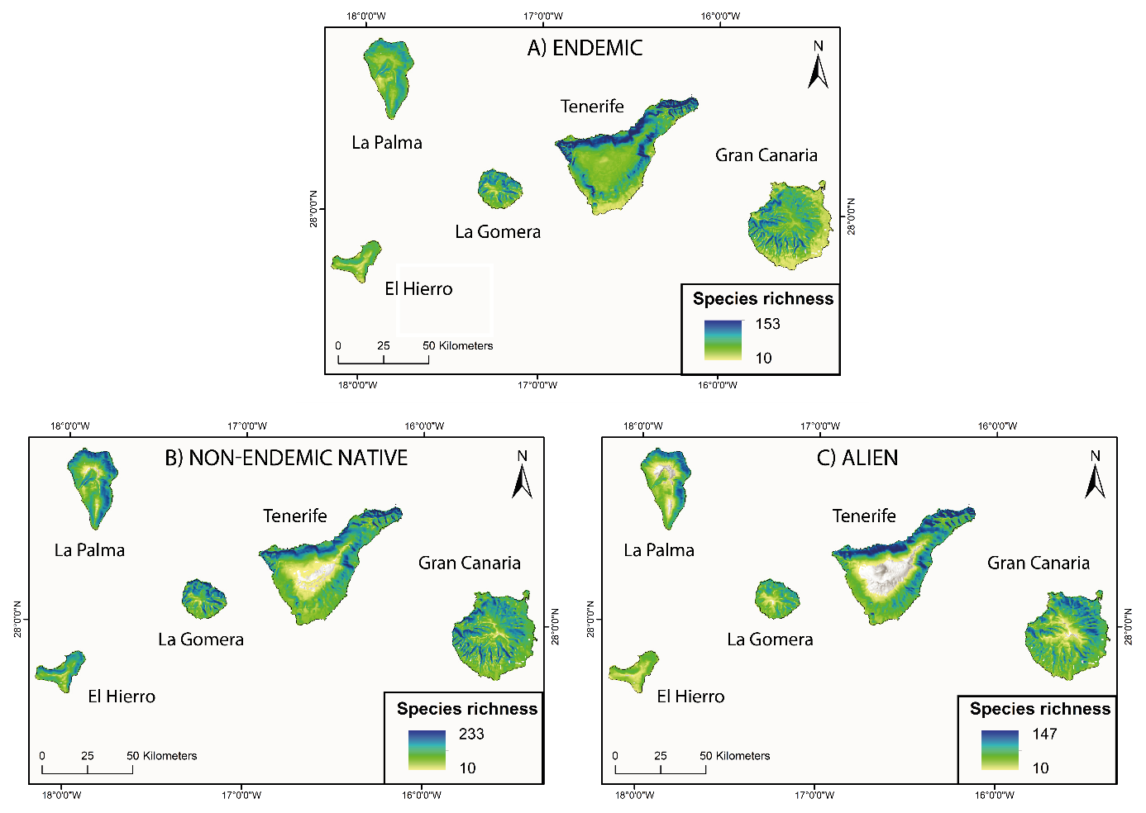
Figure S4.2. Map of modelled plant species richness per 500 m x 500 m across the Canary Islands for a) endemic, b) non-endemic native and c) alien assemblages (> 10 species).
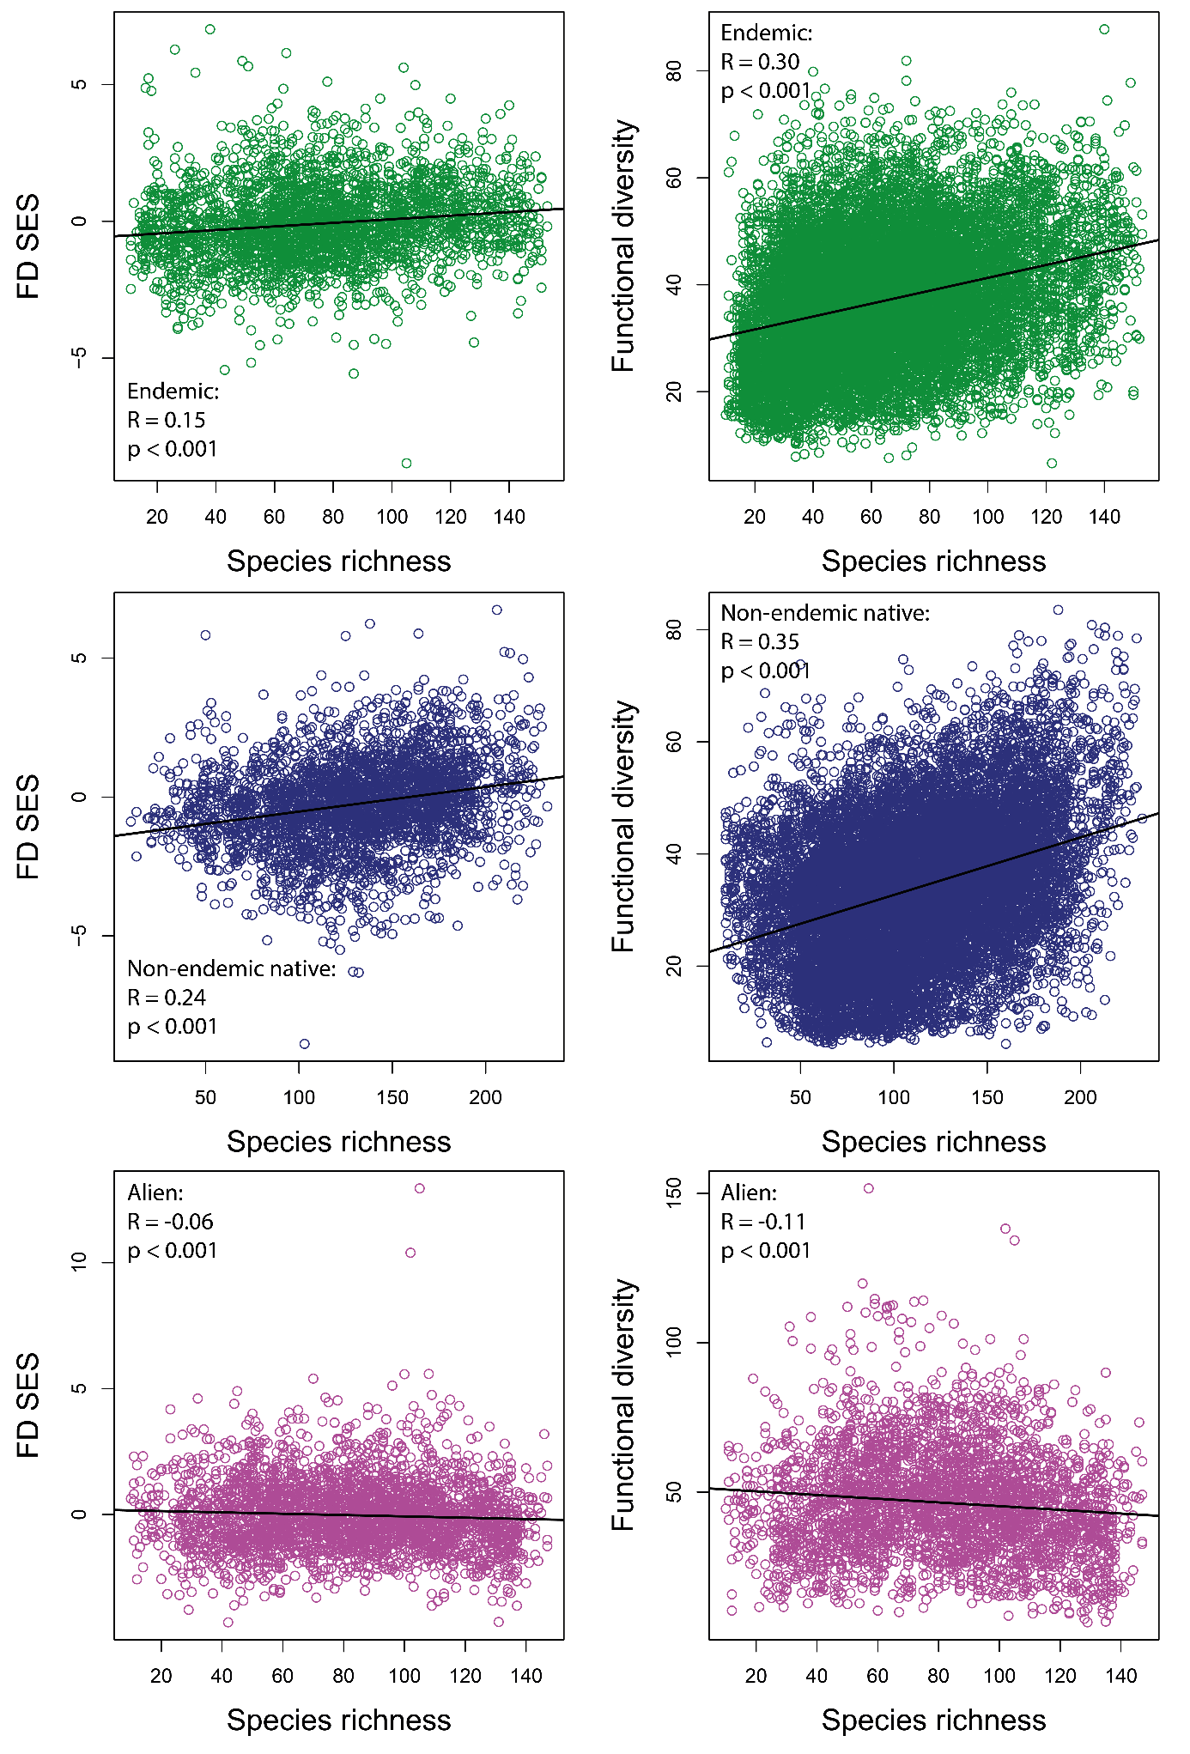
Figure S4.3. Pearson’s correlation between a-c) species richness and FD_{SES} and d-f) species richness and functional diversity based on 500 m x 500 m grid cells for observed endemic (n = 3,065), non-endemic (n = 3,063) and alien (n = 3,056) species assemblages. R is Pearson’s correlation coefficient and p indicates the statistical significance. Simple linear regression lines are depicted on the graphs for a clearer visualisation of the trends.

