Supplementary Figure S1: Behavioural performance while performing the task inside the MEG. A) Graph representing the mean reaction times for correct responses. B) Graph representing the mean percent correct. Blue bars represent reaction times/correct response rates in the pre-training session; while red bars represent the post-training session. Error bars represent the standard error of the mean (SEM).
Supplementary Figure S2: A time course of the near-significant channels (p = 0.06) for the interaction between SOA and Training. The time window of the near-significant interaction is indicated by the dashed window (-0.17s - 0.32s).
Supplementary Figure S3: Time-frequency plots for each SOA, averaged over pre- and post-training blocks. Main effects of SOA were not due to differences between the baseline window and time of interest.

Supplementary Figure S1
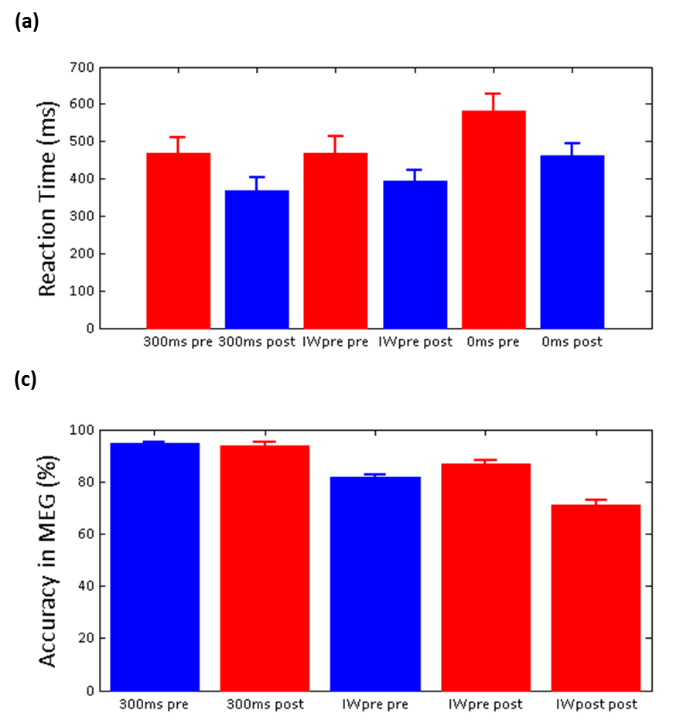
Mean Accuracy (%)
(B)
(A)

Supplementary Figure S2
Power (z-score)
Time (ms)

Supplementary Figure S3
