**Supplementary Materials**

This appendix is intended to provide readers with additional information about the present study.

Supplement to: Diagnosis of cirrhosis is associated with premature death in hospital admissions

**Table of Contents**

|  |  |  |
| --- | --- | --- |
|  | **Contents** | **Page** |
| **Supplementary Methods** |  | **3** |
| **Supplementary Results** |  | **6** |
| **Supplementary Table 1** | ICD-Code-based definitions of variables and outcomes | **7** |
| **Supplementary Table 2** | Risk-Adjusted prevalence rate (percent) of different chronic diseases as main diagnosis with liver cirrhosis as comorbidity | **11** |
| **Supplementary Table 3** | Demographic data of patients admitted with cirrhosis in DRG database, compared with Germany, North/Central Europe, South Europe and East Europe from CANONIC and PREDICT study. | **12** |
| **Supplementary Table 4** | Risk-Adjusted mortality rate (percent) of different chronic diseases as main diagnosis with liver cirrhosis as comorbidity | **13** |
| **Supplementary Table 5** | Multivariate multilevel logistic regression of cirrhosis and different other chronic diseases on in-hospital mortality, using type of region of the hospital as random effect. | **14** |
| **Supplementary Table 6** | Multilevel logistic regression of different specific chronic diseases and cirrhosis on in-hospital mortality | **15** |
| **Supplementary Table 7** | Multivariate multilevel logistic regression of cirrhosis and different other chronic diseases on in-hospital mortality of different length of hospital stay. | **16** |
| **Supplementary Table 8** | Risk-Adjusted prevalence rate (percent) of different etiologies of cirrhosis | **17** |
| **Supplementary Table 9** | Number of patients diagnosed with two or more etiologies of cirrhosis from year 2005 to 2018 | **18** |
| **Supplementary Table 10** | Risk-Adjusted prevalence rate (percent) of different complications of cirrhosis | **20** |
| **Supplementary Table 11** | Univariate multilevel logistic regression of cirrhosis and different other chronic diseases on in-hospital mortality, using federal states as random effect. | **21** |
| **Supplementary Table 12** | Number of admissions of cirrhosis patients with or without diagnosis of diabetes and with or without diagnosis of sarcopenia. | **22** |
| **Supplementary Table 13** | Mortality rate of patients diagnosed of cirrhosis and HCC from year 2005 to 2018 | **23** |
| **Supplementary Figure 1** | Percentage of male patients admitted with cirrhosis or other chronic diseases without diagnosis of cirrhosis; percentage of male patients admitted with different cirrhosis etiologies; percentage of male patients admitted with alcoholic cirrhosis and cirrhosis of other etiologies; mean age of patients admitted with different etiologies of cirrhosis and mean age of patients admitted with alcoholic cirrhosis and cirrhosis with other etiologies for each year from 2005 to 2018. | **24** |
| **Supplementary Figure 2** | Percentage of changes of male sex, median age and etiologies in DRG database from 2010 and 2011, to 2017 and 2018, compared with CANONIC study (2010-2011) to PREDICT study (2017-2018). | **25** |
| **Supplementary Figure 3** | Mortality rate of patients admitted for heart failure, kidney failure and COPD without diagnosis of cirrhosis, and with diagnosis of cirrhosis, each year from 2005 to 2018. | **26** |
| **Supplementary Figure 4** | Histogram of length of hospital stay in all admissions from 2005 to 2018 | **27** |
| **Supplementary Figure 5** | Number of admissions of patients diagnosed with liver cirrhosis and obesity according to different BMI categories for each year from 2008 to 2018; mean hospitalization days of patients admitted with alcoholic cirrhosis, cirrhosis with other etiology as main diagnosis and in-hospital mortality rate of patients admitted with alcoholic cirrhosis or cirrhosis of other etiology for each year from year 2005 to 2018. | **28** |
| **Supplementary Figure 6** | Number of admissions of cirrhosis patients with portal vein thrombosis, and number of admissions of cirrhosis patients with imaging examinations of CT scan, MRI/MRCP or ultrasound. | **29** |
| **Supplementary Figure 7** | Mortality rate of respiratory diseases without infection from year 2005 to 2018; mortality rate of respiratory diseases without infections in admission of cirrhosis patients and non-cirrhosis patients; and mortality rate of admissions of cirrhosis patients with or without infection | **30** |
| **Supplementary Figure 8** | Fold changes of admissions of cirrhosis patients with or without diagnosis of diabetes; and fold changes of admissions of cirrhosis patients with or without diagnosis of sarcopenia. | **31** |
| **Supplementary Figure 9** | Distribution of hospital admissions per 100,000 person-years and distribution of mortality rate of admissions of patients with other chronic diseases without diagnosis of liver cirrhosis in the German federal states from 2005 to 2018; | **32** |
| **Supplementary Figure 10** | Distribution of hospital admissions of patients with cirrhosis in different federal states in Germany from 2005 to 2018, and per 100,000 person-years; Distribution of numbers of in-hospital deaths due to cirrhosis in Germany from 2005 to 2018, mortality rate, and death per 100,000 person-years; | **33** |
| **Supplementary Reference** |  | **34** |

**Supplementary methods**

*Source of the data*

RDC of the Federal Statistical Office and Statistical Offices of the Federal States, (SAS, version 3·8; SAS Institute Inc., Cary, NC), (survey years 2005-2018), own calculations

*Coded etiologies for analysis*

Alcohol-related, NASH/NAFLD, primary biliary cholangitis, primary sclerosing cholangitis, chronic HBV, chronic HCV, haemochromatosis, Buddi-Chiari syndrome, Wilson’s disease and inflammatory liver diseases were included and combination of above etiologies were also analyses.

*Other categories of chronic diseases*

Patients without cirrhosis but admitted to hospital with other categories of chronic diseases were considered comparators to highlight the role of liver cirrhosis and were thus also included in the analysis. The categories of other diseases were defined according to study by UK committee, which are clinically meaningful and commonly diagnosed, avoiding over-stratification.8 The other categories of chronic diseases were defined according to the ICD-10 DRG coding system and are shown in Supplementary Table 1.

*CANONIC and PREDICT Study population*

Demographic data from European CANONIC study (2010-2011, n=1349) and PREDICT study (2017-2018, n=1273), including age, sex and etiology of decompensated cirrhosis were used for the following comparison: (1) trends overtime in the centers included in these studies with our DRG database; and (2) the comparison between Germany centers with central/north, south and east Europe. Details of these two studies have been described elsewhere.

*Compensated and decompensated cirrhosis*

Decompensated cirrhosis was defined as admissions with diagnosis of cirrhosis as well as any of the following complications, including ascites, gastrointestinal bleeding, hepatic encephalopathy, hepatorenal syndrome and/or infections. Whereas compensated cirrhosis was defined as patients admitted to hospital with cirrhosis but in absence of any of these complications*.*

*Adjusted prevalence rate and mortality rate*

Age and sex adjusted mortality rate and prevalence rate in each observational year of different diseases categories, etiologies of cirrhosis and complications were furtherly estimated using Poisson regression. Different type of region of the hospitals (urban region, region with rudimentary urban growth and rural region) from 2006 to 2018 were also used as a fixed effect to adjust clustering effects.

*Multilevel logistic regression model*

Covariates for the mortality analyses were measured and coded at hospital admission. Covariates include age of patients at admission (categorized per decades), male sex, main or secondary diagnosis of cirrhosis, chronic respiratory diseases, malignant diseases, cerebrovascular, digestive, ischemic heart, endocrine or metabolic diseases and diabetes. The diagnoses of chronic diseases are exclusive of cirrhosis, but not independently exclusive of each other. We further adjusted the model by infections, sarcopenia, and obesity without alcohol cirrhosis. Different federal states of Germany (Federal state was considered as categorical variable using Schleswig-Holstein as reference) from 2006 to 2018 were used as a random effect to control clustering effects for mortality. Univariate analysis results of these confounders were shown in Supplementary Table 11. Additionally, multilevel logistic regression models for in-hospital mortality were also performed by selecting cirrhosis, as well as other specific chronic diseases including chronic renal failure, heart failure and COPD into the model, adjusted by age and sex. The models were summarized in terms of odds ratios (OR) and 95% confidence intervals (CIs) with a forest plot. Multivariate multilevel logistic regression models of in-hospital mortality were additionally performed in the admission subgroups with length of hospital stay of no more than 7 days.

*Calculation for disability-adjusted life years (DALYs)*

DALYs are the sum of years of life lost (YLLs) due to premature death and years lived with disability (YLDs). To calculate YLDs, the number of disease admissions was multiplied by a disease disability weight. In compensated cirrhosis, patients have a disease disability weight of 0, whereas decompensated cirrhosis was assigned a disability weight of 0·1781. The prevalence rate and DALY rate were then calculated per 100,000 inhabitants of the German population in the respective year according to the Federal Statistical Office of Germany´s estimate.

*Map of prevalence and mortality of cirrhosis in Germany*

Prevalence and mortality data of individual federal states of Germany were mapped using Microsoft Excel 2019. The total number of admissions and number of deaths during the fourteen years period were further standardized to the number per 100,000 person-years according to local inhabitants of respective federal state.

*Softwares*

All statistical analyses were performed with SAS software (version 3·8; SAS Institute Inc., Cary, NC) and plotted with Prism (version 8·4·3 GraphPad Software, LLC).

**Supplementary results**

*Complications and etiologies of cirrhosis*

Though experienced a slightly decrease from 19·5% to 17·8%, mortality rate in admissions of cirrhosis patients with infection is significantly higher than patients without infection (Supplementary Figure 7).

Supplementary Figure 8 and Supplementary Table 12 shows additionally the fold change of sarcopenia as a complication of cirrhosis, which experienced a steep increase of more than eight times in the observational period.

Mortality rate of HCC has a significant decrease in 2018 (10.56%) compared to 2005 (14.13%) (Supplementary Table 13)

*Regional distribution of hospital admissions and mortality in Germany from 2005 to 2018*

Supplementary Figure 9 shows the distribution of the total number of hospital admissions in the federal states of Germany from 2005 to 2018, while the prevalence rate distribution is further depicted as per 100,000 person-years. North Rhine-Westphalia (471,492) had the highest raw number of admissions of liver cirrhosis (Supplementary Figure 10A), followed closely by Bavaria (334,628) and Baden-Wurttemberg (286,853). After admissions were normalized to 100,000 person-years (Supplementary Figure 10B), the eastern federal states of Saxony-Anhalt (287), Saxony (285) and Mecklenburg Western Pomerania (282) had the highest prevalence rate of cirrhosis.

As expected, the federal states with the highest number of in-hospital deaths due to liver cirrhosis was the federal state with the highest number of admissions, i.e. North Rhine Westphalia (48,887) (Supplementary Figure 10C). However, the highest in-hospital mortality rate of liver cirrhosis was found to be concentrated in north-eastern German states, where Saxony had the highest density of deaths with 31 deaths per 100,000 person-years (Supplementary Figure 10D). Interestingly, the highest mortality rate distribution of non-liver cirrhosis diseases was observed in Saxony and Saxony-Anhalt (Supplementary Figure 9), while the highest in-hospital mortality rate among all admissions with diagnosis of liver cirrhosis were observed in Schleswig-Holstein with 12·2% and Brandenburg with 12·1%. The southern federal states of Baden-Wurttemberg, Hesse, Bavaria and Rhineland-Palatinate had the lowest mortality rates (<10·7) (Supplementary Figure 10E).

Supplementary table 1: ICD-10-Code, OPS code and based definitions of variables and outcomes

|  |  |  |
| --- | --- | --- |
| **Variable** | **ICD - 10** | **Definitions** |
| **Liver cirrhosis** | K74, K70.3 | Fibrosis and cirrhosis of the liver and alcoholic cirrhosis of the liver |
| **Etiologies of cirrhosis** |  |  |
| Alcohol | K70.3 | Alcoholic cirrhosis of the liver |
| Chronic HCV | B18.2 | Chronic viral hepatitis C |
| Primary biliary cholangitis | K74.3 | Primary biliary cirrhosis  Includes: Chronic non-purulent destructive cholangitis |
| Chronic HBV | B18.0, B18.1 | Chronic viral hepatitis B with delta virus and chronic viral hepatitis B without delta virus |
| Primary sclerosing cholangitis | K83.0 | Cholangitis  Includes: ascending, purulent, primary, recurrent, secondary and sclerosing cholangitis.  Excludes: Cholangitis with choledocholithiasis liver abscess and chronic non-purulent destructive cholangitis |
| NAFLD | K76 | Fatty liver [fatty degeneration], not classified elsewhere  Includes: Non-alcoholic fatty liver  Excludes: Non-alcoholic steatohepatitis [NASH] |
| NASH | K75.8 | Other specified inflammatory liver diseases  Includes: Non-alcoholic steatohepatitis [NASH] |
| Hemochromatosis | E83.1 | Disorders of iron metabolism  Includes: hemochromatosis  Excludes: Iron deficiency and sideroachrestic [sideroblastic] anemia |
| Inflammatory liver disease | K75.9 | Inflammatory liver disease, unspecified |
| Budd-Chiari syndrome | I82.0 | Budd-Chiari-Syndrome |
| Wilson's disease | E83.0 | Disorders of copper metabolism  Includes: Menkes syndrome (kinky hair) (steely hair) and Wilson's disease |
| **Complications of liver cirrhosis** | |  |
| Anemia | D50, D51, D52, D53, D55 to D64 | Alimentary anemia, hemolytic anemia, and aplastic and other anemias |
| Ascites | R18 | Ascites  Includes: Fluid accumulation in the abdominal cavity |
| Hepatic encephalopathy | K72 | Liver failure, not classified elsewhere  Include: Coma, hepatic encephalopathy, yellow liver, atrophy or dystrophy, brilliantly, not classified elsewhere, with liver failure, malignant elsewhere not classified, with liver failure, liver (cell) necrosis with liver failure |
| Infections | A00 to A09, A20 to A28, A30 to A89, A92 to A99, B95 to B98, N39, J12, J13, J14, J15, J16, J17, J18, L00, L01, L02, L03, L04, L05, L06, L07, L08, M72, K65, K83 | Infectious intestinal diseases; certain bacterial zoonoses; other bacterial diseases; infections that are mainly transmitted through sexual intercourse; other spirochete diseases; other diseases caused by chlamydia; rickettsioses; viral infections of the central nervous system; arthropod-borne viral diseases and viral hemorrhagic fevers; bacteria, viruses and other infectious agents as the cause of diseases that are classified in other chapters; pneumonia; urinary tract infection; skin and subcutaneous infections; fibromatoses and peritonitis and cholangitis. |
| Hepatocellular carcinoma | C22.0 | Liver carcinoma  Includes: Hepatocellular carcinoma |
| Gastrointestinal bleeding | K92.2 | Gastrointestinal bleeding, unspecified  Includes: Bleeding: Intestine and stomach  Excludes: Acute hemorrhagic gastritis, angiodysplasia of the small intestine with bleeding, angiodysplasia of the colon with bleeding, angiodysplasia of the stomach and duodenum with bleeding, hemorrhage of the anus and rectum with peptic ulcer |
| Hepatorenal syndrome | K76.7 | Hepatorenal syndrome  Excludes: After labor and delivery |
| Esophageal variceal bleeding | I85.0 | Esophageal varices with bleeding  Excludes: Esophageal varices with indication of bleeding in liver diseases and esophageal varices with indication of bleeding in schistosomiasis |
| Portal vein thrombosis | I81 | Portal vein thrombosis  Includes: Portal vein closure  Excludes: Portal vein phlebitis |
| Sarcopenia | M62.5 | Muscle wasting and atrophy, not classified elsewhere  Includes: inactivity atrophy, not classified and elsewhere sarcopenia |
| Obesity | E66 |  |
| BMI 31-34kg/m2  BMI 35-39kg/m2  BMI > 40 kg/m2 | E66.90  E66.91  E66.92 | Obesity, unspecified: Obesity grade I (WHO) in patients aged 18 years and older;  Obesity, unspecified: Obesity grade II (WHO) in patients aged 18 years and older;  Obesity, unspecified: Obesity grade III (WHO) in patients aged 18 years and older |
| **Other diseases of admissions** | |  |
| Malignant diseases | C00 – C99 | Malignant neoplasms at precisely identified locations, identified or suspected to be primary, excluding lymphatic, hematopoietic and related tissue; Malignant neoplasms of the lip, oral cavity and pharynx, the digestive organs, the respiratory organs and other intrathoracic organs, bone and articular cartilage, melanoma and other malignant neoplasms of the skin, the mesothelial and soft tissue, the mammary gland [mamma], the female genital organs, the male genital organs, the urinary organs, the eye, brain and other parts of the central nervous system, the thyroid and other endocrine glands, in imprecise, secondary and unspecified locations, the lymphatic, hematopoietic and related tissues, identified or suspected to be primary and malignant neoplasms as primary tumors in several locations. |
| Circulatory | I00 – I99 | Acute rheumatic fever, chronic rheumatic heart diseases, hypertension, ischemic heart disease, pulmonary heart disease and diseases of the pulmonary circulation, other forms of heart disease, cerebrovascular diseases, diseases of the arteries, arterioles and capillaries, diseases of the veins, lymphatic vessels, and lymph nodes, not elsewhere classified, other and unspecified diseases of the circulatory system |
| Diabetes | E10, E11, E12, E13, E14 | Diabetes mellitus type 1, diabetes mellitus type 2, diabetes mellitus in connection with malnutrition or malnutrition [malnutrition], other specified diabetes mellitus and unspecified diabetes mellitus |
| Digestive system | K00–K93 (exclude K74, K70.3) | Diseases of the oral cavity, salivary glands and jaw, diseases of the esophagus, stomach and duodenum, diseases of the appendix, hernias, non-infectious enteritis and colitis, other diseases of the intestine, diseases of the peritoneum, liver diseases exclude cirrhosis, diseases of the gallbladder, biliary tract and pancreas and other digestive disorders |
| Endocrine or metabolic | E00–E90 (exclude E10 - E14) | Diseases of the thyroid, other disorders of blood glucose regulation and internal secretion of the pancreas, diseases of other endocrine glands, malnutrition, other nutritional deficiencies, obesity and other overeating and metabolic disorders |
| Ischemic heart | I20, I21, I22, I23, I24, I25 | Angina pectoris, acute myocardial infarction, recurrent myocardial infarction, certain acute complications after acute myocardial infarction, other acute ischemic heart disease and chronic ischemic heart disease |
| Cerebrovascular | I60, I61, I62, I63, I64, I65, I66, I67, I68, I69 | Cerebrovascular Diseases  Includes: with indication of hypertension  Excludes: traumatic intracranial hemorrhage, vascular dementia, transient cerebral ischemia and related syndromes |
| Respiratory | J00 – J99 | Acute upper respiratory tract infections, flu and pneumonia, other acute lower respiratory infections, other upper respiratory diseases, chronic lower respiratory diseases, lung diseases caused by exogenous substances, other respiratory diseases mainly affecting the interstitium, purulent and necrotizing lower respiratory diseases, other diseases of the pleura and other diseases of the respiratory system. |
| Others | A00-B99, D00-D48, F00-F99, H00-H59, L00-L99, M00-M99, N00-N99, O00-O99, P00-P96, Q00-Q99, R00-R99, S00-T98, V01-Y84, Z00-Z99, U00-U99 | Certain infectious and parasitic diseases, in-situ neoplasms, benign neoplasms, neoplasms of unsafe or unknown behavior, mental and behavioral disorders, diseases of the eye and the appendages, diseases of the skin and subcutaneous tissue, musculoskeletal and connective tissue diseases, diseases of the genitourinary system, pregnancy, childbirth and the puerperium, certain conditions that originate in the perinatal period, congenital malformations, deformities and chromosomal abnormalities, symptoms and abnormal clinical and laboratory findings not elsewhere classified, injuries, poisoning and certain other consequences of external causes, external causes of morbidity and mortality, factors that affect health and lead to health care utilization, and key numbers for special purposes |
| **Specific chronic diseases of admissions** | |  |
| Chronic renal failure | N18 | Chronic kidney disease  Includes: Chronic kidney failure, renal retinitis,  uremic dementia, uremic neuropathy and uremic pericarditis |
| Chronic heart failure | I50 | Heart failure  Excludes: as a complication in abortion, ectopic or molar pregnancy, as a complication of obstetric surgeries and measures, congestive heart failure of newborn and after heart surgery or because of a heart prosthesis |
| Chronic obstructive pulmonary disease (COPD) | J44 | Other chronic obstructive pulmonary disease  Includes: chronic bronchitis asthmatic (obstructive), chronic bronchitis emphysematous, chronic bronchitis with emphysema, chronic obstructive bronchitis, and chronic obstructive tracheobronchitis  Excludes: bronchial asthma, asthmatic bronchitis, bronchiectasis, chronic bronchitis, chronic simple and mucous-purulent bronchitis, chronic tracheitis, chronic tracheobronchitis, emphysema and lung diseases caused by exogenous substances |
| **Compensated cirrhosis** | K74 or K70.3 exclude R18, K72 J12, J13, J14, J15, J16, J17, J18, L01, L02, L03, M72, K65, K92.2 or K76.7 | Cirrhosis without ascites, hepatic encephalopathy, infections, hepatorenal syndrome, esophageal variceal bleeding |
| **Decompensated cirrhosis** | K74, K70.3 with R18, K72 J12, J13, J14, J15, J16, J17, J18, L01, L02, L03, M72, K65, K92.2, or K76.7 | Cirrhosis with ascites, hepatic encephalopathy, infections, hepatorenal syndrome, esophageal variceal bleeding |
| **Interventions** | **OPS codes** |  |
| Liver transplantation | 5-504 | Liver transplant  Excludes: allogeneic hepatocyte transplantation |
| Ultrasound | 3-030 | Complex differential diagnostic sonography with digital image and video documentation |
| CT | 3-207, 3-225 | Native computed tomography of the abdomen, computed tomography of the abdomen with contrast agent |
| MRT or MRCP | 3-803, 3-825, 3-843 | Native magnetic resonance imaging of the heart, magnetic resonance imaging of the abdomen with contrast agent and magnetic resonance cholangiopancreatography [MRCP] |

Supplementary table 2. Risk-Adjusted prevalence rate (percent) of different chronic diseases as main diagnosis with liver cirrhosis or its complications as comorbidity

|  |  |  |  |  |  |  |  |  |  |  |  |  |  |  |  |
| --- | --- | --- | --- | --- | --- | --- | --- | --- | --- | --- | --- | --- | --- | --- | --- |
| Risk-Adjusted prevalence rate (percent) | 2005 | 2006 | 2007 | 2008 | 2009 | 2010 | 2011 | 2012 | 2013 | 2014 | 2015 | 2016 | 2017 | 2018 | Ajusted Rate Ratio per Year (95%CI) |
| **Cirrhosis as comborbidity** | |  |  |  |  |  |  |  |  |  |  |  |  |  |  |
| **Digestive system** | 25.33(20.47 - 31.33) | 25.28(20.44 - 31.26) | 25.25(20.38 - 31.27) | 25.2(20.35 - 31.22) | 25.18(20.31 - 31.22) | 25.1(20.26 - 31.1) | 25.07(20.22 - 31.09) | 25.03(20.18 - 31.03) | 24.98(20.15 - 30.95) | 24.91(20.14 - 30.81) | 24.86(20.11 - 30.74) | 24.83(20.07 - 30.71) | 24.8(20.07 - 30.63) | 24.77(20.02 - 30.66) | 1(0.999 - 1.001) |
| Malignant diseases | 11.67(7.7 - 17.69) | 11.47(7.54 - 17.44) | 11.42(7.48 - 17.44) | 11.37(7.44 - 17.39) | 11.32(7.4 - 17.32) | 11.31(7.38 - 17.32) | 11.11(7.21 - 17.13) | 11.07(7.19 - 17.05) | 11.03(7.17 - 16.98) | 11.03(7.18 - 16.94) | 10.99(7.15 - 16.88) | 10.95(7.12 - 16.84) | 10.91(7.11 - 16.75) | 10.85(7.05 - 16.69) | 0.993(0.992 - 0.995) |
| Circulatory | 11.64(5.29 - 25.62) | 11.68(5.32 - 25.68) | 11.72(5.29 - 25.97) | 11.76(5.31 - 26.08) | 11.77(5.29 - 26.21) | 11.88(5.34 - 26.42) | 11.91(5.34 - 26.56) | 11.95(5.35 - 26.67) | 12.01(5.39 - 26.76) | 12.11(5.46 - 26.84) | 12.16(5.5 - 26.89) | 12.2(5.5 - 27.05) | 12.23(5.54 - 26.98) | 12.24(5.51 - 27.17) | 0.997(0.996 - 0.998) |
| Diabetes | 3.85(3.38 - 4.38) | 3.82(3.35 - 4.34) | 3.79(3.33 - 4.32) | 3.76(3.31 - 4.29) | 3.74(3.28 - 4.26) | 3.71(3.26 - 4.23) | 3.69(3.23 - 4.2) | 3.66(3.21 - 4.17) | 3.63(3.19 - 4.14) | 3.61(3.17 - 4.11) | 3.58(3.14 - 4.08) | 3.56(3.12 - 4.06) | 3.53(3.1 - 4.03) | 3.51(3.08 - 4) | 0.993(0.99 - 0.995) |
| Respiratory | 3.31(2.77 - 3.96) | 3.4(2.84 - 4.06) | 3.49(2.92 - 4.18) | 3.59(3 - 4.3) | 3.69(3.07 - 4.42) | 3.79(3.16 - 4.54) | 3.89(3.24 - 4.67) | 4(3.33 - 4.8) | 4.11(3.42 - 4.93) | 4.23(3.52 - 5.07) | 4.34(3.62 - 5.21) | 4.46(3.72 - 5.35) | 4.58(3.82 - 5.5) | 4.71(3.92 - 5.65) | 1.026(1.024 - 1.029) |
| Endocrine or metabolic | 2.27(1.16 - 4.44) | 2.35(1.21 - 4.59) | 2.44(1.24 - 4.8) | 2.52(1.28 - 4.97) | 2.62(1.33 - 5.18) | 2.7(1.37 - 5.34) | 2.8(1.42 - 5.55) | 2.91(1.47 - 5.76) | 3(1.52 - 5.95) | 3.1(1.57 - 6.12) | 3.21(1.63 - 6.32) | 3.32(1.68 - 6.57) | 3.45(1.75 - 6.78) | 3.58(1.81 - 7.08) | 1.041(1.038 - 1.044) |
| Cerebrovascular | 1.98(1.16 - 3.38) | 1.94(1.14 - 3.31) | 1.9(1.11 - 3.26) | 1.87(1.09 - 3.2) | 1.83(1.07 - 3.14) | 1.8(1.05 - 3.09) | 1.76(1.03 - 3.03) | 1.73(1.01 - 2.97) | 1.7(0.99 - 2.91) | 1.67(0.98 - 2.85) | 1.64(0.96 - 2.8) | 1.61(0.94 - 2.74) | 1.57(0.92 - 2.68) | 1.54(0.9 - 2.64) | 0.976(0.973 - 0.98) |
| Ischemic heart | 1.72(0.79 - 3.74) | 1.69(0.78 - 3.68) | 1.67(0.76 - 3.65) | 1.64(0.75 - 3.6) | 1.61(0.73 - 3.55) | 1.59(0.72 - 3.51) | 1.57(0.71 - 3.46) | 1.54(0.7 - 3.41) | 1.52(0.69 - 3.37) | 1.5(0.68 - 3.32) | 1.48(0.67 - 3.26) | 1.46(0.66 - 3.22) | 1.43(0.65 - 3.16) | 1.41(0.64 - 3.12) | 0.98(0.976 - 0.983) |

Note: Risk-adjusted rates of prevalence of different chronic diseases as main diagnosis to for each calendar year are reported for the overall admissions. Rates were adjusted for age, sex, calendar year and type of region of the hospital. Type of region of the hospital was considered as categorical variable using urban region as reference. Adjusted risk ratios were determined with a Poisson regression model evaluating calendar year as a continuous variable.

Abbreviations: CI, confidence interval

Supplementary Table 3. Comparison of demographic data of all cirrhosis or decompensated cirrhosis patients with DRG (2010, 2011, 2017 and 2018), Germany, North/Central Europe, South Europe and East Europe from CANONIC2 and PREDICT3,4 study.

|  |  |  |  |  |  |  |
| --- | --- | --- | --- | --- | --- | --- |
|  | DRG  all cirrhosis  (n=680,876) | DRG decompensated  (n=259,345) | Germany  (n=442) | North/Central Europe  (n=602) | South Europe  (n=1397) | East Europe  (n=181) |
| Median age, year | 64 a | 63a | 58 | 56* | 59 | 59 |
| Male, % | 64·8 | 57.2 | 57.9 | 64.0 | 68.7* | 66.3 |
| Etiology, % | * |  |  |  | * | * |
| Alcohol | 53·3 | 62.3 | 68.6 | 72.6 | 60.0 | 80.6 |
| Viral | 5·8 | 10.4 | 13.4 | 15.4 | 34.5 | 8.8 |
| Other | 0·5 | 18.6 | 12.7 | 17.6 | 10.9 | 10.0 |

*P<0.05. Significances were compared with decompensated cirrhosis patients from Germany of the CANONIC and PREDICT study

a. Median age of DRG data base was not possible to be compared with median age of CANONIC and PREDICT study due to unavailability of data from individual patient

Supplementary Table 4. Risk-Adjusted mortality rate (percent) of different chronic diseases without liver cirrhosis

|  |  |  |  |  |  |  |  |  |  |  |  |  |  |  |  |
| --- | --- | --- | --- | --- | --- | --- | --- | --- | --- | --- | --- | --- | --- | --- | --- |
| Risk-Adjusted mortality rate (percent) | 2005 | 2006 | 2007 | 2008 | 2009 | 2010 | 2011 | 2012 | 2013 | 2014 | 2015 | 2016 | 2017 | 2018 | Ajusted Rate Ratio per Year (95%CI) |
| **Cirrhosis** | 11.27(7.35 - 17.29) | 10.95(7.14 - 16.79) | 10.76(7.01 - 16.54) | 10.58(6.87 - 16.29) | 10.39(6.74 - 16.01) | 10.24(6.65 - 15.76) | 10.08(6.53 - 15.54) | 9.91(6.42 - 15.28) | 9.75(6.33 - 15.02) | 9.6(6.24 - 14.77) | 9.42(6.12 - 14.49) | 9.26(6.01 - 14.26) | 9.1(5.92 - 13.98) | 8.93(5.78 - 13.78) | 0.979(0.978 - 0.981) |
| **Without cirrhosis** |  |  |  |  |  |  |  |  |  |  |  |  |  |  |  |
| Digestive system | 3.3(0.54 - 20.27) | 2.32(0.29 - 18.52) | 2.34(0.3 - 18.38) | 2.33(0.3 - 18.23) | 2.33(0.3 - 18.07) | 2.35(0.31 - 17.91) | 2.33(0.31 - 17.61) | 2.33(0.31 - 17.42) | 2.3(0.31 - 17.1) | 2.28(0.31 - 16.87) | 2.27(0.31 - 16.66) | 2.25(0.31 - 16.37) | 2.26(0.31 - 16.22) | 2.23(0.31 - 15.98) | 0.984(0.984 - 0.985) |
| Malignant diseases | 6.28(3 - 13.14) | 5.82(2.66 - 12.7) | 5.78(2.66 - 12.58) | 5.74(2.64 - 12.45) | 5.7(2.63 - 12.37) | 5.67(2.61 - 12.3) | 5.68(2.6 - 12.41) | 5.63(2.57 - 12.33) | 5.57(2.55 - 12.17) | 5.53(2.54 - 12.03) | 5.47(2.5 - 11.93) | 5.41(2.48 - 11.8) | 5.37(2.46 - 11.73) | 5.32(2.43 - 11.63) | 0.988(0.987 - 0.988) |
| Circulatory | 3.71(1.06 - 12.95) | 3.23(0.89 - 11.73) | 3.23(0.9 - 11.61) | 3.21(0.9 - 11.5) | 3.19(0.89 - 11.45) | 3.16(0.88 - 11.37) | 3.13(0.87 - 11.22) | 3.1(0.87 - 11.1) | 3.07(0.86 - 10.93) | 3.03(0.85 - 10.84) | 3(0.84 - 10.75) | 2.96(0.82 - 10.66) | 2.94(0.82 - 10.59) | 2.91(0.81 - 10.47) | 0.985(0.985 - 0.985) |
| Diabetes | - | 3.56(0.95 - 13.26) | 3.54(0.95 - 13.14) | 3.51(0.95 - 12.99) | 3.48(0.94 - 12.89) | 3.44(0.93 - 12.75) | 3.39(0.91 - 12.61) | 3.35(0.9 - 12.44) | 3.29(0.88 - 12.28) | 3.2(0.83 - 12.4) | 3.15(0.8 - 12.43) | 3.07(0.76 - 12.42) | 3.03(0.74 - 12.48) | 2.95(0.69 - 12.55) | 0.982(0.981 - 0.982) |
| Endocrine or metabolic | - | 2.82(0.48 - 16.74) | 2.85(0.48 - 16.77) | 2.88(0.5 - 16.6) | 2.9(0.52 - 16.27) | 2.91(0.52 - 16.21) | 2.89(0.52 - 15.89) | 2.88(0.53 - 15.74) | 2.85(0.52 - 15.66) | 2.82(0.52 - 15.35) | 2.8(0.51 - 15.31) | 2.75(0.5 - 15.1) | 2.77(0.51 - 14.97) | 2.73(0.5 - 14.86) | 0.986(0.986 - 0.986) |
| Chronic respiratory | 4.43(0.52 - 38.02) | 2.41(0.17 - 34.13) | 2.43(0.17 - 33.78) | 2.45(0.18 - 33.06) | 2.43(0.18 - 32.71) | 2.49(0.19 - 32.51) | 2.51(0.2 - 32.02) | 2.55(0.21 - 31.53) | 2.51(0.2 - 30.95) | 2.51(0.21 - 30.12) | 2.5(0.21 - 29.57) | 2.45(0.21 - 28.79) | 2.5(0.22 - 28.37) | 2.45(0.22 - 27.68) | 0.976(0.975 - 0.976) |
| Cerebrovascular | - | 6.87(3.01 - 15.68) | 6.79(2.97 - 15.5) | 6.71(2.94 - 15.31) | 6.65(2.92 - 15.15) | 6.59(2.89 - 15) | 6.5(2.86 - 14.8) | 6.41(2.82 - 14.58) | 6.33(2.78 - 14.38) | 6.24(2.74 - 14.19) | 6.16(2.7 - 14.06) | 6.06(2.64 - 13.91) | 5.99(2.61 - 13.77) | 5.9(2.55 - 13.65) | 0.986(0.985 - 0.986) |
| Ischemic heart | - | 3.91(1.22 - 12.51) | 3.89(1.22 - 12.42) | 3.88(1.22 - 12.33) | 3.86(1.22 - 12.27) | 3.84(1.21 - 12.18) | 3.81(1.2 - 12.04) | 3.77(1.19 - 11.92) | 3.73(1.19 - 11.73) | 3.69(1.18 - 11.57) | 3.65(1.16 - 11.47) | 3.6(1.14 - 11.36) | 3.58(1.13 - 11.29) | 3.54(1.12 - 11.19) | 0.983(0.982 - 0.983) |

Note: Risk-adjusted rates of prevalence of different chronic diseases as main diagnosis to for each calendar year are reported for the overall admissions. Rates were adjusted for age, sex, calendar year and type of the region of the hospital. Type of the region of the hospital was considered as categorical variable using urban region as reference. Adjusted risk ratios were determined with a Poisson regression model evaluating calendar year as a continuous variable.

Abbreviations: CI, confidence interval.

Supplementary Table 5. Multivariate multilevel logistic regression of cirrhosis and different other chronic diseases on in-hospital mortality, using different federal state of Germany as random effect.

|  |  |  |  |
| --- | --- | --- | --- |
|  | **Odds ratio** | **95% Confidence Limits** | |
| **Cirrhosis** | 6.200 | 6.134 | 6.265 |
| **Infections** | 4.746 | 4.723 | 4.768 |
| **Malignant diseases** | 4.106 | 4.088 | 4.124 |
| **Respiratory diseases** | 3.440 | 3.420 | 3.459 |
| **Cerebrovascular diseases** | 1.925 | 1.915 | 1.935 |
| **Sarcopenia** | 1.516 | 1.466 | 1.568 |
| **Age group** | 1.460 | 1.458 | 1.463 |
| **Digestive diseases** | 1.288 | 1.282 | 1.293 |
| **Endocrine diseases** | 1.278 | 1.273 | 1.283 |
| **Ischemic heart diseases** | 1.190 | 1.185 | 1.196 |
| **Male sex** | 1.162 | 1.158 | 1.167 |
| **Diabetes** | 1.027 | 1.022 | 1.031 |
| **Circulatory diseases** | 0.997 | 0.992 | 1.002 |
| **Obese without alcoholism** | 0.553 | 0.548 | 0.559 |

Supplementary Table 6. Multivariate multilevel logistic regression of different specific chronic diseases and cirrhosis on in-hospital mortality of admissions within 7 days of hospital stay, using federal states as random effect.

|  |  |  |  |
| --- | --- | --- | --- |
| **Admission within 7 days** | **Odds ratio** | **95% Confidence Interval** | |
| Age group | 1.792 | 1.79 | 1.794 |
| Male sex | 1.059 | 1.057 | 1.062 |
| Cirrhosis | 8.510 | 8.451 | 8.569 |
| Heart failure | 3.399 | 3.390 | 3.409 |
| Neurovascular diseases | 2.909 | 2.900 | 2.919 |
| Malignant diseases | 2.842 | 2.834 | 2.850 |
| COPD | 1.359 | 1.353 | 1.364 |
| Renal failure | 1.318 | 1.314 | 1.322 |
| Digestive diseases | 1.209 | 1.206 | 1.212 |
| Diabetes | 0.98 | 0.977 | 0.983 |

Supplementary Table 7. Multivariate multilevel logistic regression of cirrhosis and different other chronic diseases on in-hospital mortality of admissions within 7 days of hospital stay.

|  |  |  |  |
| --- | --- | --- | --- |
| **Admission within 7 days** | **Odds ratio** | **95% Confidence Interval** | |
| **Cirrhosis** | 13.466 | 13.365 | 13.567 |
| **Respiratory** | 6.526 | 6.51 | 6.542 |
| **Neurovascular** | 2.935 | 2.924 | 2.945 |
| **Carcinoma** | 2.69 | 2.682 | 2.698 |
| **Age** | 1.872 | 1.87 | 1.874 |
| **Heart** | 1.234 | 1.231 | 1.238 |
| **Digestive diseases** | 1.233 | 1.23 | 1.237 |
| **Endocrine** | 1.09 | 1.087 | 1.093 |
| **Diabetes** | 1.036 | 1.033 | 1.04 |
| **Male sex** | 0.951 | 0.949 | 0.954 |

Supplementary Table 8. Risk-Adjusted prevalence rate (percent) of different etiologies of cirrhosis

|  |  |  |  |  |  |  |  |  |  |  |  |  |  |  |  |  |  |  |  |  |  |  |  |  |  |  |  |  |
| --- | --- | --- | --- | --- | --- | --- | --- | --- | --- | --- | --- | --- | --- | --- | --- | --- | --- | --- | --- | --- | --- | --- | --- | --- | --- | --- | --- | --- |
| **Risk-Adjusted prevalence rate (percent** | **2005** | | **2006** | | **2007** | | **2008** | | **2009** | | **2010** | | **2011** | | **2012** | | **2013** | | **2014** | | **2015** | | **2016** | | **2017** | | **2018** | **Ajusted Rate Ratio per Year (95%CI)** |
| **Etiology of cirrhosis** | |  | |  | |  | |  | |  | |  | |  | |  | |  | |  | |  | |  | |
| Alcohol | 54.73(33.24 - 90.13) | | 54.44(33.04 - 89.72) | | 54.2(32.97 - 89.13) | | 54.03(32.85 - 88.87) | | 53.9(32.8 - 88.58) | | 53.51(32.61 - 87.78) | | 53.26(32.49 - 87.3) | | 52.99(32.32 - 86.88) | | 52.72(32.27 - 86.13) | | 52.41(32.13 - 85.5) | | 52.26(32.01 - 85.32) | | 52.07(31.91 - 84.98) | | 51.81(31.77 - 84.48) | | 51.61(31.58 - 84.34) | 0.998(0.998 - 0.999) |
| HCV | 6.42(2 - 20.59) | | 5.93(1.84 - 19.14) | | 5.49(1.7 - 17.76) | | 5.07(1.56 - 16.5) | | 4.69(1.44 - 15.34) | | 4.34(1.32 - 14.27) | | 4.04(1.22 - 13.34) | | 3.73(1.12 - 12.4) | | 3.45(1.03 - 11.47) | | 3.19(0.96 - 10.63) | | 2.97(0.89 - 9.86) | | 2.75(0.83 - 9.17) | | 2.55(0.76 - 8.48) | | 2.36(0.71 - 7.83) | 0.929(0.928 - 0.931) |
| HBV | 2.08(0.74 - 5.86) | | 1.97(0.7 - 5.58) | | 1.87(0.66 - 5.31) | | 1.78(0.63 - 5.08) | | 1.7(0.59 - 4.86) | | 1.61(0.56 - 4.62) | | 1.54(0.53 - 4.45) | | 1.46(0.5 - 4.22) | | 1.38(0.48 - 4.02) | | 1.32(0.46 - 3.8) | | 1.26(0.44 - 3.64) | | 1.2(0.41 - 3.47) | | 1.14(0.39 - 3.3) | | 1.08(0.37 - 3.14) | 0.955(0.952 - 0.957) |
| PBC | 1.53(0.19 - 12.13) | | 1.53(0.19 - 12.18) | | 1.52(0.19 - 12.07) | | 1.51(0.19 - 11.88) | | 1.49(0.19 - 11.77) | | 1.49(0.19 - 11.77) | | 1.49(0.19 - 11.71) | | 1.48(0.19 - 11.71) | | 1.47(0.19 - 11.59) | | 1.47(0.19 - 11.53) | | 1.46(0.19 - 11.44) | | 1.44(0.18 - 11.28) | | 1.44(0.18 - 11.3) | | 1.44(0.18 - 11.32) | 0.993(0.991 - 0.995) |
| PSC | 0.84(0.32 - 2.24) | | 0.87(0.32 - 2.32) | | 0.89(0.33 - 2.39) | | 0.92(0.34 - 2.48) | | 0.95(0.35 - 2.57) | | 0.97(0.36 - 2.63) | | 1.01(0.37 - 2.74) | | 1.04(0.38 - 2.82) | | 1.06(0.39 - 2.91) | | 1.09(0.4 - 2.98) | | 1.14(0.42 - 3.08) | | 1.17(0.43 - 3.19) | | 1.21(0.44 - 3.28) | | 1.24(0.46 - 3.39) | 1.038(1.035 - 1.041) |
| NAFLD/NASH | 0.83(0.41 - 1.66) | | 0.91(0.45 - 1.83) | | 1(0.5 - 2.01) | | 1.1(0.55 - 2.21) | | 1.2(0.6 - 2.43) | | 1.32(0.65 - 2.67) | | 1.46(0.72 - 2.96) | | 1.6(0.79 - 3.26) | | 1.75(0.86 - 3.55) | | 1.92(0.94 - 3.92) | | 2.12(1.04 - 4.32) | | 2.33(1.14 - 4.76) | | 2.55(1.25 - 5.2) | | 2.8(1.37 - 5.7) | 1.102(1.099 - 1.104) |
| Inflammatory | 0.1(0.05 - 0.24) | | 0.1(0.04 - 0.23) | | 0.09(0.04 - 0.21) | | 0.08(0.04 - 0.2) | | 0.08(0.03 - 0.19) | | 0.07(0.03 - 0.17) | | 0.07(0.03 - 0.16) | | 0.06(0.03 - 0.15) | | 0.06(0.03 - 0.14) | | 0.06(0.02 - 0.13) | | 0.05(0.02 - 0.12) | | 0.05(0.02 - 0.11) | | 0.04(0.02 - 0.11) | | 0.04(0.02 - 0.1) | 0.936(0.925 - 0.947) |
| Buddi-Chiari Syndrom | 0.06(0.01 - 0.32) | | 0.06(0.01 - 0.33) | | 0.07(0.01 - 0.33) | | 0.07(0.01 - 0.34) | | 0.07(0.01 - 0.35) | | 0.07(0.01 - 0.35) | | 0.07(0.01 - 0.36) | | 0.07(0.01 - 0.37) | | 0.07(0.01 - 0.38) | | 0.07(0.01 - 0.38) | | 0.07(0.01 - 0.38) | | 0.08(0.01 - 0.39) | | 0.08(0.01 - 0.39) | | 0.08(0.02 - 0.41) | 1.028(1.018 - 1.038) |
| Wilson's disease | 0.04(0 - 0.28) | | 0.04(0 - 0.28) | | 0.04(0 - 0.29) | | 0.04(0 - 0.29) | | 0.04(0 - 0.3) | | 0.04(0 - 0.3) | | 0.04(0 - 0.31) | | 0.04(0 - 0.32) | | 0.04(0 - 0.32) | | 0.04(0 - 0.32) | | 0.04(0.01 - 0.32) | | 0.04(0.01 - 0.33) | | 0.04(0.01 - 0.33) | | 0.04(0.01 - 0.35) | 1.032(1.021 - 1.044) |

Note: Risk-adjusted rates of prevalence of different chronic diseases as main diagnosis to for each calendar year are reported for the overall admissions. Rates were adjusted for age, sex and federal states of Germany. Federal state was considered as categorical variable using Schleswig-Holstein as reference. Adjusted risk ratios were determined with a Poisson regression model evaluating calendar year as a continuous variable.

Abbreviations: CI, confidence interval; HBV, hepatitis B virus; HCV, hepatitis C virus; NAFLD, non-alcoholic fatty liver disease; NASH, non-alcoholic steatohepatitis; PBC, primary biliary cirrhosis; PSC, primary sclerosing cholangitis.

Supplementary Table 9. Number of patients diagnosed with two or more etiologies of cirrhosis from year 2005 to 2018

|  |  |  |  |  |  |  |  |  |  |  |  |  |  |  |
| --- | --- | --- | --- | --- | --- | --- | --- | --- | --- | --- | --- | --- | --- | --- |
| **Etiologies** | **2005** | **2006** | **2007** | **2008** | **2009** | **2010** | **2011** | **2012** | **2013** | **2014** | **2015** | **2016** | **2017** | **2018** |
| **Only 1 etiology** | 96229 | 95226 | 97881 | 99885 | 101282 | 102751 | 102279 | 102169 | 102423 | 106513 | 107743 | 109432 | 108846 | 106748 |
| Alcohol | 79275 | 79015 | 81849 | 84372 | 85997 | 87722 | 87223 | 87028 | 87376 | 90915 | 92041 | 94083 | 94065 | 92643 |
| HCV | 8087 | 7699 | 7272 | 6911 | 6523 | 5931 | 5666 | 5479 | 5068 | 5049 | 4712 | 3840 | 3230 | 2550 |
| PBC | 3763 | 3729 | 3858 | 3621 | 3774 | 3887 | 4018 | 4080 | 4213 | 4195 | 4272 | 4351 | 4189 | 3750 |
| HBV | 2440 | 2198 | 2156 | 2203 | 1982 | 1957 | 1890 | 1825 | 1699 | 1707 | 1676 | 1876 | 1750 | 1832 |
| PSC | 962 | 950 | 991 | 1021 | 1159 | 1194 | 1236 | 1395 | 1325 | 1524 | 1614 | 1673 | 1714 | 1817 |
| NAFLD/NASH | 695 | 688 | 802 | 878 | 941 | 1131 | 1316 | 1474 | 1777 | 2203 | 2488 | 2671 | 2958 | 3258 |
| Hemochromatosis | 691 | 662 | 659 | 602 | 593 | 649 | 620 | 555 | 587 | 558 | 541 | 532 | 566 | 512 |
| Budd-Chiari syndrome | 117 | 87 | 124 | 120 | 116 | 111 | 116 | 137 | 161 | 140 | 196 | 162 | 142 | 126 |
| Inflammatory | 102 | 90 | 69 | 76 | 79 | 63 | 60 | 71 | 49 | 61 | 55 | 60 | 58 | 52 |
| Wilson's disease | 100 | 103 | 96 | 77 | 106 | 95 | 116 | 112 | 132 | 132 | 126 | 140 | 122 | 145 |
| **With 2 etiologies** | 3582 | 3400 | 3589 | 3621 | 3566 | 3404 | 3277 | 3276 | 3305 | 3291 | 3379 | 3296 | 3223 | 3055 |
| Alcohol and HCV | 1570 | 1490 | 1614 | 1697 | 1604 | 1615 | 1548 | 1471 | 1411 | 1505 | 1527 | 1385 | 1362 | 1273 |
| HCV and HBV | 536 | 420 | 405 | 297 | 357 | 228 | 225 | 205 | 203 | 199 | 153 | 145 | 100 | 91 |
| Alcohol and HBV | 484 | 481 | 470 | 498 | 446 | 421 | 375 | 368 | 371 | 306 | 336 | 408 | 371 | 358 |
| Alcohol and PSC | 205 | 274 | 303 | 317 | 298 | 297 | 309 | 298 | 315 | 343 | 381 | 361 | 355 | 364 |
| Alcohol and hemochromatosis | 173 | 166 | 178 | 193 | 201 | 181 | 198 | 200 | 204 | 196 | 188 | 190 | 162 | 186 |
| PBC and PSC | 134 | 127 | 130 | 109 | 127 | 143 | 136 | 176 | 177 | 155 | 161 | 173 | 231 | 179 |
| HCV and Hemochromatosis | 50 | 41 | 34 | 21 | 17 | 18 | 16 | 18 | 12 | 24 | 17 | 14 | 4 | 7 |
| PBC and NAFLD/NASH | 48 | 65 | 49 | 82 | 60 | 64 | 74 | 67 | 99 | 93 | 106 | 115 | 129 | 105 |
| HCV and NAFLD/NASH | 43 | 61 | 64 | 69 | 65 | 65 | 68 | 85 | 96 | 67 | 78 | 95 | 62 | 46 |
| Alcohol and inflammatory | 42 | 30 | 34 | 40 | 35 | 18 | 17 | 23 | 23 | 20 | 23 | 16 | 8 | 12 |
| HCV and PSC | 37 | 36 | 43 | 46 | 44 | 41 | 35 | 47 | 34 | 41 | 29 | 30 | 12 | 17 |
| HCV and PBC | 33 | 26 | 25 | 29 | 48 | 45 | 38 | 26 | 39 | 31 | 33 | 23 | 13 | 11 |
| HBV and NAFLD/NASH | 28 | 15 | 9 | 20 | 23 | 31 | 27 | 40 | 36 | 39 | 36 | 48 | 46 | 46 |
| PSC and NAFLD/NASH | 22 | 14 | 19 | 21 | 48 | 41 | 40 | 54 | 57 | 58 | 78 | 71 | 102 | 102 |
| HBV and PSC | 20 | 15 | 22 | 22 | 38 | 29 | 20 | 25 | 24 | 34 | 24 | 23 | 34 | 26 |
| HBV and PBC | 18 | 17 | 18 | 19 | 25 | 11 | 18 | 11 | 12 | 14 | 16 | 20 | 17 | 24 |
| Alcohol and PBC | 18 | 12 | 48 | 25 | 16 | 22 | 21 | 18 | 21 | 10 | 15 | 15 | 20 | 26 |
| Alcohol and Budd-Chiari syndrome | 15 | 19 | 26 | 26 | 22 | 26 | 18 | 25 | 44 | 30 | 32 | 28 | 41 | 41 |
| HCV and inflammatory | 13 | 5 | 9 | 8 | 6 | - | - | 5 | - | 5 | - | - | 0 | - |
| HBV and inflammatory | 10 | 5 | - | - | - | - | - | - | 4 | 0 | - | 0 | 5 | 0 |
| NAFLD/NASH and hemochromatosis | 9 | 9 | 5 | 10 | 14 | 19 | 19 | 16 | 26 | 30 | 39 | 24 | 41 | 37 |
| HBV and hemochromatosis | 8 | 14 | 7 | 20 | 11 | 10 | 6 | 9 | 7 | 15 | 5 | 6 | 4 | - |
| PBC and inflammatory | 8 | 7 | 11 | - | - | 4 | 9 | 6 | 6 | 5 | 0 | - | - | - |
| PSC and hemochromatosis | 7 | 4 | - | 3 | - | 10 | 3 | - | 5 | - | 10 | 14 | 5 | 10 |
| NAFLD/NASH and inflammatory | 6 | 8 | 8 | 9 | 6 | 7 | 5 | 9 | 9 | 7 | 8 | 16 | 8 | 11 |
| PBC and hemochromatosis | 6 | 4 | 4 | 5 | 6 | 7 | 6 | 14 | 12 | 7 | 10 | 8 | 6 | 5 |
| Alcohol and Wilson's disease | 6 | 6 | 7 | 5 | 5 | 7 | 6 | 8 | 7 | 8 | 15 | 8 | 17 | 15 |
| Hemochromatosis and Wilson's disease | 5 | - | 0 | - | - | 0 | 0 | 0 | - | - | 0 | 0 | 0 | 0 |
| NAFLD/NASH and Wilson's disease | 4 | - | 4 | 4 | - | 4 | - | 5 | 3 | - | 7 | 5 | 9 | 7 |
| NAFLD/NASH and Budd-Chiari syndrome | 0 | - | - | - | 0 | - | - | - | - | 4 | - | 0 | - | 4 |
| HBV and Budd-Chiari syndrome | 0 | 4 | 4 | - | 4 | 4 | - | 5 | - | - | 0 | 0 | 3 | - |
| PBC and Wilson's disease | 0 | - | - | - | 0 | 0 | 0 | - | - | - | 0 | 0 | - | - |
| PSC and Budd-Chiari syndrome | - | 4 | - | 0 | - | - | 4 | - | - | - | 5 | - | 10 | 9 |
| PSC and Wilson's disease | - | - | - | - | 3 | - | - | - | - | 4 | - | - | - | 6 |
| PSC and inflammatory | - | - | - | - | 3 | 0 | - | - | 8 | 4 | - | 8 | 4 | 4 |
| **With >=3 etiologies** | 207 | 194 | 202 | 194 | 207 | 182 | 192 | 183 | 160 | 182 | 195 | 171 | 172 | 152 |

Note: those number shown with “-” are anonymous due to limited number.

Abbreviation: HBV, hepatitis B virus; HCV, hepatitis C virus; NAFLD, non-alcoholic fatty liver disease; NASH, non-alcoholic steatohepatitis; PBC, primary biliary cirrhosis; PSC, primary sclerosing cholangitis.

Supplementary Table 10. Risk-Adjusted prevalence rate (percent) of different complications of cirrhosis

|  |  |  |  |  |  |  |  |  |  |  |  |  |  |  |  |  |  |  |  |  |  |  |  |  |  |  |  |  |
| --- | --- | --- | --- | --- | --- | --- | --- | --- | --- | --- | --- | --- | --- | --- | --- | --- | --- | --- | --- | --- | --- | --- | --- | --- | --- | --- | --- | --- |
| **Risk-Adjusted prevalence rate (percent)** | **2005** | | **2006** | **2007** | | **2008** | | **2009** | | **2010** | | **2011** | | **2012** | | **2013** | | **2014** | | **2015** | | **2016** | | **2017** | | | **2018** | **Ajusted Rate Ratio per Year (95%CI)** |
| **Complications of cirrhosis** | |  | | |  | |  | |  | |  | |  | |  | |  | |  | |  | |  | |  |
| Ascites | 28.07(24.66 - 31.94) | | 28.58(25.1 - 32.54) | 29.11(25.58 - 33.12) | | 29.66(26.08 - 33.73) | | 30.21(26.55 - 34.38) | | 30.76(27.05 - 34.98) | | 31.34(27.56 - 35.63) | | 31.91(28.06 - 36.29) | | 32.5(28.59 - 36.96) | | 33.1(29.1 - 37.65) | | 33.73(29.66 - 38.36) | | 34.35(30.2 - 39.08) | | 34.98(30.75 - 39.79) | | | 35.65(31.35 - 40.54) | 1.019(1.018 - 1.019) |
| Infections | 24.79(20.07 - 30.62) | | 25.41(20.6 - 31.34) | 26.04(21.1 - 32.12) | | 26.67(21.6 - 32.92) | | 27.3(22.13 - 33.68) | | 28.01(22.71 - 34.54) | | 28.69(23.25 - 35.39) | | 29.39(23.85 - 36.23) | | 30.14(24.5 - 37.08) | | 30.89(25.14 - 37.97) | | 31.63(25.71 - 38.91) | | 32.4(26.37 - 39.82) | | 33.21(27.02 - 40.81) | | | 33.99(27.6 - 41.86) | 1.023(1.022 - 1.024) |
| Hepatic encephalopathy | 11.47(9.14 - 14.38) | | 11.75(9.36 - 14.75) | 12.04(9.6 - 15.1) | | 12.34(9.81 - 15.52) | | 12.64(10.06 - 15.88) | | 12.94(10.31 - 16.26) | | 13.26(10.56 - 16.65) | | 13.59(10.82 - 17.08) | | 13.92(11.1 - 17.46) | | 14.24(11.36 - 17.87) | | 14.61(11.65 - 18.32) | | 14.96(11.92 - 18.77) | | 15.33(12.23 - 19.22) | | | 15.71(12.53 - 19.7) | 1.026(1.025 - 1.027) |
| HCC | 5.76(1.71 - 19.37) | | 5.79(1.73 - 19.41) | 5.84(1.73 - 19.67) | | 5.89(1.75 - 19.88) | | 5.92(1.74 - 20.1) | | 5.98(1.76 - 20.3) | | 6.02(1.77 - 20.45) | | 6.04(1.78 - 20.58) | | 6.12(1.8 - 20.75) | | 6.19(1.82 - 21.04) | | 6.21(1.83 - 21.09) | | 6.27(1.84 - 21.33) | | 6.31(1.86 - 21.37) | | | 6.32(1.85 - 21.63) | 1.001(0.999 - 1.002) |
| HRS | 4.48(3.38 - 5.94) | | 4.56(3.44 - 6.06) | 4.65(3.51 - 6.17) | | 4.74(3.57 - 6.3) | | 4.84(3.64 - 6.43) | | 4.92(3.7 - 6.53) | | 5.02(3.78 - 6.66) | | 5.11(3.85 - 6.79) | | 5.2(3.92 - 6.91) | | 5.29(3.99 - 7.02) | | 5.4(4.07 - 7.17) | | 5.51(4.15 - 7.32) | | 5.61(4.23 - 7.45) | | | 5.71(4.31 - 7.59) | 1.02(1.019 - 1.022) |
| Gastrointestinal bleeding | 3.59(2.73 - 4.74) | | 3.46(2.63 - 4.57) | 3.34(2.53 - 4.4) | | 3.22(2.44 - 4.25) | | 3.11(2.35 - 4.1) | | 3(2.27 - 3.95) | | 2.89(2.2 - 3.81) | | 2.79(2.12 - 3.67) | | 2.69(2.05 - 3.54) | | 2.6(1.97 - 3.41) | | 2.51(1.91 - 3.29) | | 2.42(1.84 - 3.17) | | 2.33(1.78 - 3.06) | | | 2.25(1.71 - 2.96) | 0.965(0.963 - 0.967) |
| Variceal bleeding | 1.77(0.92 - 3.43) | | 1.47(0.76 - 2.84) | 1.22(0.63 - 2.35) | | 1.01(0.52 - 1.95) | | 0.84(0.43 - 1.62) | | 0.69(0.36 - 1.34) | | 0.57(0.3 - 1.12) | | 0.48(0.25 - 0.92) | | 0.39(0.2 - 0.76) | | 0.33(0.17 - 0.63) | | 0.27(0.14 - 0.53) | | 0.23(0.12 - 0.43) | | 0.19(0.1 - 0.36) | | | 0.15(0.08 - 0.3) | 0.831(0.827 - 0.835) |
| Portal vein thrombosis | 1.27(0.82 - 1.98) | | 1.33(0.86 - 2.08) | 1.4(0.9 - 2.17) | | 1.47(0.94 - 2.28) | | 1.54(0.99 - 2.4) | | 1.61(1.03 - 2.51) | | 1.69(1.08 - 2.63) | | 1.77(1.14 - 2.75) | | 1.86(1.19 - 2.89) | | 1.95(1.25 - 3.03) | | 2.04(1.31 - 3.18) | | 2.14(1.38 - 3.33) | | 2.25(1.44 - 3.5) | | | 2.35(1.51 - 3.66) | 1.049(1.046 - 1.051) |

Note: Risk-adjusted rates of prevalence of different chronic diseases as main diagnosis to for each calendar year are reported for the overall admissions. Rates were adjusted for age, sex and federal states of Germany. Federal state was considered as categorical variable using Schleswig-Holstein as reference. Adjusted risk ratios were determined with a Poisson regression model evaluating calendar year as a continuous variable.

Abbreviations: CI, confidence interval; HCC, hepatocellular carcinoma; HRS, hepatorenal syndrome.

Supplementary Table 11. Univariate multilevel logistic regression of cirrhosis and different other chronic diseases on in-hospital mortality.

|  |  |  |  |
| --- | --- | --- | --- |
|  | **Odds ratio** | **95% Confidence Limits** | |
| **Age group** | 1.806 | 1.805 | 1.808 |
| **Male sex** | 1.210 | 1.208 | 1.212 |
| **Cirrhosis** | 4.995 | 4.974 | 5.017 |
| **Circulatory diseases** | 4.256 | 4.247 | 4.265 |
| **Cerebrovascular diseases** | 3.636 | 3.628 | 3.644 |
| **Malignant diseases** | 3.482 | 3.476 | 3.488 |
| **Endocrine diseases** | 2.842 | 2.837 | 2.847 |
| **Ischemic heart diseases** | 2.288 | 2.284 | 2.293 |
| **Diabetes** | 2.083 | 2.080 | 2.087 |
| **Digestive diseases** | 1.890 | 1.886 | 1.893 |
| **Respiratory diseases** | 1.084 | 1.076 | 1.094 |
| **Infections** | 5.092 | 5.084 | 5.101 |
| **Sarcopenia** | 2.574 | 2.534 | 2.614 |
| **Emergent admission** | 2.430 | 2.425 | 2.434 |

Supplementary Table 12. Number of admissions of cirrhosis patients with or without diagnosis of diabetes and with or without diagnosis of sarcopenia.

|  |  |  |  |  |  |  |  |  |  |  |  |  |  |  |
| --- | --- | --- | --- | --- | --- | --- | --- | --- | --- | --- | --- | --- | --- | --- |
| **Cirrhosis** | **2005** | **2006** | **2007** | **2008** | **2009** | **2010** | **2011** | **2012** | **2013** | **2014** | **2015** | **2016** | **2017** | **2018** |
| **Diabetes** |  |  |  |  |  |  |  |  |  |  |  |  |  |  |
| Without | 110127 | 107877 | 107923 | 108383 | 108774 | 108902 | 109136 | 109680 | 111586 | 115779 | 118072 | 120693 | 120555 | 120086 |
| With | 40981 | 42350 | 44065 | 46058 | 46919 | 48798 | 49962 | 51483 | 53400 | 57269 | 58919 | 60957 | 61835 | 61602 |
| **Sarcopenia** |  |  |  |  |  |  |  |  |  |  |  |  |  |  |
| Without | 151019 | 150122 | 151895 | 154343 | 155574 | 157553 | 158827 | 160830 | 164494 | 172513 | 176382 | 181088 | 181670 | 180929 |
| With | 89 | 105 | 93 | 98 | 119 | 147 | 271 | 333 | 492 | 535 | 609 | 562 | 720 | 759 |

Supplementary table 13. Mortality rate of patients diagnosed of cirrhosis and HCC from year 2005 to 2018

|  |  |  |  |  |  |  |  |  |  |  |  |  |  |  |
| --- | --- | --- | --- | --- | --- | --- | --- | --- | --- | --- | --- | --- | --- | --- |
| Mortality rate (%) | 2005 | 2006 | 2007 | 2008 | 2009 | 2010 | 2011 | 2012 | 2013 | 2014 | 2015 | 2016 | 2017 | 2018 |
| HCC | 14.13 | 13.55 | 12.89 | 12.58 | 12.92 | 12.67 | 12.27 | 12.38 | 11.32 | 11.62 | 11.42 | 10.84 | 11.28 | 10.56 |

Supplementary Figure 1. Panel A. Percentage of male patients admitted with cirrhosis or admitted with other chronic diseases without diagnosis of cirrhosis for each year from 2005 to 2018. Panel B. Percentage of male patients admitted with different etiologies of cirrhosis for each year from 2005 to 2018. Panel C. Mean age of patients admitted with different etiologies of cirrhosis for each year from 2005 to 2018. Panel D. Mean age of patients admitted with alcoholic cirrhosis and non-alcoholic cirrhosis for each year from 2005 to 2018. Abbreviations: HBV, hepatitis B virus; HCV, hepatitis C virus; NAFLD, non-alcoholic fatty liver disease; NASH, non-alcoholic steatohepatitis.

A



B



C D



Supplementary Figure 2. Percentage of changes of male sex, median age, and etiologies in DRG database from 2010 and 2011, to 2017 and 2018, compared with all patients or patients of German centers from the CANONIC study (2010-2011) to the PREDICT study (2017-2018)

1. B.

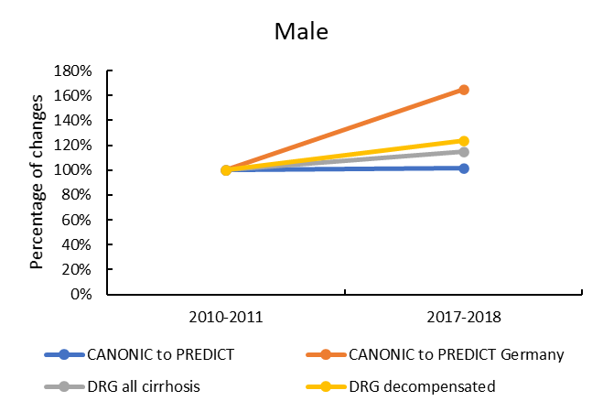 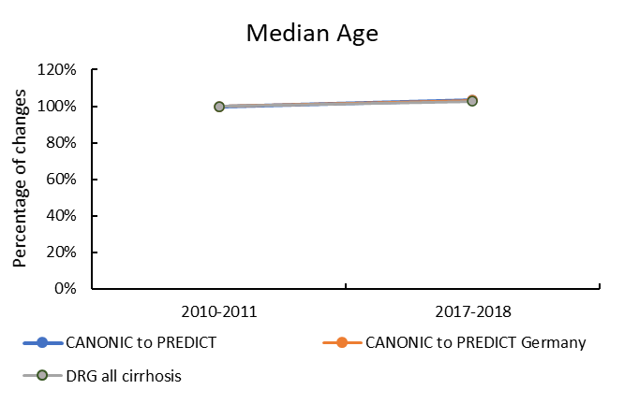

C. D.

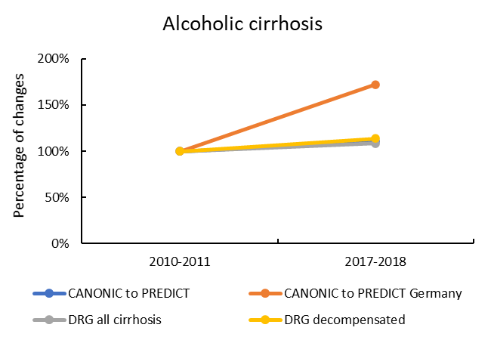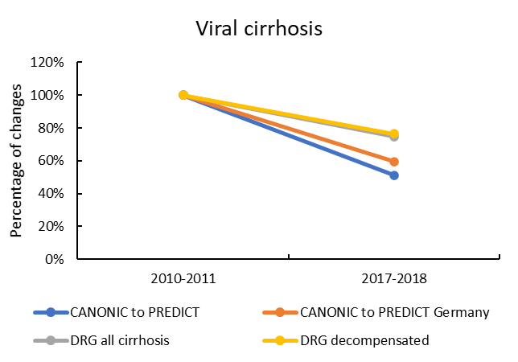

Supplementary Figure 3. Panel A. Mortality rate of patients admitted for heart failure, kidney failure and COPD without diagnosis of cirrhosis, each year from 2005 to 2018. Panel B. Mortality rate of patients admitted for heart failure, kidney failure and COPD with diagnosis of cirrhosis, each year from 2005 to 2018. Abbreviation: COPD, chronic obstructive pulmonary disease.

A.

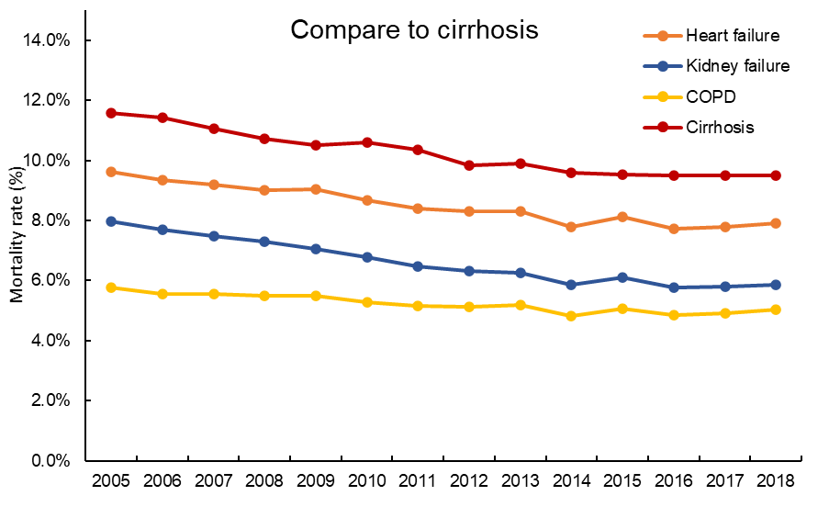

B.

黑暗中的灯光

Supplementary Figure 4. Histogram of length of hospital stay in all admissions from 2005 to 2018

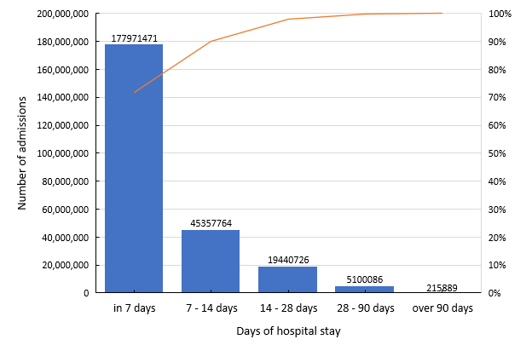

Supplementary Figure 5. Panel A. Number of admissions of patients diagnosed with liver cirrhosis and obesity according to different BMI categories for each year from 2008 to 2018. Panel B. Mean hospitalization days of patients admitted with alcoholic cirrhosis and non-alcoholic cirrhosis as main diagnosis for year 2005 to 2018. P value was compared of the slopes and intercepts between two groups with linear regression. Panel C. In-hospital mortality rate of patients admitted with alcoholic cirrhosis or non-alcoholic cirrhosis for each year from year 2005 to 2018. P value was compared of the slopes and intercepts between two groups with linear regression. Abbreviations: BMI, body mass index.

A



B C



Supplementary Figure 6. Number of admissions of cirrhosis patients with portal vein thrombosis, and number of admissions of cirrhosis patients with imaging examinations of CT scan, MRI/MRCP or ultrasound. Abbreviations: CT, computerized tomography; MRI, magnetic resonance imaging; MRCP, magnetic resonance cholangiopancreatography.



Supplementary Figure 7. Mortality rate of admissions of cirrhosis patients with or without infection.

黑暗中的灯光

Supplementary Figure 8. Panel A. Fold changes of admissions of cirrhosis patients with or without diagnosis of diabetes; Panel B. F Fold changes of admissions of cirrhosis patients with or without diagnosis of sarcopenia.

A.

夜晚亮着灯的摩天轮

B.

Supplementary Figure 9. Panel A. Distribution of hospital admissions in the German federal states from 2005 to 2018; Panel B. Distribution of hospital admissions in the German federal states from 2005 to 2018 per 100,000 person-years; Panel C. Distribution of mortality rate of admissions of patients with other chronic diseases without diagnosis of liver cirrhosis in the German federal states from 2005 to 2018.

A B

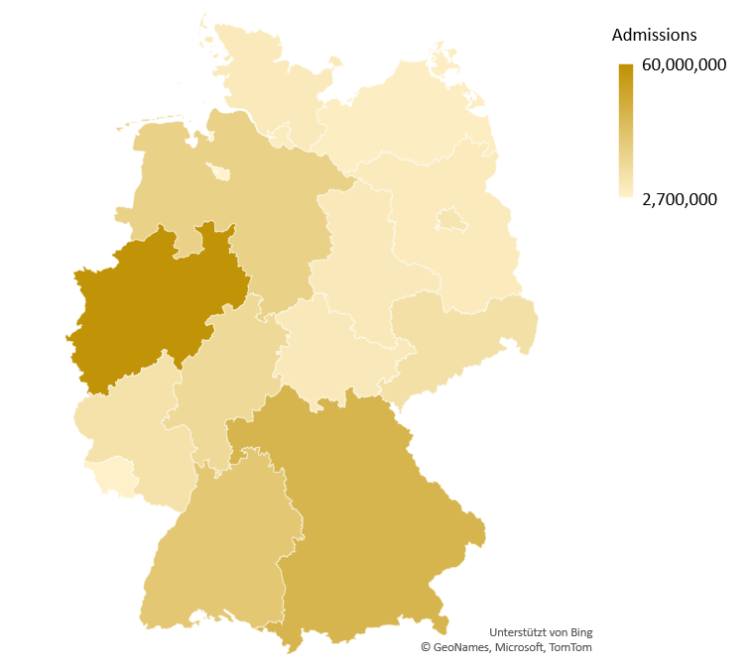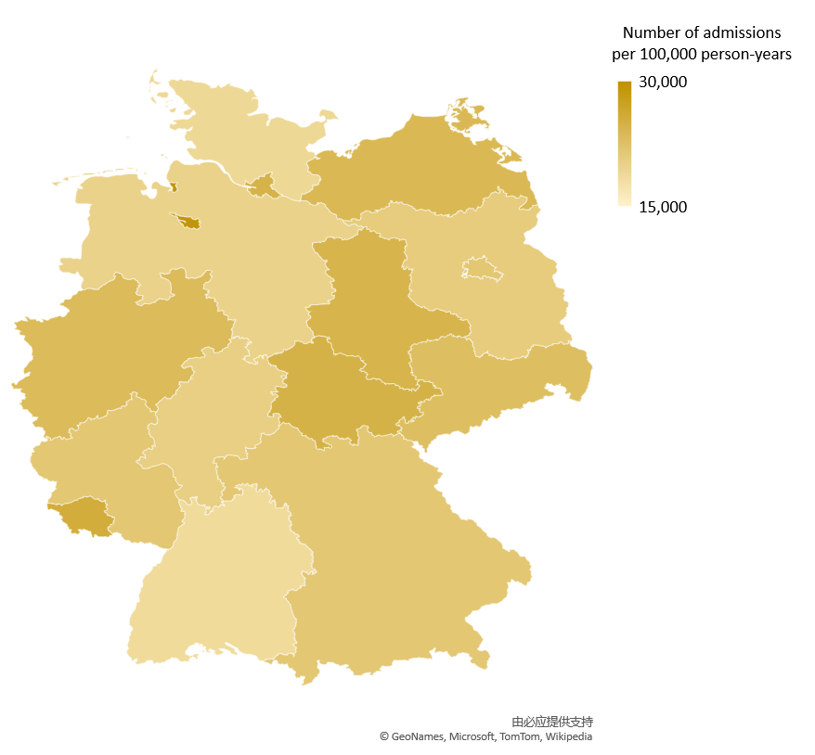

C

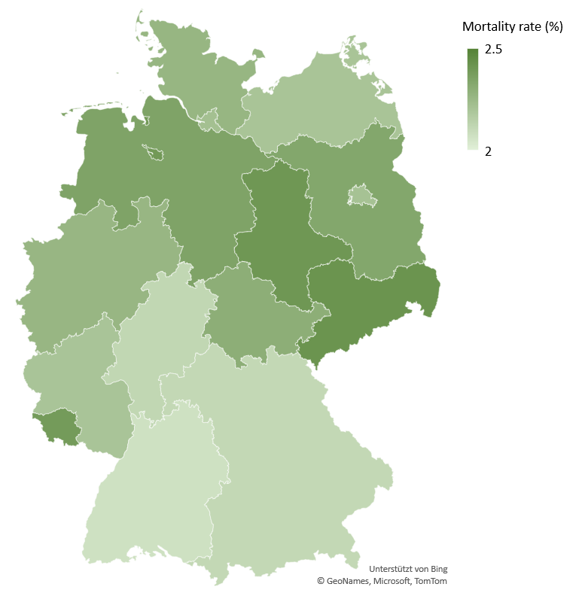

Supplementary figure 10. Panel A. Distribution of hospital admissions of patients with cirrhosis in different federal states in Germany from 2005 to 2018. Panel B. Distribution of hospital admissions of patients with cirrhosis in different federal states in Germany from 2005 to 2018 per 100,000 person-years. Panel C. Distribution of numbers of in-hospital deaths due to cirrhosis in Germany from 2005 to 2018. Panel D. Distribution of numbers of hospital death with cirrhosis in different federal states in Germany from 2005 to 2018 per 100,000 person-years. Panel E. Distribution of mortality rate of admissions of patients with liver cirrhosis in different federal states in Germany from 2005 to 2018.

A. B.

C. D.

E.

**Supplementary reference**

1. The global, regional, and national burden of cirrhosis by cause in 195 countries and territories, 1990-2017: a systematic analysis for the Global Burden of Disease Study 2017. *Lancet Gastroenterol Hepatol* 2020; **5**(3): 245-66.

2. Moreau R, Jalan R, Gines P, et al. Acute-on-chronic liver failure is a distinct syndrome that develops in patients with acute decompensation of cirrhosis. *Gastroenterology* 2013; **144**(7): 1426-37, 37.e1-9.

3. Trebicka J, Fernandez J, Papp M, et al. PREDICT identifies precipitating events associated with the clinical course of acutely decompensated cirrhosis. *J Hepatol* 2020.

4. Trebicka J, Fernandez J, Papp M, et al. The PREDICT study uncovers three clinical courses of acutely decompensated cirrhosis that have distinct pathophysiology. *J Hepatol* 2020; **73**(4): 842-54.