Supplementary files
Supplementary Figure 1. Flow Chart of the secondary analysis.
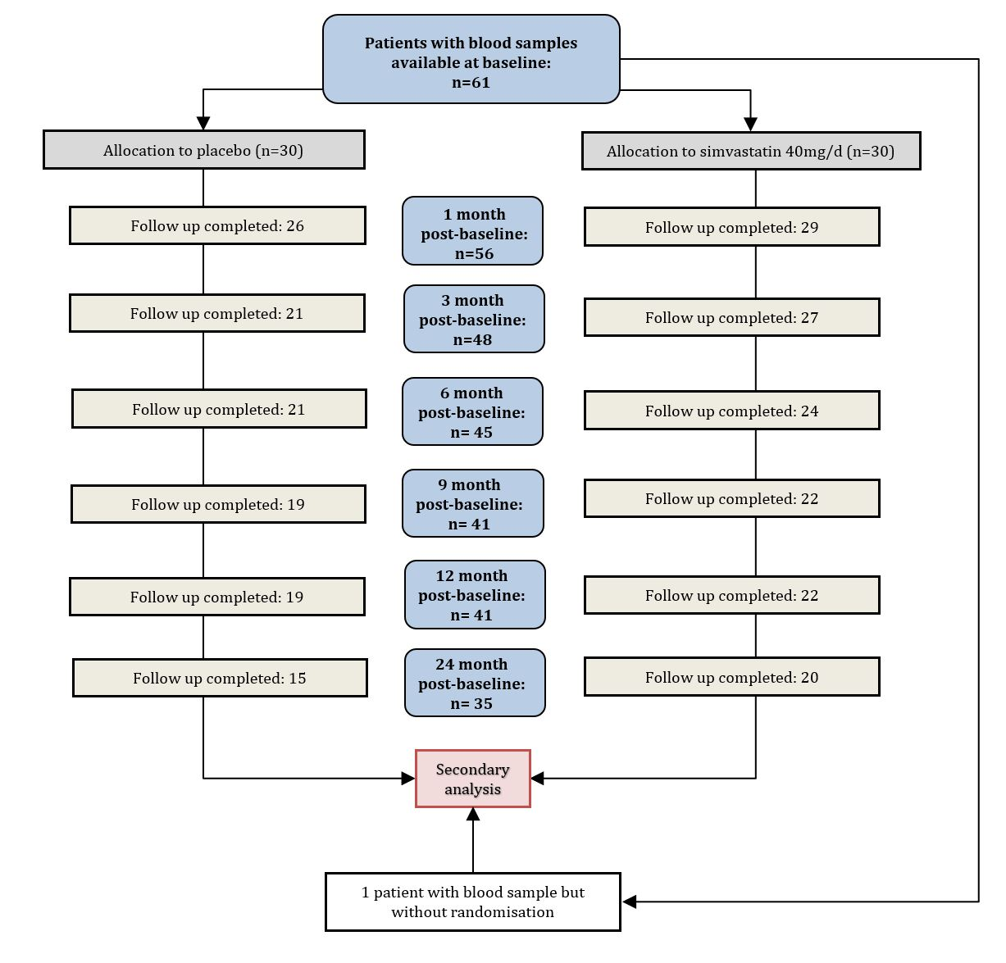

Supplementary Figure 2. CDSS total scores over time in the upregulated (A) and downregulated (B) group at baseline, 1, 6, 12, and 24 months follow up in the two treatment conditions: verum vs. placebo.
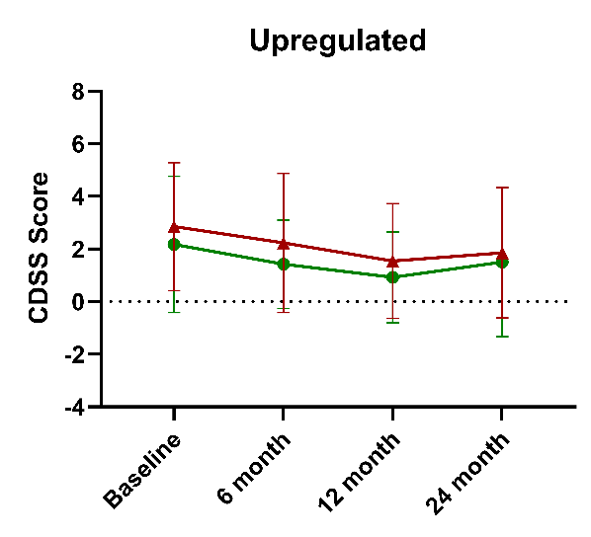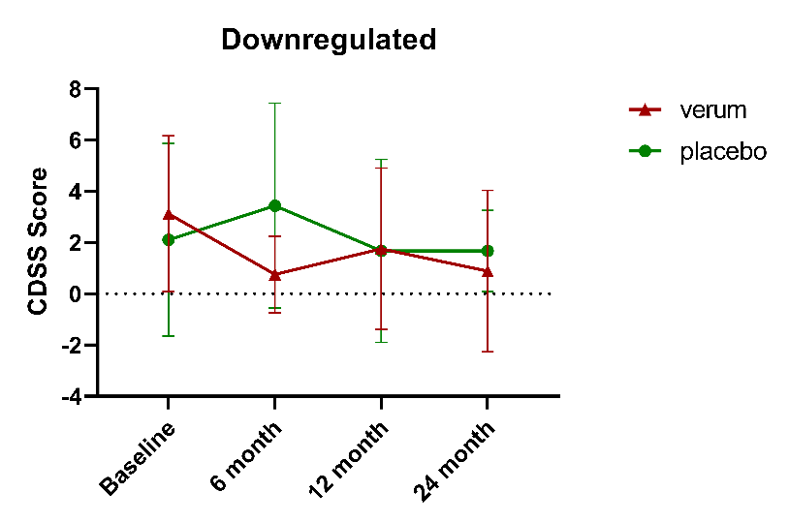
B
A

Supplementary Table 1. Gene expression in SSD (ddCT, e.g. compared to controls). sd=standard deviation, min=minimum, pctl.=percentile, max=maximum.
Gene | mean | sd | min | pctl. 25 | pctl. 50 | pctl. 75 | max
n=61
CCL7_ddCT | -0.348 | 2.69 | -4.098 | -2.263 | -0.925 | 0.719 | 7.070
STX1A_ddCT | -0.326 | 1.652 | -2.259 | -1.483 | -0.784 | 0.176 | 4.777
PTPN7_ddCT | -0.167 | 0.737 | -1.802 | -0.659 | -0.255 | 0.244 | 2.225
NAB2_ddCT | -0.058 | 1.011 | -1.925 | -0.73 | -0.283 | 0.160 | 3.399
CCL2_ddCT | -0.409 | 1.571 | -4.104 | -1.538 | -0.418 | 0.526 | 3.192
TNF_ddCT | -0.713 | 1.404 | -2.896 | -1.318 | -0.963 | -0.617 | 5.092
BAX_ddCT | -0.16 | 1.871 | -2.422 | -1.391 | -0.979 | 1.109 | 4.808
HMOX1_ddCT | -0.994 | 2.114 | -2.579 | -1.881 | -1.728 | -1.480 | 7.517
BCL10_ddCT | -0.208 | 0.556 | -0.955 | -0.538 | -0.308 | 0.040 | 1.831
CD163_ddCT | 0.122 | 0.439 | -2.029 | -0.05 | 0.139 | 0.360 | 1.064
IL1B_ddCT | 0.409 | 1.898 | -2.744 | -1.042 | 0.338 | 1.612 | 4.839
CCL20_ddCT | 0.789 | 2.954 | -5.792 | -1.038 | 1.006 | 2.840 | 7.914
CXCL2_ddCT | 0.36 | 1.864 | -3.222 | -0.987 | 0.443 | 1.626 | 5.359
IL6_ddCT | 0.739 | 2.527 | -3.731 | -0.822 | 0.200 | 2.314 | 9.190
MAFF_ddCT | 0.379 | 1.505 | -3.462 | -0.542 | 0.478 | 1.433 | 2.983
TNFAIP3_ddCT | 0.688 | 1.323 | -1.176 | -0.424 | -0.004 | 1.998 | 3.144
MXD1_ddCT | -0.242 | 0.659 | -1.571 | -0.635 | -0.252 | 0.264 | 1.309
SERPINB2_ddCT | 0.044 | 1.254 | -2.667 | -0.735 | -0.31 | 0.782 | 3.734
IL10_ddCT | -0.146 | 1.299 | -3.418 | -0.870 | -0.096 | 0.602 | 2.816
THBS1_ddCT | 0.686 | 1.199 | -4.601 | 0.755 | 0.923 | 1.000 | 3.240
ABCA1_ddCT | 0.211 | 0.592 | -1.221 | -0.155 | 0.170 | 0.473 | 1.747
ABCG1_ddCT | 0.225 | 0.685 | -1.329 | -0.118 | 0.256 | 0.642 | 1.749
MRC1_ddCT | 0.418 | 0.698 | -1.541 | -0.074 | 0.363 | 0.934 | 2.154
NR1H3_ddCT | 0.083 | 0.458 | -1.989 | -0.134 | 0.085 | 0.299 | 1.169
MVK_ddCT | 0.145 | 0.380 | -1.716 | -0.012 | 0.214 | 0.409 | 0.934
HGF_ddCT | -0.011 | 0.448 | -2.174 | -0.244 | 0.002 | 0.286 | 0.939

Supplementary Table 2. Demographic data of patients receiving treatment as usual (TAU) and placebo or TAU and simvastatin. sd= standard deviation, BMI= Body Mass Index, PANSS= Positive and Negative Syndrome Scale, CDSS Calgary Depression Scale for Schizophrenia, Childhood Trauma was assessed with the Jeugd Trauma Vragenlijst (JVT)
 | TAU+PLACEBO |  |  | TAU+SIMVASTATIN
n=30 |  | mean | sd | n=30 | mean | Sd | test statistic | p
BMI |  | 24.00 | 3.72 |  | 24.00 | 4.15 | F=0.00 | 0.996
Age baseline |  | 27.70 | 7.76 |  | 25.17 | 4.45 | F=2.41 | 0.126
Sex female n,(%) |  | 8.00 | 27.00% |  | 8.00 | 27.00% | X²=0.00 | >0.999
PANSS total |  | 57.27 | 14.75 |  | 62.43 | 13.23 | F=2.04 | 0.159
CDSS |  | 2.83 | 3.70 |  | 3.57 | 3.88 | F=0.56 | 0.456
Childhood Trauma |  | 48.07 | 10.43 |  | 50.17 | 14.23 | F=0.43 | 0.517
Illness duration (years) |  | 1.27 | 1.01 |  | 1.37 | 1.10 | F=0.13 | 0.716

Supplementary Table 3. Patients’ medication categorised by the active ingredient group. SSRI=selective serotonin reuptake inhibitor, SSNRI=selective serotonin norepinephrine reuptake inhibitor.
 | Number of patients
Antipsychotics | 53
Olanzapine | 16
Aripiprazole | 13
Quetiapine | 9
Clozapine | 6
Haloperidol | 5
Paliperidone | 4
Risperidone | 3
Amisulpride | 2
Zuclopenthixol | 1
Antidepressants | 11
SSRI | 7
SSNRI | 3
Trycyclics | 1
Benzodiazepines | 13
Somatic medication | 28

Supplementary Table 4. Overview of the patients’ drug use. Hard drugs=amphetamines/ecstasy/cocaine/psilocybin/LSD/ketamine, soft drugs=cannabis.
 | Number of patients
Hard drugs
Within the last month | 7
Lifetime | 34
Soft drugs
Within the last month | 15
Lifetime | 50

Supplementary Table 5. Median gene expression per patient cluster. sd=standard deviation.

 | “Downregulated” |  |  |  | “Upregulated”
Gene | N | Mean | SD | Median | N | Mean | SD | Median
CCL7_ddCT | 43 | -0.909 | 2.505 | -1.360 | 18 | 0.993 | 2.709 | 0.626
STX1A_ddCT | 43 | -0.468 | 1.668 | -0.849 | 18 | 0.011 | 1.609 | -0.484
PTPN7_ddCT | 43 | -0.207 | 0.700 | -0.339 | 18 | -0.070 | 0.83 | -0.167
NAB2_ddCT | 43 | -0.112 | 1.027 | -0.308 | 18 | 0.069 | 0.987 | 0.031
CCL2_ddCT | 43 | -0.713 | 1.476 | -0.677 | 18 | 0.315 | 1.594 | 0.421
TNF_ddCT | 43 | -0.876 | 1.425 | -1.055 | 18 | -0.323 | 1.308 | -0.841
BAX_ddCT | 43 | -0.486 | 1.693 | -1.182 | 18 | 0.617 | 2.089 | -0.714
HMOX1_ddCT | 43 | -0.980 | 2.115 | -1.751 | 18 | -1.026 | 2.173 | -1.710
BCL10_ddCT | 43 | -0.252 | 0.501 | -0.303 | 18 | -0.103 | 0.673 | -0.338
CD163_ddCT | 43 | 0.098 | 0.475 | 0.166 | 18 | 0.180 | 0.342 | 0.126
IL1B_ddCT | 43 | -0.571 | 1.185 | -0.500 | 18 | 2.750 | 1.006 | 2.766
CCL20_ddCT | 43 | -0.627 | 2.125 | -0.627 | 18 | 4.171 | 1.568 | 4.162
CXCL2_ddCT | 43 | -0.461 | 1.420 | -0.597 | 18 | 2.319 | 1.234 | 2.267
IL6_ddCT | 43 | -0.595 | 1.124 | -0.386 | 18 | 3.927 | 2.041 | 3.306
MAFF_ddCT | 43 | -0.138 | 1.409 | -0.066 | 18 | 1.615 | 0.893 | 1.659
TNFAIP3_ddCT | 43 | -0.038 | 0.742 | -0.12 | 18 | 2.422 | 0.545 | 2.578
MXD1_ddCT | 43 | -0.373 | 0.645 | -0.528 | 18 | 0.069 | 0.597 | 0.052
SERPINB2_ddCT | 43 | 0.069 | 1.245 | -0.310 | 18 | -0.018 | 1.311 | -0.301
IL10_ddCT | 43 | -0.117 | 1.286 | -0.227 | 18 | -0.216 | 1.364 | 0.231
THBS1_ddCT | 43 | 0.645 | 1.109 | 0.914 | 18 | 0.783 | 1.423 | 0.970
ABCA1_ddCT | 43 | 0.144 | 0.592 | 0.150 | 18 | 0.372 | 0.577 | 0.438
ABCG1_ddCT | 43 | 0.301 | 0.655 | 0.273 | 18 | 0.044 | 0.739 | 0.143
MRC1_ddCT | 43 | 0.403 | 0.759 | 0.268 | 18 | 0.452 | 0.540 | 0.512
NR1H3_ddCT | 43 | 0.112 | 0.520 | 0.158 | 18 | 0.015 | 0.255 | -0.031
MVK_ddCT | 43 | 0.163 | 0.412 | 0.226 | 18 | 0.100 | 0.294 | 0.098
HGF_ddCT | 43 | 0.038 | 0.479 | 0.026 | 18 | -0.129 | 0.347 | -0.095

Supplementary Table 6. Results of pairwise comparisons of PANSS total scores between the timepoints in the TAU+Placebo group. Df=degrees of freedom, SE=standard error, fu=follow up.
 | “Down-regulated” |  |  |  |  | “Up-regulated”
Timepoint | estimate | SE | df | t.ratio | p.value | estimate | SE | df | t.ratio | p.value
baseline - 1month | -2.55 | 2.92 | 252.00 | -0.88 | 0.574 | -2.64 | 4.67 | 260.00 | -0.56 | 0.807
baseline - 3month | -3.57 | 3.14 | 260.00 | -1.14 | 0.491 | 2.51 | 4.92 | 266.00 | 0.51 | 0.807
baseline - 6month | -1.74 | 3.14 | 261.00 | -0.56 | 0.773 | -0.32 | 4.92 | 266.00 | -0.07 | 0.995
baseline - 9month | 3.31 | 3.21 | 263.00 | 1.03 | 0.531 | 3.87 | 5.23 | 269.00 | 0.74 | 0.087
baseline - 12month | 4.81 | 3.21 | 263.00 | 1.50 | 0.329 | 3.87 | 5.23 | 269.00 | 0.74 | 0.087
baseline - 24month | 3.13 | 3.48 | 266.00 | 0.90 | 0.574 | 6.79 | 5.65 | 271.00 | 1.20 | 0.087
1month - 3month | -1.01 | 3.20 | 255.00 | 0.31 | 0.832 | 5.15 | 5.15 | 253.00 | 1.00 | 0.087
1month - 6month | 0.82 | 3.20 | 256.00 | 0.26 | 0.839 | 2.31 | 5.15 | 253.00 | 0.45 | 0.087
1month - 9month | 5.87 | 3.27 | 258.00 | 1.80 | 0.258 | 6.51 | 5.44 | 257.00 | 1.20 | 0.087
1month - 12months | 7.37 | 3.27 | 258.00 | 2.25 | 0.258 | 6.51 | 5.44 | 257.00 | 1.20 | 0.087
1month - 24month | 5.68 | 3.53 | 261.00 | 1.61 | 0.327 | 9.43 | 5.85 | 261.00 | 1.61 | 0.087
3month - 6month | 1.82 | 3.37 | 250.00 | 0.54 | 0.773 | -2.83 | 5.31 | 246.00 | -0.53 | 0.087
3month - 9month | 6.88 | 3.43 | 252.00 | 2.00 | 0.258 | 1.36 | 5.60 | 251.00 | 0.24 | 0.893
3month - 12month | 8.38 | 3.43 | 252.00 | 2.44 | 0.258 | 1.36 | 5.60 | 251.00 | 0.24 | 0.893
3month - 24month | 6.69 | 3.69 | 257.00 | 1.81 | 0.258 | 4.28 | 5.99 | 255.00 | 0.71 | 0.087
6month - 9month | 5.05 | 3.42 | 248.00 | 1.48 | 0.329 | 4.20 | 5.60 | 251.00 | 0.75 | 0.087
6month - 12month | 6.55 | 3.42 | 248.00 | 1.92 | 0.258 | 4.20 | 5.60 | 251.00 | 0.75 | 0.087
6month - 24month | 4.87 | 3.68 | 253.00 | 1.32 | 0.392 | 7.11 | 5.99 | 255.00 | 1.87 | 0.087
9month - 12month | 1.50 | 3.47 | 246.00 | 0.43 | 0.777 | 0.00 | 5.81 | 246.00 | 0.00 | 1.000
9month - 24month | -0.19 | 3.72 | 251.00 | -0.05 | 0.960 | 2.92 | 6.20 | 251.00 | 0.47 | 0.087
12month - 24month | -1.69 | 3.27 | 251.00 | -0.45 | 0.777 | 2.92 | 6.20 | 251.00 | 0.47 | 0.087

Supplementary Table 7. Results of pairwise comparisons of PANSS total scores between the timepoints in the TAU+Simvastatin group. Df=degrees of freedom, SE=standard error, 12month=follow up.
 | “Downregulated” |  |  |  |  | “Upregulated”
Timepoint | estimate | SE | df | t.ratio | p.value | estimate | SE | df | t.ratio | p.value
baseline - 1month | 2.71 | 2.88 | 249.00 | 0.94 | 0.561 | -4.11 | 4.33 | 246.00 | -0.95 | 0.380
baseline - 3month | 3.28 | 2.92 | 251.00 | 1.12 | 0.500 | -5.19 | 4.48 | 251.00 | -1.16 | 0.325
baseline - 6month | 10.12 | 3.02 | 255.00 | 3.35 | 0.020 | 4.50 | 4.67 | 256.00 | 0.96 | 0.380
baseline - 9month | 1.24 | 3.14 | 258.00 | 0.40 | 0.855 | 7.35 | 4.67 | 256.00 | 1.58 | 0.175
baseline - 12month | 3.04 | 3.14 | 258.00 | 0.97 | 0.561 | 13.64 | 4.67 | 256.00 | 2.92 | 0.013
baseline - 24month | 9.81 | 3.21 | 260.00 | 3.06 | 0.026 | 18.95 | 4.90 | 258.00 | 3.87 | 0.001
1month - 3month | 0.58 | 2.95 | 248.00 | 0.20 | 0.940 | -1.08 | 4.48 | 251.00 | -0.24 | 0.809
1month - 6month | 7.41 | 3.05 | 252.00 | 2.43 | 0.066 | 8.61 | 4.67 | 256.00 | 1.84 | 0.107
1month - 9month | -1.47 | 3.16 | 256.00 | -9.46 | 0.845 | 11.46 | 4.67 | 256.00 | 2.46 | 0.034
1month - 12month | 0.34 | 3.16 | 256.00 | 0.11 | 0.940 | 17.75 | 4.67 | 256.00 | 3.80 | 0.001
1month - 24month | 7.10 | 3.23 | 257.00 | 2.20 | 0.082 | 23.06 | 4.90 | 258.00 | 4.70 | <.0001
3month - 6month | 6.84 | 3.08 | 250.00 | 2.22 | 0.082 | 9.69 | 4.78 | 251.00 | 2.03 | 0.083
3month - 9month | -2.04 | 3.20 | 254.00 | -0.64 | 0.786 | 12.55 | 4.78 | 251.00 | 2.63 | 0.024
3month - 12month | -0.24 | 3.20 | 254.00 | -0.08 | 0.940 | 18.83 | 4.78 | 251.00 | 3.94 | 0.001
3month - 24month | 6.53 | 3.26 | 255.00 | 2.00 | 0.103 | 24.14 | 5.00 | 253.00 | 4.83 | <.0001
6month - 9month | -8.88 | 3.27 | 250.00 | -2.72 | 0.049 | 2.86 | 4.91 | 246.00 | 0.58 | 0.590
6month - 12month | -7.08 | 3.27 | 250.00 | -2.17 | 0.082 | 9.14 | 4.91 | 246.00 | 1.86 | 0.107
6month - 24month | -0.31 | 3.33 | 251.00 | -0.09 | 0.940 | 14.45 | 5.13 | 249.00 | 2.82 | 0.016
9month - 12month | 1.80 | 3.36 | 246.00 | 0.54 | 0.829 | 6.29 | 4.91 | 246.00 | 1.28 | 0.283
9month - 24month | 8.57 | 3.42 | 247.00 | 2.50 | 0.066 | 11.59 | 5.13 | 249.00 | 2.26 | 0.052
12month - 24month | 6.77 | 3.42 | 247.00 | 1.98 | 0.103 | 5.31 | 5.13 | 249.00 | 1.03 | 0.373

