Supporting Information
Surviving trees and deadwood moderate changes in soil fungal communities and associated functioning after natural forest disturbance and salvage logging

Mathias Mayer, Christoph Rosinger, Markus Gorfer, Harald Berger, Evi Deltedesco, Claus Bässler, Jörg Müller, Linda Seifert, Boris Rewald, Douglas L. Godbold

The following Supporting Information is available for this article:
Fig. S1 Topographic map of the Bavarian Forest National Park with 21 sampling plots.
Fig. S2 Relative abundance of the fungal guilds “other symbiotic fungi” and “potential plant pathogenic fungi”.
Fig. S3 Relationship between enzymatic activities and ectomycorrhizal- and saprotrophic fungi among intact plots.
Fig. S4 Relationship between enzymatic activities and the fungal guilds “other symbiotic fungi” and “potential plant pathogenic fungi”.
Fig. S5 Relationship between soil C and N stocks and tree-, deadwood-, and grass variables.
Table S1 List of fungal taxonomic groups including relative abundance and lifestyle/guild.
Methods S1 Details on primers for fungal community analysis.

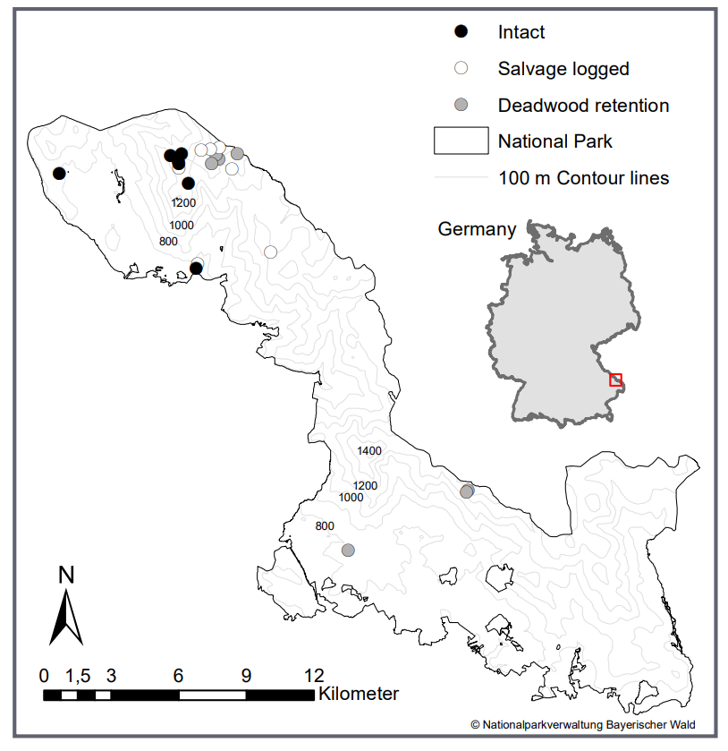
Fig. S1 Topographic map of the Bavarian Forest National Park with 21 sampling plots, i.e. intact forest stands (black), disturbed plots where deadwood retained on site (grey), and salvage logged plots (white); 100-m contour lines indicate elevation above sea level. The parks’ location within Germany is denoted

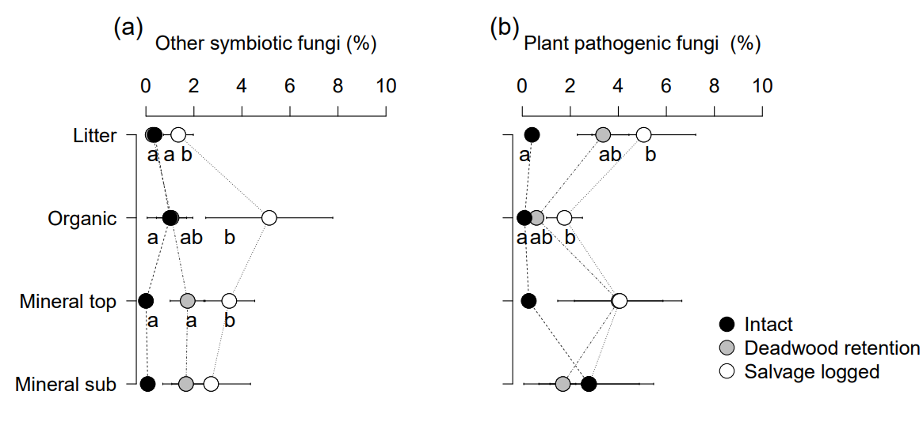
Fig. S2 Relative abundance of other symbiotic fungi (e.g. arbuscular mycorrhizal associations) (a) and potential plant pathogenic fungi (b) in litter, organic, mineral topsoil, and mineral subsoil layers of intact forest stands (black), disturbed plots where deadwood retained on site (grey), and salvage logged plots (white) in the Bavarian Forest National Park. Different letters indicate significant (P < 0.05) differences between treatments (mean ± 1 SE).

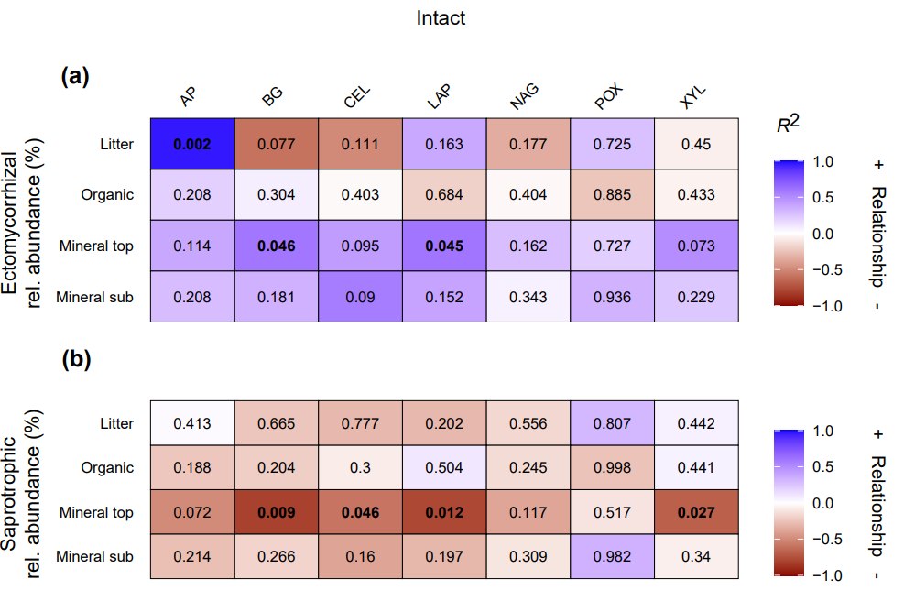

Fig. S3 Heatmaps of linear regression models between relative abundance (%) of ectomycorrhizal (a) and saprotrophic (b) fungi and soil enzymatic activities (nmol g⁻¹ h⁻¹) in litter, organic, mineral topsoil, and mineral subsoil layers among intact plots in the Bavarian Forest National Park. P-values are given, and significant (P < 0.05) relations are indicated in bold. Colour intensity of heatmaps indicates R² values and different colours indicate positive (blue) and negative (red) relationships, respectively. Abbreviations: AP, acid phosphatase; BG, β-glucosidase; CEL, cellobiohydrolase; LAP, leucine-aminopeptidase; NAG, N-acetyl-β-D-glucosaminidase; POX, phenol oxidase; XYL, β-xylosidase.

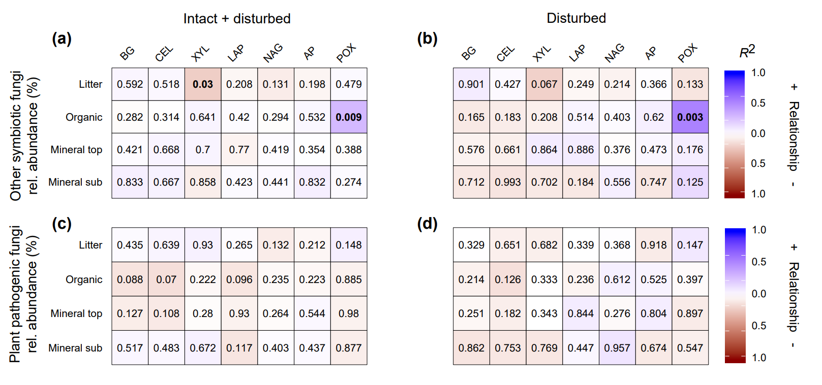

Fig. S4 Heatmaps of linear regression models between relative abundance (%) of other symbiotic fungi (e.g. arbuscular mycorrhizal associations) and plant pathogenic fungi and soil enzymatic activities (nmol g⁻¹ h⁻¹) in litter, organic, mineral topsoil, and mineral subsoil layers among intact and disturbed plots (a,c) and disturbed plots only (b,d) in the Bavarian Forest National Park. P-values are given, and significant (P < 0.05) relations are indicated in bold. Colour intensity of heatmaps indicates R² values and different colours indicate positive (blue) and negative (red) relationships, respectively. Abbreviations: BG, β-glucosidase; CEL, cellobiohydrolase; XYL, β-xylosidase; POX, phenol oxidase; LAP, leucine-aminopeptidase; NAG, N-acetyl-β-D-glucosaminidase; AP, acid phosphatase.

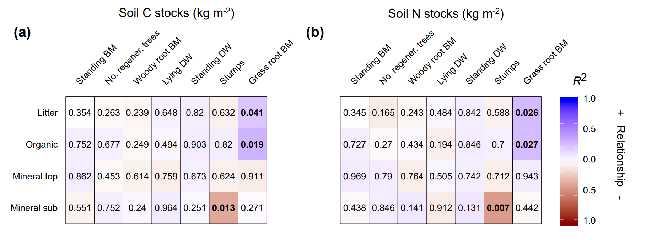
Fig. S5 Heatmaps of linear regression models between soil C (a) and N (b) stocks (kg m⁻²) in litter, organic, mineral topsoil, and mineral subsoil layers and tree-, deadwood-, and grass parameters among salvage logged and deadwood retention plots in the Bavarian Forest National Park. P-values are given, and significant (P < 0.05) relations are indicated in bold. Colour intensity of heatmaps indicates R² values and different colours indicate positive (blue) and negative (red) relationships, respectively. Abbreviations: BM, biomass; DW, deadwood.

Table S1 List of fungal taxonomic groups including relative abundance and lifestyle/guild.
See the Supporting MS Excel file for associated data in separate sheets labelled Table S1.

Methods S1 Details on primers.
Primer mixes based on original primers ITS3 and ITS4 (White et al., 1990) were used for amplification of the fungal ITS2 region from soil DNA samples (Gorfer et al., 2021). Primers contain fungal specific sequences at the 3' end (highlighted in bold, see below) and a 5'-tail for sequencing at the Illumina MiSeq platform. Primers are composed of five different forward primers – ITS31-ITS35 as specified by Tedersoo et al. (2014)– and two different reverse primers – ITS4 (White et al., 1990) and ITS43S, a degenerate version of ITS4 (Keiblinger et al., 2018). Forward and reverse primers were separately mixed in equimolar ratios to obtain ITS3-Mix and ITS4-Mix, respectively.
ITS3Mix
ITS31_NeXTf TCGTCGGCAGCGTCAGATGTGTATAAGAGACAGCATCGATGAAGAACGCAG
ITS32_NeXTf TCGTCGGCAGCGTCAGATGTGTATAAGAGACAGCAACGATGAAGAACGCAG
ITS33_NeXTf TCGTCGGCAGCGTCAGATGTGTATAAGAGACAGCACCGATGAAGAACGCAG
ITS34_NeXTf TCGTCGGCAGCGTCAGATGTGTATAAGAGACAGCATCGATGAAGAACGTAG
ITS35_NeXTf TCGTCGGCAGCGTCAGATGTGTATAAGAGACAGCATCGATGAAGAACGTGG

ITS4-Mix
ITS4_NeXTr GTCTCGTGGGCTCGGAGATGTGTATAAGAGACAGTCCTCCGCTTATTGATATGC
ITS43S_NeXTr GTCTCGTGGGCTCGGAGATGTGTATAAGAGACAGTCCTSSSCTTATTGATATGC

References
Gorfer, M., Mayer, M., Berger, H., Rewald, B., Tallian, C., Matthews, B., Sanden, H., Katzensteiner, K., Godbold, D.L., 2021. High Fungal Diversity but Low Seasonal Dynamics and Ectomycorrhizal Abundance in a Mountain Beech Forest. Microbial Ecology, 1-14.
Keiblinger, K.M., Schneider, M., Gorfer, M., Paumann, M., Deltedesco, E., Berger, H., Jöchlinger, L., Mentler, A., Zechmeister-Boltenstern, S., Soja, G., 2018. Assessment of Cu applications in two contrasting soils—effects on soil microbial activity and the fungal community structure. Ecotoxicology 27, 217-233.
Tedersoo, L., Bahram, M., Polme, S., Koljalg, U., Yorou, N.S., Wijesundera, R., Villarreal Ruiz, L., Vasco-Palacios, A.M., Thu, P.Q., Suija, A., Smith, M.E., Sharp, C., Saluveer, E., Saitta, A., Rosas, M., Riit, T., Ratkowsky, D., Pritsch, K., Poldmaa, K., Piepenbring, M., Phosri, C., Peterson, M., Parts, K., Partel, K., Otsing, E., Nouhra, E., Njouonkou, A.L., Nilsson, R.H., Morgado, L.N., Mayor, J., May, T.W., Majuakim, L., Lodge, D.J., Lee, S.S., Larsson, K.H., Kohout, P., Hosaka, K., Hiiesalu, I., Henkel, T.W., Harend, H., Guo, L.D., Greslebin, A., Grelet, G., Geml, J., Gates, G., Dunstan, W., Dunk, C., Drenkhan, R., Dearnaley, J., De Kesel, A., Dang, T., Chen, X., Buegger, F., Brearley, F.Q., Bonito, G., Anslan, S., Abell, S., Abarenkov, K., 2014. Fungal biogeography. Global diversity and geography of soil fungi. Science 346, 1256688.
White, T.J., Bruns, T., Lee, S.J.W.T., Taylor, J., 1990. Amplification and direct sequencing of fungal ribosomal RNA genes for phylogenetics In: Innis MA, Gelfand DH, Sninsky JJ, White TJ, editors. PCR protocols: a guide to methods and applications. PCR protocols: a guide to methods and applications, 315-322.

