**Supplementary Information for**

**One substrate, many fates: different ways of methanol utilization in the acetogen *Acetobacterium woodii***

Dennis Litty1, Florian Kremp1and Volker Müller1#

*1Department of Molecular Microbiology & Bioenergetics, Institute of Molecular Biosciences, Johann Wolfgang Goethe University, Max-von-Laue Str. 9, D-60438 Frankfurt, Germany*

*#Corresponding author. Mailing address: Department of Molecular Microbiology & Bioenergetics, Institute of Molecular Biosciences, Johann Wolfgang Goethe University, Max-von-Laue-Str. 9, D-60438 Frankfurt, Germany. Phone: 49-69-79829507. Fax: 49-69-79829306. E-mail:* [*vmueller@bio.uni-frankfurt.de*](mailto:vmueller@bio.uni-frankfurt.de)*.*

Running title: methanol utilization in *A. woodii*

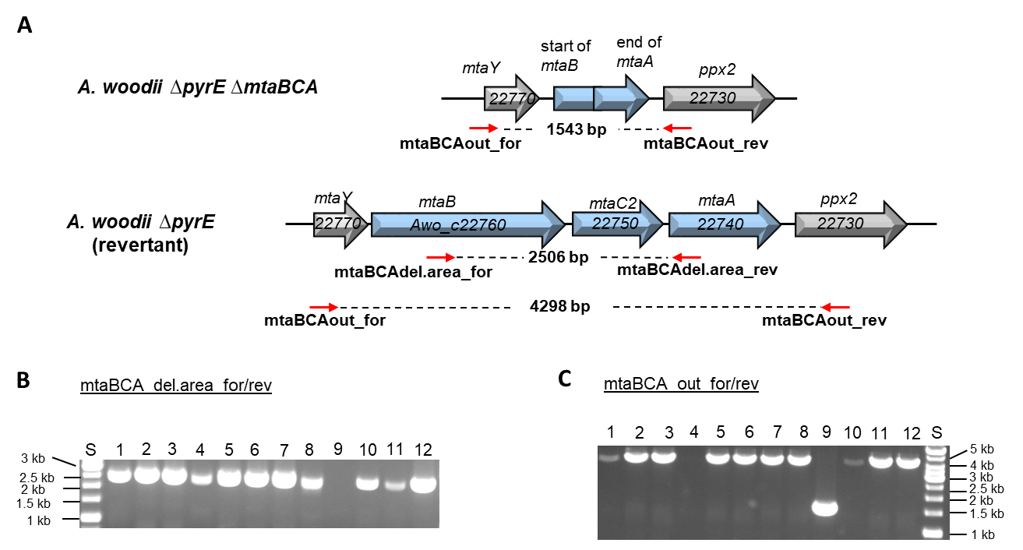

**Fig. S1. Verification of the genotype of the *A. woodii ΔpyrE ΔmtaBC2A* deletion mutant.** (A) The binding sites of the oligonucleotide pairs mtaBCAout_for/rev and mtaBCA_del.area_for/rev (red arrows) and the length of their potential PCR-products are indicated in the genome sequence of *A. woodii ΔpyrE ΔmtaBC2A* and the reversed WT *A. woodii ΔpyrE* (revertant). In *A. woodii ΔpyrE ΔmtaBC2A* the binding site of mtaBCA_del.area_for/rev is deleted. 500 µl of liquid cultures of potential deletion mutants (1-12) were centrifuged and resuspended in 100 µl sterile H2Odeion. 1 µl was used as template in a PCR, using the oligonucleotide pair mtaBCA_del.area_for/rev (B), or mtaBCAout_for/rev (C; Tab. S1). The PCR-products were separated by gel electrophoresis in an agarose gel (1 % [w/v]). DNA fragments were stained with ehidiumbromid, before detection using an UV-transiluminator (B). 2 µl of the 1 kb GeneRuler (ThermoScientific™) were used as standard (S).

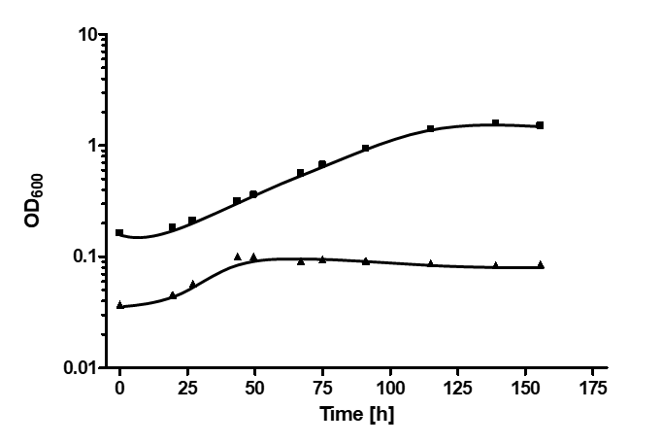

**Fig. S2. Growth of *A. woodii* Δ*pyrE* and *A. woodii* Δ*pyrE* Δ*mtaBC2A* on 60 mM methanol.** 5 ml carbonate-buffered complex medium (according to Heise *et al.* (1989)) was supplemented with 50 mg/l uracil and 60 mM methanol, before it was inoculated with 50 µl of mid-exponential cultures of *A. woodii* Δ*pyrE* (■ ) or *A. woodii* Δ*pyrE* Δ*mtaBC2A* (▲ ), pregrown on 5 mM fructose. Growth of was recorded by measuring the OD600 in regular intervals.

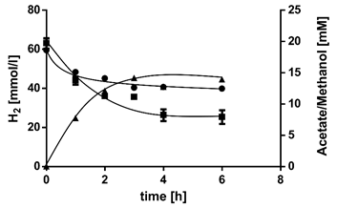

**Fig. S3.** Acetogenesis from methanol + H2 + CO2 by resting cells of the *A. woodii Δrnf* mutant. Resting cells (protein concentration, 1 mg/ml) in 40 mM imidazole buffer containing 20 mM KCl, 20 mM NaCl, 20 mM MgSO4, 2 mM DTE, and 4 μM resazurin (pH 7.0) were incubated at 30°C with 20 mM methanol + H2 + CO2 (101 kPa, 80/20% [v/v]) as substrates. Concentration of methanol (●), H2 (■) and acetate (▲).



**Fig. S4.** Growth of *A*. *woodii* wild type and the *Δrnf* mutant on methanol + H2 + CO2. *A*. *woodii* wild type and *Δrnf* were grown at 30°C in carbonate-buffered complex medium (according to Heise *et al.* (1989)) with 60 mM methanol and 101 kPa H2 + CO2 (80/20% [v/v]). Growth was followed by measuring the optical density (OD) at 600 nm. (▲) Growth of *A. woodii* wild type on methanol + H2 + CO2 under Na+-free conditions, the contaminating amount of Na+ was 171 µM; (●) First transfer of *A*. *woodii Δrnf* on methanol + H2 + CO2 in presence of Na+; (■) Second transfer of *A*. *woodii Δrnf* on methanol + H2 + CO2 in presence of Na+; (▼) Growth of *A*. *woodii* *Δrnf* on 60 mM methanol + CO2 in presence of Na+.

**Tab. S1.** List of oligonucleotides used in this study.

|  |  |  |
| --- | --- | --- |
| **Name** | **Sequence (5’🡪3’)** | **Function** |
| mtaBCA_up_F | TTTGAATTCGAAAATCTTGAAGGCGAAAAGGC | amplification of the upstream flanking region of *mtaBC2A* |
| mtaBCA_up_R | CCATCATGCTTGGACAGCTTCCATACACAAAATCG |
| mtaBCA_dn F | AAGCTGTCCAAGCATGATGGCTGATATTGTTGC | amplification of the downstream flanking region of *mtaBC2A* |
| mtaBCA_dn R | TTATCTAGACTCGCAAAGCCGTTGTTCC |
| mtaBCA_del.area_for | GCTTCCAGGCATGGATGTAAAC | Screening for Δ*mtaBC2A* deletion mutants |
| mtaBCA_del.area_rev | GCTGTGGTAACACTGCTTATCGG |
| mtaBCA_out_for | TCGCAAAGCCGTTGTTCC | Screening for Δ*mtaBC2A* deletion mutants |
| mtaBCA_out_rev | GCGACGCTAATGGGATTAACAG |

**References**

Heise, R., Müller, V., and Gottschalk, G. (1989) Sodium dependence of acetate formation by the acetogenic bacterium *Acetobacterium woodii*. *J. Bacteriol.* **171**: 5473-5478.