Genomics reveals broad hybridization in deeply divergent Palearctic grass and water snakes (Natrix spp.)

Yannis Schöneberg, Sven Winter, Oscar Arribas, Matteo Riccardo Di Nicola, Maya Master,
John Benjamin Owens, Michail Rovatsos, Wolfgang Wüster, Axel Janke, Uwe Fritz

Molecular Phylogenetics and Evolution

Supplementary Material 1

Table S1
Collection and sampling information for the studied snakes. The specimen of Natrix natrix vulgaris is the name-bearing neotype museum specimen for the taxon, collected in April 2001 (Fritz and Schmidtler, 2020).
Taxon | Specimen ID | Locality
N. astreptophora | MTD T 17821 | Spain: León: Puerto de las Señales
N. h. helvetica | Natrix-HFL1 | Wales: Gwynedd: Penrhyndeudraeth
N. h. cetti | MTD T 19155 | Italy: Cagliari: Sinnai near Cagliari, Sardinia
N. n. natrix | MTD T 20734 | Germany: Saxony: Liegau-Augustusbad
N. n. vulgaris | NMW 36405 | Austria: Niederösterrreich: Oberedlitz, Thaya
N. maura | MTD T 10636 | Portugal: Faro: near Alte
N. tessellata | MTD T 11214 | Hungary: Veszprém: Tihany
MTD T: Museum of Zoology, Senckenberg Dresden (tissue collection); NMW: Natural History Museum Vienna (herpetological collection).

Table S2
Calibration points used for the dated phylogeny.
Node | Fossil calibration | Age [Mya] | Reference
N. h. helvetica + N. h. cetti | Oldest Natrix fossil from Sardinia | 3.6 | Delfino et al. (2011)
N. tessellata + grass snake clade | Oldest record of Natrix longivertebrata | 16.9-16.0 | Vasilyan et al. (2022)

Table S3
Comparison of selected values from the Quast report and BUSCO analysis for the different N. n. natrix assemblies using Raven, wtdbg2, and Flye prior to polishing.
 | Raven | wtdbg2 | Flye
Number of contigs | 5,528 | 7,098 | 12,785
Total length | 1,670,916,630 | 1,655,683,932 | 1,736,742,333
Largest contig | 6,821,274 | 10,755,250 | 17,021,601
N50 | 634,217 | 1,050,695 | 1,581,800
L50 | 713 | 443 | 295
GC-content [%] | 41.41 | 41.16 | 41.5
Complete BUSCOs [%] | 83.2 | 81.6 | 91
Single copied BUSCOs [%] | 81.8 | 80.7 | 89.4
Duplicated BUSCOs [%] | 1.4 | 0.9 | 1.6
Fragmented BUSCOs [%] | 4.2 | 4.4 | 2
Missing BUSCOs [%] | 12.6 | 14 | 7
Total searched | 7480 | 7480 | 7480

Table S4
Comparison of selected values of the Quast report and BUSCO analysis for the two different N. h. helvetica assemblies using Raven and wtdbg2 prior to polishing.
Assembly | Polished Raven | Polished wtdbg2
contigs | 1,215 | 10,282
Largest contig | 21,110,391 | 15,563,773
Total length | 1,783,919,027 | 1,878,028,187
N50 | 4,622,328 | 2,110,479
L50 | 105 | 229
GC [%] | 41.55 | 41.61
Complete BUSCOs [%] | 92.8 | 89.7
Single copied BUSCOs [%] | 90.3 | 87.4
Duplicated BUSCOs [%] | 2.5 | 2.3
Fragmented BUSCOs [%] | 1.1 | 1.6
Missing BUSCOs [%] | 6.1 | 8.7
Total searched | 7480 | 7480

Table S5
Quality statistics for the final de-Novo assemblies of N. n. natrix and N. h. helvetica. Selected values of the Quast report and the results of the BUSCO analysis on the Sauropsida_odb10 set are shown. The N. h. helvetica assembly is the more contiguous one.
 | N. n. natrix | N. h. helvetica
Number of contigs | 12,785 | 1,215
Total length | 1,736,742,333 | 1,783,919,027
Largest contig | 17,021,601 | 21,110,391
N50 | 1,581,800 | 4,622,328
L50 | 295 | 105
GC-content [%] | 41.5 | 41.55
Complete BUSCOs [%] | 91 | 92.8
Single copied BUSCOs [%] | 89.4 | 90.3
Duplicated BUSCOs [%] | 1.6 | 2.5
Fragmented BUSCOs [%] | 2 | 1.1
Missing BUSCOs [%] | 7 | 6.1
Total searched | 7480 | 7480

Table S6
Results of repeat masking for the de-novo assemblies. The amount of repeats is given as percentage of the total assembly.
 | N. h. helvetica | N. n. natrix
Total Masked | 50.87% | 50.84%
Retroelements | 25.55% | 23.41%
SINEs: | 1.45% | 1.33%
Penelope | 0.72% | 0.81%
LINEs: | 18.13% | 16.66%
CRE/SLACS | 0.00% | 0.00%
L2/CR1/Rex | 11.82% | 10.24%
R1/LOA/Jockey | 0.00% | 0.00%
R2/R4/NeSL | 0.77% | 0.87%
RTE/Bov-B | 1.53% | 1.36%
L1/CIN4 | 3.21% | 3.30%
LTR elements: | 5.97% | 5.41%
BEL/Pao | 0.00% | 0.02%
Ty1/Copia | 0.76% | 0.63%
Gypsy/DIRS1 | 4.44% | 4.07%
Retroviral | 0.77% | 0.66%
DNA transposons | 4.49% | 2.98%
hobo-Activator | 2.60% | 1.66%
Tc1-IS630-Pogo | 0.66% | 0.50%
En-Spm | 0.00% | 0.00%
MuDR-IS905 | 0.00% | 0.00%
PiggyBac | 0.00% | 0.01%
Tourist/Harbing | 0.22% | 0.00%
Other | 0.00% | 0.00%
Rolling-circles | 0.11% | 0.28%
Unclassified | 20.12% | 21.28%
Total interspersed | 50.17% | 47.67%
Small RNA | 0.17% | 0.01%
Satellites | 0.41% | 0.47%
Simple repeats | 0.00% | 2.07%
Low complexity | 0.00% | 0.34%

Table S7
The pseudo-likelihood support values for the different number of reticulations tested in the SNAQ analysis. Adding more reticulations than three did not improve the support. Therefore, three reticulations were supported.
# reticulations | -Ploglik
0 | 77.7029192
1 | 46.151134
2 | 11.8880193
3 | 6.54374466
4 | 6.51174948
5 | 6.52191005

Table S8
The pseudo-likelihood support values fort he different number of reticulations tested in the PhyloNet analysis. The analysis does not support any reticulations.
# reticulations | -Log Lik
0 | -7488.979783
1 | -7377.272454
2 | -7479.430616
3 | -7377.068173
4 | -7377.492289
5 | -7377.278559
6 | -7377.301152
7 | -7368.977638
8 | -7377.445666
9 | -7488.601221
10 | -7377.276744

Table S9
HyDe results showing only significant results. Abbreviations: ast: Natrix astreptophora; hel: N. h. helvetica; hce: N. h. cetti; nat: N. n. natrix; nvu: N. n. natrix; mau: N. maura; tes: N. tessellata.
P1 | Hybrid | P2 | Zscore | Pvalue | Gamma | AAAA | AAAB | AABA | AABB | AABC | ABAA | ABAB | ABAC | ABBA | BAAA | ABBC | CABC | BACA | BCAA | ABCD
ast | hce | mau | 89.4 | 0 | 0.990 | 769221168 | 103214766 | 22049558.9 | 11445170.9 | 11992156 | 27780436.2 | 11023317.7 | 14621871.8 | 51844385.6 | 337271526 | 101384294 | 11340432.4 | 17728279.6 | 21214280.2 | 10404530
ast | hce | nat | 848.8 | 0 | 0.830 | 815065909 | 57915051.4 | 22438379.5 | 15189129.6 | 9489637.29 | 32452121.9 | 11074881.5 | 11528912.2 | 31097356 | 400762608 | 60275173 | 9005802.54 | 18432993.1 | 28555766.1 | 7953363.98
ast | hce | nvu | 1771.1 | 0 | 0.684 | 808839965 | 64093824.2 | 20928790 | 18367818.7 | 7678898.71 | 37853178.7 | 9127037.78 | 7934147.4 | 29148405.3 | 406362501 | 56482710.8 | 6963074.04 | 16117030.6 | 34660224.3 | 5924397.85
ast | hce | tes | 650.1 | 0 | 0.922 | 783562063 | 88976551.3 | 21794070.6 | 13105828.1 | 10893584.3 | 31559878.5 | 10065856.8 | 12106585.9 | 45857109.2 | 355406707 | 89544361.4 | 10285848 | 17218793.4 | 24485765.3 | 9310337.28
ast | hel | hce | 1607.3 | 0 | 0.297 | 863198152 | 31984096.8 | 16762664 | 28020453.5 | 8048746.57 | 50741953.4 | 8981342.18 | 9443010.3 | 17019756.2 | 488004973 | 33327439.3 | 8229790.8 | 16087636.9 | 55322032.8 | 7726423.45
ast | hel | mau | 365.7 | 0 | 0.963 | 779529571 | 114987909 | 18606198.5 | 14927265.1 | 17330205.8 | 32812894.1 | 13025341.8 | 21359847.8 | 61882905.3 | 352494828 | 121980875 | 16863025.7 | 21097078.4 | 28963032.6 | 16507077.5
ast | hel | nat | 1425.9 | 0 | 0.785 | 825836629 | 68976127.3 | 18280985.9 | 19622311.9 | 13834033.2 | 38660935.2 | 11953663 | 17457115.9 | 40013955.8 | 418527488 | 78702605.8 | 13719135.2 | 19628201.2 | 38507617.5 | 13322163.3
ast | hel | nvu | 2162.3 | 0 | 0.691 | 819299761 | 75544185.4 | 17160307.8 | 22759748.8 | 11910790.8 | 44059584.8 | 10239725.2 | 13865944 | 38298578.6 | 423683587 | 75355476 | 11680759.2 | 17756063.4 | 44649260.3 | 11278113.8
ast | hel | tes | 915.3 | 0 | 0.902 | 793620197 | 100984407 | 18584513.5 | 16687002 | 15848929.5 | 36799891.3 | 11945270.4 | 18709675.8 | 55774083.3 | 370964624 | 109881075 | 15673276.9 | 20326188.4 | 32680342.6 | 15263741.5
hce | hel | mau | 330.8 | 0 | 0.976 | 787490839 | 125835307 | 16425159.3 | 10973944.8 | 12796193.5 | 24902396.9 | 9492856.73 | 14196286.5 | 68927097.7 | 364599990 | 135978930 | 12151129.1 | 16580633.3 | 20963255.6 | 11861842.1
hce | hel | nvu | 703.4 | 0 | 0.901 | 836314546 | 77429255.6 | 17209934.6 | 13316897.6 | 10907973.2 | 27186789.6 | 10036690.9 | 12607413.4 | 39856360.6 | 452359692 | 78542732.2 | 10496984.3 | 17487416.4 | 25841820.3 | 10209301.9
mau | ast | nvu | 751.4 | 0 | 0.138 | 740122875 | 47453500 | 27927134.7 | 38143029.6 | 13808543.1 | 85453116.3 | 13380305.8 | 16732707.2 | 17339216.6 | 306603094 | 30997665.5 | 16121539.9 | 22444269.6 | 74284258.3 | 12602309.7
mau | hce | nvu | 841.4 | 0 | 0.114 | 748739825 | 48015307 | 22761436.6 | 46464959.7 | 15269811.8 | 97208965.7 | 12466877.4 | 18446028.2 | 16845545.9 | 320057824 | 32288577.8 | 15206460.2 | 20254608.7 | 90635303.3 | 13937019.3
mau | hel | nvu | 995.9 | 0 | 0.136 | 757270588 | 55005571.6 | 21276603.8 | 53316860.9 | 22564732.8 | 105695882 | 16038475.5 | 27444164.8 | 21896960.8 | 331394351 | 42895768.8 | 22804800 | 26483158.3 | 105204268 | 22035370.9
mau | nat | nvu | 288.9 | 0 | 0.037 | 738673114 | 30266692.8 | 21884477.3 | 37159377 | 9521517.31 | 80965882.9 | 7377503.79 | 5871958.29 | 8511072.56 | 300036054 | 13698496.3 | 6980216.96 | 12542915 | 66427616.5 | 3710719.94
nat | ast | mau | 544.5 | 0 | 0.893 | 748865555 | 84042396.6 | 27207195.6 | 16122753 | 15439241.7 | 38354257.6 | 13295497 | 17159113.5 | 36933285.2 | 307711203 | 71837506.4 | 14668476.3 | 22633706 | 30036895.8 | 13403615.9
nat | ast | tes | 452.5 | 0 | 0.884 | 762327440 | 71090893.5 | 28972523.7 | 16511763.5 | 14814389.2 | 39384832.3 | 14129092.8 | 16824201.6 | 32287562.9 | 324194777 | 61530619.6 | 15509085.3 | 24184635.6 | 31054399.9 | 13053136.4
nat | hce | mau | 596.1 | 0 | 0.895 | 755358800 | 91408910.7 | 24561757.6 | 17772567.1 | 17962096.6 | 41437500.9 | 14525197.2 | 22311027.3 | 42273837 | 317477140 | 82506032.4 | 17783896.6 | 23180259.2 | 34065717.8 | 16631521.1
nat | hce | tes | 999.2 | 0 | 0.804 | 770217052 | 76696467.3 | 24566591.8 | 19328752.7 | 16837037.3 | 44742734.7 | 13907728 | 20059255.6 | 36178025.3 | 335991947 | 70524360.6 | 16706962.4 | 23057977.3 | 37191365.6 | 15576940.2
nat | hel | hce | 765.5 | 0 | 0.092 | 837086607 | 27519925.1 | 17152305.5 | 44660133.6 | 10526590.4 | 76592988.9 | 9712428.32 | 12406419.6 | 13267508.1 | 437884284 | 25832388.1 | 10822809.8 | 17072720.2 | 88021722.9 | 10219495.5
nat | hel | mau | 780.0 | 0 | 0.869 | 764131484 | 100003814 | 22793324.1 | 22671862.6 | 25478422.5 | 48144021.4 | 17944919 | 31227113.2 | 49248583.7 | 329106536 | 97216675.7 | 25113484.6 | 29142687 | 44406536.5 | 24684153.8
nat | hel | nvu | 449.8 | 0 | 0.260 | 815004438 | 49511618.1 | 23003214.1 | 27110618.3 | 21959930.4 | 48342184 | 19646585.8 | 30456577.1 | 22264582.2 | 410361893 | 44088767.9 | 21837994.3 | 28713357.1 | 53584293.2 | 21471834.7
nat | hel | tes | 1178.6 | 0 | 0.784 | 778860539 | 85371077.5 | 22877109.7 | 24260763.8 | 24090450.3 | 51501773.7 | 17138655.2 | 28960233 | 42963845.7 | 348114446 | 84782190 | 24022076.5 | 28565448.2 | 47784102.8 | 23544288
nat | nvu | hce | 212.5 | 0 | 0.154 | 802821055 | 20560874.6 | 36700131.5 | 15844895.9 | 2174718.51 | 35918602.5 | 10727101.4 | 1937002.14 | 11662115.1 | 388976564 | 14206409.6 | 8974808.24 | 20816266.7 | 30711288.8 | 1375052.24
nat | nvu | tes | 30.4 | 0 | 0.994 | 753460972 | 68237160.6 | 32256838.2 | 9747340.41 | 7700907.1 | 26039658.6 | 9613764.68 | 7913948.15 | 32787864.5 | 319157026 | 57853304.8 | 11622733.1 | 16994105.3 | 17480014.7 | 5755068.29
tes | ast | mau | 1299.6 | 0 | 0.620 | 726978614 | 74199914.3 | 29639558.6 | 24245813.3 | 21285957.4 | 60217835.6 | 16267446.7 | 23960800.9 | 29282134.1 | 284155185 | 56722555.6 | 19818910.5 | 26749792.6 | 45399748 | 18418545.5
tes | ast | nvu | 415.4 | 0 | 0.111 | 754001798 | 48205430.6 | 31575257.5 | 33071855.8 | 13607051.8 | 72222996.5 | 15051106.1 | 16253851.3 | 17301225.6 | 323786454 | 32156901.4 | 14456226.1 | 25772531.1 | 64117521.4 | 12204033.6
tes | hce | mau | 1343.1 | 0 | 0.657 | 733103066 | 81588792.7 | 27264313 | 25927426.4 | 23458770 | 63571114.4 | 17528580.1 | 28762505.6 | 33582032.5 | 292587762 | 65538706.4 | 23408051.3 | 28301898.1 | 50433978.5 | 22250288.5
tes | hce | nvu | 1010.6 | 0 | 0.162 | 765554520 | 49358217.8 | 22965420.4 | 39741650.2 | 14603537.3 | 80534208 | 12483646.9 | 17504643.7 | 17771164.7 | 340435853 | 34163954.4 | 14495153.3 | 20517841.5 | 77400284.9 | 13301162.9
tes | hel | hce | 376.7 | 0 | 0.032 | 805060362 | 25428629.6 | 16978012.4 | 61429271.5 | 11830047.2 | 108371040 | 9639129.53 | 13834672.1 | 11341333.3 | 387240640 | 21956486.7 | 12186921.2 | 16867218.7 | 121151716 | 11524806.6
tes | hel | mau | 1428.4 | 0 | 0.643 | 741419753 | 88778922.5 | 26007198.3 | 31423121.4 | 31949141.6 | 70788413 | 21544576.6 | 38653039.7 | 39299680.9 | 302705284 | 77664103 | 31649633.1 | 35345968.5 | 61854955.7 | 31164977
tes | hel | nvu | 1185.8 | 0 | 0.186 | 773947733 | 56413241.4 | 21571797.1 | 46413454.7 | 21874645.1 | 89113084.6 | 15875479.5 | 26478183.5 | 22864392.4 | 352248172 | 45042845.4 | 21820959.5 | 26311382 | 91536527.6 | 21307264.9
tes | nat | mau | 975.1 | 0 | 0.674 | 717105434 | 67016147.9 | 32867891.2 | 18658368.3 | 14128293.2 | 52300446.2 | 13506685.4 | 15082927 | 24136536.2 | 271425027 | 45412725.1 | 12952626.8 | 22307529.6 | 33557315.3 | 10591899.5
tes | nvu | mau | 740.2 | 0 | 0.728 | 709529435 | 70355900.5 | 42428390.1 | 19654908.3 | 15744921.7 | 53479626.5 | 15636351.8 | 17807944 | 26395642.5 | 271451640 | 49689869 | 15466671.4 | 26103824.3 | 36199693.7 | 12851696.1

Table S10
Colubrid and natricid genomes used for comparison to our de novo assemblies available on NCBI with their NCBI accession numbers and assembly lengths.

Accession number | Taxon | Total length [bp] | Publication
GCA_022577455.1 | Arizona elegans | 1,842,534,626 | —
GCA_019457695.1 | Chrysopelea ornata | 1,334,265,196 | —
GCF_001185365.1 | Pantherophis guttatus | 1,706,961,544 | Ullate-Agote et al., 2014. Int. J. Dev. Biol. 58, 881–888. https://doi.org/10.1387/ijdb.150060at
GCA_012654085.1 | Pantherophis obsoletus | 1,692,461,844 | —
GCA_019677565.1 | Pituophis catenifer pumilus | 1,516,097,738 | —
GCA_012654045.1 | Ptyas mucosa | 1,721,466,642 | —
GCF_009769535.1 | Thamnophis elegans | 1,672,190,305 | —
GCF_001077635.2 | Thamnophis sirtalis | 1,424,897,867 | Perry et al., 2018. Genome Biol. Evol. 10, 2110–2129. https://doi.org/10.1093/gbe/evy157

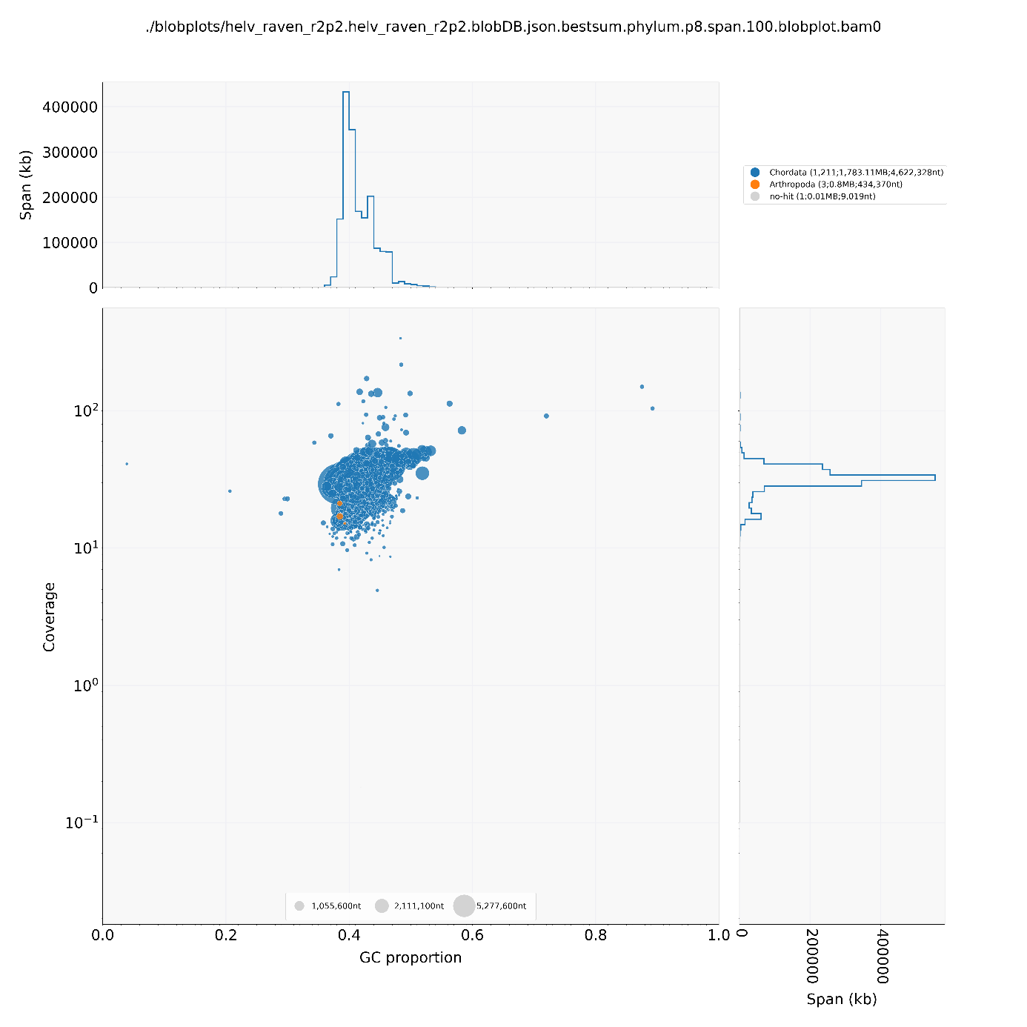
Fig. S1. Blobtools plot of the de-novo assembly of Natrix helvetica helvetica. It shows only negligible signal for contamination, which could result from small contig length and a sampling bias in NCBI. Furthermore, the putatively contaminated contigs (red) are located in the main cloud. Therefore, the assembly was not filtered.
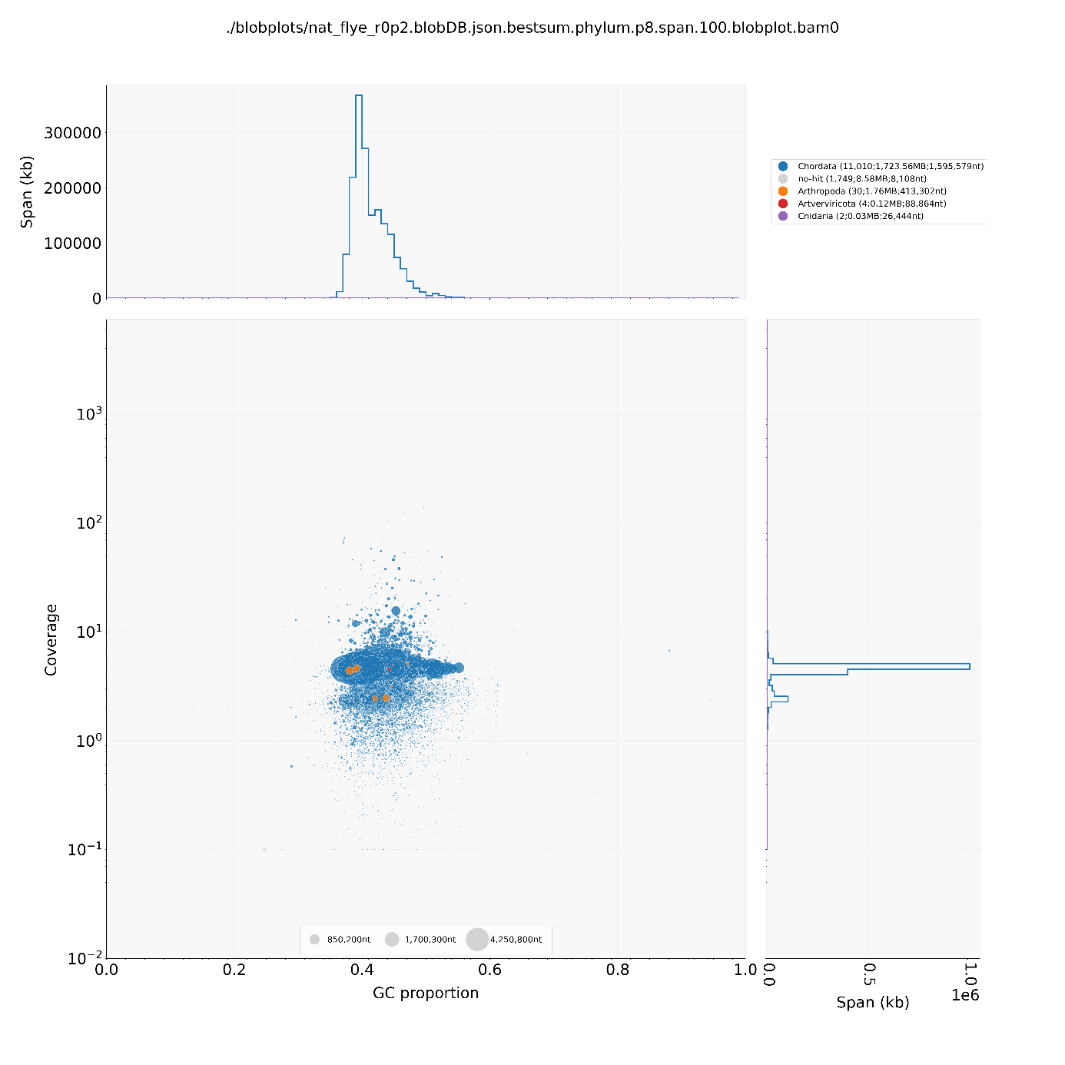
Fig. S2. Blobtools plot of the de-novo assembly of Natrix natrix natrix. It shows only negligible signal for contamination, which could result from small contig length and a sampling bias in NCBI. Furthermore, the putatively contaminated contigs (red) are located in the main cloud. Therefore, the assembly was not filtered.

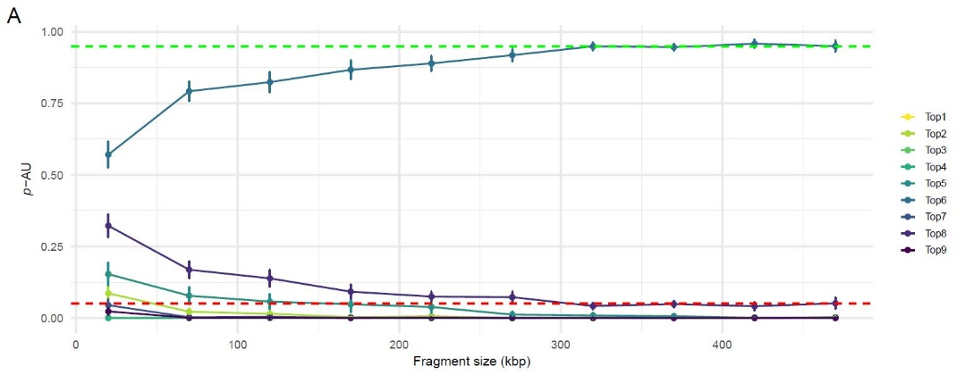
Fig. S3. Results of the AU test of nine different topologies for different fragment sizes between 20 kb and 470 kb. This analysis tests whether one of the given topologies is supported significantly (95 % p-AU) over the others. In this case, topology 6 (same as Fig. 2) was supported significantly at a fragment length of 320 kb or higher. Therefore, we chose this length as fragment length for the genome fragment analysis.
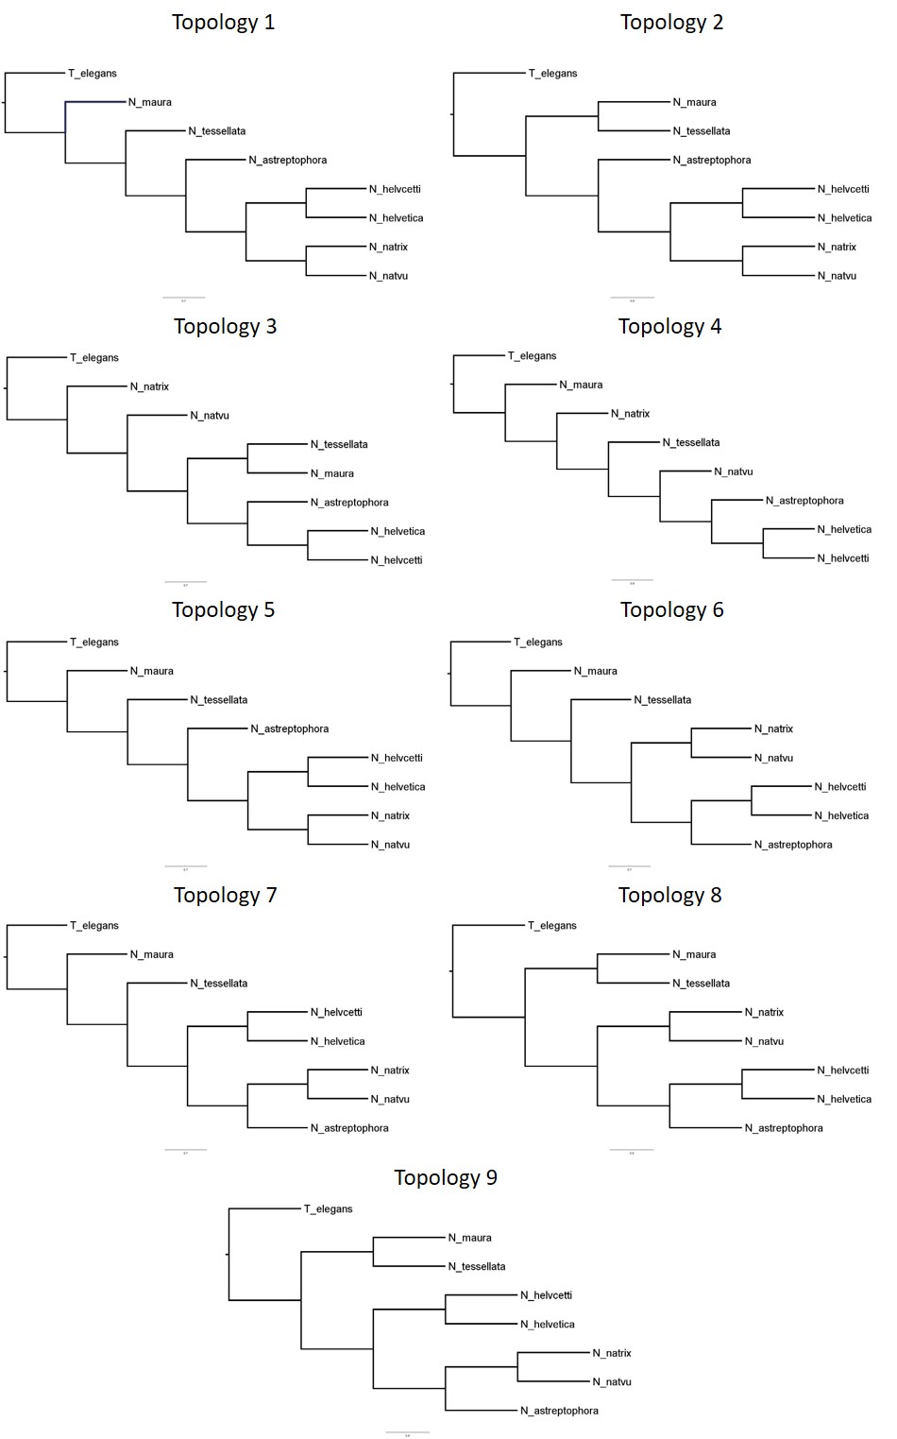
Fig. S4. Tested topologies in pAU test (Fig. S3). All nine topologies were tested to choose the best genome fragment length. At a length of ~320 kb, topology 6 was significantly supported (Fig. S3).

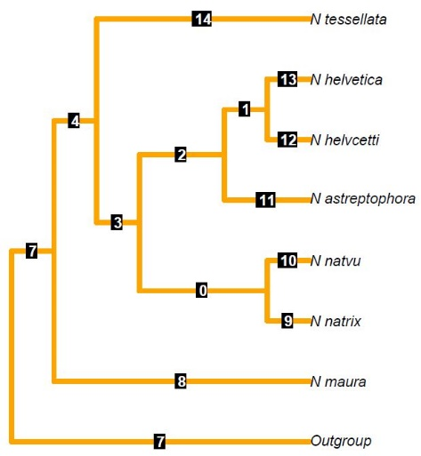
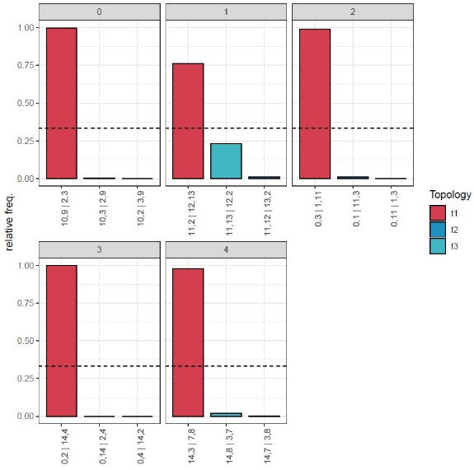

Fig. S5. Left: Quartet Frequencies in the genome fragments for the Astral species tree. These statistics show the frequencies of each possible topology for focal quartets. The numbers of the quartets given on the x-axis of each graph refers to the branch numbers given on the right. Right: Tree topology of the species tree by Astral showing the branch numeration used for Quartet Frequency analysis. N natvu stands for N. n. vulgaris, and N helvcetti for N. h. cetti.

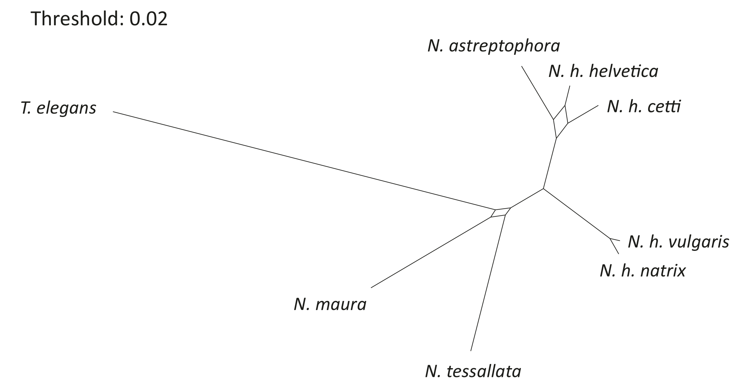
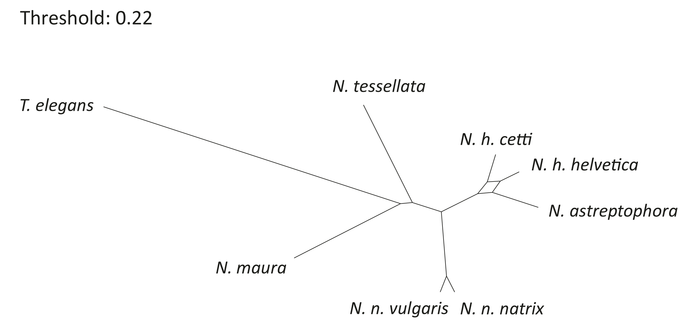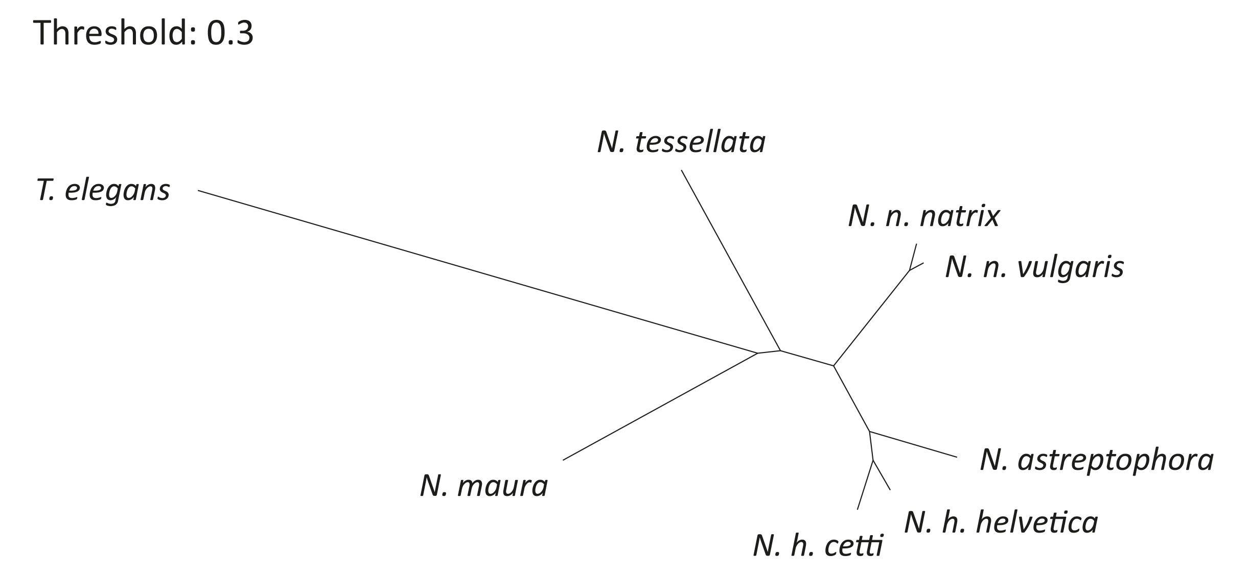Fig. S6. Phylogenetic networks based on 860 genome fragments of 320 kb length, showing phylogenetic conflict among the species at different thresholds. The shown thresholds are the lowest ones before a reticulation disappears. The networks show conflict among N. h. helvetica, N. h. cetti and N. astreptophora as between N. maura and N. tessellata.

