Supplement to the paper: Efficacy and safety of rivaroxaban compared with other therapies used in patients with peripheral artery disease undergoing peripheral revascularization – a systematic literature review and network meta-analysis
Supplementary Table 1. Credibility assessment of trials included in the NMA[1]
Trial name (acronym) | Was randomisation carried out appropriately? | Was the concealment of treatment allocation adequate? | Were the groups similar at the outset of the study in terms of prognostic factors? | Were the care providers, participants, and outcome assessors blind to treatment allocation? | Were there any unexpected imbalances in drop-outs between groups? | Is there any evidence to suggest that the authors measured more outcomes than they reported? | Did the analysis include an intention-to-treat analysis? If so, was this appropriate and were appropriate methods used to account for missing data?
WAVE[2] | Yes | Yes | Not clear | No | No | No | Yes
CASPAR[3] | Yes | Yes | Not clear | Yes | No | No | Yes
CHARISMA[4] | Yes | Yes | Yes | Yes | Not clear | No | Yes
BOA[5] | Yes | Yes | Yes | No | No | No | Yes
VOYAGER PAD[6] | Yes | Yes | Yes | Yes | No | No | Yes
CAPRIE[7] | Yes | Yes | Yes | Yes | No | Not clear | Yes
Cassar 2005[8] | Yes | Yes | Yes | Yes | No | Not clear | Yes
Eikelboom, 2005[9] | Yes | Yes | Not clear | Yes | No | Not clear | No
COMPASS[10] | Yes | Yes | Yes | Yes | No | No | Yes
Johnson, 2002&2004[11] | Yes | Yes | Not clear | No | No | Not clear | Yes
Li, 2013[12] | Not clear | Not clear | Yes | No | No | Not clear | No
Liang, 2012[13] | Yes | Not clear | Yes | Not clear | No | No | No
MIRROR[14] | Yes | Not clear | Not clear | Yes | No | Not clear | Yes

Supplementary Figure 1. Networks of evidence for the risk of amputations
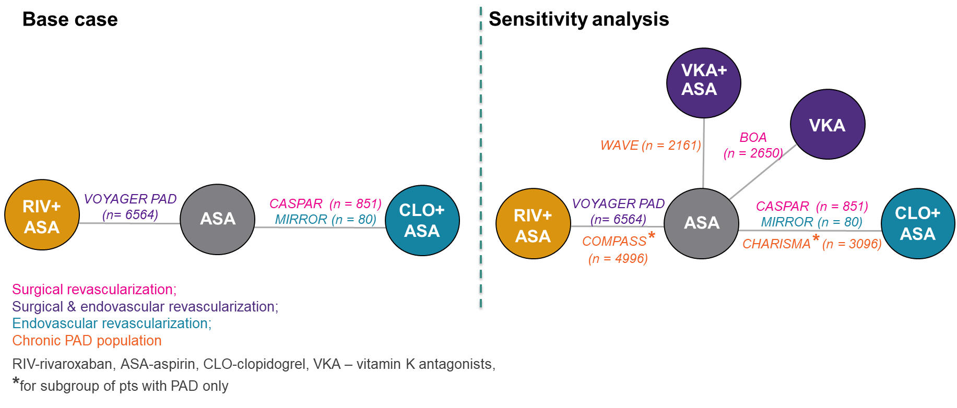

Supplementary Figure 2. Forest plots comparing RIV plus ASA versus comparators regarding amputation
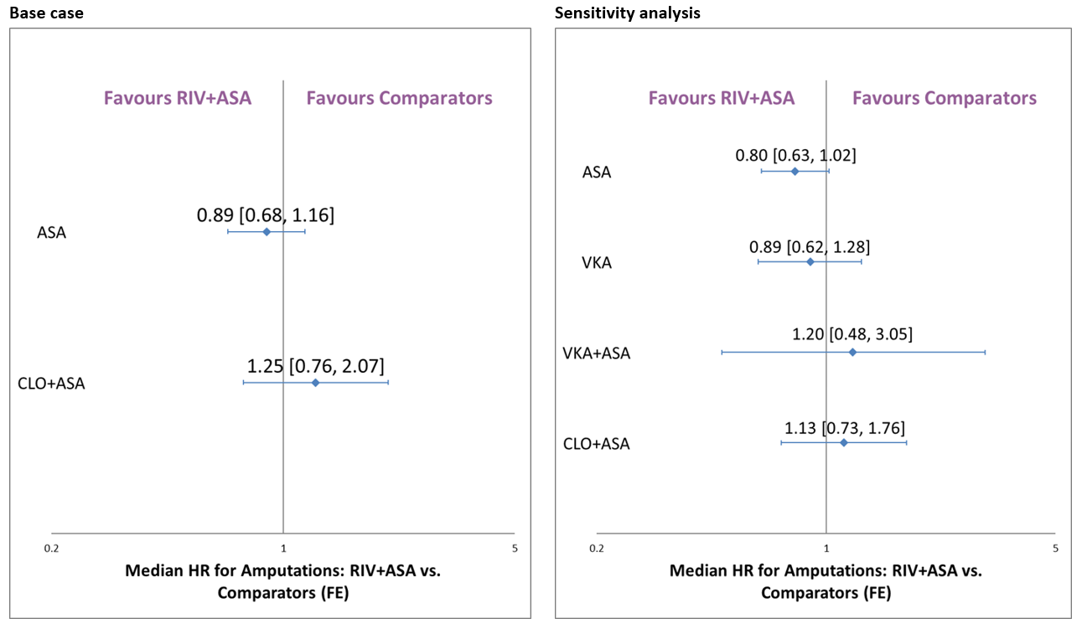
ASA, acetylsalicylic acid; FE, fixed effect; RIV, rivaroxaban.

Supplementary Table 2. Input data for the NMA of the risk of myocardial infarction
Study | Treatments | Event rate  n/N (%) | HR [95%CI] | Analysis
 |  |  |  | Base case | Sensitivity
CASPAR[3] | CLO+ASA | no data | 0.81 [0.32, 2.06] | ✔ | ✔
 | ASA | no data | Reference
CAPRIE[7] | CLO | 68/3223 (2.1%) | 0.63 [0.46, 0.85] | ❌ | ✔
 | ASA | 108/3229 (3.3%) | Reference
Johnson, 2002&2004[11] | VKA+ASA | 37/418 (8.9%) | 1.27 [0.78, 2.07] | ✔ | ✔
 | ASA | 29/413 (7.0%) | Reference
VOYAGER PAD[6] | RIV+ASA | 131/3286 (4.0%) | 0.88 [0.70, 1.12] | ✔ | ✔
 | ASA | 148/3278 (4.5%) | Reference
BOA[5] | VKA | 29/1326 (2.2%) | 0.69 [0.42, 1.10] | ❌ | ✔
 | ASA | 42/1324 (3.2%) | Reference
CHARISMA[4] | CLO+ASA | 36/1545 (2.3%) | 0.63 [0.42, 0.96] | ❌ | ✔
 | ASA | 57/1551 (3.7%) | Reference
COMPASS[10] | RIV+ASA | 51/2492 (2.0%) | 0.76 [0.53, 1.09] | ❌ | ✔
 | ASA | 67/2504 (2.7%) | Reference
WAVE[2] | VKA+ASA | 54/1080 (5.0%) | 0.82 [0.57, 1.18] | ❌ | ✔
 | ASA | 66/1081 (6.1%) | Reference
✔– study eligible for the analysis; ❌– study ineligible for the analysis
ASA, acetylsalicylic acid; CLO, clopidogrel; RIV, rivaroxaban; VKA, vitamin K antagonist.

Supplementary Figure 3. Networks of evidence for the risk of myocardial infarction
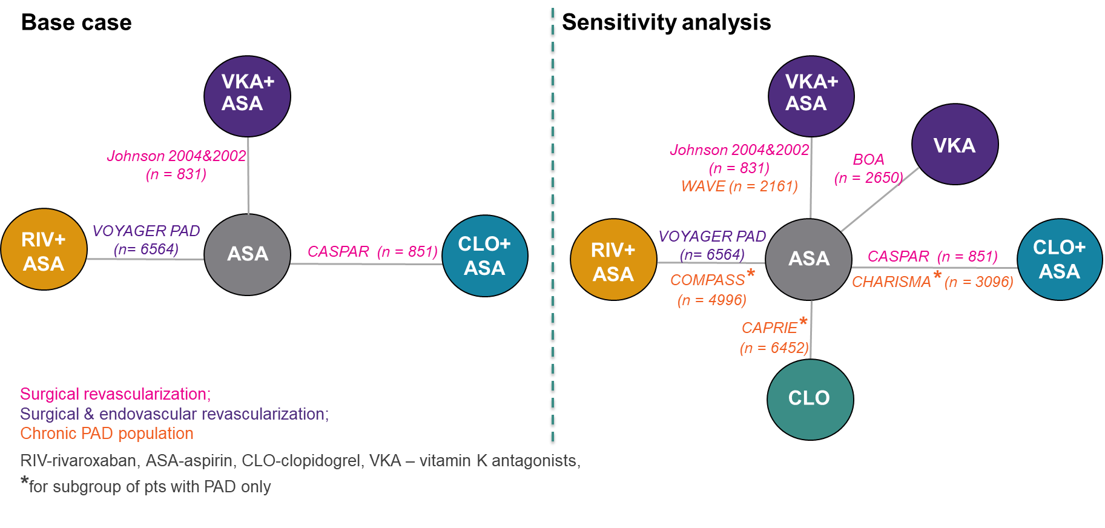

Supplementary Figure 4. Forest plots comparing RIV plus ASA versus comparators regarding myocardial infarction
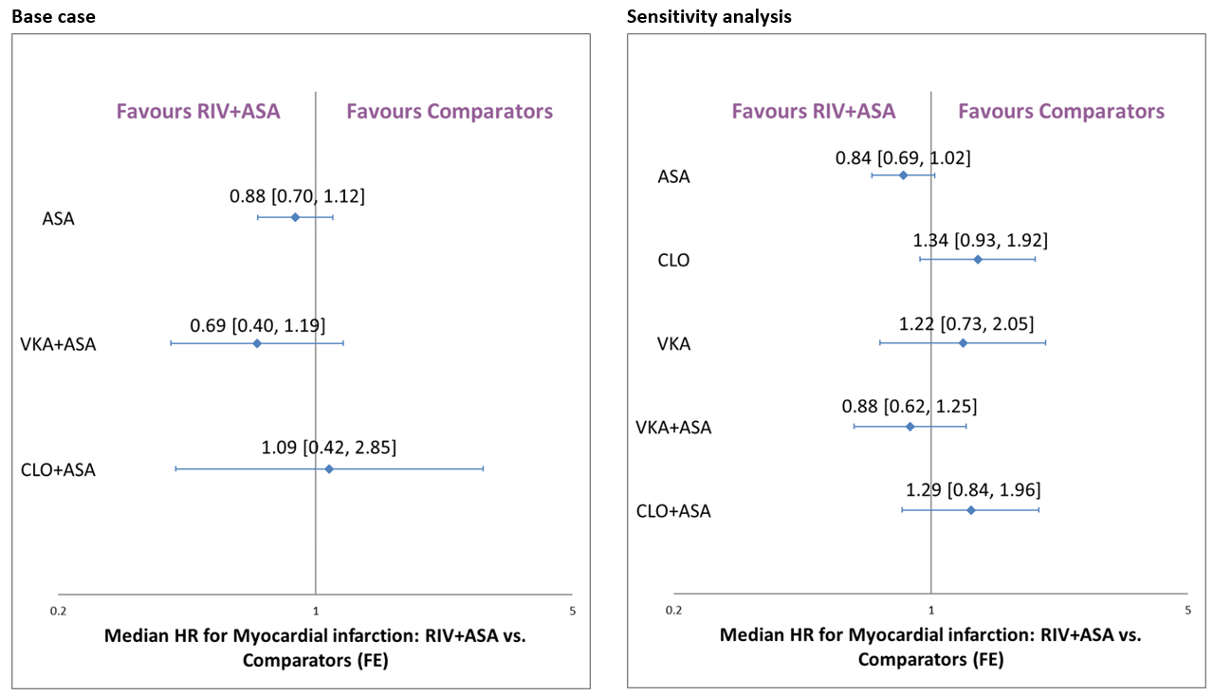
ASA, acetylsalicylic acid; FE, fixed effect; RIV, rivaroxaban.
Supplementary Table 3. Input data for the NMA of the risk of ischaemic stroke
Study | Treatments | Event rate  n/N (%) | HR [95%CI] | Analysis
 |  |  |  | Base case | Sensitivity
CAPRIE[7] | CLO | 81/3223 (2.5%) | 0.99 [0.73, 1.35] | ❌ | ✔
 | ASA | 82/3229 (2.5%) | Reference
Cassar 2005[8] | CLO+ASA | 1/54 (1.9%) | 2.93 [0.11, 76.07] | ✔ | ✔
 | ASA | 0/49 (0.0%) | Reference
VOYAGER PAD[6] | RIV+ASA | 71/3286 (2.2%) | 0.87 [0.63, 1.19] | ✔ | ✔
 | ASA | 82/3278 (2.5%) | Reference
BOA[5] | VKA | 17/1326 (1.3%) | 0.50 [0.28, 0.89] | ❌ | ✔
 | ASA | 34/1324 (2.6%) | Reference
CHARISMA[4] | CLO+ASA | 32/1545 (2.1%) | 0.82 [0.52, 1.32] | ❌ | ✔
 | ASA | 39/1551 (2.5%) | Reference
COMPASS[10] | RIV+ASA | 22/2492 (0.9%) | 0.55 [0.33, 0.93] | ❌ | ✔
 | ASA | 40/2504 (1.6%) | Reference
WAVE[2] | VKA+ASA | 24/1080 (2.2%) | 0.64 [0.38, 1.06] | ❌ | ✔
 | ASA | 38/1081 (3.5%) | Reference
✔– study eligible for the analysis; ❌– study ineligible for the analysis
ASA, acetylsalicylic acid; CLO, clopidogrel; RIV, rivaroxaban; VKA, vitamin K antagonist.

Supplementary Figure 5. Networks of evidence for the risk of ischaemic stroke
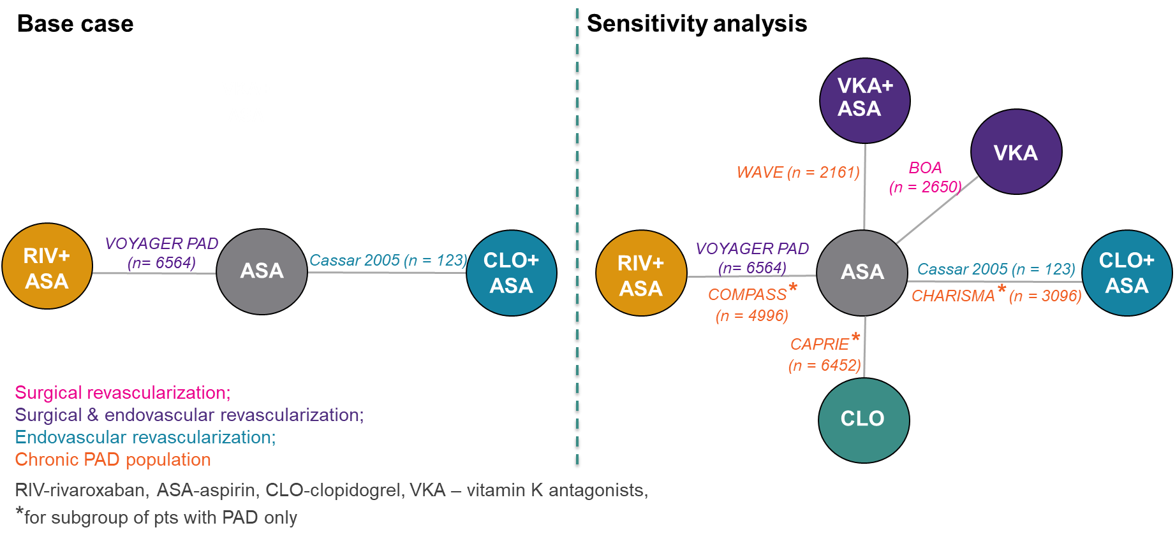

Supplementary Figure 6. Forest plots comparing RIV plus ASA versus comparators regarding ischaemic stroke
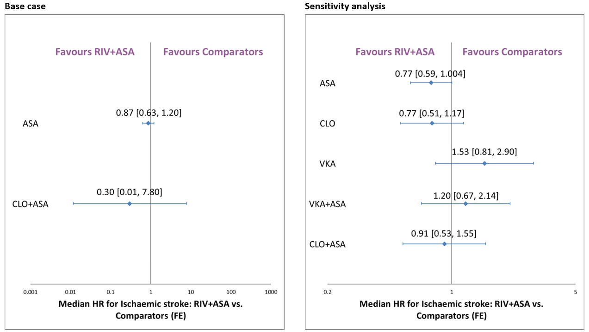
ASA, acetylsalicylic acid; FE, fixed effect; RIV, rivaroxaban.

Supplementary Table 4. Input data for the NMA of the risk of cardiovascular death
Study | Treatments | Event rate  n/N (%) | HR [95%CI] | Analysis
 |  |  |  | Base case | Sensitivity
CAPRIE[7] | CLO | 95/3223 (3.0%) | 0.78 [0.59, 1.02] | ❌ | ✔
 | ASA | 122/3229 (3.8%) | Reference
CASPAR[3] | CLO+ASA | NA/425 (NA%) | 1.49 [0.73, 3.01] | ✔ | ✔
 | ASA | NA/426 (NA%) | Reference
VOYAGER PAD[6] | RIV+ASA | 199/3286 (6.1%) | 1.14 [0.93, 1.4] | ✔ | ✔
 | ASA | 174/3278 (5.3%) | Reference
BOA[5] | VKA | 137/1326 (10.3%) | 0.94 [0.74, 1.18] | ❌ | ✔
 | ASA | 146/1324 (11.0%) | Reference
CHARISMA[4] | CLO+ASA | 65/1545 (4.2%) | 0.92 [0.65, 1.28] | ❌ | ✔
 | ASA | 71/1551 (4.6%) | Reference
COMPASS[10] | RIV+ASA | 64/2492 (2.6%) | 0.82 [0.59, 1.14] | ❌ | ✔
 | ASA | 78/2504 (3.1%) | Reference
WAVE[2] | VKA+ASA | 66/1080 (6.1%) | 1.04 [0.74, 1.46] | ❌ | ✔
 | ASA | 65/1081 (6.0%) | Reference
✔– study eligible for the analysis; ❌– study ineligible for the analysis
ASA, acetylsalicylic acid; CLO, clopidogrel; RIV, rivaroxaban; VKA, vitamin K antagonist.

Supplementary Figure 7. Networks of evidence for the risk of cardiovascular death
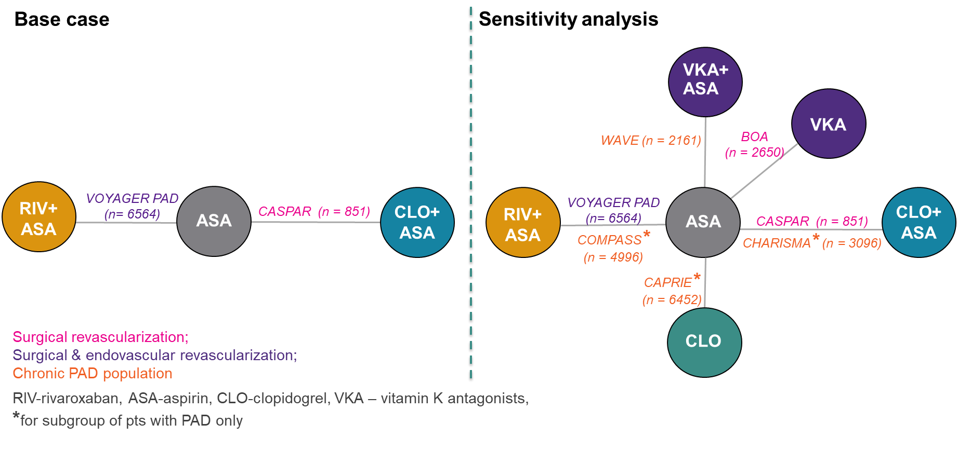

Supplementary Figure 8. Forest plots comparing RIV plus ASA versus comparators regarding cardiovascular death
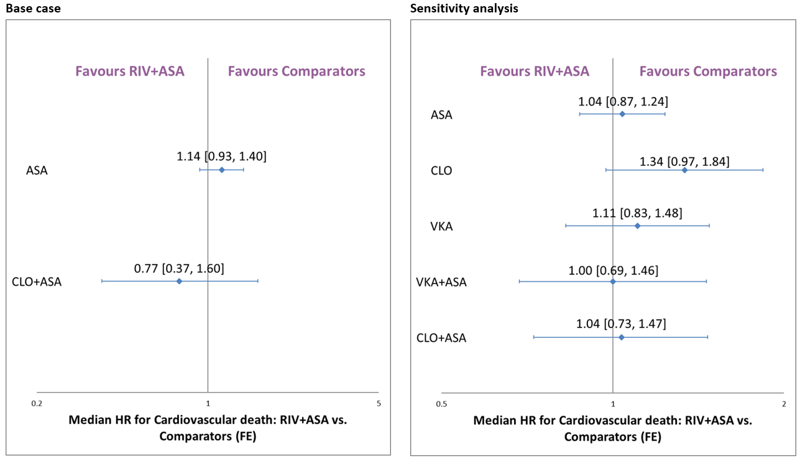
ASA, acetylsalicylic acid; FE, fixed effect; RIV, rivaroxaban.

Supplementary Table 5. Input data for the NMA of the risk of all-cause mortality
Study | Treatments | Event rate  n/N (%) | HR [95%CI] | Analysis
 |  |  |  | Base case | Sensitivity
MIRROR[14] | CLO+ASA | 0/40 (0.0%) | 0.33 [0.01, 8.08] | ✔ | ✔
 | ASA | 1/40 (2.5%) | Reference
CASPAR[3] | CLO+ASA | 24/425 (5.6%) | 1.44 [0.77, 2.68] | ✔ | ✔
 | ASA | 17/426 (4.0%) | Reference
Johnson, 2002&2004[11] | VKA+ASA | 133/418 (31.8%) | 1.41 [1.09, 1.84] | ✔ | ✔
 | ASA | 95/413 (23.0%) | Reference
VOYAGER PAD[6] | RIV+ASA | 321/3286 (9.8%) | 1.08 [0.92, 1.27] | ✔ | ✔
 | ASA | 297/3278 (9.1%) | Reference
BOA[5] | VKA | 211/1326 (15.9%) | 1.02 [0.85, 1.24] | ❌ | ✔
 | ASA | 205/1324 (15.5%) | Reference
CHARISMA[4] | CLO+ASA | 104/1545 (6.7%) | 0.89 [0.68, 1.16] | ❌ | ✔
 | ASA | 117/1551 (7.5%) | Reference
COMPASS[10] | RIV+ASA | 129/2492 (5.2%) | 0.91 [0.72, 1.16] | ❌ | ✔
 | ASA | 142/2504 (5.7%) | Reference
WAVE[2] | VKA+ASA | 99/1080 (9.2%) | 1.04 [0.79, 1.38] | ❌ | ✔
 | ASA | 96/1081 (8.9%) | Reference
✔– study eligible for the analysis; ❌– study ineligible for the analysis
ASA, acetylsalicylic acid; CLO, clopidogrel; RIV, rivaroxaban; VKA, vitamin K antagonist.

Supplementary Figure 9. Networks of evidence for the risk of all-cause mortality
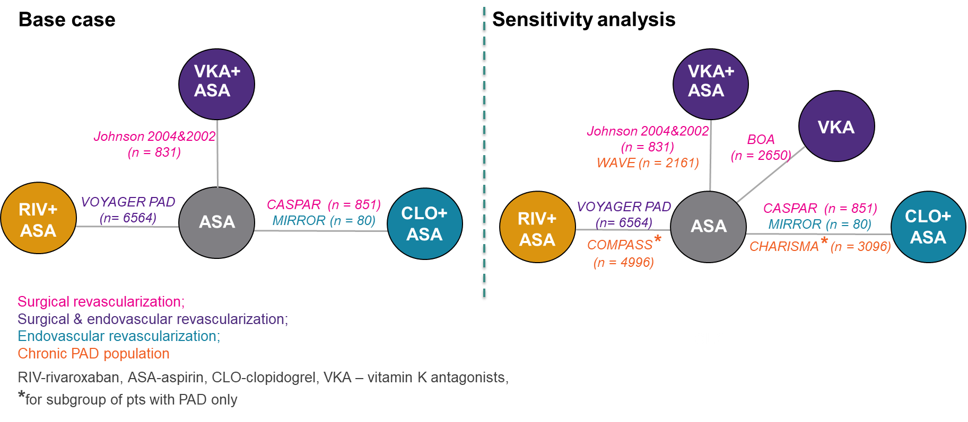

Supplementary Figure 10. Forest plots comparing RIV plus ASA versus comparators regarding all-cause mortality
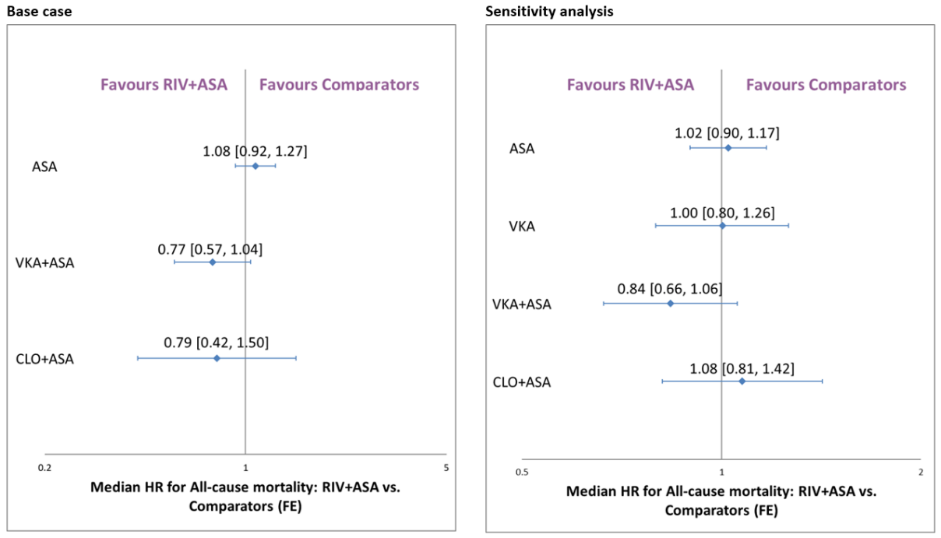
ASA, acetylsalicylic acid; FE, fixed effect; RIV, rivaroxaban.

Supplementary Table 6. Input data for the NMA of the risk of any stroke
Study | Treatments | Event rate  n/N (%) | HR [95%CI] | Analysis
 |  |  |  | Base case | Sensitivity
CAPRIE[7] | CLO | 81/3223 (2.5%) | 0.99 [0.73, 1.35] | ❌ | ✔
 | ASA | 82/3229 (2.5%) | Reference
CASPAR[3] | CLO+ASA | NA/425 (NA%) | 1.02 [0.41, 2.57] | ✔ | ✔
 | ASA | NA/426 (NA%) | Reference
Johnson, 2002&2004[11] | VKA+ASA | 31/418 (7.4%) | 1.06 [0.64, 1.76] | ✔ | ✔
 | ASA | 29/413 (7.0%) | Reference
VOYAGER PAD[6] | RIV+ASA | 81/3286 (2.5%) | 0.94 [0.69, 1.27] | ✔ | ✔
 | ASA | 86/3278 (2.6%) | Reference
BOA[5] | VKA | 35/1326 (2.6%) | 0.74 [0.48, 1.14] | ❌ | ✔
 | ASA | 47/1324 (3.5%) | Reference
CHARISMA[4] | CLO+ASA | 36/1545 (2.3%) | 0.79 [0.51, 1.21] | ❌ | ✔
 | ASA | 46/1551 (3.0%) | Reference
COMPASS[10] | RIV+ASA | 25/2492 (1.0%) | 0.54 [0.33, 0.87] | ❌ | ✔
 | ASA | 47/2504 (1.9%) | Reference
WAVE[2] | VKA+ASA | 38/1080 (3.5%) | 1.01 [0.65, 1.59] | ❌ | ✔
 | ASA | 38/1081 (3.5%) | Reference
✔– study eligible for the analysis; ❌– study ineligible for the analysis
ASA, acetylsalicylic acid; CLO, clopidogrel; RIV, rivaroxaban; VKA, vitamin K antagonist.

Supplementary Figure 11. Networks of evidence for the risk of any stroke
Supplementary Figure 12. Forest plots comparing RIV plus ASA versus comparators regarding any stroke
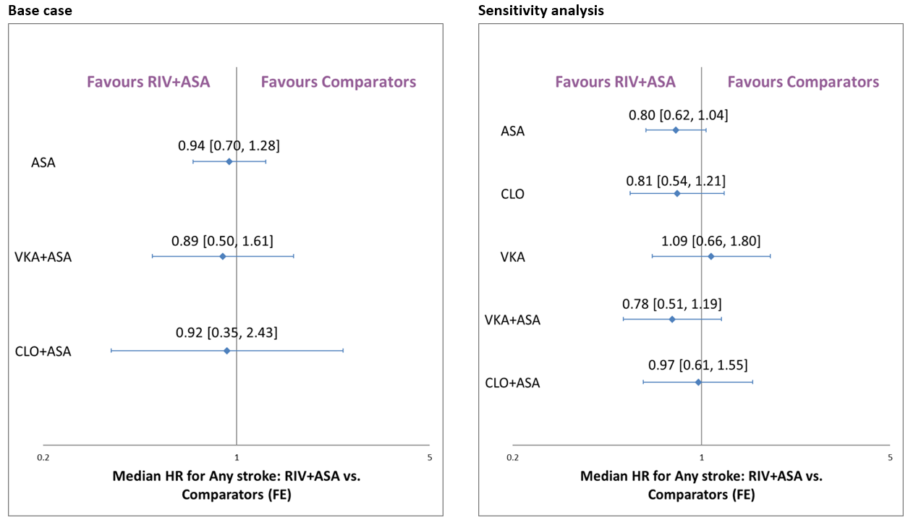
ASA, acetylsalicylic acid; FE, fixed effect; RIV, rivaroxaban.

Supplementary Table 7. Input data for the NMA of the risk of major bleeding
Study | Treatments | Event rate  n/N (%) | HR [95%CI] | Analysis |  | Definition
 |  |  |  | Base case | Sensitivity
CASPAR[3] | CLO+ASA | 9/426 (2.1%) | 1.79 [0.60,5.35] | ✔ | ✔ | GUSTO classification of “severe bleeding”
 | ASA | 5/425 (1.2%) | Reference
Johnson, 2002&2004[11] | VKA+ASA | 35/418 (8.4%) | 2.36 [1.29,4.33] | ✔ | ✔ | Intracranial bleed, hospitalization for bleeding, an operation for control of bleeding, or a blood transfusion
 | ASA | 15/413 (3.6%) | Reference
VOYAGER PAD[6] | RIV+ASA | 62/3256 (1.9%) | 1.43 [0.97, 2.10] | ✔ | ✔ | TIMI
 | ASA | 44/3248 (1.4%) | Reference
BOA[5] | VKA | 108/1326 (8.1%) | 1.96 [1.42, 2.71] | ❌ | ✔ | Fatal  bleeding episodes, intracranial haemorrhage, or any bleeding  episode requiring hospital attendance, irrespective of  interventions
 | ASA | 56/1324 (4.2%) | Reference
CHARISMA[4] | CLO+ASA | 26/1545 (1.6%) | 0.97 [0.56, 1.66] | ❌ | ✔ | GUSTO classification of “severe bleeding”
 | ASA | 27/1551 (1.7%) | Reference
COMPASS[10] | RIV+ASA | 77/2492 (3.1%) | 1.61 [1.12, 2.31] | ❌ | ✔ | Modified ISTH major bleeding definition
 | ASA | 48/2504 (1.9%) | Reference
WAVE[2] | VKA+ASA | 43/1080 (4.0%) | 3.41 [1.84, 6.35] | ❌ | ✔ | Life-threatening bleeding
 | ASA | 13/1081 (1.2%) | Reference
✔– study eligible for the analysis; ❌– study ineligible for the analysis
ASA, acetylsalicylic acid; CLO, clopidogrel; RIV, rivaroxaban; VKA, vitamin K antagonist.

Supplementary Figure 13. Networks of evidence for the risk of major bleeding
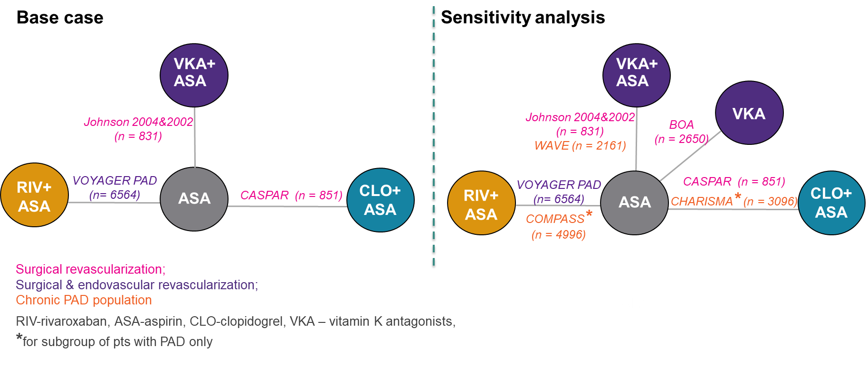
Supplementary Figure 14. Forest plots comparing RIV plus ASA versus comparators regarding major bleeding
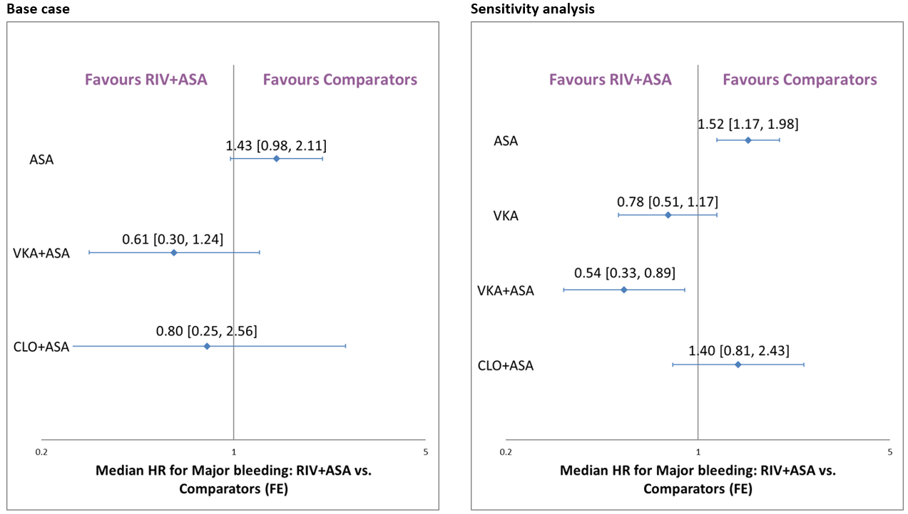
ASA, acetylsalicylic acid; FE, fixed effect; RIV, rivaroxaban.

Supplementary Table 8. Input data for the NMA of the risk of revascularisation
Study | Treatments | Event rate  n/N (%) | HR [95%CI] | Analysis
 |  |  |  | Base case | Sensitivity
MIRROR[14] | CLO+ASA | 2/40 (5.0%) | 0.23 [0.05, 1.08] | ✔ | ✔
 | ASA | 8/40 (20.0%) | Reference
CASPAR[3] | CLO+ASA | NA/425 (NA%) | 0.89 [0.65, 1.23] | ✔ | ✔
 | ASA | NA/426 (NA%) | Reference
VOYAGER PAD[6] | RIV+ASA | 584/3286 (17.8%) | 0.88 [0.79, 0.99] | ✔ | ✔
 | ASA | 655/3278 (20.0%) | Reference
BOA[5] | VKA | 429/1326 (32.4%) | 0.95 [0.84, 1.09] | ❌ | ✔
 | ASA | 446/1324 (33.7%) | Reference
CHARISMA[4] | CLO+ASA | 58/1545 (3.8%) | 0.73 [0.52, 1.03] | ❌ | ✔
 | ASA | 79/1551 (5.1%) | Reference
COMPASS[10] | RIV+ASA | 242/2492 (9.7%) | 0.93 [0.78, 1.11] | ❌ | ✔
 | ASA | 260/2504 (10.4%) | Reference
WAVE[2] | VKA+ASA | 36/1080 (3.3%) | 0.90 [0.57, 1.41] | ❌ | ✔
 | ASA | 40/1081 (3.7%) | Reference
✔– study eligible for the analysis; ❌– study ineligible for the analysis
ASA, acetylsalicylic acid; CLO, clopidogrel; RIV, rivaroxaban; VKA, vitamin K antagonist.

Supplementary Figure 15. Networks of evidence for the risk of revascularisation

Supplementary Figure 16. Forest plots comparing RIV plus ASA versus comparators regarding revascularisation
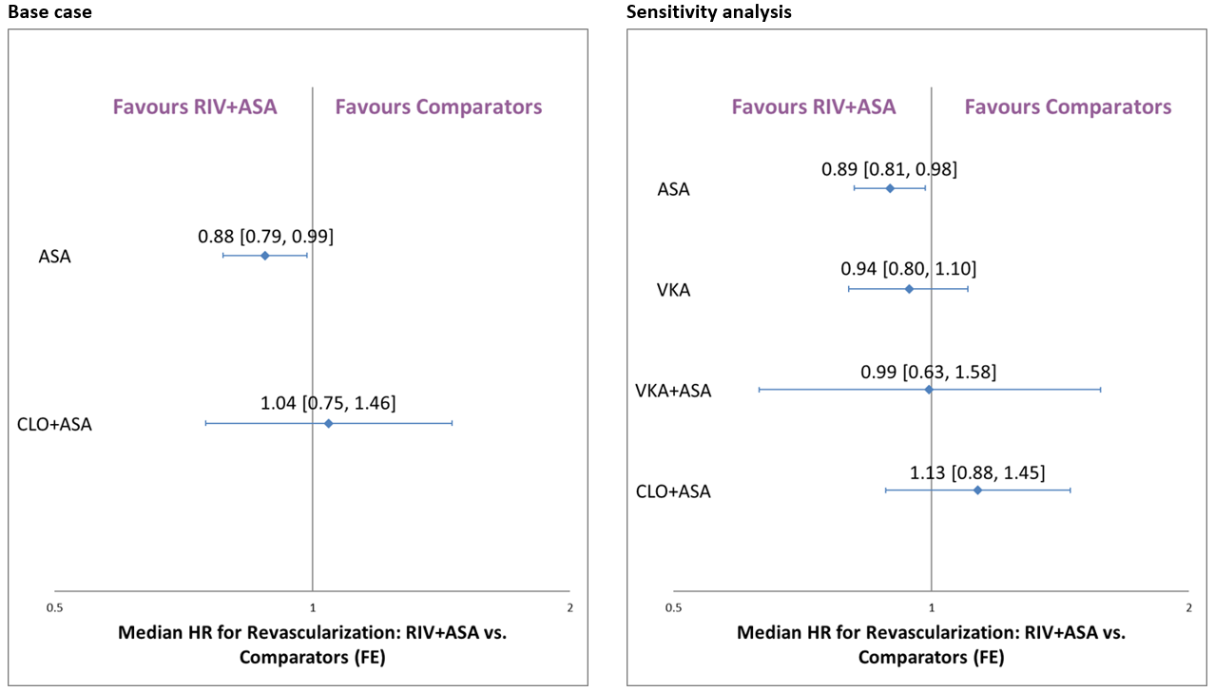
ASA, acetylsalicylic acid; FE, fixed effect; RIV, rivaroxaban.

References to supplementary tables and figures

1. Higgins JPT, Altman DG, Gøtzsche PC, et al. The Cochrane Collaboration’s tool for assessing risk of bias in randomised trials. BMJ. 2011;343:d5928.
2. Anand S, Yusuf S, Xie C, et al. Oral anticoagulant and antiplatelet therapy and peripheral arterial disease. N Engl J Med. 2007;357(3):217-27.
3. Belch JJ, Dormandy J, Biasi GM, et al. Results of the randomized, placebo-controlled clopidogrel and acetylsalicylic acid in bypass surgery for peripheral arterial disease (CASPAR) trial. J Vasc Surg. 2010;52(4):825-33, 833.e1-2.
4. Bhatt DL, Fox KA, Hacke W, et al. Clopidogrel and aspirin versus aspirin alone for the prevention of atherothrombotic events. N Engl J Med. 2006;354(16):1706-17.
5. Efficacy of oral anticoagulants compared with aspirin after infrainguinal bypass surgery (The Dutch Bypass Oral Anticoagulants or Aspirin Study): a randomised trial. Lancet. 2000;355(9201):346-51.
6. Bonaca MP, Bauersachs RM, Anand SS, et al. Rivaroxaban in Peripheral Artery Disease after Revascularization. N Engl J Med. 2020;382(21):1994-2004.
7. A randomised, blinded, trial of clopidogrel versus aspirin in patients at risk of ischaemic events (CAPRIE). CAPRIE Steering Committee. Lancet. 1996;348(9038):1329-39.
8. Cassar K, Ford I, Greaves M, et al. Randomized clinical trial of the antiplatelet effects of aspirin-clopidogrel combination versus aspirin alone after lower limb angioplasty. Br J Surg. 2005;92(2):159-65.
9. Eikelboom JW, Hankey GJ, Thom J, et al. Enhanced antiplatelet effect of clopidogrel in patients whose platelets are least inhibited by aspirin: a randomized crossover trial. J Thromb Haemost. 2005;3(12):2649-55.
10. Eikelboom JW, Connolly SJ, Bosch J, et al. Rivaroxaban with or without Aspirin in Stable Cardiovascular Disease. N Engl J Med. 2017;377(14):1319-1330.
11. Johnson WC, Williford WO. Benefits, morbidity, and mortality associated with long-term administration of oral anticoagulant therapy to patients with peripheral arterial bypass procedures: a prospective randomized study. J Vasc Surg. 2002;35(3):413-21.
12. Li H, Zhang F, Liang G, et al. A prospective randomized controlled clinical trial on clopidogrel combined with warfarin versus clopidogrel alone in the prevention of restenosis after endovascular treatment of the femoropopliteal artery. Ann Vasc Surg. 2013;27(5):627-33.
13. Liang GZ, Zhang FX, Luo XY, et al. [A prospective randomized control clinical trial about clopidogrel combined with warfarin versus clopidogrel alone in the prevention of restenosis after femoral-popliteal artery angioplasty]. Zhonghua Wai Ke Za Zhi. 2012;50(8):704-8. In Chinese.
14. Tepe G, Bantleon R, Brechtel K, et al. Management of peripheral arterial interventions with mono or dual antiplatelet therapy--the MIRROR study: a randomised and double-blinded clinical trial. Eur Radiol. 2012;22(9):1998-2006.

