Supplementary material
Table S1. Agreement between ActiGraph-defined and the other monitors (i.e., GENEActiv, Axivity, and Movisens) in the definition of sleep, sedentary time, light, and MVPA.
 |  |  | ActiGraph
 |  |  | Sleep | Sedentary | Light PA | MVPA
ActiGraph | min/d |  | 428 | 709 | 195 | 108
ActiGraph | Sensitivity |  | 0.99 | 0.89 | 0.61 | 0.75
 | Specificity |  | 0.99 | 0.93 | 0.94 | 0.97
GENEActiv | Sensitivity |  | 0.97 | 0.91 | 0.63 | 0.74
 | Specificity |  | 0.99 | 0.91 | 0.94 | 0.98
Axivity | Sensitivity |  | 0.99 | 0.91 | 0.63 | 0.75
 | Specificity |  | 0.99 | 0.93 | 0.94 | 0.98
MVPA: moderate-to-vigorous physical activity; PA: physical activity

Table S2. Agreement between GENEActiv-defined and the other monitors (i.e., ActiGraph, Axivity, and Movisens) in the definition of sleep, sedentary time, light PA, and MVPA.
 |  |  | GENEActiv
 |  |  | Sleep | Sedentary | Light PA | MVPA
GENEActiv | min/d |  | 440 | 684 | 200 | 116
ActiGraph | Sensitivity |  | 0.97 | 0.92 | 0.60 | 0.70
 | Specificity |  | 1.00 | 0.90 | 0.94 | 0.98
GENEActiv | Sensitivity |  | 0.95 | 0.92 | 0.62 | 0.71
 | Specificity |  | 0.99 | 0.89 | 0.94 | 0.98
Axivity | Sensitivity |  | 0.97 | 0.89 | 0.52 | 0.63
 | Specificity |  | 1.00 | 0.88 | 0.92 | 0.97
MVPA: moderate-to-vigorous physical activity; PA: physical activity.

Table S3. Agreement between Axivity-defined and the other monitors (i.e., ActiGraph, GENEActiv, and Movisens) in the definition of sleep, sedentary time, light PA, and MVPA.
 |  |  | Axivity
 |  |  | Sleep | Sedentary | Light PA | MVPA
Axivity | min/d |  | 425 | 711 | 198 | 107
ActiGraph | Sensitivity |  | 0.98 | 0.91 | 0.62 | 0.74
 | Specificity |  | 0.99 | 0.91 | 0.94 | 0.98
GENEActiv | Sensitivity |  | 0.99 | 0.88 | 0.63 | 0.77
 | Specificity |  | 0.98 | 0.92 | 0.94 | 0.98
Axivity | Sensitivity |  | 0.99 | 0.88 | 0.53 | 0.66
 | Specificity |  | 0.99 | 0.89 | 0.92 | 0.97
MVPA: moderate-to-vigorous physical activity; PA: physical activity.

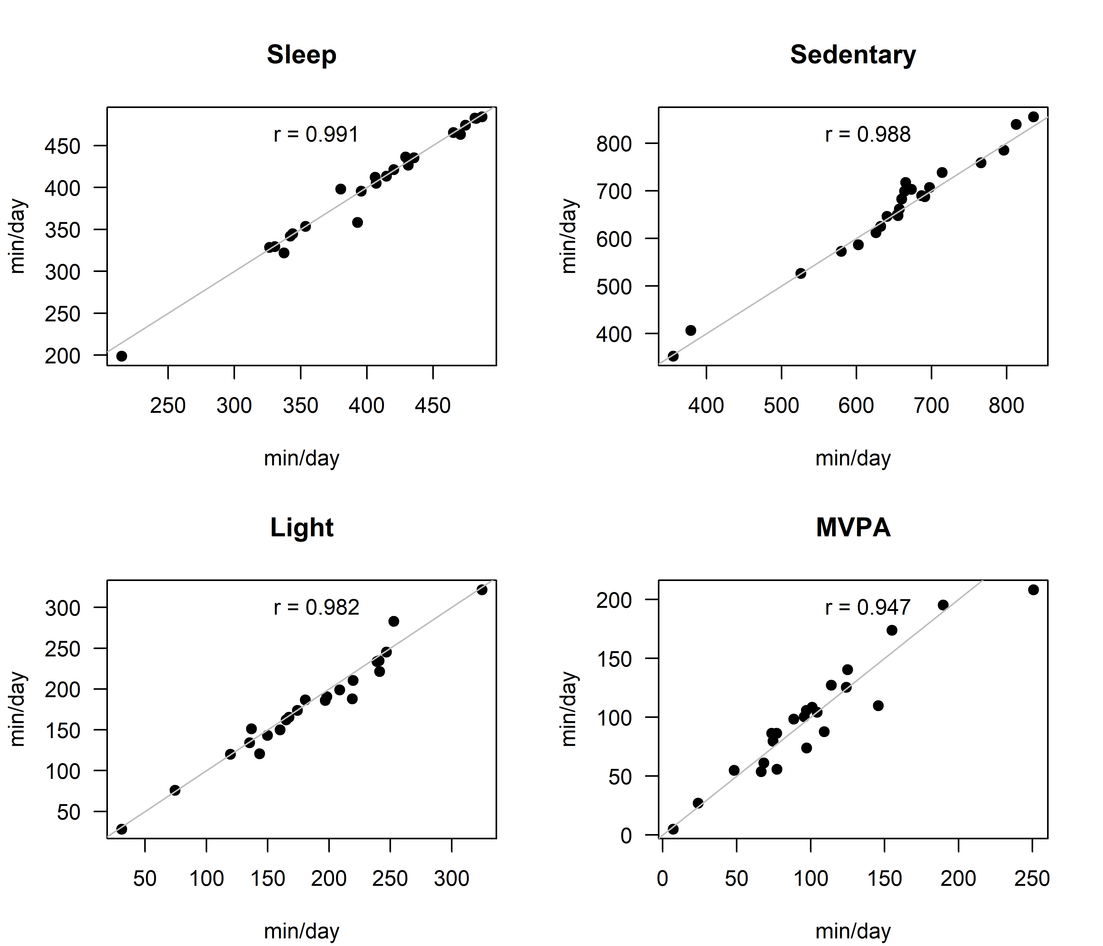
Figure S1. Scatter plots for the correlation between the Movisens and the ActiGraph in the definition of sleep, sedentary time, light PA, and MVPA. The grey line represents the perfect correlation (i.e., r = 1).
MVPA: moderate-to-vigorous physical activity; PA: physical activity.
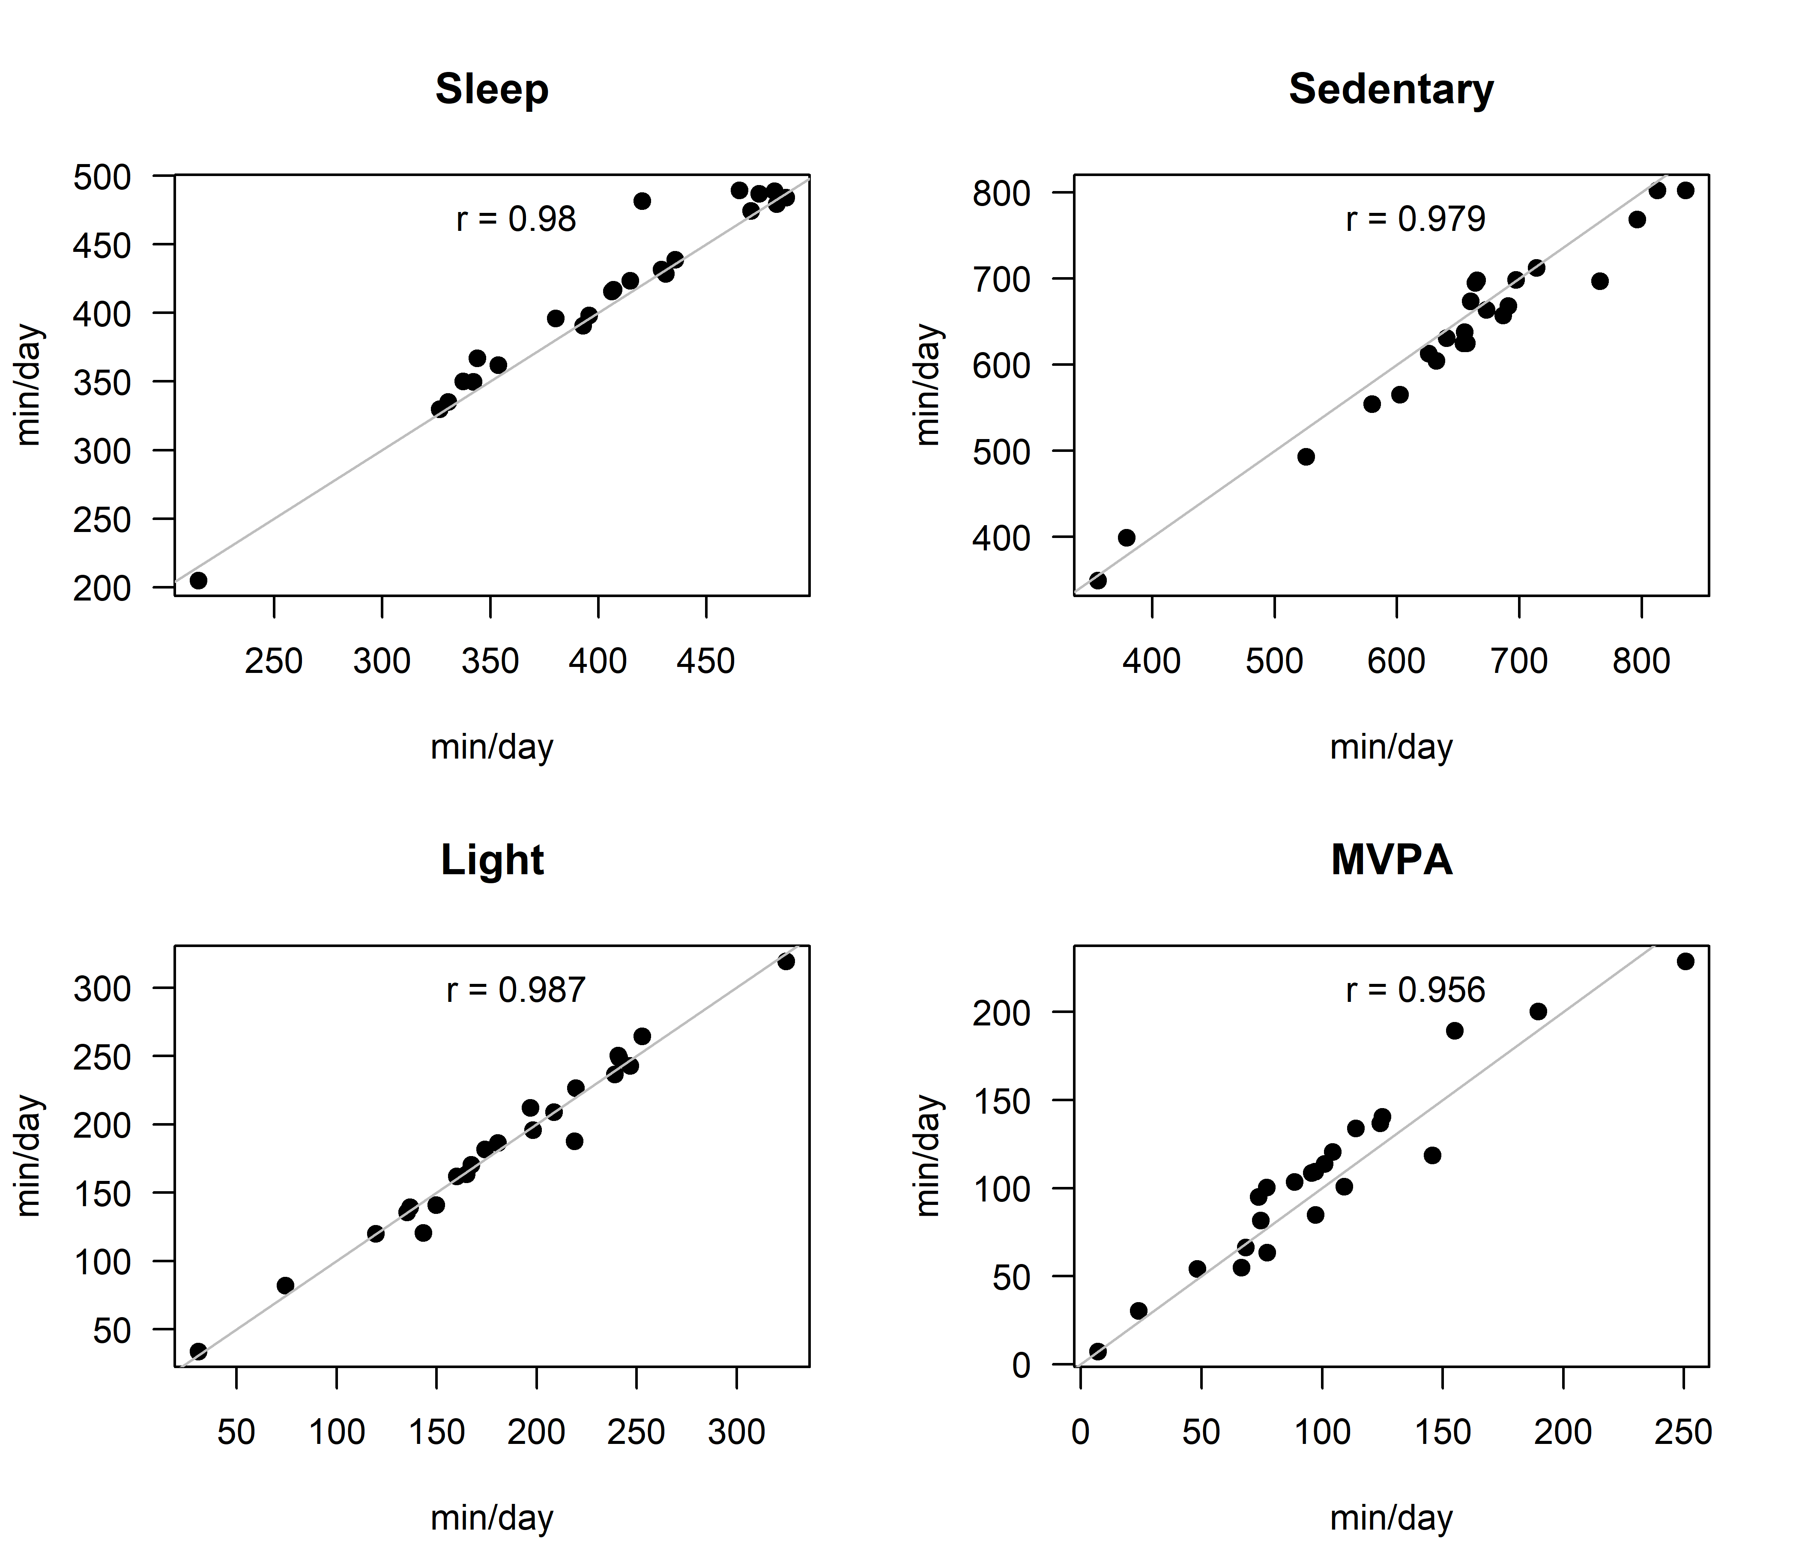
Figure S2. Scatter plots for the correlation between the Movisens and the GENEActiv in the definition of sleep, sedentary time, light PA, and MVPA. The grey line represents the perfect correlation (i.e., r = 1).
MVPA: moderate-to-vigorous physical activity; PA: physical activity.
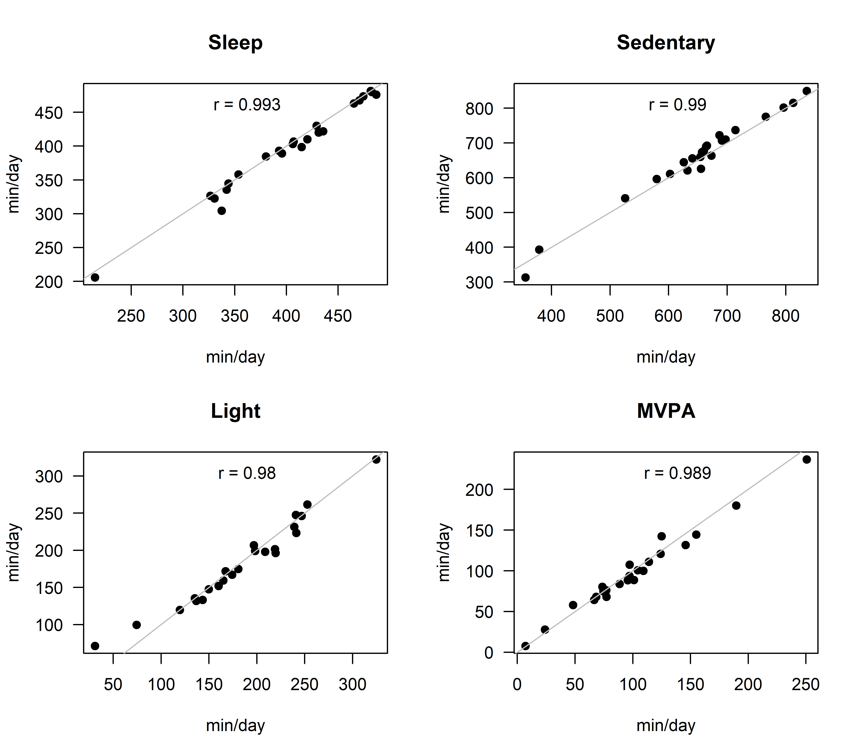
Figure S3. Scatter plots for the correlation between the Movisens and the Axivity in the definition of sleep, sedentary time, light PA, and MVPA. The grey line represents the perfect correlation (i.e., r = 1).
MVPA: moderate-to-vigorous physical activity; PA: physical activity.
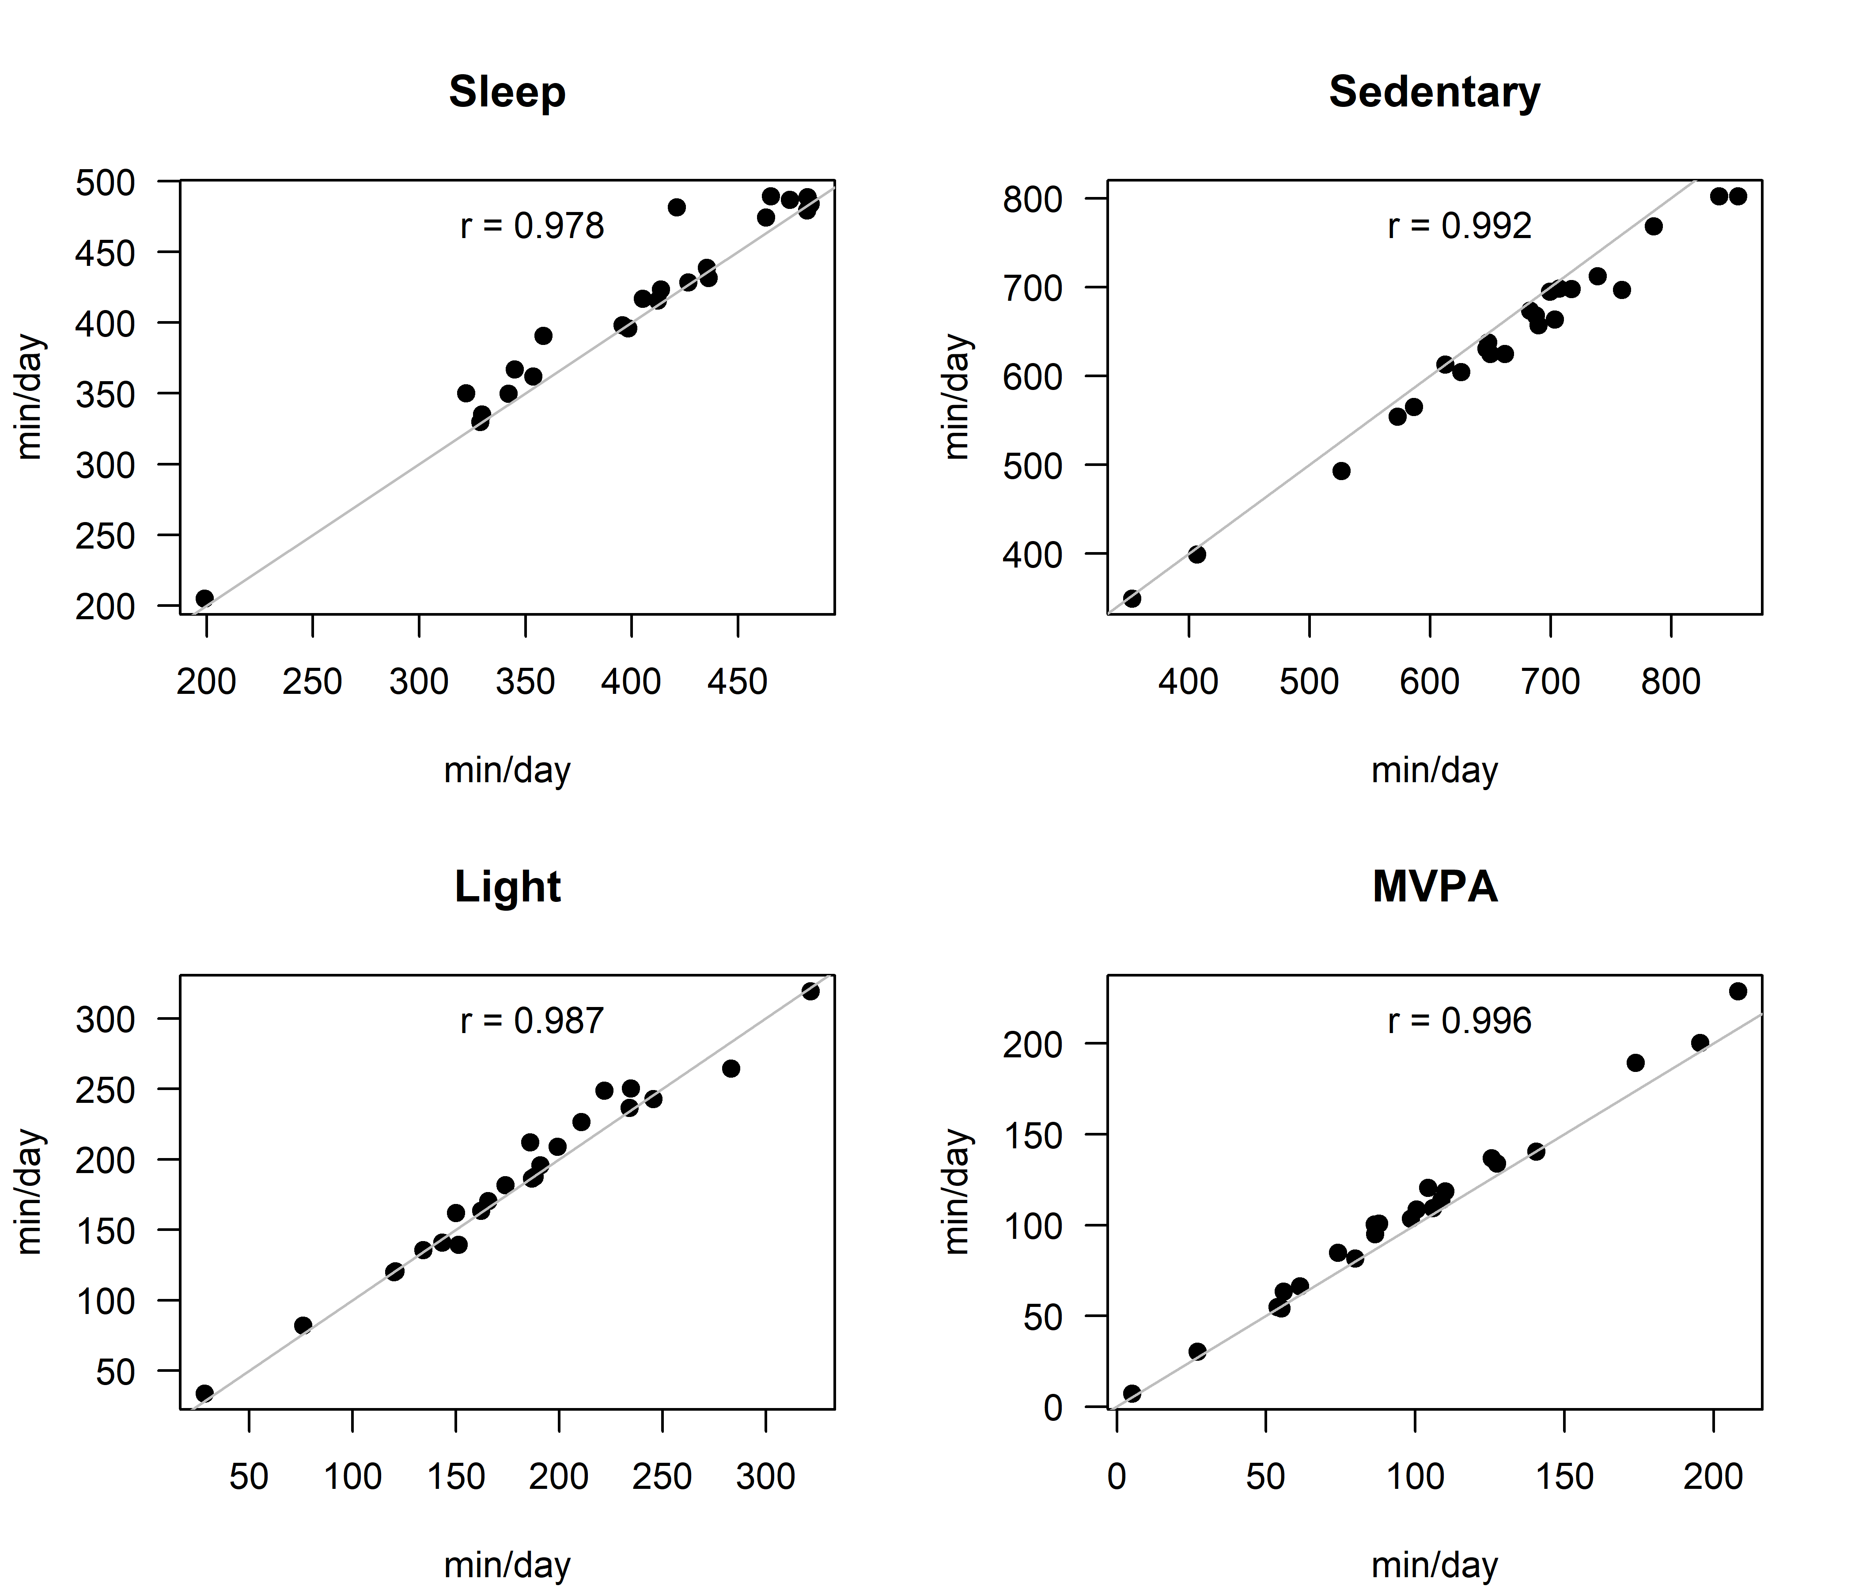
Figure S4. Scatter plots for the correlation between the ActiGraph and the GENEActiv in the definition of sleep, sedentary time, light PA, and MVPA. The grey line represents the perfect correlation (i.e., r = 1).
MVPA: moderate-to-vigorous physical activity; PA: physical activity.
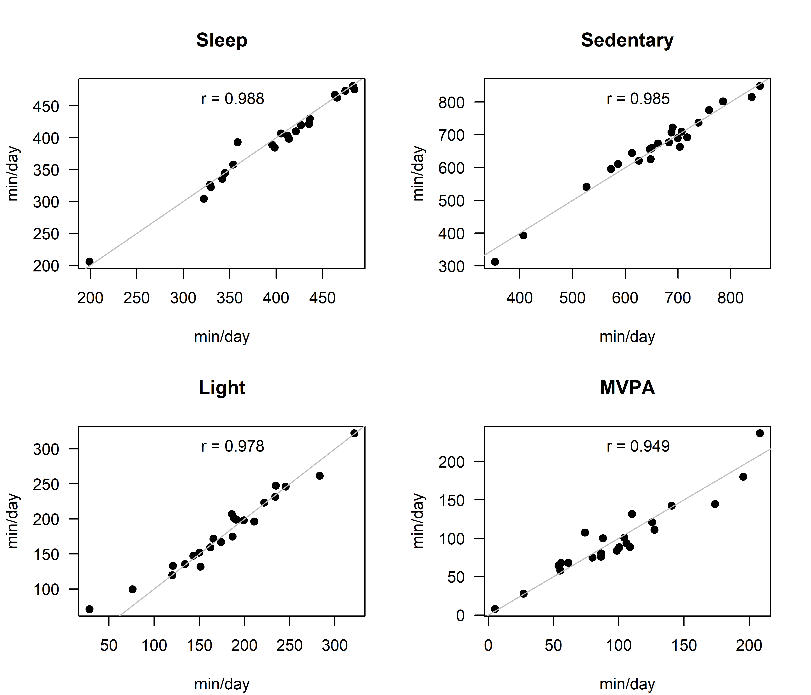
Figure S5. Scatter plots for the correlation between the ActiGraph and the Axivity in the definition of sleep, sedentary time, light PA, and MVPA. The grey line represents the perfect correlation (i.e., r = 1).
MVPA: moderate-to-vigorous physical activity; PA: physical activity.
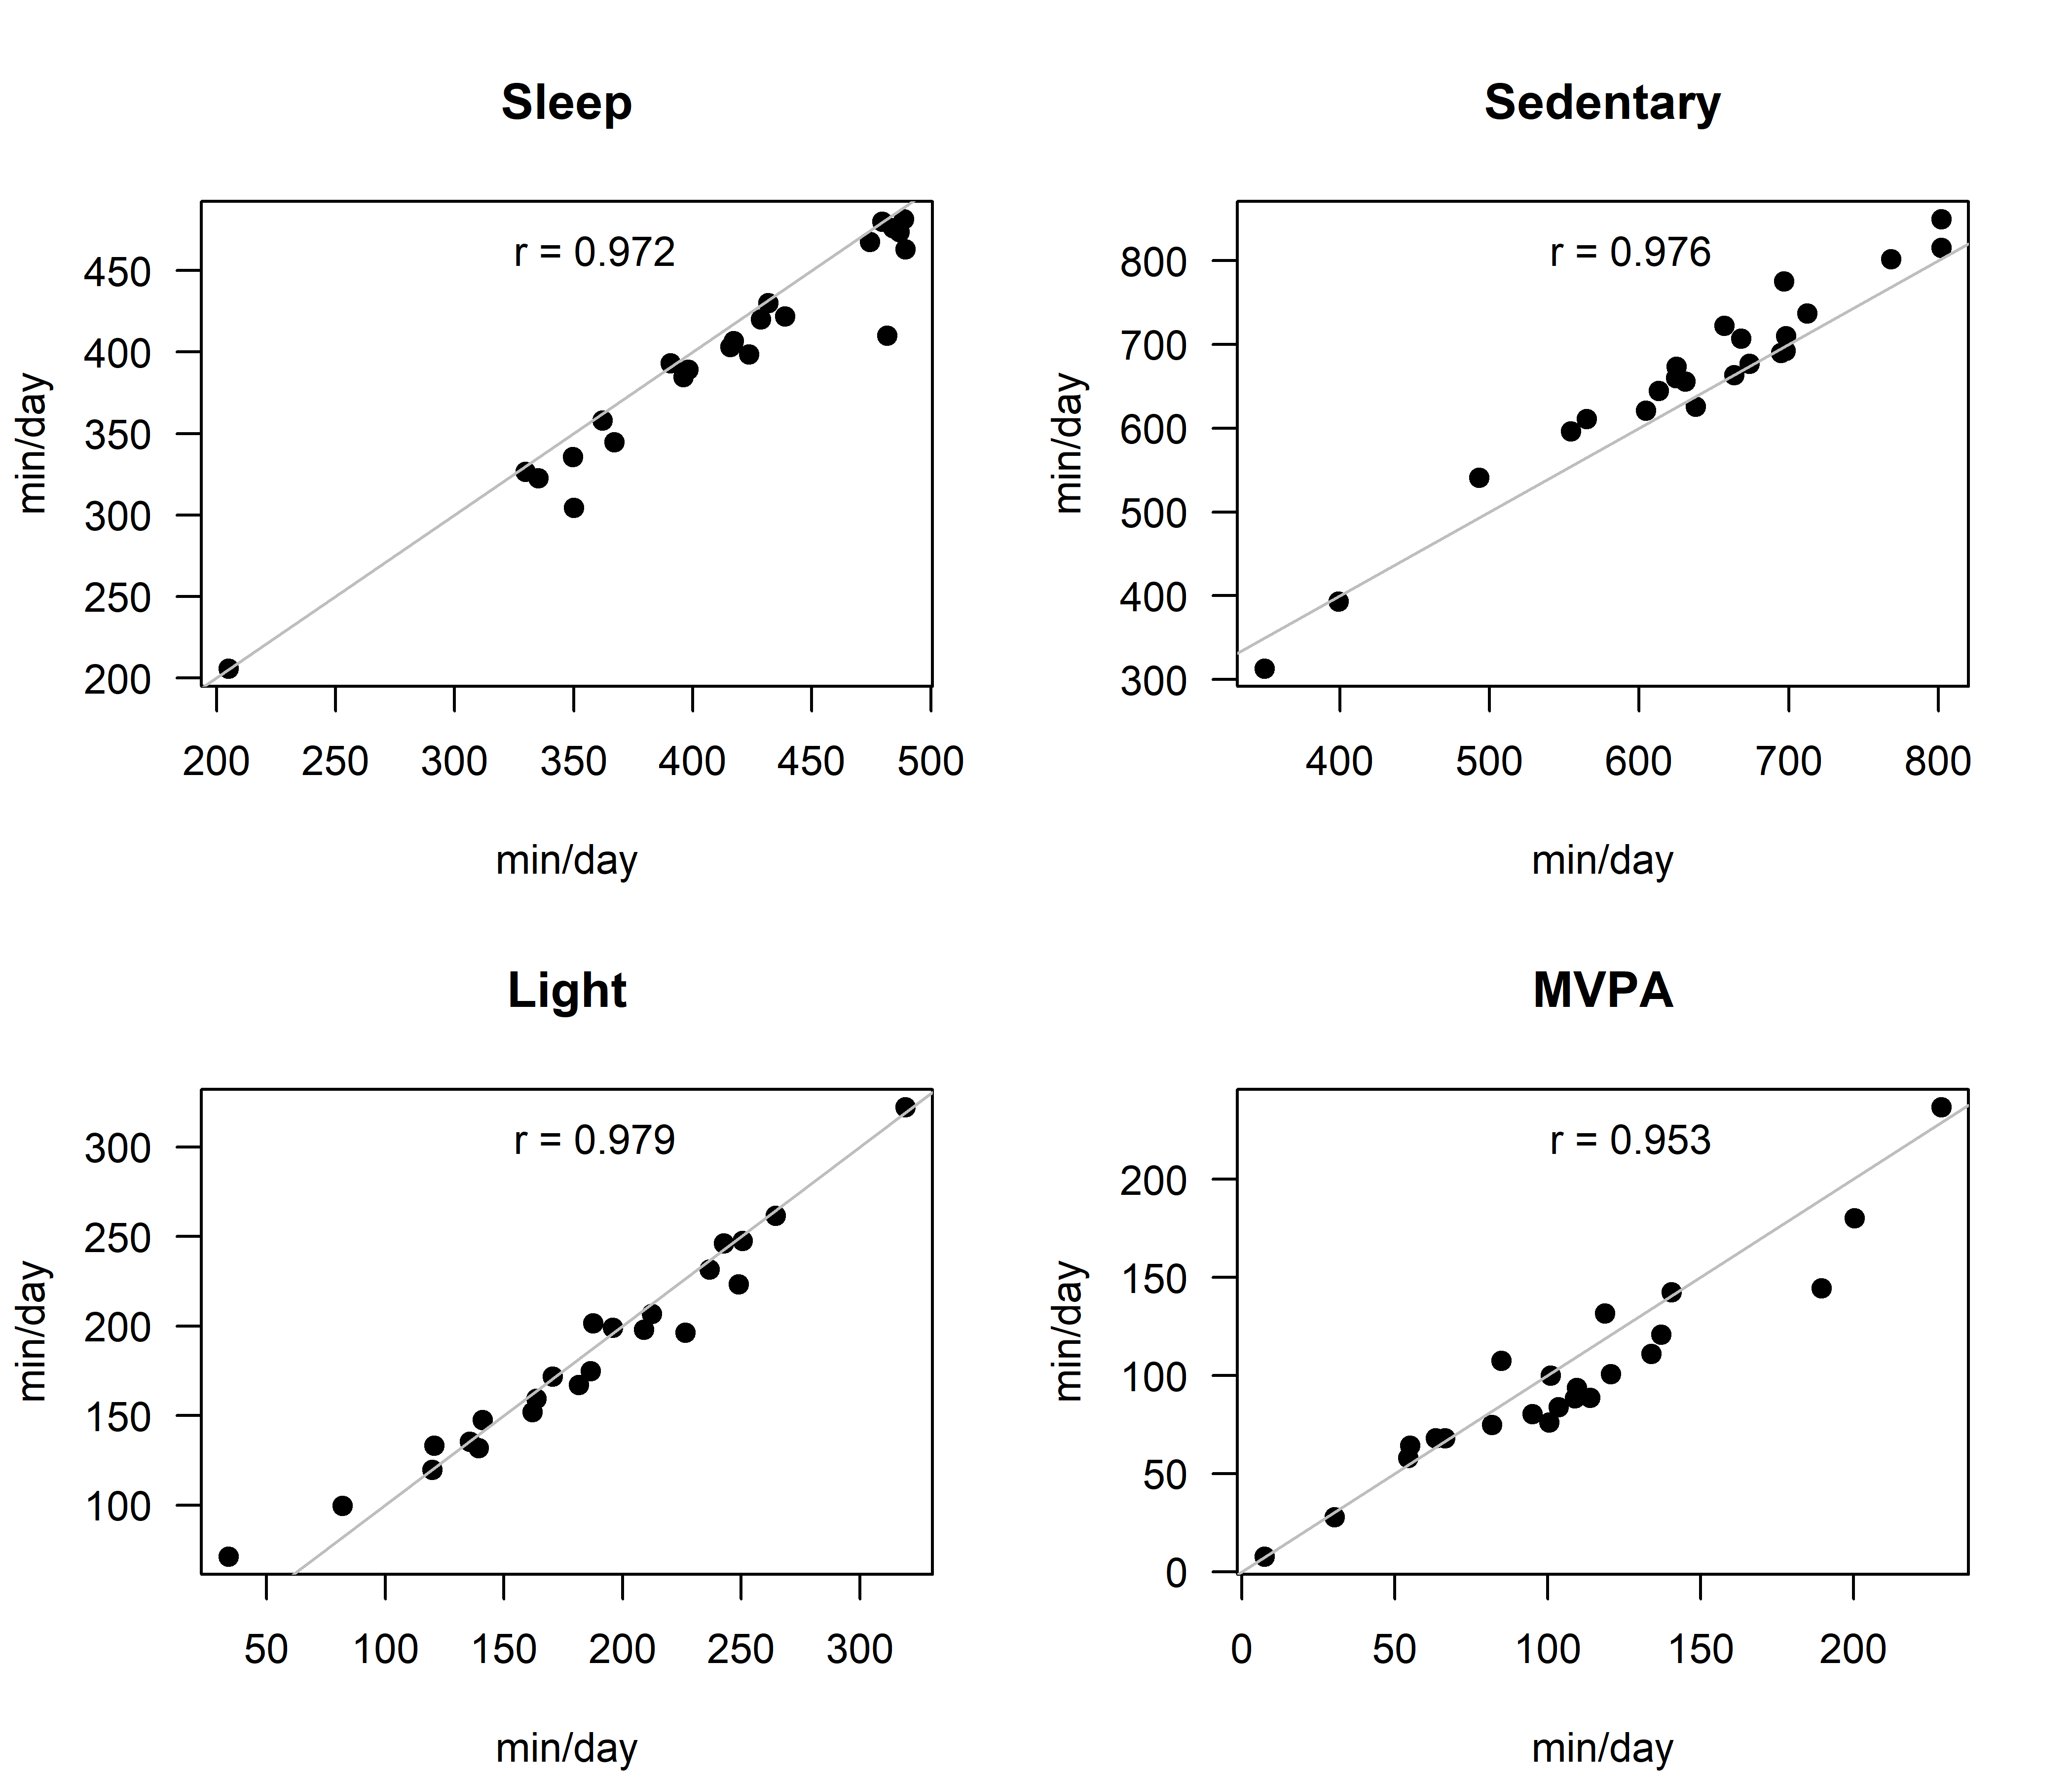
Figure S6. Scatter plots for the correlation between the GENEActiv and the Axivity in the definition of sleep, sedentary time, light PA, and MVPA. The grey line represents the perfect correlation (i.e., r = 1).
MVPA: moderate-to-vigorous physical activity; PA: physical activity.

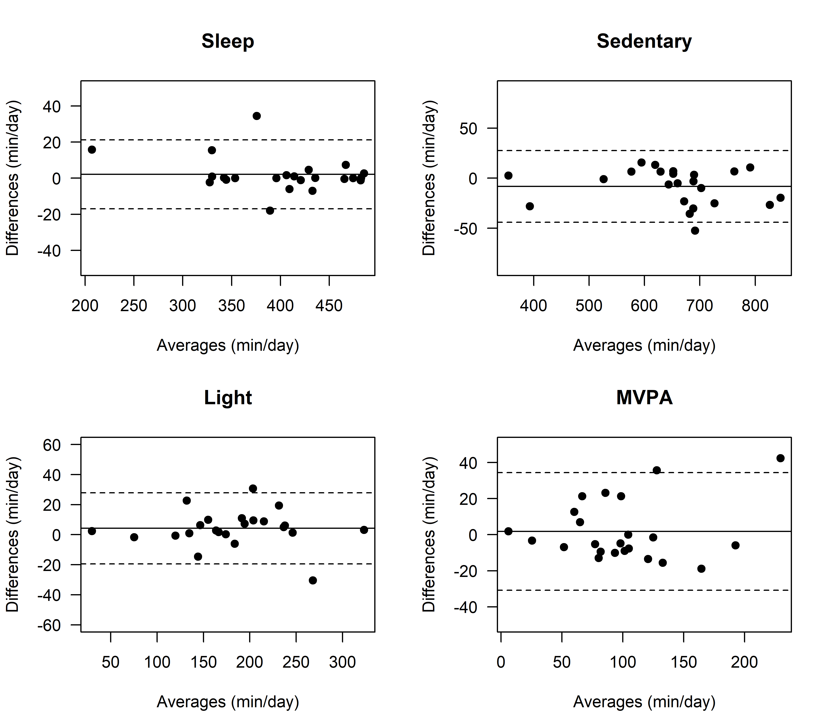
Figure S7. Bland-Altman plots for the agreement between the Movisens and the ActiGraph in the definition of sleep, sedentary time, light PA, and MVPA. The solid line represents the mean bias, and the dashed lines represent the 95% limits of agreement.
MVPA: moderate-to-vigorous physical activity; PA: physical activity.

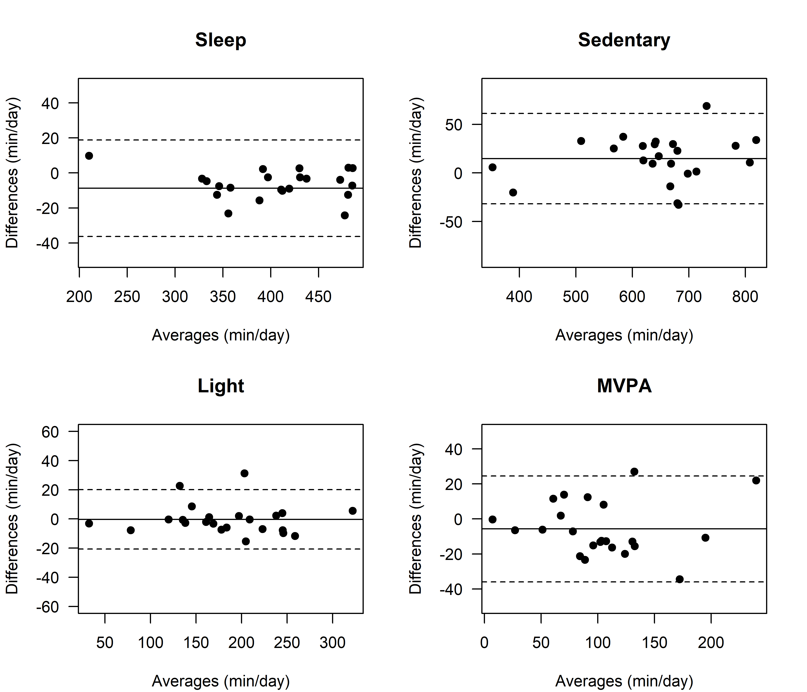
Figure S8. Bland-Altman plots for the agreement between the Movisens and the GENEActiv in the definition of sleep, sedentary time, light PA, and MVPA. The solid line represents the mean bias, and the dashed lines represent the 95% limits of agreement.
MVPA: moderate-to-vigorous physical activity; PA: physical activity.

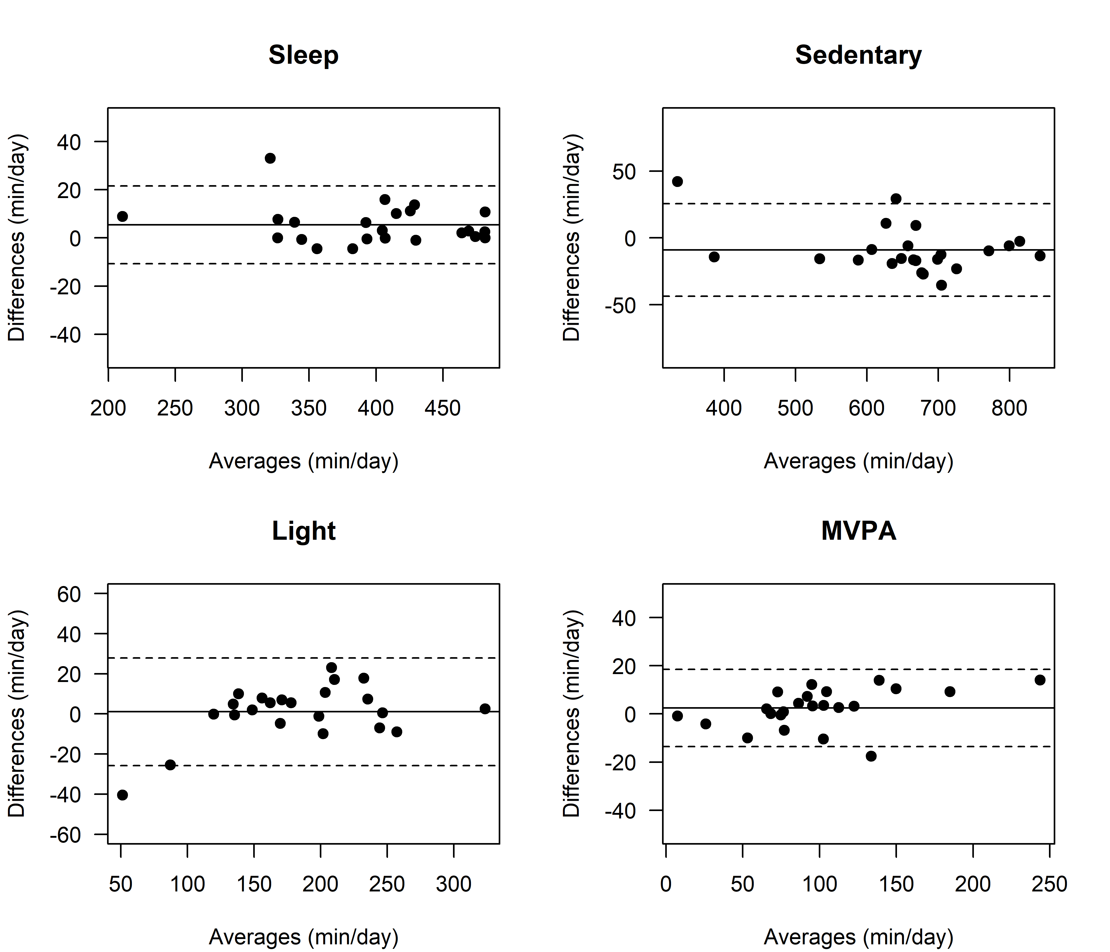
Figure S9. Bland-Altman plots for the agreement between the Movisens and the Axivity in the definition of sleep, sedentary time, light PA, and MVPA. The solid line represents the mean bias, and the dashed lines represent the 95% limits of agreement.
MVPA: moderate-to-vigorous physical activity; PA: physical activity.

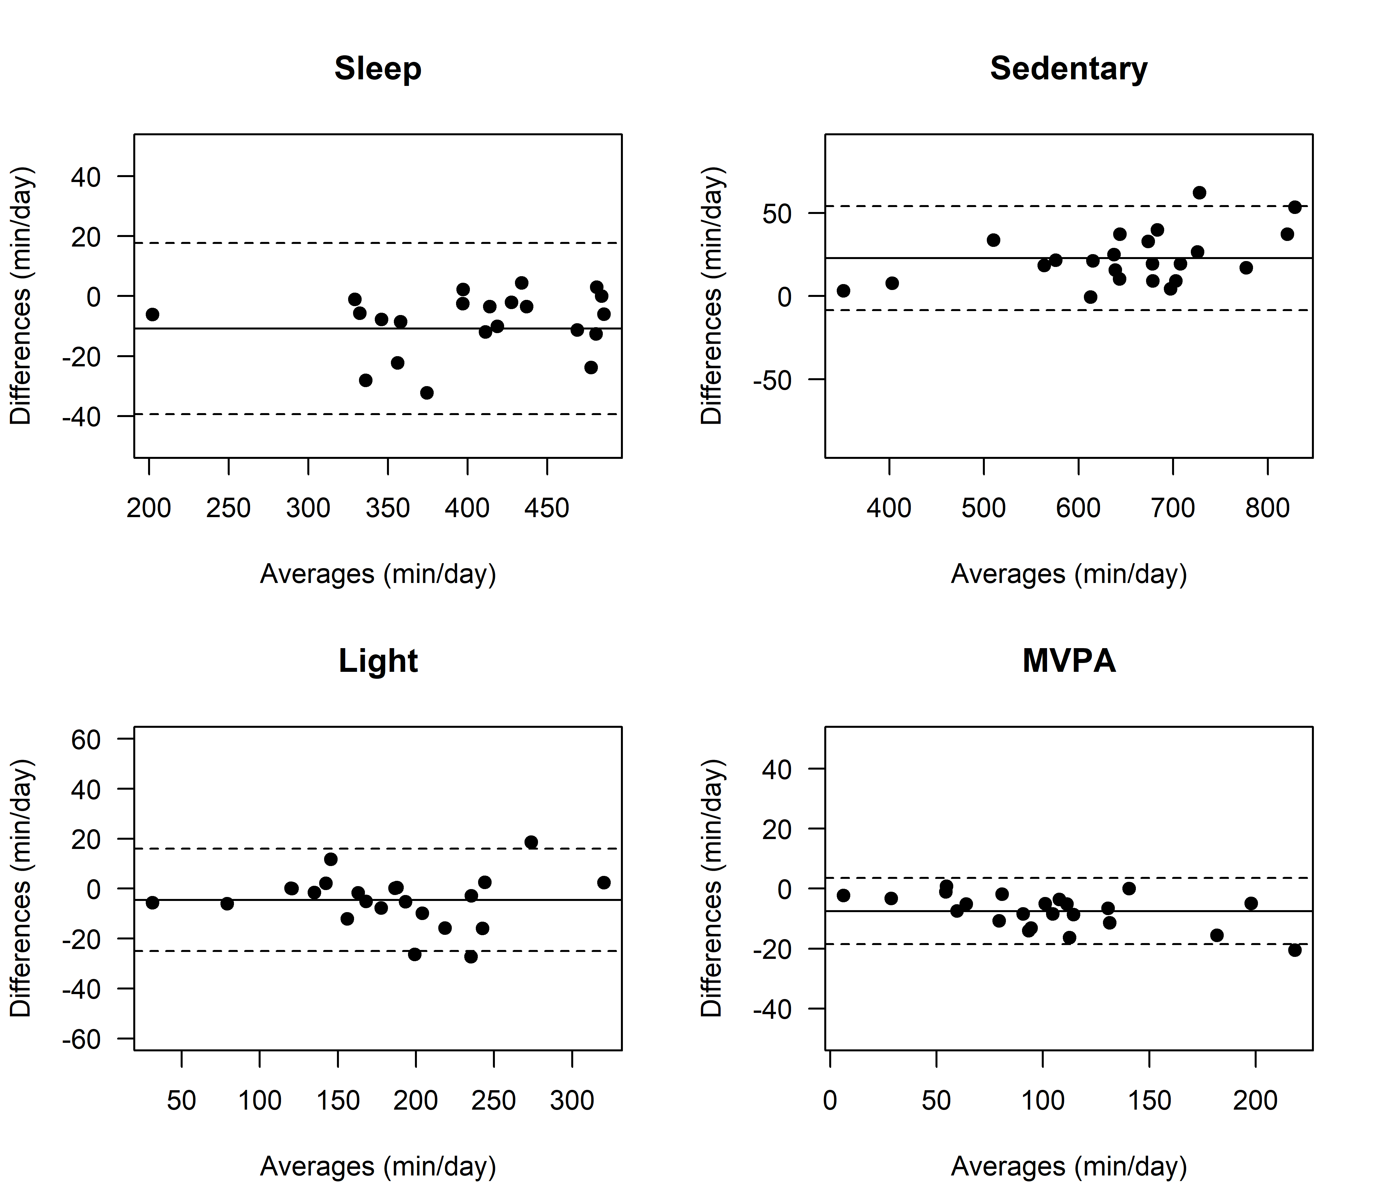
Figure S10. Bland-Altman plots for the agreement between the ActiGraph and the GENEActiv in the definition of sleep, sedentary time, light PA, and MVPA. The solid line represents the mean bias, and the dashed lines represent the 95% limits of agreement.
MVPA: moderate-to-vigorous physical activity; PA: physical activity.

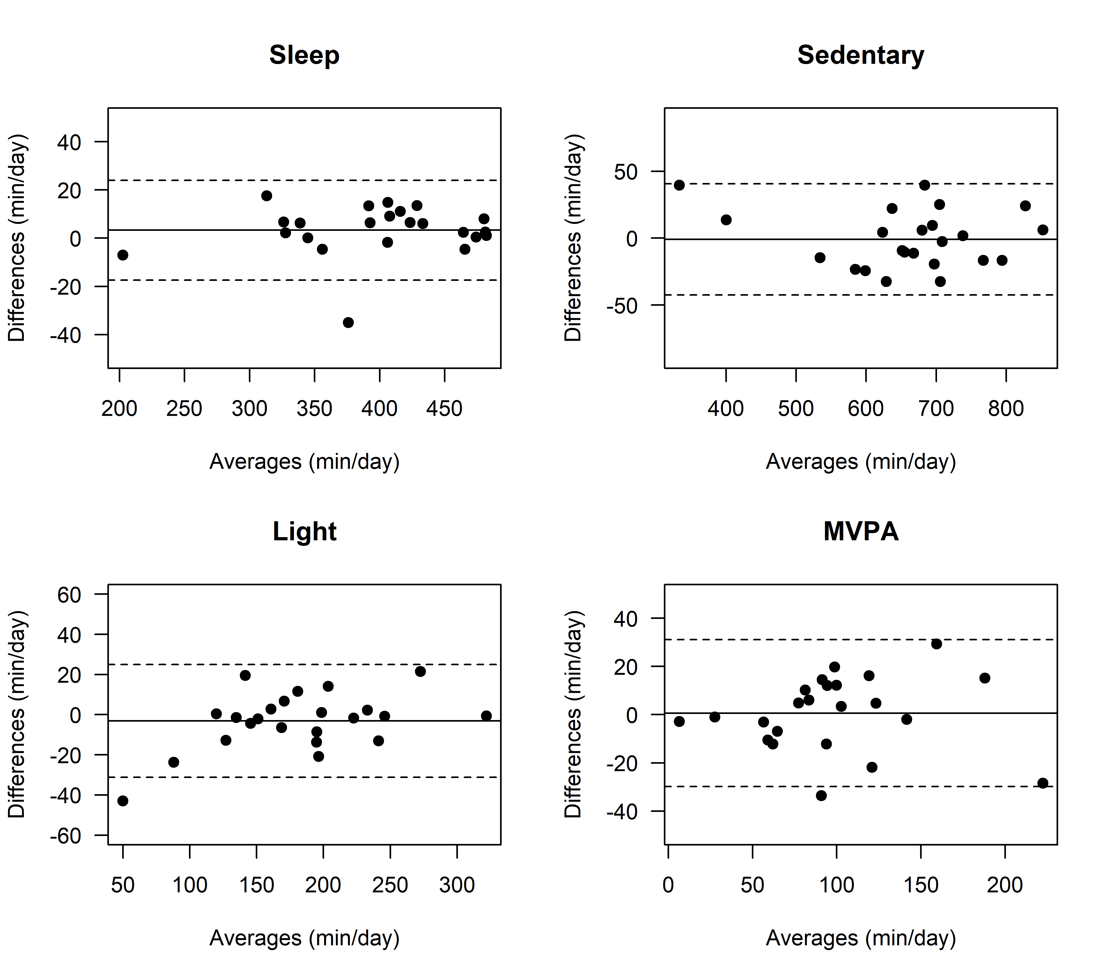
Figure S11. Bland-Altman plots for the agreement between the ActiGraph and the Axivity in the definition of sleep, sedentary time, light PA, and MVPA. The solid line represents the mean bias, and the dashed lines represent the 95% limits of agreement.
MVPA: moderate-to-vigorous physical activity; PA: physical activity.

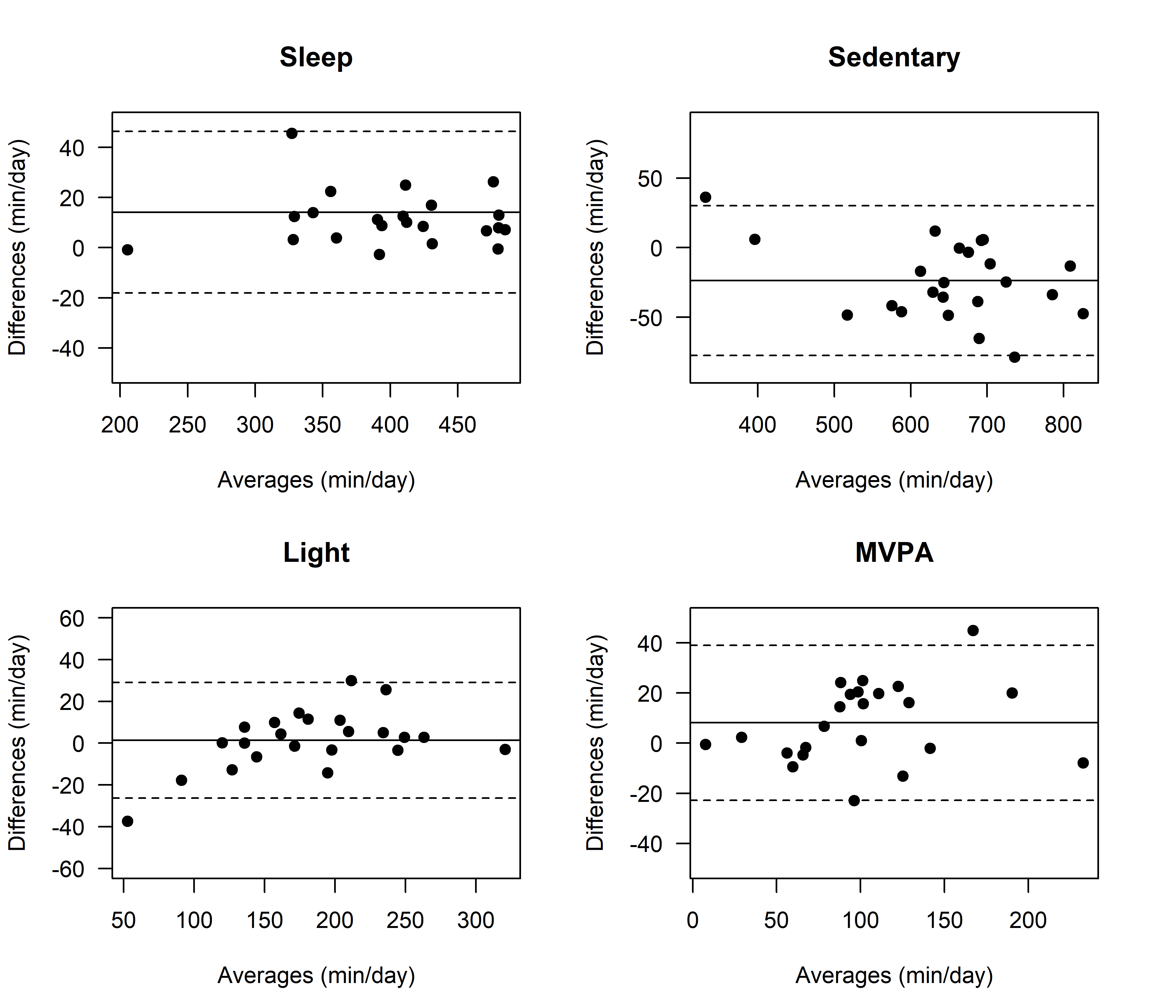
Figure S12. Bland-Altman plots for the agreement between the GENEActiv and the Axivity in the definition of sleep, sedentary time, light PA, and MVPA. The solid line represents the mean bias, and the dashed lines represent the 95% limits of agreement.
MVPA: moderate-to-vigorous physical activity; PA: physical activity.

