Supporting Information
A multi-scenario risk assessment strategy applied to mixtures of chemicals of emerging concern in the River Aconcagua basin in Central Chile
Pedro A. Inostroza^{1,2*}, Sebastian Elgueta^{3,4}, Martin Krauss⁵, Werner Brack^{5,6}, Thomas Backhaus^{1,2}
¹ Department of Biological and Environmental Sciences, University of Gothenburg, Gothenburg, Sweden
² Institute for Environmental Research, RWTH Aachen University, Aachen, Germany
³ Núcleo en Ciencias Ambientales y Alimentarias (NCAA), Universidad de las Américas, Santiago, Chile
⁴ Facultad de Medicina Veterinaria y Agronomía, Universidad de las Américas, Sede Providencia, Chile
⁵ Department of Effect-Directed Analysis, Helmholtz Centre for Environmental Research – UFZ, Leipzig, Germany
⁶ Department of Evolutionary Ecology and Environmental Toxicology, Goethe University Frankfurt/Main, Frankfurt/Main, Germany
* Corresponding author: Pedro A. Inostroza
E-mail address: pedro.inostroza@rwth-aachen.de
Number of pages: 10
Number of figures: 2
Number of tables: 5
SI Figure.
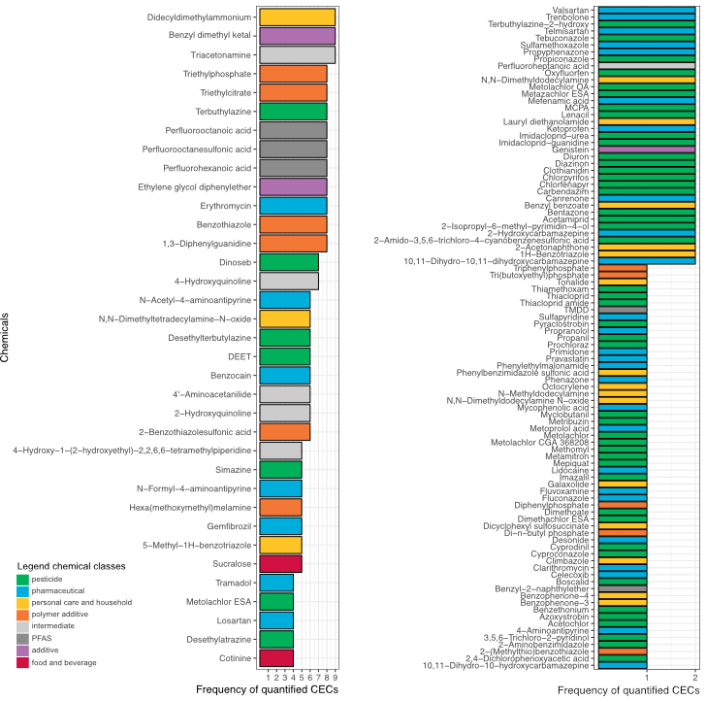
Figure S1. Frequency of detected and quantified CECs in the River Aconcagua basin. Chemicals were coloured according to their chemical classes (see legend).

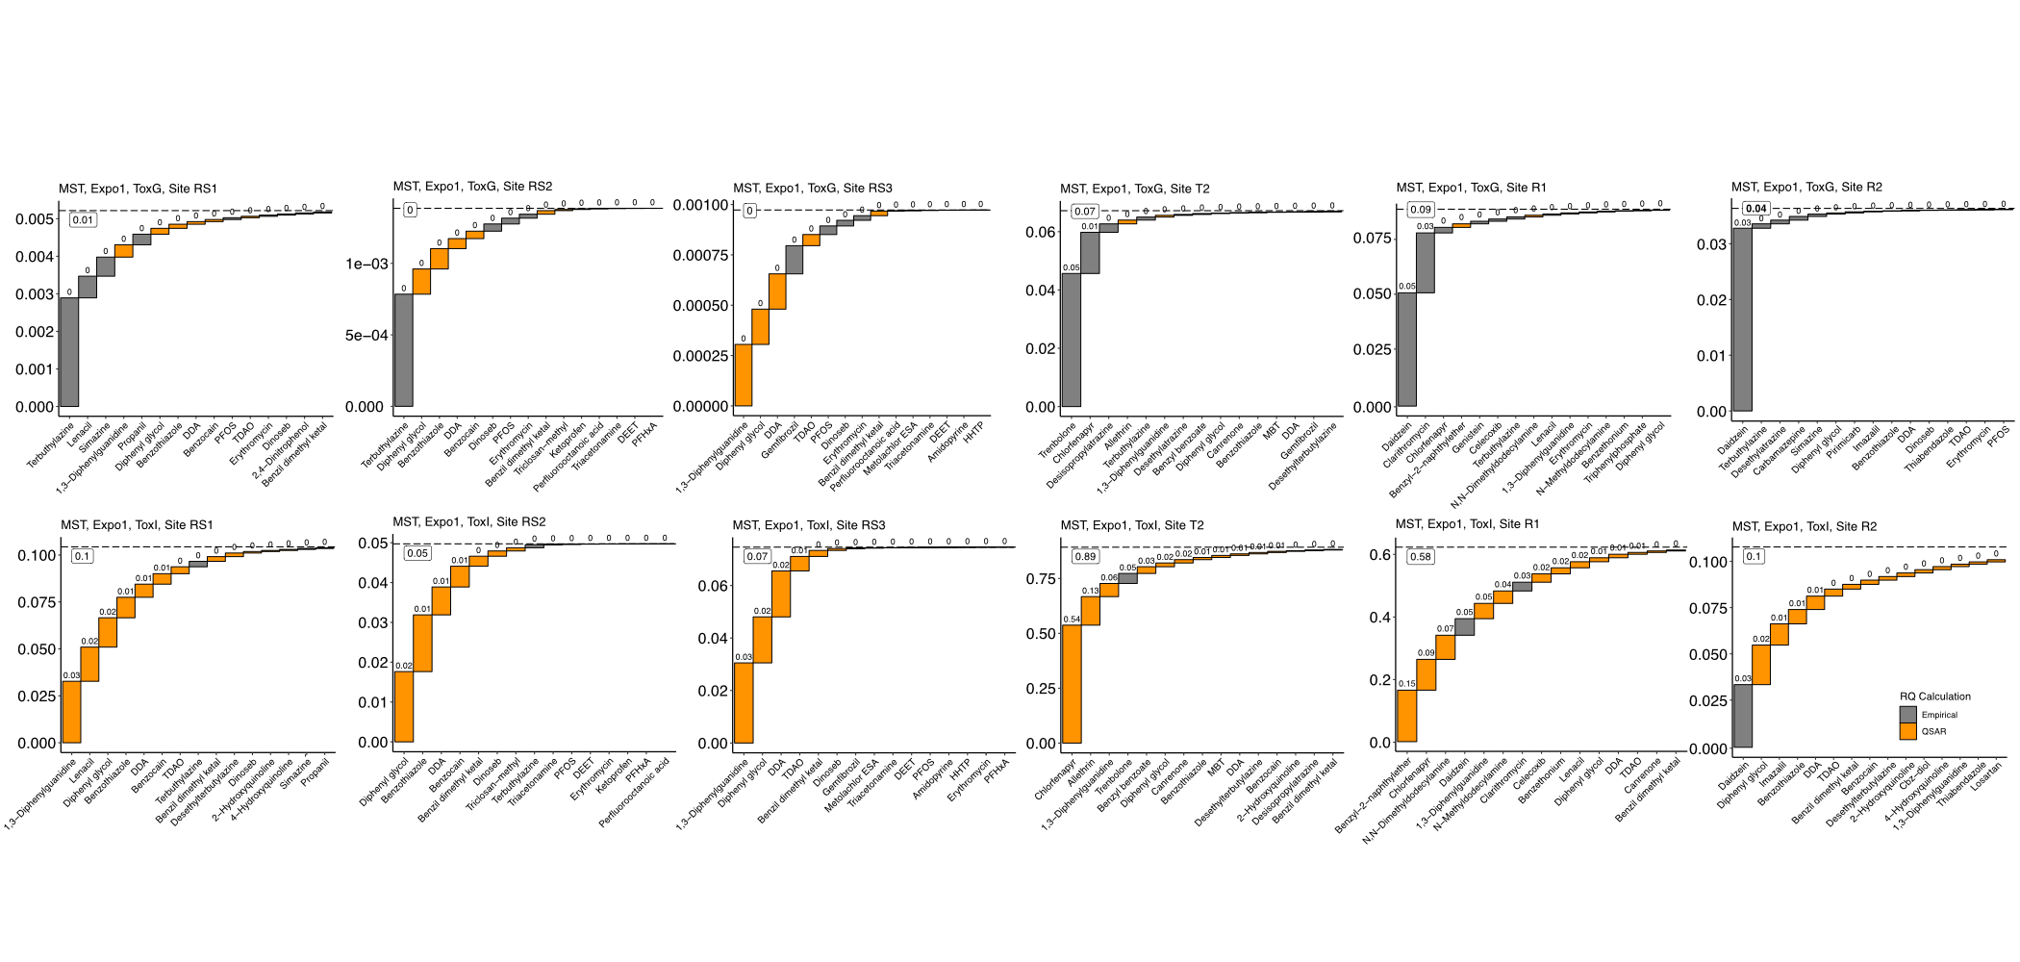
Figure S2. Mixture risk assessment estimates and risk drivers for sites RQ_{sum}<0.1 (RQ_{Expo1-ToxG-MST} and RQ_{Expo1-ToxI-MST}) in the River Aconcagua basin. Colours represent the source of the toxicity data, grey means empirical sources and orange QSAR modelling.

SI Tables
Table S1. Sampling site information. Geographic coordinates in decimal degree (WGS84).
Site ID | Type | Latitude (N) | Longitude (E)
RS1 | “Reference” | -32.854358 | -70.390044
RS2 | “Reference” | -32.509769 | -70.452537
RS3 | “Reference” | -33.003752 | -71.126355
T1 | Tributary | -32.765909 | -70.613844
T2 | Tributary | -32.695661 | -71.212179
T3 | Tributary | -32.938952 | -71.329491
R1 | Main river | -32.852416 | -70.502894
R2 | Main river | -32.762305 | -70.839624
R3 | Main river | -32.916946 | -71.425322

Table S2. RQ_{STU} estimates for the different exposures and hazard scenarios (Figure 4 and Table 1 for details). Sites at risk are highlighted.
ToxA (US EPA ECOTOX Database only)
 | Expo 1 (ZERO) |  |  |  | Expo 2 (MDL) |  |  |  | Expo 3 (KM)
Sites | Algae | Macro-invertebrates | Fish | MST | Algae | Macro-invertebrate | Fish | MST | Algae | Macro-invertebrate | Fish | MST
RS1 | 0.0012 | 0.0029 | 0.0008 | 0.0044 | 0.0041 | 0.0128 | 0.0232 | 0.0383 | 0.0012 | 0.0030 | 0.0040 | 0.0077
RS2 | 0.0001 | 0.0001 | 0.0001 | 0.0009 | 0.0032 | 0.0106 | 0.0227 | 0.0353 | 0.0001 | 0.0008 | 0.0001 | 0.0010
RS3 | 0.0001 | 0.0001 | 0.0001 | 0.0002 | 0.0031 | 0.0101 | 0.0226 | 0.0347 | 0.0001 | 0.0002 | 0.0001 | 0.0003
T1 | 0.0088 | 0.2878 | 0.2654 | 0.5305 | 0.0114 | 0.2908 | 0.2796 | 0.5500 | 0.0090 | 0.2735 | 0.2687 | 0.5179
T2 | 0.0002 | 0.0043 | 0.0598 | 0.0641 | 0.0032 | 0.0124 | 0.0693 | 0.0837 | 0.0002 | 0.0023 | 0.0696 | 0.0722
T3 | 0.0096 | 0.1421 | 0.0376 | 0.1725 | 0.0127 | 0.1437 | 0.0578 | 0.1969 | 0.0102 | 0.1480 | 0.1651 | 0.2999
R1 | 0.0275 | 0.0010 | 0.0544 | 0.0827 | 0.0280 | 0.0108 | 0.0751 | 0.1126 | 0.0039 | 0.0010 | 0.0546 | 0.0596
R2 | 0.0002 | 0.0023 | 0.0334 | 0.0356 | 0.0033 | 0.0115 | 0.0549 | 0.0683 | 0.0003 | 0.0022 | 0.0364 | 0.0387
R3 | 0.0059 | 0.0578 | 0.6259 | 0.6811 | 0.0088 | 0.0645 | 0.6359 | 0.6999 | 0.0063 | 0.0580 | 0.7043 | 0.7565
ToxB (QSAR VEGA only)
RS1 | 0.0007 | 0.0079 | 0.0020 | 0.0091 | 0.0025 | 0.0116 | 0.0057 | 0.0166 | 0.0007 | 0.0079 | 0.0022 | 0.0093
RS2 | 0.0004 | 0.0069 | 0.0017 | 0.0077 | 0.0023 | 0.0108 | 0.0054 | 0.0154 | 0.0004 | 0.0069 | 0.0018 | 0.0078
RS3 | 0.0006 | 0.0065 | 0.0018 | 0.0077 | 0.0023 | 0.0102 | 0.0047 | 0.0146 | 0.0006 | 0.0065 | 0.0018 | 0.0078
T1 | 0.0185 | 0.0549 | 0.0471 | 0.1042 | 0.0191 | 0.0582 | 0.0488 | 0.1091 | 0.0186 | 0.0550 | 0.0473 | 0.1046
T2 | 0.0052 | 0.0096 | 0.0156 | 0.0228 | 0.0067 | 0.0100 | 0.0178 | 0.0258 | 0.0052 | 0.0096 | 0.0158 | 0.0230
T3 | 0.0059 | 0.0122 | 0.0330 | 0.0428 | 0.0074 | 0.0156 | 0.0351 | 0.0487 | 0.0060 | 0.0122 | 0.0332 | 0.0433
R1 | 0.0042 | 0.0025 | 0.0174 | 0.0179 | 0.0057 | 0.0072 | 0.0198 | 0.0251 | 0.0043 | 0.0026 | 0.0175 | 0.0182
R2 | 0.0015 | 0.0056 | 0.0111 | 0.0157 | 0.0032 | 0.0066 | 0.0144 | 0.0201 | 0.0016 | 0.0057 | 0.0113 | 0.0160
R3 | 0.0150 | 0.0136 | 0.1445 | 0.1538 | 0.0166 | 0.0170 | 0.1466 | 0.1597 | 0.0151 | 0.0137 | 0.1447 | 0.1542
ToxC (QSAR ECOSAR only)
RS1 | 0.0003 | 0.0008 | 0.0007 | 0.0010 | 0.0075 | 0.0257 | 0.0073 | 0.0365 | 0.0003 | 0.0009 | 0.0007 | 0.0011
RS2 | 0.0001 | 0.0004 | 0.0004 | 0.0005 | 0.0074 | 0.0254 | 0.0072 | 0.0361 | 0.0001 | 0.0004 | 0.0004 | 0.0005
RS3 | 0.0002 | 0.0006 | 0.0005 | 0.0007 | 0.0074 | 0.0255 | 0.0071 | 0.0362 | 0.0002 | 0.0007 | 0.0005 | 0.0008
T1 | 0.0232 | 2.2479 | 0.1000 | 2.3016 | 0.0284 | 2.2489 | 0.1009 | 2.3078 | 0.0233 | 2.2479 | 0.1000 | 2.3018
T2 | 0.0013 | 0.0079 | 0.0048 | 0.0084 | 0.0084 | 0.0324 | 0.0112 | 0.0435 | 0.0013 | 0.0080 | 0.0049 | 0.0087
T3 | 0.0552 | 0.2784 | 0.0069 | 0.3323 | 0.0573 | 0.2805 | 0.0131 | 0.3399 | 0.0551 | 0.2754 | 0.0049 | 0.3294
R1 | 0.0014 | 0.0044 | 0.0046 | 0.0055 | 0.0084 | 0.0286 | 0.0106 | 0.0401 | 0.0015 | 0.0045 | 0.0047 | 0.0058
R2 | 0.0002 | 0.0006 | 0.0005 | 0.0007 | 0.0074 | 0.0254 | 0.0072 | 0.0361 | 0.0002 | 0.0006 | 0.0006 | 0.0009
R3 | 0.0016 | 0.0046 | 0.0039 | 0.0060 | 0.0088 | 0.0291 | 0.0103 | 0.0410 | 0.0016 | 0.0031 | 0.0028 | 0.0046
ToxD (US EPA ECOTOX Database amended QSAR VEGA)
RS1 | 0.0018 | 0.0040 | 0.0027 | 0.0065 | 0.0058 | 0.0143 | 0.0267 | 0.0425 | 0.0019 | 0.0042 | 0.0060 | 0.0102
RS2 | 0.0006 | 0.0019 | 0.0016 | 0.0027 | 0.0047 | 0.0124 | 0.0260 | 0.0394 | 0.0006 | 0.0020 | 0.0018 | 0.0032
RS3 | 0.0006 | 0.0005 | 0.0014 | 0.0015 | 0.0048 | 0.0111 | 0.0257 | 0.0383 | 0.0006 | 0.0006 | 0.0016 | 0.0019
T1 | 0.0129 | 0.2903 | 0.2731 | 0.5375 | 0.0161 | 0.2937 | 0.2887 | 0.5585 | 0.0132 | 0.2762 | 0.2767 | 0.5252
T2 | 0.0054 | 0.0089 | 0.0717 | 0.0783 | 0.0092 | 0.0173 | 0.0824 | 0.0993 | 0.0054 | 0.0071 | 0.0820 | 0.0870
T3 | 0.0148 | 0.1469 | 0.0674 | 0.2053 | 0.0188 | 0.1489 | 0.0888 | 0.2311 | 0.0155 | 0.1529 | 0.1949 | 0.3319
R1 | 0.0316 | 0.0035 | 0.0609 | 0.0896 | 0.0328 | 0.0137 | 0.0826 | 0.1207 | 0.0080 | 0.0037 | 0.0614 | 0.0670
R2 | 0.0017 | 0.0035 | 0.0442 | 0.0467 | 0.0056 | 0.0133 | 0.0671 | 0.0811 | 0.0018 | 0.0035 | 0.0475 | 0.0502
R3 | 0.0204 | 0.0653 | 0.7692 | 0.8269 | 0.0243 | 0.0725 | 0.7803 | 0.8470 | 0.0210 | 0.0657 | 0.8479 | 0.9022
ToxE (US EPA ECOTOX Database amended QSAR VEGA *100 deviation factor)
RS1 | 0.0012 | 0.0030 | 0.0009 | 0.0044 | 0.0041 | 0.0128 | 0.0232 | 0.0384 | 0.0013 | 0.0030 | 0.0040 | 0.0077
RS2 | 0.0001 | 0.0008 | 0.0001 | 0.0009 | 0.0032 | 0.0107 | 0.0228 | 0.0353 | 0.0001 | 0.0008 | 0.0001 | 0.0010
RS3 | 0.0003 | 0.0001 | 0.0001 | 0.0002 | 0.0031 | 0.0101 | 0.0227 | 0.0347 | 0.0001 | 0.0002 | 0.0001 | 0.0003
T1 | 0.0088 | 0.2878 | 0.2655 | 0.5306 | 0.0114 | 0.2908 | 0.2797 | 0.5501 | 0.0090 | 0.2736 | 0.2688 | 0.5180
T2 | 0.0002 | 0.0043 | 0.0599 | 0.0642 | 0.0033 | 0.0125 | 0.0694 | 0.0839 | 0.0003 | 0.0023 | 0.0698 | 0.0724
T3 | 0.0097 | 0.1421 | 0.0379 | 0.1729 | 0.0128 | 0.1437 | 0.0581 | 0.1972 | 0.0102 | 0.1480 | 0.1654 | 0.3003
R1 | 0.0276 | 0.0010 | 0.0544 | 0.0828 | 0.0280 | 0.0108 | 0.0752 | 0.1127 | 0.0040 | 0.0010 | 0.0547 | 0.0597
R2 | 0.0002 | 0.0024 | 0.0335 | 0.0358 | 0.0033 | 0.0115 | 0.0550 | 0.0684 | 0.0003 | 0.0022 | 0.0365 | 0.0388
R3 | 0.0060 | 0.0579 | 0.6274 | 0.6826 | 0.0090 | 0.0646 | 0.6373 | 0.7013 | 0.0064 | 0.0581 | 0.7058 | 0.7580
ToxF (US EPA ECOTOX Database amended QSAR VEGA /100 deviation factor)
RS1 | 0.0668 | 0.1099 | 0.1831 | 0.2302 | 0.1742 | 0.1656 | 0.3754 | 0.4950 | 0.0681 | 0.1114 | 0.1904 | 0.2395
RS2 | 0.0449 | 0.1137 | 0.1552 | 0.1952 | 0.1547 | 0.1856 | 0.3522 | 0.4808 | 0.0458 | 0.1145 | 0.1575 | 0.2007
RS3 | 0.0603 | 0.0347 | 0.1335 | 0.1397 | 0.1688 | 0.1120 | 0.3342 | 0.4311 | 0.0611 | 0.0357 | 0.1364 | 0.1456
T1 | 0.4271 | 0.5405 | 1.0358 | 1.6323 | 0.4805 | 0.5826 | 1.1840 | 1.8088 | 0.4302 | 0.5295 | 1.0478 | 1.6272
T2 | 0.5177 | 0.4696 | 1.2512 | 1.5183 | 0.6020 | 0.5009 | 1.3848 | 1.7111 | 0.5191 | 0.4698 | 1.2651 | 1.5281
T3 | 0.5320 | 0.6217 | 3.0178 | 3.4655 | 0.6207 | 0.6642 | 3.1594 | 3.6672 | 0.5357 | 0.6305 | 3.1155 | 3.4937
R1 | 0.4334 | 0.2530 | 0.7103 | 0.8812 | 0.5067 | 0.3045 | 0.8255 | 1.0639 | 0.4114 | 0.2550 | 0.7157 | 0.8720
R2 | 0.1508 | 0.1197 | 1.1169 | 1.1462 | 0.2426 | 0.1878 | 1.2724 | 1.3847 | 0.1528 | 0.1222 | 1.1262 | 1.1584
R3 | 1.4647 | 0.8113 | 14.9551 | 15.3103 | 1.5532 | 0.8572 | 15.0711 | 15.4924 | 1.4693 | 0.8142 | 15.0197 | 15.3309
ToxG (US EPA ECOTOX Database amended QSAR ECOSAR)
RS1 | 0.0015 | 0.0038 | 0.0015 | 0.0052 | 0.0053 | 0.0155 | 0.0249 | 0.0403 | 0.0015 | 0.0040 | 0.0017 | 0.0056
RS2 | 0.0003 | 0.0013 | 0.0005 | 0.0014 | 0.0043 | 0.0131 | 0.0243 | 0.0370 | 0.0003 | 0.0014 | 0.0005 | 0.0016
RS3 | 0.0002 | 0.0008 | 0.0006 | 0.0010 | 0.0042 | 0.0127 | 0.0243 | 0.0366 | 0.0003 | 0.0010 | 0.0007 | 0.0012
T1 | 0.0117 | 0.2930 | 0.2710 | 0.5341 | 0.0146 | 0.2970 | 0.2859 | 0.5544 | 0.0119 | 0.2932 | 0.2715 | 0.5351
T2 | 0.0015 | 0.0122 | 0.0622 | 0.0672 | 0.0054 | 0.0219 | 0.0727 | 0.0879 | 0.0016 | 0.0124 | 0.0624 | 0.0677
T3 | 0.0109 | 0.1481 | 0.0419 | 0.1793 | 0.0147 | 0.1513 | 0.0630 | 0.2045 | 0.0110 | 0.1482 | 0.0424 | 0.1803
R1 | 0.0286 | 0.0055 | 0.0579 | 0.0863 | 0.0298 | 0.0165 | 0.0792 | 0.1167 | 0.0286 | 0.0057 | 0.0582 | 0.0869
R2 | 0.0005 | 0.0030 | 0.0340 | 0.0364 | 0.0043 | 0.0140 | 0.0565 | 0.0701 | 0.0005 | 0.0032 | 0.0341 | 0.0368
R3 | 0.0069 | 0.0621 | 0.6298 | 0.6861 | 0.0107 | 0.0704 | 0.6405 | 0.7057 | 0.0070 | 0.0623 | 0.6300 | 0.6869
ToxH (US EPA ECOTOX Database amended QSAR ECOSAR *100 deviation factor)
RS1 | 0.0012 | 0.0030 | 0.0008 | 0.0044 | 0.0041 | 0.0128 | 0.0232 | 0.0384 | 0.0012 | 0.0030 | 0.0040 | 0.0077
RS2 | 0.0001 | 0.0008 | 0.0001 | 0.0009 | 0.0032 | 0.0107 | 0.0228 | 0.0353 | 0.0001 | 0.0008 | 0.0001 | 0.0010
RS3 | 0.0002 | 0.0001 | 0.0001 | 0.0002 | 0.0031 | 0.0101 | 0.0226 | 0.0347 | 0.0001 | 0.0002 | 0.0001 | 0.0003
T1 | 0.0088 | 0.2878 | 0.2655 | 0.5305 | 0.0114 | 0.2908 | 0.2797 | 0.5501 | 0.0090 | 0.2736 | 0.2688 | 0.5179
T2 | 0.0002 | 0.0044 | 0.0598 | 0.0641 | 0.0032 | 0.0125 | 0.0693 | 0.0838 | 0.0002 | 0.0024 | 0.0697 | 0.0723
T3 | 0.0096 | 0.1421 | 0.0376 | 0.1726 | 0.0127 | 0.1437 | 0.0578 | 0.1969 | 0.0102 | 0.1480 | 0.1651 | 0.3000
R1 | 0.0275 | 0.0010 | 0.0544 | 0.0827 | 0.0280 | 0.0108 | 0.0752 | 0.1126 | 0.0039 | 0.0011 | 0.0546 | 0.0596
R2 | 0.0002 | 0.0023 | 0.0334 | 0.0357 | 0.0033 | 0.0116 | 0.0549 | 0.0683 | 0.0003 | 0.0022 | 0.0364 | 0.0387
R3 | 0.0059 | 0.0579 | 0.6260 | 0.6812 | 0.0088 | 0.0646 | 0.6359 | 0.6999 | 0.0063 | 0.0581 | 0.7044 | 0.7565
ToxI (US EPA ECOTOX Database amended QSAR ECOSAR /100 deviation factor)
RS1 | 0.02743 | 0.0861 | 0.0683 | 0.1054 | 0.1127 | 0.2870 | 0.1926 | 0.3591 | 0.0281 | 0.0891 | 0.0709 | 0.1105
RS2 | 0.01316 | 0.0458 | 0.0362 | 0.0489 | 0.1044 | 0.2566 | 0.1731 | 0.3160 | 0.0135 | 0.0476 | 0.0377 | 0.0517
RS3 | 0.02175 | 0.0660 | 0.0489 | 0.0746 | 0.1076 | 0.2697 | 0.1770 | 0.3331 | 0.0221 | 0.0679 | 0.0501 | 0.0771
T1 | 0.30323 | 0.7962 | 0.8177 | 1.2815 | 0.3249 | 0.8675 | 0.8919 | 1.3915 | 0.3046 | 0.8003 | 0.8225 | 1.2904
T2 | 0.12656 | 0.7913 | 0.3060 | 0.8938 | 0.2111 | 0.9584 | 0.4122 | 1.0999 | 0.1278 | 0.7957 | 0.3092 | 0.9006
T3 | 0.11576 | 0.4342 | 0.3559 | 0.6081 | 0.1933 | 0.5963 | 0.4574 | 0.8108 | 0.1176 | 0.4413 | 0.3616 | 0.6212
R1 | 0.1068 | 0.4435 | 0.4030 | 0.5587 | 0.1754 | 0.5744 | 0.4705 | 0.7263 | 0.1079 | 0.4466 | 0.4047 | 0.5637
R2 | 0.0183 | 0.0599 | 0.0895 | 0.1056 | 0.1006 | 0.2571 | 0.2070 | 0.3508 | 0.0191 | 0.0636 | 0.0925 | 0.1121
R3 | 0.0981 | 0.3070 | 0.9470 | 1.0715 | 0.1811 | 0.4723 | 1.0369 | 1.26765 | 0.1003 | 0.3141 | 0.9513 | 1.0822

Table S3. Potential absolute risk drivers. Potential absolute risk drivers are chemicals that are not actual absolute risk drivers (Table 4) but could become one if their QSAR-based hazard estimate is underestimated by a factor of 100 (details in main text). Chemicals are listed in descending order of their mean RQ_{Expo1-ToxI-MST}. Experimental and QSAR ECOSAR concentrations in µM. N = number of sites where the respective chemicals were potential absolute risk driver.
Chemical Name | CAS Number | Class | minRQ | meanRQ | maxRQ | N | Algae  ECOTOX | Macroinv.  ECOTOX | Fish  ECOTOX | Algae  ECOSAR | Macroinv.  ECOSAR | Fish  ECOSAR
Chlorfenapyr | 122453-73-0 | Insecticide | 0.0923 | 0.3418 | 0.5372 | 2 |  |  | 0.003 | 0.076 | 0.008 | 0.019
Telmisartan | 144701-48-4 | Antihypertensive | 0.1708 | 0.2387 | 0.3065 | 2 |  |  |  | 0.084 | 0.004 | 0.006
Octocrylene | 6197-30-4 | UV filter | 0.2022 | 0.2022 | 0.2022 | 1 |  |  | 0.015 | 0.049 | 0.040 | 0.006
Benzyl 2-naphthyl ether | 613-62-7 | Thermal coating | 0.1544 | 0.1544 | 0.1544 | 1 |  |  |  | 1.499 | 0.282 | 0.244
Boscalid | 188425-85-6 | Fungicide | 0.1525 | 0.1525 | 0.1525 | 1 | 1.924 | 0.060 |  | 2.982 | 1.904 | 0.200
TDAO | 3332-27-2 | Surfactant | 0.1309 | 0.1309 | 0.1309 | 1 |  |  |  | 0.035 | 0.025 | 0.021
Allethrin | 584-79-2 | Insecticide | 0.0357 | 0.0901 | 0.1300 | 3 |  |  |  | 0.309 | 0.015 | 0.013
N,N-Dimethyldodecylamine | 112-18-5 | Surfactant | 0.0723 | 0.0814 | 0.0904 | 2 | 0.075 |  |  | 0.031 | 0.022 | 0.018
Lauryl diethanolamide | 120-40-1 | Surfactant | 0.0568 | 0.0568 | 0.0568 | 1 |  |  |  | 9.009 | 11.110 | 1.096
Desethylterbutylazine | 30125-63-4 | Herbicide | 0.0405 | 0.0532 | 0.0658 | 2 |  |  |  | 5.147 | 1.105 | 3.869
1,3-Diphenylguanidine | 102-06-7 | Rubber additive | 0.0301 | 0.0498 | 0.0998 | 6 |  |  |  | 1.578 | 0.596 | 2.105
Myclobutanil | 88671-89-0 | Fungicide | 0.0447 | 0.0447 | 0.0447 | 1 | 1.939 | 0.012 |  | 1.934 | 0.998 | 0.320
DDAO | 1643-20-5 | Surfactant | 0.0426 | 0.0426 | 0.0426 | 1 |  |  |  | 0.160 | 0.089 | 0.131
N-Methyldodecylamine | 7311-30-0 | Surfactant | 0.0373 | 0.0373 | 0.0373 | 1 |  |  |  | 0.043 | 0.029 | 0.026
Benzyl benzoate | 120-51-4 | Antimicrobial | 0.0307 | 0.0331 | 0.0356 | 2 |  |  |  | 3.938 | 5.420 | 1.110
Thiabendazole | 148-79-8 | Fungicide | 0.0308 | 0.0308 | 0.0308 | 1 |  | 0.208 |  | 2.278 | 1.128 | 0.709
Celecoxib | 169590-42-5 | NSAID | 0.0250 | 0.0250 | 0.0250 | 1 |  |  | 0.204 | 1.658 | 0.801 | 0.277
DEHT | 66753-06-8 | Herbicide | 0.0215 | 0.0215 | 0.0215 | 1 |  |  |  | 19.246 | 2.489 | 6.782
Diphenyl glycol | 104-66-5 | Thermal coating | 0.0206 | 0.0206 | 0.0207 | 2 |  |  |  | 7.412 | 2.039 | 2.332
TDAO = N,N-Dimethyltetradecylamine-N-oxide
DDAO = Lauramine oxide
DEHT = Terbutylazine-desethyl-2-hydroxy
NSAID = Non-steroidal anti-inflammatory drug
Table S4. Relative risk drivers are chemical which contribute 20% or more of the final RQ-sum (i.e., 20% of the total RQ_{MST}). Chemicals organised meanRelTU descending, based on RQ_{Expo1-ToxG-MST}. Experimental concentrations in µM. N = number of sites where the respective chemicals were relative risk drivers.
Chemical Name | CAS Number | Class | minRelTU | meanRelTU | maxRelTU | N | Algae  ECOTOX | Macroinv.  ECOTOX | Fish  ECOTOX
Trenbolone | 10161-33-8 | Anabolic steroid | 0.6794 | 0.7884 | 0.8974 | 2 |  |  | 0.0003
Daidzein | 486-66-8 | Phytoestrogen | 0.3742 | 0.6172 | 0.9020 | 3 |  |  | 0.0039
Terbuthylazine | 5915-41-3 | Herbicide | 0.2069 | 0.4425 | 0.5662 | 3 | 0.0529 | 0.0089 | 3.5697
1,3-Diphenylguanidine | 102-06-7 | Rubber additive | 0.3138 | 0.3138 | 0.3138 | 1
Clarithromycin | 81103-11-9 | Antibiotic | 0.3042 | 0.3042 | 0.3042 | 1 | 0.0005
Chlorpyrifos | 2921-88-2 | Insecticide | 0.2213 | 0.2213 | 0.2213 | 1 | 0.2488 | 0.0018 | 0.0126
Chlorfenapyr | 122453-73-0 | Insecticide | 0.2102 | 0.2102 | 0.2102 | 1 |  |  | 0.0033
Methomyl | 16752-77-5 | Insecticide | 0.2047 | 0.2047 | 0.2047 | 1 | 440.7491 | 0.0180 | 0.1838

Table S5. Potential relative risk drivers in the River Aconcagua basin. N = sites where the respective chemicals were potential relative risk driver, based on based on RQ_{Expo1-ToxI-MST}. No empirical data could be retrieved from ECOTOX for any of these chemicals.
Chemical Name | CAS Number | Class | minRelTU | meanRelTU | maxRelTU | N | RQMSTRelTU
Didecyldimethylammonium | 20256-56-8 | Disinfectant | 0.1800 | 0.1800 | 0.1800 | 1 | 0.2346
Diphenyl glycol | 104-66-5 | Thermal coating | 0.1274 | 0.1538 | 0.1802 | 2 | 0.3548
Benzothiazole | 95-16-9 | Rubber additive (transformation product) | 0.1028 | 0.1028 | 0.1028 | 1 | 0.2865
1,3-Diphenylguanidine | 102-06-7 | Rubber additive | 0.0628 | 0.0628 | 0.0628 | 1 | 0.3138
Telmisartan | 144701-48-4 | Antihypertensive | 0.0171 | 0.0171 | 0.0171 | 1 | 0.3585
Benzyl-2-naphthyl ether | 613-62-7 | Thermal coating | 0.0179 | 0.0179 | 0.0179 | 1 | 0.2647

