SUPPLEMENTARY MATERIAL

Reassembly of a tropical rainforest ecosystem: A new chronosequence in the Chocó tested with the recovery of tree attributes

Sebastián Escobar^{1*}, Felicity L. Newell^{2,3}, María-José Endara¹, Juan E. Guevara-Andino¹, Anna R. Landim^{4,5}, Eike Lena Neuschulz⁴, Ronja Nußer⁶, Jörg Müller⁶, Karen M. Pedersen⁷, Matthias Schleuning⁴, Constance J. Tremlett⁷, Edith Villa-Galaviz⁷, H. Martin Schaefer⁸, David A Donoso^{1,7}, Nico Blüthgen⁷

¹ Grupo de Investigación en Ecología y Evolución en los Trópicos-EETrop, Universidad de Las Américas, Quito, Ecuador.
² Florida Museum of Natural History & Department of Biology, University of Florida, Gainesville, Florida, USA
³ Division of Conservation Biology, Institute of Ecology & Evolution, University of Bern, Bern, Switzerland.
⁴ Senckenberg Biodiversity and Climate Research Centre (SBiK-F), Frankfurt am Main, Germany.
⁵ Institute for Ecology, Evolution & Diversity, Goethe University Frankfurt, Frankfurt am Main, Germany.
⁶ Field Station Fabrikschleichach, Biocenter, University of Würzburg, Rauhenebrach, Germany
⁷ Ecological Networks Lab, Department of Biology, Technische Universität Darmstadt, Darmstadt, Germany
⁸ Fundación Jocotoco, Valladolid N24-414 y Luis Cordero, Quito, Ecuador.
* Corresponding author: Sebastián Escobar
Email: sebastián.escobar.a@udla.edu.ec

Supplementary Results
Assumptions of the models for forests structure variables including normal distribution of residuals and variance homogeneity were met (all Pearson's r < 0.001, p = 1; Bartlett's K-squared = 0.007–1.603, p = 0.21–0.93; Figure S3), except for vertical vegetation heterogeneity (Bartlett's K-squared = 6.72, p = 0.009). No spatial autocorrelation of the models residuals occurred for maximum tree height, number of stems, basal area, and reversed TSF (Moran’s I_{obs} = -0.101–0.048, I_{exp} = -0.022, SD = 0.05, p = 0.12–0.96; Figure S3), but maximum tree DBH (Moran’s I_{obs} = -0.135, I_{exp} = -0.022, SD = 0.05, p = 0.03; Figure S3f) and vertical vegetation heterogeneity (Moran’s I_{obs} = 0.15, I_{exp} = -0.022, SD = 0.05, p = 8.69E-4; Figure S3o) did show spatial autocorrelation
The residuals of the model of AGB followed a normal distribution (Figure S4a), and variance homogeneity was discarded (Pearson's r < 0.001, p = 1; Figure S4b; Bartlett's K-squared = 0.03, p = 0.853). No spatial autocorrelation of the model residuals was detected (Moran’s I(obs) = -0.025, I(exp) = -0.022, SD = 0.052, p = 0.961; Figure S4c). Regarding, tree species richness, a normal distribution was observed in the residuals of the model (Figure S4d) and we discarded the presence of variance homogeneity (Pearson's r < 0.001, p = 1; Figure S4e; Bartlett's K-squared = 0.07, p = 0.791). Spatial autocorrelation was not detected (Moran’s I(obs) = 0.054, I(exp) = -0.022, SD = 0.051, p = 0.136; Figure S4f).

Supplementary Figures
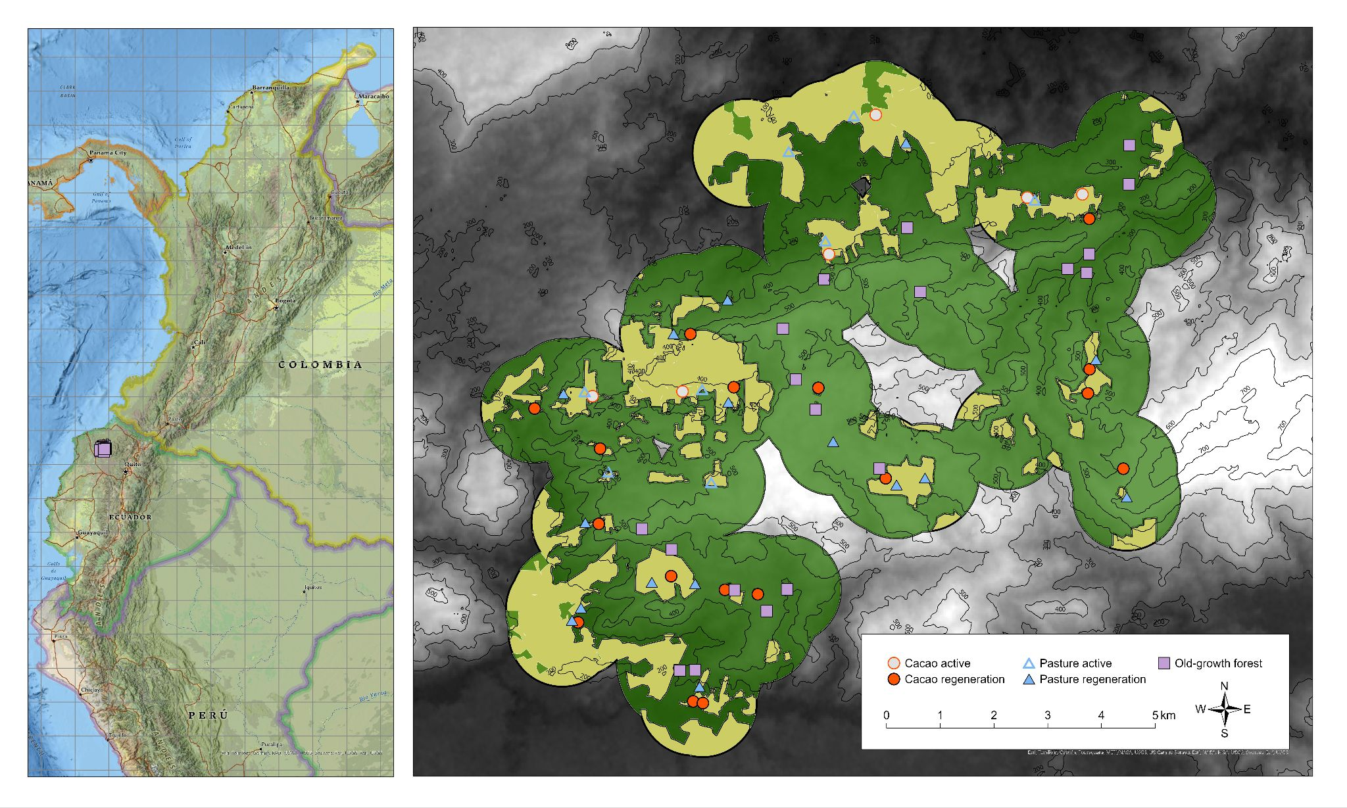
Figure S1. Distribution of the 62 study plots of the REASSEMBLY project in the Chocó
rainforest of Canandé, Ecuador. Symbols indicate different habitat and land-use types. Green indicates forest and tan indicates active/regenerating agriculture within 1-km of study plots.

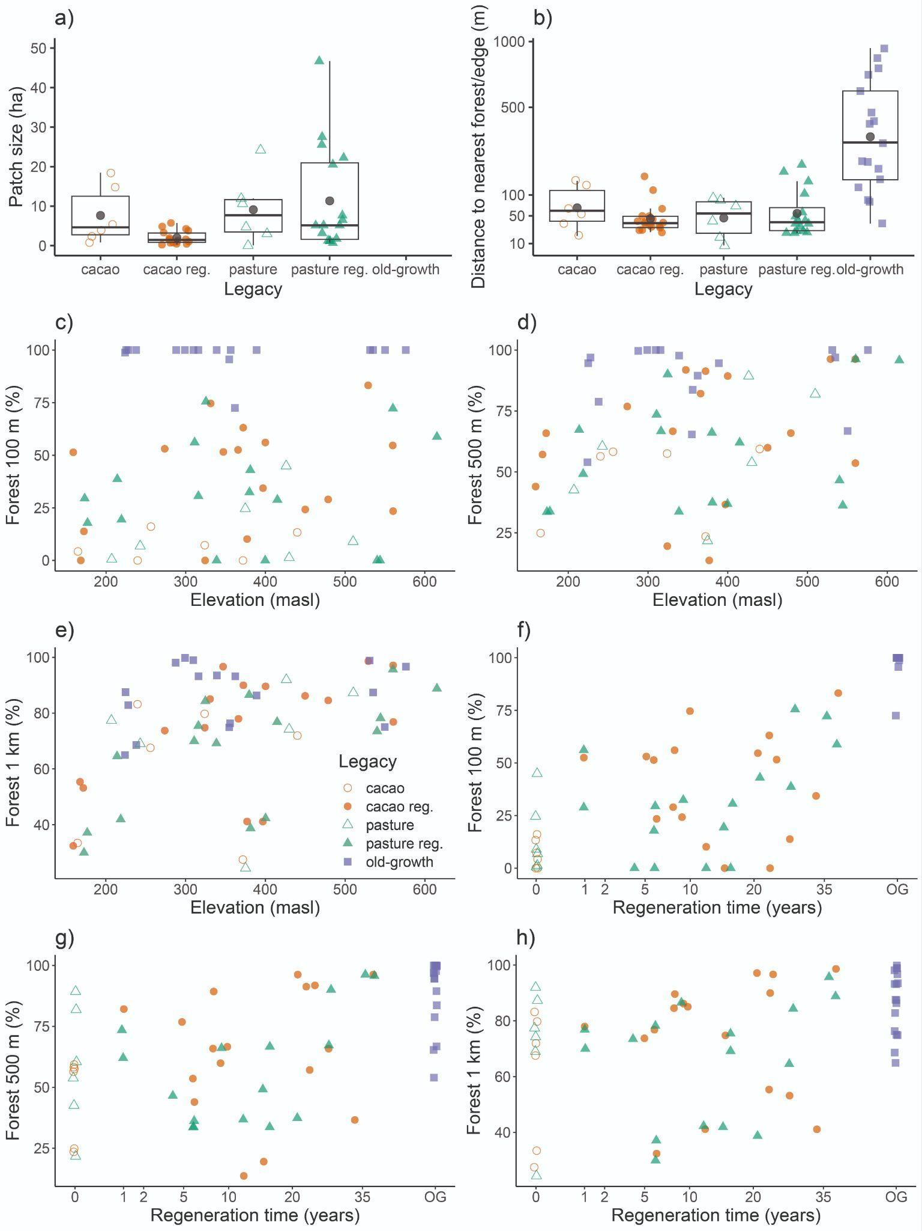
Figure S2. Plot landcover characteristics. a) Patch size (ha) within each legacy type. b) Distances to nearest forest (active and regenerating cacao and pasture plots) or nearest forest edge (old-growth forest plots). The Y axis is log-transformed to facilitate the visualization of low (active and regenerating cacao and pasture plots) and high values (old-growth forest plots). c) The percentage of forest 100 m around the centroid of the plots is not significantly correlated with elevation (Pearson’s r = 0.12, p = 0.37), but the percentage of forest d) 500 m (Pearson’s r = 0.26, p = 0.04) and e) 1 km (Pearson’s r = 0.44, p = 3E-04) around the centroid of the plots are. The percentage of forest at f) 100 m (Pearson’s r = 0.81, p = 1.5E-15), g) 500 m (Pearson’s r = 0.57, p = 1.9E-06), and h) 1 km (Pearson’s r = 0.38, p = 0.002) around the centroid of the plots are significantly correlated with square-root transformed regeneration time. Old-growth forest (OG) plots were not included in the analyses (f, g, h) because their time without human intervention is unknown and were used only as a reference. Dark circles in all boxplots represent mean values.

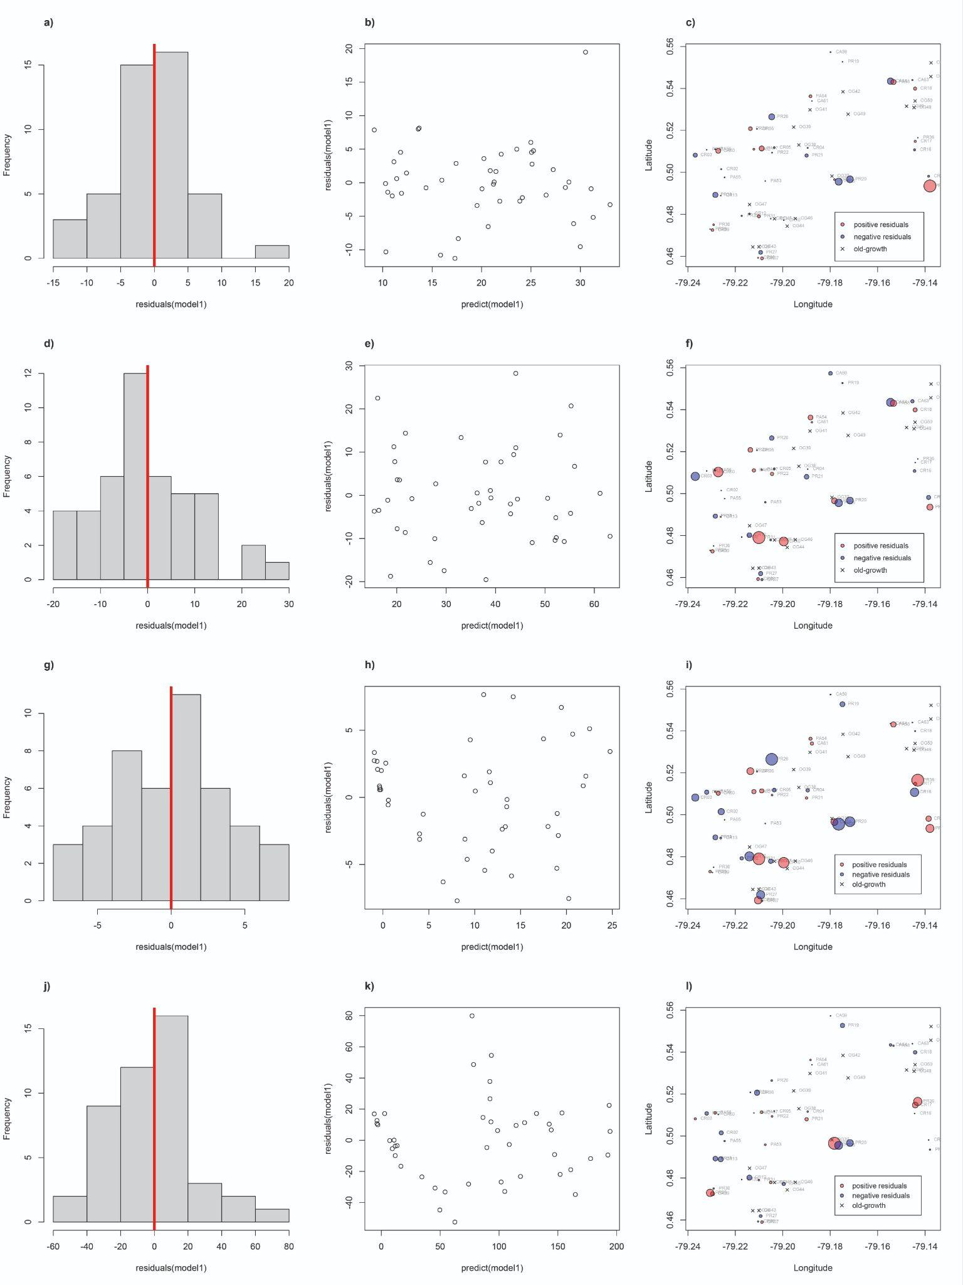
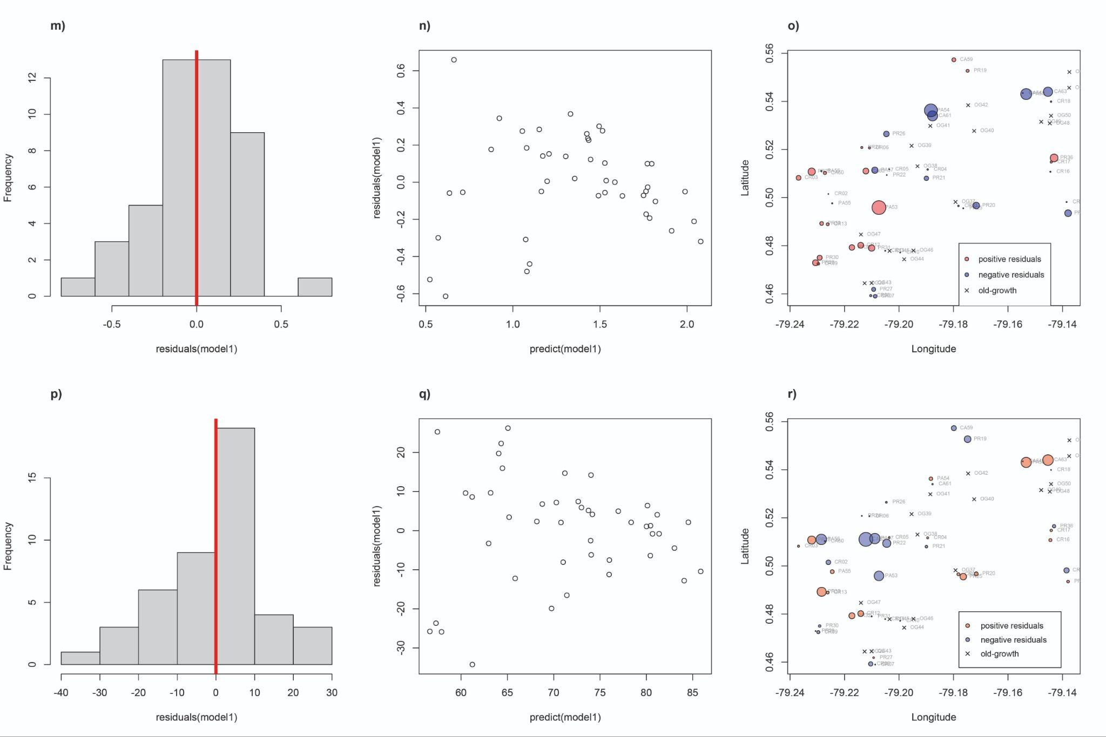
Figure S3. Linear mixed-effects model validation for forest structure variables. Histogram of the residuals, scatter plot of the fitted and residual values, and geographic distribution of the residuals of the models analyzed with maximum tree height (a, b, c), maximum tree DBH (d, e, f), basal area (g, h, i), number of stems(j, k, l), vertical vegetation heterogeneity (m, n, o), and reversed total site factor (TSF; p, q, r) as response variables. Histograms of the residuals (a, d, g, j, m, p) visually follow a normal distribution. The fitted and residual values of the models are not significantly correlated (b, e, h, k, n, q; all Pearson's r < 0.001, all p = 1). Spatial autocorrelation was only detected for maximum tree DBH (p < 0.05, f) and vertical vegetation heterogeneity (p < 0.05, o). Maximum tree height, maximum tree DBH, basal area, and number of stems were estimated for wild trees with DBH ≥ 7.95 cm. Reversed TSF was calculated as 1-TSF.

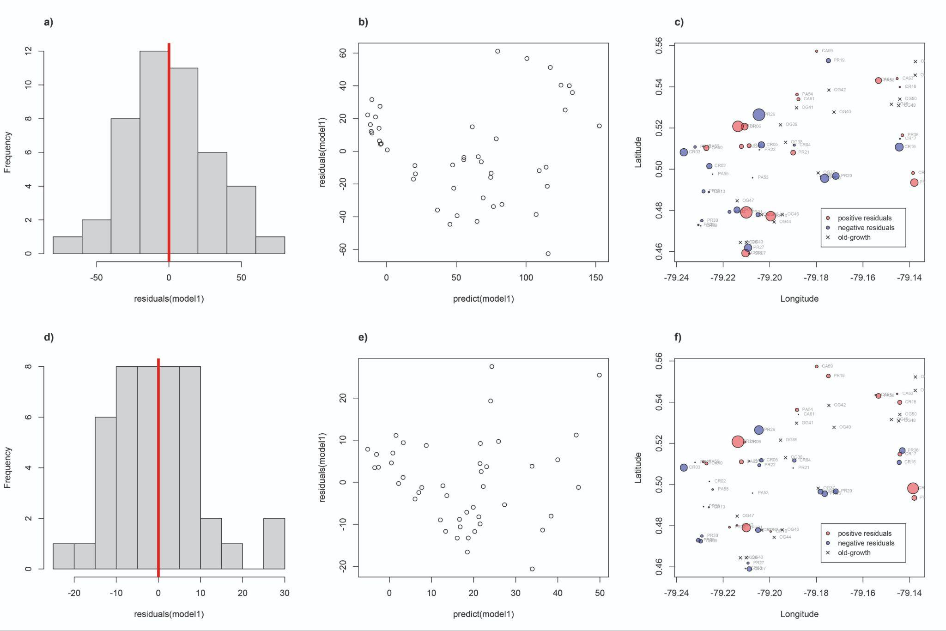
Figure S4. Linear mixed-effects model validation for aboveground biomass (AGB) and tree species richness. Histogram of the residuals, scatter plot of the fitted and residual values, and geographic distribution of the residuals of the models analyzed with AGB (a, b, c) and tree species richness (d, e, f) as response variables. Histograms of the residuals (a, d) visually follow a normal distribution. The fitted and residual values of the models are not correlated (b, e; Pearson's r < 0.001, p = 1). Spatial correlation was not observed (c, f; p > 0.05). AGB estimated using species-specific wood density along with DBH and height data, and rarefied tree species richness estimated with a coverage of 0.75 were estimated for wild trees with DBH ≥ 7.95 cm.

Supplementary Tables
Table S1. Baseline data on the 62 plots included in the study design.
Plot_ID | Treatment | Legacy | Reg_year | Duration_use | Latitude | Longitude | Elevation
CA59 | cacao active | cacao | NA | 11 | 0.55731 | -79.1799 | 165
CA60 | cacao active | cacao | NA | 23 | 0.510266 | -79.2272 | 440
CA61 | cacao active | cacao | NA | 8 | 0.534001 | -79.1877 | 324
CA62 | cacao active | cacao | NA | 6 | 0.511049 | -79.2122 | 372
CA63 | cacao active | cacao | NA | 14 | 0.544018 | -79.1453 | 240
CA64 | cacao active | cacao | NA | 23 | 0.543481 | -79.1546 | 256
CR01 | cacao regeneration | cacao | 2017 | 17 | 0.496548 | -79.1782 | 560
CR02 | cacao regeneration | cacao | 2015 | 15 | 0.501505 | -79.2259 | 400
CR03 | cacao regeneration | cacao | 2018 | 6 | 0.508212 | -79.2369 | 274
CR04 | cacao regeneration | cacao | 2002 | 7 | 0.511679 | -79.1895 | 560
CR05 | cacao regeneration | cacao | 2011 | 13 | 0.511784 | -79.2036 | 377
CR06 | cacao regeneration | cacao | 1990 | 3 | 0.520662 | -79.2108 | 397
CR07 | cacao regeneration | cacao | 2000 | 30 | 0.458986 | -79.2088 | 168
CR08 | cacao regeneration | cacao | 1996 | 26 | 0.459253 | -79.2104 | 172
CR09 | cacao regeneration | cacao | 2017 | 6 | 0.472474 | -79.2296 | 159
CR10 | cacao regeneration | cacao | 1999 | 9 | 0.477175 | -79.1996 | 347
CR11 | cacao regeneration | cacao | 2000 | 5 | 0.477893 | -79.2051 | 372
CR12 | cacao regeneration | cacao | 2008 | 7 | 0.480185 | -79.2141 | 324
CR13 | cacao regeneration | cacao | 2022 | 7 | 0.488923 | -79.2262 | 366
CR14 | cacao regeneration | cacao | 1985 | 5 | 0.49816 | -79.1385 | 529
CR16 | cacao regeneration | cacao | 2015 | 15 | 0.510746 | -79.1444 | 479
CR17 | cacao regeneration | cacao | 2014 | 14 | 0.51478 | -79.1441 | 450
CR18 | cacao regeneration | cacao | 2013 | 10 | 0.539918 | -79.1442 | 331
OG28 | old-growth | old-growth | NA | NA | 0.464406 | -79.2126 | 224
OG37 | old-growth | old-growth | NA | NA | 0.498192 | -79.1792 | 550
OG38 | old-growth | old-growth | NA | NA | 0.513057 | -79.1932 | 535
OG39 | old-growth | old-growth | NA | NA | 0.521552 | -79.1954 | 576
OG40 | old-growth | old-growth | NA | NA | 0.527723 | -79.1724 | 531
OG41 | old-growth | old-growth | NA | NA | 0.529813 | -79.1885 | 389
OG42 | old-growth | old-growth | NA | NA | 0.53843 | -79.1746 | 356
OG43 | old-growth | old-growth | NA | NA | 0.464478 | -79.2101 | 238
OG44 | old-growth | old-growth | NA | NA | 0.474349 | -79.1981 | 339
OG45 | old-growth | old-growth | NA | NA | 0.477861 | -79.2035 | 362
OG46 | old-growth | old-growth | NA | NA | 0.477978 | -79.1947 | 288
OG47 | old-growth | old-growth | NA | NA | 0.484658 | -79.214 | 355
OG48 | old-growth | old-growth | NA | NA | 0.53089 | -79.1446 | 299
OG49 | old-growth | old-growth | NA | NA | 0.531535 | -79.1478 | 310
OG50 | old-growth | old-growth | NA | NA | 0.53403 | -79.1442 | 316
OG51 | old-growth | old-growth | NA | NA | 0.552232 | -79.1375 | 228
OG52 | old-growth | old-growth | NA | NA | 0.545679 | -79.1376 | 225
PA53 | pasture active | pasture | NA | 23 | 0.495852 | -79.2074 | 510
PA54 | pasture active | pasture | NA | 23 | 0.536269 | -79.1883 | 207
PA55 | pasture active | pasture | NA | 19 | 0.497611 | -79.2245 | 426
PA56 | pasture active | pasture | NA | 23 | 0.511023 | -79.2285 | 430
PA57 | pasture active | pasture | NA | 6 | 0.511392 | -79.2089 | 375
PA58 | pasture active | pasture | NA | 7 | 0.543056 | -79.1533 | 243
PR19 | pasture regeneration | pasture | 2017 | 17 | 0.552719 | -79.1748 | 177
PR20 | pasture regeneration | pasture | 2019 | 19 | 0.496703 | -79.1717 | 540
PR21 | pasture regeneration | pasture | 1987 | 1 | 0.508024 | -79.19 | 560
PR22 | pasture regeneration | pasture | 2011 | 13 | 0.509393 | -79.2045 | 400
PR23 | pasture regeneration | pasture | 2022 | 22 | 0.51078 | -79.2321 | 415
PR24 | pasture regeneration | pasture | 2002 | 22 | 0.52082 | -79.2137 | 381
PR25 | pasture regeneration | pasture | 2017 | 17 | 0.495558 | -79.1764 | 544
PR26 | pasture regeneration | pasture | 1995 | 8 | 0.526466 | -79.2046 | 325
PR27 | pasture regeneration | pasture | 1996 | 7 | 0.461851 | -79.2093 | 214
PR29 | pasture regeneration | pasture | 2017 | 10 | 0.47292 | -79.2306 | 173
PR30 | pasture regeneration | pasture | 2008 | 6 | 0.475008 | -79.2291 | 219
PR31 | pasture regeneration | pasture | 2007 | 6 | 0.479026 | -79.2101 | 316
PR32 | pasture regeneration | pasture | 2007 | 6 | 0.479275 | -79.2173 | 339
PR33 | pasture regeneration | pasture | 2022 | 7 | 0.489245 | -79.2284 | 311
PR34 | pasture regeneration | pasture | 1985 | 5 | 0.493509 | -79.1379 | 615
PR36 | pasture regeneration | pasture | 2014 | 14 | 0.516501 | -79.1431 | 380
Continuation…
Plot_ID | Patch_ha | Distance | Forest_100m | Forest_500m | Forest_1km | Reversed_TSF | VVH
CA59 | 18.47498 | 66.69162 | 4.263157 | 24.88893 | 33.47445 | 53.61905 | 1.263654
CA60 | 2.371524 | 17.96248 | 13.3244 | 59.39237 | 71.93695 | 68.61905 | 1.359811
CA61 | 3.916493 | 54.99201 | 7.231092 | 57.51965 | 79.7493 | 59.71429 | 0.600166
CA62 | 14.87674 | 131.6154 | 0 | 23.52259 | 27.52259 | 26.96429 | 1.329297
CA63 | 0.843782 | 143.8804 | 0 | 56.39467 | 83.18785 | 91.28571 | 0.655993
CA64 | 5.376492 | 35.07122 | 16.06207 | 58.25824 | 67.55275 | 70.52381 | 1.201957
CR01 | 0.492453 | 31.84109 | 23.43878 | 53.59181 | 76.82499 | 77.47619 | 1.418911
CR02 | 0.946003 | 36.42346 | 56.05529 | 89.32652 | 89.5991 | 64.7619 | 1.585347
CR03 | 1.458779 | 33.08483 | 53.06817 | 76.82607 | 73.73364 | 78.90476 | 1.661873
CR04 | 1.861999 | 29.41603 | 54.65495 | 96.27259 | 97.12514 | 81.95238 | 1.678686
CR05 | 4.790451 | 65.63923 | 10.17473 | 13.65745 | 41.15905 | 78.33333 | 1.544394
CR06 | 0.643334 | 28.96937 | 34.34829 | 36.61514 | 41.12593 | 81.71429 | 1.896237
CR07 | 3.75544 | 114.9121 | 0 | 57.12641 | 55.37701 | 86.66667 | 1.59261
CR08 | 5.70617 | 49.9914 | 13.81523 | 65.87007 | 53.20305 | 75.42857 | 1.71472
CR09 | 1.06906 | 39.94556 | 51.39917 | 43.9749 | 32.42567 | 68.47619 | 1.568565
CR10 | 1.550152 | 25.04409 | 51.5854 | 91.85387 | 96.64203 | 80.57143 | 1.746987
CR11 | 1.55386 | 36.46924 | 63.10319 | 91.32184 | 89.96987 | 79.85714 | 1.715221
CR12 | 4.283623 | 157.6304 | 0 | 19.51279 | 74.76795 | 88.2381 | 1.79141
CR13 | 3.211388 | 38.53007 | 52.54433 | 82.12563 | 77.95376 | 75.57143 | 1.442341
CR14 | 0.526505 | 22.71859 | 83.21892 | 96.28904 | 98.61818 | 71.28571 | 1.937764
CR16 | 0.818761 | 43.87424 | 29.00042 | 65.91047 | 84.5492 | 80.09524 | 1.472184
CR17 | 1.297197 | 49.1178 | 24.23908 | 59.92649 | 86.1844 | 78.90476 | 1.630824
CR18 | 0.275992 | 25.59526 | 74.63726 | 66.66145 | 85.03603 | 80.47619 | 1.554713
OG28 | NA | 85.20277 | 98.82799 | 53.9589 | 64.95801 | 84 | 1.757592
OG37 | NA | 122.8746 | 99.99999 | 66.80653 | 75.01316 | 79.04762 | 1.924961
OG38 | NA | 403.3539 | 99.99998 | 96.97967 | 87.41406 | 77.09524 | 1.784249
OG39 | NA | 780.6852 | 99.99998 | 100 | 96.66099 | 88.19048 | 1.883757
OG40 | NA | 723.9293 | 99.99999 | 100 | 98.85801 | 92.71429 | 1.814715
OG41 | NA | 214.0048 | 99.99999 | 94.62245 | 86.31303 | 82.42857 | 1.931368
OG42 | NA | 188.4645 | 99.99998 | 83.70179 | 76.33876 | 80.71429 | 1.799954
OG43 | NA | 147.8222 | 99.99998 | 78.76785 | 68.6117 | 86.09524 | 1.889783
OG44 | NA | 302.6796 | 99.99996 | 97.73519 | 93.48595 | 70.38095 | 1.943601
OG45 | NA | 35.81112 | 72.50359 | 89.50271 | 93.17093 | 90.52381 | 1.855436
OG46 | NA | 463.8969 | 99.99998 | 99.65079 | 98.09357 | 81.14286 | 1.850355
OG47 | NA | 82.05557 | 95.58186 | 65.33918 | 74.88779 | 82.38095 | 1.933311
OG48 | NA | 942.6327 | 99.99998 | 100 | 99.82211 | 82.47619 | 1.830057
OG49 | NA | 858.3927 | 99.99997 | 99.99999 | 98.937 | 87.71429 | 1.897939
OG50 | NA | 607.9662 | 99.99999 | 100 | 93.20945 | 77.66667 | 1.834539
OG51 | NA | 413.9922 | 99.99997 | 96.9384 | 82.84373 | 81.28571 | 1.869189
OG52 | NA | 221.0001 | 99.99998 | 94.60685 | 87.53399 | 75.14286 | 1.892563
PA53 | 0.102569 | 71.47299 | 8.973976 | 81.89321 | 87.27756 | 33.61905 | 1.321049
PA54 | 10.67252 | 92.24954 | 0.574225 | 42.57853 | 77.3821 | 69.82143 | 0
PA55 | 4.69022 | 8.485378 | 44.91552 | 89.31478 | 91.95721 | 70.09524 | 0.657925
PA56 | 3.038455 | 85.73178 | 1.31309 | 53.80376 | 74.24558 | 32 | 0.577849
PA57 | 11.95958 | 16.37455 | 24.61295 | 21.70184 | 24.4259 | 30.85714 | 0.272248
PA58 | 24.17893 | 40.25524 | 6.850847 | 60.46259 | 69.02453 | 82.71429 | 0
PR19 | 6.554911 | 56.7706 | 17.85128 | 33.78026 | 37.13616 | 54.89286 | 1.31255
PR20 | 22.17156 | 142.7085 | 0 | 46.54237 | 73.48573 | 72.85714 | 0.765502
PR21 | 1.064727 | 21.16522 | 72.21343 | 96.27259 | 95.66122 | 74.04762 | 1.829033
PR22 | 7.753099 | 105.8189 | 0 | 36.82177 | 42.30408 | 49.85714 | 1.375103
PR23 | 1.687798 | 30.92214 | 28.85542 | 62.05453 | 76.83124 | 83.80952 | 1.266398
PR24 | 5.074808 | 22.19631 | 43.01681 | 37.42918 | 38.76569 | 81.09524 | 1.871864
PR25 | 25.51887 | 201.5191 | 0 | 36.22153 | 78.227 | 80.42857 | 1.113993
PR26 | 0.780134 | 25.02999 | 75.5212 | 90.06834 | 84.31897 | 78.57143 | 1.649689
PR27 | 5.227 | 50.19792 | 38.68863 | 67.25883 | 64.5287 | 85.2381 | 1.59205
PR29 | 1.237951 | 36.91717 | 29.46513 | 33.58899 | 29.96284 | 72.85714 | 1.435762
PR30 | 5.068008 | 41.53222 | 19.40616 | 49.17466 | 41.9289 | 67.85714 | 1.666489
PR31 | 27.54875 | 39.3488 | 30.6229 | 66.68842 | 75.4393 | 71.42857 | 1.796216
PR32 | 46.70698 | 174.4493 | 0 | 33.64306 | 69.16992 | 85.90476 | 1.685077
PR33 | 1.212158 | 23.11586 | 56.1268 | 73.53113 | 69.99333 | 86.61905 | 1.052204
PR34 | 3.267871 | 24.54014 | 58.78685 | 95.75187 | 88.80019 | 86.52381 | 1.758754
PR36 | 20.53949 | 35.06538 | 32.43683 | 66.12812 | 86.5253 | 62.95238 | 1.698149

Table S2. Summary of the Reassembly plots (N = 62) by land-use type and regeneration age across a 200 km² area in northwestern Ecuador. Patch size was calculated for distinct areas of continuous land use around each 50×50m plot. Distance to the nearest forest edge was calculated from the plot centroid excluding all known forest disturbances <40 yrs (some areas include older selective logging or other disturbances). Forest cover was calculated as the percentage of the total forest area within different radii buffers around the plot centroid. Regeneration areas ≤15 yrs (Regen I) were visible on optical imagery whereas local knowledge, ground-truthing, and historic Landsat were used to classify regeneration >15 yrs (Regen II). SE = standard error.
Land use |  | Agriculture |  | Regen I, 0-15 yrs |  | Regen II, 16-38 yrs |  | Old-growth
 |  | Pasture | Cacao | Pasture | Cacao | Pasture | Cacao | Forest
(number of plots) |  | (6) | (6) | (8) | (9) | (8) | (8) | (17)
Elevation (m) | Mean | 365 | 300 | 368 | 377 | 371 | 359 | 360
 | SE | 48 | 40 | 50 | 39 | 52 | 51 | 29
 | Min | 207 | 165 | 173 | 159 | 214 | 168 | 224
 | Max | 510 | 440 | 544 | 560 | 615 | 560 | 576
Patch size (ha) | Mean | 9.1 | 7.6 | 10.8 | 1.6 | 11.8 | 2.5 | -
 | SE | 3.5 | 3 | 3.6 | 0.5 | 5.8 | 0.7 | -
 | Min | 0.1 | 0.8 | 1.2 | 0.3 | 0.8 | 0.5 | -
 | Max | 24.2 | 18.5 | 25.5 | 4.8 | 46.7 | 5.7 | -
Distance (m) | Mean | 52 | 75 | 79 | 40 | 50 | 58 | 388
forest edge | SE | 15 | 21 | 23 | 4 | 18 | 18 | 72
 | Min | 8 | 18 | 23 | 26 | 21 | 23 | 36
 | Max | 92 | 144 | 202 | 66 | 174 | 158 | 943
Forest cover (%)
100 m radius | Mean | 15 | 7 | 21 | 42 | 42 | 38 | 98
 | SE | 7 | 3 | 7 | 7 | 9 | 11 | 2
 | Min | 1 | 0 | 0 | 10 | 0 | 0 | 73
 | Max | 45 | 16 | 56 | 75 | 76 | 83 | 100
500 m radius | Mean | 58 | 47 | 49 | 61 | 67 | 69 | 89
 | SE | 10 | 7 | 6 | 8 | 9 | 10 | 4
 | Min | 22 | 24 | 34 | 14 | 34 | 20 | 54
 | Max | 89 | 59 | 74 | 89 | 96 | 96 | 100
1 km radius | Mean | 71 | 61 | 62 | 72 | 70 | 76 | 87
 | SE | 10 | 10 | 8 | 7 | 7 | 8 | 3
 | Min | 24 | 28 | 30 | 32 | 39 | 41 | 65
 | Max | 92 | 83 | 87 | 90 | 96 | 99 | 100
Table S3. Pearson correlation coefficients among elevation and forest cover metrics for Reassembly plots (N = 62) located across a 200 km² area in northwestern Ecuador. Forest cover within 100 m was highly correlated with distance to the forest edge but minimally correlated with forest cover within 1 km.
Metric | Age¹ | Elevation | Patch size | Distance forest | Distance edge | Forest 100m | Forest 500m
Elevation | -0.18 | - | - | - | - | - | -
Patch size | 0.14 | -0.05 | - | - | - | - | -
Distance forest | 0.21 | -0.03 | 0.61 | - | - | - | -
Distance edge | - | 0.07 | -0.27 | -0.42 | - | - | -
Forest 100 m | -0.35 | 0.12 | -0.53 | -0.78 | 0.64 | - | -
Forest 500 m | -0.39 | 0.26 | -0.47 | -0.63 | 0.54 | 0.76 | -
Forest 1 km | -0.2 | 0.44 | -0.26 | -0.29 | 0.43 | 0.51 | 0.82
¹Correlation with regeneration age for chronosequence plots (N = 33).

Table S4. Results on forest structure, aboveground biomass (AGB), and species richness in the 62 plots included in the study design. AGB estimates for the three datasets were highly correlated between the two methods used (all Pearson's r > 0.99, all p < 0.001, all n = 62 plots). Tree species richness for the three datasets was also highly correlated between the two methods used (all Pearson's r = 0.89–0.92, all p < 0.001, all n = 62 plots).
Plot_ID | Max_tree_height | Max_tree_DBH | Number_stems | AGB_all | AGB_wild | AGB_dbh10
CA59 | 10.32 | 13.10801 | 8 | 2.787576 | 1.135715 | 0.921353
CA60 | 17.02 | 38.64285 | 10 | 22.89548 | 22.81815 | 22.68901
CA61 | 12.02 | 23.72047 | 11 | 12.65336 | 4.732821 | 4.704484
CA62 | 14.26 | 27.40014 | 7 | 13.07772 | 8.706744 | 8.706744
CA63 | 9 | 12.34248 | 4 | 11.46519 | 0.70952 | 0.625191
CA64 | 0 | 0 | 0 | 0.170411 | 0 | 0
CR01 | 20.3 | 46.40962 | 157 | 50.78292 | 50.25193 | 45.92816
CR02 | 22.68 | 38.4646 | 75 | 48.25308 | 40.79876 | 40.39214
CR03 | 14.12 | 18.53838 | 101 | 11.19531 | 11.19531 | 9.39489
CR04 | 24.68 | 49.87284 | 153 | 98.10544 | 97.60983 | 93.70121
CR05 | 19.08 | 38.77654 | 105 | 47.00866 | 42.84161 | 41.00429
CR06 | 30.18 | 61.62485 | 130 | 174.2045 | 169.1034 | 167.1477
CR07 | 29.58 | 47.03987 | 149 | 108.8982 | 104.6958 | 101.7087
CR08 | 29.2 | 62.71347 | 138 | 167.0856 | 165.424 | 162.5021
CR09 | 26.24 | 48.85424 | 119 | 58.5746 | 51.72222 | 48.47263
CR10 | 27.76 | 76.0061 | 130 | 170.7984 | 168.6575 | 165.208
CR11 | 28.94 | 51.01239 | 171 | 94.23184 | 93.85532 | 89.9804
CR12 | 21.12 | 36.47198 | 72 | 51.95116 | 50.23783 | 47.78175
CR13 | 16.36 | 30.55141 | 21 | 17.02834 | 11.58909 | 11.38873
CR14 | 29.72 | 53.69892 | 200 | 168.0343 | 168.0343 | 162.7992
CR16 | 16.14 | 30.99704 | 85 | 23.64869 | 22.0127 | 20.066
CR17 | 23.84 | 40.06888 | 130 | 62.35505 | 61.51017 | 59.34792
CR18 | 28.56 | 53.10687 | 95 | 88.06754 | 86.26249 | 84.16829
OG28 | 37.26 | 100.8343 | 236 | 411.4048 | 411.4048 | 404.6945
OG37 | 33.96 | 105.7936 | 195 | 482.5621 | 482.5621 | 477.2435
OG38 | 27.56 | 62.57978 | 148 | 167.7737 | 167.7737 | 164.0086
OG39 | 32.98 | 71.63888 | 169 | 331.322 | 331.322 | 328.3539
OG40 | 38.68 | 114.6871 | 199 | 568.3411 | 568.3411 | 563.9639
OG41 | 39.74 | 118.0803 | 149 | 554.0874 | 554.0874 | 550.5309
OG42 | 42.3 | 89.04408 | 203 | 269.0316 | 268.9615 | 265.063
OG43 | 36.62 | 129.826 | 231 | 506.1702 | 506.1702 | 495.1548
OG44 | 34.78 | 99.44646 | 198 | 387.6717 | 387.2874 | 381.961
OG45 | 31.28 | 86.79681 | 187 | 325.7297 | 325.7297 | 322.3715
OG46 | 33.96 | 86.30025 | 155 | 300.6303 | 300.6303 | 297.9593
OG47 | 33.74 | 58.88738 | 158 | 171.0831 | 171.0831 | 167.9662
OG48 | 39.48 | 106.6976 | 161 | 420.4536 | 420.4536 | 416.9278
OG49 | 37.04 | 91.0367 | 139 | 324.1274 | 324.1274 | 322.9785
OG50 | 30.2 | 74.93021 | 200 | 191.4275 | 191.4275 | 188.3268
OG51 | 38.24 | 117.2336 | 161 | 429.8627 | 429.8627 | 426.8597
OG52 | 36.4 | 84.03388 | 143 | 254.1117 | 254.1117 | 251.4532
PA53 | 10.16 | 11.75201 | 9 | 0.841214 | 0.841214 | 0.484613
PA54 | 16.34 | 30.65327 | 7 | 9.209642 | 8.693403 | 8.693403
PA55 | 13.85 | 17.03755 | 2 | 1.708514 | 1.364073 | 1.364073
PA56 | 9.1 | 12.87246 | 11 | 1.238515 | 1.238515 | 1.114699
PA57 | 21.6 | 24.10881 | 20 | 13.04157 | 13.04157 | 13.04157
PA58 | 21.84 | 36.16003 | 7 | 21.04557 | 21.04557 | 21.04557
PR19 | 19.14 | 32.03473 | 46 | 25.5894 | 25.5894 | 24.32751
PR20 | 5.04 | 11.21725 | 5 | 0.572228 | 0.572228 | 0.519884
PR21 | 26.12 | 43.22015 | 216 | 153.3002 | 153.3002 | 148.7729
PR22 | 23.12 | 45.69661 | 105 | 62.45467 | 62.45467 | 59.05338
PR23 | 13.62 | 22.29444 | 11 | 6.892375 | 6.892375 | 6.609366
PR24 | 31 | 55.13132 | 151 | 157.2817 | 157.2817 | 153.5645
PR25 | 6.02 | 12.14672 | 10 | 0.854491 | 0.854491 | 0.646478
PR26 | 20.44 | 41.63497 | 166 | 53.49908 | 53.31576 | 48.37087
PR27 | 23.2 | 42.50077 | 142 | 68.64232 | 68.64232 | 64.42916
PR29 | 21.38 | 34.78493 | 127 | 39.33975 | 38.97654 | 37.07925
PR30 | 27.88 | 43.57029 | 124 | 61.60926 | 61.60926 | 56.38492
PR31 | 30.02 | 72.34553 | 133 | 140.8203 | 140.8203 | 137.0599
PR32 | 21.9 | 41.02381 | 106 | 58.81005 | 58.69513 | 55.2664
PR33 | 9.3 | 17.66621 | 15 | 2.287332 | 2.287332 | 2.165729
PR34 | 50 | 67.04885 | 183 | 171.0477 | 171.0477 | 167.0761
PR36 | 20.98 | 36.80939 | 148 | 76.44878 | 76.40301 | 75.05918
Continuation…
Plot_ID | AGC_all | AGC_wild | AGC_dbh10 | AGB_Chave  _all | AGB_Chave  _wild | AGB_Chave  _dbh10 | basal_area  _wild
CA59 | 1.315763 | 0.536059 | 0.434699 | 2.963818 | 1.245959 | 0.977181 | 0.36946
CA60 | 10.83229 | 10.746 | 10.63063 | 17.49436 | 17.4489 | 17.31702 | 2.852707
CA61 | 5.973175 | 2.283516 | 2.239463 | 11.1116 | 5.149392 | 5.073066 | 1.497741
CA62 | 6.15256 | 4.125851 | 4.071205 | 11.79913 | 7.831022 | 7.831022 | 1.784474
CA63 | 5.40575 | 0.338241 | 0.293361 | 10.85055 | 0.61869 | 0.556192 | 0.199608
CA64 | 0.080797 | 0 | 0 | 0.104636 | 0 | 0 | 0
CR01 | 23.9585 | 23.75938 | 21.75644 | 58.52803 | 58.3175 | 55.10106 | 13.80237
CR02 | 22.76081 | 19.21374 | 19.04778 | 49.7765 | 41.50684 | 41.08213 | 7.909014
CR03 | 5.28724 | 5.284054 | 4.412674 | 14.45157 | 14.45157 | 12.21236 | 4.560115
CR04 | 46.43287 | 45.89667 | 43.95894 | 88.1489 | 87.64502 | 84.73392 | 15.81634
CR05 | 22.20553 | 20.20158 | 19.38226 | 46.78443 | 42.30087 | 41.00205 | 10.63165
CR06 | 81.92914 | 79.3329 | 78.64622 | 168.489 | 162.3497 | 160.6709 | 22.68686
CR07 | 51.41077 | 49.11734 | 47.67923 | 105.4858 | 101.6023 | 99.34045 | 17.79182
CR08 | 78.52777 | 77.49689 | 76.50774 | 175.6228 | 173.8243 | 171.6413 | 25.39069
CR09 | 27.56225 | 24.32972 | 22.85562 | 64.1061 | 56.04594 | 52.98632 | 10.53146
CR10 | 80.44356 | 79.50572 | 78.08936 | 177.7916 | 175.6487 | 172.8045 | 26.14175
CR11 | 44.47004 | 44.47425 | 42.30212 | 83.96874 | 83.59454 | 80.89874 | 16.27124
CR12 | 24.39907 | 23.54787 | 22.48008 | 45.66284 | 44.29292 | 42.24527 | 8.156208
CR13 | 8.020828 | 5.472408 | 5.336425 | 19.36646 | 13.77221 | 13.52242 | 3.12907
CR14 | 79.37552 | 78.88502 | 76.61357 | 186.1096 | 186.1096 | 182.2965 | 28.17106
CR16 | 11.05829 | 10.37793 | 9.439867 | 24.6314 | 22.78835 | 21.26706 | 5.651857
CR17 | 29.39889 | 29.06329 | 27.96397 | 71.65873 | 70.79263 | 69.00845 | 13.49378
CR18 | 41.46944 | 40.70924 | 39.50303 | 90.93297 | 89.07139 | 86.81003 | 12.78768
OG28 | 194.0413 | 193.6601 | 190.3995 | 395.1632 | 395.1632 | 390.5251 | 46.18308
OG37 | 226.4337 | 227.6329 | 224.6607 | 417.5831 | 417.5831 | 414.8614 | 48.18187
OG38 | 78.70472 | 79.02666 | 77.36273 | 148.5405 | 148.5405 | 145.6062 | 22.37227
OG39 | 155.4673 | 155.873 | 154.7234 | 277.9775 | 277.9775 | 275.8207 | 38.07224
OG40 | 266.44 | 268.5961 | 265.3372 | 462.4956 | 462.4956 | 459.4253 | 49.26581
OG41 | 261.0799 | 259.7253 | 259.1806 | 520.8736 | 520.8736 | 518.4464 | 51.21741
OG42 | 127.9153 | 127.9847 | 125.0804 | 318.1286 | 318.0127 | 315.293 | 35.21305
OG43 | 237.9154 | 238.7413 | 232.1851 | 476.3941 | 476.3941 | 470.5291 | 64.87576
OG44 | 182.2385 | 182.5944 | 180.2508 | 326.1195 | 325.6272 | 321.4548 | 39.46105
OG45 | 153.2857 | 153.4106 | 152.4527 | 299.6087 | 299.6087 | 295.9249 | 38.9399
OG46 | 140.8239 | 141.5046 | 140.7605 | 266.746 | 266.746 | 263.2668 | 35.63245
OG47 | 80.3299 | 80.47321 | 79.22419 | 163.5813 | 163.5813 | 161.252 | 23.4592
OG48 | 197.5947 | 198.0519 | 195.389 | 394.6178 | 394.6178 | 392.206 | 41.83173
OG49 | 153.1305 | 152.5035 | 153.0153 | 302.8575 | 302.8575 | 300.8325 | 34.70803
OG50 | 90.00897 | 90.28279 | 88.73964 | 181.8225 | 181.8225 | 179.2477 | 28.94262
OG51 | 200.6925 | 202.1184 | 200.5962 | 430.0826 | 430.0826 | 428.0443 | 43.07329
OG52 | 120.8431 | 120.1975 | 118.874 | 271.8805 | 271.8805 | 269.3163 | 30.75148
PA53 | 0.399213 | 0.400855 | 0.231165 | 1.006774 | 1.006774 | 0.632027 | 0.322622
PA54 | 4.36886 | 4.101714 | 4.097203 | 8.688069 | 8.379248 | 8.379248 | 1.819972
PA55 | 0.807417 | 0.633068 | 0.649766 | 2.043675 | 1.811445 | 1.811445 | 0.381475
PA56 | 0.588595 | 0.582927 | 0.535595 | 1.204982 | 1.204982 | 1.116293 | 0.461552
PA57 | 6.16793 | 6.144354 | 6.139463 | 12.1985 | 12.1985 | 12.1985 | 2.039714
PA58 | 9.842398 | 9.838893 | 9.92132 | 17.00445 | 17.00445 | 17.00445 | 2.39961
PR19 | 12.0048 | 12.10475 | 11.54125 | 24.22142 | 24.22142 | 23.37773 | 5.824567
PR20 | 0.267909 | 0.268977 | 0.245108 | 0.403004 | 0.403004 | 0.36716 | 0.257943
PR21 | 72.24867 | 72.10365 | 69.85782 | 139.5581 | 139.5581 | 135.9085 | 23.69835
PR22 | 29.36151 | 29.47238 | 27.68943 | 57.31392 | 57.31392 | 54.97984 | 12.8028
PR23 | 3.205963 | 3.258669 | 3.070761 | 5.526684 | 5.526684 | 5.243831 | 1.267664
PR24 | 73.92553 | 74.20591 | 72.23382 | 150.8137 | 150.8137 | 147.886 | 21.85526
PR25 | 0.404223 | 0.402226 | 0.303905 | 0.665638 | 0.665638 | 0.496258 | 0.375677
PR26 | 25.17734 | 25.06151 | 22.74848 | 54.97632 | 54.87473 | 50.81133 | 12.71192
PR27 | 32.21992 | 32.31323 | 30.35828 | 71.01658 | 71.01658 | 67.59827 | 13.66458
PR29 | 18.48268 | 18.37006 | 17.41904 | 52.15807 | 51.78728 | 49.76014 | 10.46434
PR30 | 28.97398 | 29.0127 | 26.55995 | 77.96909 | 77.96909 | 73.90516 | 13.36456
PR31 | 66.44245 | 66.38297 | 64.72396 | 165.8786 | 165.8786 | 162.9684 | 21.69132
PR32 | 27.81605 | 27.60214 | 25.96366 | 56.30017 | 56.2241 | 53.77012 | 11.15422
PR33 | 1.079005 | 1.082285 | 1.020387 | 2.335817 | 2.335817 | 2.160826 | 0.869318
PR34 | 80.42325 | 81.05442 | 79.58071 | 202.3533 | 202.3533 | 199.693 | 27.63492
PR36 | 35.95562 | 35.96455 | 35.25774 | 100.8272 | 100.7994 | 99.39063 | 18.63135
Continuation…
Plot_ID | sr_all | sr_wild | sr_dbh10 | sr_rar_all | sr_rar_wild | sr_rar_dbh10
CA59 | 5 | 4 | 3 | 2.812571 | 3.584374 | 3.5
CA60 | 7 | 6 | 5 | 10.84091 | 7.775 | 6.0625
CA61 | 8 | 3 | 3 | 6.447645 | 1.904779 | 2.142859
CA62 | 10 | 6 | 6 | 11.84239 | 12.71429 | 12.71429
CA63 | 4 | 1 | 1 | 1 | 1 | 1
CA64 | 1 | 0 | 0 | 1 | 0 | 0
CR01 | 21 | 20 | 18 | 8.993121 | 8.575623 | 8.932323
CR02 | 29 | 28 | 27 | 11.93446 | 21.29383 | 22.16277
CR03 | 7 | 7 | 5 | 1.950072 | 1.950072 | 1.71499
CR04 | 48 | 46 | 39 | 31.47946 | 30.35512 | 32.23276
CR05 | 28 | 26 | 21 | 10.35986 | 13.03396 | 10.23903
CR06 | 49 | 48 | 43 | 27.03717 | 45.30457 | 61.9387
CR07 | 21 | 19 | 19 | 7.035123 | 6.227121 | 6.513983
CR08 | 41 | 40 | 36 | 21.30296 | 24.35888 | 25.66961
CR09 | 21 | 19 | 16 | 6.118525 | 7.864476 | 6.85718
CR10 | 50 | 48 | 35 | 36.02956 | 37.67001 | 28.3489
CR11 | 47 | 45 | 39 | 27.39996 | 25.0312 | 25.95144
CR12 | 33 | 31 | 27 | 26.92348 | 26.79167 | 26.26574
CR13 | 12 | 10 | 9 | 1.39742 | 10.46591 | 9.143519
CR14 | 80 | 80 | 60 | 75.29818 | 75.29818 | 57.94353
CR16 | 21 | 20 | 17 | 8.890454 | 11.66669 | 10.75811
CR17 | 43 | 42 | 31 | 27.21019 | 30.83521 | 20.47517
CR18 | 41 | 40 | 33 | 26.91145 | 35.61027 | 33.21507
OG28 | 63 | 63 | 56 | 34.38046 | 34.38046 | 37.6577
OG37 | 66 | 66 | 54 | 52.81824 | 52.81824 | 43.52966
OG38 | 64 | 64 | 53 | 63.33168 | 63.33168 | 57.4442
OG39 | 64 | 64 | 57 | 56.42704 | 56.42704 | 58.53714
OG40 | 73 | 73 | 61 | 63.82126 | 63.82126 | 65.71711
OG41 | 68 | 68 | 57 | 89.40059 | 89.40059 | 95.41379
OG42 | 90 | 89 | 69 | 99.76244 | 97.30078 | 67.84392
OG43 | 76 | 76 | 62 | 56.85521 | 56.85521 | 56.02481
OG44 | 85 | 84 | 76 | 94.15538 | 91.72494 | 135.1128
OG45 | 90 | 90 | 71 | 140.6638 | 140.6638 | 134.0243
OG46 | 72 | 72 | 56 | 98.43498 | 98.43498 | 73.09375
OG47 | 71 | 71 | 63 | 77.54761 | 77.54761 | 90.00419
OG48 | 61 | 61 | 54 | 50.89135 | 50.89135 | 48.70402
OG49 | 61 | 61 | 53 | 61.2465 | 61.2465 | 57.50862
OG50 | 78 | 78 | 64 | 67.99595 | 67.99595 | 57.84781
OG51 | 50 | 50 | 43 | 34.01844 | 34.01844 | 30.2487
OG52 | 64 | 64 | 55 | 83.77564 | 83.77564 | 82.99091
PA53 | 4 | 4 | 1 | 4.416667 | 4.416667 | 1
PA54 | 5 | 3 | 3 | 7.083333 | 2.704313 | 2.704313
PA55 | 3 | 2 | 2 | 3.05 | 2.125 | 2.125
PA56 | 5 | 5 | 4 | 5.090909 | 5.090909 | 4.416667
PA57 | 5 | 5 | 5 | 4.56704 | 4.56704 | 4.56704
PA58 | 6 | 6 | 6 | 12.71429 | 12.71429 | 12.71429
PR19 | 18 | 18 | 17 | 17.50717 | 17.50717 | 27.44444
PR20 | 2 | 2 | 2 | 1.709765 | 1.709765 | 1.263953
PR21 | 65 | 65 | 56 | 43.68175 | 43.68175 | 40.39779
PR22 | 24 | 24 | 19 | 11.25214 | 11.25214 | 9.799863
PR23 | 7 | 7 | 5 | 6.453549 | 6.453549 | 5.553571
PR24 | 60 | 60 | 45 | 51.81764 | 51.81764 | 40.49612
PR25 | 4 | 4 | 3 | 2.874531 | 2.874531 | 2.512502
PR26 | 34 | 32 | 26 | 14.2727 | 13.3372 | 13.82651
PR27 | 37 | 37 | 31 | 22.0145 | 22.0145 | 22.05496
PR29 | 15 | 14 | 13 | 4.310412 | 3.168796 | 2.104218
PR30 | 30 | 30 | 25 | 13.97417 | 13.97417 | 15.47623
PR31 | 50 | 50 | 38 | 43.3435 | 43.3435 | 36.4065
PR32 | 38 | 37 | 35 | 26.96799 | 25.97878 | 33.66063
PR33 | 9 | 9 | 8 | 11.9 | 11.9 | 10.04167
PR34 | 68 | 68 | 62 | 55.55973 | 55.55973 | 56.70593
PR36 | 19 | 18 | 17 | 5.674342 | 5.513443 | 5.025963

Table S5. Results of linear models. a) Maximum tree height, b) maximum tree DBH, c) basal area, d) number of stems, e) vertical vegetation heterogeneity, and f) reversed total site factor (TSF).
Max tree height - ANOVA type II error
Variable | Sum Sq | Df | F value | p
Elevation (masl) | 22.31 | 1 | 0.588 | 0.4479
Forest 100 m around | 17.75 | 1 | 0.4678 | 0.4982
Land-use legacy | 2.12 | 1 | 0.056 | 0.8143
sqrt(Regeneration time) | 1275.6 | 1 | 3.36E+01 | 1.08E-06
Duration use | 23.67 | 1 | 0.6237 | 0.4346
Land-use legacy (pasture) : sqrt(Regeneration time) | 9.69 | 1 | 0.2554 | 0.6162
Residuals | 1442 | 38
Max tree DBH - ANOVA type II error
Elevation (masl) | 121.5 | 1 | 0.9048 | 0.3475
Forest 100 m around | 10.8 | 1 | 0.0801 | 0.7787
Land-use legacy | 128 | 1 | 0.9533 | 0.335
sqrt(Regeneration time) | 5688.1 | 1 | 42.3711 | 1.14E-07
Duration use | 47.8 | 1 | 0.3563 | 0.5541
Land-use legacy (pasture) : sqrt(Regeneration time) | 88.5 | 1 | 0.6592 | 0.4219
Residuals | 5101.3 | 38
Basal area - ANOVA type II error
Elevation (masl) | 0.64 | 1 | 0.0377 | 0.8472
Forest 100 m around | 12.87 | 1 | 0.7536 | 0.3908
Land-use legacy | 7.97 | 1 | 0.4666 | 0.4987
sqrt(Regeneration time) | 1967 | 1 | 115.1375 | 4.65E-13
Duration use | 5.31 | 1 | 0.3111 | 0.5803
Land-use legacy (pasture) : sqrt(Regeneration time) | 1.45 | 1 | 0.0848 | 0.7725
Residuals | 649.18 | 38
Number of stems - ANOVA type II error
Elevation (masl) | 84 | 1 | 0.1061 | 0.7464
Forest 100 m around | 2969 | 1 | 3.7584 | 0.06
Land-use legacy | 191 | 1 | 0.2417 | 0.6258
sqrt(Regeneration time) | 101586 | 1 | 128.6072 | 9.25E-14
Duration use | 13 | 1 | 0.0167 | 0.8977
Land-use legacy (pasture) : sqrt(Regeneration time) | 662 | 1 | 0.8387 | 0.3656
Residuals | 30016 | 38
Vertical vegetation heterogeneity - ANOVA type II error
Elevation (masl) | 0.0055 | 1 | 0.0714 | 0.790689
Forest 100 m around | 0.0969 | 1 | 1.2499 | 0.270599
Land-use legacy | 0.6654 | 1 | 8.5816 | 0.005715
sqrt(Regeneration time) | 4.1354 | 1 | 53.3366 | 9.60E-09
Duration use | 0.0773 | 1 | 0.997 | 0.324358
Land-use legacy (pasture) : sqrt(Regeneration time) | 0.5429 | 1 | 7.0016 | 0.011781
Residuals | 2.9463 | 38
Reversed TSF - ANOVA type II error
Elevation (masl) | 146.1 | 1 | 0.6922 | 0.410619
Forest 100 m around | 108.4 | 1 | 0.5138 | 0.47789
Land-use legacy | 175.5 | 1 | 0.8317 | 0.367518
sqrt(Regeneration time) | 1729.5 | 1 | 8.1957 | 0.006796
Duration use | 90.4 | 1 | 0.4283 | 0.51675
Land-use legacy (pasture) : sqrt(Regeneration time) | 38.9 | 1 | 0.1843 | 0.67014
Residuals | 8019 | 38

