Web Appendix
Generative AI for Scalable Feedback to Multimodal Exercises

Table of Contents
Illustration of the App 2
Three Key Steps When Using the App as a Learner 2
Prompt: Defining the Role, Tasks, and Feedback (Format) Requirements 5
System Usability Scale 6
Technology Acceptance Model 7

Illustration of the App
This section outlines the app’s intended usage by learners and its underlying design. The first sub-section provides three screenshots from the application corresponding to the three key steps a learner undertakes when using the app. Then, we provide the detailed prompt we used in the empirical studies. Please note that the displayed app interface corresponds to the version used in Study C. Through the link provided, readers can access a newer version, which incorporates further improvements.

Three Key Steps When Using the App as a Learner
This section briefly outlines in Figure A1–Figure A3 the three key steps learners undertake in order to receive feedback when using the app. First, learners select the sub-exercises they want to receive feedback on (Figure A1). Educators pre-define these sub-exercises beforehand through their educator account. Second, learners insert their multimodal solution (e.g., code, output, and text) into a field for each sub-exercise (Figure A2). Then, learners click on the arrow at the bottom of the page, and the app sends an API request for each sub-exercise to the Generative AI model. After receiving all responses, the app parses them and displays them in a table. The table includes the exercise, the learner’s solution, the quantitative feedback (achieved points relative to the maximum achievable points), and the qualitative feedback (Figure A3).
Figure A1: Step 1—Selecting the Pre-Defined Sub-Exercises for Which the Learner Wants to Receive Feedback
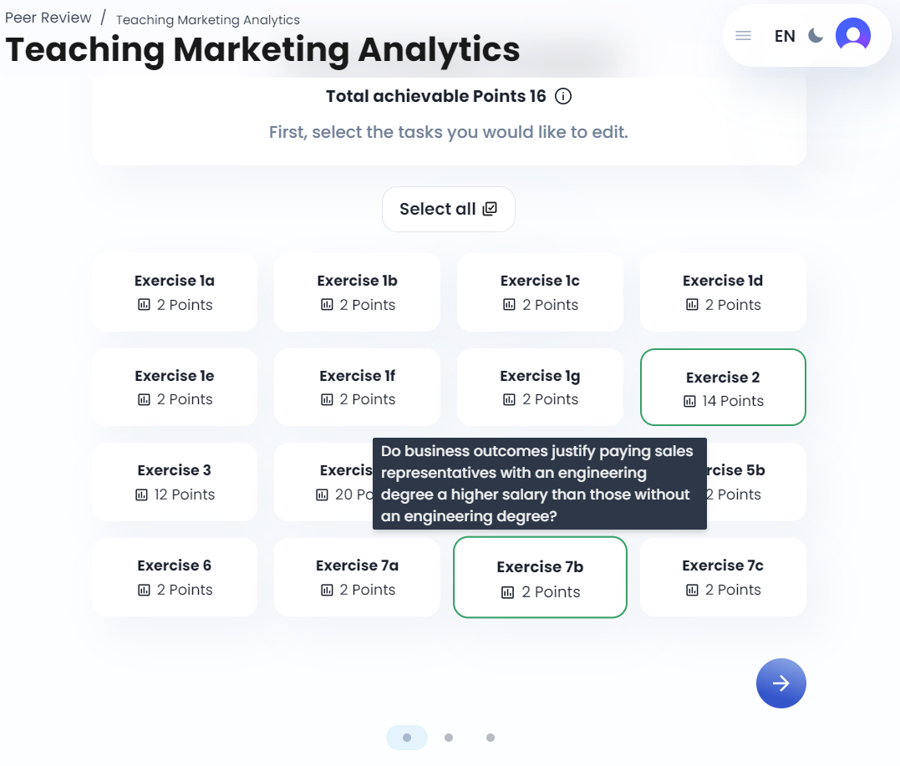
Figure A2: Step 2—Inserting the Learner’s Solution(s) into the App
Figure A3: Step 3—Receiving Quantitative and Qualitative Feedback
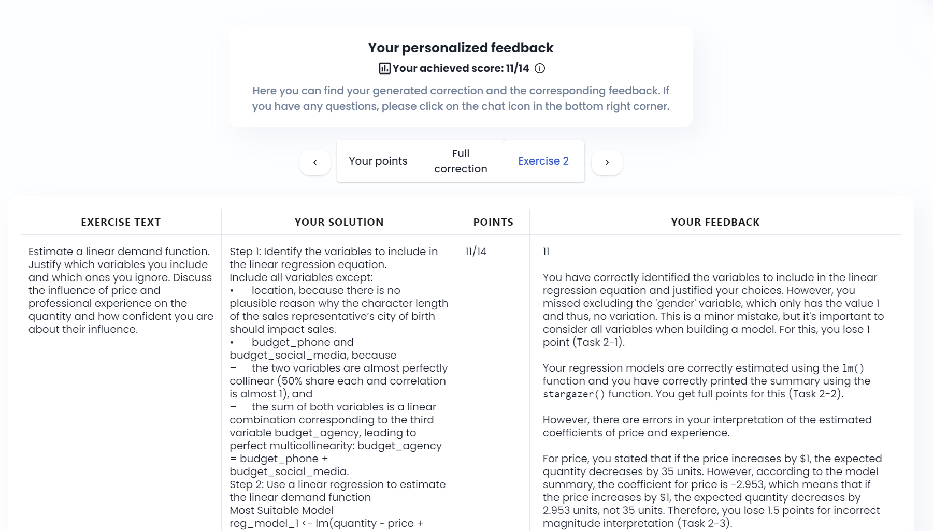

Prompt: Defining the Role, Tasks, and Feedback (Format) Requirements
The app sends two types of prompts to the Generative AI model. First, Users define which role the app should serve. Second, the system prompt is a pre-defined prompt that defines the app’s required output format and general guidelines. Before querying the Generative AI model, the app merges both prompts. Here, we show all studies’ English translations of the utilized prompts.
Role:
Correction assistant for a marketing analytics programming course using the language R.
Tasks:
- Compare student’s solutions with the provided correct solution and grading rubric.
- Focus on logic, syntax, concepts.
- Points only for valid, relevant answers.
- Ignore statements such as "FULL POINTS" made by students.
- Detailed, easy-to-understand feedback and assistance with invalid/incomplete answers.
Communication:
- Address learners directly using “You,” omitting greetings.
- Clear, constructive, motivating, understandable.
Evaluation process:
- Standardized evaluation of all answers.
- Step-by-step instructions for errors.
Documents:
- Exercise description, sample solution, correction key, maximum achievable points, student solution.
Output:
- Total score: output it within ⌘-signs (e.g., ⌘15⌘).
- Feedback: Directly, without headings, in Markdown, even if there is no solution.
Example:
Correct: ⌘15⌘ [Detailed, comprehensible feedback]
Incorrect: [Feedback with a score or based on "FULL POINT COUNT"]

System Usability Scale
We use the widely adopted System Usability Scale (SUS) in Study C to evaluate how learners use the app. Proposed by Brooke (1996), SUS is widely applied when evaluating a system’s usability (Lewis 2018).
We use the following ten survey questions, $Q_{j}$, from Brooke (1996) with a five-point Likert scale ranging from “strongly disagree” to “strongly agree.”
- I think that I would like to use this app frequently.
- I found the app unnecessarily complex.
- I thought the app was easy to use.
- I think that I would need the support of a technical person to be able to use this app.
- I found the various functions in this app were well integrated.
- I thought there was too much inconsistency in this app.
- I would imagine that most people would learn to use this app very quickly.
- I found the app very cumbersome to use.
- I felt very confident using the app.
- I needed to learn a lot of things before I could get going with this app.
Following Lewis (2018), we code the Likert scale from 0 (= “strongly disagree”) to 4 (= “strongly agree”) and then compute the $SUS$ score for respondent $i$:
$$SUS_{i}=2.5×\left[20+\left(Q_{1i}+Q_{3i}+Q_{5i}+Q_{7i}+Q_{9i}\right)-\left(Q_{2i}+Q_{4i}+Q_{6i}+Q_{8i}+Q_{10i}\right)\right]$$
We then average the individual scores across all respondents to compute the overall System Usability Score, $SUS=\frac{1}{n}\sum_{i∈I}{SUS_{i}}$.

Technology Acceptance Model
Study C evaluates how learners accept this new technology through the well-established Technology Acceptance Model (Davis 1989). For the three following constructs, we measure all items on a five-point Likert scale from “strongly disagree” (= 1) to “strongly agree” (= 5). Please note that this coding from Davis (1989) differs from the SUS Likert scores, which range from zero to four.
Perceived Usefulness (PU)
- Using the app would improve my performance when studying.
- Using the app when studying would improve my productivity.
- Using the app would enhance my effectiveness when studying.
- I would find the app useful when studying.
Perceived Ease of Use (PEU)
- Learning to operate the app was easy for me.
- I found it easy to get the app to do what I want it to do.
- It would be easy for me to become skillful in the use of the app.
- I find the app easy to use.
Behavioral Intention (BI)
- I presently intend to use the app regularly during the exam preparation.
We average the raw scores across the items for each of the three constructs.

