Gender attitudes and the new cultural divide in Europe
Supplementary material
Table of contents
A. Attitudinal variables 2
B. Factor Analysis Gender Items 3
C. Descriptive statistics 5
D. Model fit LPA Europe 8
E. Alternative LPA model Europe 9
F. Robustness checks of the LPA models 10
G. Mean attitudes LPA Europe 11
H. Alternative LPA models Western Europe 12
I. Alternative LPA models Central and Eastern Europe 13
J. Mean attitudes LPA Western and Central and Eastern Europe 14
K. Single country LPAs 15
L. Regression coefficients socio-structural analysis of single attitude dimensions 17
M. Regression coefficients socio-structural analysis of profile membership 20
References 22

A. Attitudinal variables
Table A1: Key attitudinal variables
Label | Question | Original scale
Immigration job | Immigrants take jobs away from [NATIONALITY] | Take jobs away (1) – Do not take jobs away (10)
Immigration crime | Immigrants make crime problems worse | Make it worse (1) – Do not make it worse (10)
EU enlarg | Some say that the European Union enlargement should go further. Others say it has already gone too far. Which number best describes your position? | Has gone too far (1) – Should go further (10)
EU confid | How much confidence do you have in the European Union?  (Relative to individuals’ mean on confidence in other political institutions) | None at all (0) – A great deal (6)
Gender private (index) | - When a mother works for pay, the children suffer  - A job is alright but what most women really want is a home and children  - All in all, family life suffers when the woman has a full-time job  - A man's job is to earn money; a woman's job is to look after the home and family | Agree strongly (1) – Disagree strongly (4)
Gender public (index) | - On the whole, men make better political leaders than women do  - A university education is more important for a boy than for a girl  - On the whole, men make better business executives than women do
Note: Scales are adjusted so that higher values mean more cosmopolitan/ gender egalitarian attitudes; EU confid is measured relative to other confidence items; Gender private index = Row means of all four gender private items; Gender public index = Row means of all three gender public items.

B. Factor Analysis Gender Items

Table B1: ML-confirmatory factor analysis of gender items with correlated factors
Variable | Factor | Standardized estimate | pvalue
When a mother works for pay, the children suffer | Private Gender | 0.73 | 0
A job is alright but what most women really want is a home and children | Private Gender | 0.73 | 0
All in all, family life suffers when the woman has a full-time job | Private Gender | 0.77 | 0
A man's job is to earn money; a woman's job is to look after the home and family | Private Gender | 0.76 | 0
On the whole, men make better political leaders than women do | Public Gender | 0.83 | 0
A university education is more important for a boy than for a girl | Public Gender | 0.70 | 0
On the whole, men make better business executives than women do | Public Gender | 0.84 | 0
Note: N: 30541; Cronbach’s alpha for both indices is 0.83.

Table B2: ML-exploratory factor analysis of gender items with oblique rotation
Variable | Factor 1 | Factor 2
When a mother works for pay, the children suffer | -0.02 | 0.79
A job is alright but what most women really want is a home and children | 0.18 | 0.57
All in all, family life suffers when the woman has a full-time job | -0.06 | 0.86
A man's job is to earn money; a woman's job is to look after the home and family | 0.37 | 0.47
On the whole, men make better political leaders than women do | 0.80 | 0.02
A university education is more important for a boy than for a girl | 0.67 | 0.07
On the whole, men make better business executives than women do | 0.88 | -0.05
Cronbach’s alpha | 0.83 | 0.83
Note: N: 30541; principal axis (PA) method yields similar results.

C. Descriptive statistics
Table C1 Descriptive statistics
 | Mean |  | Std. Dev. |  | Minimum | Maximum
Gender private | 2.78 |  | 0.72 |  | 1.00 | 4.00
Gender public | 3.21 |  | 0.68 |  | 1.00 | 4.00
Immigration job | 5.85 |  | 2.97 |  | 1.00 | 10.00
Immigration crime | 4.42 |  | 2.76 |  | 1.00 | 10.00
EU enlarg | 4.83 |  | 2.83 |  | 1.00 | 10.00
EU confid | 2.96 |  | 0.69 |  | 0.18 | 5.94
Income | 5.25 |  | 2.82 |  | 1.00 | 10.00
Age | 51.52 |  | 17.79 |  | 18.00 | 82.00
 | N |  |  | %
Oesch class scheme
[1] Self-employed professionals and large employers | 708 |  |  | 2.3
[2] Small business owners | 2117 |  |  | 6.9
[3] Technical (semi-)professionals | 2243 |  |  | 7.3
[4] Production workers | 7437 |  |  | 24.1
[5] (Associate) managers | 4387 |  |  | 14.2
[6] Clerks | 2885 |  |  | 9.4
[7] Socio-cultural (semi-)professionals | 4725 |  |  | 15.3
[8] Service workers | 6329 |  |  | 20.5
Non-employment
[0] Employed | 18197 |  |  | 52.5
[1] Non-employed | 16487 |  |  | 47.5
Education
[1] Lower educated | 8160 |  |  | 23.6
[2] Medium educated | 15635 |  |  | 45.2
[3] Higher educated | 10810 |  |  | 31.2
Marital Status
[1] Married | 18328 |  |  | 52.9
[2] Separated | 7752 |  |  | 22.4
[3] Not married | 8559 |  |  | 24.7
Children
[0] No child | 9599 |  |  | 27.7
[1] Child(ren) | 25034 |  |  | 72.3
Party appeal
[1] Left | 9058 |  |  | 26.2
[2] Centre | 6881 |  |  | 19.9
[3] Right | 8844 |  |  | 25.6
[4] No appeal | 9773 |  |  | 28.3
Country
Austria | 1644 |  |  | 4.7
Bulgaria | 1556 |  |  | 4.5
Croatia | 1487 |  |  | 4.3
Czechia | 1809 |  |  | 5.2
Denmark | 3361 |  |  | 9.6
Estonia | 1304 |  |  | 3.7
Finland | 1198 |  |  | 3.4
France | 1870 |  |  | 5.4
Germany | 2166 |  |  | 6.2
Hungary | 1513 |  |  | 4.3
Italy | 2277 |  |  | 6.5
Lithuania | 1448 |  |  | 4.1
Netherlands | 2400 |  |  | 6.9
Poland | 1352 |  |  | 3.9
Portugal | 1215 |  |  | 3.5
Romania | 1611 |  |  | 4.6
Slovakia | 1432 |  |  | 4.1
Slovenia | 1075 |  |  | 3.1
Spain | 1209 |  |  | 3.5
Sweden | 1193 |  |  | 3.4
Great Britain | 1788 |  |  | 5.1
Note: EVS 2017; N: 34908 Occupational Class (Oesch 2006; excluding respondents who never had a paid job) = #1 Self-employed professionals and large employers, #2 Technical (semi-)professionals, #3 (Associate) managers, #4 Socio-cultural (semi-)professionals, #5 Small business owners, #6 Production workers, #7 Clerks, #8 Service workers; Employment = Employed (Paid Employment > 30 hours a week, > 30 hours a week and self-employed), Non-Employed (Military Service, Retired/ pensioned, homemaker not otherwise employed, student, unemployed and disabled); Education = Lower educated (not completed ISCED 1 - short vocational ISCED3), medium educated (general ISCED3 without access to tertiary education - vocational ISCED4 with access to university), and higher educated (university qualification below bachelor’s degree - doctoral degree); Income = respondents’ self-reported household income in deciles; Age is the respondents’ real age; Marital Status = Married (married and registered partnership), Separated (separated, widowed, and divorced), and Not Married (never married and never registered partnership); Child(ren) = Having one child or more (irrespective of their age and whether or not they live in the respondents’ household); Party Appeal = recoded 10 point scale of national political parties into left (1-4), centre (5&6), right (7-10), and no appeal (no answer, do not know, and no party appeal).

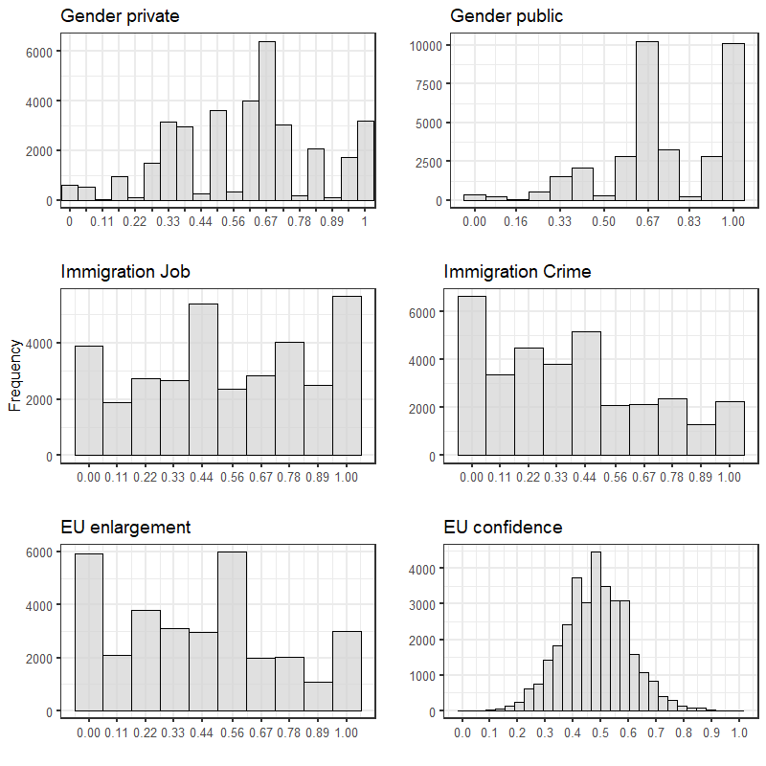
Figure C2 Histograms of attitude items
Note: EVS 2017; standardized on 0-1 scale.

D. Model fit LPA Europe
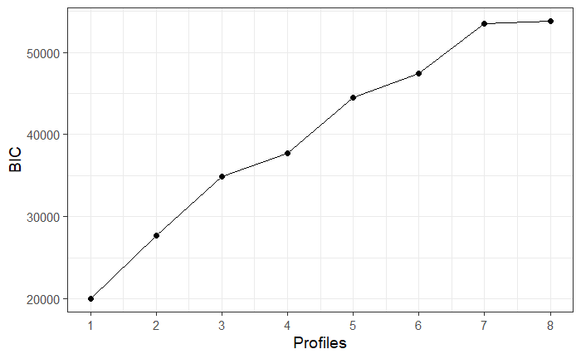
Figure D1 BIC plot of LPA models with 1-8 profiles

Table D2: Latent profile model fit statistics
Profiles | BIC | aBIC | AIC | LL | Entropy
1 | -20,052.24 | -20,099.91 | -20,179.15 | 10,104.57
2 | -27,687.20 | -27,757.12 | -27,873.33 | 13,958.67 | 0.718
3 | -34,889.15 | -34,981.31 | -35,134.51 | 17,596.25 | 0.932
4 | -37,709.50 | -37,823.91 | -38,014.08 | 19,043.04 | 0.874
5 | -44,478.91 | -44,615.57 | -44,842.71 | 22,464.36 | 0.906
6 | -47,440.17 | -47,599.07 | -47,863.19 | 23,981.60 | 0.914
7 | -53,467.15 | -53,648.29 | -53,949.39 | 27,031.70 | 0.94
8 | -53,769.63 | -53,973.02 | -54,311.10 | 27,219.55 | 0.867
Notes: EVS 2017; N=34908; weighted by population size

E. Alternative LPA model Europe
The seven-profile model below (see Figure E1) has a similar structure as the three-profile model showing primarily divides over gender attitudes, small divides over immigration attitudes and almost no divides over EU attitudes. None of the additional profiles reveal substantively new combinations of attitudes. Instead, they mainly provide more fine-grained distinctions of the three-profile structure. Perhaps the sixth profile is somewhat interesting as it combines ambivalent gender attitudes in the private realm with egalitarian attitudes in the public realm, but this within-issue cross-cuttingness is not the primary interest of this study. Furthermore, as most other additional profiles, it represents a relatively small group of less than 7 percent of the population. We, therefore, decide to use the three-profile solution for the main analysis.

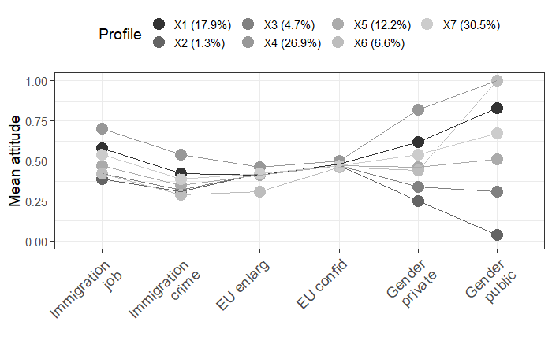
Figure E1 Latent profiles of political attitudes in Europe, 7-profile solution

F. Robustness checks of the LPA models
We conducted four different robustness tests.
First, we ran a basic LPA model without specifying any covariance between the indicators (see Figure F1), which did not change the LPA outcome.
Second, we tested the LPA model with every combination of the six immigration items with more than two values provided in the EVS: “When jobs are scarce, employers should give priority to [NATIONALITY] people over immigrants” (v80); “How would you evaluate the impact of these people [immigrants] on the development of [your country]?” (v184); “Immigrants take jobs away from [NATIONALITY]” (v185); “Immigrants make crime problems worse” (v186); “Immigrants are a strain on a country’s welfare system” (v187); “It is better if immigrants maintain their distinct customs and traditions” (v188). The item “Could you identify any that you would not like to have as neighbours? Immigrants/foreign workers” (v24) is dichotomous and was left out. This left us with 15 combinations of immigration items for which we ran separate latent profile analyses. They all yielded substantially similar results.
Third, we estimated the LPA model with the original EU confidence item instead of the construct that adjusts for individuals’ average institutional confidence. This did also not change the results substantively. Fourth, we adopted the procedure to detect the presence of direct effects suggested by Kankaras, Moors, and Vermunt (2010) to test for country differences in item responses. We estimated the three-profile LPA with country dummies regressed on each attitude indicator to explore whether there are country-specific influences on the indicators that the latent profile model cannot explain. Adding the country dummies to the model might adjust for the bias as we allow for variation in the intercepts of the indicators across those countries (ibid., p. 411). To keep our LPA model as parsimonious as possible, we only included the three country dummies per indicator which yielded the highest standardized coefficients (I_job on DE DK FI; I_crime on GB ES FR; EU_enl on BG RO PL; EU_conf on BG LI ES; G_ipriv on DK ES NE; G_ipubl on PT GB FI). This adjustment did not affect the structure and size of the three-profile model solution. We therefore stayed with the original model, which is presented in Figure 1 in the paper.
For the Western European LPA model, we also tested for measurement invariance. Again, adding the three direct country effects with the highest standardized coefficients per indicator to the model (I_job on DE DK FI; I_crime on GB ES FR; EU_enl on PT DK GB; EU_conf on ES PT IT; G_ipriv on DK ES NE; G_ipubl on PT GB FI) did not change the results. Again, we decided to stick to the original model, presented in Figure 2 in the paper.
We also tested the Central and Eastern European LPA model for measurement invariance. Adding direct country effects to the model (I_job on BG HR ET; I_crime on SL RO HR; EU_enl on BG RO HU; EU_conf on BG LI SK; G_ipriv on ET SK SL; G_ipubl on HR SL RO) leads to small changes in the structure, but not in the size of the profiles. Comparing the model fit statistics reveals that the modified model has a better fit than the basic model. We thus continued with the modified model, displayed in Figure 3 in the paper.

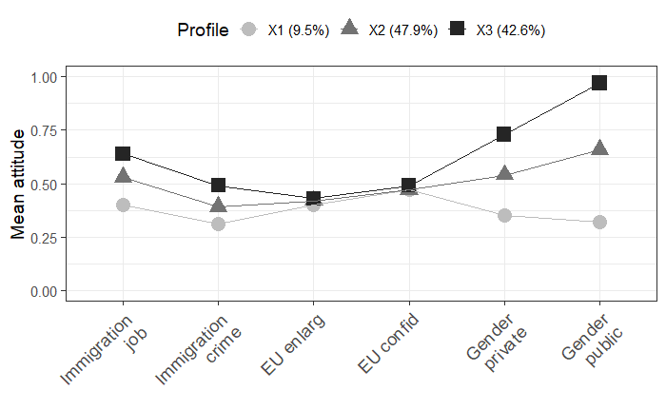
Figure F1 Latent profiles of political attitudes in Europe, 3-profile solution without covariance specification

G. Mean attitudes LPA Europe
Table G1: Mean attitude values per profile across all European countries
Attitudes | Centrist Gender Egalitarian |  | Centrist Gender Ambivalent |  | Centrist Gender Traditionalist
Immigration job | 0.64^{a,c} | (0.004) | 0.53^{a,b} | (0.004) | 0.42^{b,c} | (0.008)
Immigration crime | 0.48^{a,c} | (0.004) | 0.39^{a,b} | (0.003) | 0.32^{b,c} | (0.007)
EU enlarg | 0.43^{c*} | (0.004) | 0.42 | (0.004) | 0.40^{c*} | (0.008)
EU confid | 0.49^{a,c**} | (0.002) | 0.47ª | (0.001) | 0.47^{c**} | (0.003)
Gender private | 0.72^{a,c} | (0.003) | 0.54^{a,b} | (0.002) | 0.37^{b,c} | (0.005)
Gender public | 0.97^{a,c} | (0.001) | 0.67^{a,b} | (0.001) | 0.33^{b,c} | (0.004)
Note: EVS2017; N=34908; weighted by population size; scale range 0-1; robust standard errors in brackets; a=significant mean difference between Centrist Gender Egalitarian and Centrist Gender Ambivalent profiles at p<0.001; b=significant mean difference between Centrist Gender Ambivalent and Centrist Gender Traditionalist profiles at p<0.001; c=significant mean difference between Centrist Gender Traditionalist and Centrist Gender Egalitarian profiles at p<0.001; significant mean difference at **p<0.01; significant mean difference at *p<0.05.

H. Alternative LPA models Western Europe
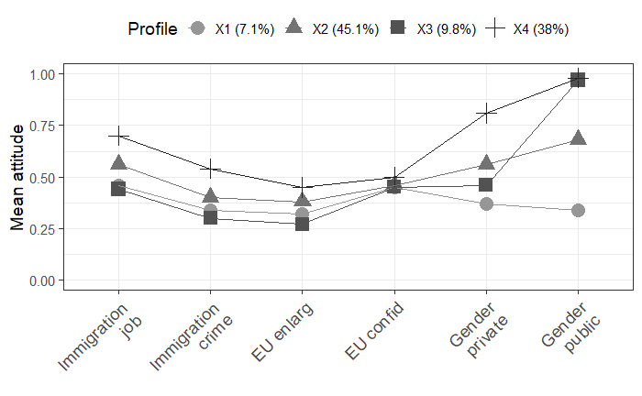
Figure H1 Latent profiles of political attitudes in Western Europe, 4-profile solution

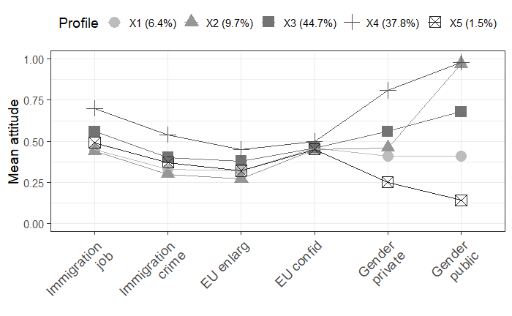
Figure H2 Latent profiles of political attitudes in Western Europe, 5-profile solution

I. Alternative LPA models Central and Eastern Europe
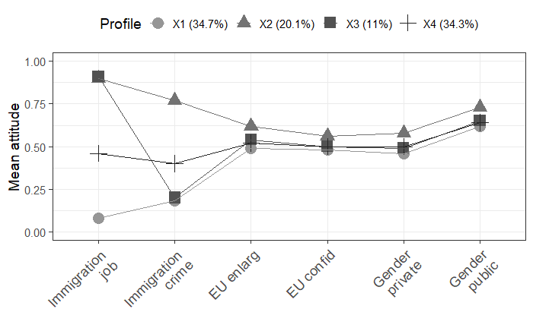
Figure I1 Latent profiles of political attitudes in Central and Eastern Europe, 4-profile solution

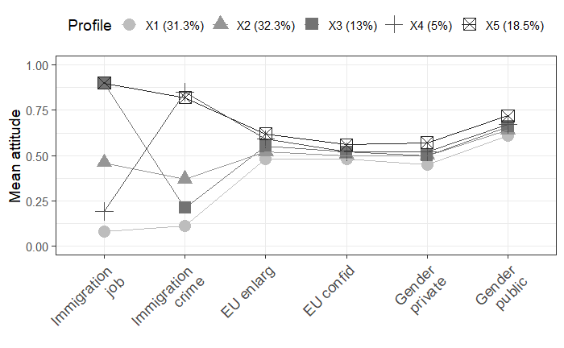
Figure I2 Latent profiles of political attitudes in Central and Eastern Europe, 5-profile solution

J. Mean attitudes LPA Western and Central and Eastern Europe
Table J1: Mean attitude values per profile across Western European countries
Attitudes | Centrist Gender Egalitarian |  | Centrist Gender Ambivalent |  | Centrist Gender Traditionalist
Immigration job | 0.65^{a,c} | (0.004) | 0.56^{a,b} | (0.004) | 0.46^{b,c} | (0.011)
Immigration crime | 0.49^{a,c} | (0.004) | 0.40^{a,b} | (0.004) | 0.34^{b,c} | (0.011)
EU enlarg | 0.41^{a,c} | (0.004) | 0.38^{a,b} | (0.004) | 0.32^{b,c} | (0.01)
EU confid | 0.49^{a,c} | (0.002) | 0.46^{a,b*} | (0.002) | 0.45^{b*,c} | (0.004)
Gender private | 0.74^{a,c} | (0.003) | 0.55^{a,b} | (0.003) | 0.37^{b,c} | (0.007)
Gender public | 0.98^{a,c} | (0.001) | 0.68^{a,b} | (0.001) | 0.34^{b,c} | (0.005)
Note: EVS 2018; N: 20321; weighted by population size; scale range 0-1; robust standard errors in brackets; a=significant mean difference between Centrist Gender Egalitarian and Centrist Gender Ambivalent profiles at p<0.001; b=significant mean difference between Centrist Gender Ambivalent and Centrist Gender Traditionalist profiles at p<0.001; c=significant mean difference between Centrist Gender Traditionalist and Centrist Gender Egalitarian profiles at p<0.001; * signals significant mean difference at p<0.05.

Table J2: Mean attitude values per profile across Central and Eastern European countries
Attitudes | Cosmopolitan Gender Ambivalent |  | Centrist Gender Ambivalent |  | Communitarian Gender Ambivalent
Immigration job | 0.90^{a,c} | (0.004) | 0.45^{a,b} | (0.004) | 0.07^{b,c} | (0.002)
Immigration crime | 0.54^{a,c} | (0.009) | 0.37^{a,b} | (0.006) | 0.16^{b,c} | (0.006)
EU enlarg | 0.54^{a,c} | (0.009) | 0.48^{a,b} | (0.008) | 0.44^{b,c} | (0.009)
EU confid | 0.53^{a,c} | (0.004) | 0.50^{a,b} | (0.003) | 0.48^{b,c} | (0.003)
Gender private | 0.54^{a,c} | (0.006) | 0.50^{a,b} | (0.005) | 0.46^{b,c} | (0.005)
Gender public | 0.69^{a,c} | (0.005) | 0.64^{a,b} | (0.005) | 0.62^{b,c} | (0.005)
Note: EVS 2018; N: 14587; weighted by population size; scale range 0-1; robust standard errors in brackets; a=significant mean difference between Cosmopolitan Gender Ambivalent and Centrist Gender Ambivalent profiles at p<0.001; b=significant mean difference between Centrist Gender Ambivalent and Communitarian Gender Ambivalent profiles at p<0.001; c=significant mean difference between Communitarian Gender Ambivalent and Cosmopolitan Gender Ambivalent profiles at p<0.001.

K. Single country LPAs
Figure K1 Latent profiles of political attitudes in the single Western European countries, 3-profile solution

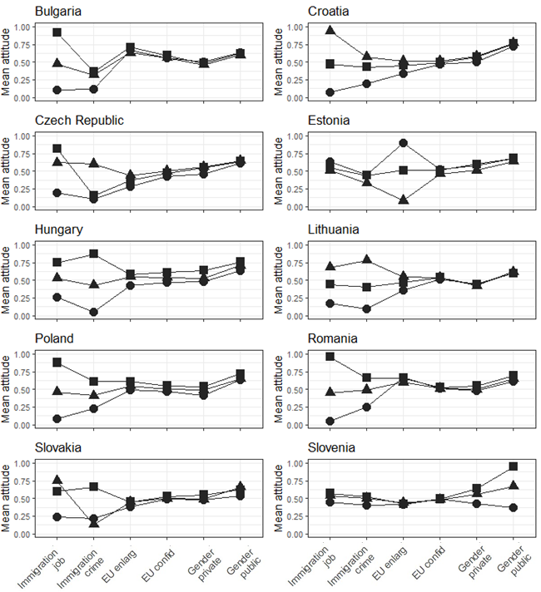
Figure K2 Latent profiles of political attitudes in the single Central and Eastern European countries, 3-profile solution

L. Regression coefficients socio-structural analysis of single attitude dimensions
Table L1: OLS Regression of socio-structural characteristics on cultural attitudes
 | Gender attitudes (WE) | Immigration attitudes (WE) | EU attitudes (WE) | Gender attitudes (CEE) | Immigration attitudes (CEE) | EU attitudes (CEE)
 | (1) | (2) | (3) | (4) | (5) | (6)
CLASS (Ref. Socio-cult. professionals)
Self-empl.+large employers | 0.026 | 0.036 | -0.032*** | -0.003 | 0.014 | -0.031
 | (0.024) | (0.022) | (0.007) | (0.005) | (0.038) | (0.019)
Small business owners | 0.040*** | 0.063*** | 0.0003 | 0.030** | 0.043* | 0.022***
 | (0.010) | (0.007) | (0.010) | (0.010) | (0.018) | (0.006)
Technical (semi-)professionals | 0.007 | 0.035*** | -0.003 | 0.016*** | 0.044** | 0.024**
 | (0.005) | (0.007) | (0.015) | (0.003) | (0.015) | (0.009)
Production workers | 0.056*** | 0.098*** | 0.006 | 0.047*** | 0.074*** | 0.027**
 | (0.007) | (0.004) | (0.012) | (0.008) | (0.011) | (0.009)
(Associate) managers | -0.006 | 0.019 | 0.002 | -0.006 | 0.018*** | 0.002
 | (0.004) | (0.014) | (0.009) | (0.010) | (0.005) | (0.007)
Clerks | 0.022*** | 0.049*** | -0.007 | 0.012 | 0.026** | 0.025***
 | (0.006) | (0.006) | (0.007) | (0.008) | (0.010) | (0.007)
Service workers | 0.037*** | 0.078*** | 0.009 | 0.027*** | 0.045*** | 0.026***
 | (0.007) | (0.008) | (0.006) | (0.004) | (0.013) | (0.005)
EMPLOYMENT STATUS (Ref. Employed)
Non-Employed | 0.022** | 0.003 | -0.003 | 0.018*** | -0.010 | -0.011***
 | (0.008) | (0.018) | (0.009) | (0.005) | (0.009) | (0.003)
EDUCATION (Ref. Higher)
Lower Educated | 0.069*** | 0.089*** | 0.030*** | 0.077*** | 0.092*** | 0.016**
 | (0.016) | (0.012) | (0.006) | (0.005) | (0.021) | (0.005)
Medium Educated | 0.027*** | 0.061*** | 0.031*** | 0.039*** | 0.043*** | 0.016***
 | (0.007) | (0.015) | (0.003) | (0.005) | (0.007) | (0.004)
INCOME | -0.006*** | -0.004 | -0.001 | -0.006*** | -0.008*** | -0.001
 | (0.001) | (0.003) | (0.001) | (0.001) | (0.002) | (0.001)
AGE | 0.001*** | 0.001 | 0.001*** | 0.001*** | 0.0003 | 0.001*
 | (0.0001) | (0.001) | (0.0001) | (0.0003) | (0.001) | (0.0004)
GENDER (Ref. Female)
Male | 0.044*** | 0.008 | 0.002 | 0.059*** | 0.013 | 0.001
 | (0.013) | (0.005) | (0.004) | (0.009) | (0.007) | (0.004)
MARITAL STATUS (Ref. Not married)
Married | 0.009 | -0.005 | 0.003 | 0.017** | 0.008 | 0.015*
 | (0.007) | (0.013) | (0.010) | (0.006) | (0.021) | (0.006)
Separated | 0.008 | -0.0001 | -0.006 | 0.013** | 0.025 | 0.019***
 | (0.005) | (0.023) | (0.014) | (0.005) | (0.021) | (0.005)
CHILDREN (Ref. No child)
Child(ren) | 0.009 | 0.019 | 0.004 | 0.001 | 0.001 | -0.001
 | (0.007) | (0.024) | (0.012) | (0.002) | (0.012) | (0.006)
PARTY APPEAL (Ref. Left)
Centre | 0.019 | 0.035** | 0.033*** | 0.051*** | 0.070*** | 0.024
 | (0.011) | (0.011) | (0.010) | (0.012) | (0.015) | (0.012)
Right | 0.047*** | 0.151*** | 0.085*** | 0.070*** | 0.177*** | 0.101***
 | (0.011) | (0.038) | (0.016) | (0.016) | (0.023) | (0.019)
No Appeal | 0.014 | 0.056 | 0.030* | 0.040** | 0.103*** | 0.058***
 | (0.007) | (0.030) | (0.012) | (0.015) | (0.017) | (0.008)
Observations | 11,109 | 11,010 | 10,911 | 13,951 | 13,856 | 13,807
R² | 0.273 | 0.178 | 0.117 | 0.271 | 0.162 | 0.129
Adjusted R² | 0.271 | 0.176 | 0.115 | 0.269 | 0.161 | 0.127
Note: EVS 2017; *p<0.05**p<0.01***p<0.001; clustered robust standard errors; dependent variables scale: 0-1, indices based on rowmeans, higher values=more traditional/communitarian, lower values=more egalitarian/cosmopolitan; control variable: country dummies.

M. Regression coefficients socio-structural analysis of profile membership

Table M1 Multinomial logistic regression of profile membership on socio-structural characteristics and party identification for Western Europe
Ref. Profile: Centrist Gender Egalitarian
 | Centrist Gender Ambivalent |  | Centrist Gender Traditional
CLASS (Ref. Socio-cult. prof.)
Self-empl.+large employers | -0.075 | (0.156) | 0.676* | (0.309)
Small business owners | 0.148 | (0.113) | 0.692** | (0.234)
Technical (semi-)professionals | 0.075 | (0.106) | 0.323 | (0.253)
Production workers | 0.409*** | (0.095) | 1.079*** | ( 0.21)
(Associate) managers | 0.045 | (0.088) | 0.139 | (0.229)
Clerks | 0.211* | ( 0.1) | 0.303 | (0.241)
Service workers | 0.207* | (0.089) | 0.578** | (0.214)
EMPLOYMENT STATUS (Ref. Employed)
Non-employed | 0.107 | (0.062) | 0.141 | (0.118)
EDUCATION (Ref. Higher)
Lower | 0.495*** | (0.079) | 0.71*** | (0.154)
Medium | 0.331*** | (0.064) | 0.163 | ( 0.14)
INCOME | -0.044*** | (0.011) | -0.104*** | (0.023)
AGE | 0.01*** | (0.002) | 0.015*** | (0.004)
GENDER (Ref. Female)
Men | 0.734*** | (0.054) | 1.095*** | (0.111)
MARITAL STATUS (Ref. Not married)
Married | 0.014 | (0.079) | 0.115 | (0.159)
Separated | -0.005 | (0.089) | 0.25 | (0.168)
CHILDREN (Ref. No child)
Child(ren) | 0.102 | (0.069) | -0.254 | (0.132)
PARTY APPEAL (Ref. Left)
Center | 0.419*** | (0.073) | 0.658*** | (0.148)
Right | 0.558*** | (0.067) | 0.915*** | (0.133)
No appeal | 0.185** | ( 0.07) | 0.428** | (0.138)
COUNTRY (Ref. DE)
AU | 0.793*** | (0.109) | 1.83*** | (0.259)
DK | 0.854*** | (0.093) | 1.092*** | (0.253)
FI | 1.376*** | (0.109) | 1.498*** | ( 0.28)
FR | 0.504*** | (0.103) | 0.696** | (0.267)
DE | 1.268*** | (0.102) | 1.353*** | (0.272)
IT | 1.483*** | (0.109) | 2.192*** | (0.258)
NE | 1.566*** | (0.098) | 1.69*** | (0.257)
ES | 0.536*** | (0.123) | 0.834** | (0.293)
GB | 1.76*** | (0.104) | 1.677*** | (0.268)
Intercept | -2.645*** | (0.157) | -5.557*** | (0.377)
Note: EVS 2017; Standard errors in parentheses; *p<0.05, **p<0.01, ***p<0.001; AIC: 23513; N: 14593

Table M2 Multinomial logistic regression of profile membership on socio-structural characteristics and party identification for Central and Eastern Europe
Ref. Profile: Cosmopolitan Gender Ambivalent
 | Centrist Gender Ambivalent |  | Communitarian Gender Ambivalent
CLASS (Ref. Socio-cult. prof.)
Self-empl.+large employers | -0.393 | ( 0.38) | -0.435 | (0.379)
Small business owners | -0.43 | (0.227) | 0.277 | ( 0.22)
Technical (semi-)professionals | -0.117 | (0.207) | 0.327 | (0.202)
Production workers | 0.103 | (0.164) | 0.58*** | (0.166)
(Associate) managers | -0.191 | (0.162) | -0.046 | (0.172)
Clerks | -0.238 | (0.192) | 0.195 | (0.194)
Service workers | -0.089 | (0.164) | 0.464** | (0.168)
EMPLOYMENT STATUS (Ref. Employed)
Non-employed | -0.247* | (0.116) | -0.166 | (0.109)
EDUCATION (Ref. Higher)
Lower | 0.447** | ( 0.17) | 1.016*** | (0.164)
Medium | 0.16 | (0.117) | 0.37** | ( 0.12)
INCOME | -0.068** | ( 0.02) | -0.099*** | (0.019)
AGE | -0.019*** | (0.004) | -0.012** | (0.004)
GENDER (Ref. Female)
Men | -0.144 | (0.099) | -0.065 | (0.094)
MARITAL STATUS (Ref. Not married)
Married | 0.303 | (0.161) | 0.232 | (0.169)
Separated | 0.464* | (0.184) | 0.403* | (0.184)
CHILDREN (Ref. No child)
Child(ren) | -0.06 | (0.141) | 0.028 | (0.144)
PARTY APPEAL (Ref. Left)
Center | -0.032 | (0.139) | 0.107 | (0.124)
Right | 0.283* | (0.142) | 0.638*** | (0.128)
No appeal | 0.215 | (0.132) | 0.109 | (0.121)
COUNTRY (Ref. DE)
BG | -0.017 | (0.134) | 0.778*** | (0.128)
HR | -0.307* | ( 0.13) | -0.047 | (0.135)
CZ | 0.637*** | (0.136) | 1.304*** | (0.134)
ET | 0.349** | (0.126) | 0.038 | (0.138)
HU | 0.341* | (0.134) | 1.164*** | (0.129)
LI | 1.107*** | (0.139) | 1.267*** | (0.144)
RO | -0.078 | (0.141) | 0.677*** | (0.135)
SK | 1.452*** | (0.165) | 1.779*** | (0.165)
SL | 0.372** | (0.135) | 0.179 | (0.148)
Intercept | 0.919** | (0.278) | -0.553 | (0.285)
Note: EVS 2017; Standard errors in parentheses; *p<0.05, **p<0.01, ***p<0.001; AIC: 21685; N: 10495

References
Kankaras M., Moors G., Vermunt J.K. (2010). Testing for measurement invariance with latent class analysis. In Davidov E., Schmidt P., Billiet J., Meuleman B. (Eds.), Cross-cultural analysis. Methods and applications. New York: Routledge, pp. 359-384.
Oesch D. (2006). Coming to Grips with a Changing Class Structure: An Analysis of Employment Stratification in Britain, Germany, Sweden and Switzerland. International Sociology, 21, 263–288.

