S2 Fig: Forest plots of the HR of MI in group A (asymptomatic individuals with three or more CVD risk factors) with 95% CIs

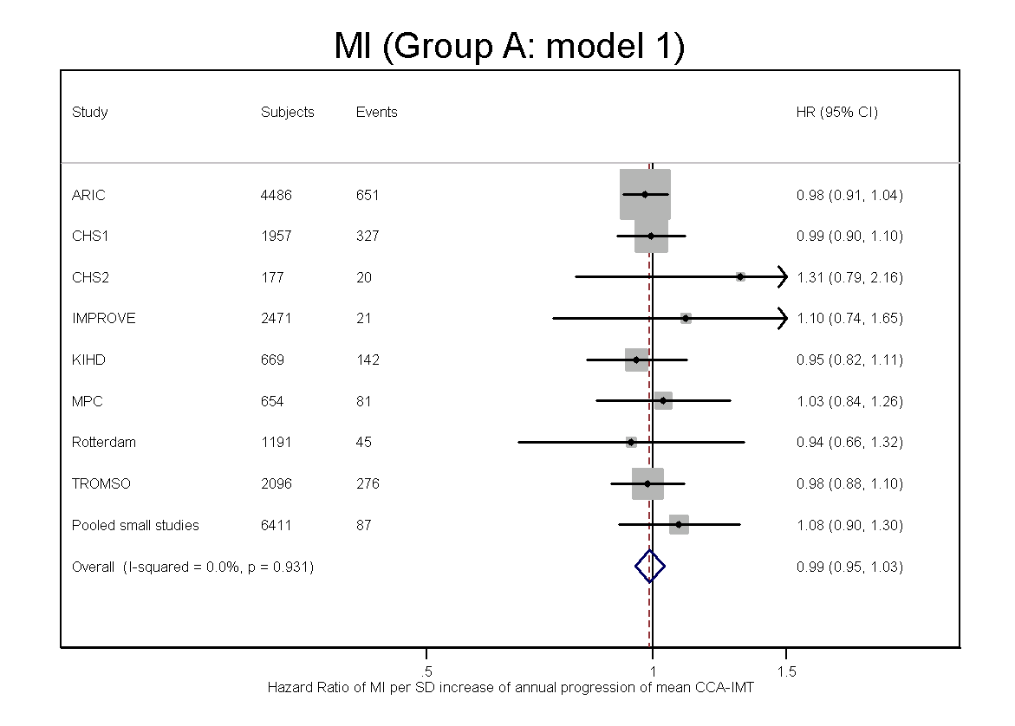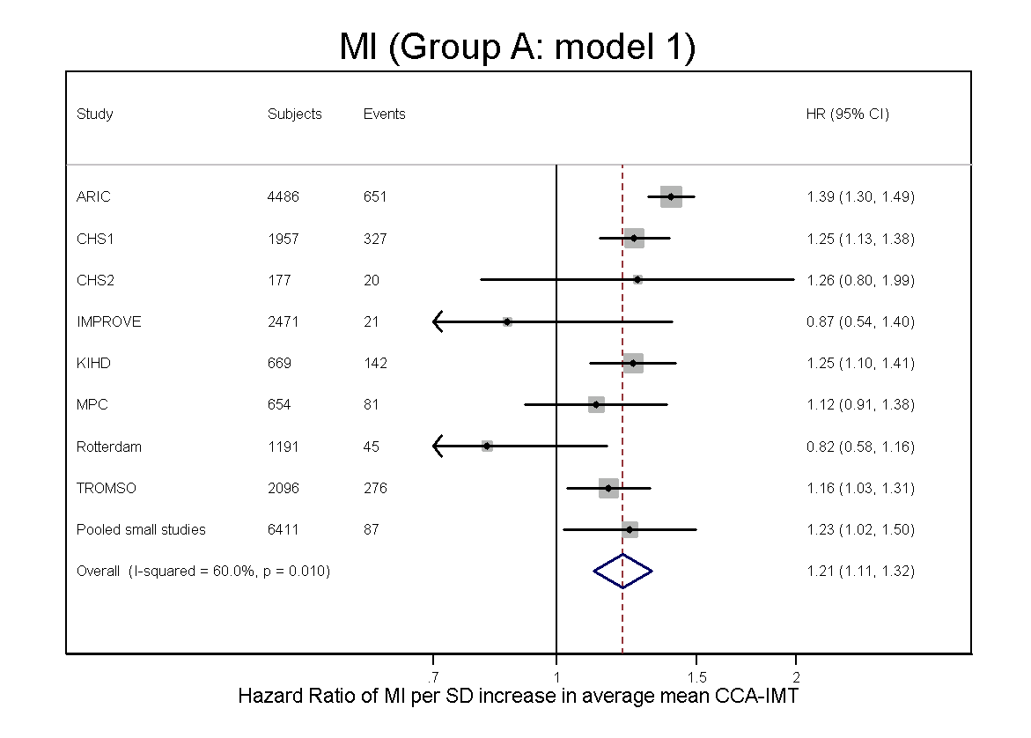
Left panel: HR for MI per one SD of annual mean CCA-IMT change, adjusted for age, sex and average mean CCA-IMT (model 1)
Right panel: HR for MI per one SD of average mean CCA-IMT, adjusted for age, sex and annual mean CCA-IMT change (model 1)

