Multimedia Appendix 4. Bland-Altman analysis of protein, fat, carbohydrate, sugar, and fiber intake.
Protein
The mean difference of protein intake was not normally distributed. Therefore, natural log transformation was performed, as recommended by Bland and Altman (1986) [1]. The antilogs of the limits were taken and multiplied by 100 to allow interpretation of the ln-transformed data as percentages (100%=ideal agreement).
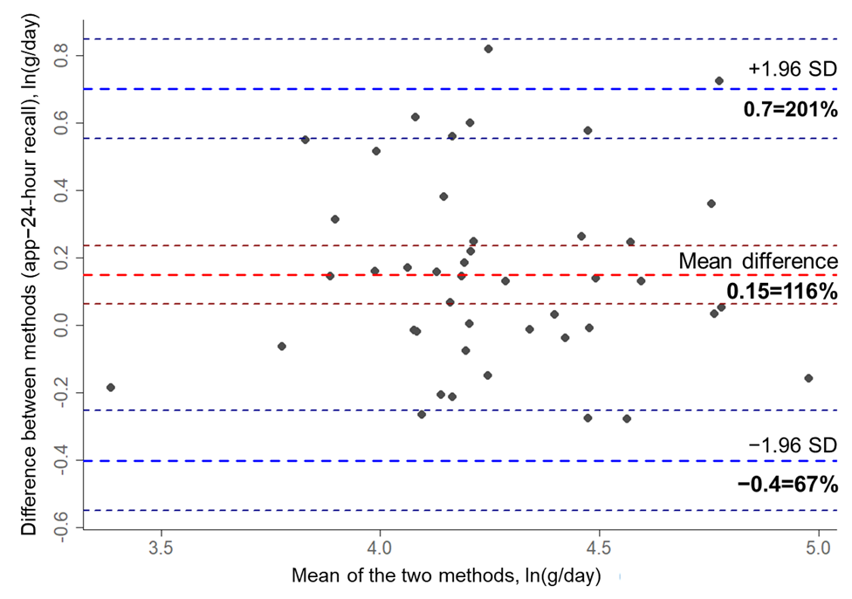
Figure 1. Bland-Altman plot assessing agreement between habitual protein intake in g per day captured by the APPetite-food record and the 24-hour recall (red line: mean difference=app –24-hour recall; dark red lines: 95% CI of mean difference; blue lines: lower and upper limits of agreement; dark blue lines: 95% CI of lower and upper limits of agreement).

Mean difference: 0.15=116% (95% CI 0.06 to 0.24=106.6% to 126.5%)
Lower limits of agreement: –0.4=67% (95% CI –0.55 to –0.25=57.7% to 77.6%)
Upper limits of agreement: 0.7=201% (95% CI 0.55 to 0.85=137.8% to 233.7%)

The limits of agreement transcended the predefined acceptable limits of agreement of 10% considerably.
Fat
The mean difference of fat intake was not normally distributed. The same procedure as described for protein intake was used.
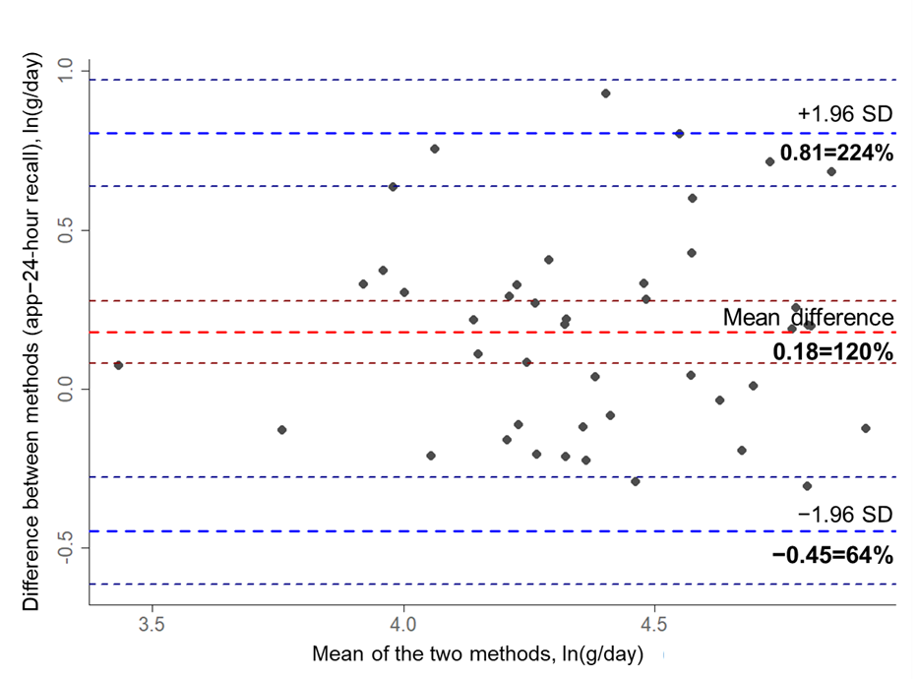
Figure 2. Bland-Altman plot assessing agreement between habitual fat intake in g per day captured by the APPetite-food record and the 24-hour recall (red line: mean difference=app–24-hour recall; dark red lines: 95% CI of mean difference; blue lines: lower and upper limits of agreement; dark blue lines: 95% CI of lower and upper limits of agreement).

Mean difference: 0.18=120% (95% CI 0.08 to 0.28=108.6% to 131.8%)
Lower limits of agreement: –0.45=64% (95% CI –0.61 to –0.28=54.1% to 75.7%)
Upper limits of agreement: 0.81=224% (95% CI 0.64 to 0.97=189% to 264.5%)

The limits of agreement exceeded the predefined acceptable limits of agreement of 10% substantially.

Carbohydrates
The mean difference of carbohydrates intake was normally distributed.
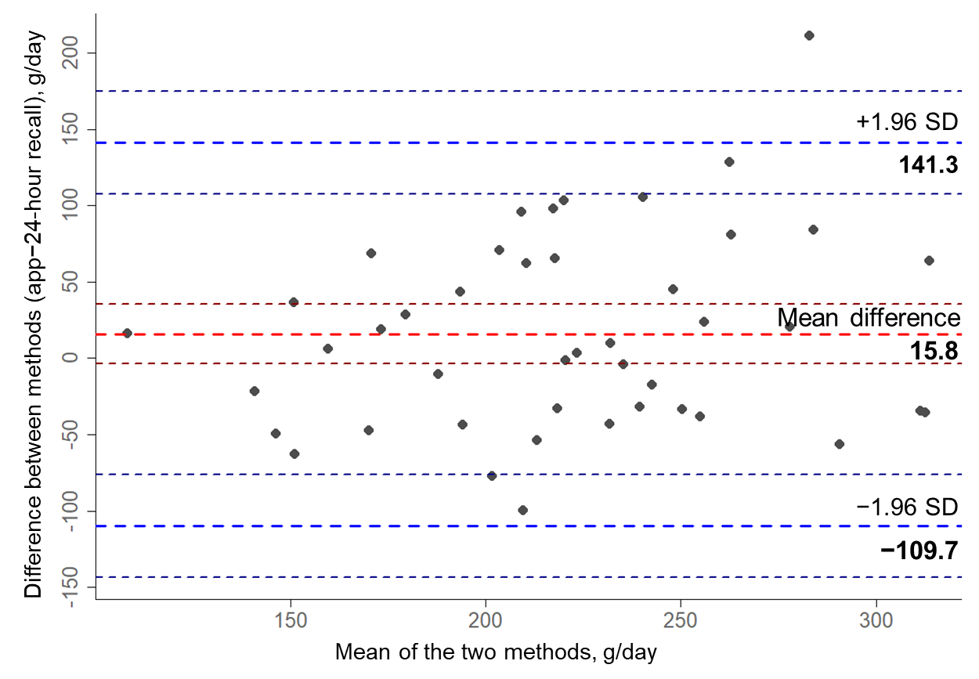
Figure 3. Bland-Altman plot assessing agreement between habitual carbohydrate intake in g per day captured by the APPetite-food record and the 24-hour recall (red line: mean difference=app–24-hour recall; dark red lines: 95% CI of mean difference; blue lines: lower and upper limits of agreement; dark blue lines: 95% CI of lower and upper limits of agreement).

Mean difference: 15.8 (95% CI –3.7 to 35.3)
Lower limits of agreement: –109.7 (95% CI –143.4 to –75.97)
Upper limits of agreement: 141.3 (95% CI 107.6 to 175.1)

The pre-established acceptable limits of agreement were 22.1 g, which were exceeded considerably.

Sugar
Normal distribution of the differences of sugar intake was given.
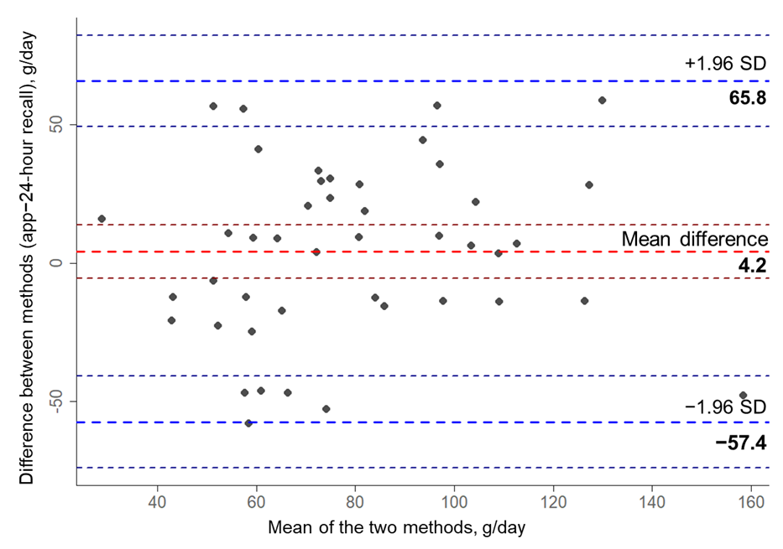
Figure 4. Bland-Altman plot assessing agreement between habitual sugar intake in g per day captured by the APPetite-food record and the 24-hour recall (red line: mean difference=app–24-hour recall; dark red lines: 95% CI of mean difference; blue lines: lower and upper limits of agreement; dark blue lines: 95% CI of lower and upper limits of agreement).

Mean difference: 4.2 (95% CI –5.3 to 13.8)
Lower limits of agreement: –57.4 (95% CI –73.9 to –40.8)
Upper limits of agreement: 65.8 (95% CI 49.3 to 82.4)

Disagreement of 7.9 g was predefined as acceptable, but was transcended substantially.

Fiber
The difference of fiber intake between the two methods was normally distributed.
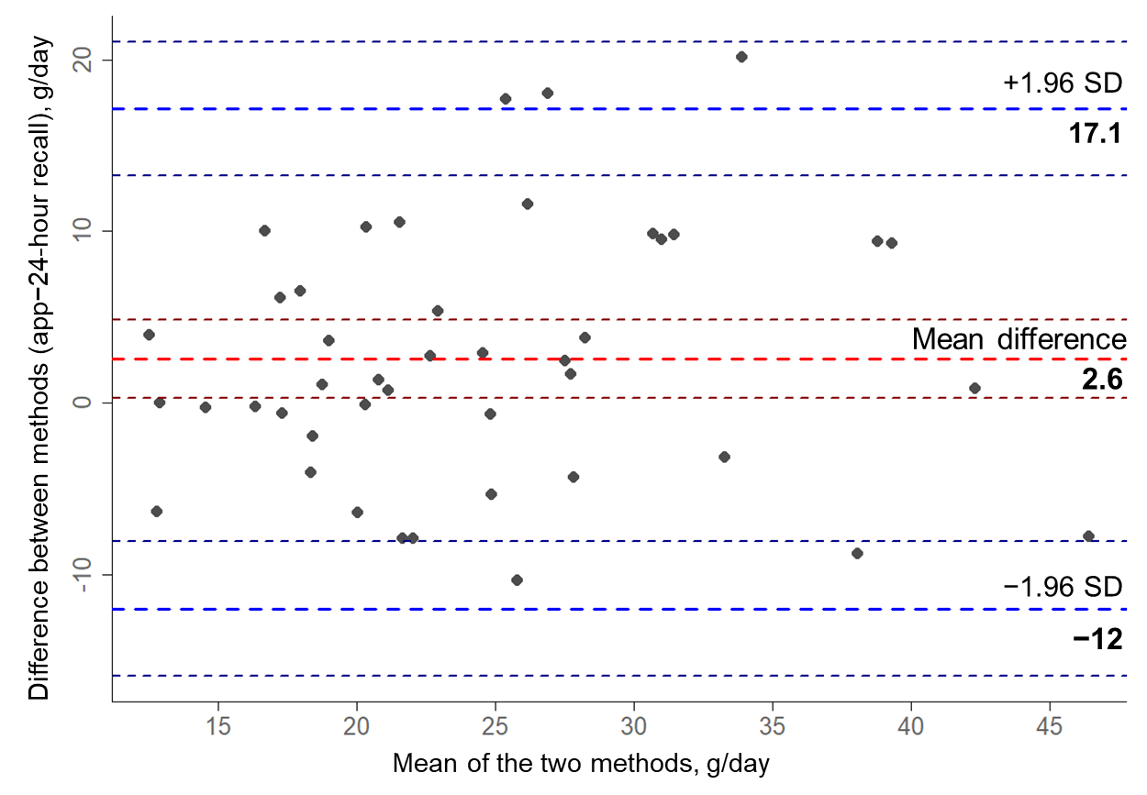
Figure 5. Bland-Altman plot assessing agreement between habitual fiber intake in g per day captured by the APPetite-food record and the 24-hour recall (red line: mean difference=app–24-hour recall; dark red lines: 95% CI of mean difference; blue lines: lower and upper limits of agreement; dark blue lines: 95% CI of lower and upper limits of agreement).

Mean difference: 2.6 (95% CI 0.3 to 4.8)
Lower limits of agreement: –12 (95% CI –15.9 to –8.1)
Upper limits of agreement: 17.1 (95% CI 13.2 to 21.1)

The limits of agreement exceeded the predefined acceptable disagreement of 2.5 g.

1. Bland JM, Altman DG. Statistical methods for assessing agreement between two methods of clinical measurement. Lancet. 1986;1(8476):307–310. PMID: 2868172

