Ingestion and toxicity of microplastics in the freshwater gastropod Lymnaea stagnalis: No microplastic-induced effects alone or in combination with copper

Supplementary data

Annkatrin Weberª, Marvin von Randowª, Anna-Lisa Voigtª, Marcus von der Au^{b,c}, Emily Fischer^{b}, Björn Meermann^{b,c}, Martin Wagner^{d*}
ª Goethe University Frankfurt am Main, Faculty of Biological Sciences, Department of Aquatic Ecotoxicology, Max-von-Laue-Straße 13, 60438 Frankfurt am Main, Germany

^{b} Federal Institute of Hydrology, Department Aquatic Chemistry, Am Mainzer 1, 56068 Koblenz, Germany
^{c} Federal Institute for Materials Research and Testing, Division Inorganic Trace Analysis, Richard-Willstätter-Straße 11, 12489 Berlin, Germany

^{d} Norwegian University of Science and Technology, Department of Biology,
Høgskoleringen 5, 7491 Trondheim, Norway

*Corresponding author’s contact details: Martin Wagner, martin.wagner@ntnu.no

S1 Materials and methods

S1.1 Particle concentration and size distribution
S1.1.1 Numerical particle concentrations in the stock suspensions for the ingestion and excretion study
The numerical particle concentrations in the microplastic (MP) stock suspensions were determined by CoulterCounter (Beckman Coulter, Multisizer™ 3, Krefeld, Germany). Due to high particle concentrations in the stock suspensions, we pre-diluted the stock suspensions in ultrapure water. For analysis of the 5, 10 and 45 µm PS sphere stock suspension, we further mixed 5–10 µL of each pre-diluted stock suspensions with 100–150 mL of electrolytic solution (0.9% NaCl solution, <0.2 µm sterile-filtered). The resulting suspension was constantly stirred and directly measured with a 100 µm capillary (Beckman Coulter, Krefeld, Germany, detection range: 2-60 µm, electric current: -1,600 µA, gain: 2, analytical volume: 0.5-1 mL, n = 2). Particle number concentration in the 90 µm stock suspension were determined likewise, but with a 400 µm capillary (Beckman Coulter, Krefeld, Germany, detection range: 8-240 µm, electric current: -1,600 µA, gain: 2, average analytical volume: 7.7 mL, n = 2).

S1.1.2 Particle number concentration and size distribution in the PS powder for the toxicity study
Details on the methodology for particle number concentration and size distribution analysis for the PS powder used in the toxicity study are included in the Supplementary data (chapter S1.3) by Weber et al. (2020).
Results on particle size distributions from Coulter Counter measurements were averaged and fitted with GraphPad-Prism Software (Version 7.04, San Diego, CA). Relative particle size distributions were approximated with a “One phase decay” fit, while for cumulative particle size distributions we used a “One phase association” (MP particle distribution) and a “Cumulative Gaussian-Percentage” fit (DI particle distribution). From cumulative particle size distributions, we determined the maximum size which in average 50%, 75% 90%, 95% and 99% of the particles obtained.
Results on particle abundance as well as on particle size distribution in the MP and diatomite (DI) powder used in this study are included in chapter S2.1.
S1.2 Scanning electron microscopy of microplastics and diatomite
Shape and size of particles in the MP and DI powder were qualitatively analysed with a scanning electron microscope (SEM, Hitachi, S4500, Krefeld, Germany). For examination, particles were fixed on aluminium discs with coal glue and coated with a gold monolayer (Agar Scientific, Sputter Coater, Stansted, United Kingdom). Resulting SEM images are included in chapter S2.2.

S1.3 Test design of the microplastics toxicity study
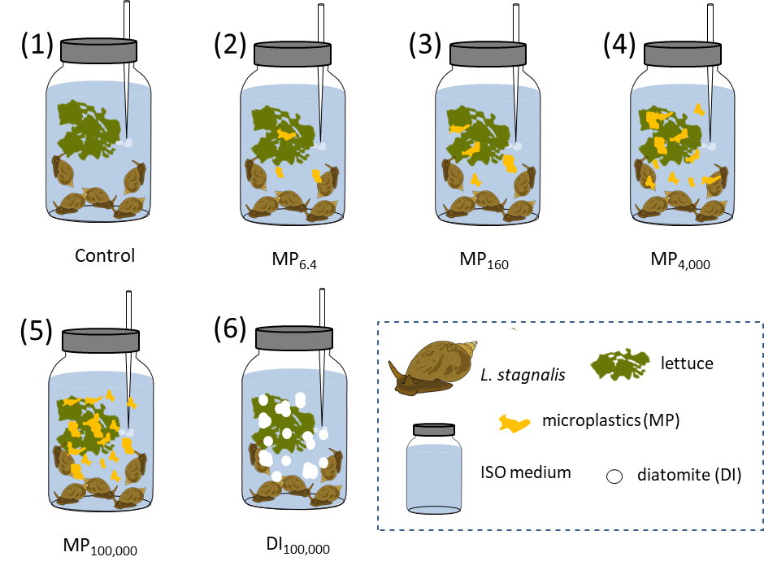
Fig. S1: Study design of the microplastics toxicity study. Subscript numbers indicate the particle number concentrations (particles mL⁻¹ (p mL⁻¹)). Number of jars per treatment: n=6.

S1.4 Test design of the mixture toxicity study
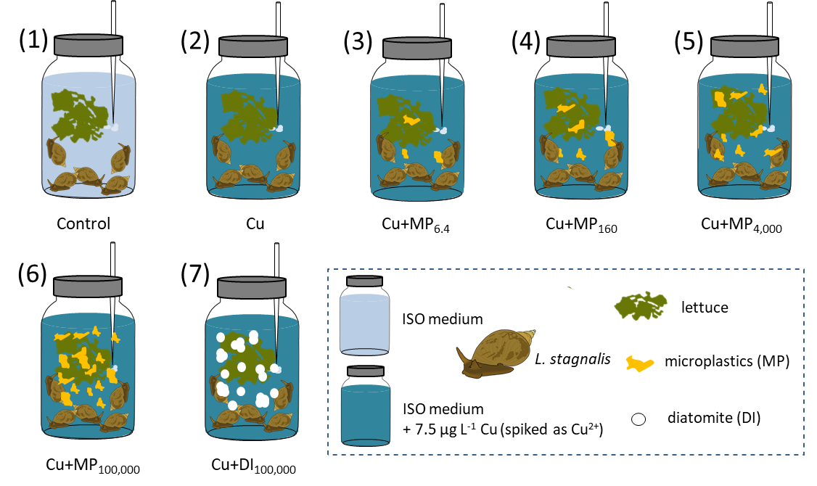
Fig. S2: Test design of the mixture toxicity study with copper and microplastics. Subscript numbers indicate the particle number concentrations (p mL⁻¹). Number of jars per treatment: n=7.

S1.5 Copper distribution analysis
For copper (Cu) distribution analysis (Fig. S3), we established 15 tests (with 3 jars each) using 0 or 7.5 µg L⁻¹ Cu (spiked as Cu²⁺) and varying amounts of MP/DI (6.4–100,000 p mL⁻¹) or lettuce (1.5, 4.5, 7.5 g).
Test 1 examined Cu contamination in the ISO medium prior and after a 3 day (d) incubation of the medium in aerated 1 L glass jars (to address a potential leaching of Cu). Tests 2–6 evaluated a possible Cu contamination originating from the MP and DI particles (samples were taken after a 3 d exposure; Tests 2–6 were prepared from the same ISO medium as Test 1 and therefore we did not take additional samples from Tests 2–6 prior to the experiment).
In Test 7, we analyzed the Cu concentration directly after spiking the ISO medium (we used the same medium as for Tests 1–6) with 7.5 µg L⁻¹ Cu (spiked as Cu²⁺) as well as after 3 d incubation in the 1 L glass jars. Tests 8–12 address the effects of MP or lettuce on Cu water concentrations in spiked ISO medium over 3 d (samples were taken after 3 d; Tests 8–12 were prepared from the same ISO medium and spiked with the same Cu stock solution as Tests 7 and therefore we did not take additional samples from Tests 8–12 prior to the experiment). Water samples were sterile filtered, preserved, stored and analyzed as described in chapters 2.5 and S1.6.
In addition to the Cu concentration in the water phase, we determined Cu concentrations adsorbed to the lettuce (Tests 13–15). For Cu analysis, we wet-weighed the lettuce from the Tests 13–15 as well as a further non-exposed sample of the same lettuce, freeze-dried it and determined the dry weight, before performing Cu analysis (see chapter S1.6).
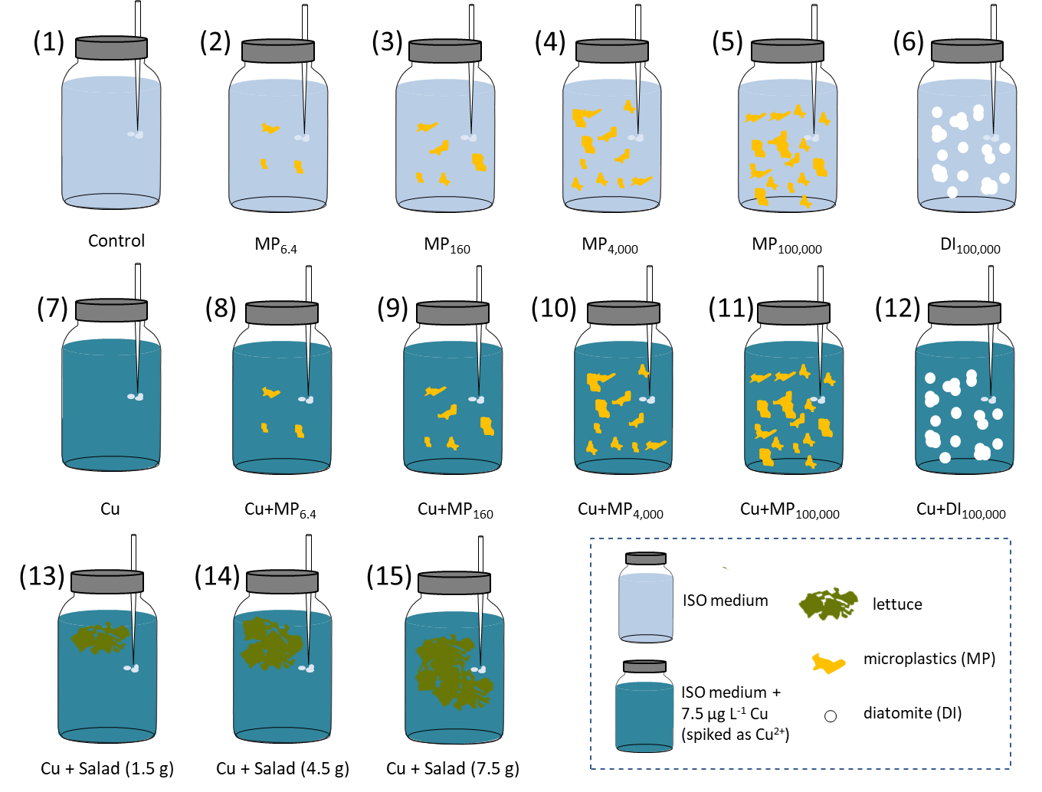
Fig. S3: Test design of the copper distribution study with 15 different tests. Subscript numbers indicate the particle number concentrations (p mL⁻¹). Number of replicate jars for each of the tests (1) to (15): n=3.

S1.6 Copper analysis in the water, tissue and lettuce samples
The snail and lettuce samples were digested using a MLS turboWAVE system (MLS GmbH, Leutkirch im Allgäu, Germany). To do so, approximately 50 mg of the freeze-dried and milled sample were weighted into a PTFE beaker. Afterwards, 1 mL of nitric acid (65%, Emsure, Merck KGaA, Darmstadt, Germany) which had previously been purified via a subboiling procedure (70 °C, DST-4000, Savillex, Minnesota, USA), was added and the beaker was microwaved (heating program: 2.5 min 80 °C (ramp), 8.0 min 160 °C (ramp), 4.0 min 220 °C (ramp), 9.0 min 220 °C (hold)). The resulting solution was diluted to 50 mL in DigiTubes (SCP Science, Quebec, Canada, 1.3% (v/v) subboiled HNO₃) by adding purified water (18.2 MΩ, Satorius AG, Göttingen, Germany).
In order to analyze the water, tissue and lettuce samples, ICP-QQQ-MS (8800 Triple Quadrupole ICP-MS, Agilent Technologies, Inc., Japan) was applied. The KED modus was set to identify the concentration of copper and the isotope ⁶³Cu was detected (plasma parameters: power: 1550 W, sampling depth: 9 mm, carrier gas: 0.82 L min⁻¹, makeup gas: 0.24 L min⁻¹; CRC parameters: helium flow: 5 mL min⁻¹, oct. bias: -18 V, oct. RF 160 V, energy dis.: 3 V, the other lenses were optimized daily). The internal correction was ensured by using a 50 µg L⁻¹ rhodium solution, which was added on-line at an ISTD mixing ratio of 1:10. As reference material for the experiments, we used standard mussel tissue (ERMCE278K (elements), Merck KGaA, Darmstadt, Germany) for the snails as well as standard white cabbage (BCR679 (trace elements), Merck KGaA, Darmstadt, Germany). Both reference materials were processed as described for the samples. The ICP-MS analyses were verified in means of the reference materials SPS-SW1 (Spectrapure Standards, Oslo, Norway) and 1640a (NIST, Maryland, USA).

S1.7 Preparation of midgut gland homogenates
Midgut glands (MGG) were mixed with 600 µL of potassium-phosphate-buffer (PPB; 10 mM, pH 7.4) and homogenated with two stainless steel balls (ø 3 mm) in a swing mill for 20 min (10x2 min) at 30 Hz. The tissue samples as well as its homogenates were constantly cooled between the processing steps to avoid degradation.
For the glycogen and lipid assay, 150 µL of MGG homogenate were mixed with 50 µL 2% (m/v) Na₂SO₄ solution (Sigma-Aldrich, Munich, Germany). 25 µL of this mixture were further diluted with 6.25 µL of 2% Na₂SO₄ solution and 18.75 µL of dest. H₂O to obtain the required dilution for the protein assay.
For the thiobarbituric reactive substances assay (TBARS), 100 µL of each tissue homogenate were used directly in the assay. The dilution for the oxygen radical absorbance capacity assay (ORAC) was produced by mixing 10 µL of the TBARS dilution with 90 µL PPB.
S1.8 Hemocyte phagocytosis activity
Hemocyte phagocytic activity was determined according to Weber et al. (2020, Supplementary data, chapter S.1.7) with following modifications:
For the analysis, we extracted 400–500 µL hemolymph from five to seven gastropods per treatment. Hemolymph samples were diluted with L. stagnalis serum to a total volume of 600 µL and a concentration of 600,000 cells mL⁻¹. 1 µm PS spheres (Fluoresbrite® YG microspheres, PolyScience, Hirschberg an der Bergstraße, Germany, excitation: 441 nm, emission: 486 nm) suspended in L. stagnalis serum were added at a ratio of 25 spheres per hemocyte cell (9 µL of a 10⁹ spheres mL⁻¹ stock solution) to the hemolymph. Each exposure sample was gently vortexed and directly split in two subsamples with 300 µL each, one being incubated at room temperature and the other one on ice.
S2 Results
S2.1 Particle size distribution in the PS powder for the toxicity study
The MP and the DI powder contained 456,704 p mg⁻¹ and 4,633,920 p mg⁻¹, respectively. Fig. S4 illustrates the size distributions of particles in the MP and DI powder (2–60 µm). The insets in Fig. S4 further summarize results from the cumulative particle size distributions regarding the maximum size of 50, 75, 90, 95 and 99% of all particles.
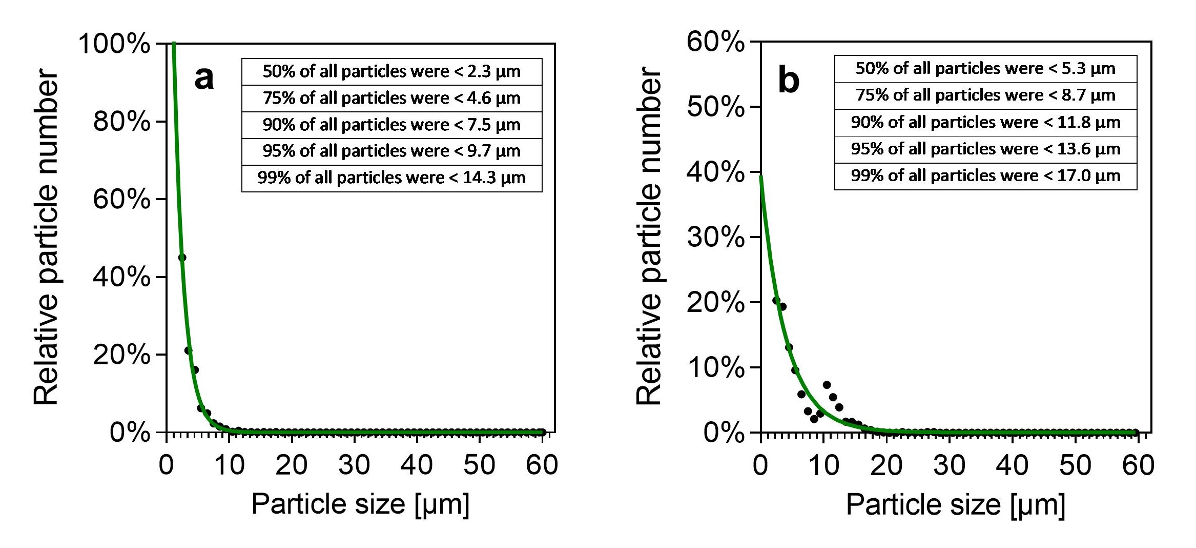
Fig. S4: Relative size distribution of (a) microplastics (MP) and (b) diatomite (DI) particles determined in three (DI) or four (MP) measurements and fitted with a One phase decay model using GraphPad Prism. The insets summarize results from the cumulative particle distributions.
S2.2 Scanning electron microscopy of the microplastics and diatomite
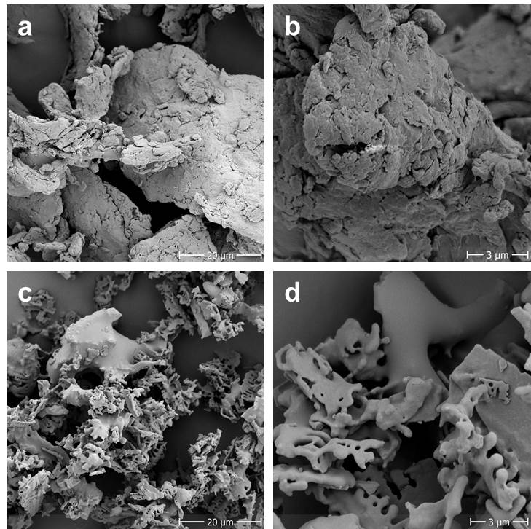
Fig. S5: Scanning electron microscopy images of the (a,b) microplastic and (c,d) diatomite particles used in the toxicity studies. Magnification: 1,500× (a,c) and 7,000× (b,d).

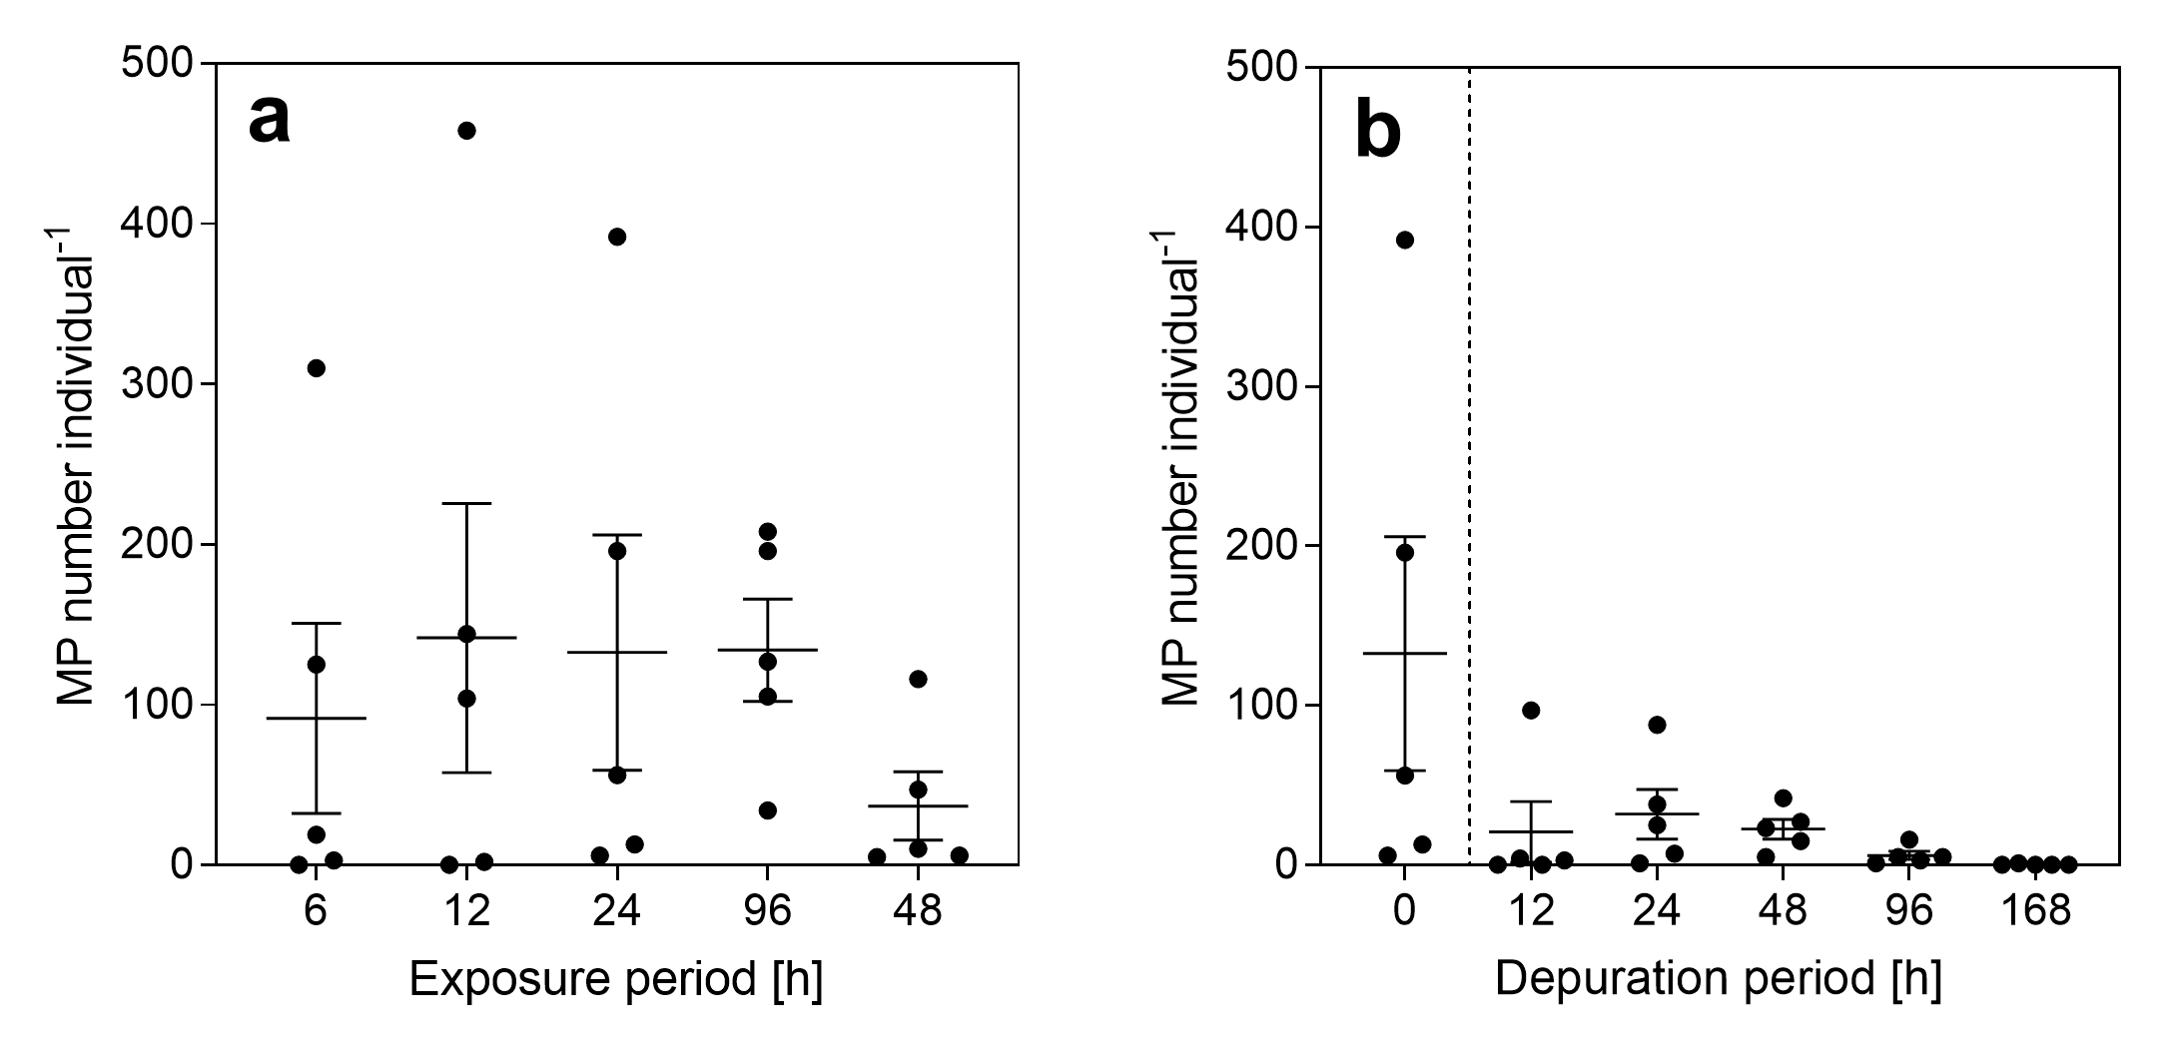
S2.3 Microplastic ingestion and excretion

Fig. S6: Ingestion and excretion of 90 µm PS spheres (MP) by L. stagnalis. (a) Mean (± standard error) number of spheres per individual after 6–96 h exposure (2 p mL⁻¹, n=5 per exposure period). (b) Mean (± standard error) number of spheres per individual after 24 h of exposure (2 p mL⁻¹, 0 h = 24 h in a) followed by a 12–168 h depuration period in MP-free medium (n=5 per depuration period).

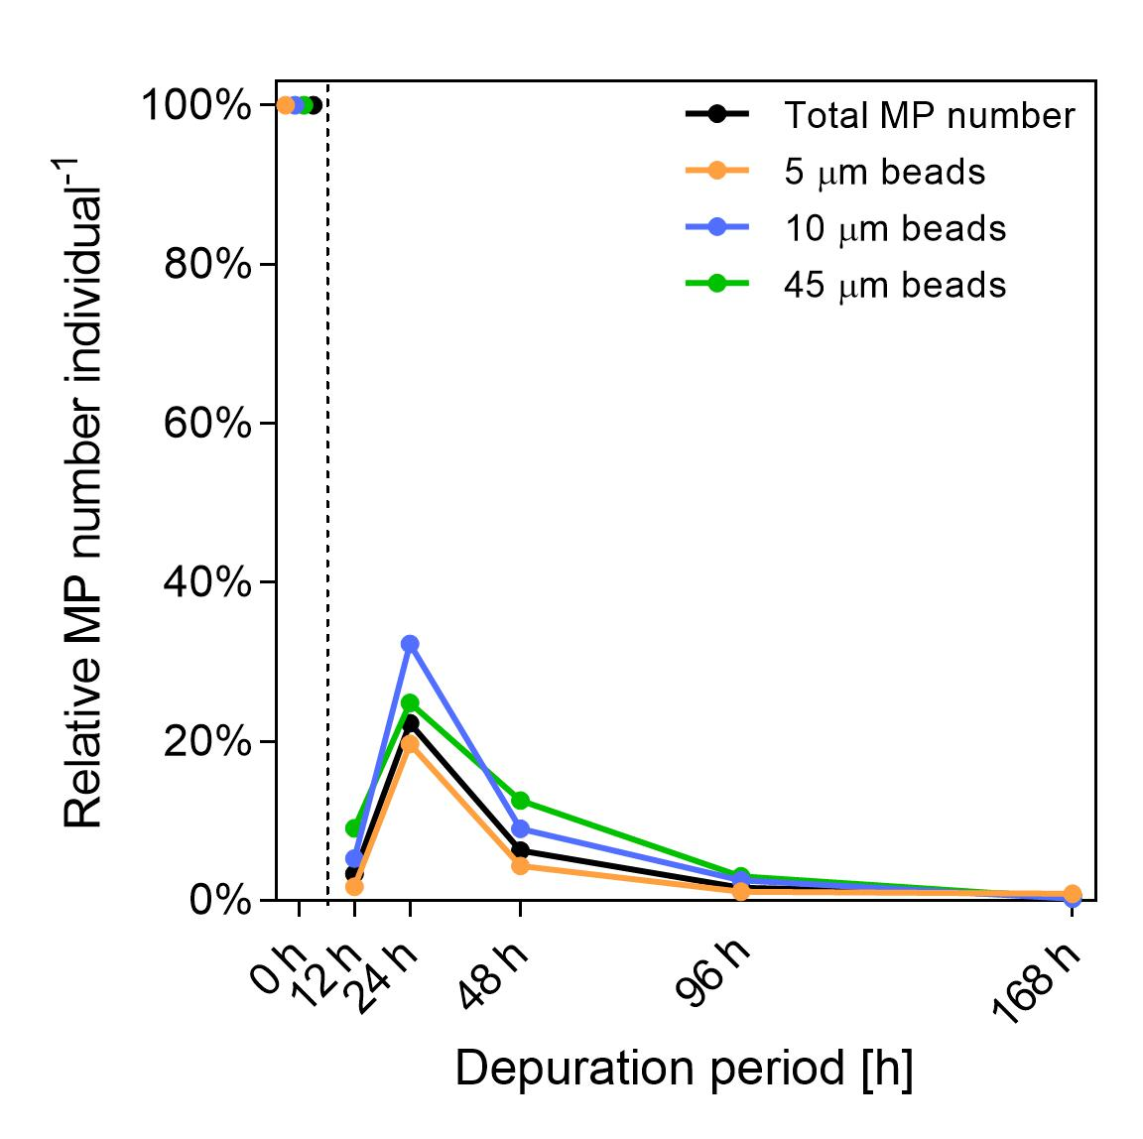
Fig. S7: Mean relative tissue levels of MP in L. stagnalis after a 24 h exposure to 5, 10 and 45 µm PS spheres (t = 0) followed by a 12–168 h depuration period in MP-free medium. Relative levels were determined by comparing the number of MP for each particle type after the various depuration periods with the respective number after 24 h exposure without depuration (0 h depuration period, respective data was derived from the ingestion study, see Fig. 1a). n=5 per depuration period.

S2.4 Test validity
The MP toxicity study was valid according to the OECD criteria with a mortality rate of 13.3% and a reproduction of 7.83 egg clutches individual⁻¹ in the control (over 28 d exposure) as well as an oxygen content of > 6 mg L⁻¹ and pH of 6.5–8.5 in all jars. However, the average water temperature was 18.8 ± 0.4 °C compared to the 20 ± 1 °C foreseen by OECD due to technical difficulties with the air conditioning. In few jars, water conductivity exceeded the suggested maximum of 800 µS cm⁻¹, but average conductivity in the six treatments was still within the reference frame. Water hardness (CaCO₃) was on average 265 ± 15 mg L⁻¹ and, thus, slightly higher than suggested (250 mg L⁻¹). Detailed results on temperature and water parameters are included in Tab. S1.
In the mixture toxicity study, OECD (2016) validity criteria for mortality (17.1% in the control) and reproduction (8.06 egg clutches individual⁻¹ in the control throughout 28 d) were fulfilled. Further, in all jars a constant water temperature of 20 ± 1 °C and a required conductivity of 600 ± 200 µS cm⁻¹ were maintained at all times. In very few jars, oxygen content and pH fell below the required minimum (O₂: > 6 mg L⁻¹; pH: 6.5), but average results for the six treatment groups were within the required limits. Similar to the toxicity study, the average water hardness (252 ± 15 mg L⁻¹) was slightly higher than suggested (250 mg L⁻¹, detailed results in Tab. S1).

Tab. S1: Mean water parameter measurements (± standard deviation) from each treatment group in the microplastics and mixture toxicity study.
 |  | Temperature [°C] | Oxygen content  [mg L⁻¹] | Conductivity [µS cm⁻¹] | pH | Water hardness  [mg L⁻¹]
Microplastics toxicity study | Control | 18.78 ± 0.35 | 8.24 ± 0.34 | 735.6 ± 109.0 | 7.19 ± 0.33 | 264.4 ± 20.3
 | MP_{6.4} | 19.08 ± 0.33 | 7.74 ± 0.59 | 706.5 ± 112.3 | 7.12 ± 0.19 | 262.5 ± 16.7
 | MP₁₆₀ | 18.89 ± 0.39 | 8.15 ± 0.36 | 730.4 ± 118.8 | 7.18 ± 0.23 | 264.4 ± 14.5
 | MP_{4,000} | 18.81 ± 0.53 | 7.95 ± 0.74 | 729.1 ± 110.1 | 7.24 ± 0.32 | 268.1 ± 15.1
 | MP_{100,000} | 18.61 ± 0.44 | 8.19 ± 0.23 | 733.8 ± 111.4 | 7.23 ± 0.25 | 267.5 ± 19.1
 | DI_{100,000} | 18.83 ± 0.24 | 7.86 ± 0.57 | 723.6 ± 111.0 | 7.29 ± 0.19 | 264.4 ± 13.5
Mixture toxicity study | Control | 19.96 ± 0.36 | 7.40 ± 0.83 | 506.5 ± 30.0 | 7.29 ± 0.35 | 246.9 ± 14.9
 | Cu | 19.88 ± 0.38 | 7.32 ± 0.73 | 525.7 ± 21.4 | 7.18 ± 0.43 | 256.3 ± 11.9
 | Cu+MP_{6.4} | 19.82 ± 0.25 | 7.46 ± 0.69 | 512.1 ± 26.4 | 7.18 ± 0.44 | 250.6 ± 16.1
 | Cu+MP₁₆₀ | 19.69 ± 0.17 | 6.85 ± 0.88 | 514.1 ± 29.0 | 7.14 ± 0.42 | 254.4 ± 15.0
 | Cu+MP_{4,000} | 19.75 ± 0.13 | 7.12 ± 0.75 | 508.9 ± 24.3 | 7.11 ± 0.40 | 245.6 ± 14.7
 | Cu+MP_{100,000} | 19.78 ± 0.25 | 6.85 ± 1.15 | 510.1 ± 26.7 | 7.09 ± 0.33 | 248.8 ± 13.6
 | Cu+DI_{100,000} | 19.85 ± 0.28 | 6.91 ± 1.00 | 519.3 ± 22.6 | 7.11 ± 0.34 | 250.0 ± 15.8

S2.5 Qualitative analysis of MP in L. stagnalis feces
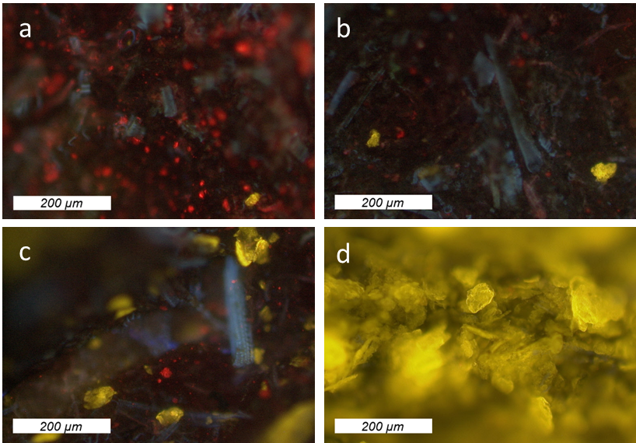
Fig. S8: Microplastics (yellow) in feces of L. stagnalis exposed to (a) 6.4, (b) 160, (c) 4,000 and (d) 100,000 p mL⁻¹. No yellow fluorescent particles were observed in feces from control animals. The red fluorescence may originate from chlorophyll in non-digested lettuce.

S2.6 Hemocyte phagocytosis activity
Results from FACS analysis (performed and analyzed as described by Weber et al. (2020)) are summarized in Fig. S9. Dead cells were excluded from the main population by propidium iodide staining (PI, Fig. S9a–b, Gate P2: living hemocytes in the main cell population; Gate P5: dead hemocytes in the main cell population). Gate P6 (Fig. S9c) represents the subpopulation of living hemocytes with ≥ 3 spheres from Gate P2. Only FACS analyses with ≥ 5,000 living cell counts (P2) were used. We extrapolated data from all FACS measurements to 10,000 living cells to allow data comparability between the different samples. Results from the sample exposed at room temperature were corrected for the number of hemocytes with ≥ 3 spheres from sample exposed on ice to account for particles which were adsorbed on the hemocytes cell surface, but not phagocytized. Based on the corrected data, we determined the fraction of living hemocytes with ≥ 3 spheres compared to all analyzed living hemocytes.
a
b
c
Fig. S9: Characterization of L. stagnalis hemocytes exposed to 1 µm PS spheres using a BD FACSVerse. (a) Size (FSC) vs. granularity (SSC) of hemocytes (488 nm laser, SSC filter: 481-496 nm), (b) Gating of living (gate P2) and dead (gate P5) hemocytes due to propidium iodide fluorescence (488 nm laser, 7-AAD (filter: 673-727, mirror: 665 LP)), (c) Gating of living hemocytes (from Gate P2) with ≥ 1 (P3), ≥ 2 (P4), ≥ 3 (P6) or ≥ 4 spheres (P7) (488 nm laser, Alexa 488 (filter: 511-543, mirror: 507 LP)).
S2.7 Copper distribution experiment
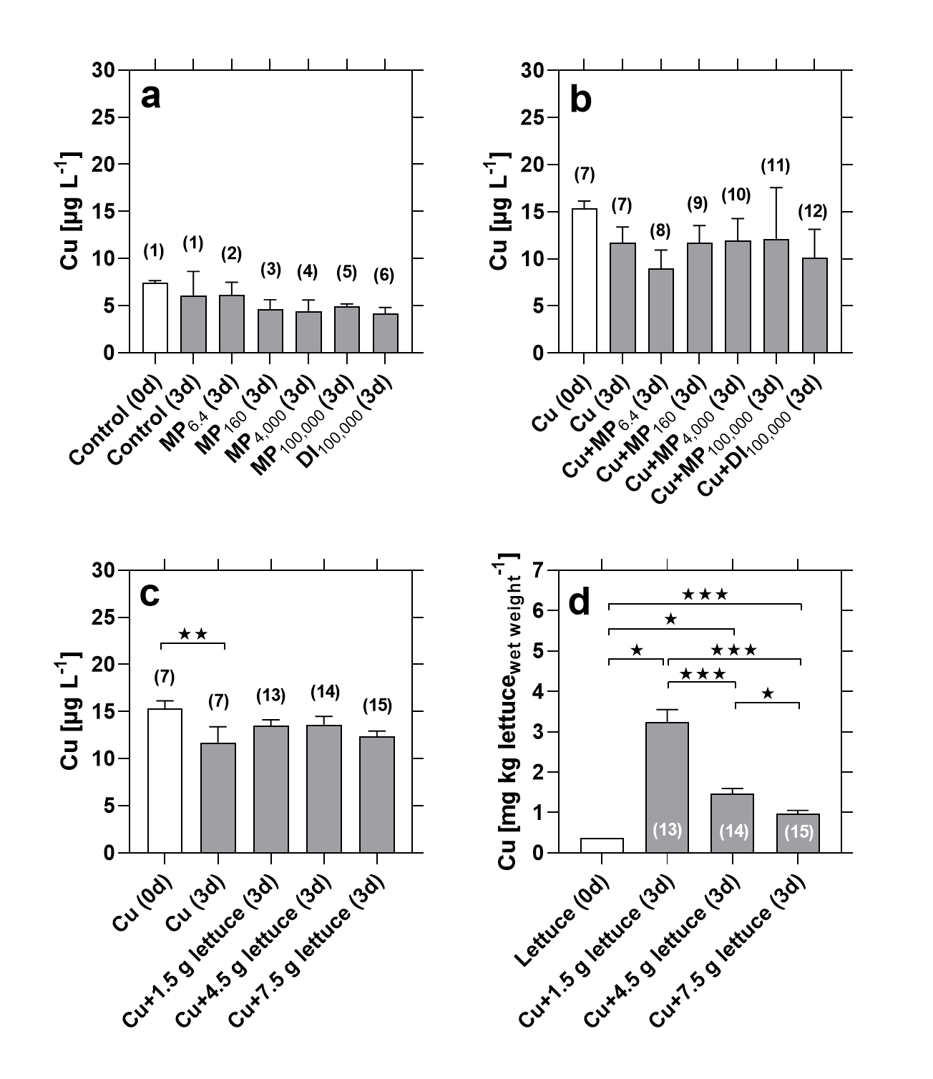
Fig. S10: Copper (Cu) concentrations (total concentration of all copper species) in the Cu distribution study. (a) Water concentrations in the unspiked ISO medium before (0d) and after 3 days (3d) of incubation with and without microplastics (MP, 6.4–100,000 p mL⁻¹) or diatomite (DI, 100,000 p mL⁻¹). (b, c) Water concentrations directly after spiking with 7.5 µg L⁻¹ Cu and after 3 d of incubation with (b) MP, DI or (c) lettuce. (d) Cu concentration in the lettuce before and after 3 d of incubation in Cu-spiked ISO medium. The numbers above/in the bars refer to the labelling of the 15 tests as shown in Fig. S3. Subscript numbers indicate particle concentrations (p mL⁻¹). Statistics: (a,b) Kruskal-Wallis test with Dunn’s post-test, comparisons: Cu (3d) vs. all other tests; (c,) One-way ANOVA with Sidak’s post-test, comparisons: Cu (3d) vs. all other tests; (d) One-way ANOVA with Sidak’s post-test, comparisons: all possible pairwise combinations. = p<0.05, = p<0.01, = p<0.001. Number of jars per test: n = 3 (except for (d) lettuce (0d): n = 1).

S2.8 Copper concentrations in the mixture toxicity study
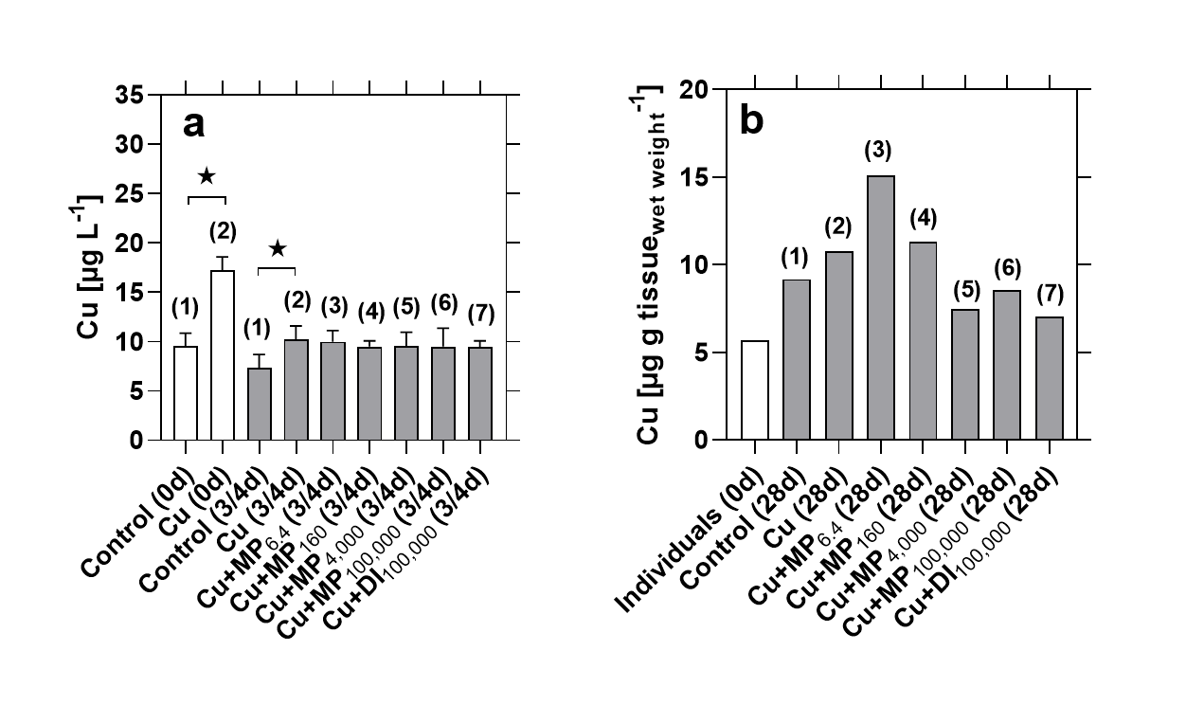
Fig. S11: Copper (Cu) concentrations (total Cu concentration of all copper species) in the mixture toxicity study. (a) Water concentrations in the freshly prepared unspiked and Cu-spiked (7.5 µg L⁻¹) medium before the water exchange (0d) as well as after 3–4 days of exposure (3/4d). (b) Tissue concentrations in L. stagnalis individuals (pool of four individuals per treatment group) prior (0d) and at the end (28d) of the mixture toxicity study. The numbers above the bars refer to test numbers in Fig. S2. Subscript numbers indicate particle concentrations (p mL⁻¹). Statistics for (a): Kruskal-Wallis test with Dunn’s post-test; comparison: Control (0d) vs. Cu (0d) + Control (0d) vs. Control (3/4d) + Cu (0d) vs. Cu (3/4d) + Control (3/4d) vs. Cu (3/4d) + Cu (3/4d) vs. all Cu+MP treatments and the Cu+DI_{100,000} treatment. = p<0.05. Number of tested water samples/tissue samples per treatment (see 2.5 for details): (a) n = 7–8; (b) n = 1.

S3 References
Weber, A., Jeckel, N., Wagner, M., 2020. Combined effects of polystyrene microplastics and thermal stress on the freshwater mussel Dreissena polymorpha. Science of the Total Environment 718, 137253. DOI: 10.1016/j.scitotenv.2020.137253.

