Supplemental Tables and Figures
Table S1. Baseline Tumor Assessments Summary
Tumor Assessment | Nivolumab +  RT + TMZ  n = 358  No. (%) | Placebo +  RT + TMZ  n = 358  No. (%)
Patients with ≥1 lesion | 335 (93.6) | 328 (91.6)
Site of lesion^{a,b}  Temporal lobe  Frontal lobe  Parietal lobe  Occipital lobe  Corpus callosum  Basal ganglia  Thalamus  Brain stem  Caudate nucleus  Hippocampus  Cerebellum  Leptomeningeal  Other | 139 (38.8)  109 (30.4)  75 (20.9)  39 (10.9)  23 (6.4)  8 (2.2)  7 (2.0)  3 (0.8)  2 (0.6)  1 (0.3)  0  0  20 (5.6) | 124 (34.6)  104 (29.1)  73 (20.4)  37 (10.3)  20 (5.6)  11 (3.1)  7 (2.0)  1 (0.3)  0  2 (0.6)  1 (0.3)  1 (0.3)  28 (7.8)
Measurable target lesion | 98 (27.4) | 76 (21.2)
SPD of measurable target lesions  Median (range), mm² | 542.5 (140-4454) | 620.0 (120-3930)
Site of target lesion(s)  Temporal lobe  Frontal lobe  Parietal lobe  Corpus callosum  Occipital lobe  Basal ganglia  Thalamus  Hippocampus  Other | 35 (9.8)  22 (6.1)  21 (5.9)  11 (3.1)  8 (2.2)  2 (0.6)  1 (0.3)  1 (0.3)  8 (2.2) | 25 (7.0)  19 (5.3)  12 (3.4)  9 (2.5)  9 (2.5)  2 (0.6)  0  0  10 (2.8)
RT, radiotherapy; SPD, sum of products of perpendicular diameters; TMZ, temozolomide.
ª Includes both measurable and nonmeasurable lesions.
^{b} Patients may have lesions at >1 site.

Table S2. Immune-Mediated Select Adverse Events by Category
Patients | Nivolumab +  RT + TMZ  n = 355  No. (%) |  | Placebo +  RT + TMZ  n = 354  No. (%)
 | Any Grade | Grade 3/4 | Any Grade | Grade 3/4
Select treatment-related AEs by category
Gastrointestinal | 43 (12.1) | 8 (2.3) | 25 (7.1) | 0
Hepatic | 69 (19.4) | 32 (9.0) | 38 (10.7) | 4 (1.1)
Pulmonary | 7 (2.0) | 3 (0.8) | 1 (0.3) | 0
Renal | 17 (4.8) | 3 (0.8) | 8 (2.3) | 0
Dermal | 117 (33.0) | 10 (2.8) | 91 (25.7) | 6 (1.7)
Hypersensitivity/infusion reaction | 28 (7.9) | 2 (0.6) | 9 (2.5) | 0
AE, adverse event; RT, radiotherapy; TMZ, temozolomide.

Figure S1. Study Profile
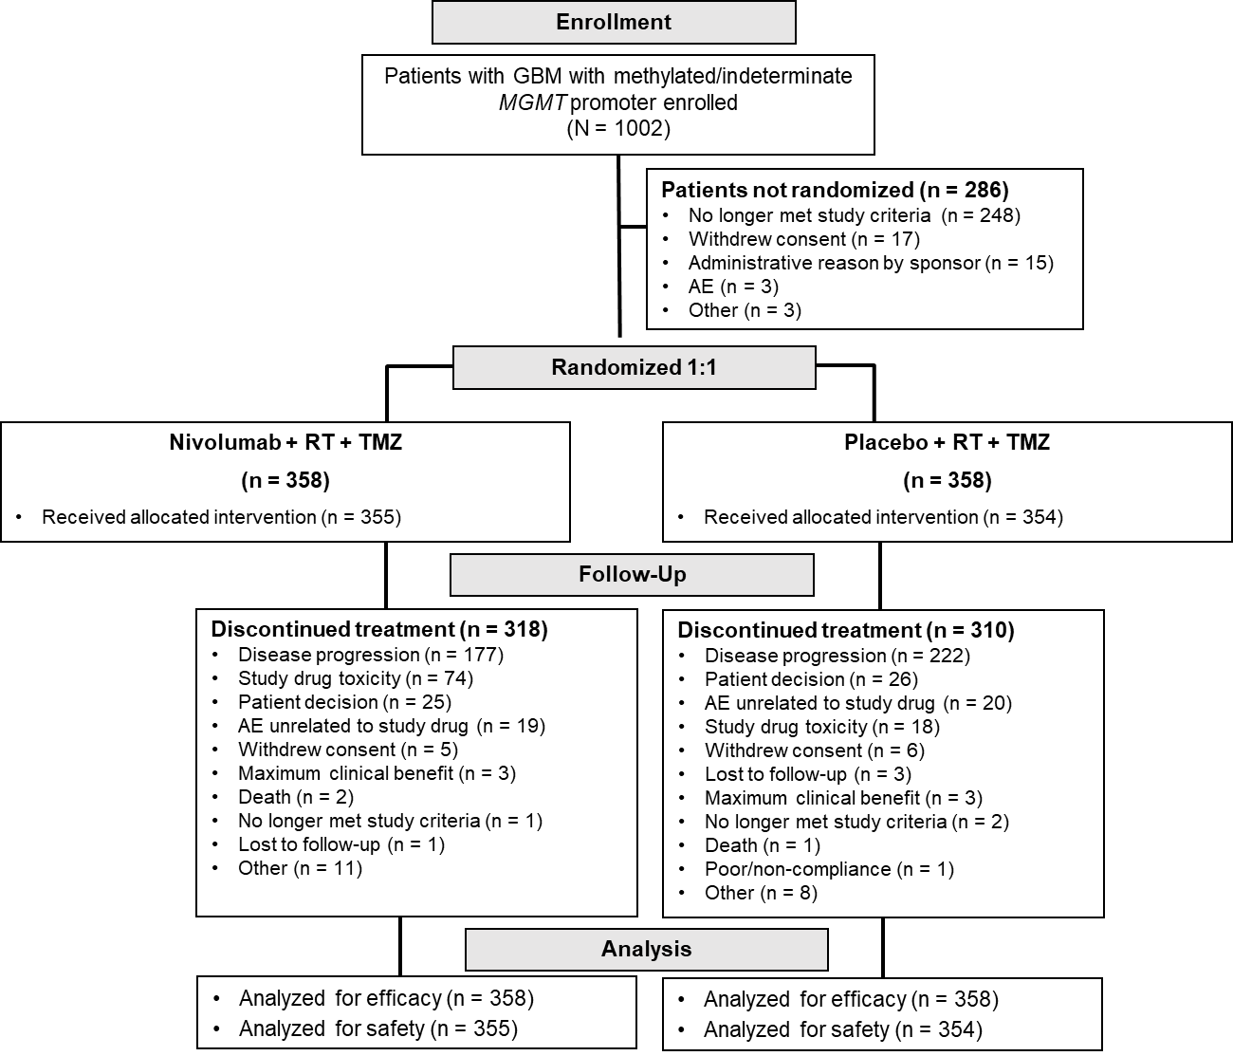

Figure S1. Study Profile.
CONSORT diagram showing the number of patients in CheckMate 548 who were enrolled, treated with nivolumab + RT + TMZ or placebo + RT + TMZ, discontinued treatment, and were analyzed for efficacy and safety. AE, adverse event; MGMT, O⁶-methylguanine DNA methyltransferase; RT, radiotherapy; TMZ, temozolomide.
Figure S2. Progression-Free Survival and Overall Survival by PD-L1 Expression (5% cutoff)
A.
 | Nivolumab +  RT + TMZ  PD-L1 ≥5%  n = 87 | Placebo +  RT + TMZ  PD-L1 ≥5%  n = 89
No. of events | 68 | 71
PFS, median, mo  95% CI | 8.4  6.2-12.3 | 9.9  6.5-13.1
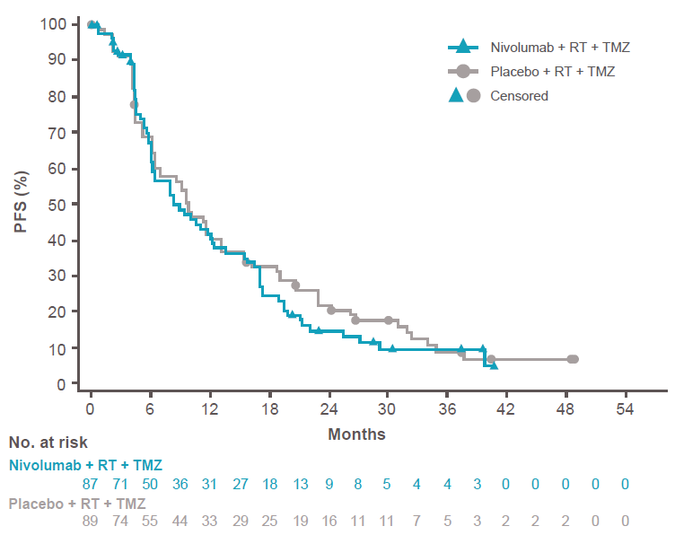
HR, 1.1 (95% CI, 0.8-1.6)

B.
 | Nivolumab +  RT + TMZ  PD-L1 <5%  n = 269 | Placebo +  RT + TMZ  PD-L1 <5%  n = 267
No. of events | 205 | 210
PFS, median, mo  95% CI | 11.5  9.7-12.1 | 11.3  9.8-13.1
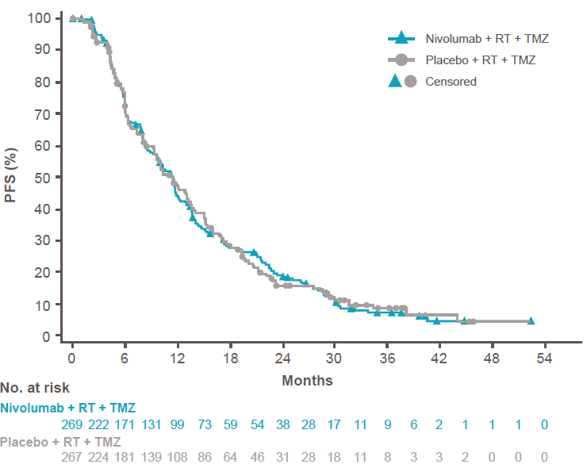
HR, 1.0 (95% CI, 0.8-1.2)
C.
 | Nivolumab +  RT + TMZ  PD-L1 ≥5%  n = 87 | Placebo +  RT + TMZ  PD-L1 ≥5%  n = 89
No. of events | 49 | 53
OS, median, mo  95% CI | 29.2  21.8-42.9 | 31.3  23.2-36.0
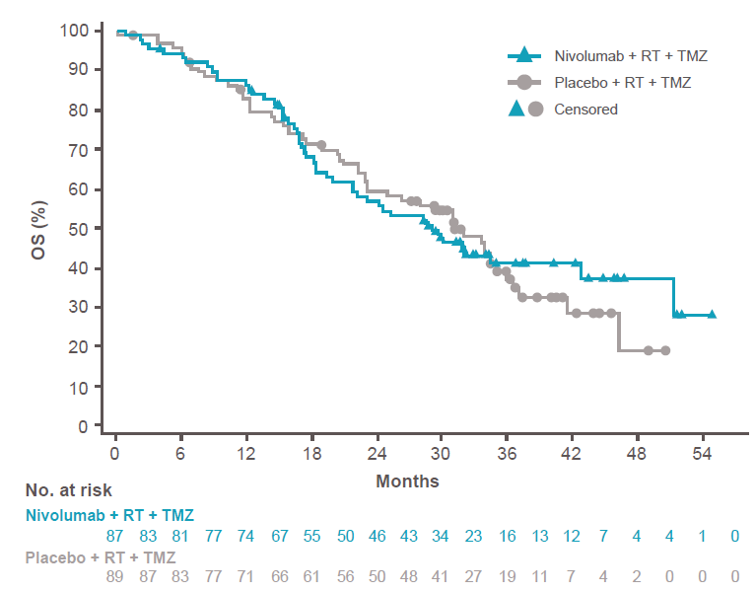
HR, 1.0 (95% CI, 0.6-1.4)

D.
 | Nivolumab +  RT + TMZ  PD-L1 <5%  n = 269 | Placebo +  RT + TMZ  PD-L1 <5%  n = 267
No. of events | 172 | 163
OS, median, mo  95% CI | 28.9  23.7-31.6 | 31.8  28.8-33.8
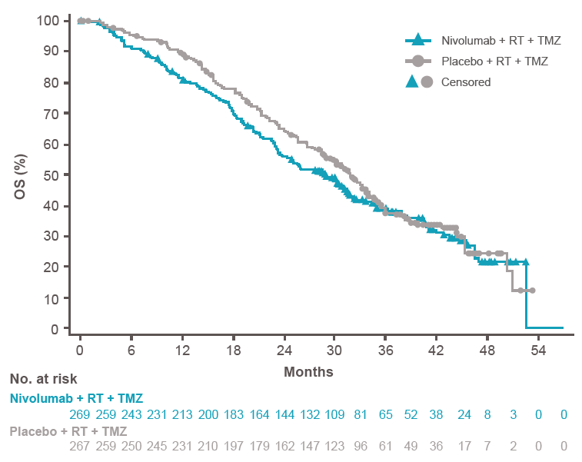
HR, 1.1 (95% CI, 0.9-1.4)
Figure S2. Progression-Free Survival and Overall Survival by PD-L1 Expression (5% cutoff)
Number of events, median PFS, and Kaplan-Meier curves for PFS in all patients with baseline PD-L1 expression ≥5% (A) and <5% (B). Number of events, median OS, and Kaplan-Meier curves for OS in all patients with baseline PD-L1 expression ≥5% (C) and <5% (D). Symbols indicate censored observations. BICR, blinded independent central review; OS, overall survival; PD-L1, programmed death-1 ligand 1; PFS, progression-free survival; RT, radiotherapy; TMZ, temozolomide.

Figure S3. Overall Survival in Prespecified Patient Subgroups Defined by Baseline Clinical Characteristics in Patients Without Baseline Corticosteroids
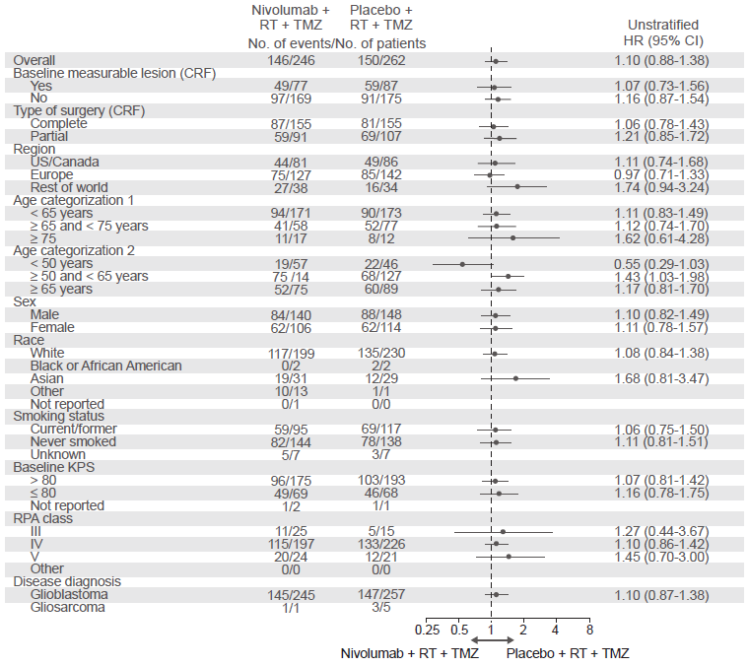
Figure S3. Overall Survival in Prespecified Patient Subgroups Defined by Baseline Clinical Characteristics in Patients Without Baseline Corticosteroids
Forest plots of unstratified hazard ratios for death in the analysis of treatment effect in prespecified patient subgroups according to baseline characteristics in patients without baseline corticosteroids. CRF, case report form; mOS, median overall survival; RPA, recursive partitioning analysis class; RT, radiotherapy; TMZ, temozolomide.

