# 

# Supplemental data

# Allogeneic hematopoietic cell transplantation in older myelofibrosis patients: a study of the Chronic Malignancies Working Party of EBMT and the Spanish Myelofibrosis Registry

**Table S1**. Baseline characteristics of 556 myelofibrosis patients aged 65 years or older undergoing allogeneic hematopoietic cell transplantation.

|  |  |  |
| --- | --- | --- |
| **Characteristic** | **No. evaluable cases** |  |
| Age, yrs* | 556 | 67 (65-76) |
| Male sex | 556 | 380 (68) |
| KPS < 90% | 498 | 211 (42) |
| HCT-CI ≥ 3 | 427 | 127 (30) |
| Year of transplant | 556 |  |
| 2000-2009 |  | 73 (13) |
| 2010-2017 |  | 483 (87) |
| Female donor to male recipient | 556 | 106 (19) |
| CMV serostatus patient/donor | 535 |  |
| +/+ |  | 219 (41) |
| +/- |  | 119 (22) |
| -/+ |  | 45 (8) |
| -/- |  | 152 (29) |
| Myeloablative conditioning | 556 | 141 (25) |
| Type of conditioning | 552 |  |
| Busulfan-based |  | 369 (67) |
| Melphalan-based |  | 78 (14) |
| Others |  | 105 (19) |
| Graft source | 556 |  |
| Peripheral blood |  | 525 (94) |
| Bone marrow |  | 25 (5) |
| Cord blood |  | 5 (1) |
| Donor type | 554 |  |
| Syngeneic |  | 1 (0) |
| HLA-matched related |  | 134 (24) |
| HLA-mismatched related |  | 5 (1) |
| Haploidentical |  | 22 (4) |
| HLA-matched unrelated |  | 255 (46) |
| HLA-mismatched unrelated |  | 71 (13) |
| Unrelated, HLA-match unknown |  | 61 (11) |
| Cord blood |  | 5 (1) |
| ATG | 552 | 371 (67) |
|  |  |  |

Data are given as frequency (%) except otherwise specified. Percentages are calculated over the number of patients who had the data.

KPS: Karnofsky Performance Status.

HCT-CI: Hematopoietic Cell Transplantation-specific Comorbidity Index.

ATG: antihuman T-lymphocyte immunoglobulin.

* Median (range).

**Table S2**. Factors associated with increased risk of non-relapse mortality and disease relapse after HCT in myelofibrosis patients aged 65 years or older. Both risks were estimated in the setting of competing events.

|  |  |  |  |  |  |  |  |
| --- | --- | --- | --- | --- | --- | --- | --- |
|  | **Non-relapse mortality** | | |  | **Disease relapse** | | |
| **Covariate** | **No. patients** | **SHR (95% CI)** | **p** |  | **No. patients** | **SHR (95% CI)** | **p** |
| Year < 2010 | 556 | 1.26 (0.87 - 1.81) | 0.22 |  | 540 | 1.32 (0.83 - 2.12) | 0.24 |
| Age ≥ 68 yrs | 556 | 0.96 (0.73 - 1.26) | 0.77 |  | 540 | 0.76 (0.51 - 1.13) | 0.17 |
| Male sex | 556 | 1.13 (0.84 - 1.51) | 0.43 |  | 540 | 0.95 (0.63 - 1.42) | 0.79 |
| Primary myelofibrosis | 556 | 1.02 (0.76 - 1.38) | 0.88 |  | 540 | 0.82 (0.55 - 1.23) | 0.33 |
| DIPSS high risk | 241 | 0.85 (0.54 - 1.36) | 0.51 |  | 236 | 1.06 (0.58 - 1.95) | 0.85 |
| *JAK2* + | 338 | 2.11 (1.05 - 4.25) | **0.036** |  | 331 | 1.21 (0.55 - 2.64) | 0.64 |
| *CALR* + | 338 | 0.52 (0.22 - 1.24) | 0.14 |  | 331 | 0.70 (0.27 - 1.85) | 0.47 |
| *MPL* + | 338 | 0.18 (0.02 - 1.41) | 0.1 |  | 331 | 0.89 (0.21 - 3.81) | 0.88 |
| Triple negative | 338 | 0.69 (0.19 - 2.52) | 0.57 |  | 331 | 1.71 (0.42 - 6.89) | 0.45 |
| HCT-CI ≥ 3 | 427 | 1.28 (0.92 - 1.78) | 0.14 |  | 416 | 1.08 (0.67 - 1.76) | 0.74 |
| Karnofsky index < 90 | 498 | 1.27 (0.95 - 1.71) | 0.1 |  | 483 | 0.84 (0.55 - 1.27) | 0.4 |
| Prior ruxolitinib | 556 | 0.98 (0.72 - 1.35) | 0.91 |  | 540 | 0.74 (0.45 - 1.22) | 0.24 |
| MAC vs. RIC | 556 | 0.96 (0.71 - 1.31) | 0.82 |  | 540 | 0.83 (0.52 - 1.33) | 0.44 |
| Busulfan conditioning | 552 | 0.63 (0.48 - 0.82) | **0.001** |  | 536 | 1.38 (0.90 - 2.11) | 0.14 |
| Female donor/male patient | 556 | 1.01 (0.73 - 1.41) | 0.94 |  | 540 | 1.18 (0.75 - 1.86) | 0.46 |
| CMV patient+/donor- | 556 | 1.86 (1.38 – 2.52) | **< 0.001** |  | 540 | 1.15 (0.74 - 1.82) | 0.52 |
| HLA mismatched | 556 | 0.95 (0.71 - 1.27) | 0.73 |  | 540 | 0.96 (0.63 - 1.46) | 0.83 |
| Matched, unrelated | 389 | 1.27 (0.90 - 1.78) | 0.18 |  | 379 | 0.50 (0.32 - 0.78) | **0.002** |
| Source: BM vs. PB | 531 | 1.28 (0.26 - 6.37) | 0.76 |  | Non evaluable | | |
| ATG use | 552 | 0.98 (0.74 - 1.30) | 0.88 |  | 536 | 0.77 (0.52 - 1.15) | 0.20 |

SHR: sub-hazard ratio.

Numbers in bold are those with a significant p value on the statistical analysis (p<0.05).

**Table S3.** Main features of myelofibrosis patients aged 65 or older treated with allo-HCT or non-transplant approaches.

|  |  |  |  |
| --- | --- | --- | --- |
|  | Non-transplant  (n=176) | Allo-HCT  (n=556) | p |
| Age, median (IQR) | 72 (69-74) | 67 (66-69) | < 0.001 |
| Age ≥ 70 yrs | 117 (66%) | 87 (16%) | < 0.001 |
| Sex, male | 106 (60%) | 380 (68%) | 0.047 |
| Primary myelofibrosis | 118 (60%) | 398 (72%) | 0.25 |
| Mutational status* |  |  |  |
| *JAK2+* | 92 (52%) | 290 (52%) |  |
| *CALR+* | 11 (6%) | 28 (5%) |  |
| *MPL+* | 0 | 13 (2%) |  |
| Triple negative | 0 | 7 (1%) |  |
| Incomplete study | 73 (42%) | 218 (40%) |  |
| DIPSS |  |  |  |
| Low | 0 | 2 (1%) |  |
| Intermediate-1 | 0 | 40 (16%) |  |
| Intermediate-2 | 235 (79%) | 106 (44%) |  |
| High | 61 (21%) | 93 (39%) |  |
| Exposition to ruxolitinib | 45 (25%) | 126 (23%) | 0.43 |
| Follow-up, yrs |  |  |  |
| Median (95 % CI) | 4.6 (3.1 -5.3) | 3.4 (1.9-5.6) | 0.10 |
| Deaths | 99 (56%) | 306 (55%) |  |
| Estimated survival |  |  |  |
| Median (95% CI) | 3.3 (2.7-4.0) | 2.1 (1.4-3.3) |  |
| At 1 year | 79% (73-85) | 59% (54-63) |  |
| At 2 years | 69% (61-76) | 49% (46-55) |  |
| At 5 years | 33% (25-42) | 40% (35-45) |  |
| At 7 years | 19% (11-28) | 32% (26-37) |  |
| At 10 years | 7% (2-17) | 24% (17-33) |  |

**Table S4**. Adjusted association of presenting features with increased mortality in patients with myelofibrosis, aged 65 to 76 years, classified within the intermediate-2 and high risk DIPSS categories, and managed without HCT

|  |  |  |
| --- | --- | --- |
| **Feature** | **Hazard ratio (95% CI)** | **p** |
| Male sex | 2.01 (1.31 – 3.08) | 0.001 |
| Age (per year) | 1.05 (0.99 – 1.12) | 0.09 |
| High vs. intermediate-2 DIPSS categories | 0.99 (0.58 – 1.07) | 0.98 |

**Figure S1**. Unadjusted association between patient and procedure characteristics and risk of mortality after allo-HCT in 556 myelofibrosis patients aged 65 years or older.



a HCT-CI: hematopoietic cell transplant-comorbidity index.

b MAC: myeloablative conditioning *vs* RIC: reduced intensity conditioning.

c Busulfan *vs* any other conditioning regimen.

d CMV serostatus patient-positive/donor-negative.

e Bone marrow *vs* peripheral blood.

GVHD: graft-versus-host disease.

**Figure S2.** Estimated survival after allo-HCT in myelofibrosis patients aged 65 years or older according to the conditioning regimen (busulfan-based vs.melphalan-based).

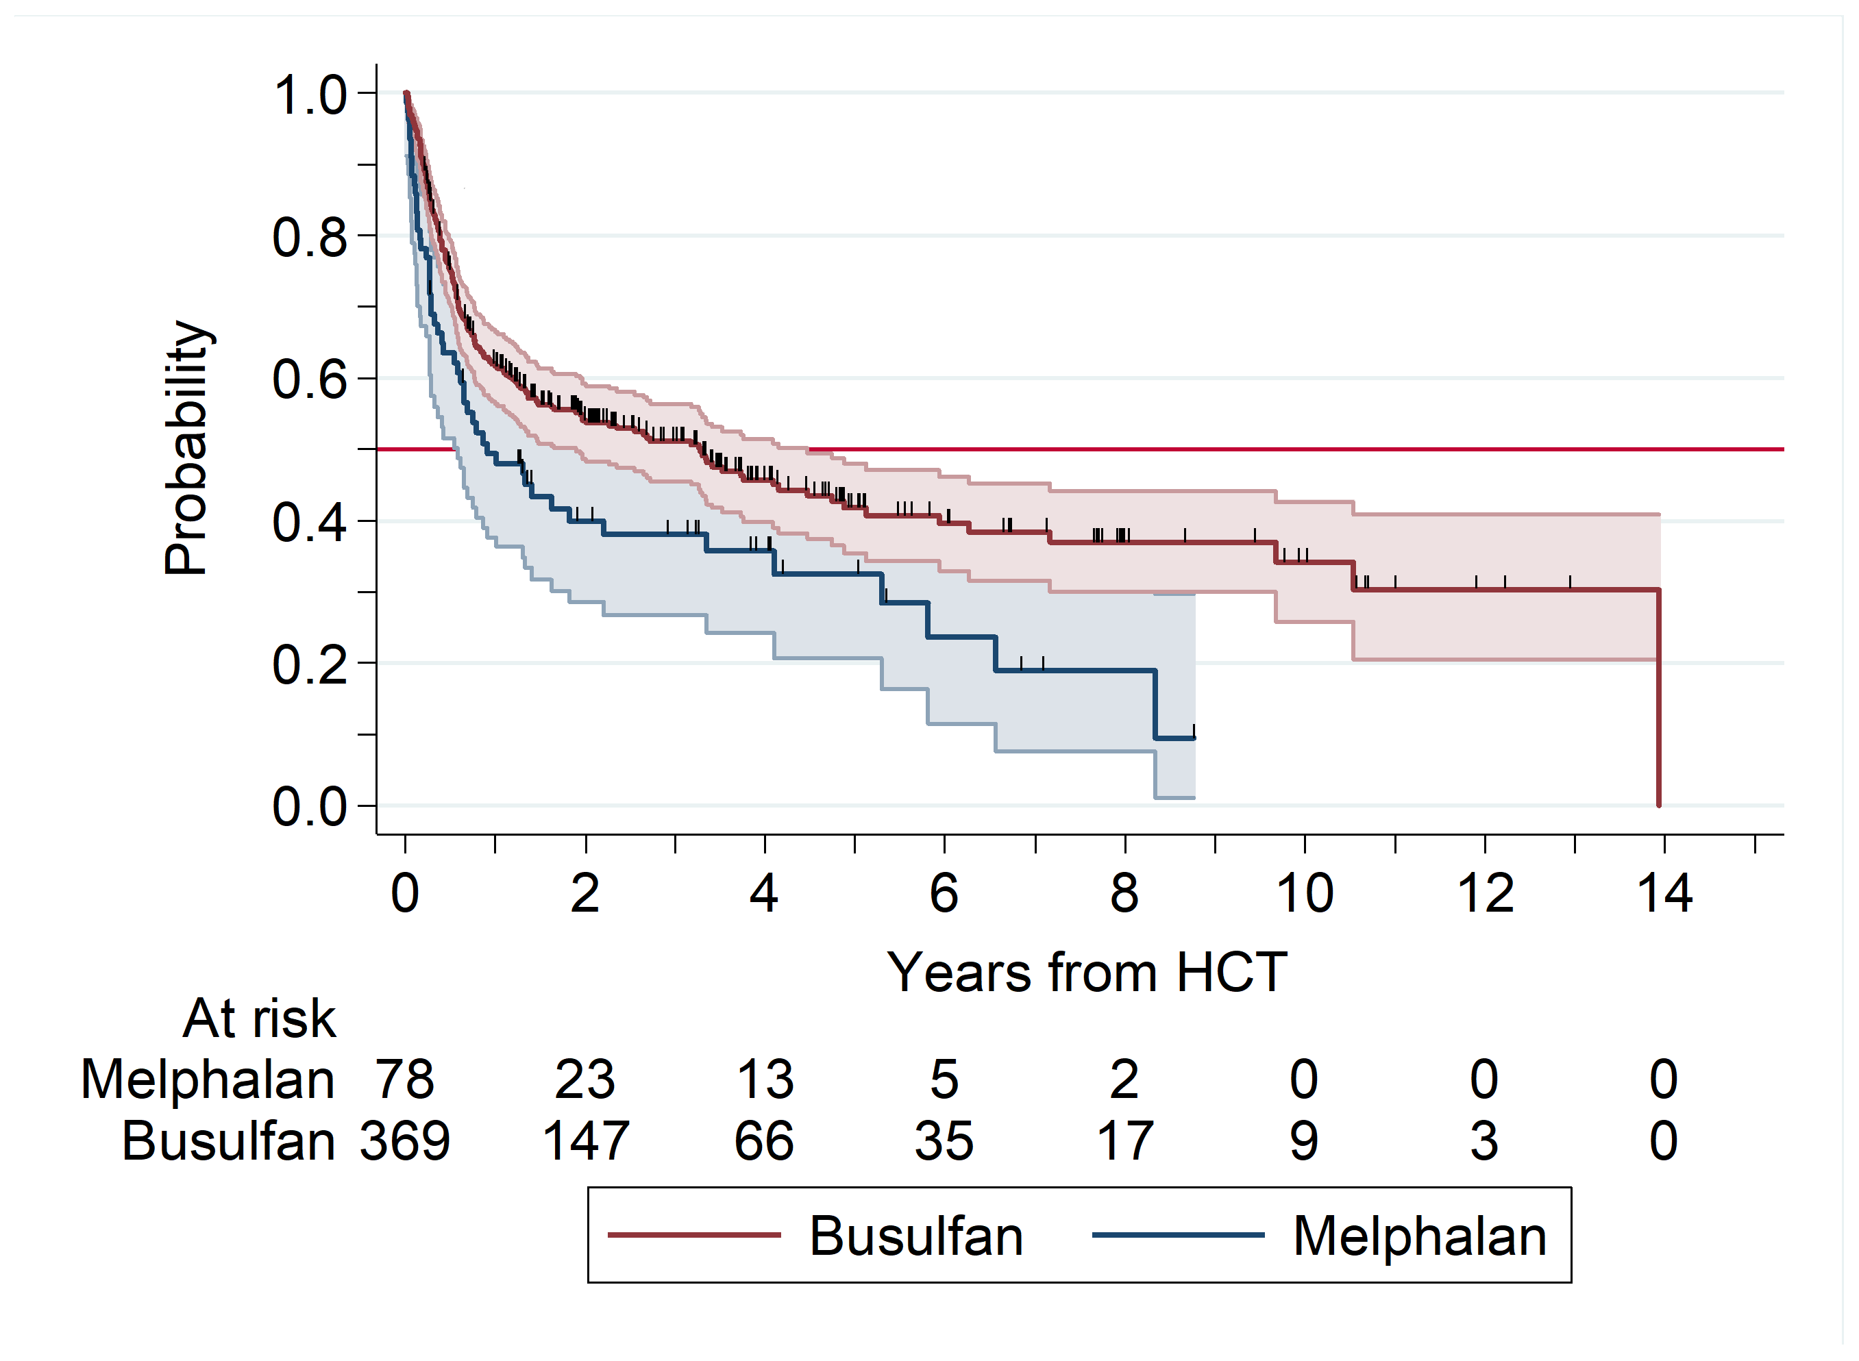

**Figure S3**. Cumulative incidence of relapse/progression and competing death without relapse/progression. Shaded areas represent the 95% CI .



**Figure S4**. Estimated survival in 176 myelofibrosis patients aged 65 to 76 years who were assigned to the intermediate-2 or high risk DIPSS categories at diagnosis and were managed with non-transplant treatment.

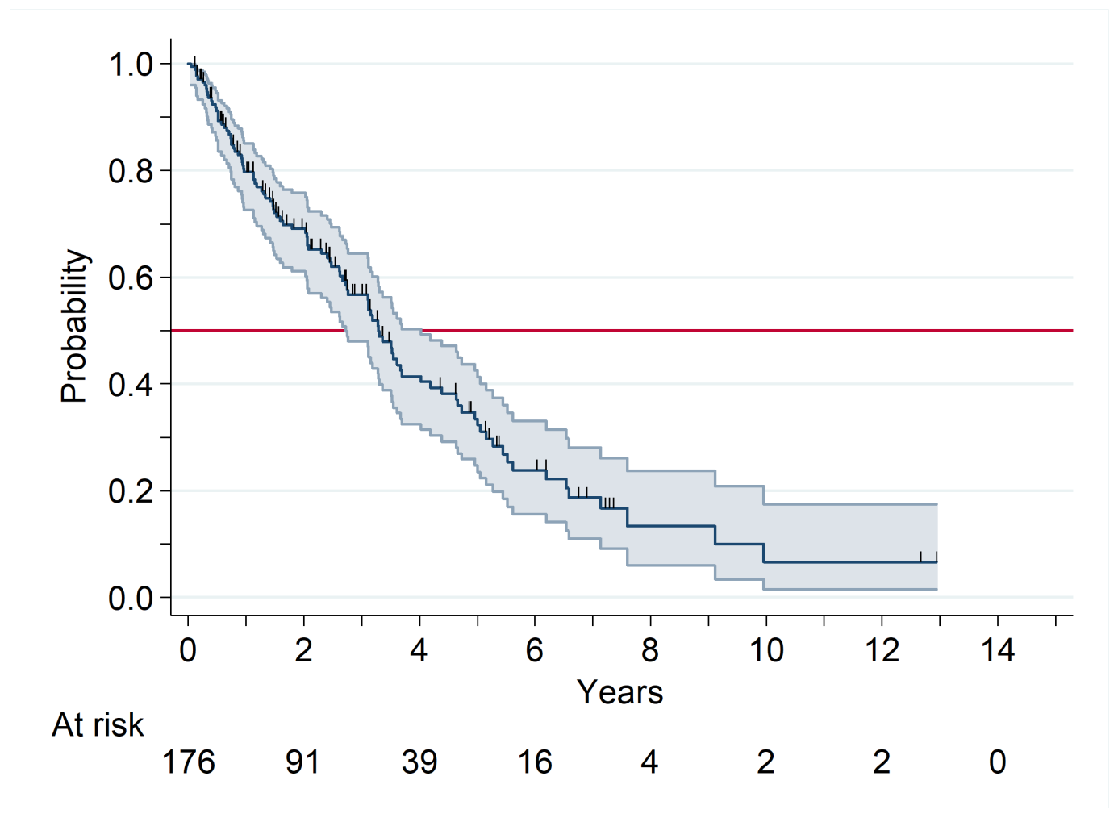

**Contributing EBMT centers**

Emanuele Angelucci, Ospedale San Martino, Genova, Italy; Jenny Byrne, Nottingham University, Nottingham, United Kingdom; Virginie Gandemer, Centre Hospitalier Universitaire de Rennes, Rennes, France; Wu Ka Lung, ZNA, Antwerp, Belgium; Mohamad Mohty, Hospital Saint Antione, Paris, France; Jakob Passweg, University Hospital, Basel, Switzerland; Jean Henri Bourhis, Gustave Roussy Cancer Campus, Val de Marne, France; Eva Maria Wagner-Drouet, University Medical Center Mainz, Mainz, Germany; David Beauvais, CHU de Lille, Univ Lille, INSERM U1286, Infinite, 59000 Lille; Yves Chalandon, Hôpitaux Universitaires De Genève, Geneva, Switzerland; Mercedes Colorado Araujo, Hospital U. Marqués de Valdecilla, Santander, Spain; Peter Dreger, University of Heidelberg, Heidelberg, Germany; Matthias Edinger, University of Regensburg, Regensburg, Germany; Pierre-Simon Rohrlich, CHU Nice - Hôpital de l'Archet I, Nice, France; Matthias Stelljes, University of Münster, Muenster, Germany; Joan Hendrik Veelken, Leiden University Hospital, Leiden, Netherlands; Wolfgang Bethge, Universitaet Tuebingen, Tuebingen, Germany; Amandine Charbonnier, CHU Amiens University of Amiens, Amiens, France; Stefan Klein, Universitaetsmedizin Mannheim, Mannheim, Germany; Wolfgang Rösler, University Hospital Erlangen, Erlangen, Germany; David Valcárcel, Hospital Vall d'Hebron, Barcelona, Spain; Gwendolyn van Gorkom, University Hospital Maastricht, Maastricht, Netherlands; Mareike Verbeek, Klinikum Rechts der Isar der Technischen Universitaet München; Yves Beguin, CHU Sart-Tilman University of Liege, Liege, Belgium; Jochen Casper, Klinikum Oldenburg, Oldenburg, Germany; Gandhi Damaj, CHU Caen, Caen, France; Arnold Ganser, Hannover Medical School, Hannover, Germany; Cecilia Isaksson, Umea University Hospital, Umeå, Sweden; Johan Maertens, University Hospital Gasthuisberg, Leuven, Belgium; Ellen Meijer, VU University Medical Center, Amsterdam, Netherlands; Arnon Nagler, Chaim Sheba Medical Center, Tel-Hashomer, Israel; Emma Nicholsson, Royal Marsden Hospital, London Surrey, United Kingdom; Murawski Nielsen, University of Saarland, Homburg (Saar), Germany; Manos Nikolousis, Birmingham Heartlands Hospital, Birmingham, United Kingdom; Xavier Poiré, Cliniques Universitaires St. Luc, Brussels, Belgium; Wilfried Schroyens, Antwerp University Hospital, Antwerp, Belgium; Dominik Selleslag, A.Z. Sint-Jan, Brugge, Belgium; Marie Robin, Hopital St. Louis, Paris, France; Igor Wolfgang Blau, Campus Virchow Klinikum CVK, Berlin, Germany; Donal Bunjes, Universitaetsklinikum Ulm, Ulm, Germany; Patrice Chevallier, CHU Nantes, Nantes, France; Fabio Ciceri, Ospedale San Raffaele s.r.l., Milan, Italy; Renato Fanin, Azienda Ospedaliero Universitaria di Udine, Udine, Italy; Sonja Martin, Robert-Bosch-Krankenhaus, Stuttgart, Germany; Sebastien Maury, Hôpital Henri Mondor, Creteil, France; Stephan Mielke, Karolinska University Hospital, Stockholm, Sweden; Kim Orchard, Southampton Gernal Hospital, Southampton, United Kingdom; Andy Peniket, Cancer and Haematology Centre Churchill Hospital, Oxford, United Kingdom; Victoria Potter, Kings College Hospital, London, United Kingdom; Rachel Protheroe, Avon Haematology Unit, Bristol, United Kingdom; Alessandro Rambaldi, AAST Papa Giovanni XXIII, Bergamo, Italy; Marie Thérèse Rubio, CHRU Brabois, Nancy, France; Kerstin Schäfer-Eckart, Klinikum Neurnberg, Nuernberg, Germany; John Snowden, Royal Hallamshire Hospital, Sheffield, United Kingdom; Gerald Wulf, Universitaetsklinkum Goettingen, Goettingen, Germany; Jacques-Olivier Bay, CHU Estaing, Clermont, France; Peter Brossart, Universitaet Bonn, Bonn, Germany; Claude Eric Bulabois, CHU Grenoble Alpes - Université Grenoble Aples, Grenoble, France; Dolores Caballero, Hospital Clínico, Salamanca, Spain; Jörg Cammenga, University Hospital, Linkoeping, Sweden; Goda Choi, University Medical Center Groningen, Groningen, Netherlands; Johannes Clausen, Elisabethinen-Hospital, Linz, Austria; Paolo Corradini, University of Milano, Milano, Italy; Charles Craddock, Queen Elizabeth Hospital, Birmingham, United Kingdom; Dries Deeren, AZ Delta, Roeselare, Belgium; Hildegard Greinix, LKH - University Hospital Graz, Graz, Austria; Denis Guyotat, Institut de Cancerologie Lucien Neuwirth, Saint Etienne, France; Anne Huynh, CHU - Institut Universitaire du Cancer Toulouse, Toulouse, France; Hélène Labussière-Wallet, Centre Hospitalier Lyon Sud, Lyon, France; Murray Martin, Leicester Royal Infirmary, Leicester, United Kingdom; Massimo Martino, Grande Ospedale Metropolitano, Reggio C, Italy; Grant McQuaker, Beatson West of Scotland Cancer Centre Gartnaval General Hospital, Glasgow, United Kingdom; Patrick Medd, University Hospital Plymouth NHS Trust Derriford Hospital, Plymouth, United Kingdom; Francesco Merli, Arcispedale S. Maria Nuova, Reggio E, Italy; Andreas Neubauer, Philipps Universitaet Marburg, Marburg, Germany; Pietro Pioltelli, Ospedale San Gerardo, Monza, Italy; Nicolaas Schaap, Radboud University - Nijmegen Medical Centre, Nijmegen, Netherlands; Johanna Tischer, Klinikum Groshadern, Munich, Germany; Nikolas von Bubnoff, University Medical Center Schleswig-Holstein, Luebeck, Germany; Tsila Zuckerman, Rambam Medical Center, Haifa, Israel; Juan Pio Torres Carrete, Complejo Hospitalario de A Coruna, La Coruna, Spain; Fabio Benedetti, Policlinico G.B. Rossi, Verona, Italy; Francesca Bonifazi, Bologna University, S.Orsola-Malpighi Hospital, Bologna, Italy; Benedetto Bruno, S.S.C.V.D. Trapianto di Cellule Staminali A.O.U. Citta della Salute e della Scienza di Torino, Torino, Italy; Paola Carluccio, Azienda Ospedaliero Universitaria Policlinico Bari, Bari, Italy; Ben Carpenter, University College London Hospital, London, United Kingdom; Matthew Collin, Freeman Hospital, Newcastle, United Kingdom; Marco Casini Comprensorio Sanitario di Bolzano, Bolzano, Italy; Nicola Di Renzo, Presidio Ospedaliero Vito Fazzi, Lecce, Italy; Ahmet  Elmaagacli, Asklepios Klinik St. Georg, Hamburg, Germany; Nathalie Fegueux, CHU Lapeyronie, Montpellier, France; John Gribben, St. Bartholomew's and the Royal London NHS Trust, London, United Kingdom; Mathias Haenel, Klinikum Chemnitz GmbH, Chemnitz, Germany; Thomas Heinicke, Universitaetsklinkum Magdeburg, Magdeburg, Germany; Olivier Hermine, Hôpital Necker, Paris, France; Mathilde Hunault-Berger, CHRU Service des Maladies du Sang, Angers, France; Jan-Erik Johansson, Sahlgrenska University Hospital, Goeteborg, Sweden; Edgar Jost, University Hospital Aachen, Aachen, Germany; Peter  Kalhs, Medizinische Universitaet Wien, Vienna, Austria; Guido Kobbe, Heinrich Heine Universitaet, Duesseldorf, Germany; Marco Casini Ladetto, H S. Antonio e Biagio, Alessandria, Italy; Xavier Leleu, Hopital La Miletrie, Poitiers, France; Joaquin Martínez López, Hospital Univ. 12 de Octubre, Madrid, Spain; Patrizio Mazza, Ospedale Nord, Taranto, Italy; Noel Milpied, CHU Bordeaux, Pessac, France; Nicola Mordini, Az. Ospedaliera S. Croce e Carle, Cuneo, Italy; Maurizio Musso, Ospedale La Maddalena, Palermo, Italy; Bendt Nielsen, Arhus Amtssygehus, Aarhus, Denmark; Erfan Nur, Amsterdam University Medical Center, Amsterdam, Netherlands; Attilio Olivieri, Azienda Ospedali Riuniti di Ancona, Ancona, Italy; Amit Patel, Royal Liverpool University Hospital, Liverpool, United Kingdom; Josep Maria Ribera Santasusana, ICO-Hospital Universitari Germans Trias I Pujol, Badalona, Spain; Mark Ringhoffer, Klinikum Karlsruhe GmbH, Karlsruhe, Germany; Stella Santarone, Ospedale Civile, Pescara, Italy; Jaime Sanz, Hospital Universitari I politècnic La Fe, Valencia, Spain; Urs Schanz, University Hospital, Zürich, Switzerland; Christof Scheid, University of Cologne, Cologne, Germany; Christoph Schmid, Klinikum Augsburg, Augsburg, Germany; Rosanna Scimè, U.O.D. Trapianti di midollo osseo, Palermo, Italy; Simona Sica, Universita Cattolica S. Cuore, Rome, Italy; Jorge Sierra, Hospital Santa Creu I Sant Pau, Barcelona, Spain; Polina Stepensky, Hadassah University Hospital, Jerusalem, Israel; Corrado  Tarella, European Institute of Oncology, Milan, Italy; Pascal Turlure, CHRU Limoges, Limoges, France; Carlos Vallejo Llamas, Hospital Universitario Donostia, S Sebastian Gipuzkoa, Spain; Teresa Zudaire, Complejo Hospitalario de Navarra, Pamplona, Spain.

**Contributing GEMFIN centers**

Raquel Fernández Ordoño, HOSPITAL UNIVERSITARIO INFANTA LEONOR; Mª José Ramírez, HOSPITAL DE ESPECIALIDADES DE JEREZ DE LA FRONTERA; Ángel Ramírez Páyer, HOSPITAL UNIVERSITARIO CENTRAL DE ASTURIAS; José Ángel Hernández Rivas, HOSPITAL UNIVERSITARIO INFANTA LEONOR; Silvia García Palomares, HOSPITAL UNIVERSITARI I POLITÈCNIC LA FE; María Casanova, HOSPITAL RAMÓN Y CAJAL; Alberto Álvarez-Larran, HOSPITAL CLINIC I PROVINCIAL DE BARCELONA, SEU SABINO DE ARANA; Anna Angona, INSTITUT CATALÀ D''ONCOLOGIA GIRONA (ICO); Laura Fox, HOSPITAL UNIVERSITARI VALL D'HEBRON; Maria García Fortés, HOSPITAL VIRGEN DE LA VICTORIA; Elvira Gómez Sanz, HOSPITAL UNIVERSITARIO DEL SURESTE; María Teresa Gómez Casares, HOSPITAL DE GRAN CANARIA DR. NEGRIN; Ana Esther Kerguelen Fuentes, HOSPITAL UNIVERSITARIO LA PAZ; Santiago Osorio, COMPLEJO HOSPITALARIO GREGORIO MARAÑÓN; Raúl Pérez López, HOSPITAL CLÍNICO UNIVERSITARIO VIRGEN DE LA ARRIXACA; Rosa María Ayala Díaz, HOSPITAL UNIVERSITARIO 12 DE OCTUBRE; Beatriz López Pulido, HOSPITAL DE ESPECIALIDADES DE JEREZ DE LA FRONTERA; Regina García Delgado, HOSPITAL VIRGEN DE LA VICTORIA; Juan Manuel Alonso Domínguez, HOSPITAL UNIVERSITARIO FUNDACIÓN JIMÉNEZ DÍAZ; María Dolores Carrera Merino, HOSPITAL ARNAU DE VILANOVA VALENCIA; Lucía Guerrero Fernández, HOSPITAL RIO CARRIÓN; Ilda María Murillo Florez, HOSPITAL GENERAL SAN JORGE; Beatriz Cuevas, HOSPITAL UNIVERSITARIO DE BURGOS; M. Teresa Cobo, HOSPITAL UNIVERSITARIO DEL SURESTE; Montserrat Cortés Sansa, HOSPITAL GENERAL DE GRANOLLERS; Silvia Oliete, HOSPITAL CLÍNICO UNIVERSITARIO LOZANO BLESA; María José Fernández Llavador, HOSPITAL UNIVERSITARIO DR. PESET; Elena Magro Mazo, HOSPITAL UNIVERSITARIO PRÍNCIPE DE ASTURIAS; Elvira Mora, HOSPITAL UNIVERSITARI I POLITÈCNIC LA FE; Jesús Mª Hernández Rivas, HOSPITAL UNIVERSITARIO DE SALAMANCA; Inmaculada Llopis Calatayud, HOSPITAL UNIVERSITARIO DE LA RIBERA; Antonio Cerveró, CONSORCIO HOSPITAL GENERAL UNIVERSITARIO DE VALENCIA; Nieves Somolinos de Marcos, HOSPITAL UNIVERSITARIO DE GETAFE; Francisca Mª Hernández Mohedo, HOSPITAL SAN CECILIO; Pilar Portasany, HOSPITAL UNIVERSITARIO 12 DE OCTUBRE; Maria Luisa Martín Mateos, HOSPITAL SAN PEDRO DE ALCANTARA; Natalia De Heras Rodriguez, HOSPITAL DE LEÓN; Maria Victoria Cuevas Ruiz, HOSPITAL UNIVERSITARIO DE BURGOS; Juan Carlos Hernández Boluda, HOSPITAL CLÍNICO UNIVERSITARIO VALENCIA; Francisca Ferrer, HOSPITAL J.M. MORALES MESEGUER; Gonzalo Caballero, HOSPITAL UNIVERSITARIO MIGUEL SERVET; María Antonia Durán Pastor, HOSPITAL UNIVERSITARI SON ESPASES; Carmen García Hernández, HOSPITAL GENERAL UNIVERSITARIO DE ALICANTE; Elisa Arbelo Granados, HOSPITAL VIRGEN MACARENA; Carlos Fernández Lago, COMPLEXO HOSPITALARIO UNIVERSITARIO A CORUÑA; María Concepción Ruíz Nuño, COMPLEJO HOSPITALARIO REGIONAL DE MÁLAGA; Concepción Boqué Genovard, INSTITUT CATALÀ D''ONCOLOGIA L''HOSPITALET (ICO); Blanca Xicoy Cirici, HOSPITAL UNIVERSITARI GERMANS TRIAS I PUJOL DE BADALONA; José María Raya Sánchez, HOSPITAL UNIVERSITARIO DE CANARIAS (H.U.C); Pilar Aragües, HOSPITAL UNIVERSITARIO DE CRUCES; Manuel Pérez Encinas, COMPLEXO HOSPITALARIO UNIVERSITARIO DE SANTIAGO; Alberto Cantalapiedra Díez, HOSPITAL UNIVERSITARIO RIO HORTEGA; Dolors Vela Payan, HOSPITAL GENERAL DE GRANOLLERS; Clara Martínez Valverde, HOSPITAL DE LA SANTA CREU I SANT PAU; Armando Luaña Galán, HOSPITAL UNIVERSITARI ARNAU DE VILANOVA DE LLEIDA; Raúl Córdoba Mascuñano, HOSPITAL UNIVERSITARIO INFANTA SOFÍA; Mª Isabel Montero Cuadrado, HOSPITAL VIRGEN DEL ROCÍO; Berta Valls, INSTITUT CATALÀ D''ONCOLOGIA GIRONA (ICO); Asunción Peña, HOSPITAL CLÍNICO SAN CARLOS; Francisco Ibáñez Alís, CONSORCIO HOSPITAL GENERAL UNIVERSITARIO DE VALENCIA; Gabriela Silva Carreras, HOSPITAL UNIVERSITARIO DE LA PRINCESA; Janilson Do Nascimiento Ferreira, HOSPITAL UNIVERSITARI JOAN XXIII DE TARRAGONA; José Antonio Moreno Chulilla, HOSPITAL CLÍNICO UNIVERSITARIO LOZANO BLESA; María Nieves Sáez Perdomo, GERENCIA HOSPITAL UNIVERSITARIO DE GRAN CANARIA DR. NEGRÍN; Marta Fernández González, HOSPITAL UNIVERSITARIO DE CANARIAS (H.U.C); Raquel Pla García, HOSPITAL J.M. MORALES MESEGUER; Sonia González de Villambrosia, HOSPITAL UNIVERSITARIO MARQUÉS DE VALDECILLA; Miriam Gutiérrez Serrano, HOSPITAL UNIVERSITARIO INFANTA SOFÍA; María Ángeles Goñi Herranz, COMPLEJO HOSPITALARIO DE NAVARRA; Pepi Delgado Santiago, HOSPITAL GENERAL JUAN RAMÓN JIMENEZ; Alejandro Avendaño Pita, HOSPITAL UNIVERSITARIO DE SALAMANCA; Iryna Luts Khoroz, HOSPITAL NUESTRA SEÑORA DEL PRADO; Ana Valdivielso López, HOSPITAL GENERAL DE LLERENA; María Luisa Antelo Caamaño, COMPLEJO HOSPITALARIO DE NAVARRA; Ángela Martínez Hellín, HOSPITAL SAN CECILIO; Virginia Cardos Gómez, HOSPITAL GENERAL DE SEGOVIA; Ángeles Escolá Rivas, CONSORCIO HOSPITALARIO PROVINCIAL DE CASTELLÓN; Tamara Arias Fernández, HOSPITAL UNIVERSITARIO CENTRAL DE ASTURIAS; Ana Lerma Verdejo, HOSPITAL NUESTRA SEÑORA DEL PRADO; Josefa Marco Buades, HOSPITAL UNIVERSITARIO DR. PESET; Marcio Andrade Campos, HOSPITAL DEL MAR; Rosana Díez Angulo, HOSPITAL UNIVERSITARIO MIGUEL SERVET; Miriam Ratia, INSTITUT CATALÀ D''ONCOLOGIA L''HOSPITALET (ICO); Rosalía Bustelos Rodríguez, HOSPITAL UNIVERSITARIO DEL SURESTE; José Ramón Álamo Moreno, HOSPITAL UNIVERSITARIO PUERTA DE HIERRO MAJADAHONDA; Miguel Ángel Cortés Vázquez, HOSPITAL UNIVERSITARIO MARQUÉS DE VALDECILLA; Miriam Castillo Rodríguez, HOSPITAL J.M. MORALES MESEGUER; Damir Blazevic, INSTITUT CATALÀ D''ONCOLOGIA L''HOSPITALET (ICO); Isabel Recio Rueda, HOSPITAL PROVINCIAL DE ÁVILA; Isabel Navarro, HOSPITAL ARNAU DE VILANOVA VALENCIA; Mª Isabel Mata Vázquez, COMPLEJO HOSPITAL COSTA DEL SOL.