Supporting Information
¹H, ¹³C and ¹⁵N chemical shift assignment of the stem-loops 5b + c from the 5'-UTR of SARS-CoV-2

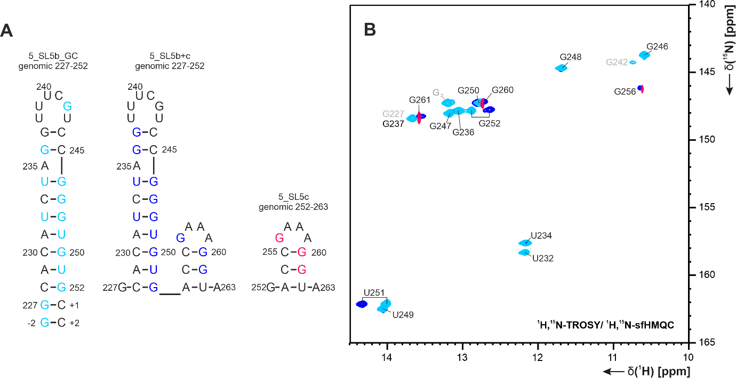
SI Figure 1: A Predicted secondary structures of RNAs used for the divide-and-conquer approach of element SL5b+c. B Comparison of ¹H,¹⁵N-imino regions of SL5b+c to SL5b_GC and SL5c to verify consistent secondary structure by chemical shift similarity of sub-elements at 283 K (for experimental data see Table 1 I, SI Table 1 I, and SI Table 2 I).

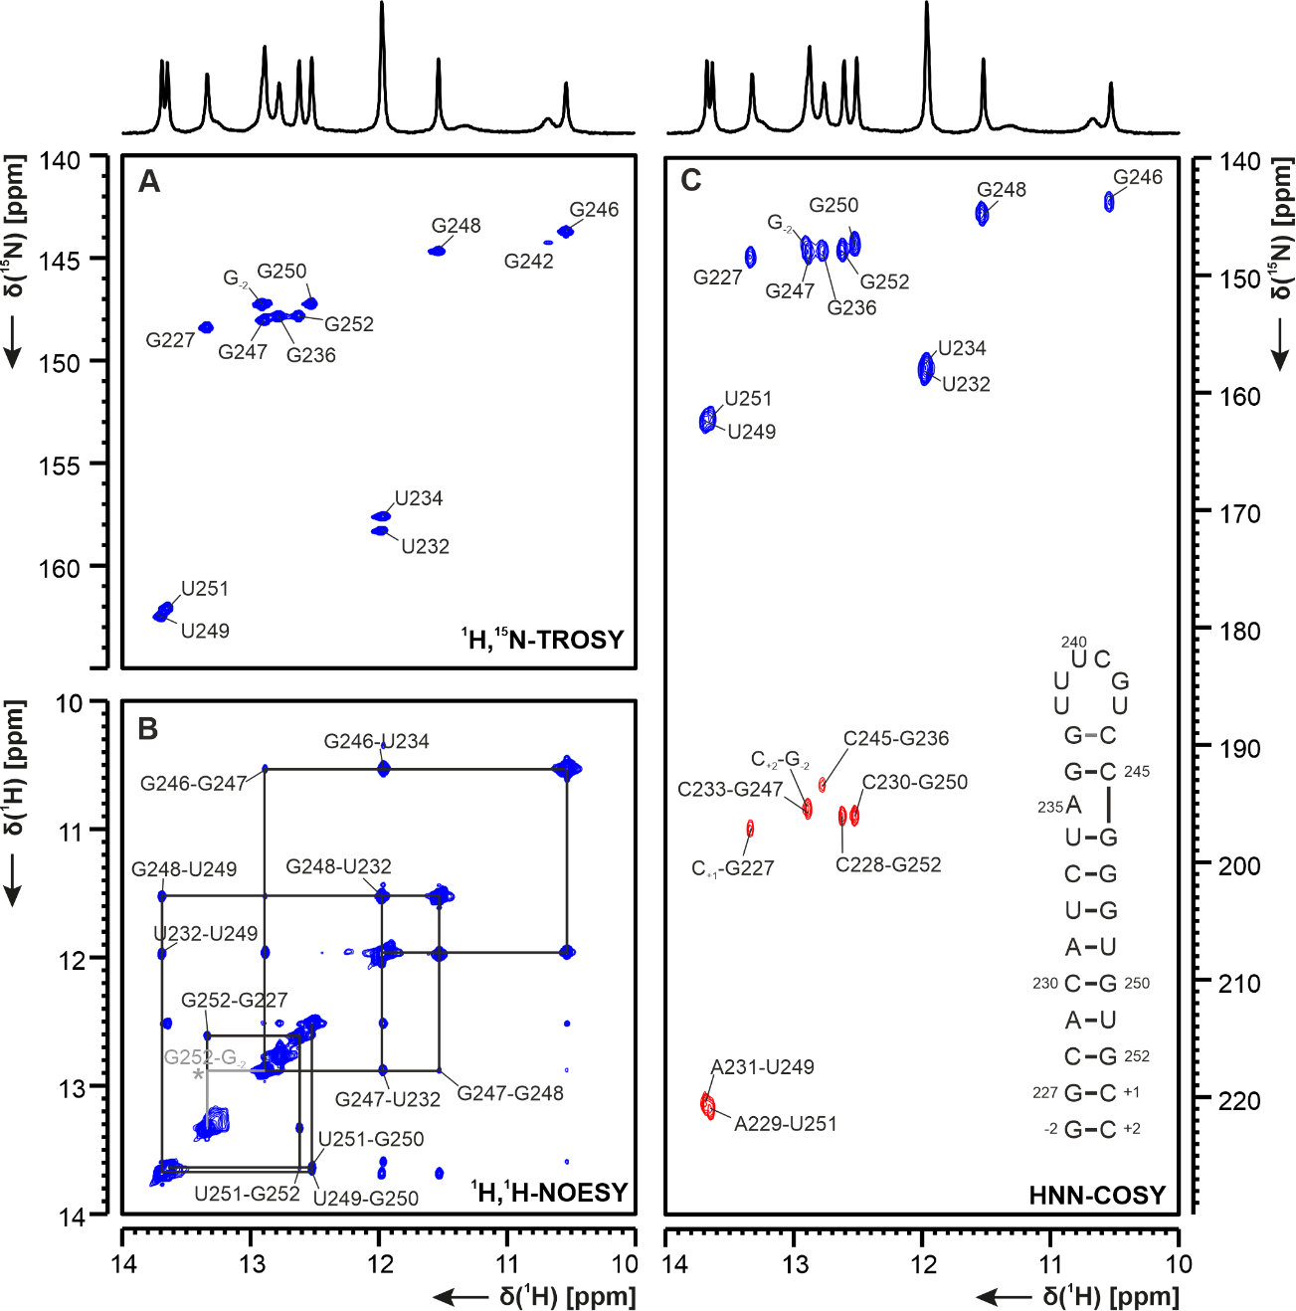
SI Figure 2 A ¹H,15N-TROSY, B ¹H,¹H-NOESY and C HNN-COSY spectra for imino-proton correlation of SL5b_GC at 283K. Positive contours are given in blue, negative contours in red. The imino-proton correlations are annotated using the genomic numbering. Imino-proton correlations in B of closing base pairs are shown in grey, * denote crosspeak visible at lower contour setting. Included in C is the overall experimentally observed secondary structure of SL5b_GC with genomic numbering. Additional closing base pairs are annotated with ‘±x’. For experimental data see SI Table 1 I-III.

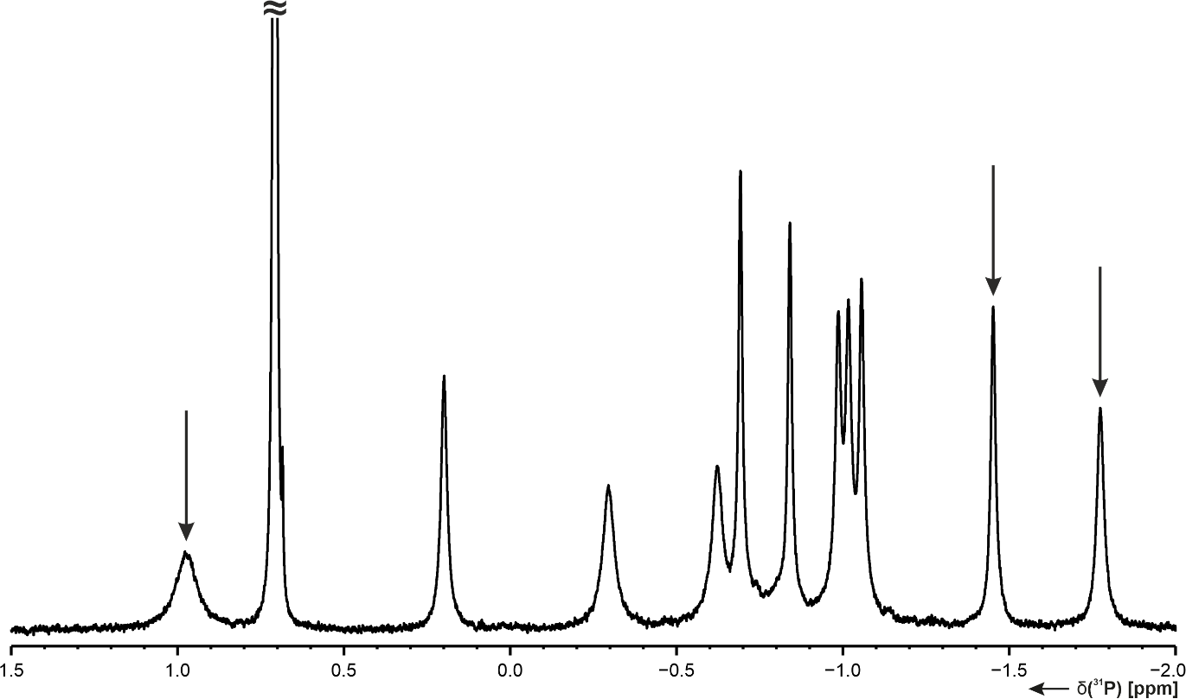
SI Figure 3 ³¹P 1D spectrum of the SL5c GAAA tetraloop at 298 K in buffer (100% D₂O). Highlighted by arrows are typical GAAA tetraloop shift patterns for ³¹P as described in the literature (Legault & Pardi, 1994).

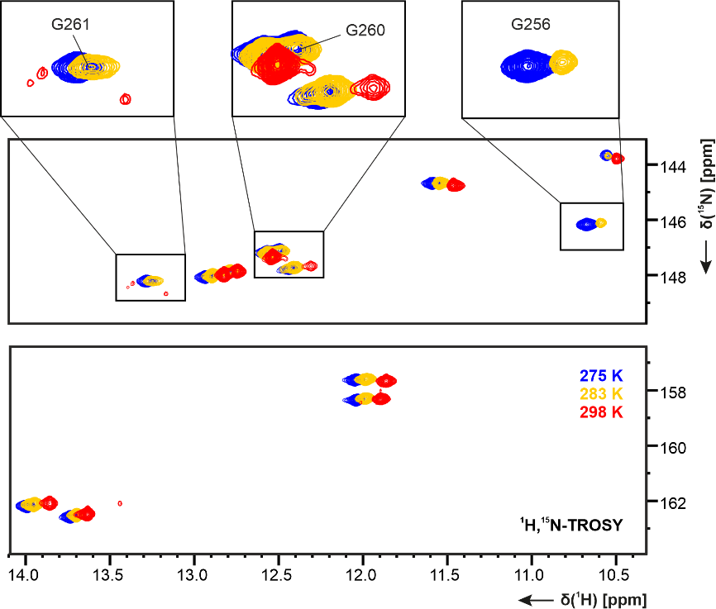
SI Figure 4 ¹H,¹⁵N-TROSY-based comparison of SL5b+c measured between 275 K and 298 K showing temperature response of the 15 imino signals (experimental information of spectra in Table 1 I). The signals of SL5c G256, G260, and G261 are not detectable at 298 K.

SI Table 1 List of NMR experiments for SL5b_GC conducted at BMRZ at temperatures a: 278 K, b: 283 K or c: 298 K. Spectra were recorded in NMR buffer with A: 95% H₂O/ 5% D₂O or B: 100% D₂O. Experimental parameters and experiment-specific parameters are given. ns = number of scans, sw = spectral width, aq = acquisition time, o1/2/3 = carrier frequencies on channels 1/2/3, rel. delay = relaxation delay, CT = constant time, JR = jump-return, fw = forward.
# | NMR experiment | Experimental parameters | Characteristic parameters
I | ¹H,¹⁵N-TROSY^{BMRZ} | A a 700 MHz, ns: 16, sw(f2): 21.0 ppm, sw(f1): 24.6 ppm, aq(f2): 68.6 ms, aq(f1): 73.1 ms, o1(¹H): 4.7 ppm, o2(¹³C): 101 ppm, o3(¹⁵N): 153 ppm, rel. delay: 0.3 s, time: 30 min  A b 600 MHz, ns: 8, sw(f2): 24.0 ppm, sw(f1): 25.3 ppm, aq(f2):62.3 ms, aq(f1): 83.2 ms, o1(¹H): 4.7 ppm, o2(¹³C): 101 ppm, o3(¹⁵N): 153 ppm, rel. delay: 0.3 s, time: 15 min  A c 800 MHz, ns: 16, sw(f2): 21.0 ppm, sw(f1): 24.6 ppm, aq(f2): xx ms, aq(f1): 60.0 ms, o1(¹H): 4.7 ppm, o2(¹³C): 101 ppm, o3(¹⁵N): 153 ppm, rel. delay: 0.3 s, time: 1 h
II | ¹H,¹⁵N-HNN-COSY^{BMRZ} | A b 600 MHz, ns: 16, sw(f3,¹H): 8.75 ppm, sw(f2,¹⁵N): 90 ppm, sw(f1,¹⁵N): 120 ppm, aq(f3): 62.7 ms, aq(f2): 0.09 ms, aq(f1): 13.1 ms, o1(¹H): 4.7 ppm, o2(¹³C): 185 ppm, o3(¹⁵N): 185 ppm, rel. delay: 0.3 s, time: 2 h  A c 600 MHz, ns: 64, sw(f3,¹H): 19.8 ppm, sw(f2,¹⁵N): 30 ppm, sw(f1,¹⁵N): 100 ppm, aq(f3): 105 ms, aq(f2): 0.03 ms, aq(f1): 31.7 ms, o1(¹H): 4.7 ppm, o2(¹³C): 183 ppm, o3(¹⁵N): 183 ppm, rel. delay: 0.3 s, time: 3 h 35 min
III | ¹H,¹H-NOESY^{BMRZ}  jump-return water suppression | A b 600 MHz, ns: 128, sw(f2): 20.8 ppm, sw(f1): 11.9 ppm, aq(f2): 31.4 ms, aq(f1): 63.28 ms, o1(¹H): 4.7 ppm, o2(¹³C): 105 ppm, o3(¹⁵N): 153 ppm, rel. delay: 1.0 s, time: 19 h 40 min  A c 800 MHz, ns: 224, sw(f2): 21.1 ppm, sw(f1): 11.9 ppm, aq(f2): 60.6 ms, aq(f1): 18.5 ms, o1(¹H): 4.7 ppm, o2(¹³C): 120 ppm, o3(¹⁵N): 153 ppm, rel. delay: 1.0 s, time: 5 h | b NOE mixing time 150 ms, JR-delay 50 µs  c NOE mixing time 250 ms, JR-delay 39 µs
IV | ¹H,¹⁵N-HSQC^{BMRZ}  Amino  (Mori et al. 1995) | A a 700 MHz, ns: 8, sw(f2): 9.8 ppm, sw(f1): 32.9 ppm, aq(f2): 74.5 ms, aq(f1): 41.1 ms, o1(¹H): 4.7 ppm, o2(¹³C): 101 ppm, o3(¹⁵N): 86 ppm, rel. delay: 0.8 s, time: 23 min  A b 600 MHz, ns: 32, sw(f2): 10 ppm, sw(f1): 30.8 ppm, aq(f2): 85.2 ms, aq(f1): 68.2 ms, o1(¹H): 4.7 ppm, o2(¹³C): 101 ppm, o3(¹⁵N): 86.5 ppm, rel. delay: 0.8 s, time: 2 h | INEPT transfer time 2.2 ms (¹J_{NH} 110 Hz)
V | ¹H,¹H-xf-NOESY^{BMRZ}  xf: selectively filtering N-bond protons, watergate water suppression  (Ikura and Bax 1992; Piotto et al. 1992; Sklenáŕ et al. 1993) | A c 800 MHz, ns: 128, sw(f2): 10 ppm, sw(f1): 6.25 ppm, aq(f2): 64 ms, aq(f1): 49.6 ms, o1(¹H): 4.7 ppm, o2(¹³C): 115 ppm, o3(¹⁵N): 86 ppm, rel. delay: 1.0 s, time: 27 min | NOE mixing time 250 ms
VI | ¹H,¹H-TOCSY^{BMRZ}  excitation sculpting water suppression  (Shaka et al. 1988; Hwang and Shaka 1995) | A c 800 MHz, ns: 32, sw(f2): 8.75 ppm, sw(f1): 6.25 ppm, aq(f2): 99.8 ms, aq(f1): 51.2 ms, o1(¹H): 4.7 ppm, o2(¹³C): 101 ppm, o3(¹⁵N): 86 ppm, rel. delay: 1.0 s, time: 5 h 32 min | CC-TOCSY mixing time 40 ms
VII.1 | ¹H,¹³C-HSQC^{BMRZ}  aromatic region, H-C2/6/8 | A c 800 MHz, ns: 4, sw(f2): 8.3 ppm, sw(f1): 24.0 ppm, aq(f2): 76.8 ms, aq(f1): 39.8 ms, o1(¹H): 4.7 ppm, o2(¹³C): 143 ppm, o3(¹⁵N): 150 ppm, rel. delay: 1.0 s, time: 40 min | INEPT transfer time 2.5 ms (¹J_{CH} 200 Hz), off-resonant Q3 shaped pulse for C5 decoupling at 99 ppm with 15 ppm bandwidth
VII.2 | ¹H,¹³C-HSQC^{BMRZ}  aromatic region, H-C5 | A c 800 MHz, ns: 4, sw(f2): 9.0 ppm, sw(f1): 20.0 ppm, aq(f2): 79.8 ms, aq(f1): 63.6 ms, o1(¹H): 4.7 ppm, o2(¹³C): 99 ppm, o3(¹⁵N): 185 ppm, rel. delay: 1.0 s, time: 40 min | INEPT transfer time 2.8 ms (¹J_{CH} 180 Hz), off-resonant Q3 shaped pulse for C2/6/8 decoupling at 150 ppm with 40 ppm bandwidth
VII.3 | ¹H,¹³C-HSQC^{BMRZ}  ribose region, H-C1’ | A c 800 MHz, ns: 4, sw(f2): 9.0 ppm, sw(f1): 20.0 ppm, aq(f2): 79.8 ms, aq(f1): 63.6 ms, o1(¹H): 4.7 ppm, o2(¹³C): 90 ppm, o3(¹⁵N): 158.5 ppm, rel. delay: 1.0 s, time: 40 min | INEPT transfer time 2.9 ms (¹J_{CH} 170 Hz), off-resonant Q3 shaped pulse for C2’ decoupling at 72 ppm with 12 ppm bandwidth
VIII | ¹H,¹³C-ct-HSQC^{BMRZ}  full  (Vuister and Bax 1992) | A c 600 MHz, ns: 8, sw(f2): 8.33 ppm, sw(f1): 37.88 ppm, aq(f2): 102.4 ms, aq(f1): 44.8 ms, o1(¹H): 4.7 ppm, o2(¹³C): 77 ppm, o3(¹⁵N): 155 ppm, rel. delay: 1.0 s, time: 1 h 20 min | INEPT transfer time 1.5 ms (¹J_{CH} 165 Hz), CT period 25 ms (¹J_{CC} 40 Hz)
IX | (H)C(CCN)H^{BMRZ}  imino-to-aromatics  (Piotto et al. 1992; Sklenář et al. 1996) | A c 600 MHz, ns: 336, sw(f3): 20.9 ppm, sw(f2): 9.9 ppm, aq(f3): 90.2 ms, aq(f2): 42.6 ms, o1(¹H): 4.7 ppm, o2(¹³C): 137 ppm, o3(¹⁵N): 154 ppm, rel. delay: 1.8 s, time: 1 d 33 min | CC-TOCSY mixing time 28 ms
X | H(N)CO^{BMRZ}  imino-to-carbon  (Favier and Brutscher 2011; Solyom et al. 2013) | A c 600 MHz, ns: 512, sw(f3): 21.0 ppm, sw(f1): 22.1 ppm, aq(f3): 62.6 ms, aq(f1): 19.2 ms, o1(¹H): 4.7 ppm, o2(¹³C): 159 ppm, o3(¹⁵N): 153 ppm, rel. delay: 0.3 s, time: 8 h 31 min | NC-INEPT transfer time 18 ms (¹J_{CN} 28 Hz)
XI | 3D ¹³C-NOESY-HSQC^{BMRZ}  aromatics and ribose  (Piotto et al. 1992; Sklenáŕ et al. 1993) | A c 800 MHz, ns: 16, sw(f3,¹H): 8.75 ppm, sw(f2,¹³C): 21.06 ppm, sw(f1,¹H): 6.25 ppm, aq(f3): 73.1 ms, aq(f2): 9.4 ms, aq(f1): 20.0 ms, o1(¹H): 4.7 ppm, o2(¹³C): 137 ppm, o3(¹⁵N): 154 ppm, rel. delay: 0.9 s, time: 22 h (NUS) | NOE mixing time 200 ms, HSQC transfer time 1.4 ms (¹J_{CH} 180 Hz)
XII | 3D TROSY-HCCH-COSY^{BMRZ}  adenine C2-to-C8  (Simon et al. 2001) | B c 600 MHz, ns: 16, sw(f3,¹H): 8.75 ppm, sw(f2,¹³C): 22.1 ppm, sw(f1,¹³C): 58.47 ppm, aq(f3): 97 ms, aq(f2): 9.5 ms, aq(f1): 7.25 ms, o1(¹H): 4.7 ppm, o2(¹³C): 142.5 ppm, o3(¹⁵N): 150 ppm, rel. delay: 1.0 s, time: 1 d 20 h | Bruker standard parameter set
XIII.1 | 3D HCCH-TOCSY^{BMRZ}  ribose C1’-to-C2’  (Kay et al. 1993; Richter et al. 2010) | A c 800 MHz, ns: 8, sw(f3,¹H): 8.56 ppm, sw(f2,¹³C): 9.47 ppm, sw(f1,¹³C): 35.5 ppm, aq(f3): 74.7 ms, aq(f2): 21.0 ms, aq(f1): 8.96 ms, o1(¹H): 4.7 ppm, o2(¹³C): 76.5 ppm, o3(¹⁵N): 153 ppm, rel. delay: 1.0 s, time: 1 d 3 h | CC-TOCSY mixing time 5.4 ms
XIII.2 | 3D HCCH-TOCSY^{BMRZ}  ribose C1’-to-C5’  (Kay et al. 1993; Richter et al. 2010) | A c 800 MHz, ns: 8, sw(f3,¹H): 8.56 ppm, sw(f2,¹³C): 9.47 ppm, sw(f1,¹³C): 35.5 ppm, aq(f3): 74.7 ms, aq(f2): 21.0 ms, aq(f1): 11.2 ms, o1(¹H): 4.7 ppm, o2(¹³C): 76.5 ppm, o3(¹⁵N): 153 ppm, rel. delay: 0.97 s, time: 1 d 9 h 20 min | CC-TOCSY mixing time 16 ms
XIV | 3D HCN^{BMRZ}  C6/8-N1/9-C1’  (Sklenář et al. 1993) | A c 600 MHz, ns: 32, sw(f3,¹H): 8.33 ppm, sw(f2,¹³C): 13.25 ppm, sw(f1,¹⁵N): 41.1 ppm, aq(f3): 102.4 ms, aq(f2): 14.0 ms, aq(f1): 25.6 ms, o1(¹H): 4.7 ppm, o2(¹³C): 115 ppm, o3(¹⁵N): 158 ppm, rel. delay: 1.0 s, time: 22 h (NUS)
XV | 3D fw directed HCC-TOCSY-CCH^{BMRZ}  ribose H1’-to-H3’  (Schwalbe et al. 1995; Marino et al. 1995; Glaser et al. 1996) | A c 600 MHz, ns: 8, sw(f3,¹H): 8.33 ppm, sw(f2,¹³C): 38.54 ppm, sw(f1,¹H): 4.17 ppm, aq(f3): 102.4 ms, aq(f2): 8.25 ms, aq(f1): 35.2 ms, o1(¹H): 4.7 ppm, o2(¹³C): 77 ppm, o3(¹⁵N): 155 ppm, rel. delay: 1.0 s, time: 1 d 22 h | CC-TOCSY mixing time 9.2 ms

SI Table 2: List of NMR experiments for SL5c conducted at BMRB at 283 K if not noted otherwise. Spectra were recorded in NMR buffer with A: 95% H₂O/ 5% D₂O or B: 100% D₂O. Experimental parameters and experiment-specific parameters are given. ns = number of scans, sw = spectral width, aq = acquisition time, o1/2/3 = carrier frequencies on channels 1/2/3, rel. delay = relaxation delay, JR = jump-return.
# | NMR experiment | Experimental parameters | Characteristic parameters
I | ¹H,¹⁵N-sfHMQC^{BMRZ}  (Schanda and Brutscher 2005) | A 600 MHz, ns: 4096, sw(f2): 23.9 ppm, sw(f1): 25.3 ppm, aq(f2): 71.2 ms, aq(f1): 41.5 ms, o1(¹H): 4.7 ppm, o2(¹³C): 101 ppm, o3(¹⁵N): 153 ppm, rel. delay: 0.3 s, time: 11.5 h
II | ¹H,¹H-NOESY^{BMRZ}  jump-return water suppression | A iminos: 800 MHz, ns: 208, sw(f2): 21.0 ppm, sw(f1): 11.9 ppm, aq(f2): 60 ms, aq(f1): 31 ms, o1(¹H): 4.7 ppm, o2(¹³C): 150 ppm, o3(¹⁵N): 153 ppm, rel. delay: 1.0 s, time: 18 h  B aromatics: 600 MHz, ns: 64, sw(f2): 14 ppm, sw(f1): 6 ppm, aq(f2): 122 ms, aq(f1): 83 ms, o1(¹H): 4.7 ppm, o2(¹³C): 99 ppm, o3(¹⁵N): 153 ppm, rel. delay: 1.5 s, time: 19 h 45 min | A: NOE mixing time 150 ms, JR-delay 200 µs  B: NOE mixing time 150 ms, JR-delay 200 µs
III | ¹H,¹H-TOCSY^{BMRZ}  excitation sculpting water suppression  (Shaka et al. 1988; Hwang and Shaka 1995) | A 800 MHz, ns: 32, sw(f2): 9.0 ppm, sw(f1): 6.2 ppm, aq(f2): 71 ms, aq(f1): 38 ms, o1(¹H): 4.7 ppm, o2(¹³C): 101 ppm, o3(¹⁵N): 86 ppm, rel. delay: 1.0 s, time: 4 h  B 600 MHz, ns: 16, sw(f2): 9.0 ppm, sw(f1): 9.0 ppm, aq(f2): 308 ms, aq(f1): 47 ms, o1(¹H): 4.7 ppm, rel. delay: 1.5 s, time: 4 h 40 min | A CC-TOCSY mixing time 40 ms  B CC-TOCSY mixing time 80 ms
IV | ¹H,¹³C-HSQC^{BMRZ}  full  (Bodenhausen and Ruben 1980) | B 600 MHz, ns: 256, sw(f2): 10.0 ppm, sw(f1): 106 ppm, aq(f2): 85 ms, aq(f1): 14 ms, o1(¹H): 4.7 ppm, o2(¹³C): 108 ppm, o3(¹⁵N): 154.5 ppm, rel. delay: 1.0 s, time: 11 h 15 min | INEPT transfer time 1.47 ms (¹J_{CH} 170 Hz)

References
Bodenhausen G, Ruben DJ (1980) Natural abundance nitrogen-15 NMR by enhanced heteronuclear spectroscopy. Chemical Physics Letters 69:185–189. https://doi.org/10.1016/0009-2614(80)80041-8
Favier A, Brutscher B (2011) Recovering lost magnetization: polarization enhancement in biomolecular NMR. J Biomol NMR 49:9–15. https://doi.org/10.1007/s10858-010-9461-5
Glaser SJ, Schwalbe H, Marino JP, Griesinger C (1996) Directed TOCSY, a method for selection of directed correlations by optimal combinations of isotropic and longitudinal mixing. J Magn Reson B 112:160–180. https://doi.org/10.1006/JMRB.1996.0126
Hwang TL, Shaka AJ (1995) Water Suppression That Works. Excitation Sculpting Using Arbitrary Wave-Forms and Pulsed-Field Gradients. Journal of Magnetic Resonance, Series A 112:275–279. https://doi.org/10.1006/jmra.1995.1047
Ikura M, Bax A (1992) Isotope-filtered 2D NMR of a protein-peptide complex: study of a skeletal muscle myosin light chain kinase fragment bound to calmodulin. J. Am. Chem. Soc. 114:2433–2440. https://doi.org/10.1021/ja00033a019
Kay LE, Xu GY, Singer AU, Muhandiram DR, Formankay JD (1993) A Gradient-Enhanced HCCH-TOCSY Experiment for Recording Side-Chain 1H and 13C Correlations in H2O Samples of Proteins. J Magn Reson B 101:333–337. https://doi.org/10.1006/JMRB.1993.1053
Marino JP, Schwalbe H, Anklin C, Bermel W, Crothers DM, Griesinger C (1995) Sequential correlation of anomeric ribose protons and intervening phosphorus in RNA oligonucleotides by a 1H, 13C, 31P triple resonance experiment: HCP-CCH-TOCSY. J Biomol NMR 5:87–92. https://doi.org/10.1007/BF00227473
Mori S, Abeygunawardana C, Johnson MO, van Zijl PC (1995) Improved sensitivity of HSQC spectra of exchanging protons at short interscan delays using a new fast HSQC (FHSQC) detection scheme that avoids water saturation. J Magn Reson B 108:94–98. https://doi.org/10.1006/JMRB.1995.1109
Piotto M, Saudek V, Sklenár V (1992) Gradient-tailored excitation for single-quantum NMR spectroscopy of aqueous solutions. J Biomol NMR 2:661–665. https://doi.org/10.1007/BF02192855
Richter C, Kovacs H, Buck J, Wacker A, Fürtig B, Bermel W, Schwalbe H (2010) 13C-direct detected NMR experiments for the sequential J-based resonance assignment of RNA oligonucleotides. J Biomol NMR 47:259–269. https://doi.org/10.1007/S10858-010-9429-5
Schanda P, Brutscher B (2005) Very fast two-dimensional NMR spectroscopy for real-time investigation of dynamic events in proteins on the time scale of seconds. J Am Chem Soc 127:8014–8015. https://doi.org/10.1021/ja051306e
Schwalbe H, Marino JP, Glaser SJ, Griesinger C (1995) Measurement of H,H-Coupling Constants Associated with .nu.1, .nu. 2, and .nu.3 in Uniformly 13C-Labeled RNA by HCC-TOCSY-CCH-E.COSY. J. Am. Chem. Soc. 117:7251–7252. https://doi.org/10.1021/ja00132a028
Shaka AJ, Lee CJ, Pines A (1988) Iterative schemes for bilinear operators; application to spin decoupling. Journal of Magnetic Resonance (1969) 77:274–293. https://doi.org/10.1016/0022-2364(88)90178-3
Simon B, Zanier K, Sattler M (2001) A TROSY relayed HCCH-COSY experiment for correlating adenine H2/H8 resonances in uniformly 13C-labeled RNA molecules. J Biomol NMR 20:173–176. https://doi.org/10.1023/A:1011214914452
Sklenár V, Peterson RD, Rejante MR, Feigon J (1993) Two- and three-dimensional HCN experiments for correlating base and sugar resonances in 15N,13C-labeled RNA oligonucleotides. J Biomol NMR 3:721–727. https://doi.org/10.1007/BF00198375
Sklenár V, Dieckmann T, Butcher SE, Feigon J (1996) Through-bond correlation of imino and aromatic resonances in 13C-, 15N-labeled RNA via heteronuclear TOCSY. J Biomol NMR 7:83–87. https://doi.org/10.1007/BF00190460
Solyom Z, Schwarten M, Geist L, Konrat R, Willbold D, Brutscher B (2013) BEST-TROSY experiments for time-efficient sequential resonance assignment of large disordered proteins. J Biomol NMR 55:311–321. https://doi.org/10.1007/S10858-013-9715-0

