Supplementary Information
for the manuscript:

The monofunctional CO dehydrogenase CooS is essential for growth of Thermoanaerobacter kivui on
carbon monoxide

Surbhi Jain¹, Alexander Katsyv¹, Mirko Basen² and Volker Müller^{1#}

¹Department of Molecular Microbiology & Bioenergetics, Institute of Molecular Biosciences, Johann Wolfgang Goethe University, Max-von-Laue-Str. 9, 60438 Frankfurt, Germany
²Microbiology, Institute of Biological Sciences, University of Rostock, 18059 Rostock, Germany

#correspondence address: Prof. Volker Müller, Department of Molecular Microbiology & Bioenergetics, Institute of Molecular Biosciences, Johann Wolfgang Goethe University, Frankfurt am Main, Germany; Phone: 49-6979829507; Fax: 49-69-79829306;
E-mail: vmueller@bio.uni-frankfurt.de

Fig. S1
Fig. S2
Fig. S3
Fig. S4
Fig. S5

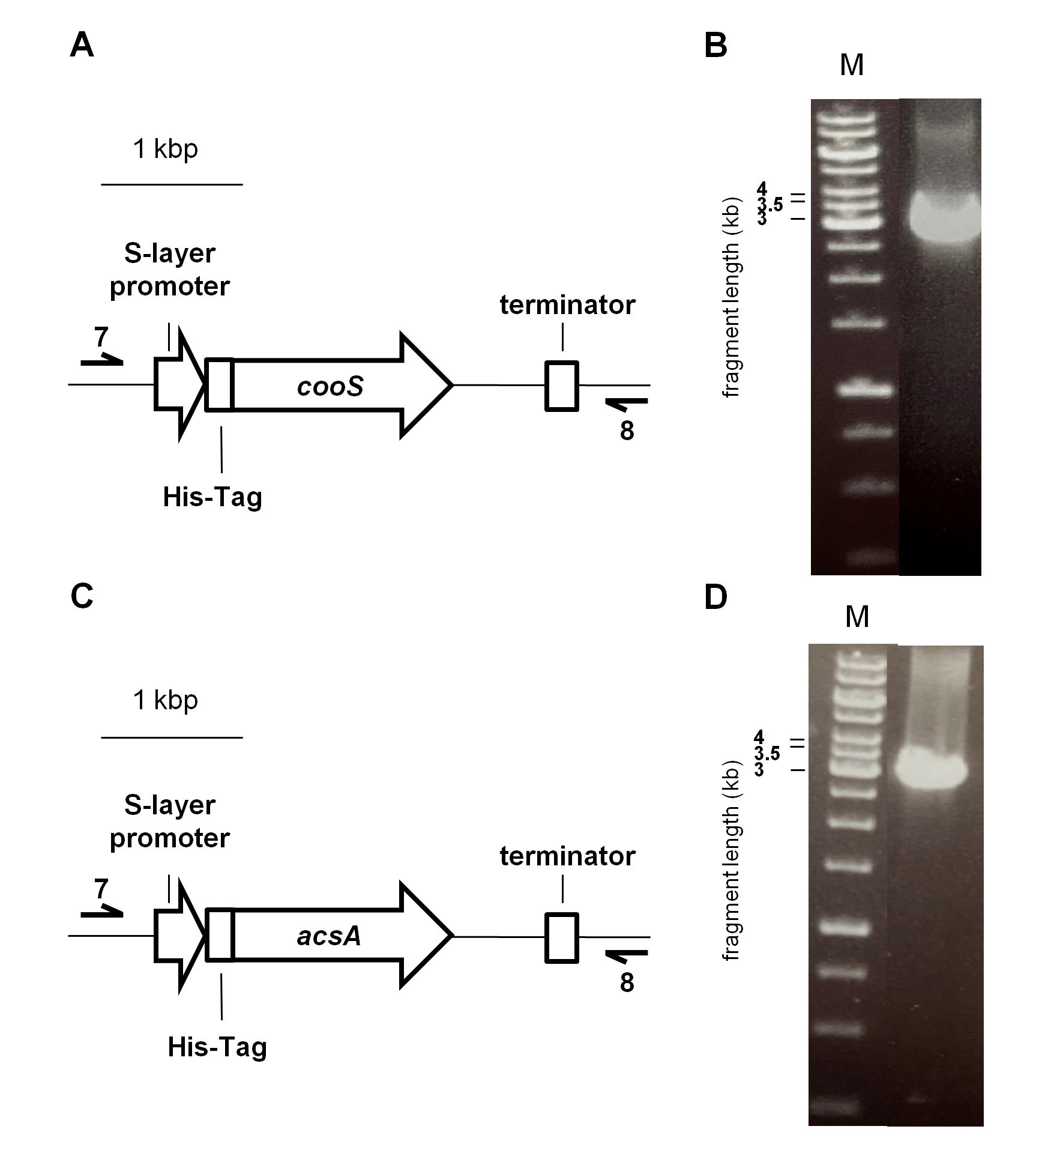
Fig. S1 Verification of the pMU131_His-cooS and pMU131_His-acsA construct transformed in T. kivui. To verify the nature of the plasmids pMU131_His-cooS or pMU131_His-acsA after propagation, T. kivui colonies were picked and the plasmid was checked by using primers that bind to the pMU131 backbone and amplifying the complete His-cooS (A) or His-acsA (B). The resulting DNA fragments were 3110 bp (C) or 3083 bp (D). M, Gene Ruler 1 kb DNA ladder

Fig. S2 Physical map of plasmids pSJ006 and pSJ008. The pSJ006 (A) and pSJ008 (B) construct was cloned as described in Materials & Methods. UFR, upstream flanking region; DFR, downstream flanking region

Fig. S3 Temperature, pH, CO and Fd dependence of CO:Fd oxidoreductase activity as catalysed by His-AcsAB. Temperature (A) or pH (B) effect of the CO-dependent Fd reduction was measured in 1.8-ml anaerobic cuvettes containing an overall liquid volume of 1 ml under a 100% CO atmosphere at 22 - 85 °C (A) or 66 °C (B). The assay contained 1 ml of buffer D (50 mM Tris/HCl, 10 mM NaCl, 2 mM DTE, 4 μM resazurin, pH 7.5) (A) or buffer F (50 mM Tris, 50 mM MES, 50 mM CHES, 50 mM CAPS, 50 mM Bis-Tris, 10 mM NaCl, 2 mM DTE, 4 µM Resazurin, pH 5 - 10) (B), 1 μg AcsAB and 30 μM Fd. CO (C) and Fd dependence (D) on AcsAB activity was measured in 1.8-ml anoxic cuvettes containing an overall liquid volume of 1 ml buffer D. The assay contained 1 μg AcsAB and different amounts of CO (C) or Fd (D). Shown is the average of two measurements from one representative experiment out of two independent replicates. Error bars represent the SEM.

Fig. S4 Temperature, pH, CO and Fd dependence of CO:Fd oxidoreductase activity as catalysed by His-CooSF₁. Temperature (A) or pH (B) effect on the CO-dependent Fd reduction was measured in 1.8-ml anaerobic cuvettes containing an overall liquid volume of 1 ml under a 100% CO atmosphere at 22 - 85 °C (A) or 66 °C (B). The assay contained 1 ml of buffer D (50 mM Tris/HCl, 10 mM NaCl, 2 mM DTE, 4 μM resazurin, pH 7) (A) or buffer F (50 mM Tris, 50 mM MES, 50 mM CHES, 50 mM CAPS, 50 mM Bis-Tris, 10 mM NaCl, 2 mM DTE, 4 µM Resazurin, pH 5 - 10) (B), 1 μg His-CooSF₁ and 30 μM Fd. CO (C) and Fd dependence (D) on His-CooSF₁ activity was measured in 1.8-ml anoxic cuvettes containing an overall liquid volume of 1 ml buffer D. The assay contained 1 μg His-CooSF₁ and different amounts of CO (C) or Fd (D). Shown is the average of two measurements from one representative experiment out of two independent replicates. Error bars represent the SEM.

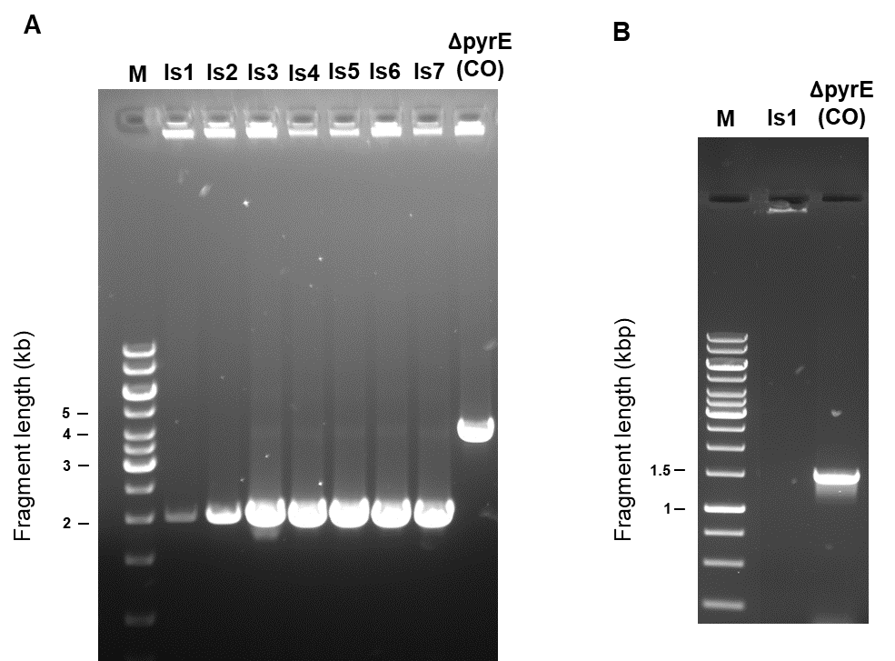

Fig. S5 Verification of the cooS deletion in T. kivui ∆pyrE via PCR. To verify the deletion of cooS after propagation, genomic DNA was isolated from T. kivui ∆pyrE (CO) or T. kivui ∆cooS isolates (isolates (Is) 1-7) and checked by PCR using primers which bind (A) outside the cooS gene (B) or inside the cooS gene. M, Gene Ruler 1 kb DNA ladder

