Additional File 1
Table 1. The number, sex and original life-stage of Ae. aegypti individuals used per Pool-Seq sample. The set-up of Pool-Seq samples comprising DNA of ≥96 adult individuals per Ae. agypti population from four sampling site in Central Nepal. Immature life-history stages were reared to adulthood prior to DNA isolation. Altitude of sampling sites of Ae. aegypti populations: CH200 = 200 m asl, DH600 = 600 m asl, DK800 = 800 m asl, KT1300 = 1300 m asl.

 | CH200 |  | DH600 |  | DK800 |  | KT1300
 | F | M | F | M | F | M | F | M
individuals per sex | 51 | 51 | 51 | 51 | 53 | 43 | 52 | 51
larvae/pupae/adult (F0) | 32 | 35 | 51 | 51 | 42 | 33 | 52 | 51
eggs (F0) | 19 | 16 | - | - | 11 | 10 | - | -
Individuals in total | 102 |  | 102 |  | 96 |  | 103

Table 2. Number of individuals that cover a microsatellite region of eight populations using PoolSeq data. Regions with a less than 4 individuals are marked in bold. Altitude of sampling sites of Ae. aegypti populations: CH200 = 200 m asl, DH600 = 600 m asl, DK800 = 800 m asl, KT1300 = 1300 m asl.
Microsatellite | Liverpool  (West Africa) | Innisfail  (Australia) | Clovis  (USA) | Puntarenas  (Costa Rica) | CH200  (Nepal) | DH600  (Nepal) | DK800  (Nepal) | KT1300  (Nepal)
A1 | 1 | 0 | 3 | 9 | 29 | 17 | 23 | 18
A9 | 12 | 3 | 5 | 21 | 22 | 18 | 25 | 29
AC1 | 4 | 2 | 1 | 14 | 10 | 12 | 28 | 2
AC2 | 1 | 6 | 2 | 5 | 27 | 34 | 0 | 10
AC4 | 9 | 5 | 8 | 17 | 44 | 27 | 42 | 31
AC5 | 3 | 3 | 1 | 7 | 20 | 10 | 58 | 26
AG2 | 8 | 9 | 1 | 8 | 20 | 19 | 10 | 24
AG4 | 3 | 4 | 3 | 22 | 26 | 29 | 38 | 24
B2 | 4 | 5 | 3 | 12 | 21 | 27 | 27 | 21
B3 | 6 | 3 | 1 | 11 | 35 | 23 | 9 | 15
CT2 | 2 | 8 | 4 | 9 | 49 | 28 | 35 | 26

Table 3. Resolution of environmental data used for PCA. Microclimate has been derived from logger data and regional climate estimates from CHELSA (including all Bio variables 1-19; (1))
 | mean temperature | minimum temperature | maximum temperature | precipitation
Logger data | per season/annually | per season/annually | per season/annually
CHELSA | per month | per month | per month | per month

Table 4. Detailed description of logger data and their installation period in the field. I = indoors; SH= shadowed artificial substrates. Altitude of sampling sites of Ae. aegypti populations: CH200 = 200 m asl, DH600 = 600 m asl, DK800 = 800 m asl, KT1300 = 1300 m asl. SH logger at DH600 was lost during data recording.

Altitude [m] | Microclimate | Start 2017 | End 2019 | Missing data
CH200 | I1 | 16.11.2017 | 03.2019
 | I2 | 16.11.2017 | 03.2019
 | SH | 16.11.2017 | 03.2019
DH600 | I1 | 01.02.2018 | 03.2019
 | I2 | 16.11.2017 | 03.2019
 | SH | Missing logger
DK1300 | I1 | 15.11.2017 | 03.2019
 | I2 | 15.11.2017 | 03.2019
 | SH | 12.11.2017 | 03.2019
RP1800 | I1 | 03.10.2018 | 03.2019
 | I2 | 03.10.2017 | 03.2019
 | SH | 03.10.2017 | 03.2019 | 3.10.18-7.10.18
DU2050 | I | 09.11.2017 | 03.2019
 | I2 | 09.11.2017 | 03.2019
 | SH | 09.11.2017 | 03.2019

Table 5. Climate variables and Bioclim dataset used in the PCA. The respective highest components per PC loading are given. Climate variables were collected from HOBO logger datasets 11/2017-03/2019 and CHELSA (C.) database (1979-2013) and the Bioclim dataset from 1979-2013 (see also Additional File 1 Figure 6-8). Temperature = Temp; Precipitation = Prec; Minimum = min; Maximum = max.
Term of Parameter | related to | Logger | CHELSA | Bioclim | PC1 | PC2 | PC3
Longitude |  | X
Latitude |  | X
Altitude |  | X |  |  | 0.97
Annual mean | Temperature | X
Annual min | Temperature | X
Annual max | Temperature | X
Pre-monsoon mean | Temperature | X
Pre-monsoon min. | Temperature | X
Pre-monsoon max. | Temperature | X
Monsoon mean | Temperature | X
monsoon min. | Temperature | X
Monsoon max. | Temperature | X
Post-monsoon mean | Temperature | X
Post-monsoon min. | Temperature | X
Post-monsoon max. | Temperature | X
winter mean | Temperature | X
winter min. | Temperature | X
winter max. | Temperature | X
Max. January C. | Temperature |  | X
Max. February C. | Temperature |  | X
Max. March C. | Temperature |  | X
Max. April C. | Temperature |  | X
Max. May C. | Temperature |  | X
Max. June C. | Temperature |  | X
Max. July C. | Temperature |  | X
Max. August C. | Temperature |  | X
Max. September C. | Temperature |  | X
Max. October C. | Temperature |  | X
Max. November C. | Temperature |  | X
Max. December C. | Temperature |  | X
Min. January C. | Temperature |  | X
Min. February C. | Temperature |  | X
Min. March C. | Temperature |  | X
Min. April C. | Temperature |  | X
Min. May C. | Temperature |  | X
Min. June C. | Temperature |  | X
Min. July C. | Temperature |  | X
Min. August C. | Temperature |  | X
Min. September C. | Temperature |  | X
Min. October C. | Temperature |  | X
Min. November C. | Temperature |  | X
Min. December C. | Temperature |  | X
Mean January C. | Temperature |  | X
Mean February C. | Temperature |  | X
Mean March C. | Temperature |  | X
Mean April C. | Temperature |  | X
Mean May C. | Temperature |  | X
Mean June C. | Temperature |  | X
Mean July C. | Temperature |  | X
Mean August C. | Temperature |  | X
Mean September C. | Temperature |  | X
Mean October C. | Temperature |  | X
Mean November C. | Temperature |  | X
Mean December C. | Temperature |  | X
Prec. January C. | Precipitation |  | X
Prec. February C. | Precipitation |  | X
Prec. March C. | Precipitation |  | X
Prec. April C. | Precipitation |  | X
Prec. May C. | Precipitation |  | X
Prec. June C. | Precipitation |  | X
Prec. July C. | Precipitation |  | X
Prec. August C. | Precipitation |  | X
Prec. September C. | Precipitation |  | X
Prec. October C. | Precipitation |  | X
Prec. November C. | Precipitation |  | X
Prec. December C. | Precipitation |  | X
Annual mean | Temperature |  |  | X
Mean diurnal range | Temperature |  |  | X
Isothermality | Temperature |  |  | X
Temp. seasonality | Temperature |  |  | X |  |  | 0.93
Max. Temp. of warmest month | Temperature |  |  | X
Min. Temp. of coolest month | Temperature |  |  | X
Temp. annual range | Temperature |  |  | X
Mean Temp. of wettest month | Temperature |  |  | X
Mean Temp. of driest month | Temperature |  |  | X
Mean Temp. of warmest quarter | Temperature |  |  | X
Mean Temp. of coldest quarter | Temperature |  |  | X
Annual mean of precipitation | Precipitation |  |  | X |  | 0.62
Prec. of wettest month | Precipitation |  |  | X
Prec. of driest month | Precipitation |  |  | X
Prec. seasonality | Precipitation |  |  | X
Prec. of wettest quarter | Precipitation |  |  | X |  | 0.49
Prec. of driest quarter | Precipitation |  |  | X
Prec. of warmest quarter | Precipitation |  |  | X |  | 0.48
Prec. of coldest quarter | Precipitation |  |  | X

Table 6. LFMM median values per sampling site and environmental variables (LFFM input file: PCA scores and cold tolerance data (2).
Analysis | Sampling site | PC 1 = ENV1 | PC 2= ENV2 | PC 3 = ENV3 | CT = ENV4
PCA | CH200 | -533.73 | 230.69 | -42.07 | 6.40
 | DH600 | -114.23 | -65.76 | 106.09 | 20.08
 | DK800 | 46.29 | -386.85 | -50.737 | 23.00
 | KT1300 | 601.67 | 221.92 | -13.28 | 11.86
LFMM | - | 0.066 | 0.759 | 0.346 | -0.177

Table 7. Characteristic of amino acid before and after alternative base exchange at non-synonymous SNP position (3,4).
Chromosome | Position | Gene | Base | Alternative  base | Amino acid exchange | characteristic
NC_035107.1 | 59746123 | adenylate cyclase type 9* | G | T | PH | nonpolar polar (basic)
NC_035107.1 | 70557897 | proto-oncogene tyrosine-protein kinase ROS | T | C | IV | nonpolar nonpolar
NC_035108.1 | 223930033 | homeobox protein araucan | G | A | AV | nonpolar nonpolar
NC_035108.1 | 295810879 | uncharacterized protein LOC5566519* | G | A | EK | polar (acidic) polar (basic)
NC_035108.1 | 370218447 | breast cancer anti-estrogen resistance protein 3 | G | A | VI | nonpolar nonpolar
NC_035108.1 | 402025916 | toll-like receptor Tollo* | T | A | HQ | polar (basic) polar
NC_035109.1 | 278880294 | zinc finger CCCH domain-containing protein 13* | G | T | ED | polar (acidic) polar (acidic)
NC_035109.1 | 300326627 | uncharacterized protein LOC5574261 | T | A | IK | nonpolar polar(basic)
NC_035109.1 | 307981403 | probable peptide chain release factor C12orf65, mitochondrial* | A | T | FI | nonpolar nonpolar
NC_035109.1 | 308648742 | tubulin-specific chaperone D | G | A | VI | nonpolar nonpolar
NC_035109.1 | 314722675 | coatomer subunit beta' | G | A | AT | nonpolar polar
NC_035109.1 | 319909869 | uncharacterized protein LOC5578603 | C | G | LV | nonpolar nonpolar

Table 8. Significantly enriched GO terms (p < 0.05) among candidate genes (EAP-OW) per ENV and their biological functions involved in climate adaptation. To increase resolution, the GO term analysis was conducted per ENV (ENV1 ~ altitude, ENV2 ~ precipitation, ENV4 = cold tolerance) as described by (5). The definition of GO terms was used from the webpage: (6). If literature for comparison was accessible, the biological function and the link with ENVs was discussed.
Enriched GO term | ENV1 | ENV2 | ENV4 | Definition of GO terms involved in climate adaptation | Biological function involved in climate adaptation
small GTPase mediated signal transduction (GO:0007264) | X | X | X | Any series of molecular signals in which a small monomeric GTPase relays one or more of the signals.
protein phosphorylation (GO:0006468) | X | X | X | The process of introducing a phosphate group on to a protein. | One of the most important post-translational modifications is protein phosphorylation. Protein phosphorylation is vital for the coordination of organic and cellular function such as the regulation of metabolism, proliferation, apoptosis, subcellular trafficking, inflammation, and other important physiological processes (7). ENV1, ENV2 and ENV4 seem to affect this important function. This GO term correlating with climate variation was also enriched in a GEA study in ants (8), whereas in the GEA study of Waldvogel (5) this GO term was enriched in candidate genes for local adaptation.
transmembrane receptor protein tyrosine kinase signaling pathway (GO:0007169) | X | X | X | A series of molecular signals initiated by the binding of an extracellular ligand to a receptor on the surface of the target cell where the receptor possesses tyrosine kinase activity, and ending with regulation of a downstream cellular process, e.g. transcription. | The major mechanism for intercellular communication during development as well as in the adult organism and in disease-associated processes is the signaling through receptor tyrosine kinases (9). ENV1, ENV2 and ENV4 seem to affect this important function. This GO term correlating with climate variation was also enriched in a GEA study in ants (8).
ubiquitin-dependent protein catabolic process (GO:0006511) | X |  | X | Chemical reactions and pathways leading to a breakdown of a protein or peptide by hydrolysis of its peptide bonds.
translational termination (GO:0006415) | X |  | X | The process that leads to the release of a polypeptide chain form the ribosome when a termination codon on the mRNA occurs.
regulation of pH (GO:0006885) |  | X |  | Within an organism or cell, processes involved in the maintenance of an internal equilibrium of hydrogen ions, thereby modulating the internal pH. | This GO term is upregulated in the highly secreting pleuropodia. Pleuropodia appear on the first abdominal segment in embryos of insects. This organ secrete a “hatching enzyme” that enables the hatching of larvae by digesting the serosal cuticle (10). Thus, the association of this GO term with precipitation adds up.
sodium ion transport (GO:0006814) |  | X |  | Movement of sodium ions within, into or out of a cell, or between cells by some agents such as a transporter or pore. | In Ae. aegypti larvae the exchange of sodium occurs through the anal papillae, as well as smaller amounts enter the haemolymph through the gut and general body surface (11). In Nepal, sodium as well as chloride concentration in rainfall is high, especially in the monsoon season (12). Thus, larvae may need to cope with concentrations of these ions, which may affect survival and explain the association with precipitation.
Proteolysis (GO:0006508) |  | X | X | Hydrolysis of proteins into smaller polypeptides and/or amino acids, respectively by cleavage of their peptide bonds. | Temperature extremes affect protein stability and cells have to cope with stress-induced protein denaturation (13). Adaptation of the proteolysis machinery implies a response to the upper temperature extremes along the thermal cline (5). In the GEA study of Waldvogel (5)within Chironomidae species, this GO term was enriched in candidate genes for climate adaptation and was associated with warm temperatures, whereas in this study the GO term is associated with precipitation and cold tolerance. In addition, this GO term was significantly enriched among candidate genes of climate differentiation in Drosophila (5,14).

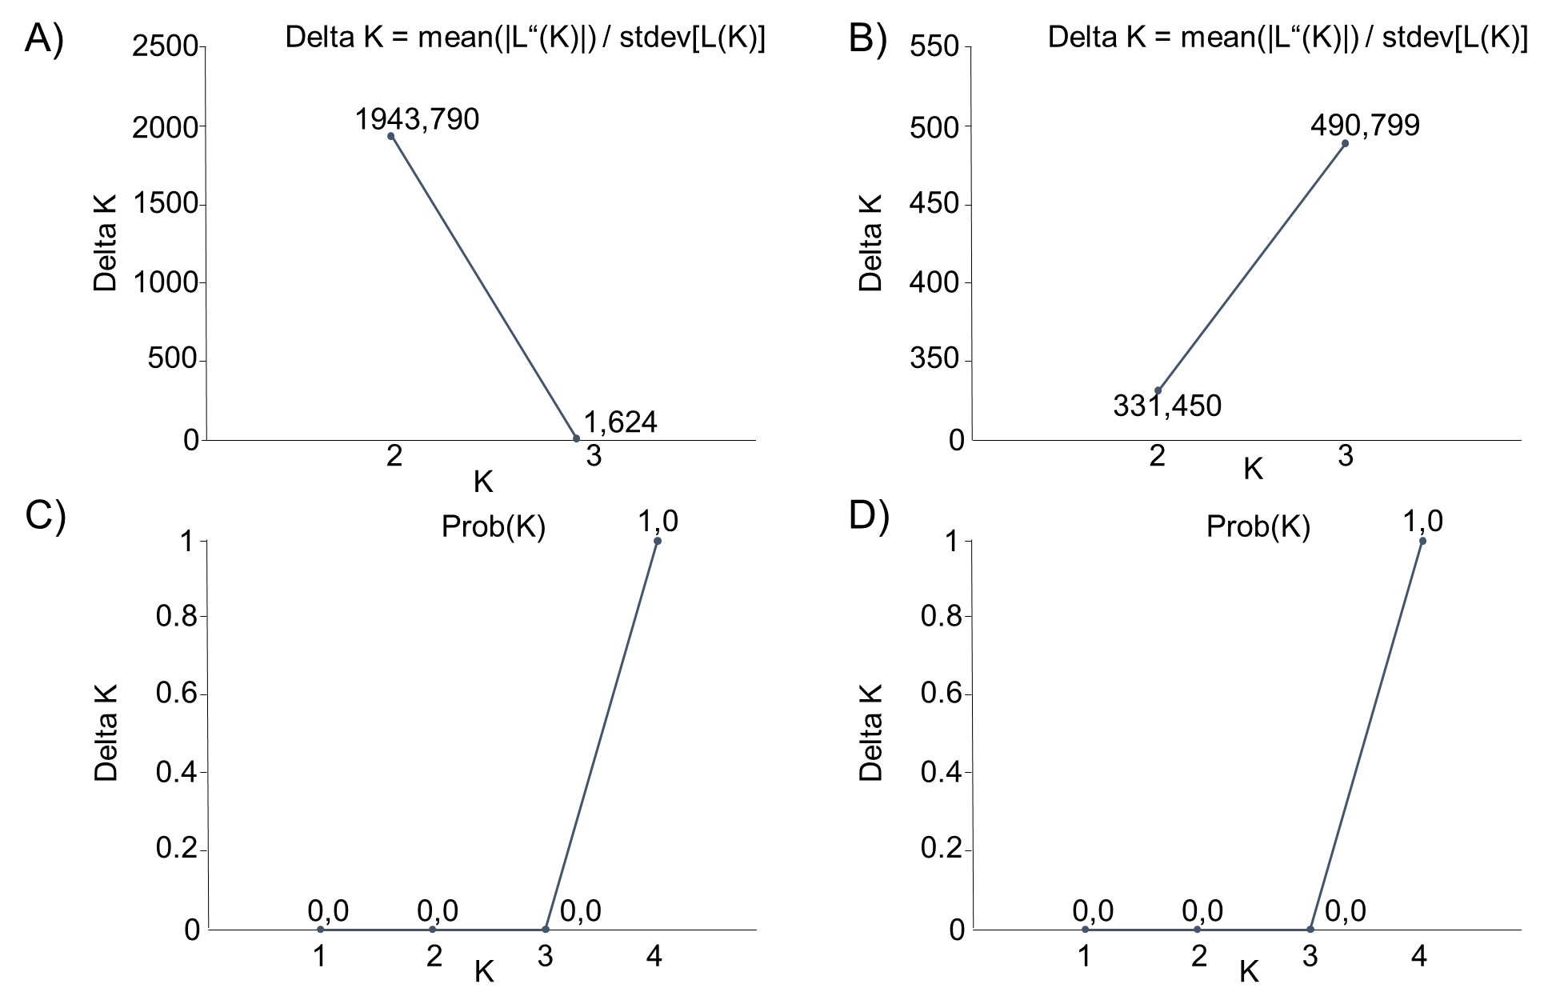
Figure 1. Delta K (A, B) and Probability by K (C,D) from the structure analysis. Delta K=Optimal K by Evanno is given. A+C) show the result of the STRUCTURE/CLUMPAK comparison between Nepal and Africa, Costa Rica and Australia using 6 microsatellite regions (15). Division of runs by mode for K=2 was 10/10 and for K=3 9/10, 1/10. C+D) show the results of the STRUCUTRE/ CLUMPAK comparison of only Nepalese populations using 11 microsatellite regions. Division of runs by mode for all K1-4 was 10/10.
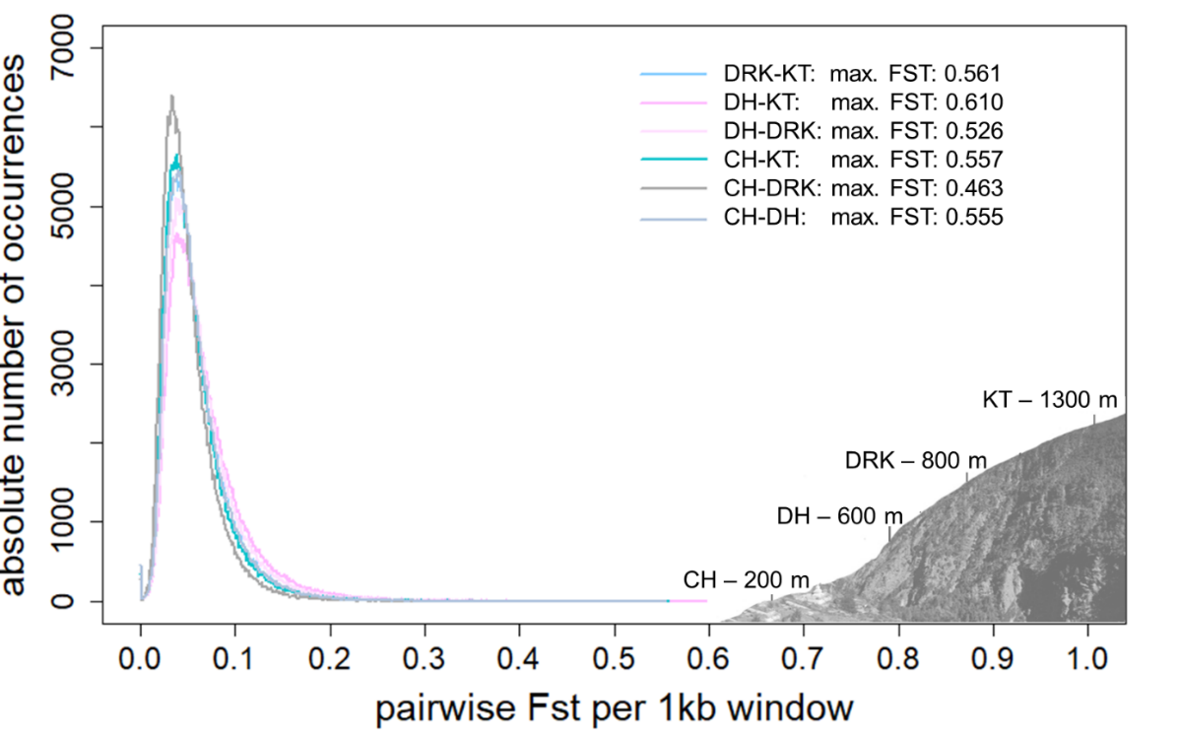
Figure 2. Pairwise F_{ST} distribution per 1 kb-windows (OW) of Nepalese Ae. aegypti populations sampled along an altitudinal gradient in Nepal (200-1300m). Altitude of sampling sites of Ae. aegypti populations in Central Nepal: CH200 = 200 m asl (Chitwan), DH600 = 600 m asl (Dhading), DK800 = 800 m asl (Dharke), KT1300 = 1300 m asl (Kathmandu).
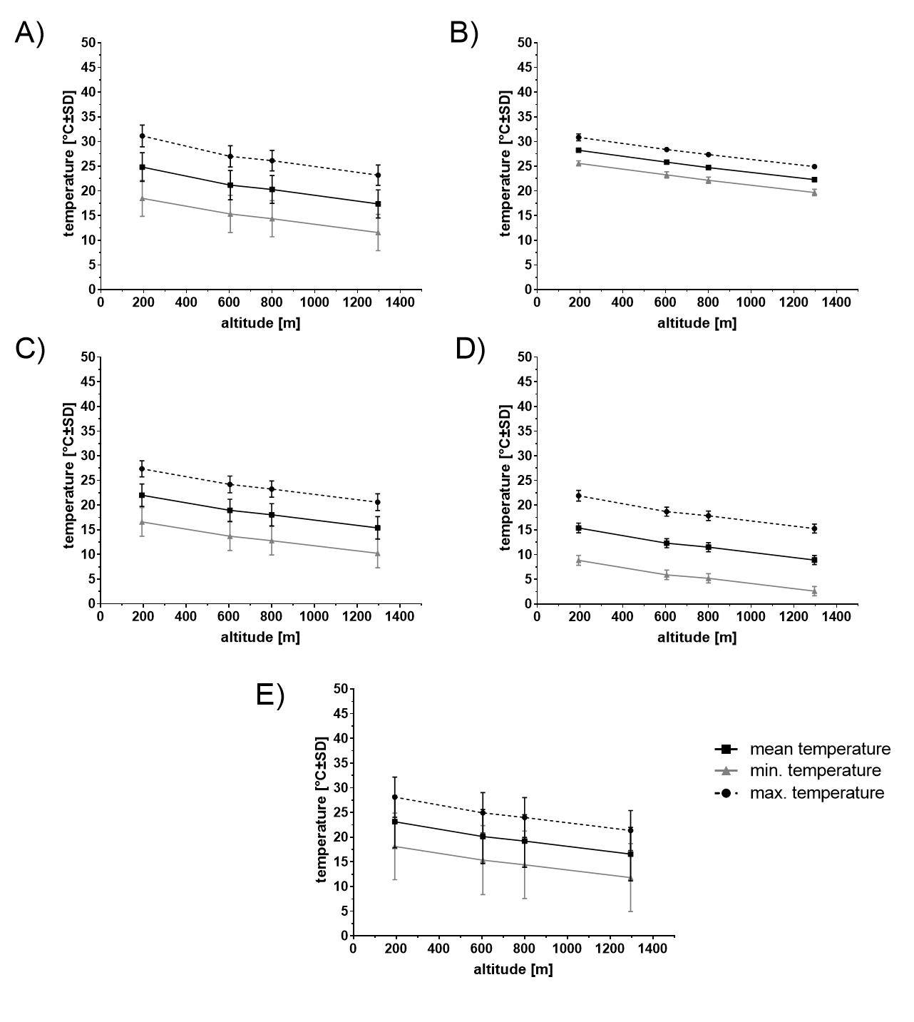
Figure 3. Climate (air temperature) along the altitudinal gradient in Central Nepal. Mean, minimum and maximum temperature (CHELSA data) in different time seasons from 1979 to 2013: A) pre-monsoon (March-May), B) monsoon (June-September), C) post-monsoon (October-November), D) winter (December-February), E) annual.

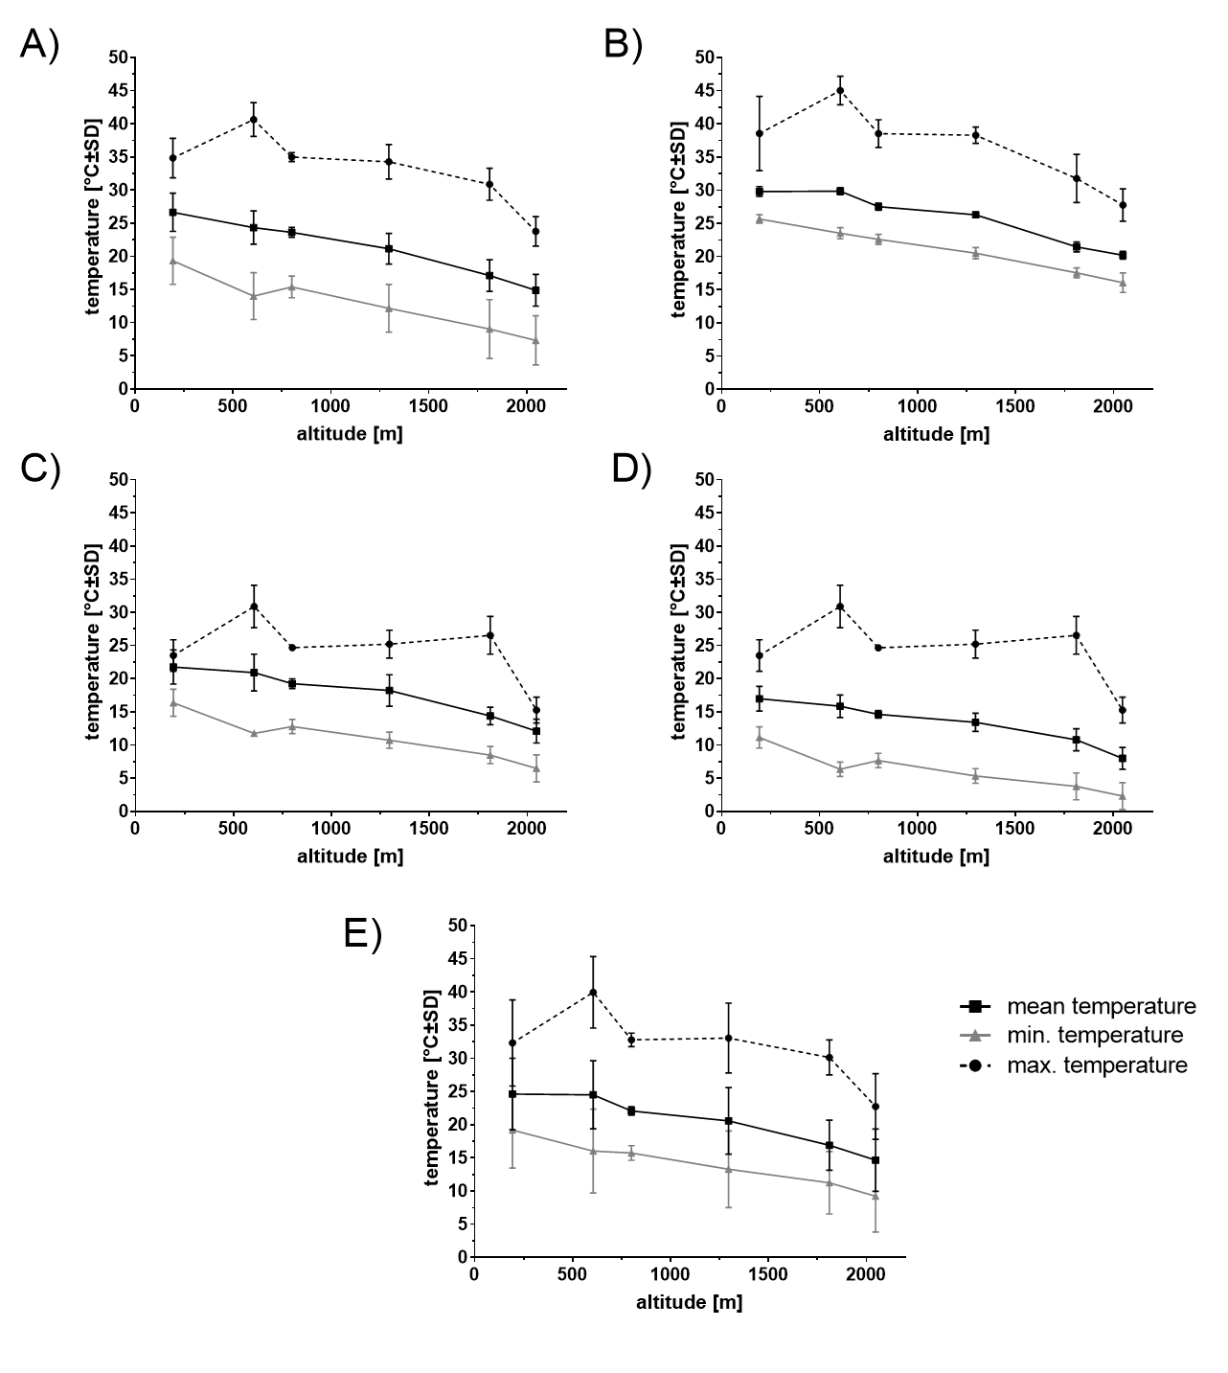
Figure 4. Microclimate (air temperature) along the altitudinal gradient in Central Nepal. Mean, minimum and maximum temperature (HOBO logger data; microclimate see also Additional File 1 Table 3) in different seasons from November 2017 to March 2019: A) pre-monsoon (March-May), B) monsoon (June-September), C) post-monsoon (October-November), D) winter (December-February), E) annual. The 800 meter population was interpolated using raw data of loggers.

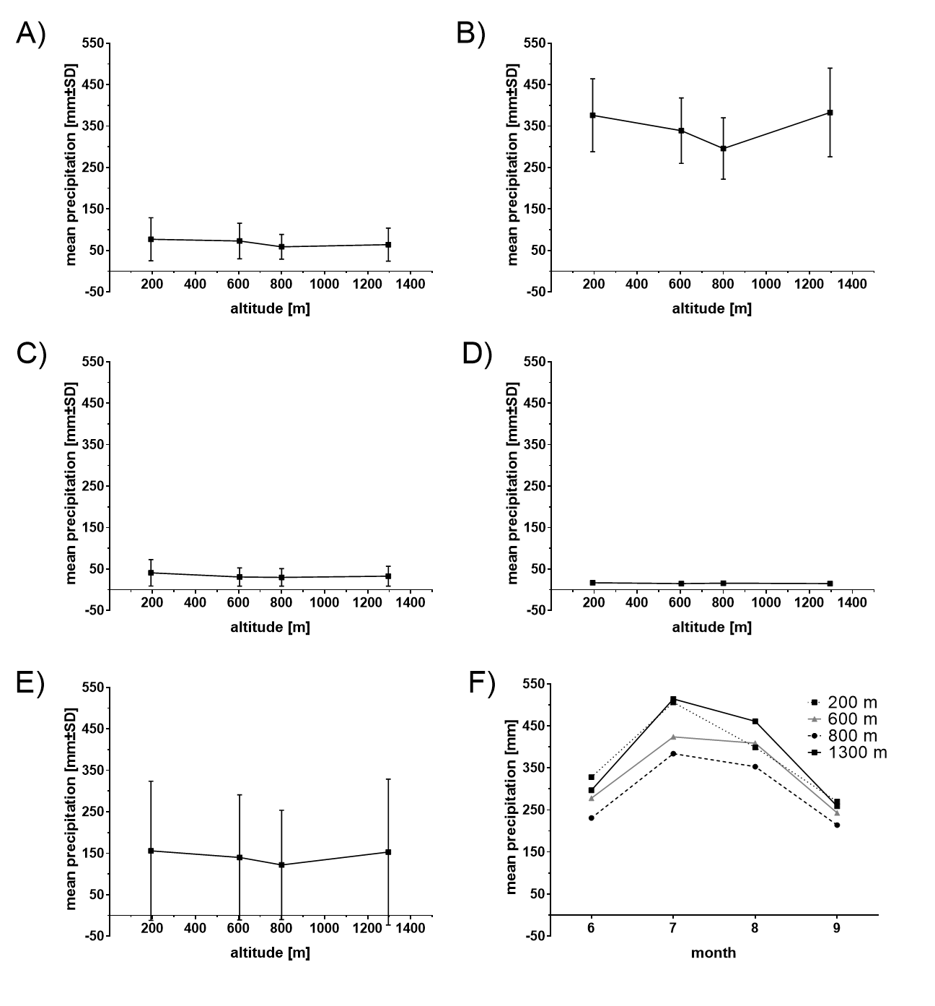

Figure 5. Precipitation along the altitudinal gradient in Central Nepal. Mean precipitation (CHELSA data) in different seasons from 1979 to 2013: A) pre-monsoon (March-May), B) monsoon (June-September), C) post-monsoon (October-November), D) winter (December-February), E) annual, F) monthly monsoon mean precipitation
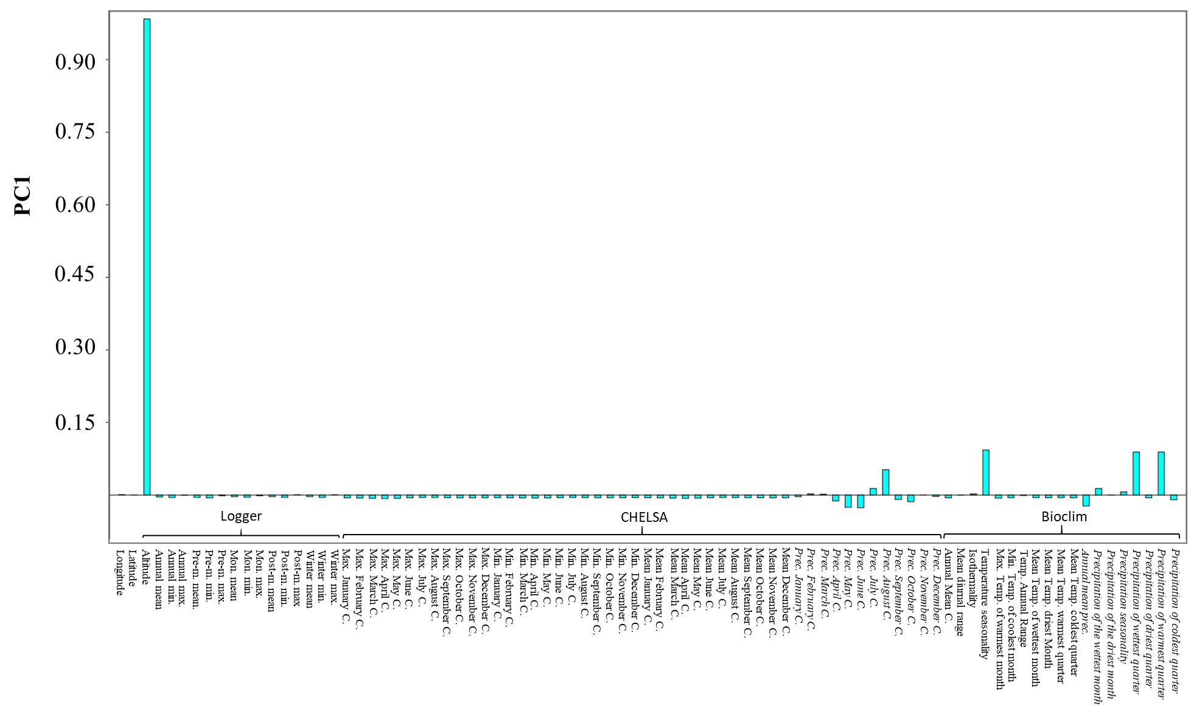
Figure 6. Loadings from PC (principal component) analysis: PC1 is associated with altitude. Precipitation related variables are highlighted using Italic font. Temperature related variables and longitude, latitude and altitude are given in non-italic font.

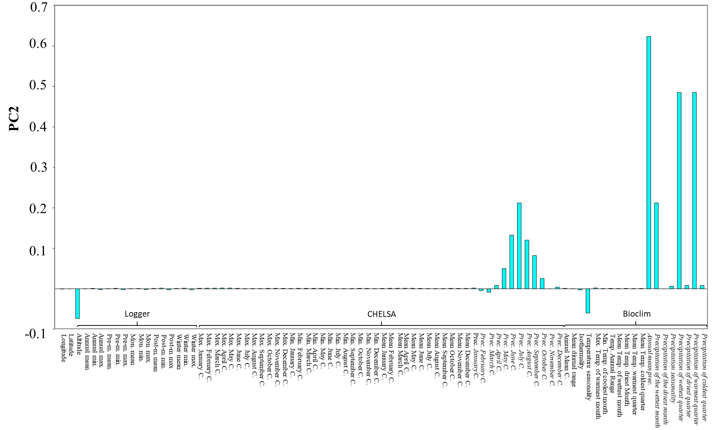
Figure 7. Loadings from PC (principal component) analysis: PC2 is associated with precipitation. Precipitation related variables are highlighted using Italic font. Temperature related variables and longitude, latitude and altitude are given in non-italic font.

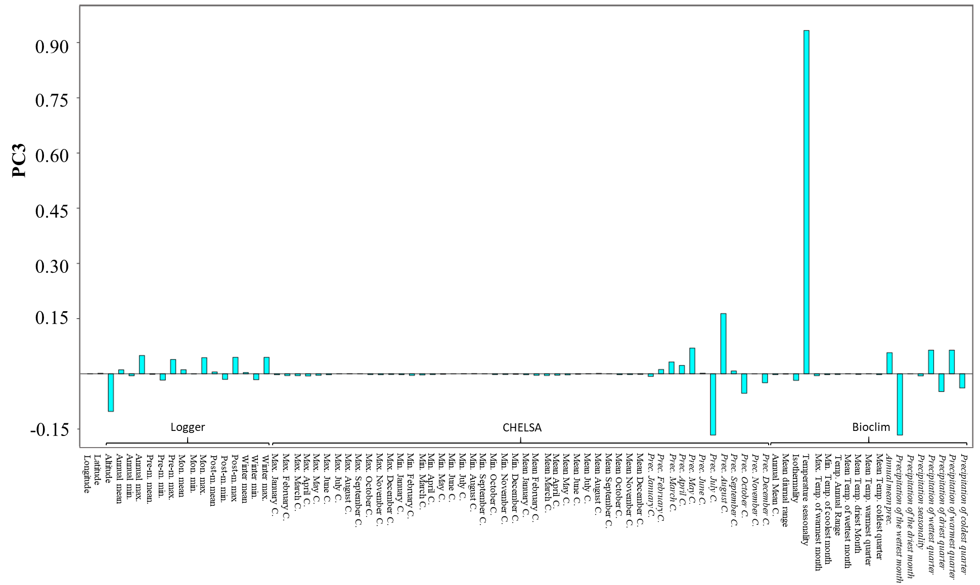
Figure 8. Loadings from PC (principal component) analysis: PC3 is associated with seasonality. Precipitation related variables are highlighted using Italic font. Temperature related variables and longitude, latitude and altitude are given in non-italic font.
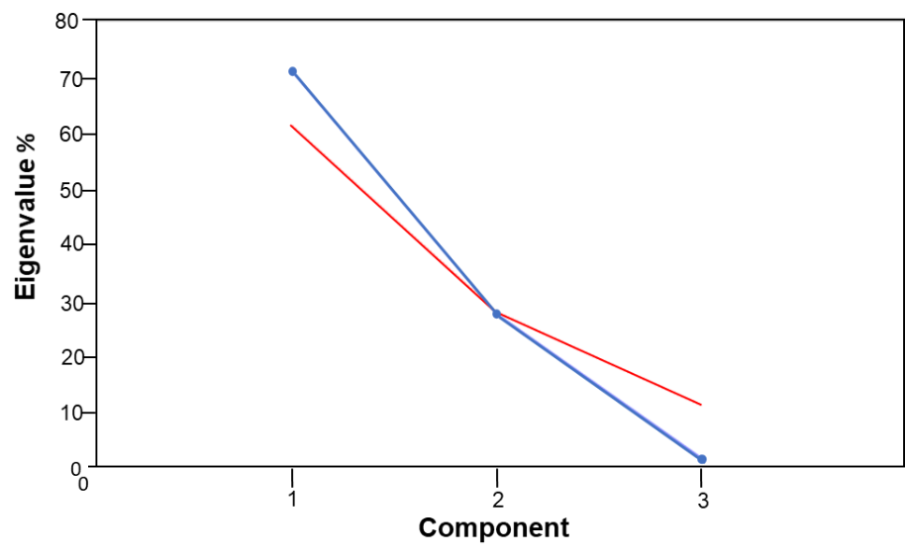
Figure 9. Distribution of Eigenvalues (%) of principal components (blue line). Gained from principal component analysis with 85 climatic variables (logger data, CHELSA, Bioclim) at 4 different sampling sites of Ae. aegypti populations along an altitudinal gradient in Nepal. Broken stick analysis is given as red line and indicates that PC3 componenent under this line is non significant.
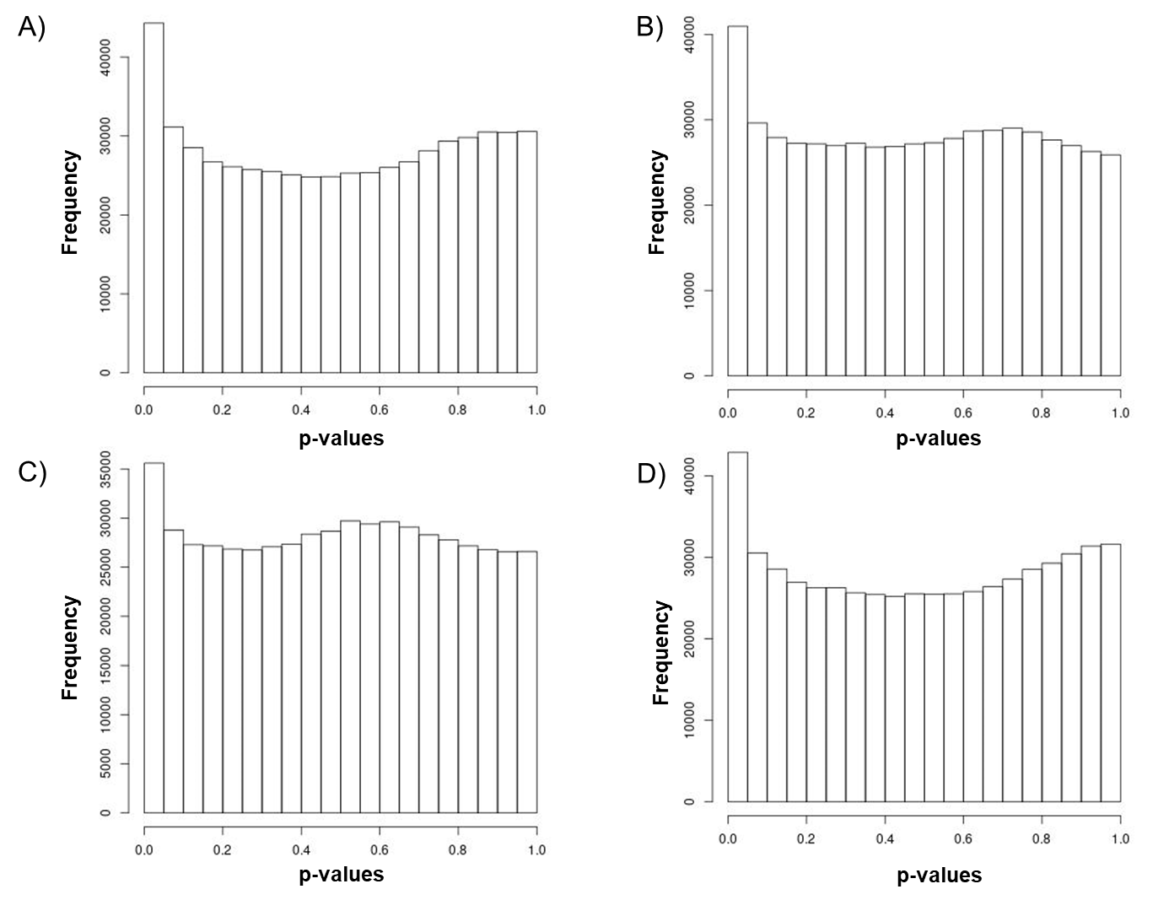
Figure 10. The frequency distribution of adjusted p-values after association (genotype-enviornment association analysis) to four different environmental variables (ENVs) using LFMM. 1) ENV1 = PC1 associated with altitude, 2) ENV2 = PC2 associated with precipitation, 3) ENV3 = PC3 associated with seasonality and 4) ENV4 = cold tolerance of Ae. aegypti (2).

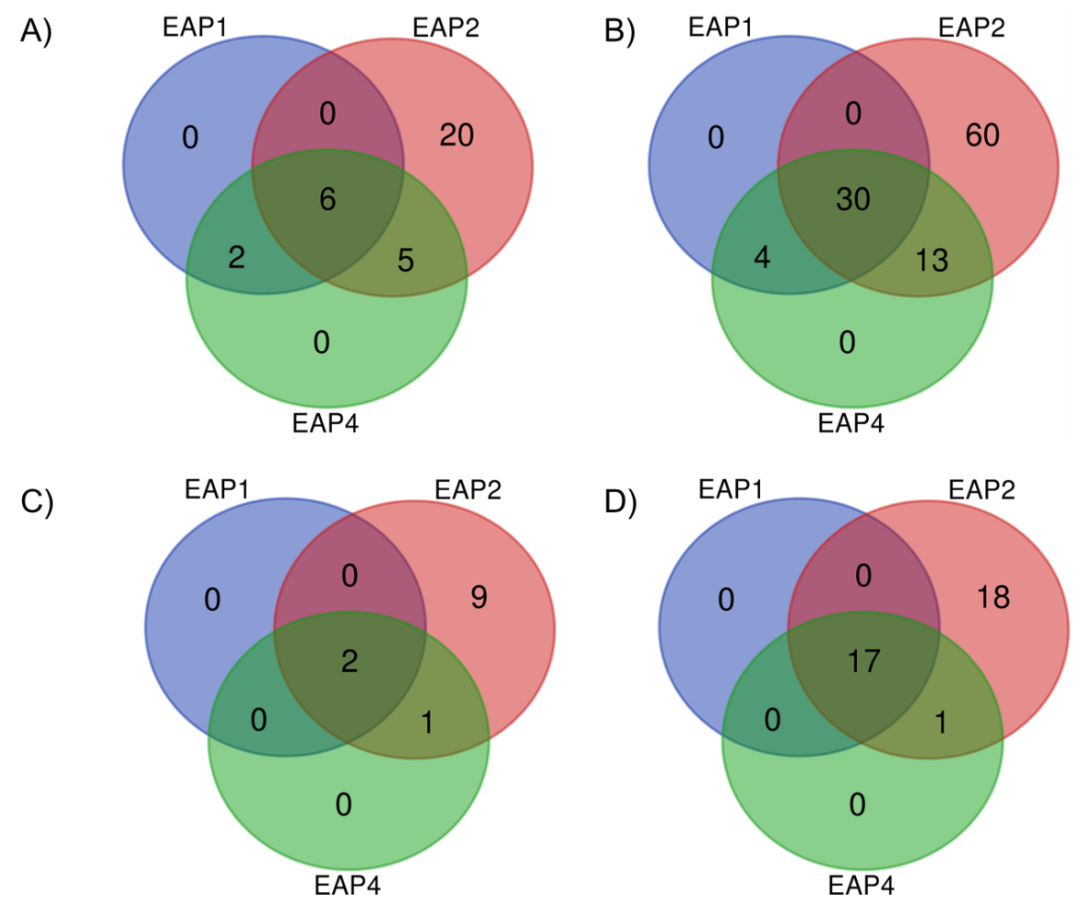
Figure 11. Gene IDs (A, C) or protein IDs (B,D) present in all different significant environmental variable associated positions (EAP) laying in an overlapping singificant 1kb-F_{ST}-window (OW, A and B) and contain a non-synonymous mutation (C and D).

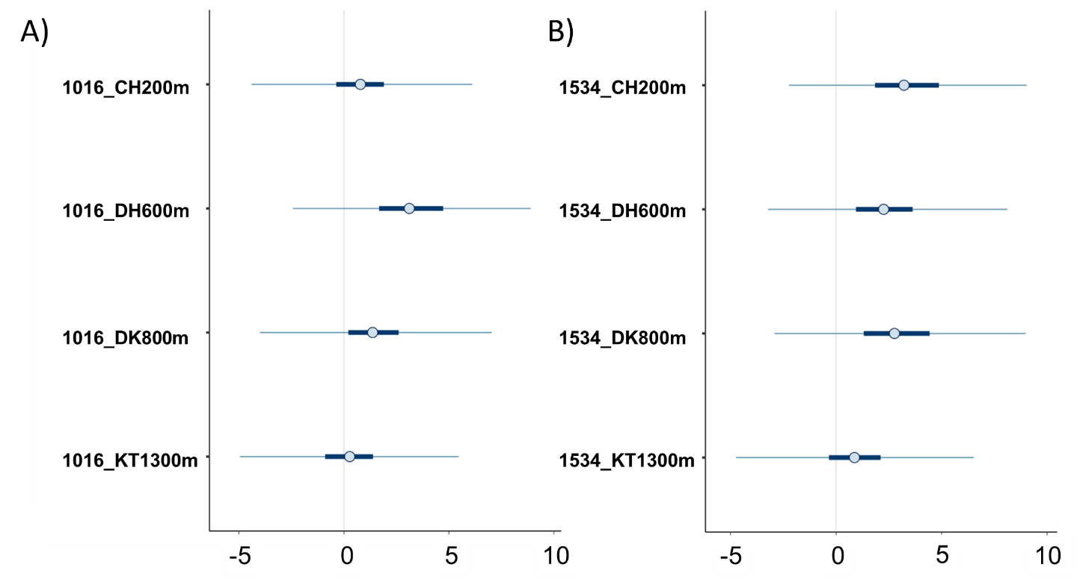
Figure 12. Posterior uncertainty intervals for kdr mutation a) V1016G and b) F1534C. Depicted are the median, 50% and 90% posterior intervals. CH200 = 200 m asl, DH600 = 600 m asl, DK800 = 800 m asl, KT1300 = 1300 m asl.

Supplementary Information 1
Go terms
In the present study, the GO term ‘transmembrane receptor protein tyrosine kinase signaling pathway‘ and ‘protein phosphorylation’ were found to be associated with all environmental clines. The first plays a major role in the intercellular communication during the development (9). The second is important for the regulation of organic and cellular functions such as the metabolism, proliferation or apoptosis (7), underlining the impact of the environmental clines on the life-cycle of Ae. aegypti. Further, both of these GO terms were already found to be enriched in candidate genes for climate variation in ants (8). In addition, ‘proteolysis’ is associated with precipitation and cold tolerance and may imply a response to climate extremes/stress (5,14). The GO term ‘proteolysis’ was already found to be enriched in candidate genes for climate adaptation in other GEA studies in Chironomus and Drosophila (5,14). The GO term ‘regulation of pH’, which is associated with precipitation, was already previously identified for playing a role in the hatching of larvae (10). The association with precipitation aligns with the fact that rainwater is needed for the hatching of Ae. aegypti eggs (16). In Nepal, sodium concentration in the rain water is high, and especially in the monsoon season (12). Thus, immature life stages may need to cope with varying concentrations of these ions which explains the association with precipitation of the GO term ‘sodium ion transport’.
Candidate genes containing non-synonymous mutations
The candidate gene ‘proto-oncogene tyrosine-protein kinase ROS’ including a non-synonymous mutation is associated with ENV1, ENV2 and ENV4 (altitude, precipitation and CT survivorship) is suggested to play a role in development or/and energy metabolism (17,18). These biological processes are important in survival after cold temperatures (CT survivorship), the start of a life-cycle as well as the general life-cycle linked to precipitation and is influenced by the environment at different altitudes.
Precipitation is a vital factor for Ae. aegypti (16). In Nepal vector and dengue occurrence is linked with precipitation or more specifically the monsoon season (19–21). Thus, the following genes which play a role in immune response were all associated with precipitation. The ‘toll-like receptor Tollo’ was already studied in Ae. aegypti and plays a role in the immune response especially in the anti-dengue defense (22–28). In addition, the non-synonymous mutations within this candidate gene leads to an amino acid with different characteristics (Additional File 1 Table 7). Other candidate genes play also a role in dengue viral defense (immune response) such as the ‘probable peptide chain release factor C12orf65’ (also plays a role in protein regulation- Table 4), ‘breast cancer anti estrogen resistance protein 3’ (29) as well as the ‘zinc finger CCCH domain-containing protein 13’ (30,31). With increasing altitude, the dengue risk decreases with being the greatest below 500 m asl and moderate between 550-1500 m asl (32). This altitudinal distribution of dengue disease risk could explain the association between altitude and the ‘breast cancer anti estrogen resistance protein 3’ that is as well involved in dengue infection or defense (29).
The candidate gene ‘adenylate cyclase type 9’ is associated with precipitation (ENV2) was the only gene in the climate adaptation analysis that is in parallel involved in insecticide resistance and contains a non-synonymous mutation leading to a characteristic amino acid exchange. In the mosquito Culex quinquefasciatus, this gene is involved in the regulation of the resistance-related P450 gene expression (33,34). In Nepal, insecticides use is declining as summarized by (35)The association of an insecticide resistance related gene to precipitation might be justified by the use of insecticides mainly in the monsoon season (high peak mosquito season) and the influence of rainfall on the distribution of insecticides (36), subsequently this influences the vector Ae. aegypti.
Candidate genes involved in the life-cycle such as the ‘Tubulin-specific chaperone D’, ‘coatomer subunit beta’, ‘homeobox protein auracan’ and the ‘zinc finger CCCH domain-containing protein 13’ are likewise associated with precipitation (ENV2; Table 4). ‘Tubulin-specific chaperone D’ is involved in the reproduction (37). The ‘coatomer subunit beta’ including a non-synonymous mutation leading to a characteristic amino acid shift has an major impact on blood digestion and egg maturation (38,39). The ‘homeobox protein auracan’ is involved in the embryonic development (40,41) and the ‘zinc finger CCCH domain-containing protein 13’ has an impact on development processes and reproduction (30,31,42). The association with precipitation of these candidate genes underlines the importance of precipitation in the life cycle of Ae. aegypti.

References
- Karger DN, Conrad O, Böhner J, Kawohl T, Kreft H, Soria-Auza RW, et al. Climatologies at high resolution for the earth’s land surface areas. Scientific Data. 2017;4.
- Kramer IM, Pfeiffer M, Steffens O, Schneider F, Gerger V, Phuyal P, et al. The ecophysiological plasticity of Aedes aegypti and Aedes albopictus concerning overwintering in cooler ecoregions is driven by local climate and acclimation capacity. Science of the Total Environment. 2021;778:146128.
- Löffler G, Petrides PE, Heinrich PC. Biochemie und Pathobiochemie. 8th ed. Springer Medizin Verlag; 2007.
- Voet D, Voet JG, Pratt CW. Fundamentals of Biochemistry - Life at the molecular level. John Wiley & Sons, Inc.; 2008.
- Waldvogel AM, Wieser A, Schell T, Patel S, Schmidt H, Hankeln T, et al. The genomic footprint of climate adaptation in Chironomus riparius. Molecular Ecology. 2018;27:6.
- Dimmer EC, Huntley RP, Barrell DG, Binns D, Draghici S, Camon EB, et al. The Gene Ontology - Providing a Functional Role in Proteomic Studies. Proteomics. 2008;8.
- Ardito F, Giuliani M, Perrone D, Troiano G, Muzio L Lo. The crucial role of protein phosphorylation in cell signalingand its use as targeted therapy. International Journal of Molecular Medicine. 2017;40:2.
- Hartke J, Waldvogel AM, Sprenger PP, Schmitt T, Menzel F, Pfenninger M, et al. Little parallelism in genomic signatures of local adaptation in two sympatric, cryptic sister species. Journal of Evolutionary Biology. 2021;34:6.
- Haj FG, Markova B, Klaman LD, Bohmer FD, Neel BG. Regulation of receptor tyrosine kinase signaling by protein tyrosine phosphatase-1B. Journal of Biological Chemistry. 2003;278:2.
- Konopová B, Buchberger E, Crisp A. Transcriptome of pleuropodia from locust embryos supports that these organs produce enzymes enabling the larva to hatch. Frontiers in Zoology. 2020;17:1).
- Treherne JE. The Exchange of Labelled Sodium in the Larva of Aedes Aegypti L. Journal of Experimental Biology. 1954;31:3.
- Wilson AM, Williams MW, Kayastha RB, Racoviteanu A. Use of a hydrologic mixing model to examine the roles of meltwater, precipitation and groundwater in the Langtang River basin, Nepal. Annals of Glaciology. 2016;57:71.
- Feder ME, Hofmann GE. Heat-Shock proteins, molecular chaperones, and the stress Response: Evolutionary and Ecological Physiology. Annual Review of Physiology. 1999.
- Kolaczkowski B, Kern AD, Holloway AK, Begun DJ. Genomic differentiation between temperate and tropical Australian populations of Drosophila melanogaster. Genetics. 2011;187:1.
- Matthews BJ, Dudchenko O, Kingan SB, Koren S, Antoshechkin I, Crawford JE, et al. Improved reference genome of Aedes aegypti informs arbovirus vector control. Nature. 2018;563:7732.
- Cromar L, Cromar K. Dengue fever and climate change. In: Pinkerton KE, Rom W, editors. Global Climate Change and Public Health. Humana,Cham; 2014. p. 273-310.
- Zhang SZ, Yu HZ, Deng MJ, Ma Y, Fei DQ, Wang J, et al. Comparative transcriptome analysis reveals significant metabolic alterations in eri-silkworm (Samia cynthia ricini) haemolymph in response to 1-deoxynojirimycin. PLoS ONE. 2018;13:1.
- Acquaviva J, Wong R, Charest A. The multifaceted roles of the receptor tyrosine kinase ROS in development and cancer. Biochimica et Biophysica Acta - Reviews on Cancer. 2009;1795:1.
- Tuladhar R, Singh A, Banjara MR, Gautam I, Dhimal M, Varma A, et al. Effect of meteorological factors on the seasonal prevalence of dengue vectors in upland hilly and lowland Terai regions of Nepal. Parasites and Vectors. 2019;12:1.
- Phuyal P, Kramer IM, Klingelhöfer D, Kuch U, Madeburg A, Groneberg DA, et al. Spatiotemporal distribution of dengue and chikungunya in the Hindu Kush Himalayan region: A systematic review. International Journal of Environmental Research and Public Health. 2020;17:18.
- Dhimal M, Kramer IM, Phuyal P, Budhathoki SS, Hartke J, Ahrens B, et al. Climate change and its association with the expansion of vectors and vector-borne diseases in the Hindu Kush Himalayan region: A systematic synthesis of the literature. Advances in Climate Change Research. 2021;12.
- Shin SW, Bian G, Raikhel AS. A toll receptor and a cytokine, Toll5A and Spz1C, are involved in toll antifungal immune signaling in the mosquito Aedes aegypti. Journal of Biological Chemistry. 2006;281:51.
- Waterhouse RM, Kriventseva E v, Meister S, Xi Z, Alvarez S, Bartholomay LC, et al. Evolutionary Dynamics of Immune-Related Genes and Pathways in Disease-Vector Mosquitoes Robert. 2007;316:5832.
- Leulier F, Lemaitre B. Toll-like receptors - Taking an evolutionary approach. Nature Reviews Genetics. 2008;9:3.
- Ramirez JL, Dimopoulos G. The Toll immune signaling pathway control conserved anti- dengue defenses across diverse Ae. aegypti strains and against multiple dengue virus serotypes. Bone. 2010;34:6.
- Xi Z, Ramirez JL, Dimopoulos G. The Aedes aegypti toll pathway controls dengue virus infection. PLoS Pathogens. 2008;4:7.
- Souza-Neto JA, Sim S, Dimopoulos G. An evolutionary conserved function of the JAK-STAT pathway in anti-dengue defense. Proceedings of the National Academy of Sciences of the United States of America. 2009;106:42.
- Palatini U, Masri RA, Cosme L V., Koren S, Thibaud-Nissen F, Biedler JK, et al. Author Correction: Improved reference genome of the arboviral vector Aedes albopictus (Genome Biology. Genome Biology. 2021;22:1.
- Xuanhao C. Screening for Differentially Expressed Genes in Dengue Infection Under Antibody Dependent Enhancement Conditions. Master Thesis. 2010.
- Guo J, Tang HW, Li J, Perrimon N, Yan D. Xio is a component of the Drosophila sex determination pathway and RNA N6-methyladenosine methyltransferase complex. Proceedings of the National Academy of Sciences of the United States of America. 2018;115:14.
- Ma Z, Gao X, Shuai Y, Xing X, Ji J. The m6A epitranscriptome opens a new charter in immune system logic. Epigenetics. 2020;16:8
- Gyawali N, Johnson BJ, Dixit SM, Devine GJ. Patterns of dengue in Nepal from 2010–2019 in relation to elevation and climate. Transactions of The Royal Society of Tropical Medicine and Hygiene. 2020.
- Li T, Liu N. Regulation of P450-mediated permethrin resistance in Culex quinquefasciatus by the GPCR/Gαs/AC/cAMP/PKA signaling cascade. Biochemistry and Biophysics Reports. 2017;12:August.
- Li T, Liu N. Role of the g-protein-coupled receptor signaling pathway in insecticide resistance. International Journal of Molecular Sciences. 2019;20:17.
- Kawada H, Futami K, Higa Y, Rai G, Suzuki T, Rai SK. Distribution and pyrethroid resistance status of Aedes aegypti and Aedes albopictus populations and possible phylogenetic reasons for the recent invasion of Aedes aegypti in Nepal. Parasites and Vectors. 2020;13:1.
- Jiang W, Haver D, Rust M, Gan J. Runoff of pyrethroid insecticides from concrete surfaces following simulated and natural rainfalls. Water Research. 2012;46:3.
- Deitz KC, Takken W, Slotman MA. The Genetic Architecture of Post-Zygotic Reproductive Isolation Between Anopheles coluzzii and An. quadriannulatus. Frontiers in Genetics. 2020;11:August.
- Isoe J, Stover W, Miesfeld RB, Miesfeld RL. COPI-mediated blood meal digestion in vector mosquitoes is independent of midgut ARF-GEF and ARF-GAP regulatory activities. 2013;43:8.
- Isoe J, Collins J, Badgandi H, Day WA, Miesfeld RL. Defects in coatomer protein I (COPI) transport cause blood feeding-induced mortality in Yellow Fever mosquitoes. Proceedings of the National Academy of Sciences of the United States of America. 2011;108:24.
- Kerner P, Ikmi A, Coen D, Vervoort M. Evolutionary history of the iroquois/Irx genes in metazoans. BMC Evolutionary Biology. 2009;9:1.
- Negre B, Simpson P. The achaete-scute complex in Diptera: Patterns of noncoding sequence evolution. Journal of Evolutionary Biology. 2015;28:10.
- Knuckles P, Lence T, Haussmann IU, Jacob D, Kreim N, Carl SH, et al. Zc3h13/Flacc is required for adenosine methylation by bridging the mRNA-binding factor RbM15/spenito to the m6 a machinery component Wtap/Fl(2)d. Genes and Development. 2018;32:5–6.

