ONLINE APPENDIX

TABLE A1: Related Research on Gendered Occupational Characteristics

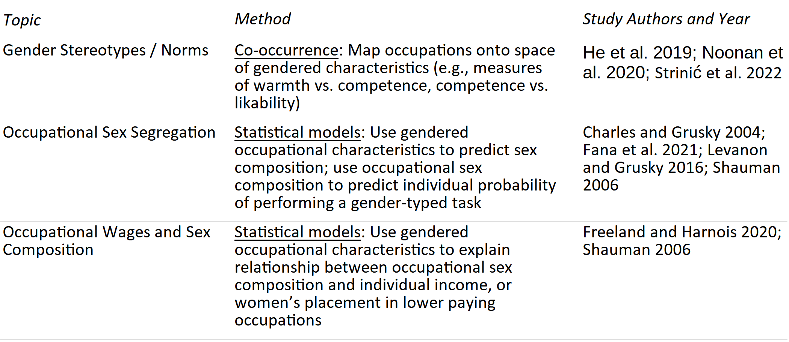

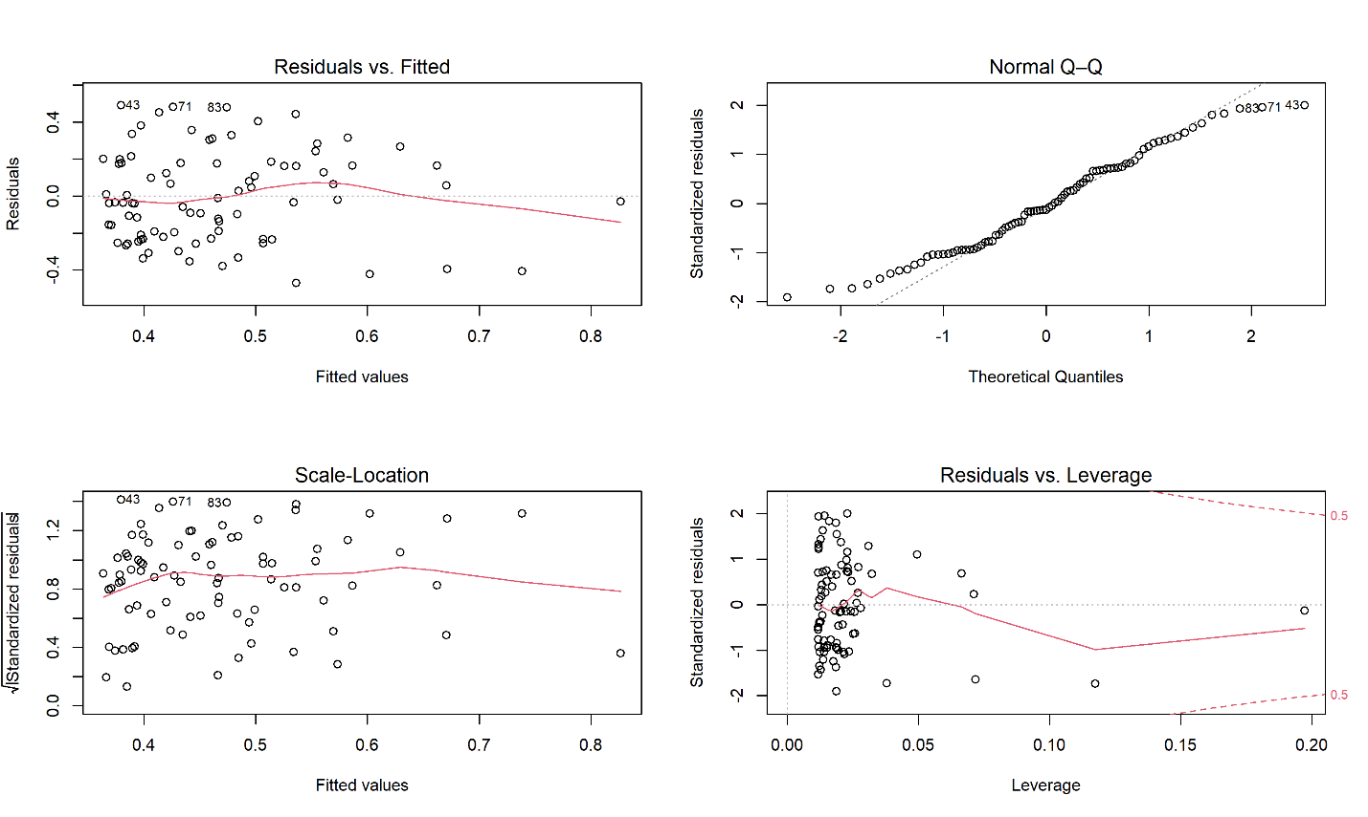
FIGURE A1a: Diagnostic Plots for Figure 1, Professional Occupations

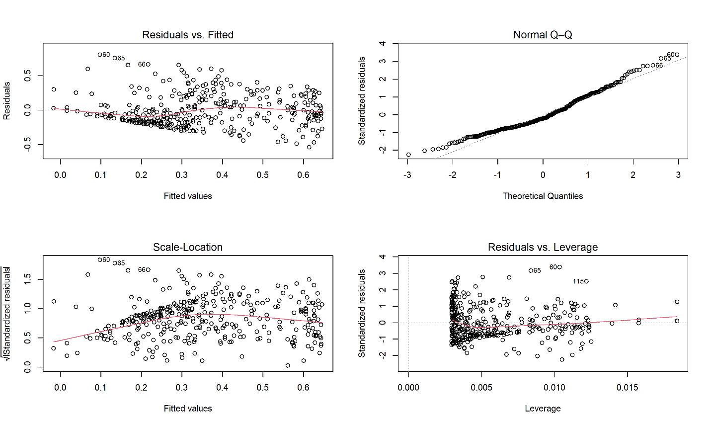

FIGURE A1b: Diagnostic Plots for Figure 1, Nonprofessional Occupations

TABLE A2: Linear vs. Robust Regression Results for Figure 1

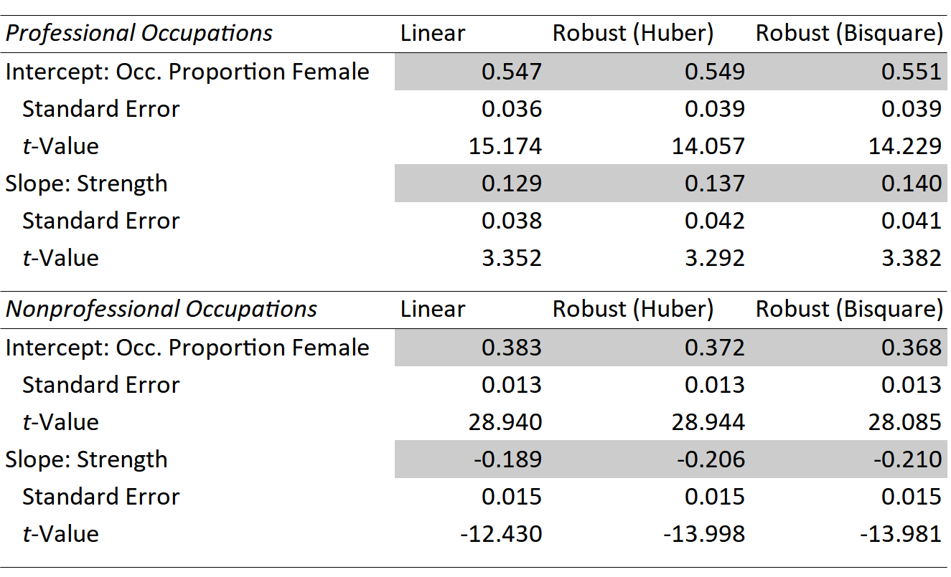

TABLE A3: O*NET Components and Factor Loadings of Gender-Typed Skill
Measures
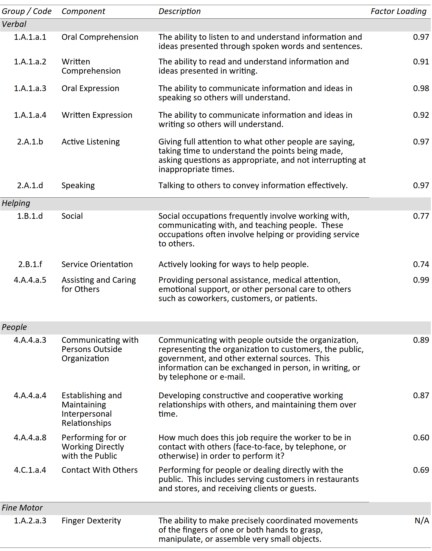
TABLE A3: (continued)

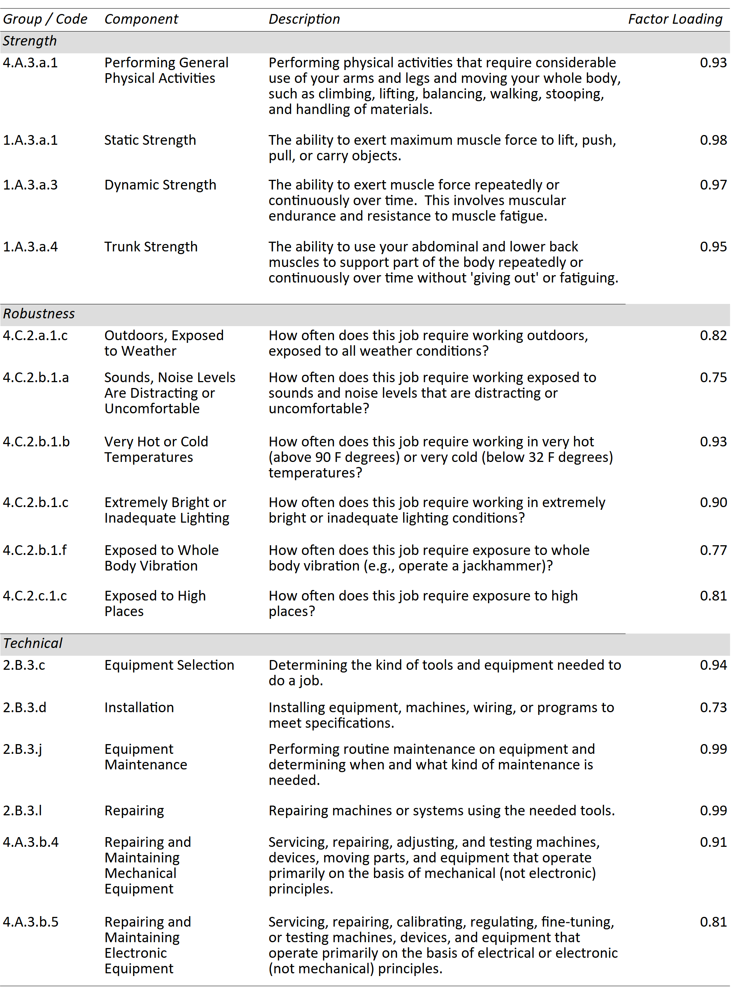
TABLE A3: (continued)

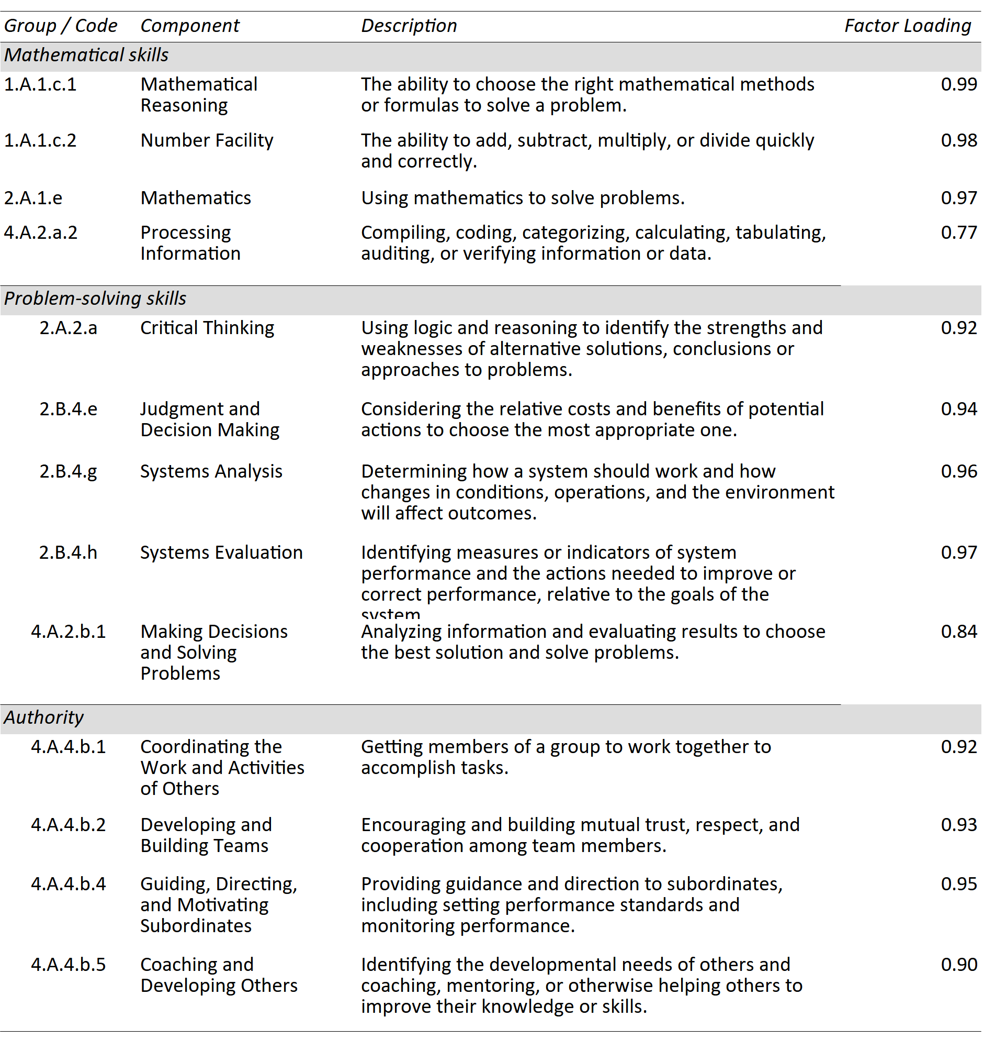

TABLE A4: Median Gender-Typed Skill Values by Year, 2011–2015

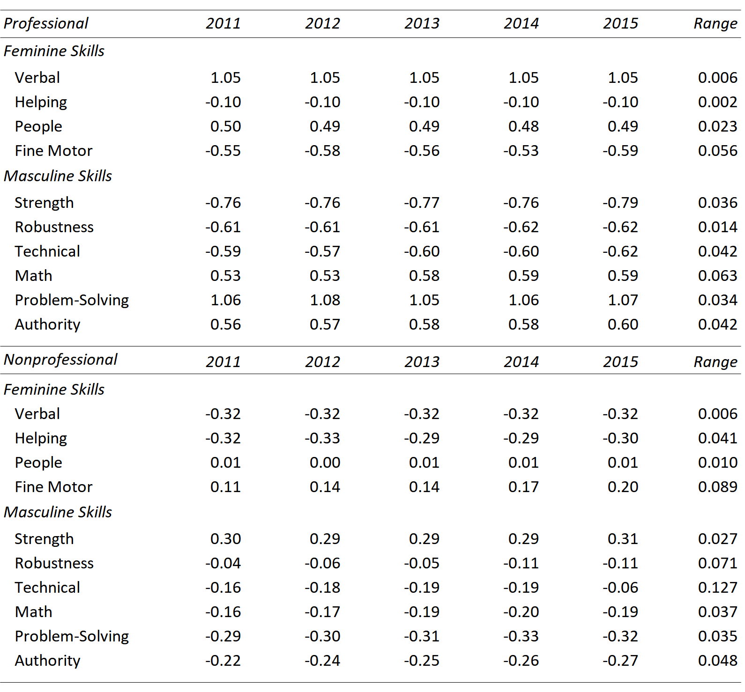

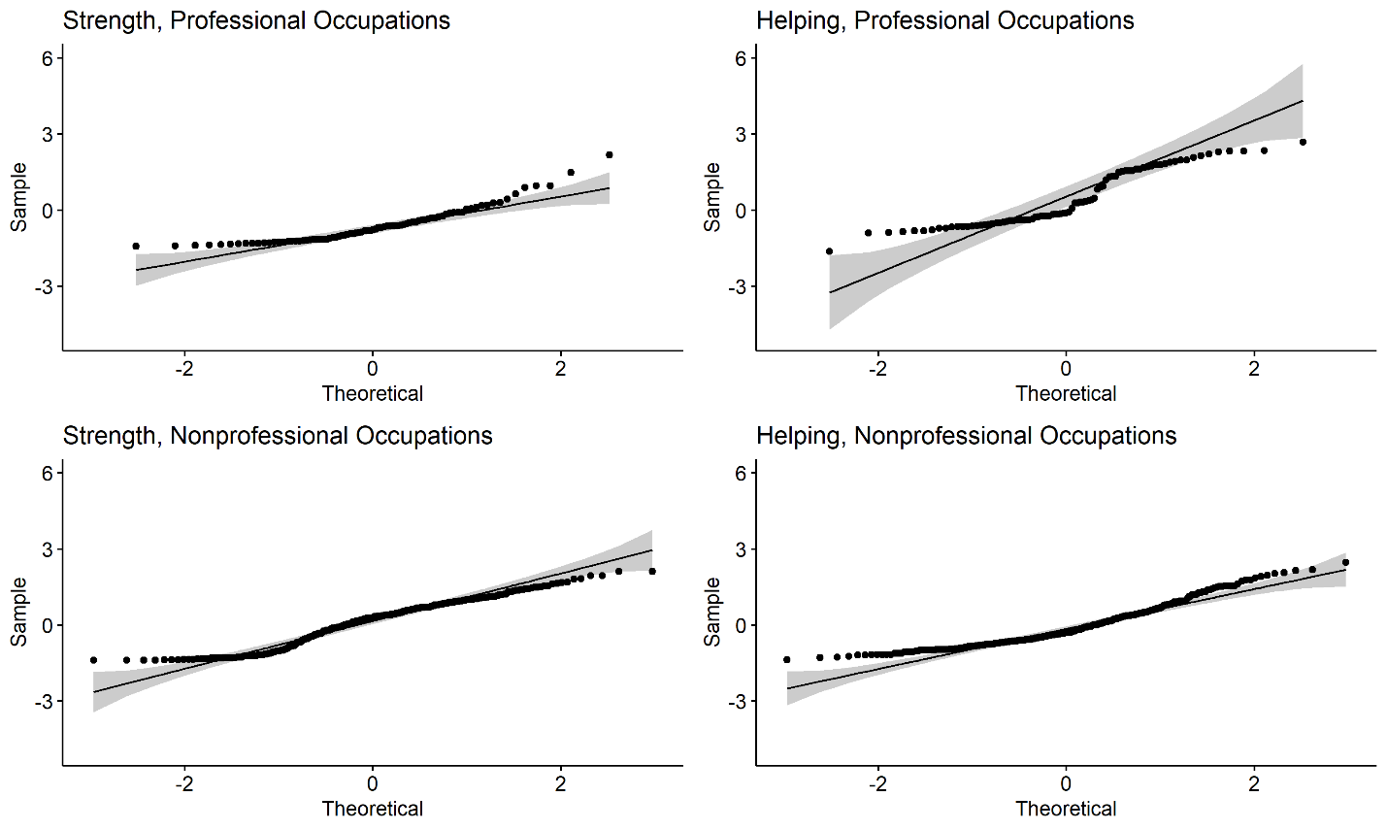

FIGURE A2a: Q–Q Plots for Selected Non-Normally Distributed Gender-Typed
Skills: Strength and Helping

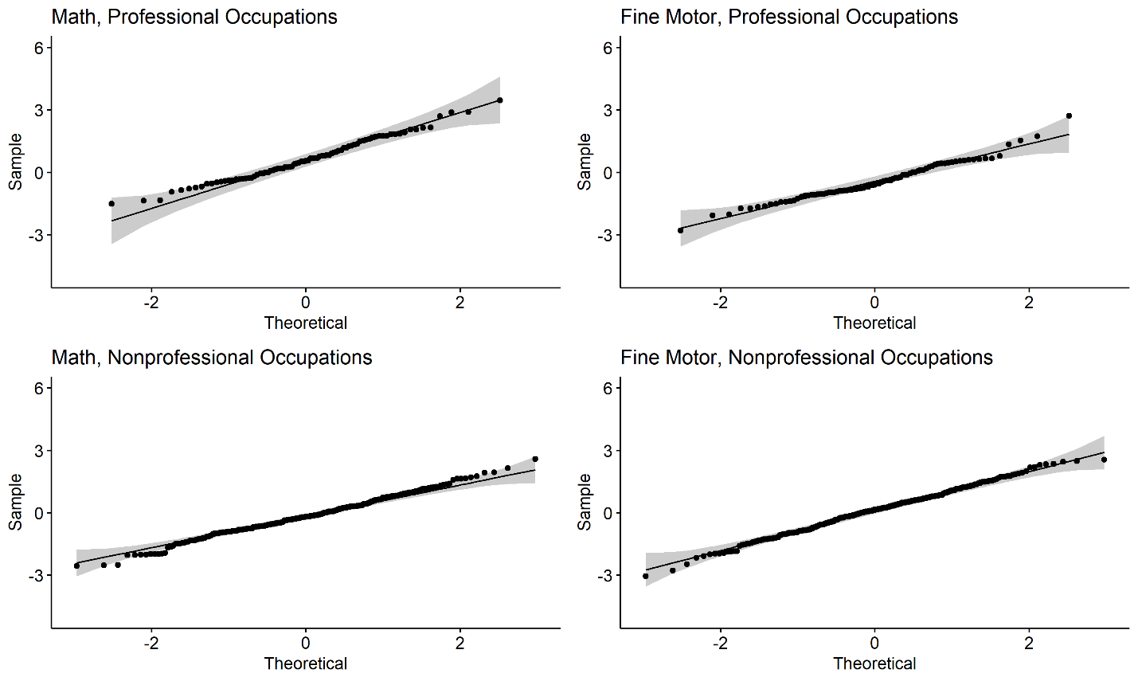

FIGURE A2b: Q–Q Plots for Selected Normally Distributed Gender-Typed Skills:
Math and Fine Motor

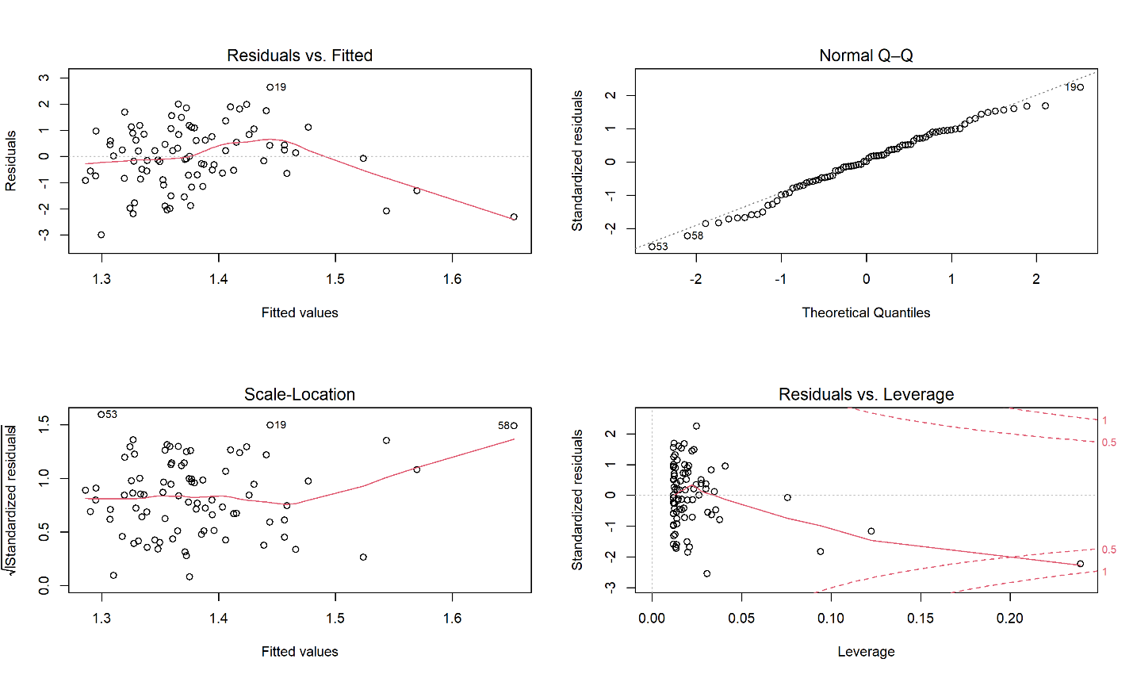

FIGURE A3a: Diagnostic Plots for Figure 2, Occupational Wage, Professional
Occupations

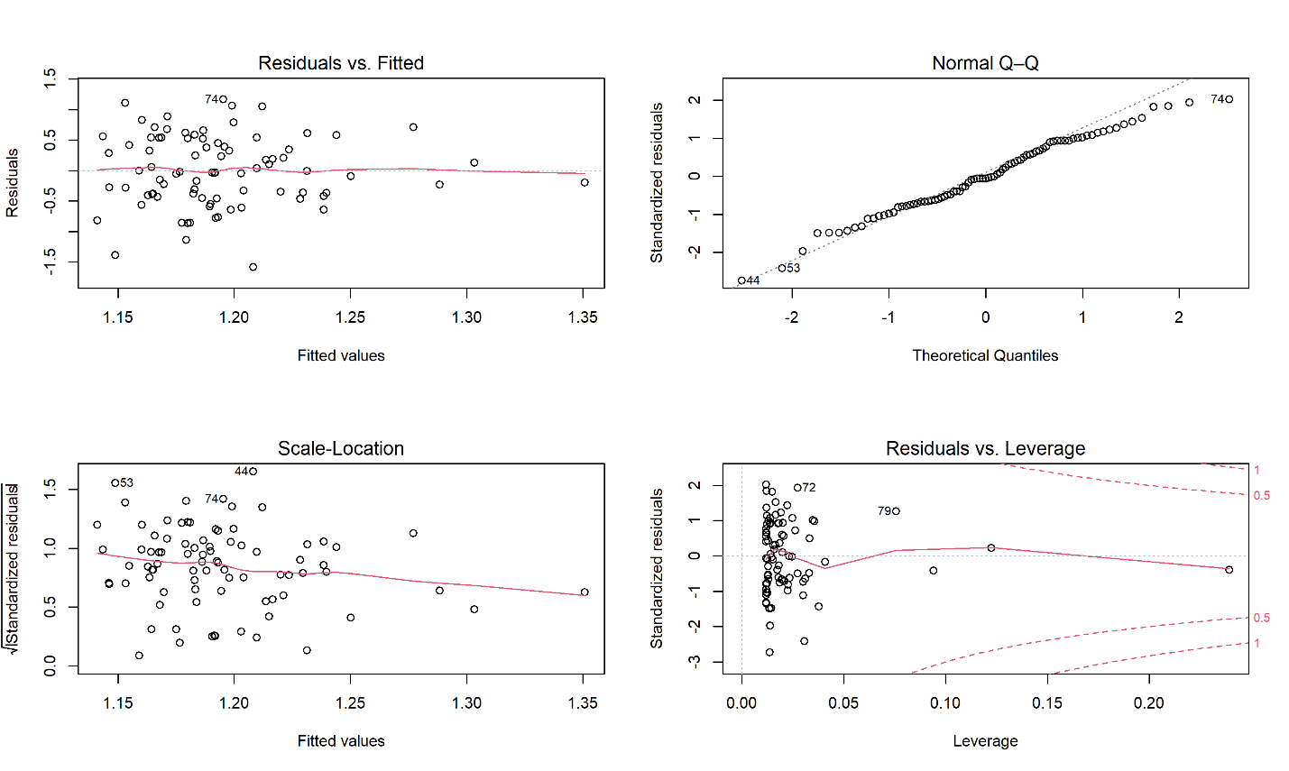

FIGURE A3b: Diagnostic Plots for Figure 2, Occupational Prestige, Professional
Occupations

TABLE A5: Linear vs. Robust Regression Results for Figure 2, Professional
Occupations

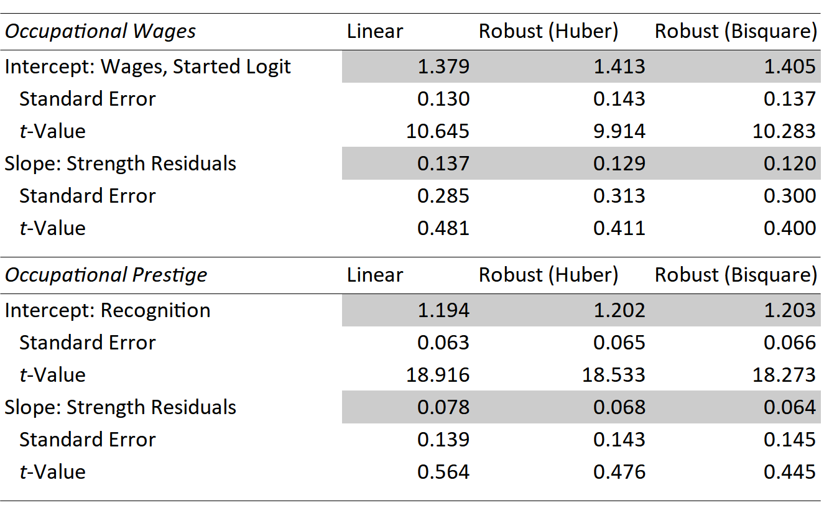

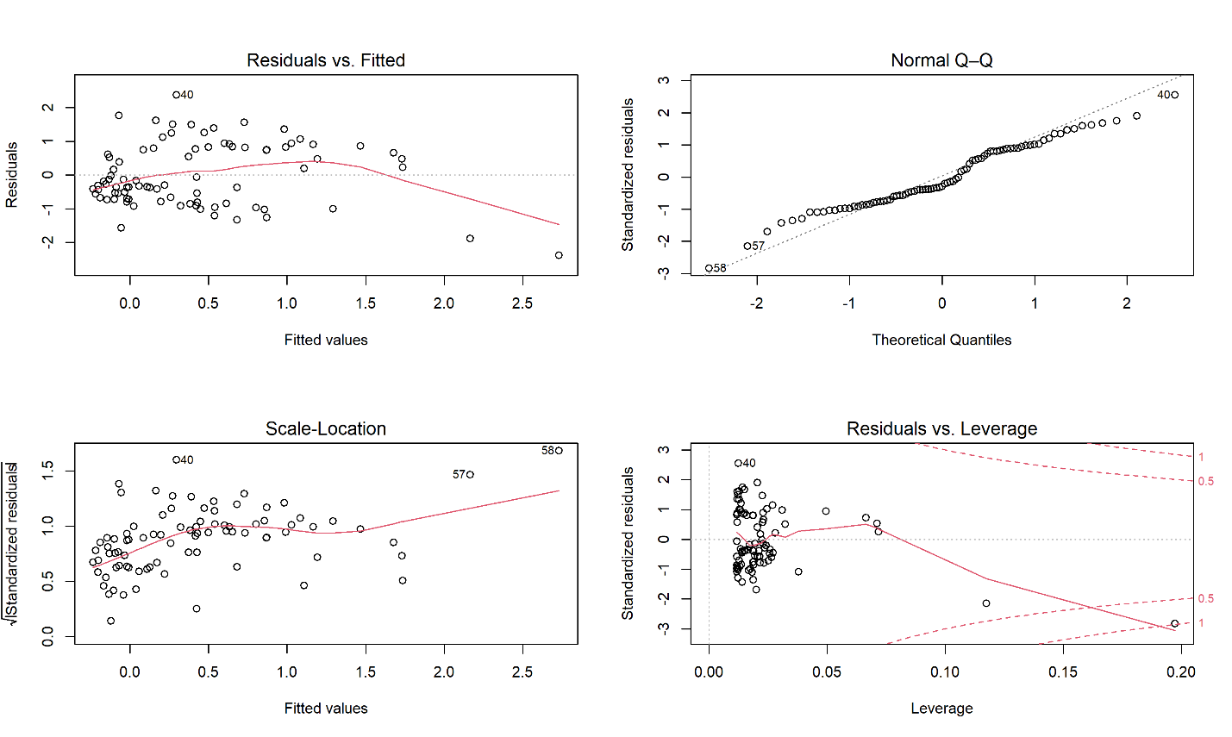

FIGURE A4: Diagnostic Plots for Figure 3, Strength vs. Helping Skills,
Professional Occupations

TABLE A6: Linear vs. Robust Regression Results for Figure 3, Professional
Occupations

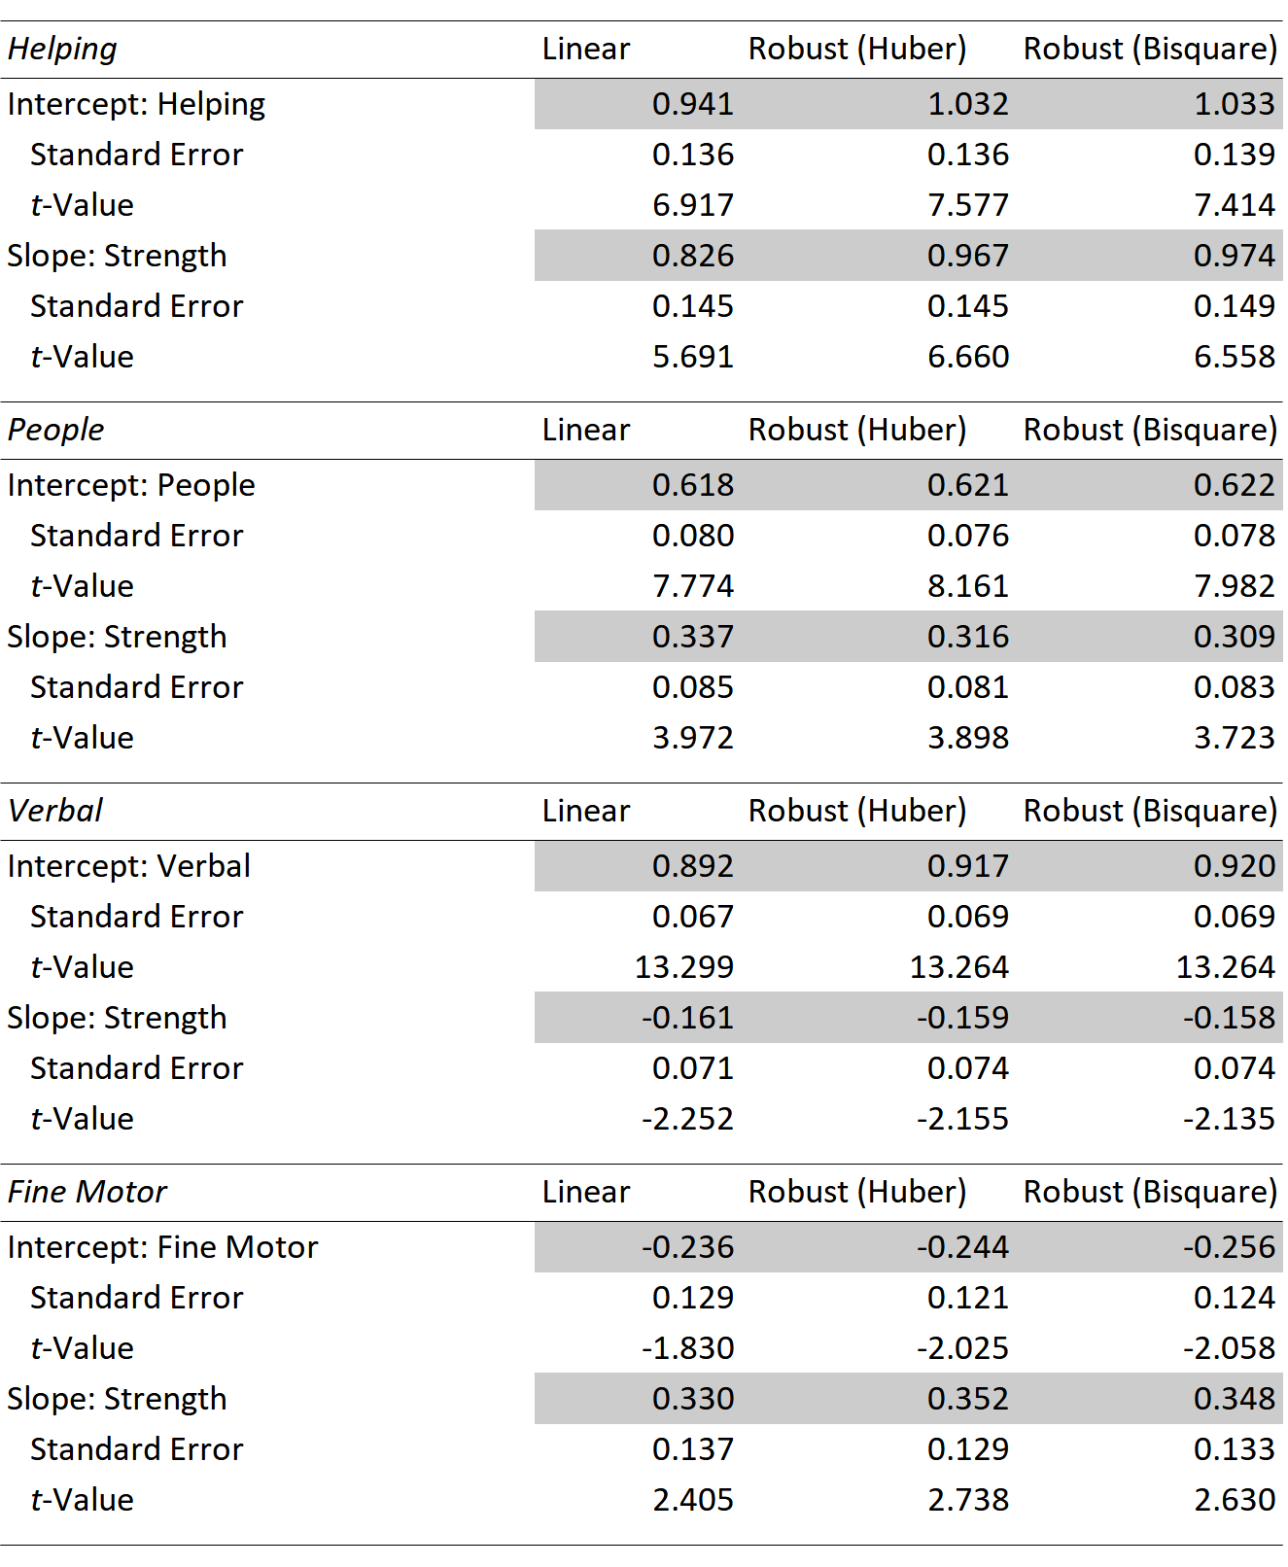

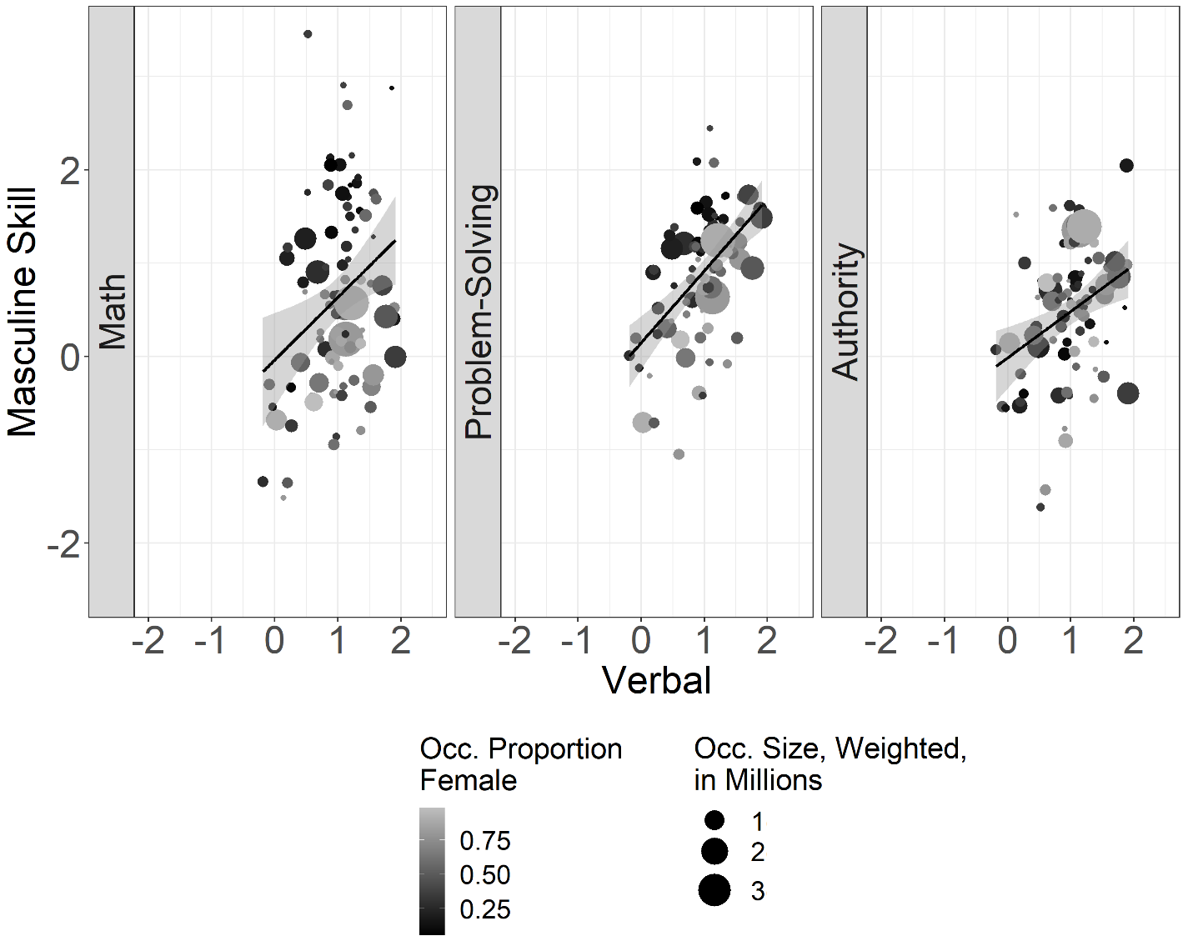

FIGURE A5: Co-occurrence Hypothesis Scatterplots, Professional Occupations
(Occ.): Verbal vs. Selected Masculine Skills

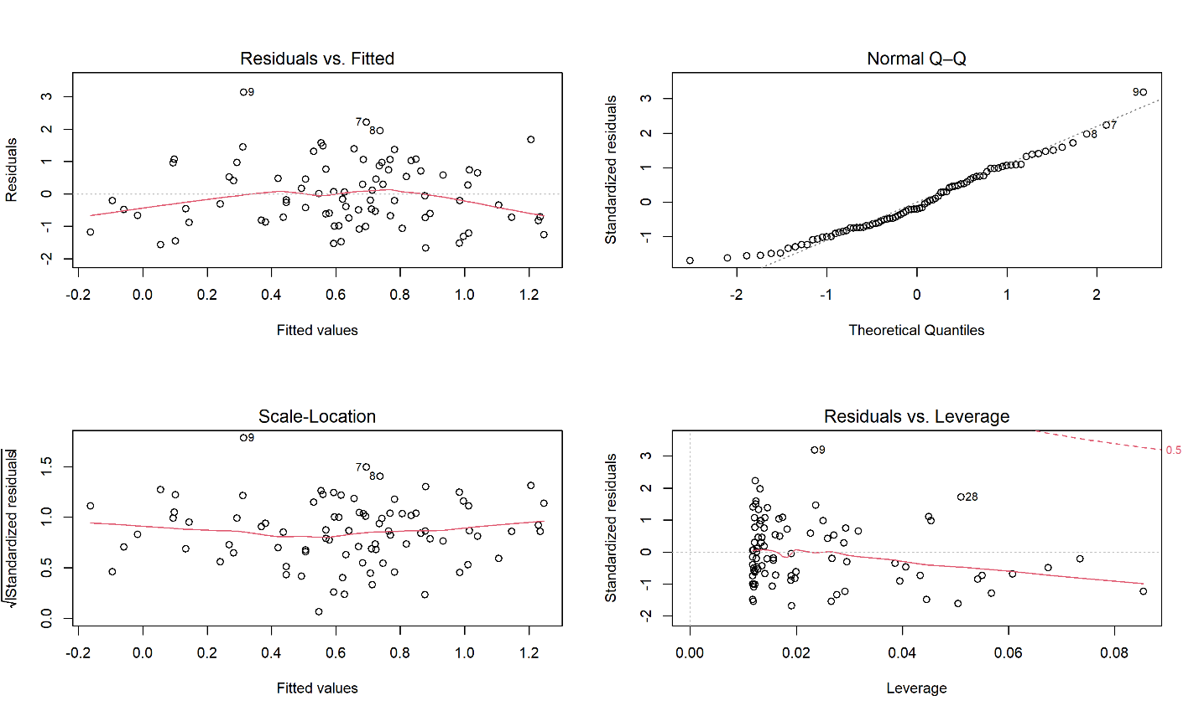

FIGURE A6: Diagnostic Plots for Figure A5, Verbal vs. Math Skills, Professional
Occupations

TABLE A7: Linear vs. Robust Regression Results for Figure A5, Professional
Occupations

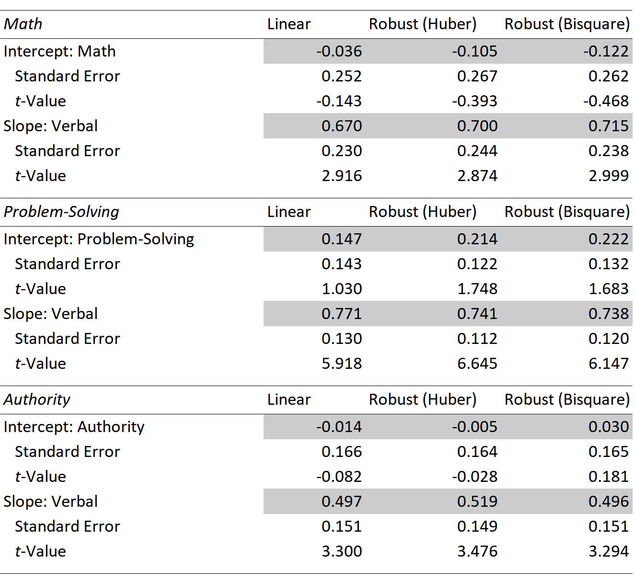

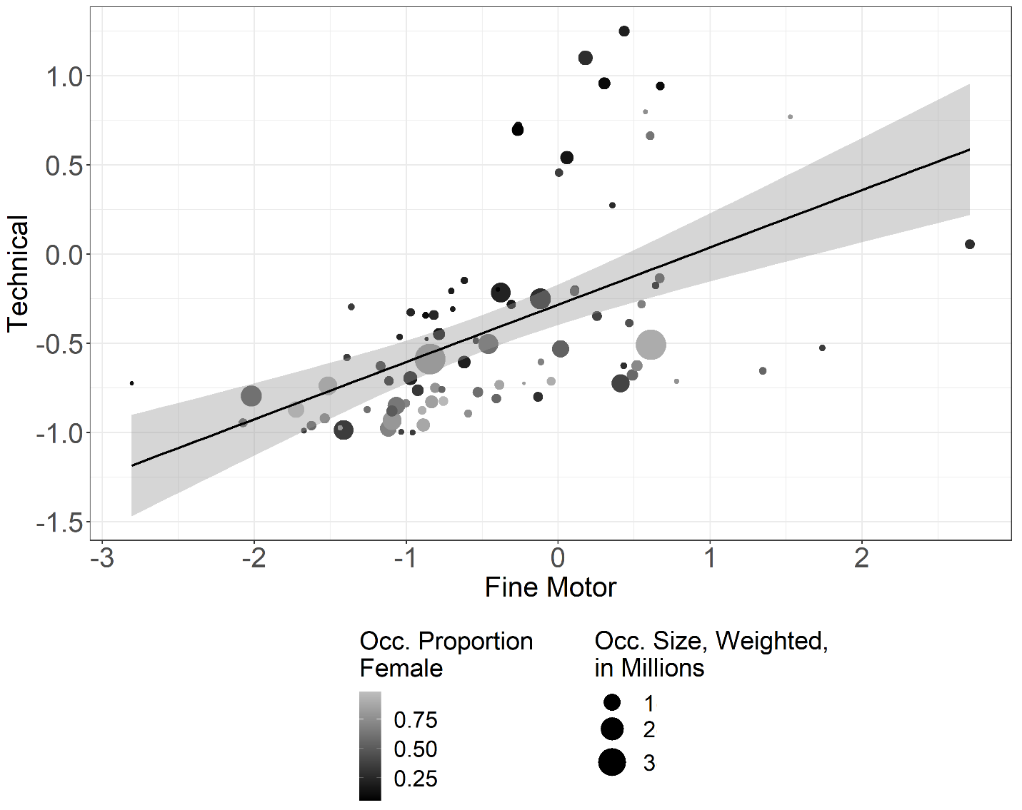

FIGURE A7: Co-occurrence Hypothesis Scatterplot, Professional Occupations (Occ.): Fine Motor vs. Technical Skills

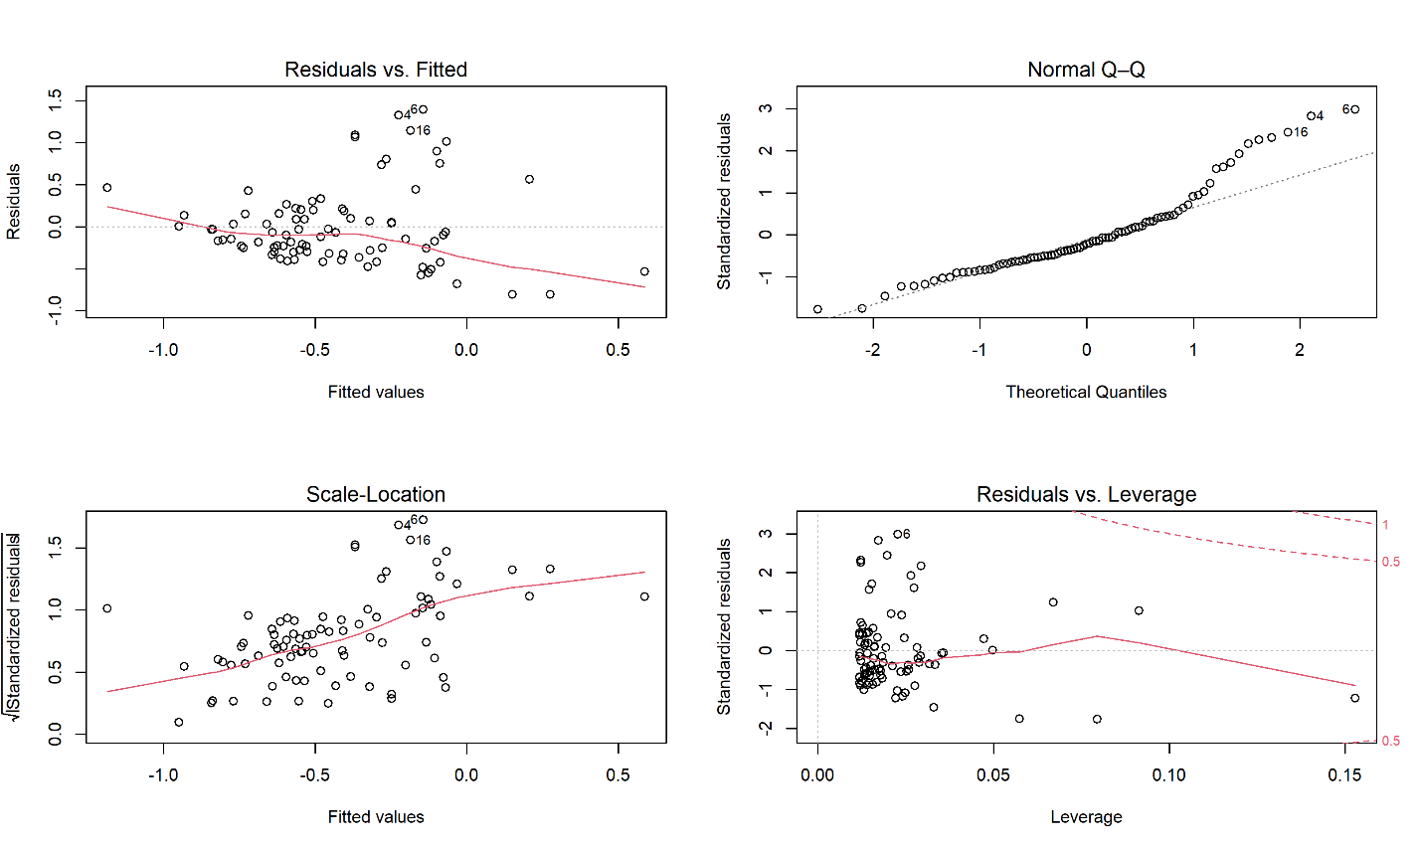

FIGURE A8: Diagnostic Plots for Figure A7, Fine Motor vs. Technical Skills,
Professional Occupations

TABLE A8: Linear vs. Robust Regression Results for Figure A7, Professional
Occupations

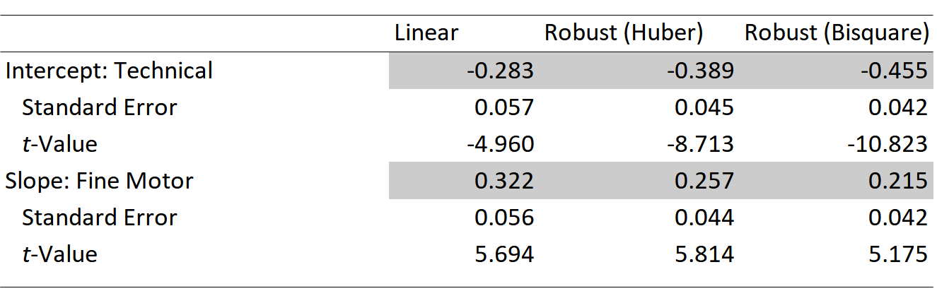

TABLE A9: Linear vs. Robust Regression Results for Figure 4, Nonprofessional
Occupations

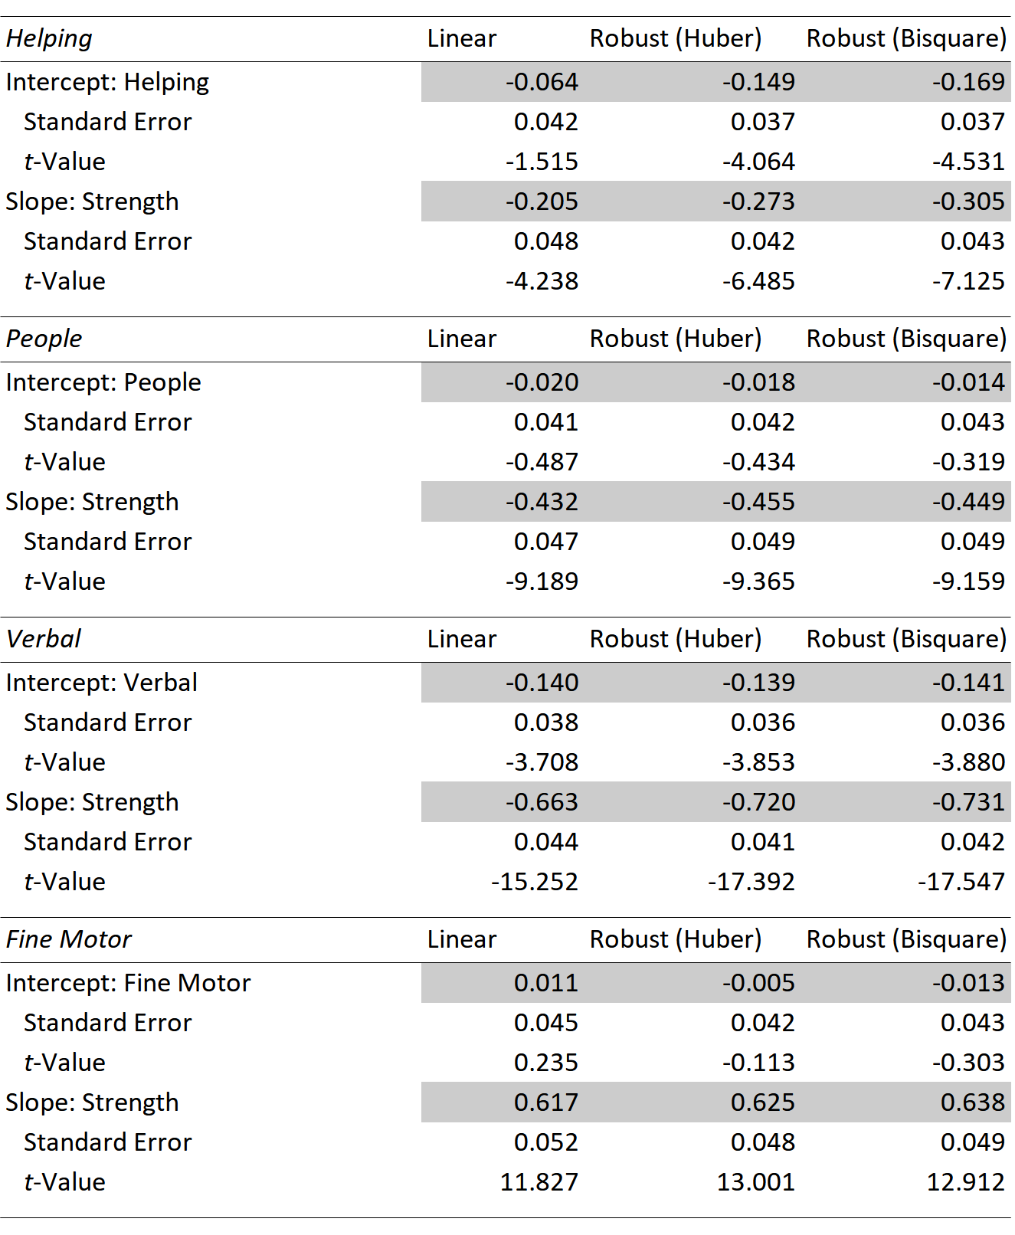

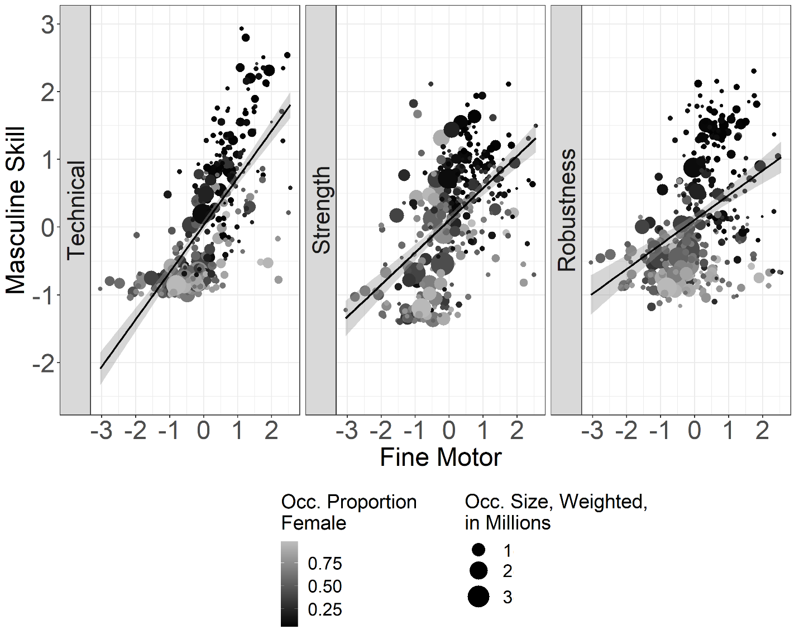

FIGURE A9: Co-occurrence Hypothesis Scatterplots, Nonprofessional
Occupations (Occ.): Fine Motor vs. Selected Masculine Skills

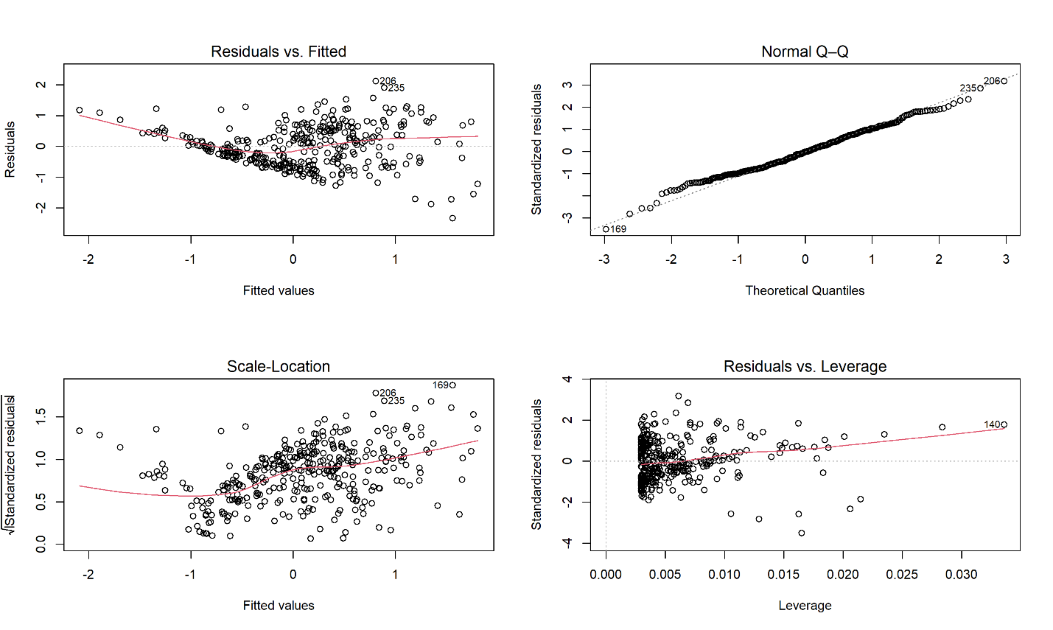

FIGURE A10a: Diagnostic Plots for Figure A9, Fine Motor vs. Technical Skills,
Nonprofessional Occupations

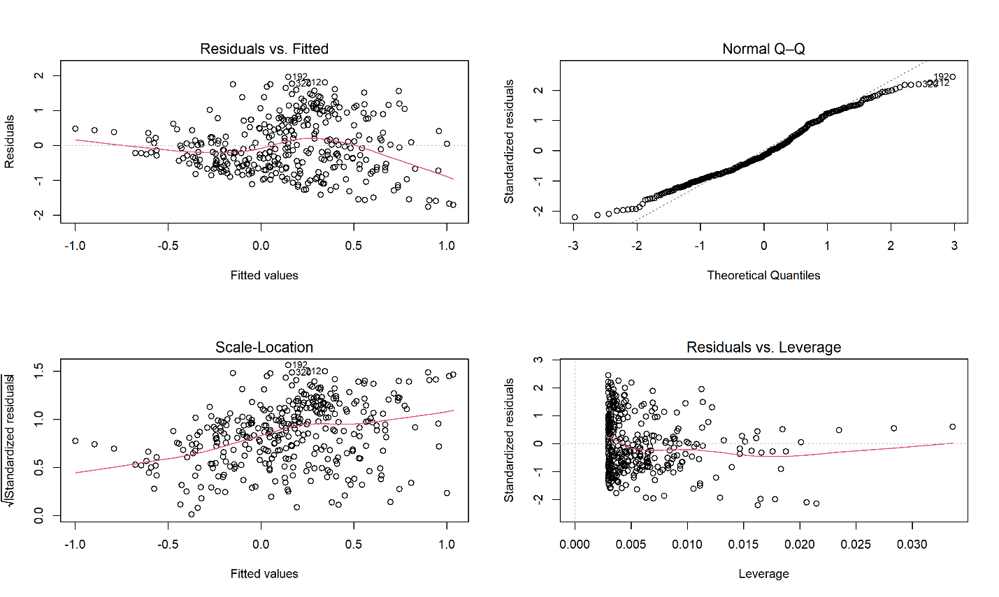

FIGURE A10b: Diagnostic Plots for Figure A9, Fine Motor vs. Robustness Skills,
Nonprofessional Occupations

TABLE A10: Linear vs. Robust Regression Results for Figure A9,
Nonprofessional Occupations

