Supplementary File 1
Table 1. Overview of abbreviations used.
Abbreviation | Description
VBDs | vector-borne diseases
HKH | Hindu Kush Himalayan
GEA | genotype-environment association
CH200 | Population sampled in Nepal at 200 m asl
Dh600 | Population sampled in Nepal at 600 m asl
DK800 | Population sampled in Nepal at 800 m asl
KT1300 | Population sampled in Nepal at 1300 m asl
RP1800 | Population sampled in Nepal at 1800 m asl
DU2050 | Population sampled in Nepal at 2050 m asl
SNP | single nucleotide polymorphism
OW | highly significant FST outlier window (1kb)
OP | highly significant FST outlier position
CDS | coding region/coding sequence
LFMM | Latent Factor Mixed Model
PCA | principal component analysis
CT | cold tolerance
MAD | Median Absolute Deviation
ENV | Environmental variable
EAP | significant positions associated with an environmental variable (LFMM-output)
EAP-OW | a significant position associated with an environmental variable is also present in an highly significant FST outlier window (1kb)--> candidates for climate adaptation
GO | Gene ontology
OW-OP | highly significant FST outlier positions laying also in an highly significant FST outlier window (1kb)--> candidates for local adaptation
kdr | knockdown resistance
IBE | isolation by environment pattern

Table 2. The coordinates of sampling sites and number, sex and original life-stage of Ae. aegypti individuals used per Pool-Seq sample. The set-up of Pool-Seq samples comprising DNA of ≥96 adult individuals per Ae. agypti population from four sampling site in Central Nepal. Immature life-history stages were reared to adulthood prior to DNA isolation. Altitude of sampling sites of Ae. aegypti populations: CH200 = 200 m asl, DH600 = 600 m asl, DK800 = 800 m asl, KT1300 = 1300 m asl.

 | CH200 |  | DH600 |  | DK800 |  | KT1300
Latitude | 27°39′03.8″N |  | 27°54′38.3″N |  | 27°44′ 04.0″N |  | 27°43′10.0″N
Longitude | 84°24′43.1″E |  | 84°53′41.6″E |  | 85°08′05.6″E |  | 85°19′21.7″E
Sex | F | M | F | M | F | M | F | M
individuals per sex | 51 | 51 | 51 | 51 | 53 | 43 | 52 | 51
larvae/pupae/adult (F0) | 32 | 35 | 51 | 51 | 42 | 33 | 52 | 51
eggs (F0) | 19 | 16 | - | - | 11 | 10 | - | -
Individuals in total | 102 |  | 102 |  | 96 |  | 103

Table 3. Number of alleles that cover a microsatellite region of eight populations using PoolSeq data. Regions with a less than 4 individuals are marked in bold. Altitude of sampling sites of Ae. aegypti populations: CH200 = 200 m asl, DH600 = 600 m asl, DK800 = 800 m asl, KT1300 = 1300 m asl.
Microsatellite | Liverpool  (West Africa) | Innisfail  (Australia) | Clovis  (USA) | Puntarenas  (Costa Rica) | CH200  (Nepal) | DH600  (Nepal) | DK800  (Nepal) | KT1300  (Nepal)
A1 | 1 | 0 | 3 | 9 | 29 | 17 | 23 | 18
A9 | 12 | 3 | 5 | 21 | 22 | 18 | 25 | 29
AC1 | 4 | 2 | 1 | 14 | 10 | 12 | 28 | 2
AC2 | 1 | 6 | 2 | 5 | 27 | 34 | 0 | 10
AC4 | 9 | 5 | 8 | 17 | 44 | 27 | 42 | 31
AC5 | 3 | 3 | 1 | 7 | 20 | 10 | 58 | 26
AG2 | 8 | 9 | 1 | 8 | 20 | 19 | 10 | 24
AG4 | 3 | 4 | 3 | 22 | 26 | 29 | 38 | 24
B2 | 4 | 5 | 3 | 12 | 21 | 27 | 27 | 21
B3 | 6 | 3 | 1 | 11 | 35 | 23 | 9 | 15
CT2 | 2 | 8 | 4 | 9 | 49 | 28 | 35 | 26

Table 4. Resolution of environmental data used for PCA. Microclimate has been derived from logger data and regional climate estimates from CHELSA (including all Bio variables 1-19; (Karger et al., 2017))
 | mean temperature | minimum temperature | maximum temperature | precipitation
Logger data | per season/annually | per season/annually | per season/annually
CHELSA | per month | per month | per month | per month

Table 5. Detailed description of logger data and their installation period in the field. I = indoors; SH= shadowed artificial substrates. Altitude of sampling sites of Ae. aegypti populations: CH200 = 200 m asl, DH600 = 600 m asl, DK800 = 800 m asl, KT1300 = 1300 m asl. SH logger at DH600 was lost during data recording.

Altitude [m] | Microclimate | Start 2017 | End 2019 | Missing data
CH200 | I1 | 16.11.2017 | 03.2019
 | I2 | 16.11.2017 | 03.2019
 | SH | 16.11.2017 | 03.2019
DH600 | I1 | 01.02.2018 | 03.2019
 | I2 | 16.11.2017 | 03.2019
 | SH | Missing logger
DK1300 | I1 | 15.11.2017 | 03.2019
 | I2 | 15.11.2017 | 03.2019
 | SH | 12.11.2017 | 03.2019
RP1800 | I1 | 03.10.2018 | 03.2019
 | I2 | 03.10.2017 | 03.2019
 | SH | 03.10.2017 | 03.2019 | 3.10.18-7.10.18
DU2050 | I | 09.11.2017 | 03.2019
 | I2 | 09.11.2017 | 03.2019
 | SH | 09.11.2017 | 03.2019

Table 6. Climate variables and Bioclim dataset used in the PCA. The respective highest components per PC loading are given. Climate variables were collected from HOBO logger datasets 11/2017-03/2019 and CHELSA (C.) database (1979-2013) and the Bioclim dataset from 1979-2013 (see also Supplementary file 1 Figure 8-10). Temperature = Temp; Precipitation = Prec; Minimum = min; Maximum = max.
Term of Parameter | related to | Logger | CHELSA | Bioclim | PC1 | PC2 | PC3
Longitude |  | X
Latitude |  | X
Altitude |  | X |  |  | 0.97
Annual mean | Temperature | X
Annual min | Temperature | X
Annual max | Temperature | X
Pre-monsoon mean | Temperature | X
Pre-monsoon min. | Temperature | X
Pre-monsoon max. | Temperature | X
Monsoon mean | Temperature | X
monsoon min. | Temperature | X
Monsoon max. | Temperature | X
Post-monsoon mean | Temperature | X
Post-monsoon min. | Temperature | X
Post-monsoon max. | Temperature | X
winter mean | Temperature | X
winter min. | Temperature | X
winter max. | Temperature | X
Max. January C. | Temperature |  | X
Max. February C. | Temperature |  | X
Max. March C. | Temperature |  | X
Max. April C. | Temperature |  | X
Max. May C. | Temperature |  | X
Max. June C. | Temperature |  | X
Max. July C. | Temperature |  | X
Max. August C. | Temperature |  | X
Max. September C. | Temperature |  | X
Max. October C. | Temperature |  | X
Max. November C. | Temperature |  | X
Max. December C. | Temperature |  | X
Min. January C. | Temperature |  | X
Min. February C. | Temperature |  | X
Min. March C. | Temperature |  | X
Min. April C. | Temperature |  | X
Min. May C. | Temperature |  | X
Min. June C. | Temperature |  | X
Min. July C. | Temperature |  | X
Min. August C. | Temperature |  | X
Min. September C. | Temperature |  | X
Min. October C. | Temperature |  | X
Min. November C. | Temperature |  | X
Min. December C. | Temperature |  | X
Mean January C. | Temperature |  | X
Mean February C. | Temperature |  | X
Mean March C. | Temperature |  | X
Mean April C. | Temperature |  | X
Mean May C. | Temperature |  | X
Mean June C. | Temperature |  | X
Mean July C. | Temperature |  | X
Mean August C. | Temperature |  | X
Mean September C. | Temperature |  | X
Mean October C. | Temperature |  | X
Mean November C. | Temperature |  | X
Mean December C. | Temperature |  | X
Prec. January C. | Precipitation |  | X
Prec. February C. | Precipitation |  | X
Prec. March C. | Precipitation |  | X
Prec. April C. | Precipitation |  | X
Prec. May C. | Precipitation |  | X
Prec. June C. | Precipitation |  | X
Prec. July C. | Precipitation |  | X
Prec. August C. | Precipitation |  | X
Prec. September C. | Precipitation |  | X
Prec. October C. | Precipitation |  | X
Prec. November C. | Precipitation |  | X
Prec. December C. | Precipitation |  | X
Annual mean | Temperature |  |  | X
Mean diurnal range | Temperature |  |  | X
Isothermality | Temperature |  |  | X
Temp. seasonality | Temperature |  |  | X |  |  | 0.93
Max. Temp. of warmest month | Temperature |  |  | X
Min. Temp. of coolest month | Temperature |  |  | X
Temp. annual range | Temperature |  |  | X
Mean Temp. of wettest month | Temperature |  |  | X
Mean Temp. of driest month | Temperature |  |  | X
Mean Temp. of warmest quarter | Temperature |  |  | X
Mean Temp. of coldest quarter | Temperature |  |  | X
Annual mean of precipitation | Precipitation |  |  | X |  | 0.62
Prec. of wettest month | Precipitation |  |  | X
Prec. of driest month | Precipitation |  |  | X
Prec. seasonality | Precipitation |  |  | X
Prec. of wettest quarter | Precipitation |  |  | X |  | 0.49
Prec. of driest quarter | Precipitation |  |  | X
Prec. of warmest quarter | Precipitation |  |  | X |  | 0.48
Prec. of coldest quarter | Precipitation |  |  | X

Table 7. LFMM median values per sampling site and environmental variables (LFFM input file: PCA scores and cold tolerance data (2).(2).
Analysis | Sampling site | PC 1 = ENV1 | PC 2= ENV2 | PC 3 = ENV3 | CT = ENV4
PCA | CH200 | -533.73 | 230.69 | -42.07 | 6.40
 | DH600 | -114.23 | -65.76 | 106.09 | 20.08
 | DK800 | 46.29 | -386.85 | -50.737 | 23.00
 | KT1300 | 601.67 | 221.92 | -13.28 | 11.86
LFMM | - | 0.066 | 0.759 | 0.346 | -0.177

Table 8. Mapping and coverage statistics of four Ae. aegypti populations sampled along an altitudinal gradient. Population genomic parameters estimated per site (1b) or in non-overlapping 1kb-windows: nucleotide diversity (π), population mutation parameter theta (θ) and effective population size (Ne) calculated as Ne= θ/4µ with µ= 2.1 × 10−9 (Oppold & Pfenninger, 2017). Altitude of sampling sites of Ae. aegypti populations in Central Nepal: CH200 = 200 m asl (Chitwan), DH600 = 600 m asl (Dhading), DK800 = 800 m asl (Dharke), KT1300 = 1300 m asl (Kathmandu).
Parameter | region | window | CH200 | DH600 | DK800 | KT1300
mapped reads (%) | genome- wide | - | 66.07 | 66.79 | 64.27 | 65.99
mean coverage | genome- wide | - | 22.46 | 17.86 | 21.1 | 19.02
genome coverage (%) | genome- wide | - | 72.66 | 63.87 | 70.64 | 66.55
PoPoolation analysis
π | genome- wide | 1kb | 0.0130 | 0.0125 | 0.0129 | 0.0126
 | genome- wide | 1b | 0.0135 | 0.0132 | 0.0135 | 0.0133
 | exon | 1b | 0.0079 | 0.0077 | 0.0080 | 0.0077
θ | genome- wide | 1kb | 0.0130 | 0.0125 | 0.0129 | 0.0127
N_{e} | genome-wide | 1kb | 1,548,452.4 | 1,485,238.1 | 1,536,904.8 | 1,507,976.2

Table 9. Details on gene function of the nine characterized candidate genes associated to environmental variables. ENV1 ~ altitude. ENV2 ~ precipitation, ENV4 = cold tolerance. Three other uncharacterized genes are not included in this list.
ENV1 | ENV2 | ENV4 | Gene description | Isoform | Function | Overall functional description | Species analysed | Reference
 | X |  | adenylate cyclase type 9 | X1, X2 | - insecticide resistance - regulating resistance-related P450 gene expression | Insecticide resistance | Culex quinquefasciatus, Drosophila melanogaster | (Li & Liu, 2019
 |  |  |  |  | - insecticide resistance - regulating resistance-related P450 gene expression  - highly expressed in the brain of mosquitoes  - signalling transduction, and regulation  - expressed in the different life stages of mosquitoes  - functional importance in response to exposure to insecticides during mosquito life stages |  | Cx. quinquefasciatus | (Li & Liu, 2017)
X | X | X | proto-oncogene tyrosine-protein kinase ROS | X1-X4 | - ROS is mainly related to the ATP binding pathway  - energy metabolism  - ROS were up-regulated - response of haemolymph to 1-deoxynojirimycin | Lifecycle: development | Samia cynthia ricini (butterfly) | (Zhang et al., 2018)
 |  |  |  |  | - suggested: development |  | Drosophila | (Acquaviva et al., 2009)
 | X |  | homeobox protein araucan |  | - larval development and metamorphosis  - formation of sense organs (including the eyes), in the specification of the dorsal part of the adult thorax and in the patterning of the wing veins, as well as in the segmentation of the body during embryonic development | Lifecycle: development | Drosophila | (Kerner et al., 2009)
 |  |  |  |  | - homeobox proteins Araucan (Ara) mediates the activation of the ac (proneural genes achaete) and sc promoters  - in relation to embryonic development and wing growth |  | Dr. melanogaster | (Negre & Simpson, 2015)
X | X | X | breast cancer anti-estrogen resistance protein 3 | X1-X5 | - dengue infection- different expression up/down regulated BCAR3 | Immune response | cells | (Xuanhao, 2010)
 | X |  | toll-like receptor Tollo |  | - suggested: mosquito immunity | Immune response | Ae. aegypti | (Shin et al., 2006)
 |  |  |  |  | - antifungal and antibacterial responses and implications in cellular antiviral responses  - expanded Toll-1/Toll-5 clade in mosquitoes is related to their interactions with viruses merits detailed functional investigation |  | Ae. aegypti | (Waterhouse et al., 2007)
 |  |  |  |  | - embryogenesis and post-embryonic development  - immune responses |  | Drosophila | (Leulier & Lemaitre, 2008)
 |  |  |  |  | - anti-dengue defence |  | Ae. aegypti | (Ramirez & Dimopoulos, 2010)
 |  |  |  |  | - anti-dengue defence |  | Ae. aegypti | (Xi et al., 2008)
 |  |  |  |  | - anti-dengue defence |  | Ae. aegypti | (Souza-Neto et al., 2009)
 |  |  |  |  | - immunity gene |  | Ae. albopictus | (Palatini et al., 2020)
 | X |  | zinc finger CCCH domain-containing protein 13 |  | - m(6)A writer- m(6)A (N6-methyladenosine) the most prevalent internal modification in mRNA is induced by writers  - m(6)A epi-transcriptome impacts on immune response and function | Immune response & lifecycle: development and reproduction | review | (Ma et al., 2020)
 |  |  |  |  | - Examined the biogenesis of mRNA-derived endogenous short interfering RNAs with and without infection of the Sindbis virus. If infected overexpression of this gene occurred. |  | Ae. aegypti | (Adelmann et al., 2012
 |  |  |  |  | - interactor of m(6)A methyltransferase complex components  - sex determination  - miss regulation of m6A by ZC3H13 lead to disease like glioblastoma progression and schizophrenia |  | Drosophila | (Knuckles et al., 2018)
 |  |  |  |  | - associated with several m(6)A writer factors  - xio/ZC3H13: encodes a member of the m6A methyl transferase complex involved in mRNA modification  - loss of xio/ZC3H13: asexual transformations, Sxl splicing defect, held-out wings, flight-less flies, and reduction of m6A levels  - development, disease, stem cell differentiation, immunity, and behavior, by controlling various aspects of RNA metabolism, such as splicing, stability, folding, export, and translation |  | Drosophila | (Guo et al., 2018)
 | X |  | probable peptide chain release factor C12orf65, mitochondrial |  | - mitochondrial RF family (mitochondrial release factor)  - mitochondrial protein synthesis  - loss of C12orf65: mitochondrial dysfunction | Protein regulation & immune response | Homo sapiens | (Chrzanowska-Lightowlers et al., 2011)
 |  |  |  |  | - dengue infection- different expression up/down regulated |  | cells | (Xuanhao, 2010)
 |  |  |  |  | - Suggestion: a role in recycling abortive peptidyl-tRNAs that are released from the ribosome during translational elongation |  | Homo sapiens | (Christian & Spremulli, 2012)
 |  |  |  |  | - Suggestion: likely to function on stalled ribosomes or large subunits with peptidyl-tRNA still anchored within, allowing them to be recycled for a new round of translation |  | Homo sapiens | (Wesolowska et al., 2014)
 | X |  | tubulin-specific chaperone D |  | - tubulin heterodimer consists of one alpha- and one beta-tubulin polypeptide. Tubulin-specific chaperones are essential for bring the alpha- and beta-tubulin subunits together into a tightly associated heterodimer  - related functions to mating- sperm microtubule morphogenesis and function | Lifecycle: reproduction | Anopheles coluzzii, Anopheles quadriannulatus | (Deitz et al., 2020)
 | X |  | coatomer subunit beta' | X1, X2 | - coatomer subunits are needed for vesicle coat and induce membrane budding, loss of one of the subunits disrupt the entire complex  - β′COPI subunit facilitates the underlying triskelion structure within the lattice of the vesicle coat  - mosquito blood digestion and egg maturation | Lifecycle: blood feeding and reproduction | Ae. aegypti | (Isoe et al., 2011)
 |  |  |  |  | - in general: COPI-mediated (coatomer proteins) blood meal digestion  - Blood feeding |  | Anopheles stephensi | (Isoe et al., 2013)

Table 10. Significantly enriched GO terms (p < 0.05) among candidate genes (EAP-OW) per ENV and their biological functions involved in climate adaptation. To increase resolution, the GO term analysis was conducted per ENV (ENV1 ~ altitude, ENV2 ~ precipitation, ENV4 = cold tolerance) as described by (Waldvogel et al., 2018). The definition of GO terms was used from the webpage: (Dimmer et al., 2008). If literature for comparison was accessible, the biological function and the link with ENVs was discussed.
Enriched GO term | ENV1 | ENV2 | ENV4 | Definition of GO terms involved in climate adaptation | Biological function involved in climate adaptation
small GTPase mediated signal transduction (GO:0007264) | X | X | X | Any series of molecular signals in which a small monomeric GTPase relays one or more of the signals.
protein phosphorylation (GO:0006468) | X | X | X | The process of introducing a phosphate group on to a protein. | One of the most important post-translational modifications is protein phosphorylation. Protein phosphorylation is vital for the coordination of organic and cellular function such as the regulation of metabolism, proliferation, apoptosis, subcellular trafficking, inflammation, and other important physiological processes (Ardito et al., 2017). ENV1, ENV2 and ENV4 seem to affect this important function. This GO term correlating with climate variation was also enriched in a GEA study in ants (Hartke et al., 2021), whereas in the GEA study of Waldvogel (Waldvogel et al., 2018) this GO term was enriched in candidate genes for local adaptation.
transmembrane receptor protein tyrosine kinase signaling pathway (GO:0007169) | X | X | X | A series of molecular signals initiated by the binding of an extracellular ligand to a receptor on the surface of the target cell where the receptor possesses tyrosine kinase activity, and ending with regulation of a downstream cellular process, e.g. transcription. | The major mechanism for intercellular communication during development as well as in the adult organism and in disease-associated processes is the signaling through receptor tyrosine kinases (Haj et al., 2003). ENV1, ENV2 and ENV4 seem to affect this important function. This GO term correlating with climate variation was also enriched in a GEA study in ants (Hartke et al., 2021).
ubiquitin-dependent protein catabolic process (GO:0006511) | X |  | X | Chemical reactions and pathways leading to a breakdown of a protein or peptide by hydrolysis of its peptide bonds.
translational termination (GO:0006415) | X |  | X | The process that leads to the release of a polypeptide chain form the ribosome when a termination codon on the mRNA occurs.
regulation of pH (GO:0006885) |  | X |  | Within an organism or cell, processes involved in the maintenance of an internal equilibrium of hydrogen ions, thereby modulating the internal pH. | This GO term is upregulated in the highly secreting pleuropodia. Pleuropodia appear on the first abdominal segment in embryos of insects. This organ secrete a “hatching enzyme” that enables the hatching of larvae by digesting the serosal cuticle (Konopová et al., 2020). Thus, the association of this GO term with precipitation adds up.
sodium ion transport (GO:0006814) |  | X |  | Movement of sodium ions within, into or out of a cell, or between cells by some agents such as a transporter or pore. | In Ae. aegypti larvae the exchange of sodium occurs through the anal papillae, as well as smaller amounts enter the haemolymph through the gut and general body surface (Treherne, 1954). In Nepal, sodium as well as chloride concentration in rainfall is high, especially in the monsoon season (Wilson et al., 2016). Thus, larvae may need to cope with concentrations of these ions, which may affect survival and explain the association with precipitation.
Proteolysis (GO:0006508) |  | X | X | Hydrolysis of proteins into smaller polypeptides and/or amino acids, respectively by cleavage of their peptide bonds. | Temperature extremes affect protein stability and cells have to cope with stress-induced protein denaturation (Feder & Hofmann, 1999). Adaptation of the proteolysis machinery implies a response to the upper temperature extremes along the thermal cline (Waldvogel et al., 2018). In the GEA study of Waldvogel (Waldvogel et al., 2018) within Chironomidae species, this GO term was enriched in candidate genes for climate adaptation and was associated with warm temperatures, whereas in this study the GO term is associated with precipitation and cold tolerance. In addition, this GO term was significantly enriched among candidate genes of climate differentiation in Drosophila (Kolaczkowski et al., 2011; Waldvogel et al., 2018).

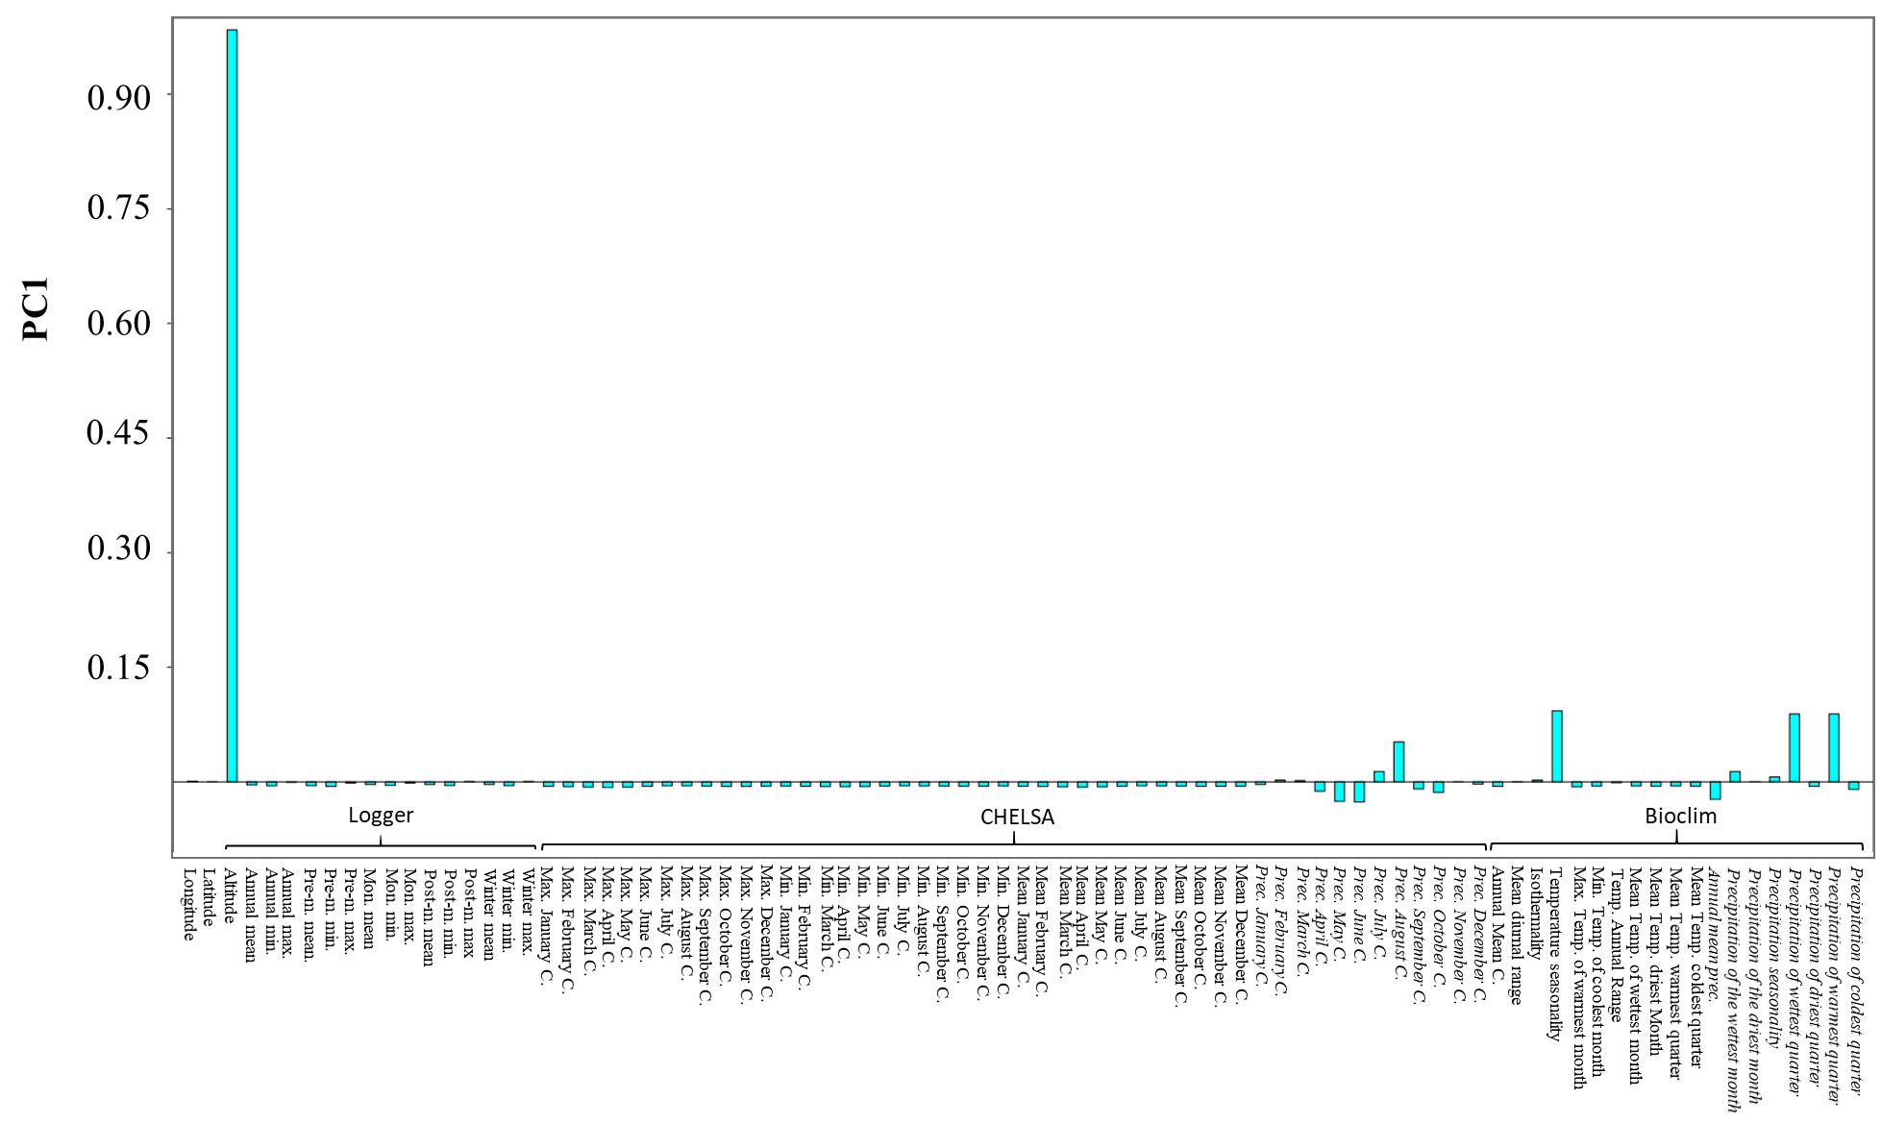
Figure 1. Loadings from PC (principal component) analysis: PC1 is associated with altitude. Precipitation related variables are highlighted using Italic font. Temperature related variables and longitude, latitude and altitude are given in non-italic font.

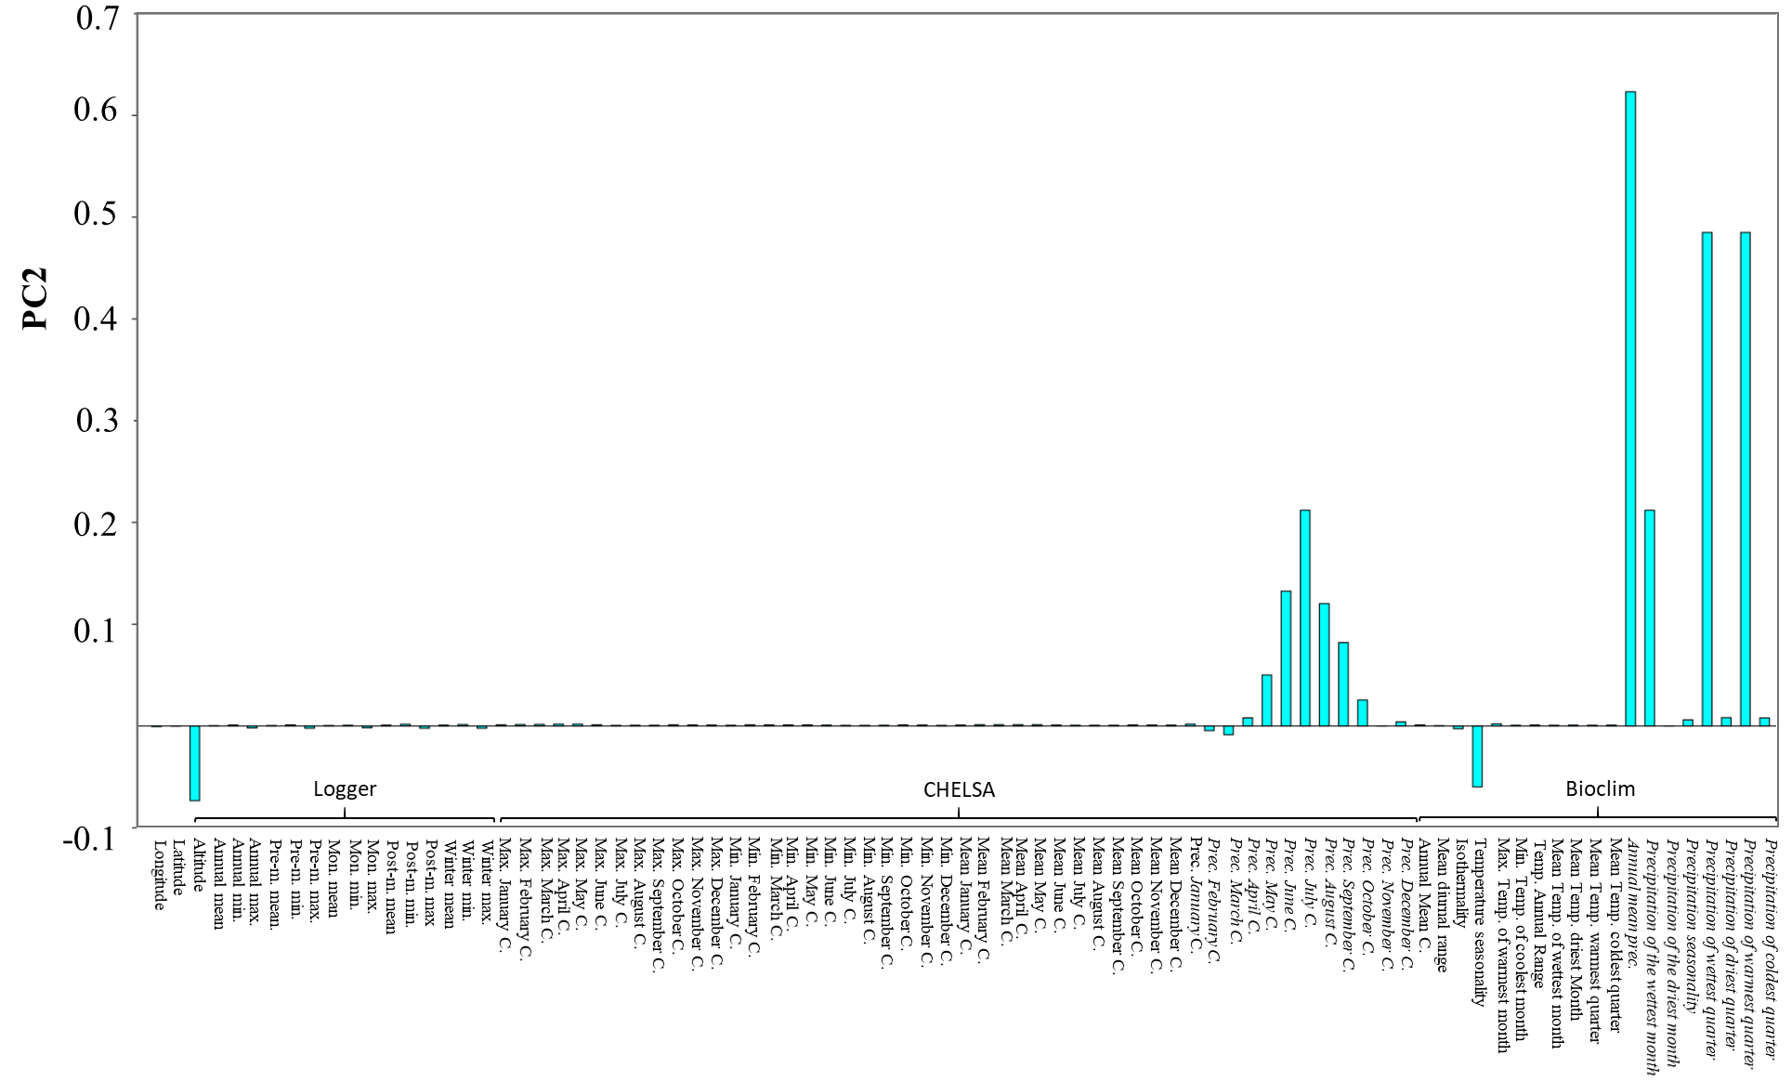
Figure 2. Loadings from PC (principal component) analysis: PC2 is associated with precipitation. Precipitation related variables are highlighted using Italic font. Temperature related variables and longitude, latitude and altitude are given in non-italic font.

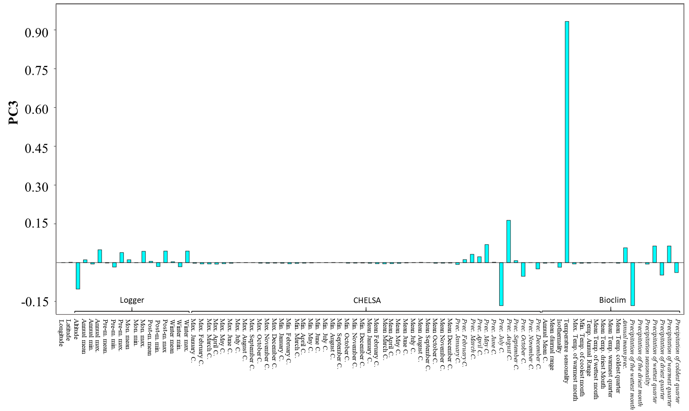
Figure 3. Loadings from PC (principal component) analysis: PC3 is associated with seasonality. Precipitation related variables are highlighted using Italic font. Temperature related variables and longitude, latitude and altitude are given in non-italic font.
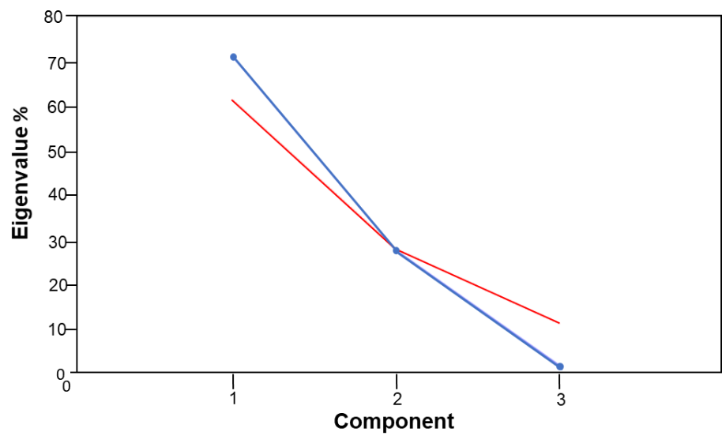
Figure 4. Distribution of Eigenvalues (%) of principal components (blue line). Gained from principal component analysis with 85 climatic variables (logger data, CHELSA, Bioclim) at 4 different sampling sites of Ae. aegypti populations along an altitudinal gradient in Nepal. Broken stick analysis is given as red line and indicates that PC3 componenent under this line is non significant.
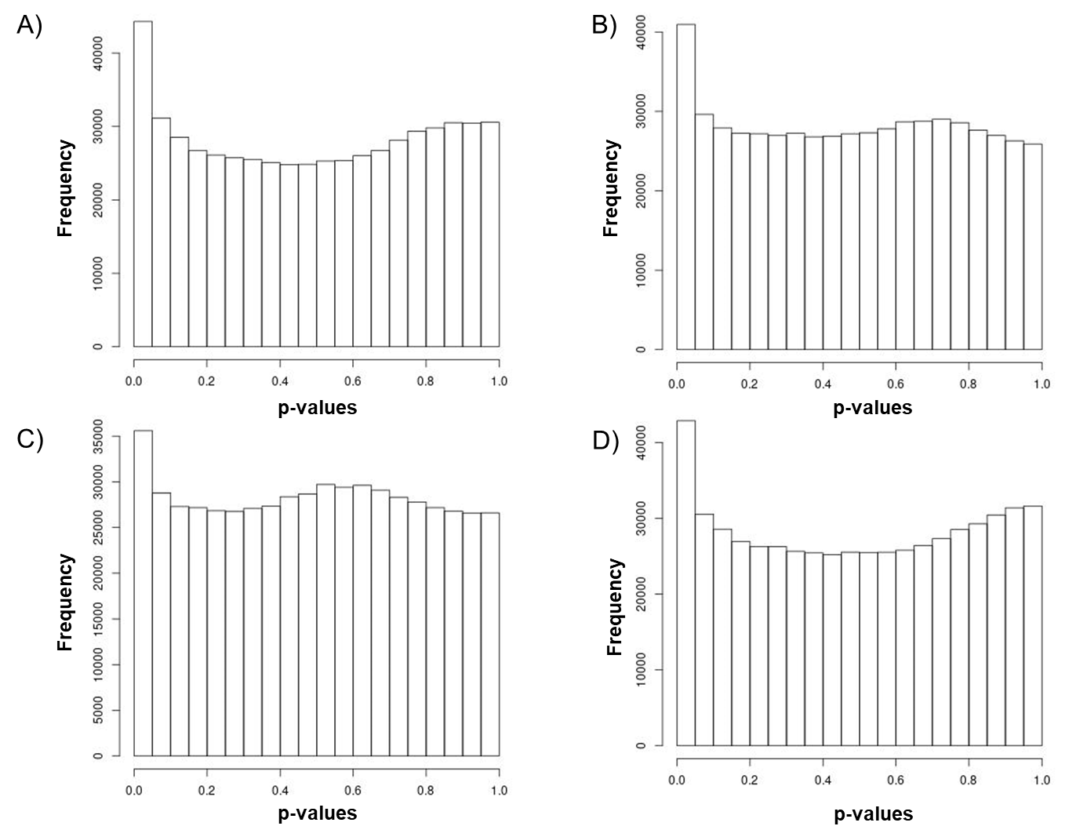
Figure 5. The frequency distribution of adjusted p-values after association (genotype-enviornment association analysis) to four different environmental variables (ENVs) using LFMM. 1) ENV1 = PC1 associated with altitude, 2) ENV2 = PC2 associated with precipitation, 3) ENV3 = PC3 associated with seasonality and 4) ENV4 = cold tolerance of Ae. aegypti (Kramer, Pfeiffer, et al., 2021).

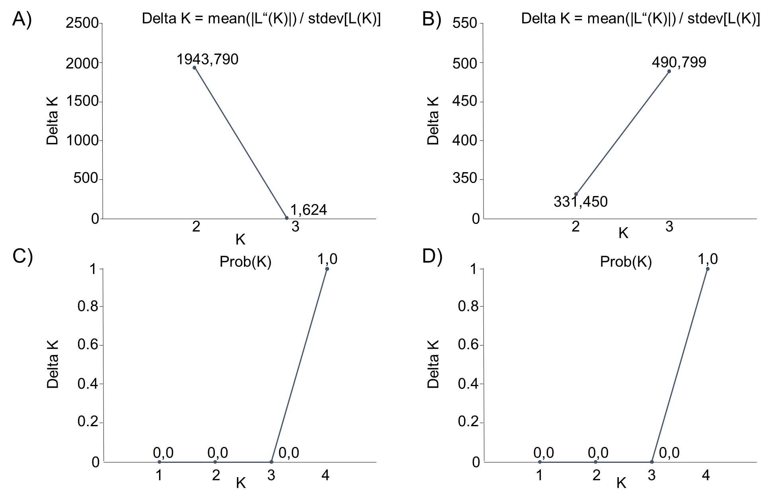
Figure 6. Delta K (A, B) and Probability by K (C,D) from the structure analysis. Delta K=Optimal K by Evanno is given. A+C) show the result of the STRUCTURE/CLUMPAK comparison between Nepal and Africa, Costa Rica and Australia using 6 microsatellite regions (Matthews et al., 2018). Division of runs by mode for K=2 was 10/10 and for K=3 9/10, 1/10. B+D) show the results of the STRUCUTRE/ CLUMPAK comparison of only Nepalese populations using 11 microsatellite regions. Division of runs by mode for all K1-4 was 10/10.
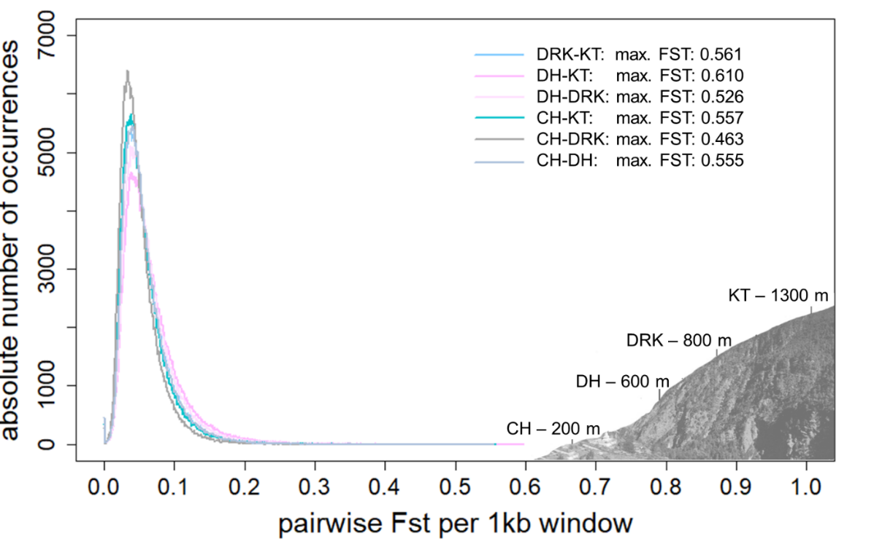
Figure 7. Pairwise F_{ST} distribution per 1 kb-windows (OW) of Nepalese Ae. aegypti populations sampled along an altitudinal gradient in Nepal (200-1300m). Altitude of sampling sites of Ae. aegypti populations in Central Nepal: CH200 = 200 m asl (Chitwan), DH600 = 600 m asl (Dhading), DK800 = 800 m asl (Dharke), KT1300 = 1300 m asl (Kathmandu).
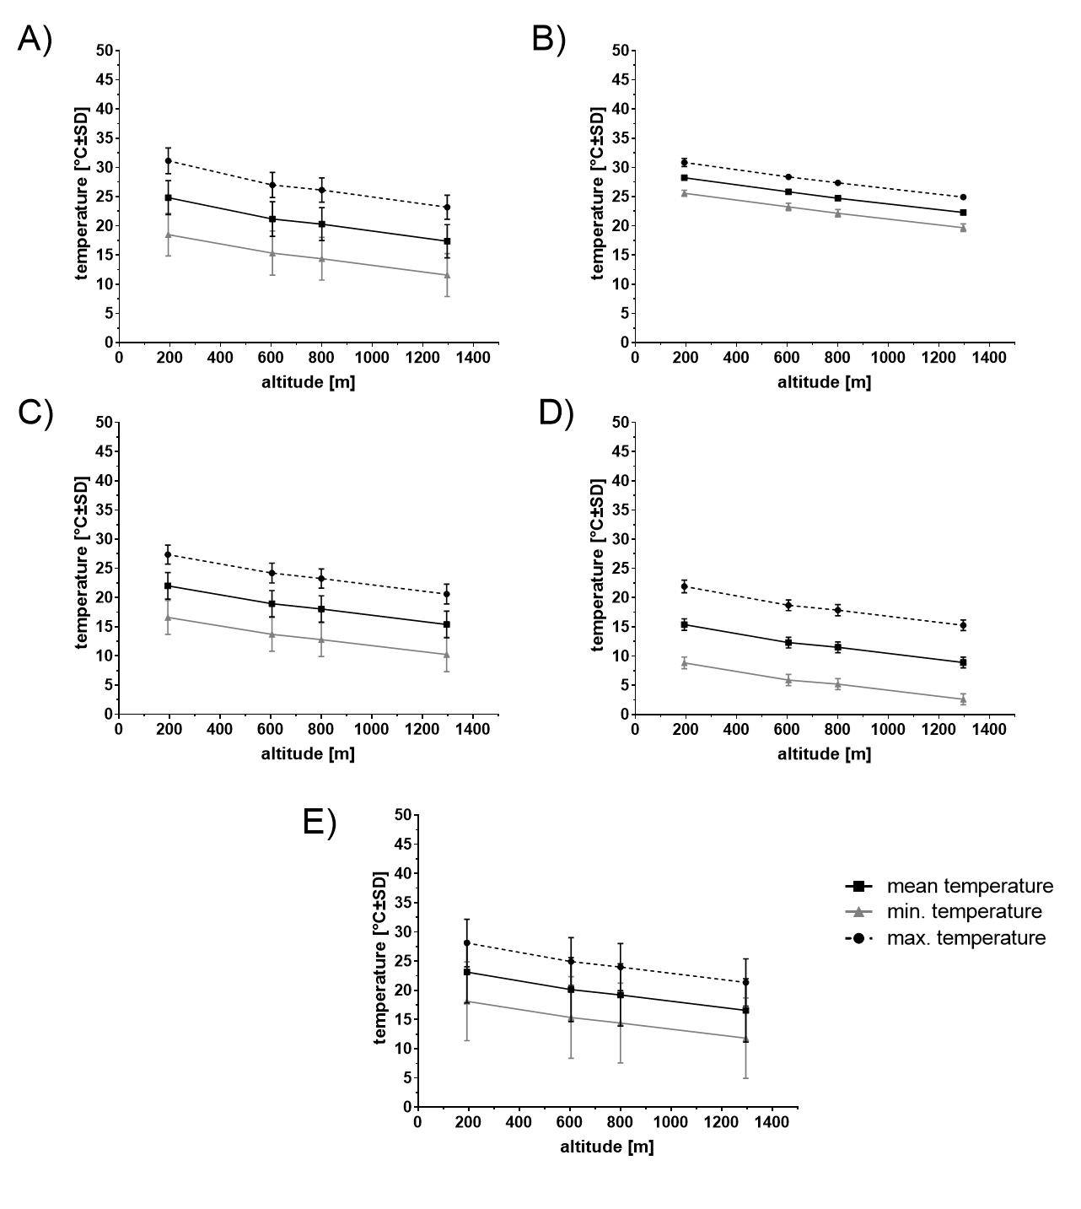
Figure 8. Climate (air temperature) along the altitudinal gradient in Central Nepal. Mean, minimum and maximum temperature (CHELSA data) in different time seasons from 1979 to 2013: A) pre-monsoon (March-May), B) monsoon (June-September), C) post-monsoon (October-November), D) winter (December-February), E) annual.

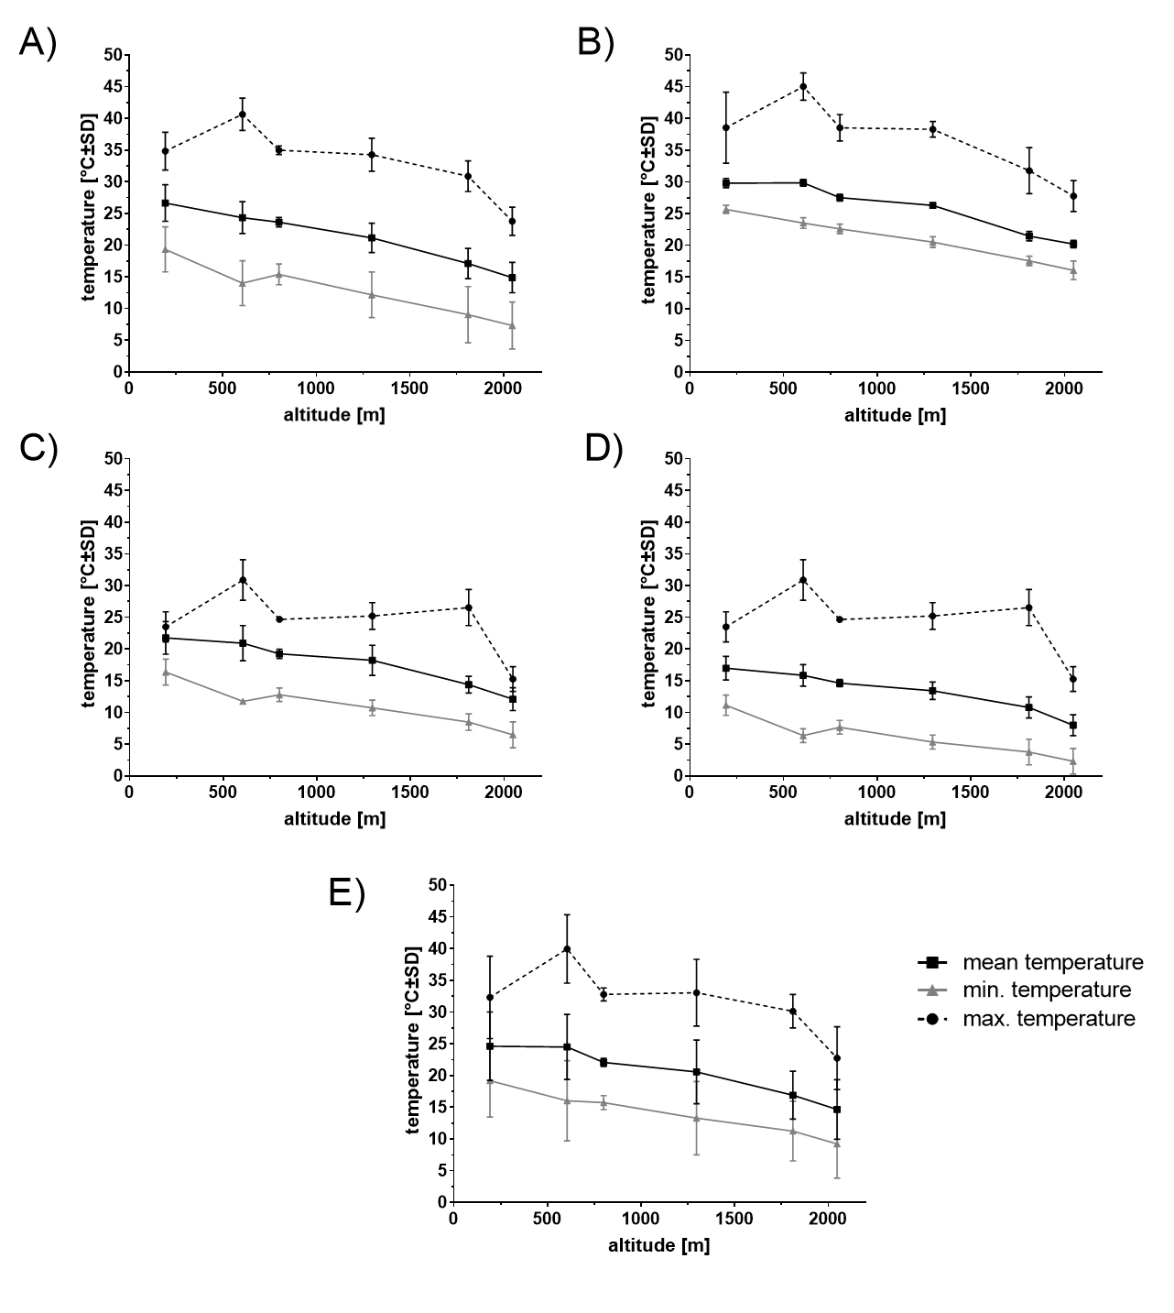
Figure 9. Microclimate (air temperature) along the altitudinal gradient in Central Nepal. Mean, minimum and maximum temperature (HOBO logger data; microclimate see also Supplementary file 1 Table 5) in different seasons from November 2017 to March 2019: A) pre-monsoon (March-May), B) monsoon (June-September), C) post-monsoon (October-November), D) winter (December-February), E) annual. The 800 meter population was interpolated using raw data of loggers.

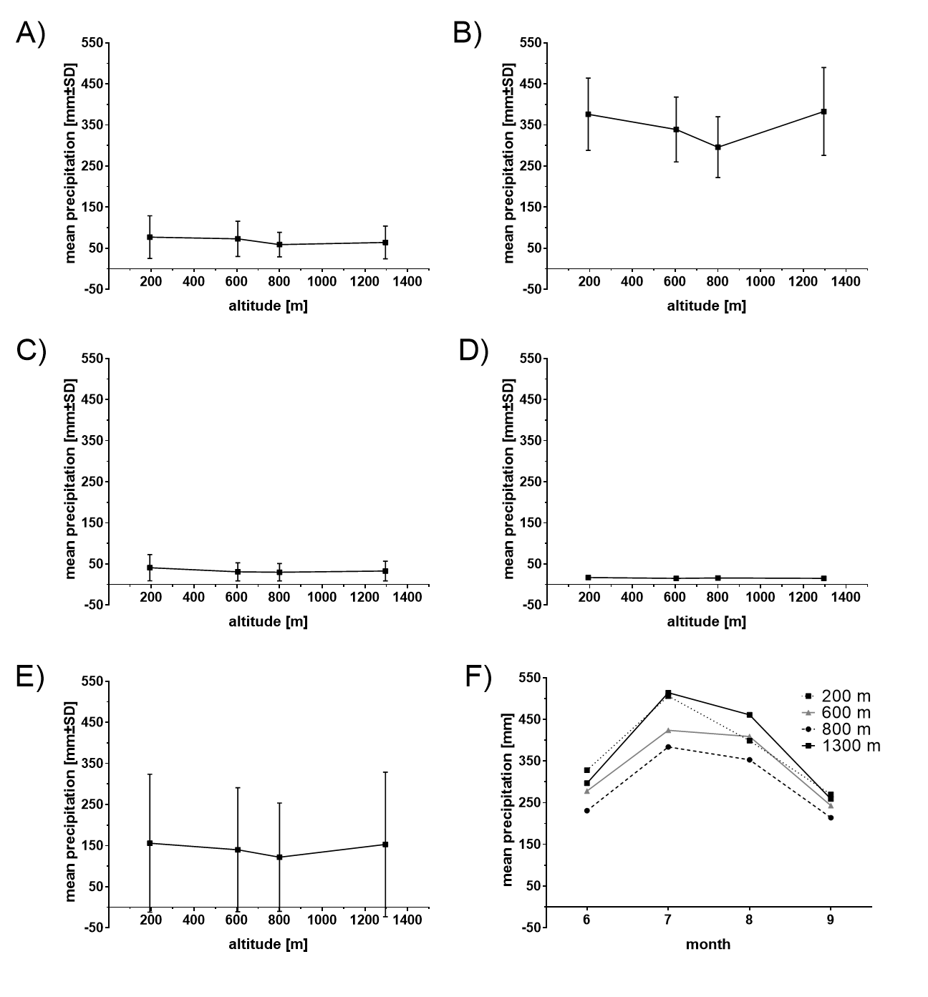

Figure 10. Precipitation along the altitudinal gradient in Central Nepal. Mean precipitation (CHELSA data) in different seasons from 1979 to 2013: A) pre-monsoon (March-May), B) monsoon (June-September), C) post-monsoon (October-November), D) winter (December-February), E) annual, F) monthly monsoon mean precipitation
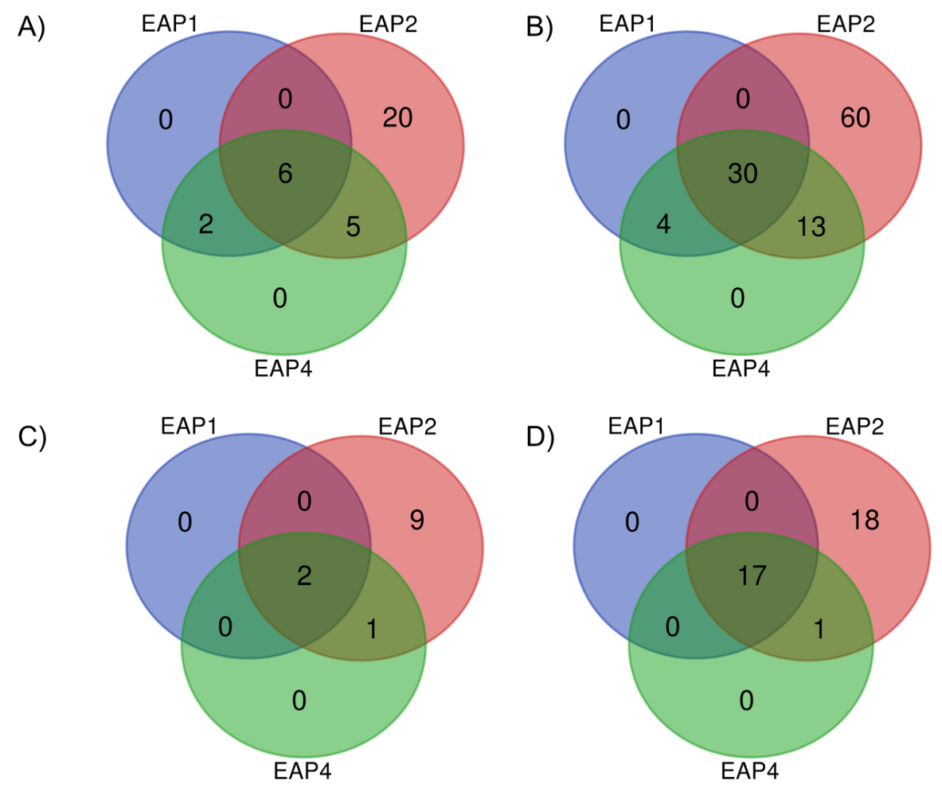
Figure 11. Gene IDs (A, C) or protein IDs (B,D) present in all different significant environmental variable associated positions (EAP) laying in an overlapping singificant 1kb-F_{ST}-window (OW, A and B) and contain a non-synonymous mutation (C and D).

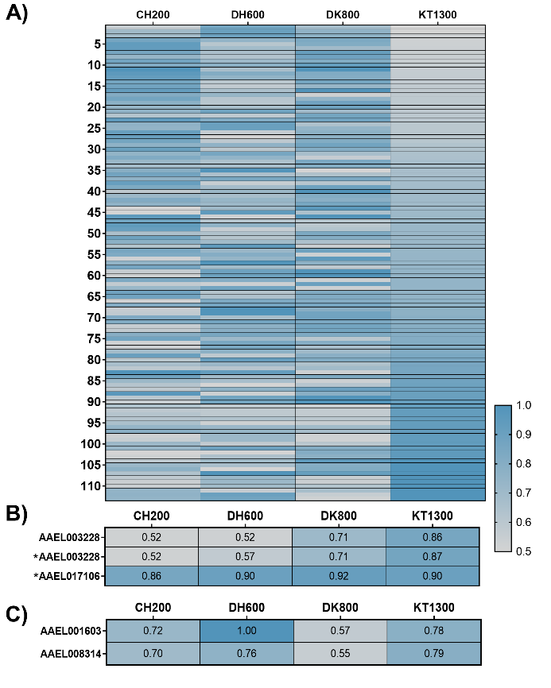
Figure 12. Heat map of allele frequency distribution at candidate loci containing non-synonymous mutations for A) 113 detoxification genes of Ae. aegypti, B) genes associated with DENV-1 infection or C) genes associated with DENV-3 infection of Ae. aegypti. For A) allele frequencies were sorted after KT1300. Altitude of sampling sites of Ae. aegypti populations: CH200 = 200 m asl, DH600 = 600 m asl, DK800 = 800 m asl, KT1300 = 1300 m asl. Non-synonymous (marked with a *).

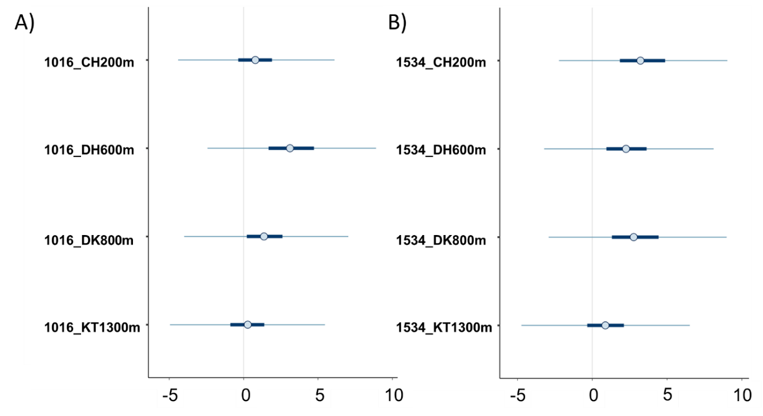
Figure 13. Posterior uncertainty intervals for kdr mutation a) V1016G and b) F1534C. Depicted are the median, 50% and 90% posterior intervals. CH200 = 200 m asl, DH600 = 600 m asl, DK800 = 800 m asl, KT1300 = 1300 m asl.

Supplementary Information 1
Detail Methods: Sampling of Mosquitoes
Aedes larvae, pupae and adults that were available in/near temporary water reservoirs, such as containers or tires, were collected during the high mosquito season (late monsoon and early post-monsoon; September till October 2018; (Kramer, Baral, et al., 2021). Individuals were at least sampled at 10 different subsampling spots including samples from multiple different breeding sites. Immature stages were reared to adults using paper cups covered with a net and water from their respective sampling site. If less than 100 Ae. aegypti individuals (larvae, pupae, adults) were sampled in the field, eggs from the same sampling campaign were reared to adulthood at the Department of Environmental Toxicology & Medical Entomology, Institute of Occupational, Social and Environmental Medicine; Goethe University Frankfurt, Germany (more details in Supplementary file 1 Table 2 and (Kramer, Baral, et al., 2021; Kramer, Pfeiffer, et al., 2021). Eggs were sampled as well at multiple subsampling spots, per site at least 30 ovitraps were used (Kramer, Baral, et al., 2021)(Kramer, Baral, et al., 2021). Adults either sampled or emerged from rearing were conserved in 100% ethanol. This combination ensured that all individuals of the pool represented true field samples, only differing in the developmental stages at the time point of sampling.
Detail Methods: XtX outlier detection using BayPass
BayPass allows for a correction of demographic effects, while identifying differentiated markers across populations. First, BayPass gives the allele frequency covariance matrix Ω giving information on the shared demographic histories of the populations. As described by Gautier (2015), the R function simulate.baypass() was used to simulate a pseudo-observed dataset based on a covariance matrix that consists of 250.000 SNPs. The so-called F_{ST}-like parameter XtX was next calculated (Günther & Coop, 2013). The upper 1% quantile threshold of the simulate data set was next used to define outliers in our empirical da sets which may reflect signatures of local adaptation (Hartke et al., 2021). OW-OPs were in addition compared with significant XtX positions of the BayPass analysis.

Detail Methods: kdr mutations- Bayesian multivariate response model
We fitted a Bayesian multivariate response model with binomial distribution of the allele frequency differences of kdr mutations with the brms package (Bürkner, 2017), which is a high-level interface to Stan (Carpenter et al., 2017) with R v.4.0.5 (R Core Team, 2021) in RStudio v.1.3.959 (RStudio Team, 2020). The response variable “allele frequency” was included as the proportion of the major allele observations to all allele counts using “trials”. In addition to the fixed factor “altitude”, an “additive overdispersion” random effect was added to estimate the residual correlation. The model was run without intercept, and additionally without the residual random effect as well as without altitude and tested for differences between those models using the “leave-one-out” criterion. As the model fit did not differ between models, the full model including altitude and the random factor is reported only. The full model was run with 4 parallel chains with 3,500 iterations each, where the first 1,000 were used as warm up and discarded. Priors were flat for allele frequencies as suggested by the “get_prior” function. Trace plots, effective sample sizes (range of effective sample sizes: 755 – 4822) and R-hat (Gelman & Rubin, 1992) values (1 < 1.02) confirmed a proper convergence.

Supplementary Information 2
Go terms
In the present study, the GO term ‘transmembrane receptor protein tyrosine kinase signaling pathway‘ and ‘protein phosphorylation’ were found to be associated with all environmental clines. The first plays a major role in the intercellular communication during the development (Haj et al., 2003). The second is important for the regulation of organic and cellular functions such as the metabolism, proliferation or apoptosis (Ardito et al., 2017), underlining the impact of the environmental clines on the life-cycle of Ae. aegypti. Further, both of these GO terms were already found to be enriched in candidate genes for climate variation in ants (Hartke et al., 2021). In addition, ‘proteolysis’ is associated with precipitation and cold tolerance and may imply a response to climate extremes/stress (Kolaczkowski et al., 2011; Waldvogel et al., 2018). The GO term ‘proteolysis’ was already found to be enriched in candidate genes for climate adaptation in other GEA studies in Chironomus and Drosophila (Kolaczkowski et al., 2011; Waldvogel et al., 2018). The GO term ‘regulation of pH’, which is associated with precipitation, was already previously identified for playing a role in the hatching of larvae (Konopová et al., 2020). The association with precipitation aligns with the fact that rainwater is needed for the hatching of Ae. aegypti eggs (Cromar & Cromar, 2014). In Nepal, sodium concentration in the rain water is high, and especially in the monsoon season (Wilson et al., 2016). Thus, immature life stages may need to cope with varying concentrations of these ions which explains the association with precipitation of the GO term ‘sodium ion transport’.

Candidate genes for local adaptation
The first gene ‘putative vitellogenin receptor’ significantly differs between the DH600 population versus the other populations and the second ’xanthine dehydrogenase’ only significantly differs between the CH200 and DH600 population. The tropical climate at the respective lowland populations (CH200, DH600) and the populations from Panama support the indication that the genes could be important in coping with tropical climate variables such as high humidity or high temperature. In general, it is known that the ‘putative vitellogenin receptor’ plays a role in the vitellogenesis (yolk formation) of Ae. aegypti females and is increasingly upregulated post-emergence prior to the first gonotrophic cycle (de Carvalho et al., 2021) while the ‘xanthine dehydrogenase’ is involved in survival of blood-fed Ae. aegypti mosquitoes. Silencing of this gene influences digestion, excretion and reproduction. Due to the lethal effect in blood-fed mosquitoes, this gene could be targeted to control vector populations (Isoe et al., 2017).
Candidate genes containing non-synonymous mutations: climate adaptation
The candidate gene ‘proto-oncogene tyrosine-protein kinase ROS’ including a non-synonymous mutation is associated with ENV1, ENV2 and ENV4 (altitude, precipitation and CT survivorship) is suggested to play a role in development or/and energy metabolism (Acquaviva et al., 2009; Zhang et al., 2018). These biological processes are important in survival after cold temperatures (CT survivorship), the start of a life-cycle as well as the general life-cycle linked to precipitation and is influenced by the environment at different altitudes.
Precipitation is a vital factor for Ae. aegypti (Cromar & Cromar, 2014). In Nepal vector and dengue occurrence is linked with precipitation or more specifically the monsoon season (Dhimal et al., 2021; Phuyal et al., 2020; Tuladhar et al., 2019). Thus, the following genes which play a role in immune response were all associated with precipitation. The ‘toll-like receptor Tollo’ was already studied in Ae. aegypti and plays a role in the immune response especially in the anti-dengue defense (Leulier & Lemaitre, 2008; Palatini et al., 2021; Ramirez & Dimopoulos, 2010; Shin et al., 2006; Souza-Neto et al., 2009; Waterhouse et al., 2007; Xi et al., 2008). In addition, the non-synonymous mutations within this candidate gene leads to an amino acid with different characteristics (Table 2). Other candidate genes play also a role in dengue viral defense (immune response) such as the ‘probable peptide chain release factor C12orf65’ (also plays a role in protein regulation- Table 4), ‘breast cancer anti estrogen resistance protein 3’ (Xuanhao, 2010) as well as the ‘zinc finger CCCH domain-containing protein 13’ (Guo et al., 2018; Ma et al., 2020). With increasing altitude, the dengue risk decreases with being the greatest below 500 m asl and moderate between 550-1500 m asl (Gyawali et al., 2020). This altitudinal distribution of dengue disease risk could explain the association between altitude and the ‘breast cancer anti estrogen resistance protein 3’ that is as well involved in dengue infection or defense (Xuanhao, 2010).
The candidate gene ‘adenylate cyclase type 9’ is associated with precipitation (ENV2) was the only gene in the climate adaptation analysis that is in parallel involved in insecticide resistance and contains a non-synonymous mutation leading to a characteristic amino acid exchange. In the mosquito Culex quinquefasciatus, this gene is involved in the regulation of the resistance-related P450 gene expression (Li & Liu, 2017, 2019). In Nepal, insecticides use is declining as summarized by (Kawada et al., 2020) The association of an insecticide resistance related gene to precipitation might be justified by the use of insecticides mainly in the monsoon season (high peak mosquito season) and the influence of rainfall on the distribution of insecticides (Jiang et al., 2012), subsequently this influences the vector Ae. aegypti.
Candidate genes involved in the life-cycle such as the ‘Tubulin-specific chaperone D’, ‘coatomer subunit beta’, ‘homeobox protein auracan’ and the ‘zinc finger CCCH domain-containing protein 13’ are likewise associated with precipitation (ENV2; Supplementary File 1 Table 9). ‘Tubulin-specific chaperone D’ is involved in the reproduction (Deitz et al., 2020). The ‘coatomer subunit beta’ including a non-synonymous mutation leading to a characteristic amino acid shift has an major impact on blood digestion and egg maturation (Isoe et al., 2011, 2013). The ‘homeobox protein auracan’ is involved in the embryonic development (Kerner et al., 2009; Negre & Simpson, 2015) and the ‘zinc finger CCCH domain-containing protein 13’ has an impact on development processes and reproduction (Guo et al., 2018; Knuckles et al., 2018; Ma et al., 2020). The association with precipitation of these candidate genes underlines the importance of precipitation in the life cycle of Ae. aegypti.

References
Acquaviva, J., Wong, R., & Charest, A. (2009). The multifaceted roles of the receptor tyrosine kinase ROS in development and cancer. Biochimica et Biophysica Acta - Reviews on Cancer, 1795(1), 37–52. https://doi.org/10.1016/j.bbcan.2008.07.006
Adelmann, Z. N., Anderson, M. A. E., Liu, M., Zhang, L., & Myles, K. M. (2012). Sindbis virus induces the production of a novel class of endogenous siRNAs in Aedes aegypti mosquitoes. Insect Mol Biol., 21(3), 357–368. https://doi.org/10.1111/j.1365-2583.2012.01141.x.Sindbis
Ardito, F., Giuliani, M., Perrone, D., Troiano, G., & Muzio, L. lo. (2017). The crucial role of protein phosphorylation in cell signalingand its use as targeted therapy (Review). International Journal of Molecular Medicine, 40(2), 271–280. https://doi.org/10.3892/ijmm.2017.3036
Bürkner, P.-C. (2017). brms: An R Package for Bayesian Multilevel Models Using Stan. Journal of Statistical Software, 80(1).
Carpenter, B., Gelman, A., Hoffman, M. D., Lee, D., Goodrich, B., Betancourt, M., Brubaker, M., Guo, J., Li, P., & Riddell, A. (2017). Stan: A Probabilistic Programming Language. Journal of Statistical Software, 76(1).
Christian, B. E., & Spremulli, Bl. L. (2012). Mechanism of protein biosynthesis in mammalian mitochondria. Biochim Biophys Acta., 1819(9–10), 1035–1054. https://doi.org/10.1093/oxfordjournals.bmb.a070399
Chrzanowska-Lightowlers, Z. M. A., Pajak, A., & Lightowlers, R. N. (2011). Termination of protein synthesis in mammalian mitochondria. Journal of Biological Chemistry, 286(40), 34479–34485. https://doi.org/10.1074/jbc.R111.290585
Cromar, L., & Cromar, K. (2014). Dengue fever and climate change. In Global Climate Change and Public Health. https://doi.org/10.1007/978-1-4614-8417-2_10
de Carvalho, S. S., Rodovalho, C. M., Gaviraghi, A., Mota, M. B. S., Jablonka, W., Rocha-Santos, C., Nunes, R. D., Sá-Guimarães, T. da E., Oliveira, D. S., Melo, A. C. A., Moreira, M. F., Fampa, P., Oliveira, M. F., da Silva-Neto, M. A. C., Mesquita, R. D., & Atella, G. C. (2021). Aedes aegypti post-emergence transcriptome: Unveiling the molecular basis for the hematophagic and gonotrophic capacitation. In PLoS Neglected Tropical Diseases, 15(1). https://doi.org/10.1371/journal.pntd.0008915
Deitz, K. C., Takken, W., & Slotman, M. A. (2020). The Genetic Architecture of Post-Zygotic Reproductive Isolation Between Anopheles coluzzii and An. quadriannulatus. Frontiers in Genetics, 11(August), 1–15. https://doi.org/10.3389/fgene.2020.00925
Dhimal, M., Kramer, I. M., Phuyal, P., Budhathoki, S. S., Hartke, J., Ahrens, B., Kuch, U., Groneberg, D. A., Nepal, S., Qi-Yong, L., Cun-Rui, H., Cissé, G., Ebi, K. L., Klingelhöfer, D., & Müller, R. (2021). Climate change and its association with the expansion of vectors and vector-borne diseases in the Hindu Kush Himalayan region: A systematic synthesis of the literature. Advances in Climate Change Research, 12(3), 421–429. https://doi.org/10.1016/j.accre.2021.05.003
Dimmer, E. C., Huntley, R. P., Barrell, D. G., Binns, D., Draghici, S., Camon, E. B., Hubank, M., Talmud, P. J., Apweiler, R., & Lovering, R. C. (2008). The Gene Ontology - Providing a Functional Role in Proteomic Studies. Proteomics, 8(23–24), n/a-n/a. https://doi.org/10.1002/pmic.200800002
Feder, M. E., & Hofmann, G. E. (1999). Heat-Shock proteins, molecular chaperones, and the stress Response: Evolutionary and Ecological Physiology. Annual Review of Physiology, 61:243-82. https://doi.org/10.1146/annurev.physiol.61.1.243
Gautier, M. (2015). Genome-wide scan for adaptive divergence and association with population-specific covariates. Genetics, 201(4), 1555–1579. https://doi.org/10.1534/genetics.115.181453
Gelman, A., & Rubin, D. B. (1992). Inference from Iterative Simulation Using Multiple Sequences. In Science,7(4), 457-472. https://doi.org/10.1214/ss/1177011136
Guo, J., Tang, H. W., Li, J., Perrimon, N., & Yan, D. (2018). Xio is a component of the Drosophila sex determination pathway and RNA N6-methyladenosine methyltransferase complex. Proceedings of the National Academy of Sciences of the United States of America, 115(14), 3674–3679. https://doi.org/10.1073/pnas.1720945115
Günther, T., & Coop, G. (2013). Robust identification of local adaptation from allele frequencies. Genetics, 195(1), 205–220. https://doi.org/10.1534/genetics.113.152462
Gyawali, N., Johnson, B. J., Dixit, S. M., & Devine, G. J. (2020). Patterns of dengue in Nepal from 2010–2019 in relation to elevation and climate. Transactions of The Royal Society of Tropical Medicine and Hygiene, 1–9. https://doi.org/10.1093/trstmh/traa131
Haj, F. G., Markova, B., Klaman, L. D., Bohmer, F. D., & Neel, B. G. (2003). Regulation of receptor tyrosine kinase signaling by protein tyrosine phosphatase-1B. Journal of Biological Chemistry, 278(2), 739–744. https://doi.org/10.1074/jbc.M210194200
Hartke, J., Waldvogel, A. M., Sprenger, P. P., Schmitt, T., Menzel, F., Pfenninger, M., & Feldmeyer, B. (2021). Little parallelism in genomic signatures of local adaptation in two sympatric, cryptic sister species. Journal of Evolutionary Biology, 34, 937–952. https://doi.org/10.1111/jeb.13742
Isoe, J., Collins, J., Badgandi, H., Day, W. A., & Miesfeld, R. L. (2011). Defects in coatomer protein I (COPI) transport cause blood feeding-induced mortality in Yellow Fever mosquitoes. Proceedings of the National Academy of Sciences of the United States of America, 108(24). https://doi.org/10.1073/pnas.1102637108
Isoe, J., Stover, W., Miesfeld, R. B., & Miesfeld, R. L. (2013). COPI-mediated blood meal digestion in vector mosquitoes is independent of midgut ARF-GEF and ARF-GAP regulatory activities. 43(8), 732–739. https://doi.org/10.1016/j.ibmb.2013.05.005.COPI-mediated
Jiang, W., Haver, D., Rust, M., & Gan, J. (2012). Runoff of pyrethroid insecticides from concrete surfaces following simulated and natural rainfalls. Water Research, 46(3), 645–652. https://doi.org/10.1016/j.watres.2011.11.023
Karger, D. N., Conrad, O., Böhner, J., Kawohl, T., Kreft, H., Soria-Auza, R. W., Zimmermann, N. E., Linder, H. P., & Kessler, M. (2017). Climatologies at high resolution for the earth’s land surface areas. Scientific Data, 4, 1–20. https://doi.org/10.1038/sdata.2017.122
Kawada, H., Futami, K., Higa, Y., Rai, G., Suzuki, T., & Rai, S. K. (2020). Distribution and pyrethroid resistance status of Aedes aegypti and Aedes albopictus populations and possible phylogenetic reasons for the recent invasion of Aedes aegypti in Nepal. Parasites and Vectors, 13(1), 1–13. https://doi.org/10.1186/s13071-020-04090-6
Kerner, P., Ikmi, A., Coen, D., & Vervoort, M. (2009). Evolutionary history of the iroquois/Irx genes in metazoans. BMC Evolutionary Biology, 9(1), 1–14. https://doi.org/10.1186/1471-2148-9-74
Knuckles, P., Lence, T., Haussmann, I. U., Jacob, D., Kreim, N., Carl, S. H., Masiello, I., Hares, T., Villaseñor, R., Hess, D., Andrade-Navarro, M. A., Biggiogera, M., Helm, M., Soller, M., Bühler, M., & Roignant, J. Y. (2018). Zc3h13/Flacc is required for adenosine methylation by bridging the mRNA-binding factor RbM15/spenito to the m6 a machinery component Wtap/Fl(2)d. Genes and Development, 32(5–6), 415–429. https://doi.org/10.1101/gad.309146.117
Kolaczkowski, B., Kern, A. D., Holloway, A. K., & Begun, D. J. (2011). Genomic differentiation between temperate and tropical Australian populations of Drosophila melanogaster. Genetics, 187(1), 245–260. https://doi.org/10.1534/genetics.110.123059
Konopová, B., Buchberger, E., & Crisp, A. (2020). Transcriptome of pleuropodia from locust embryos supports that these organs produce enzymes enabling the larva to hatch. Frontiers in Zoology, 17(1), 1–22. https://doi.org/10.1186/s12983-019-0349-2
Kramer, I. M., Baral, S., Gautam, I., Braun, M., Magdeburg, A., Phuyal, P., Kadel, I., Dhimal, M., Ahrens, B., Groneberg, D. A., & Müller, R. (2021). STtech: sampling and transport techniques for Aedes eggs during a sampling campaign in a low-resource setting. Entomologia Experimentalis et Applicata, 169(4), 374–383. https://doi.org/10.1111/eea.13022
Kramer, I. M., Pfeiffer, M., Steffens, O., Schneider, F., Gerger, V., Phuyal, P., Braun, M., Magdeburg, A., Ahrens, B., Groneberg, D. A., Kuch, U., Dhimal, M., & Müller, R. (2021). The ecophysiological plasticity of Aedes aegypti and Aedes albopictus concerning overwintering in cooler ecoregions is driven by local climate and acclimation capacity. Science of the Total Environment, 778, 146128. https://doi.org/10.1016/j.scitotenv.2021.146128
Leulier, F., & Lemaitre, B. (2008). Toll-like receptors - Taking an evolutionary approach. Nature Reviews Genetics, 9(3), 165–178. https://doi.org/10.1038/nrg2303
Li, T., & Liu, N. (2017). Regulation of P450-mediated permethrin resistance in Culex quinquefasciatus by the GPCR/Gαs/AC/cAMP/PKA signaling cascade. Biochemistry and Biophysics Reports, 12(August), 12–19. https://doi.org/10.1016/j.bbrep.2017.08.010
Li, T., & Liu, N. (2019). Role of the g-protein-coupled receptor signaling pathway in insecticide resistance. International Journal of Molecular Sciences, 20(17). https://doi.org/10.3390/ijms20174300
Matthews, B. J., Dudchenko, O., Kingan, S. B., Koren, S., Antoshechkin, I., Crawford, J. E., Glassford, W. J., Herre, M., Redmond, S. N., Rose, N. H., Weedall, G. D., Wu, Y., Batra, S. S., Brito-Sierra, C. A., Buckingham, S. D., Campbell, C. L., Chan, S., Cox, E., Evans, B. R., … Vosshall, L. B. (2018). Improved reference genome of Aedes aegypti informs arbovirus vector control. Nature, 563(7732), 501–507. https://doi.org/10.1038/s41586-018-0692-z
Ma, Z., Gao, X., Shuai, Y., Xing, X., & Ji, J. (2020). The m6A epitranscriptome opens a new charter in immune system logic. Epigenetics, 00(00), 1–19. https://doi.org/10.1080/15592294.2020.1827722
Negre, B., & Simpson, P. (2015). The achaete-scute complex in Diptera: Patterns of noncoding sequence evolution. Journal of Evolutionary Biology, 28(10), 1770–1781. https://doi.org/10.1111/jeb.12687
Oppold, A.-M., & Pfenninger, M. (2017). Direct estimation of the spontaneous mutation rate by short-term mutation accumulation lines in Chironomus riparius . Evolution Letters, 1(2), 86–92. https://doi.org/10.1002/evl3.8
Palatini, U., Masri, R. A., Cosme, L. v., Koren, S., Thibaud-Nissen, F., Biedler, J. K., Krsticevic, F., Johnston, J. S., Halbach, R., Crawford, J. E., Antoshechkin, I., Failloux, A. B., Pischedda, E., Marconcini, M., Ghurye, J., Rhie, A., Sharma, A., Karagodin, D. A., Jenrette, J., … Bonizzoni, M. (2020). Improved reference genome of the arboviral vector Aedes albopictus. Genome Biology, 21(1), 1–29. https://doi.org/10.1186/s13059-020-02141-w
Palatini, U., Masri, R. A., Cosme, L. v., Koren, S., Thibaud-Nissen, F., Biedler, J. K., Krsticevic, F., Johnston, J. S., Halbach, R., Crawford, J. E., Antoshechkin, I., Failloux, A. B., Pischedda, E., Marconcini, M., Ghurye, J., Rhie, A., Sharma, A., Karagodin, D. A., Jenrette, J., … Bonizzoni, M. (2021). Author Correction: Improved reference genome of the arboviral vector Aedes albopictus (Genome Biology, (2020), 21, 1, (215), 10.1186/s13059-020-02141-w). Genome Biology, 22(1), 13059. https://doi.org/10.1186/s13059-021-02431-x
Phuyal, P., Kramer, I. M., Klingelhöfer, D., Kuch, U., Madeburg, A., Groneberg, D. A., Wouters, E., Dhimal, M., & Müller, R. (2020). Spatiotemporal distribution of dengue and chikungunya in the hindu kush himalayan region: A systematic review. International Journal of Environmental Research and Public Health, 17(18), 1–18. https://doi.org/10.3390/ijerph17186656
Ramirez, J. L., & Dimopoulos, G. (2010). The Toll immune signaling pathway control conserved anti- dengue defenses across diverse Ae. aegypti strains and against multiple dengue virus serotypes. Bone, 34(6), 625–629. https://doi.org/10.1016/j.dci.2010.01.006.The
R Core Team. (2021). R: A Language and Environment for Statistical Computing. R Foundation for Statistical Computing, Vienna, Austria, Vienna, Au.
RStudio Team. (2020). RStudio:Integrated Development for R. RStudio, PBC, Boston, MA. http://www.rstudio.com/.
Shin, S. W., Bian, G., & Raikhel, A. S. (2006). A toll receptor and a cytokine, Toll5A and Spz1C, are involved in toll antifungal immune signaling in the mosquito Aedes aegypti. Journal of Biological Chemistry, 281(51), 39388–39395. https://doi.org/10.1074/jbc.M608912200
Souza-Neto, J. A., Sim, S., & Dimopoulos, G. (2009). An evolutionary conserved function of the JAK-STAT pathway in anti-dengue defense. Proceedings of the National Academy of Sciences of the United States of America, 106(42), 17841–17846. https://doi.org/10.1073/pnas.0905006106
Treherne, J. E. (1954). The Exchange of Labelled Sodium in the Larva of Aedes Aegypti L. Journal of Experimental Biology, 31(3), 386–401. https://doi.org/10.1242/jeb.31.3.386
Tuladhar, R., Singh, A., Banjara, M. R., Gautam, I., Dhimal, M., Varma, A., & Choudhary, D. K. (2019). Effect of meteorological factors on the seasonal prevalence of dengue vectors in upland hilly and lowland Terai regions of Nepal. Parasites and Vectors, 12(1), 1–15. https://doi.org/10.1186/s13071-019-3304-3
Waldvogel, Wieser, A., Schell, T., Patel, S., Schmidt, H., Hankeln, T., Feldmeyer, B., & Pfenninger, M. (2018). The genomic footprint of climate adaptation in Chironomus riparius. Molecular Ecology, 27(6), 1439–1456. https://doi.org/10.1111/mec.14543
Waterhouse, R. M., Kriventseva, E. v, Meister, S., Xi, Z., Alvarez, S., Bartholomay, L. C., Barillas-mury, C., Bian, G., Christensen, B. M., Dong, Y., Jiang, H., Kanost, M. R., Koutsos, A. C., Levashina, E. A., Li, J., Ligoxygakis, P., Maccallum, M., Mayhew, G. F., Mendes, A., … Chrisophides, G. K. (2007). Evolutionary Dynamics of Immune-Related Genes and Pathways in Disease-Vector Mosquitoes Robert. 316(5832), 1738–1743.
Wesolowska, M. T., Richter-Dennerlein, R., Lightowlers, R. N., & Chrzanowska-Lightowlers, Z. M. A. (2014). Overcoming stalled translation in human mitochondria. Frontiers in Microbiology, 5(JULY), 1–7. https://doi.org/10.3389/fmicb.2014.00374
Wilson, A. M., Williams, M. W., Kayastha, R. B., & Racoviteanu, A. (2016). Use of a hydrologic mixing model to examine the roles of meltwater, precipitation and groundwater in the Langtang River basin, Nepal. Annals of Glaciology, 57(71), 155–168. https://doi.org/10.3189/2016aog71a067
Xi, Z., Ramirez, J. L., & Dimopoulos, G. (2008). The Aedes aegypti toll pathway controls dengue virus infection. PLoS Pathogens, 4(7). https://doi.org/10.1371/journal.ppat.1000098
Xuanhao, C. (2010). Screening for Differentially Expressed Genes in Dengue Infection Under Antibody Dependent Enhancement Conditions for the Degree of Master of Science. Master Thesis.
Zhang, S. Z., Yu, H. Z., Deng, M. J., Ma, Y., Fei, D. Q., Wang, J., Li, Z., Meng, Y., & Xu, J. P. (2018). Comparative transcriptome analysis reveals significant metabolic alterations in eri-silkworm (Samia cynthia ricini) haemolymph in response to 1-deoxynojirimycin. PLoS ONE, 13(1), 1–14. https://doi.org/10.1371/journal.pone.0191080

