Supplementary Material

Supplementary Tables
Supplementary Table 1. Donor characteristics for primary cell isolations.
Donor | Pathology | Age (years) | Gender
1 | Emphysema | 58 | f
2 | Emphysema | 49 | f
3 | Emphysema | 57 | f
4 | Cystic fibrosis | 31 | m
5 | Cystic fibrosis | 42 | m
6 | Cystic fibrosis | 33 | f
Supplementary Table 2. Primer and probe sequences for RT-qPCR
Target | Function | Sequences (5‘-3‘) | Reference
GAPDH | forward primer | ATTCCACCCATGGCAAATTC | (4)
 | reverse primer | CGCTCCTGGAAGATGGTGAT
 | probe | JOE-CGTTCTCAGCCTTGACGGTGCCA-BHQ1
HRV | forward primer | GGTGTGAAGAGCCGCGTG | modified from (5)
 | reverse primer | CAAAGTAGTCGGTCCCATCC
 | probe | FAM-TCCTCCGGCCCCTGAATGTGG-BHQ1
IL-6 | forward primer | GGTACATCCTCGACGGCATCT | modified from (6)
 | reverse primer | GTGCCTCTTTGCTGCTTTCAC
 | probe | FAM- TGTTACTCT-ZENQ-TGTTACATGTCTCCTTTCTCAGGGCT-IowaBlackFQ
CXCL-8  (IL-8) | forward primer | CTGGCCGTGGCTCTCTTG | (7)
 | reverse primer | TTAGCACTCCTTGGCAAAACTG
 | probe | FAM-CCTTCCTGATTTCTGCAGCTCTGTGTGAA-BHQ1
Pro-  IL-1β | forward primer | CTTCGAGGCACAAGGCACAA | in house assay
 | reverse primer | TTCACTGGCGAGCTCAGGTA
 | probe | FAM-TCTGCCATGGCTGCTTCAGACACT-BHQ1
IFN-β | forward primer | CGCCGCATTGACCATCTA | (8)
 | reverse primer | TTAGCCAGGAGGTTCTCAACAATAGTCTCA
 | probe | FAM-TCAGACAAGATTCATCTAGCACTGGCTGGA-BHQ1
IFN-λ₁ | forward primer | GGACGCCTTGGAAGAGTCACT | (8)
 | reverse primer | AGAAGCCTCAGGTCCCAATTC
 | probe | FAM-AGTTGCAGCTCTCCTGTCTTCCCCG-BHQ1
FOXJ1 | forward primer | CAACTTCTGCTACTTCCGCC | modified from (9)
 | reverse primer | CGAGGCACTTTGATGAAGC
 | probe | FAM-ACGCAGATCCCACCTGGCAGAA-BHQ1
SNTN | forward primer | GTCAGTAGCGACCTAGAGCAC | in house assay
 | reverse primer | GCCTGGCCAATTCATTACTGT
 | probe | FAM-CATCTACTTGATGGAACTGCTGAGGA-BHQ1
SCGB3A1 | forward primer | CATAGAGGGCTCCCAGAAGTG | modified from (9)
 | reverse primer | CAGCGTCTTGTCCTCAGGTG
 | probe | FAM- ATGCTCCAGTCTCGGCTCAGC-BHQ1

Supplementary Figure

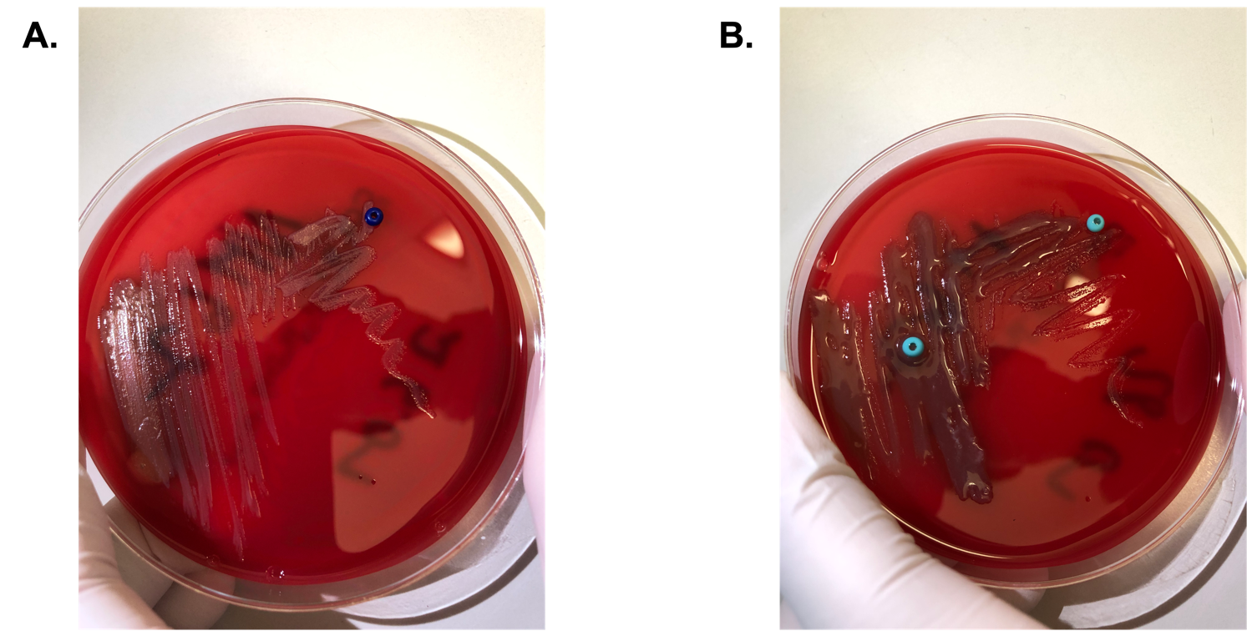
Supplementary Figure 1: Overnight cultures of P. aeruginosa (PA) clinical isolates used in the study (A) non-mucoid PA (B) mucoid PA.

