Needle stick injuries: A density equalizing mapping and socioeconomic analysis of the global research
Short title: needle stick density equalizing mapping

Online Supplement:
Sub-analysis on NSI and HIV.
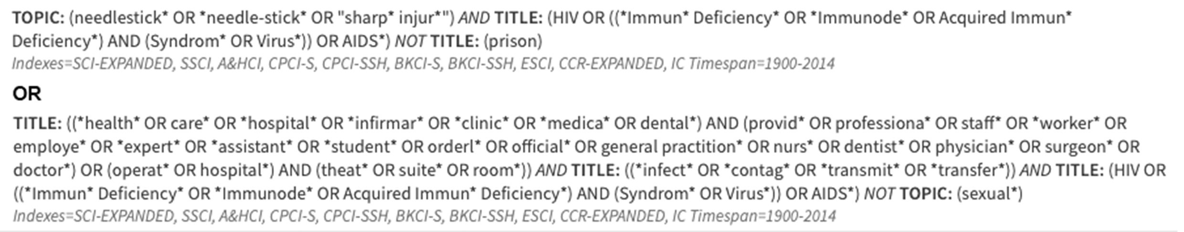
Sub-analysis on NSI and hepatitis.
