A single N¹-methyladenosine on the large ribosomal subunit rRNA impacts locally its structure and the translation of key metabolic enzymes

Sunny Sharma^{1,2,3, §, #}, Johannes David Hartmann^{1, §}, Peter Watzinger¹, Arvid Klepper¹, Christian Peifer¹, Peter Kötter¹, Denis LJ Lafontaine², Karl-Dieter Entian^{1, #}

¹ Institute of Molecular Biosciences, Goethe University, Frankfurt am Main, D-60438, Germany
² RNA Molecular Biology, Fonds National de la Recherche (F.R.S./FNRS), ULB-Cancer Research Center (U-CRC), Center for Microscopy and Molecular Imaging (CMMI), Université Libre de Bruxelles (ULB), BioPark campus, B-6041 Gosselies-Charleroi, Belgium
³ Present address – Massachusetts General Hospital Centre for Cancer Research and Department of Medicine, Harvard Medical School, Boston -02129, USA

§ Joint first author

# Corresponding author: Correspondence should be addressed to Dr. Sunny Sharma: ssharma33@mgh.harvard.edu and Prof. Dr. Karl-Dieter Entian: entian@bio.uni-frankfurt.de and

Supplementary Figures
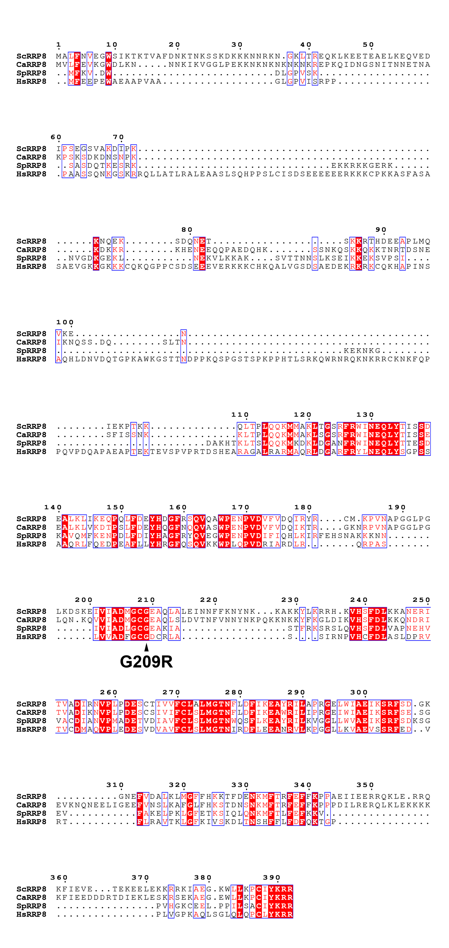
Figure S1 Rrp8 is a highly-conserved protein among eukaryotes. Amino acid sequence alignment of Rrp8 from S. cerevisiae (Sc), C. albicans (ca), S. pombe (Sp) and Homo sapiens (Hs). All multi-alignments were performed with the open-source software T-coffee (32). EsPript was used to visualize alignments.

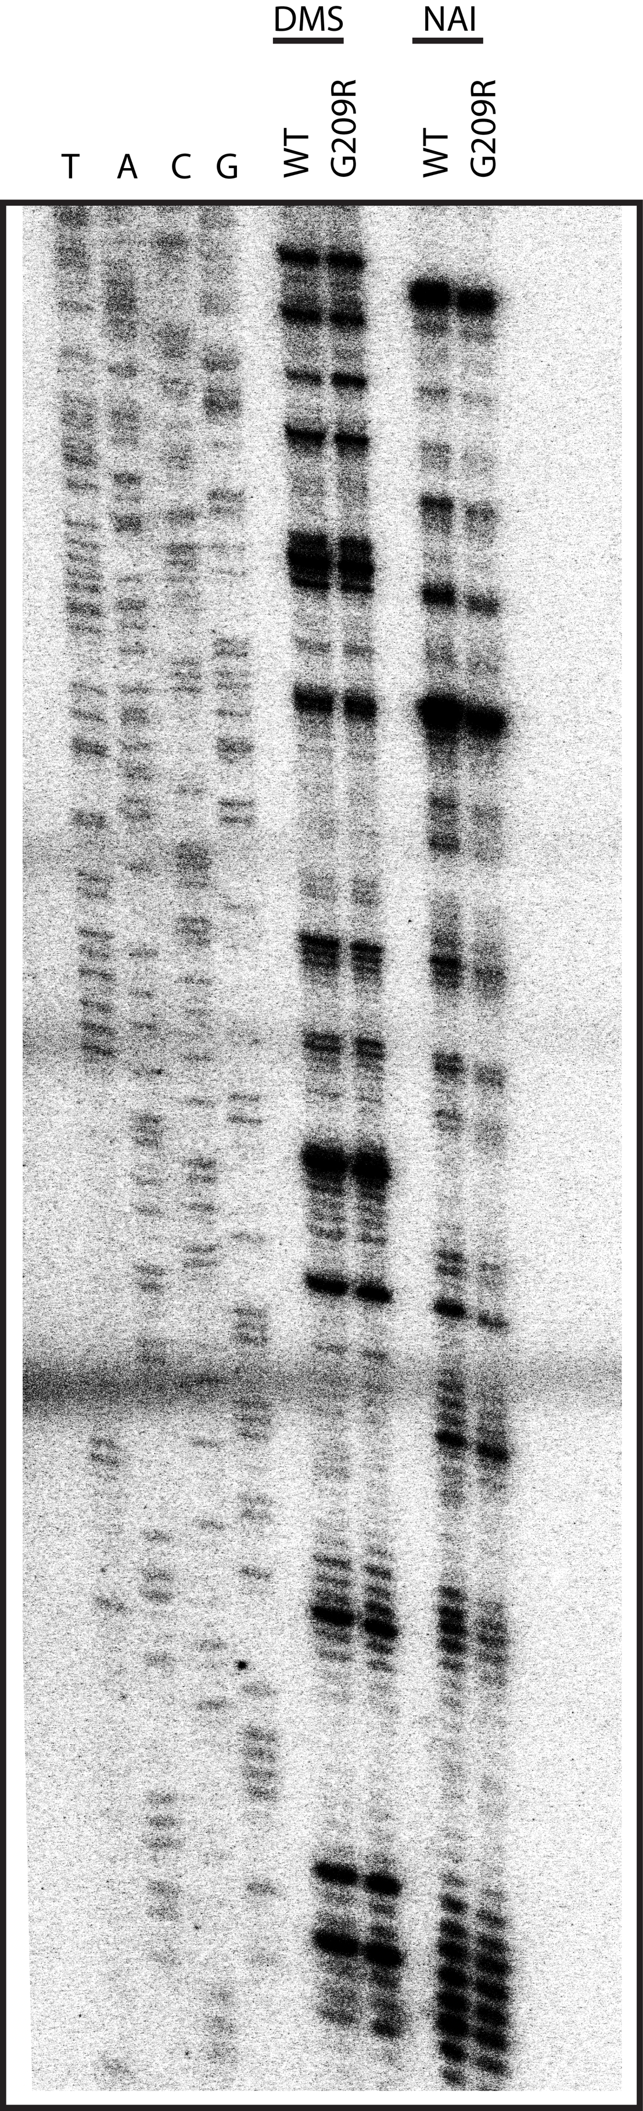

Figure S2 Loss of m¹A₆₄₅ does not influence the conformation of helix 72. Representative gel showing structure probing with DMS or SHAPE analysis with NAI in the rrp8^{G209R} loss of methylation mutant. ³²P-labeled primer (helix72_StrPrb) complementary to nucleotides 2428 to 2448 of human 28S rRNA were used for the analysis.

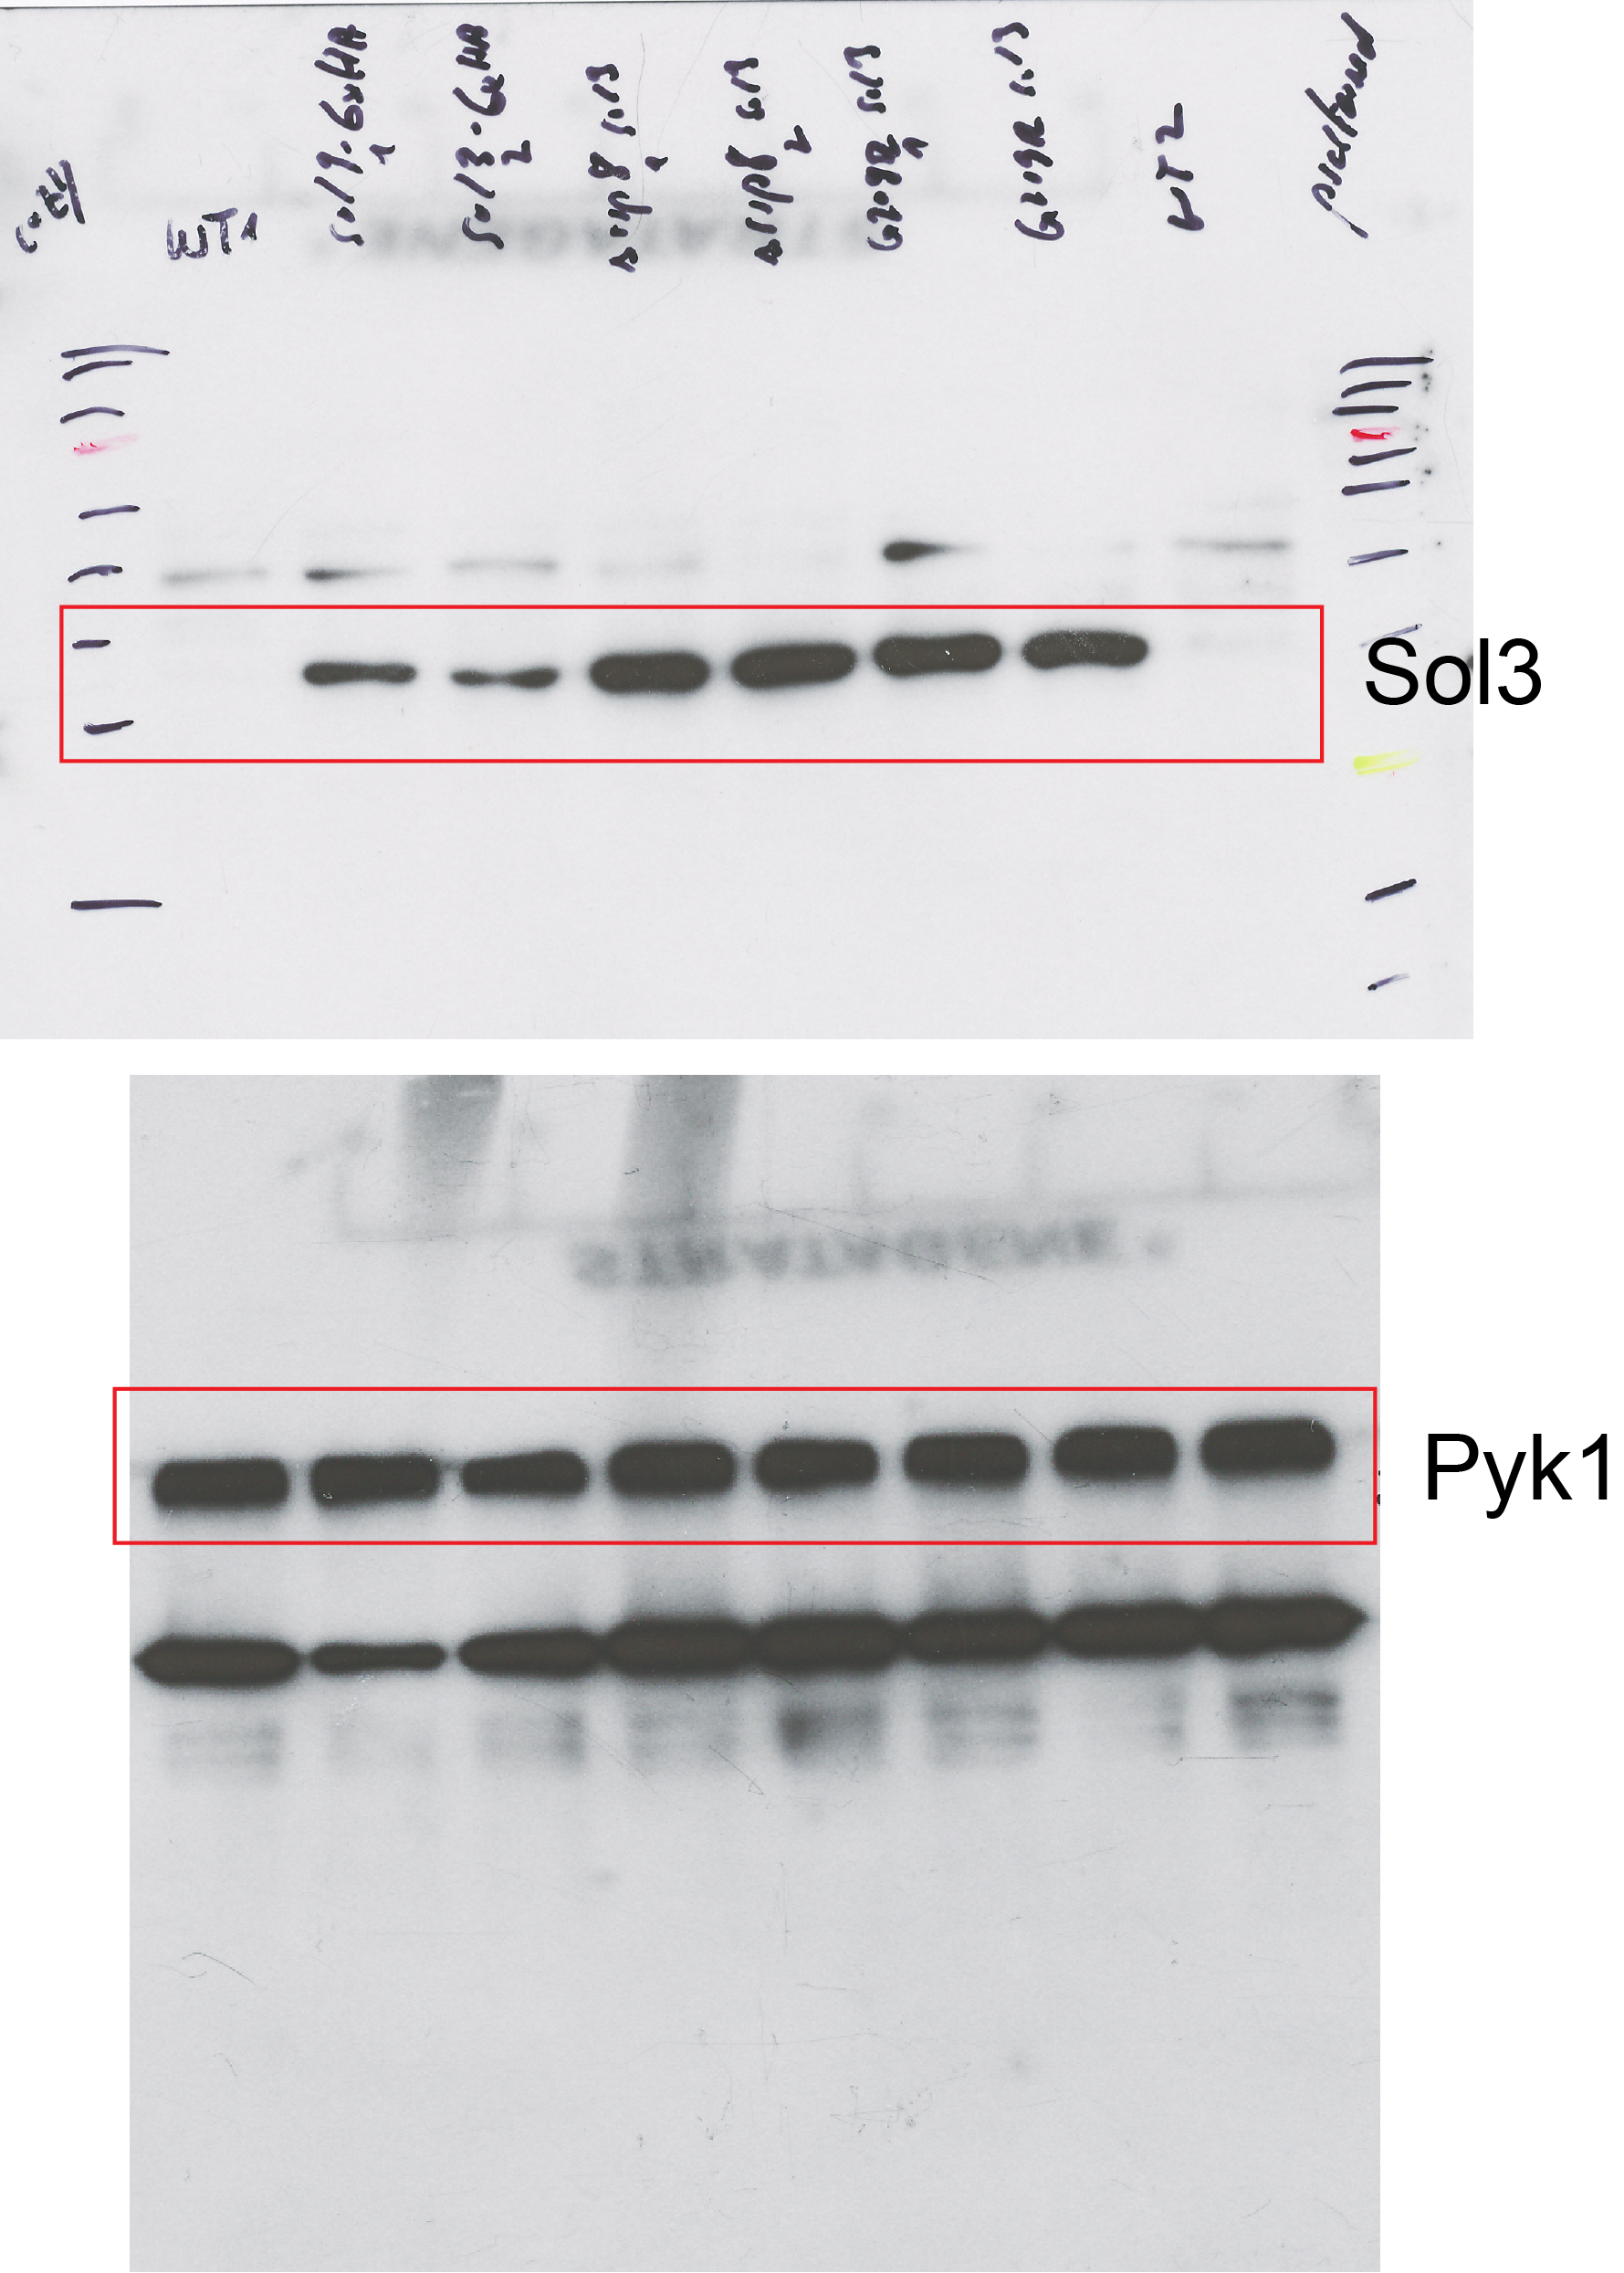
Figure S3. Uncropped Western blots, shown in Fig 6C

Supplementary Tables

Table S1 S. cerevisiae strains used within this work
Strain | Genotype | Reference
CEN.PK2-1C | MATa; ura3-52; his3-Δ1; leu2-3,112; trp1-289; MAL2-8^{c}; SUC2 | Entian, K.-D. & Kötter, P. Yeast Genetic Strain and Plasmid Collections. Methods in Microbiology Academic Press Ltd. 36, 629–666 (2007).
CEN.PK1265-4D | MATa; ura3-52; his3-Δ1; leu2-3,112; trp1-289; MAL2-8c; SUC2;  rrp8(51,1050)::loxP-natMX4-loxP | This study
CEN.CP6-2A | MATa; ura3-52; his3-Δ1; leu2-3,112; trp1-289; MAL2-8c; SUC2;  rrp8(G682C) | Peifer, C. et al. Yeast Rrp8p, a novel methyltransferase responsible for m1A 645 base modification of 25S rRNA. Nucleic acids research 41, 1151–1163 (2013).
CEN.PK1174-16A | MATa; ura3-52; his3-Δ1; leu2-3,112; trp1-289; MAL2-8^{c}; SUC2;  sol3(STOP,-40)::6xHA-kanMX4 | This study
CEN.MB678-2A | MATa; ura3-52; his3-Δ1; leu2-3,112; trp1-289; MAL2-8c; SUC2;  rrp8(788-895)::loxP-SpHIS5-loxP | Peifer, C. et al. Yeast Rrp8p, a novel methyltransferase responsible for m1A 645 base modification of 25S rRNA. Nucleic acids research 41, 1151–1163 (2013).
CEN.PK1175-1C | MATa; ura3-52; his3-Δ1; leu2-3,112; trp1-289; MAL2-8c; SUC2;  rrp8(788,895)::loxP-kanMX4-loxP  sol3(STOP,-40)::6xHA-kanMX4 | This study (from crossing CEN.MB677-1C x CEN.PK1174-2B)
CEN.DH37-4C | MATa; ura3-52; his3-Δ1; leu2-3,  112; trp1-289; MAL2-8c; SUC2;  sol3(STOP,-40)::6xHA-loxP-KanMX-loxP rrp8(G682C) | This study (from crossing (CEN.CP6-2C und CEN.PK1174-2D)
Y00000 | BY4741; MATa; his3Δ1; leu2Δ0; lys2Δ0; ura3Δ0 | EUROSCARF
Y04018 | BY4741; MATa; ura3Δ0; leu2Δ0; his3Δ1; met15Δ0; YDR083w::kanMX4 | EUROSCARF
Y02857 | BY4741; MATa; ura3Δ0; leu2Δ0; his3Δ1; met15Δ0; YHR163w::kanMX4 | EUROSCARF
BY.PK1177-1C | MATa; ura3Δ0; leu2Δ0; his3Δ1; met15Δ0; YHR163w::kanMX4 YDR083w::kanMX4 | This study (from crossing Y14018 x Y02857)
Y01971 | BY4741; MATa; ura3Δ0; leu2Δ0; his3Δ1; met15Δ0; YNL241c::kanMX4 | EUROSCARF
BY.PK1184-9B | MATa; ura3Δ0; leu2Δ0; his3Δ1; met15Δ0; YNL241c::kanMX4 YDR083w::kanMX4 | This study (from crossing Y14018 x Y01971)
Y06998 | BY4741; MATa; ura3Δ0; leu2Δ0; his3Δ1; met15Δ0; YGR248w::kanMX4 | EUROSCARF
BY.PK1186-12A | MATa; ura3Δ0; leu2Δ0; his3Δ1; met15Δ0; YGR248w::kanMX4 YDR083w::kanMX4 | This study (from crossing Y14018 x Y06998)
BY.DH4-1C | MATa; ura3Δ0; leu2Δ0; his3Δ1; met15Δ0; YDR083w::natMX4 | This study
BY.PK1179-5D | MATa; ura3Δ0; leu2Δ0; his3Δ1; met15Δ0;YHR163w::kanMX4 YGR248w::kanMX4 | This study (from crossing Y02857 x Y16998)
BY.DH5-3B | MATa; ura3Δ0; leu2Δ0; his3Δ1; met15Δ0;YDR083w::natMX4 YHR163w::kanMX4 YGR248w::kanMX4 | This study (from crossing BY.PK1179-5D X BY.DH4-1C)

Table S2 Plasmids used within this work
Plasmids | Reference
pPK468 | Peter Kötter, unpublished data
pPK468-CaRRP8 | this study
pPK468-SpRRP8 | this study
pPK468-NML | this study
pPK468-nml^{G318R} | this study

Table S3 Oligonucleotides used within this work
name | sequence | application
RRP8-S1 | TTAACGTAGAAGGTTGGTCTATTAAGACAAAAACCGTCGCCAGCTGAAGCTTCGTACGC | Deletion of ScRRP8-ORF
RRP8-S2 | CAACTTCAATAAACTTTTGTCTTCTTTCCAATTTCTGCCTGCATAGGCCACTAGTGGATCTG | Deletion of ScRRP8-ORF
CaRRP8_EcoRI | GGTGAATTCATGGTGTTATTTGAAGTTAAAGG | Construction of pPK468-CaRRP8
CaRRP8_XhoI | CTACTCGAGTTACCTCCTTTTATATATACAAGG | Construction of pPK468-CaRRP8
SpRRP8_Gap_for | ACCAAGAACTTAGTTTCGAATAAACACACATAAACAAACGATGTTTAAAGTAGATTGGGAC | Construction of pPK468-SpRRP8
SpRRP8_Gap_rev | TATAAAAAGAAAATTTATTTAAATGCAAGATTTAAAGTAGTTATCTTCTTTTGTAAATGC | Construction of pPK468-SpRRP8
HsRRP8_Gap_for | ACCAAGAACTTAGTTTCGAATAAACACACATAAACAAACGATGTTCGAAGAGCCTGAGTGG | Construction of pPK468-NML
HsRRP8_Gap_rev | TATAAAAAGAAAATTTATTTAAATGCAAGATTTAAAGTAGTCACCTGCGCTTGTAGAGAC | Construction of pPK468-NML
NML-G318R-1 | CTAGTGGTGGCTGACTTCGGCTGTCGGGATTGCCGCTTGGCTTCAAGTATC | Site-directed mutagenesis NML
NML-G318R-2 | GATACTTGAAGCCAAGCGGCAATCCCGACAGCCGAAGTCAGCCACCACTAG | Site-directed mutagenesis NML
SOL3-6HA-1 | TAATGAGGAAGCTTTTGGAAAAGTTCAAACGAAAACTTTTCGTACGCTGCAGGTCGAC | C-terminal tagging of ScSOL3
SOL3-6HA-2 | CTATGTCATTTTATAAAGTTTGGTATATATAACACGTAATATCGATGAATTCGAGCTCG | C-terminal tagging of ScSOL3
Oligo645 | CACTCGCATAGACGTTAGACTCCTTGGTCCGTGTTTCAAGACGGGCGG | Mungbean Oligo
ITS1(A2-A3) | GATTGCTGCAATGCCCAAAG | Northern hybridization
ITS2 (C1-C2) | TTGTTCGCCTAGACGCTCTC | Northern hybridization
ITS2 (E-C2) | CACTCACTACCAAACAGAAT | Northern hybridization
helix25.1_StrPrb | TCACTTTCATTACGCGTATG | Primer extension
Str_Prb_h25b | TCCGTGTTTCAAGACGGGCG | Primer extension
helix72_StrPrb | CTATGTCTCTTCACAATGTC | Primer extension
m¹A₁₃₂₂ | ACGGCGGCTTTCGTGCGAGC | Primer extension
166 | AGAGGAGGCAAAUAGAGUAtt | siRNA for NML depletion
167 | GAAGGGUAGUACUACAAAUtt | siRNA for NML depletion
168 | CGGCAAAAGAAUAAGAGAAtt | siRNA for NML depletion
ACT1-RT-fwd | TGAAGTGTGATGTCGATGTCCG | RT-qPCR oligo
ACT1-RT-rev | CGATAGATGGACCACTTTCGTCG | RT-qPCR oligo
ASC1-RT-fwd | GATCTCCTGGAAGTTGACTGGTG | RT-qPCR oligo
ASC1-RT-rev | CCAGAGATAATCATGGAAGCCTTC | RT-qPCR oligo
RPS5-RT-fwd | GCTGGTCGTTACGCCAACAAG | RT-qPCR oligo
RPS5-RT-rev | GACAGCTTGACGTCTAGCAGC | RT-qPCR oligo
RPS10A-RT-fwd | GGGTTACGTCAAGACTCA | RT-qPCR oligo
RPS10A-RT-rev | GGTACCTGGAACAATGTG | RT-qPCR oligo
ENO2-RT-fwd | TGGGTGCTAACGCTATCTTG | RT-qPCR oligo
ENO2-RT-rev | AGCACCGTATCTCTTCTTGG | RT-qPCR oligo
PGK1-RT-fwd | GCTCACAGAGCTCACTCTTC | RT-qPCR oligo
PGK1-RT-rev | CCTTGGCACCACCTAAGATG | RT-qPCR oligo
SOL3-RT-fwd | GAGGGCTAGTTTGACCCATC | RT-qPCR oligo
SOL3-RT-rev | GTCCGTCAGTGGCACAATTC | RT-qPCR oligo

