Supplementary Materials for

Assessment of the acute effects of 2C-B vs psilocybin on subjective experience, mood and cognition
¹Pablo Mallaroni*, ¹Natasha L. Mason, ¹Johannes T. Reckweg, ¹Riccardo Paci, ²Sabrina Ritscher, ²Stefan W. Toennes, ¹Eef L Theunissen, ¹Kim PC Kuypers, ¹Johannes G. Ramaekers*

Author affiliations
¹Department of Neuropsychology and Psychopharmacology, Faculty of Psychology and Neuroscience, Maastricht University, P.O. Box 616, 6200 MD Maastricht, the Netherlands
²Institute of Legal Medicine, University Hospital, Goethe University, Frankfurt/Main, Germany

Corresponding authors’ emails*
p.mallaroni@maastrichtuniversity.nl, j.ramaekers@maastrichtuniversity.nl

Table of Contents:
- S1. Methods: Inclusion/exclusion criteria
- S2. Methods: Screening procedure
- S3. Methods: Study drugs and dose selection
- S4. Methods: Study procedures
- S5. Methods: Acute subjective effects
- S6. Methods: Retrospective subjective effects
- S7. Methods: Neuropsychological task battery
- S8. Methods: Serum analytics
- S9. Methods: Power calculation
- S10. Results: CONSORT flowchart
- S11. Results: Demographics
- S12. Results: Missing data
- S13. Results: Duration of effect
- S14. Results: MET task performance (+270 min)
- S15. Results: Cmax correlations
- References

S1. Methods: Inclusion/exclusion criteria

The inclusion criteria were: 18-40 years of age; previous experience with a psychedelic drug but not within the past 3 months; body mass index between 18 and 28 kg/m2; free from medication (any drug prescribed for a medical indication); good physical health, including absence of major medical, endocrine, and neurological conditions; and written informed consent. Psychedelic experienced participants were recruited as to further minimise the likelihood of serious adverse psychological effects ¹. The exclusion criteria included history of drug abuse or addiction, pregnancy, or lactation, current or history of psychiatric disorders, absence of reliable contraceptives, previous experience of serious side effects to psychedelics, and MRI contraindications. Before inclusion, participants were screened and examined by an independent study physician, who checked for general health, conducted a resting ECG, and took blood and urine samples in which haematology, clinical chemistry and urine analyses were conducted.

All participants were fully informed of all procedures, possible adverse reactions, legal rights, and responsibilities, expected benefits, and their right to voluntary termination without consequences. All participants provided their informed consent, in writing, prior to their inclusion in the study and are to be remunerated for their participation.

S2. Methods: Screening procedure

Preliminary eligibility was determined via online pre-screening (Qualtrics XM) assessing prior use history, frequency, and location. If eligible, subjects were invited for an online debriefing of the study procedures and measures. After obtaining written informed consent, subjects were administered digital evaluations of their psychiatric (DSM axis 1 or WHO ICD-10 diagnostic classification) and drug use history using structured self-report inventories. If consistent with the study inclusion criteria, subjects were invited to a in-depth in-person evaluation in which the information provided was thoroughly cross-examined by the study psychiatrist during a one-on-one medical screening interview. The following was performed; thorough evaluation of the patient's physical and mental health, vital signs, weight, and electrocardiogram were recorded, and a physical examination was conducted. Laboratory tests performed included: urine toxicology for street drugs, urinalysis, serum chemistry, haematology, and liver function. Participants were told that while they may not benefit from study participation, their participation may lead to knowledge that may help others.

S3. Methods: Study drugs and dose selection

In the absence of existing 5-HT_{2A} receptor occupancy data for 2C-B, moderate “equivalent” doses of 20 mg 2C-B and 15 mg psilocybin were approximated according to their psychotropic equivalence ², as defined by subjective drug high and intensity extrapolated from prior study data ³⁻⁵. Previous head-to-head trials employing classical psychedelics and entactogens have employed equivalent outcome-based approaches to selecting equipotent doses ⁶. In addition, these doses have been indicated to share comparable cardiovascular effects, tolerability, and effect onset times ^{5,7,8}. Synthetic (powder) formulations of 2C-B and psilocybin were employed. 2C-B was obtained from Duchefa Farma B.V., Haarlem, Netherlands. Psilocybin was obtained from THC Pharm GmbH, Frankfurt, Germany. A permit for obtaining, storing, and administering 2C-B and psilocybin was obtained from the Dutch Drug Enforcement Administration.

S4. Methods: Study procedures
Upon enrolment, and prior to the start of testing cycles, participants were invited to a preparatory training visit where they met and built rapport with the experimenters and were trained on all computerised tasks and procedures.

Each acute experimental session lasted approximately 7 hours. On the morning of the dosing day, participants were instructed to have a light breakfast at home. Participants were reminded to refrain from drug use, including psychedelic drugs (≥ 3 months), alcohol (≥24 hours), and all other drugs of abuse (≥7 days) before each experimental visit. Additionally, participants were asked to refrain from caffeine and nicotine use on each test day. All psychoactive drug use was prohibited throughout the duration of the study (7 weeks). On arrival of a test day, absence of drug and alcohol use was assessed via a urine drug screen and a breath alcohol screen. A pregnancy test was given to females. If all tests were found to be negative, a venous catheter was placed, and participants were allowed to proceed with administration. The acute experimental sessions were conducted in a quiet psychopharmacology lab. In between testing, the participants could interact with the investigator, rest, read, or listen to music via headphones. Participants stayed under supervision until the testing day was complete and the experimenters deemed they were fit to go home.

S5. Methods: Acute subjective effects

Subjective effect (VAS)
Subjective effects were assessed repeatedly using visual analog scales (VASs) at baseline (0h), +0.5, +1, +1.5, +2, +3, +4, +5, +6 hours after drug administration. These scales included the primary VAS items: “any drug effect,” “good drug effect”, “bad drug effect”, “drug liking,” “drug high”, presented as 100-mm horizontal lines (0–100%), marked from “not at all” on the left to “extremely” on the right ⁶. The VAS “any drug effect” is an overall effect measure to characterise the overall effect intensity and time course. Prior dose-effect studies have previously demonstrated it to useful marker for pharmacokinetic-pharmacodynamic modeling of psilocybin and LSD’s effects ^{9,10}. Separately, “any drug effect” is interrelated with “drug high”, a measure of stimulating effects. The VAS “good drug effect” is an overall measure of positive effects and interrelated with other measures such as “drug liking”. The VAS “bad drug effect” is an overall measure of any negative effects. These items have been demonstrated to sensitive to the acute effects of psychedelics (LSD, psilocybin), entactogens (MDMA, MDA) and psychostimulants (d-amphetamine, mephedrone) as well as 2C-B and 2C-E ^{3,6-8,11,12}. Secondary VAS items comprised “happy”,” concentration”,” creative”, “productive”, ”sociable”, “sense of time”. Items were bidirectional, marked from “not at all “on the left (0) to “extremely” on the right (+100) with ”sense of time” marked from “slow” on the left (0) to “fast” on the right (+100). These items have been found to sufficiently sensitive to enhancing effects at subperceptual doses of LSD ¹³.
Profile of Mood States (POMS)
The POMS consists of 72 adjectives commonly used to describe momentary mood states ¹⁴. Subjects rate from 0 (not at all) to 5 (extremely) the extent to which each adjective describes how they feel at that moment. Item sums produce seven primary factors: Tension, Anger, Fatigue, Depression, Confusion, Vigour, Friendliness and a Total Mood Disturbance score (Tension + Depression + Anger + Fatigue) − Vigour). Derived elements¹⁵ include: Elation, Arousal ((Tense + Vigour) − (Fatigue + Confusion)) and Positive Mood (Elation − Depression). The POMS has previously been used to ascertain the mood-enhancing effects of 2C-B ⁵ as well as other psychostimulants and entactogens such as 4-FA and MDMA ^{16,17}.

Clinician-Administered Dissociative States Scale (CADSS)
The CADSS is an instrument designed to be a standardized measure of present-state dissociative symptomatology ¹⁸. It comprises 19-self report items, ranging in intensity from 0 ‘not at all’ to 4 ‘extremely present’. The additional seven observer-rated items in the scale, were not employed in the present study. It is comprised of three factors: 1) depersonalisation (feeling detached from oneself), 2) derealisation (feeling detached from ones surroundings) and 3) amnesia (gaps in memory, identity confusion and alteration). Summed together, these subscales form a total dissociative score. The CADSS serves as a rapid assessment of psychedelic effects due to its conceptual overlap with the core loss of subjective self-identity and disembodiment under serotonergic hallucinogens ¹⁹⁻²².

The Bowdle Visual Analogue Scale (B-VAS)
The B-VAS is a self-report inventory specifically devised to assess acute psychedelic effects ²³⁻²⁵. It consists of 13 100-mm VAS from which two composite scales, internal perception (six items) and external perception (five items) are calculated outside of two filler items. The former scale reflects inner feelings not correspondent with reality and the latter scale reflects a misperception of external stimuli or a change in the awareness of the person’s surroundings. A third intensity scale - High, is also extrapolated ²⁶.

Sensitivity to Drug Reinforcement Questionnaire (SDRQ).
The SDRQ is the adapted form of the Sensitivity to Cannabis Reinforcement Questionnaire, previously used to assess drug desirability ^{27,28}. This 4-item questionnaire asks participants to rate current and general liking and wanting of the intervention. Subjective valence of liking and wanting is scored from 1 (somewhat) to 5 (extremely).

S6. Methods: Retrospective subjective effects

Altered States of Consciousness Rating Scale (5D-ASC)
The 5D-ASC ²⁹ consists of 94 retrospective 100-mm VAS. The ASC items are grouped into five main dimensions comprising 11 lower-order scales (1) ‘oceanic boundlessness’ (OB) measures derealization and depersonalization accompanied by changes in affect ranging from heightened mood to euphoria and/or exaltation as well as alterations in the sense of time. The corresponding subfactors include “experience of unity,” “spiritual experience,” “blissful state,” “insightfulness,” and “disembodiment.” (2) ‘anxious ego dissolution’ (AED) measures ego disintegration associated with loss of self-control, thought disorder, arousal, and anxiety. The corresponding subfactors comprise “impaired control of cognition”, “disembodiment” and “anxiety.” (3) ‘visionary restructuralisation’ (VR) refers to ‘elementary hallucinations’, ‘visual (pseudo-) hallucinations’, ‘synaesthesia’, ‘changed meaning of percepts’, ‘facilitated recollection’, and ‘facilitated imagination’. It consists of the lower-order scales “complex imagery,” “elementary imagery,” “audio-visual synesthesia,” and “changed meaning of percepts.” (4) ‘auditory alterations’ (AA) refers to acoustic hallucinations and distortions in auditory experiences and (5) the dimension ‘reduction of vigilance’ (RV) relates to states of drowsiness, reduced alertness, and related impairment of cognitive function. The 5D-ASC is the most widely used psychometric assessment of classical psychedelic and entactogenic effects and has been deployed across a range of altered states of consciousness. Furthermore, acute ratings on the 5D-ASC after administration of psilocybin have been used to predict long-term effects of psychedelic-assisted therapy in patients and healthy volunteers ^{30,31} while holding good convergence with other clinically used psychometric assessments such as the Mystical Experience Questionnaire ³².

The Ego-Dissolution Inventory (EDI)
The Ego-Dissolution Inventory is a self-reported scale used to specifically assess subjective feelings of ego-dissolution/loss of self after drug intake ³³. The questionnaire consists of 8 VAS items (100-mm) which participants have to rate retrospectively, including: I experienced a dissolution of my “self” or ego; I felt at one with the universe; I felt a sense of union with others; I experienced a decrease in my sense of self-importance; I experienced a disintegration of my “self” or ego; I felt far less absorbed by my own issues and concerns; I lost all sense of ego; All notion of self and identity dissolved away. The EDI has been shown to relate with the underlying effects of 5-HT_{2A} agonists on functional brain organisation ^{34,35}.

Hallucinogen Rating Scale (HRS)
The HRS includes 71 items scored 0 (not at all) to 4 (extremely) across six scales: Somaesthesia, reflecting somatic effects including interoceptive, visceral and tactile effects; Affect, sensitive to emotional and affective responses; Volition, indicating the subject's capacity to wilfully interact with his/her ‘self’ and/or the environment; Cognition, describing impedance in thought processes or content; Perception, measuring visual, auditory, gustatory and olfactory experiences; and finally Intensity, which reflects the strength of the overall experience ³⁶. The HRS has been extensively used in hallucinogen research employing psilocybin ^{37,38}, DMT ³⁹, ketamine ^{39,40}, Salvia divinorum ^{41,42}, 2C-B ³, MDE (3,4-methylenedioxy-N-ethyl-amphetamine) ⁴³, MDMA ⁴⁴ and ayahuasca ^{45,46} as well as psychedelic-assisted psychotherapy studies employing psilocybin ⁴⁷.
Interpersonal Reactivity Index (IRI)
The IRI is a 28-item retrospective inventory using a 5-point scale (1=never; 5=always) which assesses 4 constructs of trait empathy: ‘Fantasy’ (tendency to imaginatively transpose oneself into fictional situations), ‘Perspective-Taking’ (capacity to spontaneously adopt the psychological viewpoint of others), ‘Empathic Concern’, (feelings of sympathy, compassion and concern for others), and ‘Personal Distress’ (assesses personal distress, unease and anxiety stemming from tense interpersonal settings). The first two scales are a measure of Cognitive Empathy (how well an individual can perceive and understand the emotions of another), the latter two (‘Empathetic Concern and ‘Personal Distress’) assess Emotional Empathy, reflecting emotional contagion ⁴⁸. The IRI was employed as a confound to assess whether any acute state-dependent empathy-enhancing effects of 2C-B or psilocybin (as assessed by the multifaceted empathy test (MET) arise independently from fluctuations in a subject’s trait-level empathy ⁴⁹.

S7. Methods: Neuropsychological task battery

Impairments in cognitive domains pertinent to the acute effects of psychedelics, entactogens and psychostimulants were assessed using a computerised task battery delivered on a dedicated testing laptop at fixed timepoints throughout the test day.

The Motor Control Task (MCT)
The MCT is an analogue of the CANTAB Motor Screen Task ⁵⁰ and provides a general assessment of whether sensorimotor deficits will limit the collection of valid data from the participant. Coloured targets are presented in different locations on the screen, one at a time. The participant must select the target on the screen as quickly and accurately as possible. Outcome measures assessed include a participant’s reaction time and the accuracy of pointing (selecting the cross), the latter defined as the mean Euclidean distance in pixels from the target centre.

Tower of London (TOL)
The TOL serves as a measure of executive functioning, specifically dimensions pertaining to mental planning and decision making ^{51,52}. Task difficulty is dictated by elements such as for example the minimum number of moves required to complete the goal, goal hierarchy (i.e., ambiguity of the sequence of final moves derived from the configuration of the goal state). The present version consists of computer-generated images of begin- and end-arrangements of three coloured balls. Every individual movement of the ball is counted as one step. Participants decide as quickly as possible, whether the end-arrangement can be accomplished in 2, 3, 4 or 5 steps from the begin arrangement by pushing the corresponding coded button. Reaction times and total correct responses are the main dependent variables. Separate counterbalanced versions comprising unique problem sequences were provided for each test day. The TOL has been previously employed in acute studies administering ayahuasca ⁵³.

Psychomotor Vigilance Task (PVT)
The PVT assesses reaction times in response to a visual stimulus as a measure of sustained attention ⁵⁴. The visual stimulus is a red circle presented at random intervals. Participants must press a button as quickly as possible upon its onset. Outcome measures were mean reaction time (milliseconds) and the number of attentional lapses. An attention lapse is the failure to react, or a reaction time exceeding 500 ms. Typically employed in circumstances of diminished reduced arousal, such as sleep deprivation, the PVT has also been used to assess the stimulating effects of MDMA and d-amphetamine ⁵⁵⁻⁵⁷.

Digit Symbol Substitution Test (DSST)
The DSST is a computerised version of the original paper and pencil test taken from the Wechsler Adult Intelligence Scale ⁵⁸. The participant is shown an encoding scheme consisting of a row of squares at the top of the screen, wherein nine digits are randomly associated with particular symbols. The same symbols are presented in a fixed sequence at the bottom of the screen as a row of separate response buttons. The randomisation procedure is chosen such that symbols never appear at the same ordinal position within both rows. The encoding scheme and the response buttons remain visible while the participant is shown successive presentations of a single digit at the centre of the screen. The goal is to match each digit with a symbol from the encoding list and click the corresponding response button. The number of digits correctly encoded within 3 minutes is the primary outcome. Secondary outcomes include number of attempts, percentage accuracy (total correct/total attempts) and reaction time. Unique counterbalanced versions of the task were deployed on each test day, differing in symbol types and ordering. The DSST has been employed in assessments of cognitive impairment under psilocybin, MDMA, dissociatives (ketamine, dextromethorphan), psychostimulants (mephedrone,4-FA,d-amphetamine) ^{16,59-63}.

Spatial Memory Test (SMT)
The SMT consists of an immediate and a delayed recognition phase, serving to evaluate visuospatial memory and reasoning in psychopharmacological drug trials ^{64,65}. The immediate recall phase is composed of six trials in which ten black-and-white pictures (total 60 pictures) are subsequently presented on a computer screen at different locations for a duration of 2 s and inter-stimulus interval of 1 s. After every trial, the pictures reappear one by one in the middle of the screen for 2 s followed by the presentation of a “1” and a “2” in different locations. The participant must indicate whether each picture corresponded with either location 1 or 2. The delayed recognition phase is completed after a 30 min delay in which the participant must indicate the correct picture location.

Matching Familiar Figures Test (MFFT)
The Matching Familiar Figures test (MFFT) is an information sampling task assessing reflection-impulsivity ⁶⁶⁻⁶⁸. This task was developed to assess the processes involved in the gathering and presented with a target figure on the left-hand side of the screen alongside six alternative figures on the right-hand side which differ in one or more details, all except one. Subjects must identify and select the matching alternative as quickly as possible by pressing the corresponding number on the keypad. If the initial choice is incorrect, a beep is played, and participants are required to repeat the trial. The task comprises 20 test trials preceded by 2 practice trials. Primary outcomes include mean latency to first response and total number of errors. Additional outcomes include: an Impulsivity score (I-score) serving as a composite score of impulsivity and an Efficiency score (E-score) which serves as an index of the balance between “fast and accurate” vs “slow and inaccurate” responding ⁶⁹. Counterbalanced versions of the task were employed for each dosing day, comprising novel figures. The MFFT has been previously used to assess impulsive action under MDMA and psychostimulants ^{17,28,70}.

Multifaceted Empathy Test (MET)
The MET consists of 40 pictures of people conveying a complex emotional state which was positive in 50% of the pictures and negative in the other half. To assess cognitive empathy, participants had to select, out of 4 words, the emotion word which matched the picture. To assess emotional empathy (EE), participants had to rate on a scale from 1-9 ‘how aroused this picture made them feel’ (Implicit EE) and ‘how concerned they were for the person’ (Explicit EE). Primary outcomes comprise the number of correct classified pictures and the IEE/ EEE ratings per valence ⁷¹. The MET has been previously used to identify empathogenic qualities under entactogens and classical psychedelics ⁷².

S8. Methods: Serum analytics

All samples were centrifuged, and serum was stored frozen at -20°C until analysis.

Analysis of 2C-B. Serum (200 µl) was extracted with 1 ml of ethyl acetate/methyl tertiary-butyl ether (80:20, v/v) after addition of 0.2 ml phosphate buffer pH 9 and 50 µl of internal standard (acetonitrile containing 0.5 ng of 2C-B-d6 from Toronto Research Chemicals, Toronto, Canada). Analysis of psilocin in serum was performed according to Martin, et al. 2013⁷³. Serum (200 µl) was extracted with 1 ml of ethyl acetate after addition of phosphate buffer pH 9, 20 ng psilocin-d 10 and 10 µl of 0.1 M ascorbic acid for stabilization ⁷³.

For both analysis streams, the organic phase was evaporated and reconstituted with 100 µl of 0.1 % formic acid/acetonitrile (80:20, v/v). The analysis of (5 µl 2C-B, 2 µl psilocin) was performed on an Agilent (Waldbronn, Germany) LC-MS/MS system consisting of a 1290 Infinity Liquid Chromatograph coupled via JetStream Electrospray Interface (ESI) to a G6460A Triple Quadrupole Mass Spectrometer. Analytes were separated on a Kinetex® 2.6 µm XB-C18 100 Å LC column (100 x 2.1 mm) plus corresponding guard column from Phenomenex (Aschaffenburg, Germany) at 30 °C. Gradient elution at a flow rate of 0.5 ml/min using 0.01% formic acid containing 5 mM ammonium formate (A) and acetonitrile containing 0.1 % formic acid (B) started with 5 % B, increased to 95 % B during 4 min and was held for 2 min. Source parameters were: gas temperature 300 °C, gas flow 11 l/min, nebulizer 45 psi, sheath gas temperature 400 °C, sheath gas flow 12 l/min and capillary voltage 3500 V. Detection was performed in the multiple reaction monitoring mode (m/z, collision energy in parentheses, quantifier underlined): 2C-B-d6: 266→249.0 (8V); 2C-B 260→243 (8V); 228 (20V); psilocin-d10: 215®66 (12), psilocine 205®58 (12); 205®160 (16). Seven calibration standards were prepared in the range 0.2 – 50 ng 2C-B and five calibration standards in the range 1 – 100 ng/ml for psilocin per ml human serum and were analysed with the samples. Calibrations were linear (regression coefficients >0.99).

Prior to pharmacokinetic analyses, incomplete time courses were interpolated using multiple imputation chain equations (MICE), derived from the mice (version 3.15.0) package ⁷⁴, following no detection of deviation from missing completely at random (MCAR) based on Little’s MCAR test. Preliminary serum area under the curve (AUC) and half-lives were extrapolated using the NonCompart (version 0.6.0) package ⁷⁵. All pharmacokinetic analyses were performed in a non-compartmental fashion.

S9. Methods: Power calculation

The primary study outcome of this trial (CCMO register: NL73539.068.20) was defined as the number of correct responses on the DSST as a measure of global impairment, due to its correspondence with the remaining neurocognitive test battery. A G*Power calculation based on a repeated mixed effect model study was determined by inputting 3 levels of treatment: 2 active conditions ( 2C-B, psilocybin) and 1 inactive condition (bitter lemon placebo), revealing that given a significance level of p =0.05, a minimal expected effect size of 0.33 and power set at 90%, a minimum of 12 participants were needed to significantly detect differences in task performance between our active and placebo treatments.

S10. Results: CONSORT flowchart

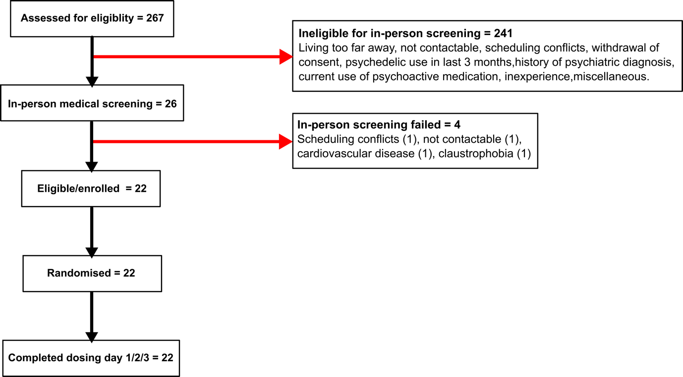

S11. Results: Demographics

Variable (n = 22) | Mean (SD)
Sex (male/female), n, total | 11/11
Age, years | 25 (4.00)
Weight, kg | 69.94 (10.07)
History of psychedelic use, years | 4 (2.00)
Lifetime psychedelic use, number of occasions | 24 (41.00)
Cannabis consumption, per month | 2.12 (1.94)
Alcohol consumption, glasses per week | 2.80 (3.70)
Caffeine consumption, glasses per week | 12.55 (9.64)
Nicotine consumption, cigarettes per week | 2.73 (9.75)

S12. Results: Missing data

Outcomes |  | N of total responses across dosing visits (n = 66)
Cognition | MST | 2
 | TOL | 1
 | PVT | 1
 | DSST | 3
 | SMT - immediate | 3
 | SMT – delayed | 5
 | MFFT | 1
 | MET | 1
Pharmacokinetics
 | No available data | 2
 | Missing timepoints | 3

S13. Results: Duration of effect

We extrapolated the onset, temporal maximum, and duration of subjective effects for 2C-B and psilocybin for each subject by on/off cut-off of 10% of the maximum individual response for the VAS “Any drug effect”. Effect onsets were 1.20 (SD: ±0.95) and 1.16 (±0.70) respectively with absolute Tmaxs arising at 2.55 (SD: ±1.02) and 3.32 (SD: ±1.24) for 2C-B and psilocybin.

S14. Results: MET task performance (+270 min)

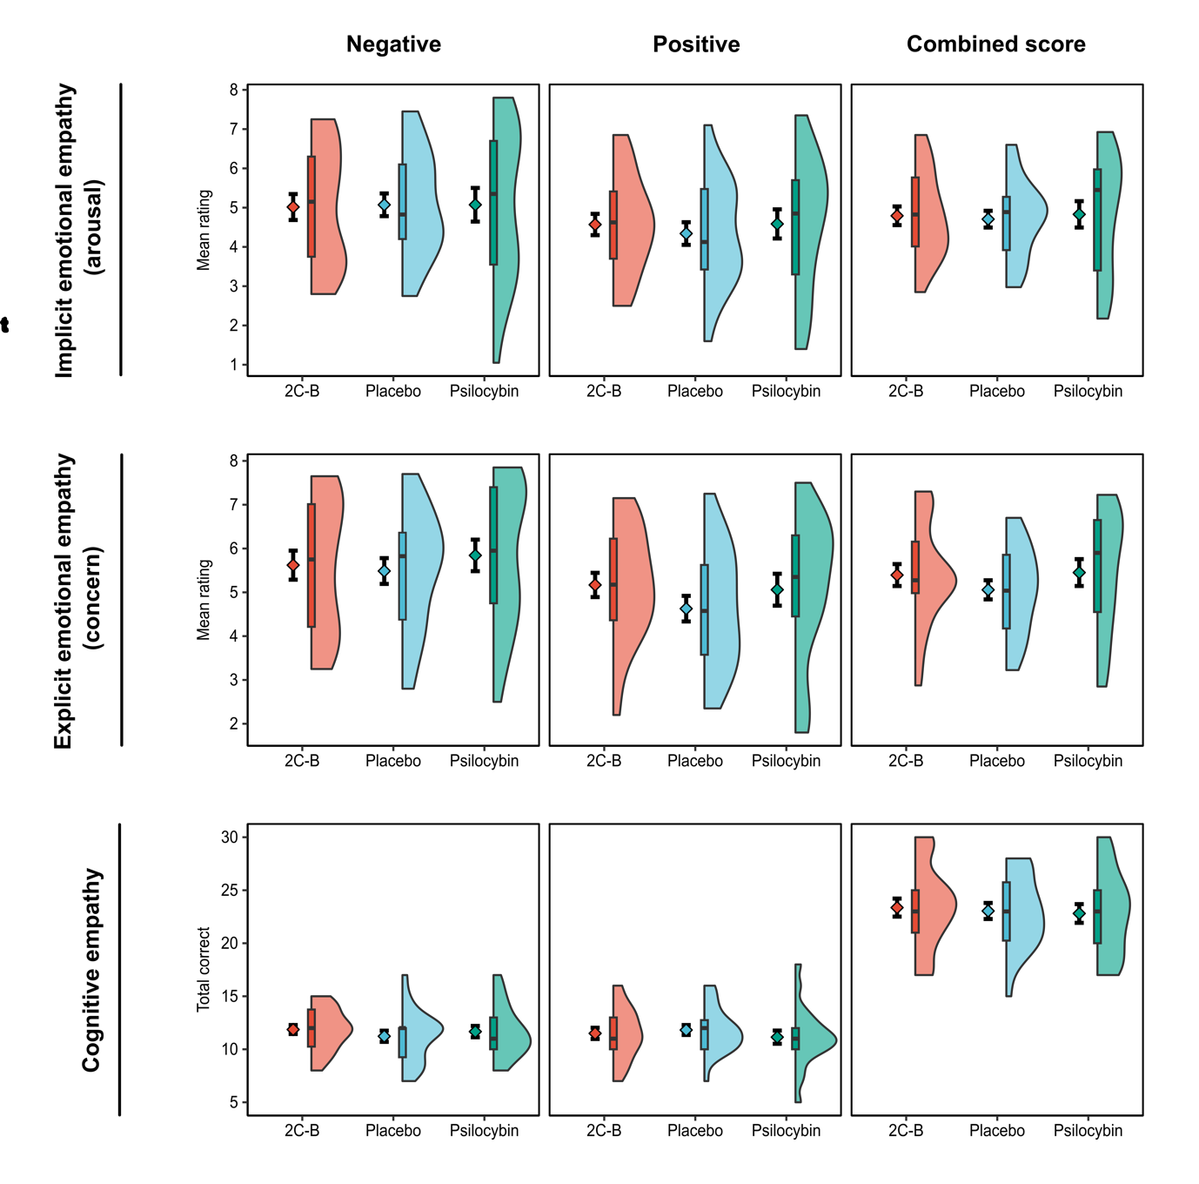

Multifaceted empathy test (MET) performance at +270 minutes. Scores for the MET dimensions of emotional empathy (implicit & explicit) and cognitive empathy are plotted on combined split-half violin plots. The plot is a combination of a probability density plot, boxplot, and mean line (± standard error of mean). In the boxplot, the line dividing the box represents the median of the data, the ends represent the upper 75th / lower 25th percentiles, and the extreme lines represent the highest and lowest values excluding outliers. No significant effect of drug was identified for any outcome measure of the MET (see supplementary table S3).

S15. Results: Cmax correlations

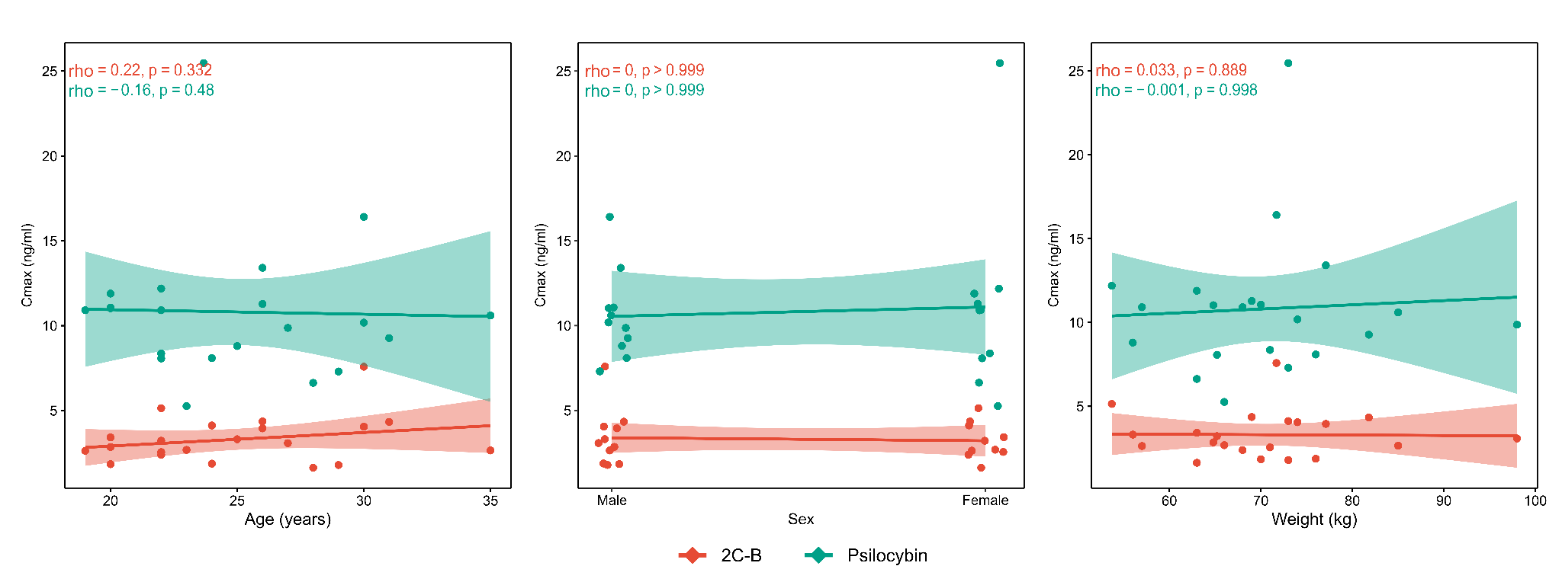
Spearman rank C_{max} correlation scatterplots. Raw datapoints are displayed per drug, alongside linear trend lines. Spearman rank correlations were performed for age, sex and weight versus serum drug concentration C_{max}. Sex associations were assessed using a point biserial spearman rank correlation approach in order to account for the binomial distributions of sex. Line shadings reflect correlation confidence intervals. Spearman rho’s and corresponding p-values are made available for each plot. No significant associations were identified.

References

1 Aday, J. S., Davis, A. K., Mitzkovitz, C. M., Bloesch, E. K. & Davoli, C. C. Predicting Reactions to Psychedelic Drugs: A Systematic Review of States and Traits Related to Acute Drug Effects. ACS Pharmacol Transl Sci 4, 424-435, doi:10.1021/acsptsci.1c00014 (2021).
2 Theunissen, E. L., Kuypers, K. P. C., Mason, N. L. & Ramaekers, J. G. A comparison of acute neurocognitive and psychotomimetic effects of a synthetic cannabinoid and natural cannabis at psychotropic dose equivalence. Frontiers in psychiatry 13 (2022).
3 Papaseit, E. et al. Acute Pharmacological Effects of 2C-B in Humans: An Observational Study. Front Pharmacol 9, 206, doi:10.3389/fphar.2018.00206 (2018).
4 Mason, N. et al. Spontaneous and deliberate creative cognition during and after psilocybin exposure. Translational psychiatry 11, 209 (2021).
5 González, D., Torrens, M. & Farré, M. Acute Effects of the Novel Psychoactive Drug 2C-B on Emotions. Biomed Res Int 2015, 643878, doi:10.1155/2015/643878 (2015).
6 Holze, F. et al. Distinct acute effects of LSD, MDMA, and D-amphetamine in healthy subjects. Neuropsychopharmacology 45, 462-471 (2020).
7 Papaseit, E. et al. Acute Effects of 2C-E in Humans: An Observational Study. Frontiers in Pharmacology 11, doi:10.3389/fphar.2020.00233 (2020).
8 Holze, F. et al. Direct comparison of the acute effects of lysergic acid diethylamide and psilocybin in a double-blind placebo-controlled study in healthy subjects. Neuropsychopharmacology 47, 1180-1187 (2022).
9 Holze, F., Becker, A. M., Kolaczynska, K. E., Duthaler, U. & Liechti, M. E. Pharmacokinetics and Pharmacodynamics of Oral Psilocybin Administration in Healthy Participants. Clinical Pharmacology & Therapeutics n/a, doi:https://doi.org/10.1002/cpt.2821.
10 Dolder, P. C. et al. Pharmacokinetics and pharmacodynamics of lysergic acid diethylamide in healthy subjects. Clinical pharmacokinetics 56, 1219-1230 (2017).
11 Baggott, M. J. et al. Effects of the Psychedelic Amphetamine MDA (3,4-Methylenedioxyamphetamine) in Healthy Volunteers. Journal of Psychoactive Drugs 51, 108-117, doi:10.1080/02791072.2019.1593560 (2019).
12 Papaseit, E. et al. Human Pharmacology of Mephedrone in Comparison with MDMA. Neuropsychopharmacology 41, 2704-2713, doi:10.1038/npp.2016.75 (2016).
13 Hutten, N. R. P. W. et al. Mood and cognition after administration of low LSD doses in healthy volunteers: A placebo controlled dose-effect finding study. European Neuropsychopharmacology 41, 81-91, doi:https://doi.org/10.1016/j.euroneuro.2020.10.002 (2020).
14 McNair, D. M., Lorr, M. & Droppleman, L. F. Manual profile of mood states. (1971).
15 de Wit, H., Enggasser, J. L. & Richards, J. B. Acute administration of d-amphetamine decreases impulsivity in healthy volunteers. Neuropsychopharmacology 27, 813-825 (2002).
16 de Sousa Fernandes Perna, E. B. et al. Safety profile and neurocognitive function following acute 4-fluoroamphetamine (4-FA) administration in humans. Frontiers in Pharmacology, 713 (2018).
17 van Wel, J. H. et al. Effects of acute MDMA intoxication on mood and impulsivity: role of the 5-HT2 and 5-HT1 receptors. PLoS One 7, e40187, doi:10.1371/journal.pone.0040187 (2012).
18 Bremner, J. D. et al. Measurement of dissociative states with the Clinician-Administered Dissociative States Scale (CADSS). J Trauma Stress 11, 125-136, doi:10.1023/a:1024465317902 (1998).
19 Puxty, D. J. et al. MDMA-Induced Dissociative State not Mediated by the 5-HT(2A) Receptor. Front Pharmacol 8, 455, doi:10.3389/fphar.2017.00455 (2017).
20 Sanches, R. F. et al. Antidepressant Effects of a Single Dose of Ayahuasca in Patients With Recurrent Depression: A SPECT Study. J Clin Psychopharmacol 36, 77-81, doi:10.1097/jcp.0000000000000436 (2016).
21 Mathai, D. S., Meyer, M. J., Storch, E. A. & Kosten, T. R. The relationship between subjective effects induced by a single dose of ketamine and treatment response in patients with major depressive disorder: a systematic review. Journal of Affective Disorders 264, 123-129 (2020).
22 Schmidt, A., Kometer, M., Bachmann, R., Seifritz, E. & Vollenweider, F. The NMDA antagonist ketamine and the 5-HT agonist psilocybin produce dissociable effects on structural encoding of emotional face expressions. Psychopharmacology (Berl) 225, 227-239, doi:10.1007/s00213-012-2811-0 (2013).
23 Bowdle, T. A. et al. Psychedelic effects of ketamine in healthy volunteers: relationship to steady-state plasma concentrations. Anesthesiology 88, 82-88, doi:10.1097/00000542-199801000-00015 (1998).
24 Kuypers, K. P. C. et al. A First-in-Man Study with 4-Fluoroamphetamine Demonstrates it Produces a Mild Psychedelic State. Journal of Psychoactive Drugs 51, 225-235, doi:10.1080/02791072.2019.1569286 (2019).
25 Dumont, G. et al. Acute psychomotor, memory and subjective effects of MDMA and THC co-administration over time in healthy volunteers. Journal of Psychopharmacology 25, 478-489, doi:10.1177/0269881110376687 (2011).
26 Zuurman, L. et al. Effect of intrapulmonary tetrahydrocannabinol administration in humans. Journal of psychopharmacology 22, 707-716 (2008).
27 Theunissen, E. L. et al. Neurocognition and subjective experience following acute doses of the synthetic cannabinoid JWH-018: a phase 1, placebo-controlled, pilot study. British Journal of Pharmacology 175, 18-28, doi:https://doi.org/10.1111/bph.14066 (2018).
28 Kuypers, K. P. C. et al. Drug liking and wanting, not impulsive action or reflection is increased by 4-fluoroamphetamine. Psychopharmacology 235, 2349-2356, doi:10.1007/s00213-018-4931-7 (2018).
29 Studerus, E., Gamma, A. & Vollenweider, F. X. Psychometric evaluation of the altered states of consciousness rating scale (OAV). PLoS One 5, e12412, doi:10.1371/journal.pone.0012412 (2010).
30 Roseman, L., Nutt, D. J. & Carhart-Harris, R. L. Quality of Acute Psychedelic Experience Predicts Therapeutic Efficacy of Psilocybin for Treatment-Resistant Depression. Frontiers in Pharmacology 8, doi:10.3389/fphar.2017.00974 (2018).
31 Schmid, Y. & Liechti, M. E. Long-lasting subjective effects of LSD in normal subjects. Psychopharmacology 235, 535-545, doi:10.1007/s00213-017-4733-3 (2018).
32 Liechti, M. E., Dolder, P. C. & Schmid, Y. Alterations of consciousness and mystical-type experiences after acute LSD in humans. Psychopharmacology (Berl) 234, 1499-1510, doi:10.1007/s00213-016-4453-0 (2017).
33 Nour, M. M., Evans, L., Nutt, D. & Carhart-Harris, R. L. Ego-Dissolution and Psychedelics: Validation of the Ego-Dissolution Inventory (EDI). Frontiers in Human Neuroscience 10, doi:10.3389/fnhum.2016.00269 (2016).
34 Lebedev, A. V. et al. Finding the self by losing the self: Neural correlates of ego‐dissolution under psilocybin. Human brain mapping 36, 3137-3153 (2015).
35 Mason, N. L. et al. Me, myself, bye: regional alterations in glutamate and the experience of ego dissolution with psilocybin. Neuropsychopharmacology 45, 2003-2011, doi:10.1038/s41386-020-0718-8 (2020).
36 Strassman, R. J., Qualls, C. R., Uhlenhuth, E. H. & Kellner, R. Dose-response study of N,N-dimethyltryptamine in humans. II. Subjective effects and preliminary results of a new rating scale. Arch Gen Psychiatry 51, 98-108, doi:10.1001/archpsyc.1994.03950020022002 (1994).
37 Griffiths, R. R. et al. Psilocybin occasioned mystical-type experiences: immediate and persisting dose-related effects. Psychopharmacology 218, 649-665 (2011).
38 Griffiths, R. R., Richards, W. A., McCann, U. & Jesse, R. Psilocybin can occasion mystical-type experiences having substantial and sustained personal meaning and spiritual significance. Psychopharmacology 187, 268-283 (2006).
39 Gouzoulis-Mayfrank, E. et al. Psychological effects of (S)-ketamine and N, N-dimethyltryptamine (DMT): a double-blind, cross-over study in healthy volunteers. Pharmacopsychiatry 38, 301-311 (2005).
40 Bowdle, A. T. et al. Psychedelic effects of ketamine in healthy volunteers: relationship to steady-state plasma concentrations. The Journal of the American Society of Anesthesiologists 88, 82-88 (1998).
41 MacLean, K. A., Johnson, M. W., Reissig, C. J., Prisinzano, T. E. & Griffiths, R. R. Dose-related effects of salvinorin A in humans: dissociative, hallucinogenic, and memory effects. Psychopharmacology 226, 381-392 (2013).
42 Johnson, M. W., MacLean, K. A., Reissig, C. J., Prisinzano, T. E. & Griffiths, R. R. Human psychopharmacology and dose-effects of salvinorin A, a kappa opioid agonist hallucinogen present in the plant Salvia divinorum. Drug and alcohol dependence 115, 150-155 (2011).
43 Gouzoulis-Mayfrank, E. et al. Psychopathological, neuroendocrine and autonomic effects of 3,4-methylenedioxyethylamphetamine (MDE), psilocybin and d-methamphetamine in healthy volunteersResults of an experimental double-blind placebo-controlled study. Psychopharmacology 142, 41-50, doi:10.1007/s002130050860 (1999).
44 Tancer, M. & Johanson, C.-E. The effects of fluoxetine on the subjective and physiological effects of 3, 4-methylenedioxymethamphetamine (MDMA) in humans. Psychopharmacology 189, 565-573 (2007).
45 Riba, J. et al. Human pharmacology of ayahuasca: subjective and cardiovascular effects, monoamine metabolite excretion, and pharmacokinetics. J Pharmacol Exp Ther 306, 73-83, doi:10.1124/jpet.103.049882 (2003).
46 Dos Santos, R. G. et al. Autonomic, neuroendocrine, and immunological effects of ayahuasca: a comparative study with d-amphetamine. Journal of clinical psychopharmacology 31, 717-726 (2011).
47 Bogenschutz, M. P. et al. Psilocybin-assisted treatment for alcohol dependence: a proof-of-concept study. Journal of psychopharmacology 29, 289-299 (2015).
48 Davis, M. H. Interpersonal reactivity index. (1980).
49 Foell, J., Brislin, S. J., Drislane, L. E., Dziobek, I. & Patrick, C. J. Creation and Validation of an English-Language Version of the Multifaceted Empathy Test (MET). Journal of Psychopathology and Behavioral Assessment 40, 431-439, doi:10.1007/s10862-018-9664-8 (2018).
50 Sandberg, M. A. in Encyclopedia of Clinical Neuropsychology (eds Jeffrey S. Kreutzer, John DeLuca, & Bruce Caplan) 480-482 (Springer New York, 2011).
51 Kaller, C. P., Unterrainer, J. M. & Stahl, C. Assessing planning ability with the Tower of London task: psychometric properties of a structurally balanced problem set. Psychological Assessment 24, 46 (2012).
52 Phillips, L. H., Wynn, V., McPherson, S. & Gilhooly, K. Mental planning and the Tower of London task. The Quarterly Journal of Experimental Psychology Section A 54, 579-597 (2001).
53 Bouso, J. C., Fábregas, J. M., Antonijoan, R. M., Rodríguez-Fornells, A. & Riba, J. Acute effects of ayahuasca on neuropsychological performance: differences in executive function between experienced and occasional users. Psychopharmacology (Berl) 230, 415-424, doi:10.1007/s00213-013-3167-9 (2013).
54 Dinges, D. F. & Powell, J. W. Microcomputer analyses of performance on a portable, simple visual RT task during sustained operations. Behavior research methods, instruments, & computers 17, 652-655 (1985).
55 Bosker, W. M., Kuypers, K. P., Conen, S. & Ramaekers, J. G. Dose-related effects of MDMA on psychomotor function and mood before, during, and after a night of sleep loss. Psychopharmacology 209, 69-76 (2010).
56 Kuypers, K. P. C., Wingen, M., Samyn, N., Limbert, N. & Ramaekers, J. G. Acute effects of nocturnal doses of MDMA on measures of impulsivity and psychomotor performance throughout the night. Psychopharmacology 192, 111-119, doi:10.1007/s00213-006-0679-6 (2007).
57 Roberts, C. A., Jones, A., Sumnall, H., Gage, S. H. & Montgomery, C. How effective are pharmaceuticals for cognitive enhancement in healthy adults? A series of meta-analyses of cognitive performance during acute administration of modafinil, methylphenidate and D-amphetamine. European Neuropsychopharmacology 38, 40-62 (2020).
58 Jaeger, J. Digit Symbol Substitution Test: The Case for Sensitivity Over Specificity in Neuropsychological Testing. J Clin Psychopharmacol 38, 513-519, doi:10.1097/jcp.0000000000000941 (2018).
59 Barrett, F. S., Carbonaro, T. M., Hurwitz, E., Johnson, M. W. & Griffiths, R. R. Double-blind comparison of the two hallucinogens psilocybin and dextromethorphan: effects on cognition. Psychopharmacology (Berl) 235, 2915-2927, doi:10.1007/s00213-018-4981-x (2018).
60 Papaseit, E. et al. Human Pharmacology of Mephedrone in Comparison with MDMA. Neuropsychopharmacology 41, 2704-2713, doi:10.1038/npp.2016.75 (2016).
61 Cami, J. et al. Human pharmacology of 3,4-methylenedioxymethamphetamine ("ecstasy"): psychomotor performance and subjective effects. J Clin Psychopharmacol 20, 455-466, doi:10.1097/00004714-200008000-00010 (2000).
62 Carter, L. P., Kleykamp, B. A., Griffiths, R. R. & Mintzer, M. Z. Cognitive effects of intramuscular ketamine and oral triazolam in healthy volunteers. Psychopharmacology (Berl) 226, 53-63, doi:10.1007/s00213-012-2883-x (2013).
63 Dolder, P. C., Strajhar, P., Vizeli, P., Odermatt, A. & Liechti, M. E. Acute effects of lisdexamfetamine and D-amphetamine on social cognition and cognitive performance in a placebo-controlled study in healthy subjects. Psychopharmacology 235, 1389-1402, doi:10.1007/s00213-018-4849-0 (2018).
64 Sambeth, A. et al. Memory impairments in humans after acute tryptophan depletion using a novel gelatin-based protein drink. J Psychopharmacol 23, 56-64, doi:10.1177/0269881108089577 (2009).
65 Kuypers, K. P. C. & Ramaekers, J. G. Acute dose of MDMA (75 mg) impairs spatial memory for location but leaves contextual processing of visuospatial information unaffected. Psychopharmacology 189, 557-563, doi:10.1007/s00213-006-0321-7 (2007).
66 Cairns, E. & Cammock, T. Development of a more reliable version of the Matching Familiar Figures Test. Developmental Psychology 14, 555 (1978).
67 Kagan, J. Reflection-impulsivity: The generality and dynamics of conceptual tempo. Journal of abnormal psychology 71, 17 (1966).
68 Viator, R. E., Wu, Y. J. & Viator, A. S. Testing the validity and reliability of the Matching Familiar Figures Test-2021: An updated behavioral measure of reflection-impulsivity. Front Psychol 13, 977808, doi:10.3389/fpsyg.2022.977808 (2022).
69 Perales, J. C., Verdejo-García, A., Moya, M., Lozano, Ó. & Pérez-García, M. Bright and dark sides of impulsivity: Performance of women with high and low trait impulsivity on neuropsychological tasks. Journal of Clinical and Experimental Neuropsychology 31, 927-944 (2009).
70 Arkell, T. R., Bradshaw, K., Downey, L. A. & Hayley, A. C. Acute effects of amphetamine and related psychostimulants on impulsivity: a systematic review of clinical trials. Addiction Biology 27, e13128, doi:https://doi.org/10.1111/adb.13128 (2022).
71 Dziobek, I. et al. Dissociation of cognitive and emotional empathy in adults with Asperger syndrome using the Multifaceted Empathy Test (MET). J Autism Dev Disord 38, 464-473, doi:10.1007/s10803-007-0486-x (2008).
72 Preller, K. H. & Vollenweider, F. X. Modulation of Social Cognition via Hallucinogens and “Entactogens”. Frontiers in Psychiatry 10, doi:10.3389/fpsyt.2019.00881 (2019).
73 Martin, R., Schürenkamp, J., Gasse, A., Pfeiffer, H. & Köhler, H. Determination of psilocin, bufotenine, LSD and its metabolites in serum, plasma and urine by SPE-LC-MS/MS. Int J Legal Med 127, 593-601, doi:10.1007/s00414-012-0796-1 (2013).
74 van Buuren, S. & Groothuis-Oudshoorn, K. mice: Multivariate Imputation by Chained Equations in R. Journal of Statistical Software 45, 1 - 67, doi:10.18637/jss.v045.i03 (2011).
75 Kim, H., Han, S., Cho, Y. S., Yoon, S. K. & Bae, K. S. Development of R packages: 'NonCompart' and 'ncar' for noncompartmental analysis (NCA). Transl Clin Pharmacol 26, 10-15, doi:10.12793/tcp.2018.26.1.10 (2018).

